**Lab6**

**Part 1**

**1-**

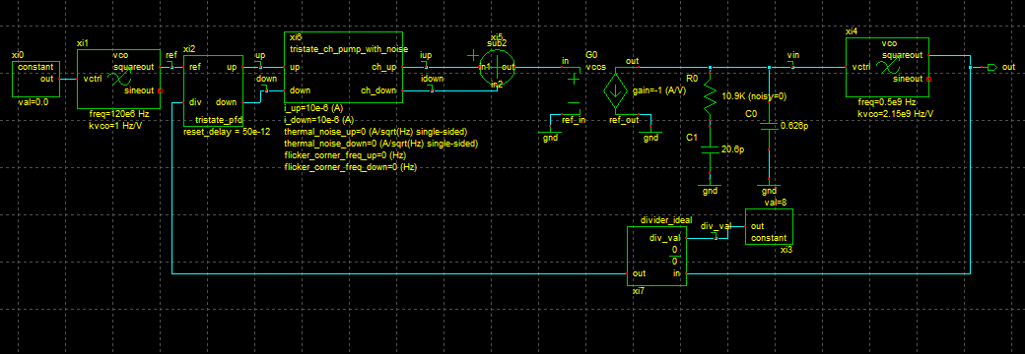

**2-**

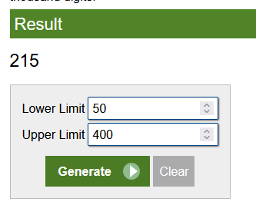

KVCO = (215 / 100 )*1e9 = 2.15e9

3- f(out) = f(in) + Kvco *vin

8*120e6 = 0.5e9 + 2.15e9*vin

Vin = 0.2139 V

4- 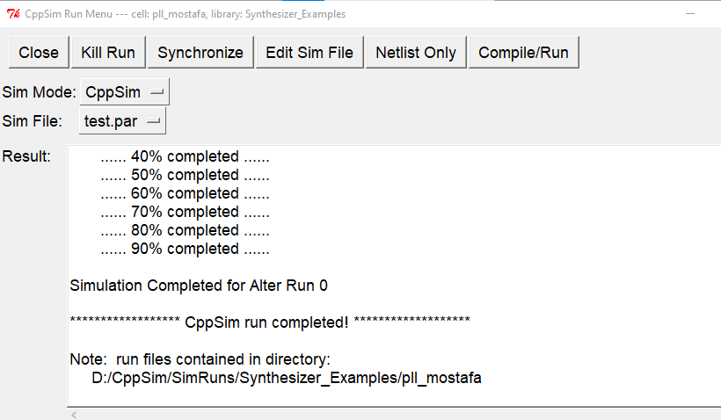

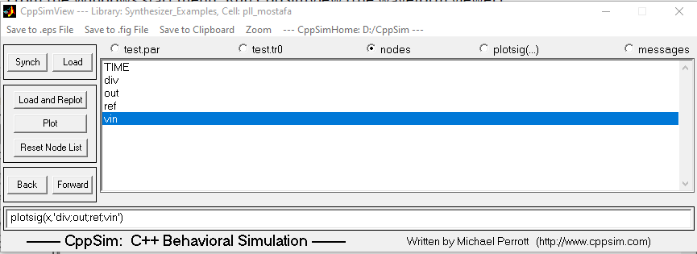

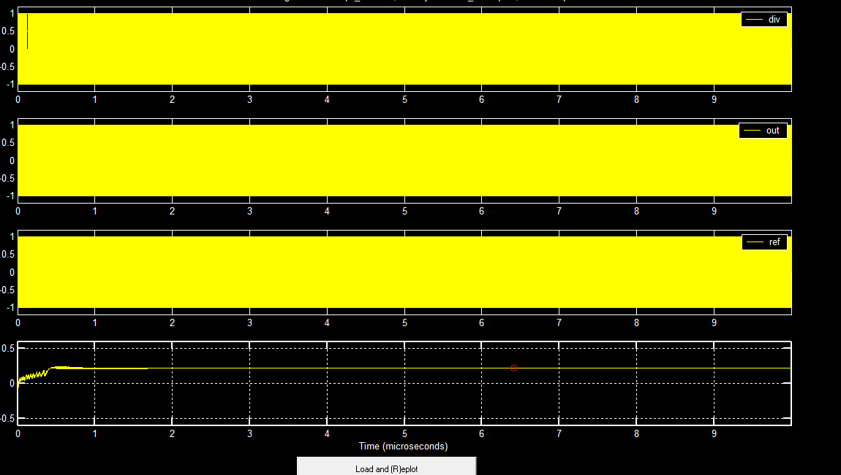

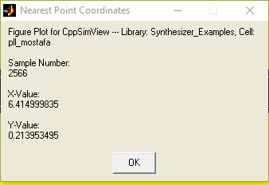

|  |  |  |
| --- | --- | --- |
|  | Analytically | CppSim |
| Vin | 0.2139 | 0.21395 |

We can observe that the value of Vin(Vctrl) from simulation is exactly the same as the value obtained analytically .

Before lock :

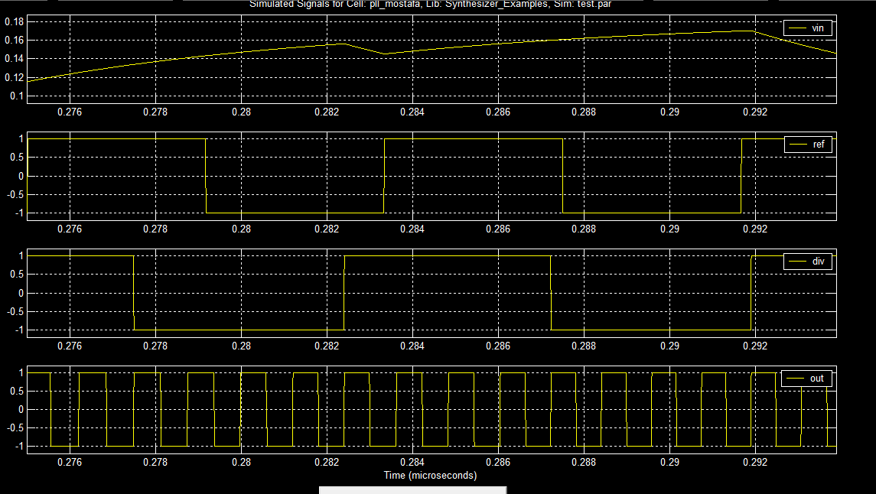

After lock:

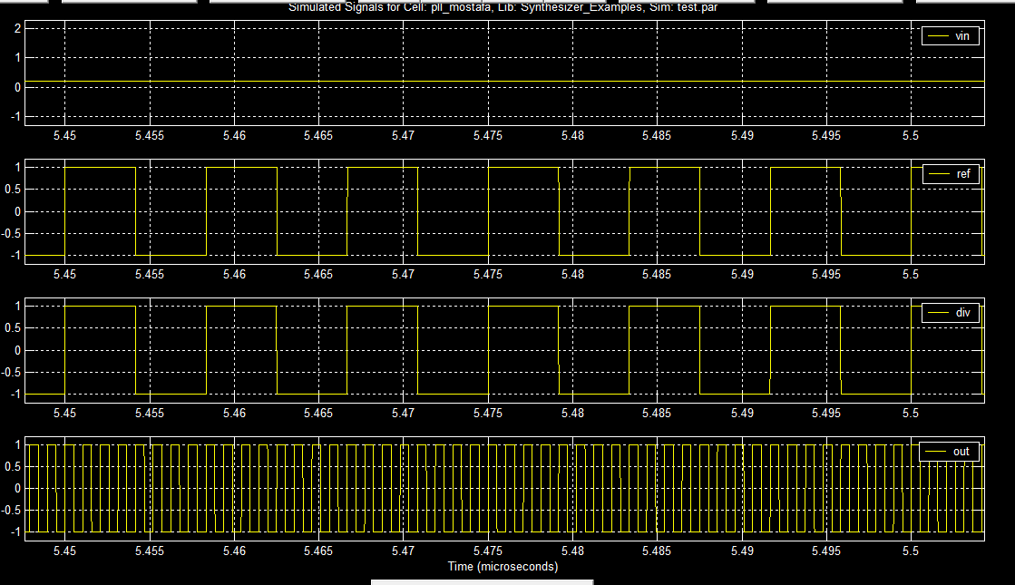

Part 2

1-

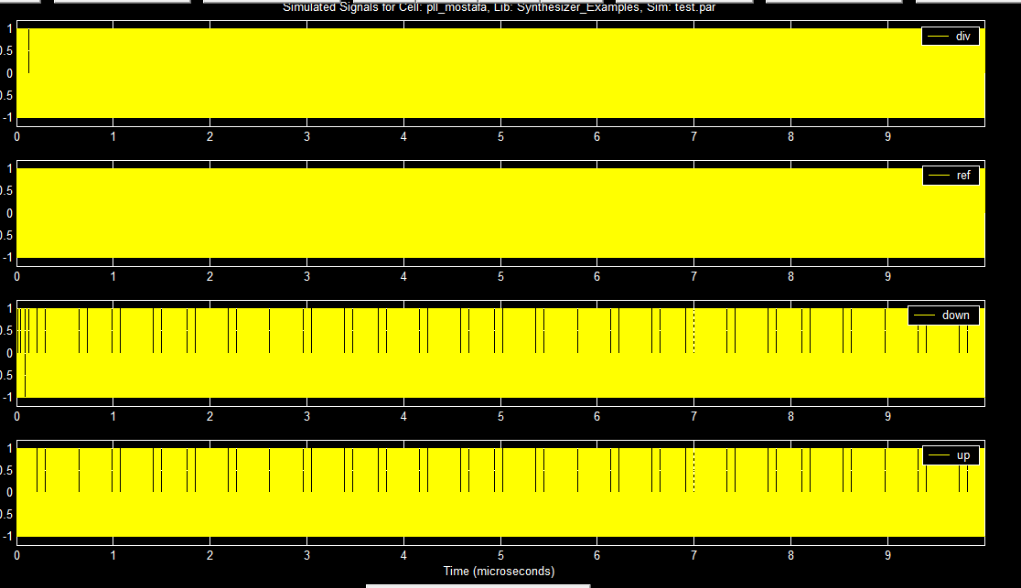

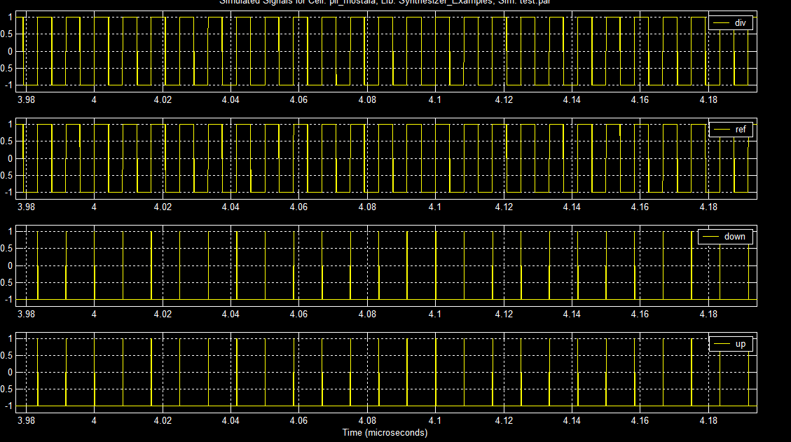

2- 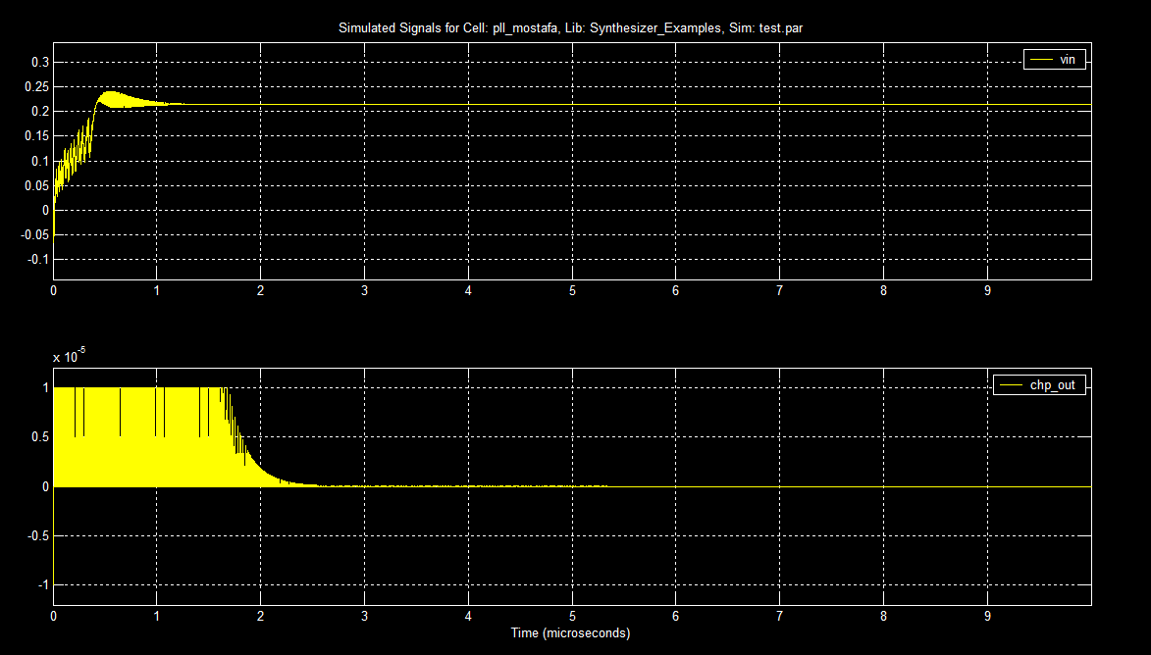

Before lock:

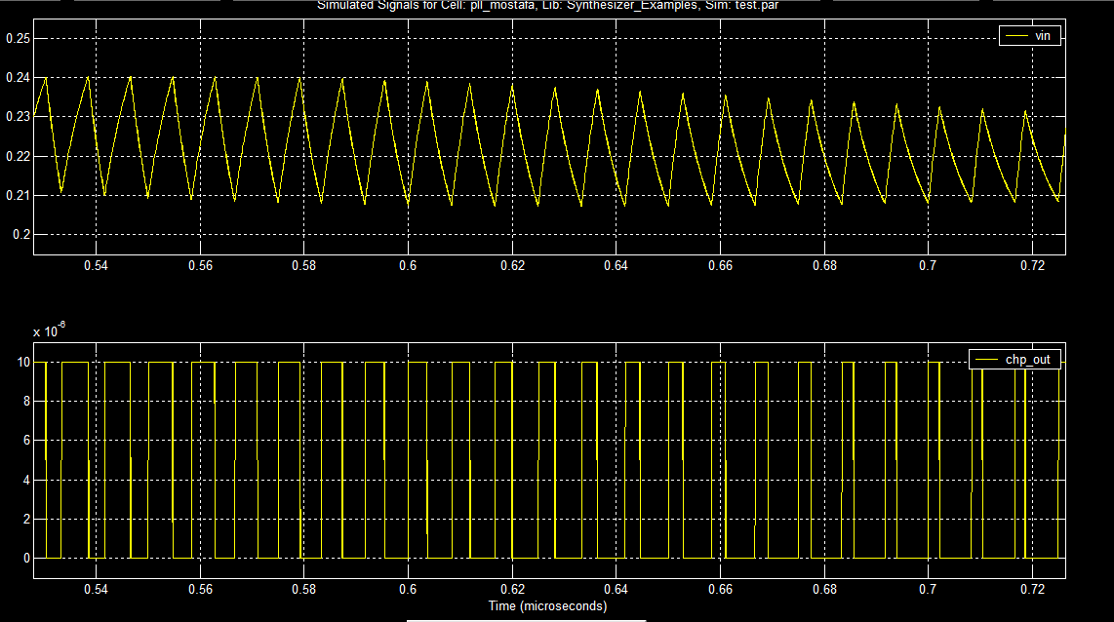

After lock:

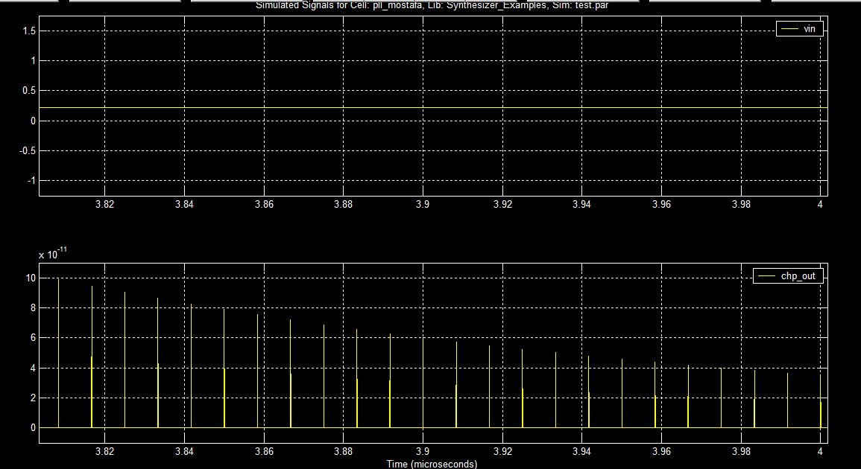

Part 3

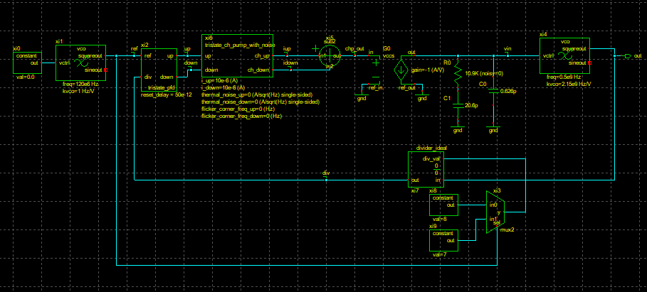

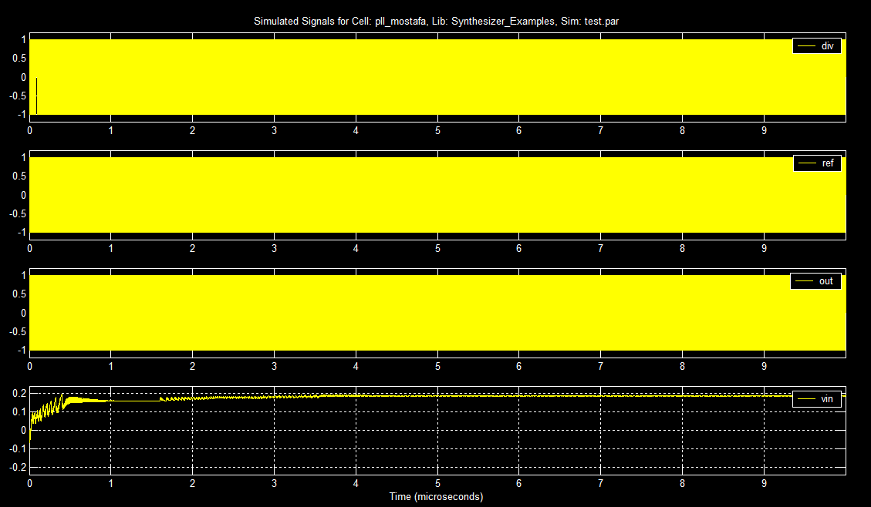

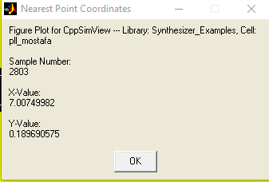

f(out) -f(in) = Kvco * vin

7.5*120e6 = 0.5e9 + 2.15e9*vin

Vin = 0.186 V

|  |  |  |
| --- | --- | --- |
|  | Analytically | CppSim |
| Vin | 0.186 | 0.18969 |

We can observe that the value of Vin(Vctrl) from simulation is near the value obtained analytically but not exactly the same because the Vin value isn’t stable due to changing the divider value between 7 and 8 .

Using mux to divide over two different values using the same divider made Vin not stable but gave us the effect of using fractional N divider so we substituted with N = 7.5 in the equation .

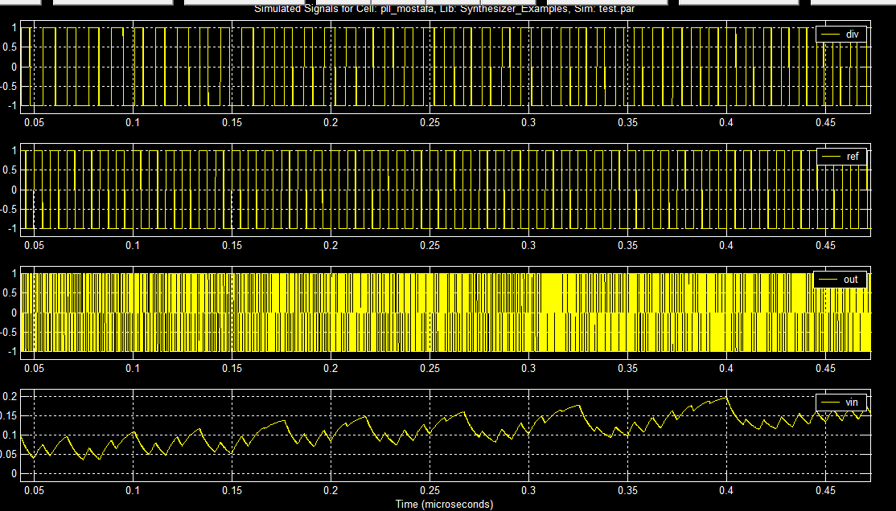

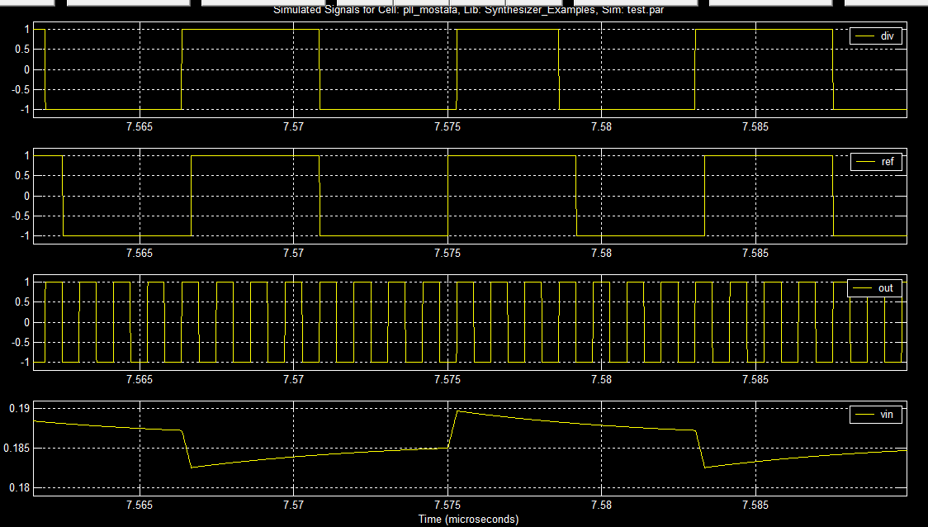

3-

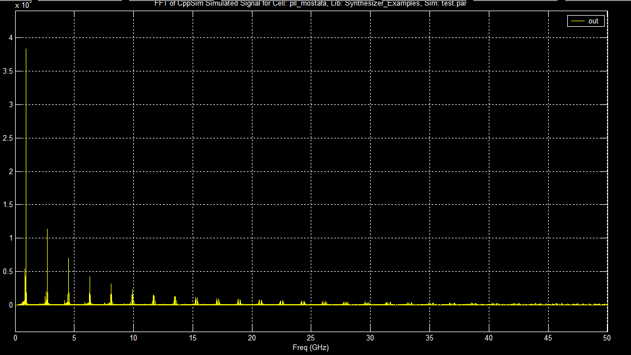

1. We can see the main tone at 0.96 GHZ which aligns perfectly with the expected locked VCO frequency:

fvco​=N*fref​=8*120 MHz=960 MHz

1. there is additional odd harmonics with decreasing power with high frequencies .

These are harmonics of the square-wave VCO output and because we are alternating between two divider values which introduces some unwanted spurs