**Lab #6: Mixer**

In this lab we will learn the use of periodic steady state (pss) simulation tools in spectre (cadence) in the characterization of the major figures of merit of a down-conversion mixer: noise figure and conversion gain. To understand the basic operation of a Gilbert-cell-based CMOS Mixer and analyze its performance trade-offs.

Begin by drawing the circuit schematic as shown in the following figure:

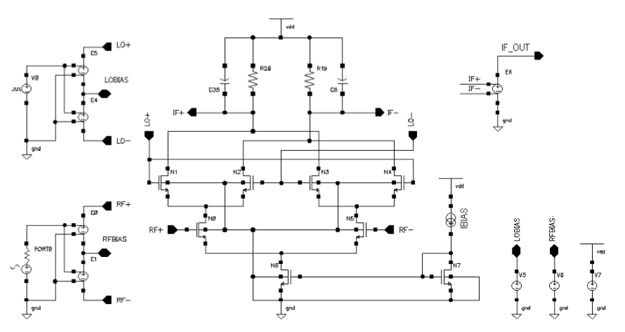

Transistor parameters :

|  |  |  |  |
| --- | --- | --- | --- |
| Transistor | W [m] | L [m] | M |
| N7 | 10u | 1u | 3 |
| N6 | 12u | 1u | 15 |
| N0, N5 | 15u | 120n | 20 |
| N1, N2, N3, N4 | 30u | 120n | 4 |

Component values:

|  |  |
| --- | --- |
| Component | Value |
| R19, R20 | 200ohm |
| C6, C35 | 100fF |
| E0, E1, E4, E5, E6 | Gain = 0.5 V/V |
| IBIAS | 1mA |
| LOBIAS | 0.85V |
| RFBIAS | 0.8V |
| VDD | 1.2V |

Sources:

|  |  |  |  |
| --- | --- | --- | --- |
| Instance | PORT0 | Instance | V0 |
| Cell name | psin | Cell Name | vpulse |
| Frequency name | F1 | Voltage 1 | 300mV |
| Resistance | 50ohms | Voltage 2 | -300mV |
| Port number | 1 | Rise time | 10ps |
| Source type | Sine | Fall time | 10ps |
| Amplitude (dBm) | PRF | Pulse width | 230ps |
| Frequency | 1.9GHz | Period | 500ps |

Q1 ) Describe the operation of the Gilbert cell as a down-conversion mixer.

From ADE L :

1. Perform DC analysis and check the regions of operation.
2. Select PSS analysis and set its properties as follows:

PSS analysis will be employed to characterize the conversion gain and noise figure

of the mixer.

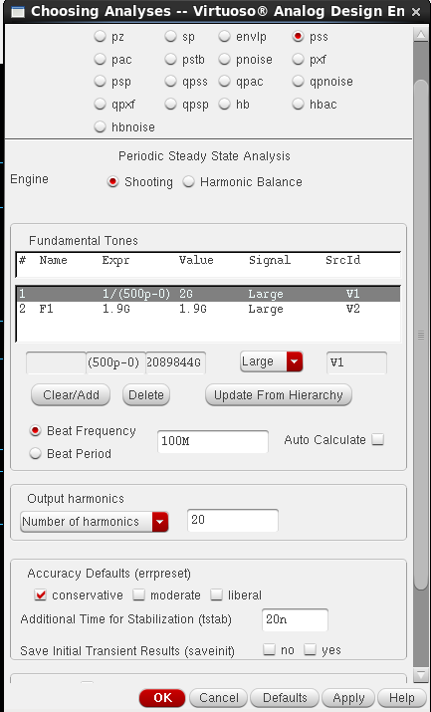

PSS simulation setup

1. Run simulation then configure the results window as shown :

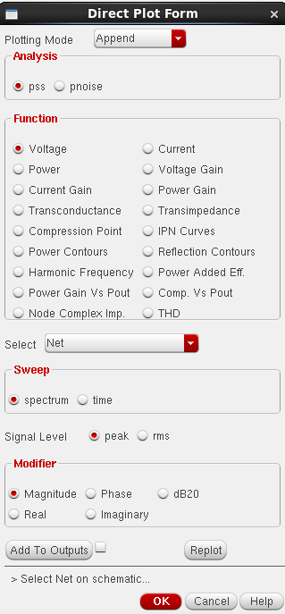

PSS results setup

1. Select the net at the top of PORT0 and IF_OUT.

Q2) Explain the result.

1. Plot the voltage at the same nets with the modifier dB20.

Q3) What is the conversion gain of the mixer in dB? Explain the origin of all the tones you see at the IF output. What is the RF isolation? What is the LO isolation? Is there any LO self-mixing happening? How do these characteristics change if the RF frequency is change to 1GHz and 2.5GHz? (adjusting the LO frequency so that the IF is always 100MHz).

**Noise Figure Simulation**

1. Change the settings of PORT0 to dc source. For noise analysis you will need to run pss and pnoise analyses together. Configure pss and pnoise analyses as shown:

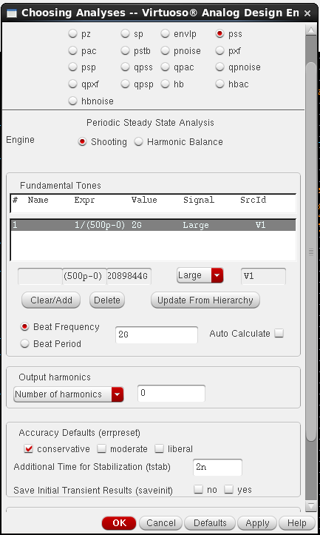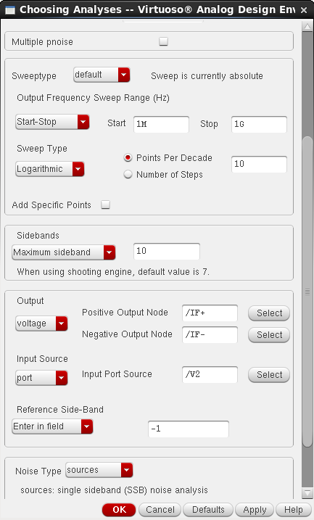

PSS (left) and Pnoise(right) simulation setups

The noise figure of the mixer can be plotted as follows:

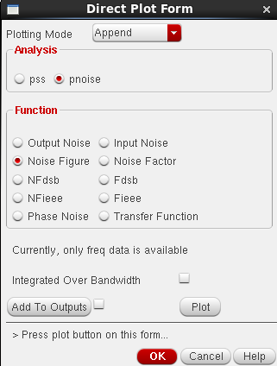

NF results setup

Q4) Is the shape of the NF Vs. frequency plot what you expect? What is missing in the noise analysis?

1. Using the simulation techniques shown above, create plots of Conversion Gain Vs. LO amplitude and NF Vs. LO amplitude for a range between 50mV to 300mV. Consider both, a square (as in the examples above) and a sinusoidal LO signal