Supplementary Material for: DT-GSK: Dimension-Tiered Adaptive Control and Deterministic Refinement for Gaining-Sharing Knowledge Optimization
Mostafa Elsayed Masoud $​^{1,*}$, Heba Sayed Mohamed Roshdy $​^{1}$ and Ali Wagdy Mohamed $​^{1}$
Abstract
This Supplementary Material accompanies the main paper on Dimension-Tiered Gaining-Sharing Knowledge (DT-GSK) optimization. It contains the complete per-function CEC2017 panel tables (Section S1), the DT-GSK-versus-GSK head-to-head matrices and the CEC2011 and CEC2013 detail tables (Section S2), the convergence figure sets for CEC2017, CEC2011 and CEC2013 (every scored function at the prespecified dimensions, Section S3), a population-reduction schedule and diagnostic-availability note (Section S4), a reproducibility appendix documenting the seed schedule, the frozen configuration, the evidence release, and the analysis pipeline (Section S5), a supplement-only component-contribution study (a scaffold remove-one ablation, a direct interaction-structure-memory isolation, and a by-class conditional-benefit breakdown, Section S6), the complete CEC2013LSGO large-scale suite record (protocol, evidential tiers, family statistics, effect sizes, and per-function detail, Section S7), and the pre-registered CEC2020 confirmatory suite record (Section S8). Every empirical value in Sections S1–S5 derives from the promoted, read-only evidence release accompanying this article; the Section S6 scaffold and isolation results derive from a separate, immutable ablation release; the Section S7 and Section S8 values derive from two further separate, non-superseding evidence releases identified in those sections; no primary result is altered by any of it. All comparative wording is scoped to the seven-algorithm GSK-family panel.
Article
$​^{1}$ Operations Research Department, Faculty of Graduate Studies for Statistical Research, Cairo University, Giza 12613, Egypt; moustafa.masoud@gmail.com (M.E.M. ORCID 0009-0003-8415-2158); hmhmdss@yahoo.com (H.S.M.R. ORCID 0000-0003-0387-5876); aliwagdy@gmail.com (A.W.M. ORCID 0000-0002-5895-2632)
* Correspondence: moustafa.masoud@gmail.com
Keywords: metaheuristic optimization; gaining-sharing knowledge; dimension-tiered adaptive control; deterministic final refinement; adaptive operator selection; population-size reduction; interaction-structure memory; CEC benchmark suites; nonparametric statistical comparison; reproducibility
This Supplementary Material is organized so that the main paper remains auditable without it: the headline comparative claims are supported by main-text exhibits, and the material here provides the complete per-function, per-problem, and per-checkpoint record behind those exhibits. Unless a caption states otherwise, the following frozen protocol applies throughout. CEC2017 is the primary suite with 29 scored functions (F1, F3–F30; F2 is excluded per protocol), $D∈\{10,30,50,100\}$, 51 runs per (function, dimension) cell, and $MaxFES={10}^{4}⋅D$ [1].
CEC2011 comprises 22 real-world problems at their native dimensions with 25 runs per problem and $MaxFES=150,000$; on problems without published optima the error column is undefined by design and the raw best objective value is authoritative [2].
CEC2013 is the second comparison suite, reported for breadth of comparison: 28 functions, $D∈\{10,30,50\}$, 51 runs per cell [3].
CEC2020 is the pre-registered confirmatory suite: 10 functions at $D∈\{5,10,15,20\}$, with F6 and F7 undefined at $D=5$ (38 scored cells), 30 runs per cell, and a dimension-dependent budget of $MaxFES=5×{10}^{4}$, ${10}^{6}$, $3×{10}^{6}$ and ${10}^{7}$ at $D=5,10,15,20$ respectively [4].
CEC2013LSGO is the large-scale suite, family-internal by registered scope: 15 functions at native $D=1000$ (F13/F14 at $D=905$), 25 runs per function, $MaxFES=3×{10}^{6}$, reported on the raw best-objective basis [5].
CEC2017, CEC2013 and CEC2020 report the final error $f(x)−f(x^{*})$ with the suite success floor (error values below ${10}^{−8}$ are treated as zero per suite convention); CEC2011 and CEC2013LSGO are raw-objective suites.
The run counts (51/25/51/30/25 for CEC2017/CEC2011/CEC2013/CEC2020/ CEC2013LSGO) and endpoint bases (error vs. raw objective) are heterogeneous across suites by each suite’s own convention, and no statistic in this paper ever pools suites: there is no cross-suite Friedman family, no pooled run set, no cross-suite rank averaging, and no cross-suite multiplicity family; the only cross-suite statement made anywhere is the count of independent per-suite descriptive standings.
Pairwise inference uses the two-sided Wilcoxon signed-rank test [6] with Holm’s step-down correction [7] at family level and $α=0.05$; win/tie/loss counts use the tie rule $|Δ|<{10}^{−8}$.
Panel ranking uses the Friedman test [8] with the Iman–Davenport correction and Nemenyi post-hoc critical-difference (CD) analysis [9].
The panel order everywhere is GSK, AGSK, APGSK, FDB-AGSK, ATMALS-GSK, eGSK, DT-GSK, and all comparative wording is scoped within the GSK-family panel, never field-wide.

S1. Complete CEC2017 Per-Function Panel Tables
Table A1 lists the 29 scored CEC2017 functions with their class in the suite taxonomy and their known optimal value, so the function-class reading in Section S6.6 can be checked against a stated inventory rather than an implicit one.
Table A1. CEC2017 scored-function inventory: class and known optimal value $f^{*}$ for each of the 29 scored functions. The class boundaries and the $f^{*}(F_{i})=100i$ rule are read from the benchmark suite definition (benchmarks/cec_suite_python/cec2017/functions.py), not from a secondary source. F2 is excluded under the adopted protocol because of documented instability, uniformly in every panel cell, and so does not appear.
Function | Class | f*
F1 | Unimodal | 100
F3 | Unimodal | 300
F4 | Simple multimodal | 400
F5 | Simple multimodal | 500
F6 | Simple multimodal | 600
F7 | Simple multimodal | 700
F8 | Simple multimodal | 800
F9 | Simple multimodal | 900
F10 | Simple multimodal | 1000
F11 | Hybrid | 1100
F12 | Hybrid | 1200
F13 | Hybrid | 1300
F14 | Hybrid | 1400
F15 | Hybrid | 1500
F16 | Hybrid | 1600
F17 | Hybrid | 1700
F18 | Hybrid | 1800
F19 | Hybrid | 1900
F20 | Hybrid | 2000
F21 | Composition | 2100
F22 | Composition | 2200
F23 | Composition | 2300
F24 | Composition | 2400
F25 | Composition | 2500
F26 | Composition | 2600
F27 | Composition | 2700
F28 | Composition | 2800
F29 | Composition | 2900
F30 | Composition | 3000
Tables A2–A5 give the complete seven-algorithm per-function record on CEC2017: mean $±$ standard deviation of the final error over 51 runs for each of the 29 functions at each dimension, with the best mean per function in bold.
These tables are the per-function basis behind the condensed panel summaries and the statistical exhibits of the main paper (Section 4); they carry no aggregation beyond the per-function statistics shown.
One disclosed evidence limitation applies to the APGSK column at $D=10$, $30$, and $50$: at the analysis freeze the APGSK CEC2017 per-run record was available at $D=100$ only (a sidecar-overwrite anomaly in the evidence tree), so the APGSK cells at the three lower dimensions were taken from the final-checkpoint columns of the per-generation logs of the same runs (verified equivalent during the evidence audit) and were never imputed. The missing per-run records were subsequently recovered after the freeze — deterministically, from the seed-identical per-run logs — in a documented post-freeze recovery; the recovered records reproduce the tabulated values, which are therefore unchanged.
Table A2. CEC2017 at $D=10$: mean $±$ SD of the final error over 51 runs for all 7 GSK-family algorithms on each of the 29 functions (F1, F3–F30; success floor ${10}^{−8}$); best mean per function in bold. APGSK cells derive from the final-checkpoint columns of the per-generation logs (per-run file unavailable at this dimension at the analysis freeze; recovered post-freeze, values unchanged; never imputed).
Func. | GSK | AGSK | APGSK | FDB-AGSK | ATMALS-GSK | eGSK | DT-GSK
F1 | 0.00E+00±0.00E+00 | 0.00E+00±0.00E+00 | 0.00E+00±0.00E+00 | 0.00E+00±0.00E+00 | 0.00E+00±0.00E+00 | 0.00E+00±0.00E+00 | 0.00E+00±0.00E+00
F3 | 0.00E+00±0.00E+00 | 0.00E+00±0.00E+00 | 0.00E+00±0.00E+00 | 0.00E+00±0.00E+00 | 0.00E+00±0.00E+00 | 0.00E+00±0.00E+00 | 0.00E+00±0.00E+00
F4 | 0.00E+00±0.00E+00 | 0.00E+00±0.00E+00 | 0.00E+00±0.00E+00 | 1.20E-06±7.02E-06 | 0.00E+00±0.00E+00 | 0.00E+00±0.00E+00 | 0.00E+00±0.00E+00
F5 | 2.04E+01±3.19E+00 | 6.37E+00±2.01E+00 | 8.36E+00±2.83E+00 | 6.00E+00±1.96E+00 | 1.21E+01±5.11E+00 | 4.82E+00±2.33E+00 | 2.83E+00±1.04E+00
F6 | 0.00E+00±0.00E+00 | 7.35E-06±2.04E-05 | 1.78E-05±5.70E-05 | 2.14E-05±8.50E-05 | 0.00E+00±0.00E+00 | 0.00E+00±0.00E+00 | 1.60E-07±4.28E-07
F7 | 2.96E+01±3.43E+00 | 1.89E+01±2.63E+00 | 2.02E+01±3.70E+00 | 1.83E+01±2.78E+00 | 2.03E+01±3.99E+00 | 1.42E+01±1.58E+00 | 1.18E+01±7.64E-01
F8 | 2.12E+01±3.50E+00 | 7.87E+00±2.12E+00 | 8.92E+00±3.10E+00 | 7.31E+00±2.50E+00 | 1.29E+01±5.06E+00 | 4.33E+00±1.95E+00 | 2.40E+00±1.15E+00
F9 | 0.00E+00±0.00E+00 | 1.76E-03±1.25E-02 | 0.00E+00±0.00E+00 | 1.76E-03±1.25E-02 | 0.00E+00±0.00E+00 | 0.00E+00±0.00E+00 | 0.00E+00±0.00E+00
F10 | 1.03E+03±1.26E+02 | 3.24E+02±7.50E+01 | 3.44E+02±9.56E+01 | 3.06E+02±1.00E+02 | 5.12E+02±2.67E+02 | 6.22E+02±2.01E+02 | 1.30E+02±1.02E+02
F11 | 6.09E-09±2.52E-08 | 1.84E-01±3.80E-01 | 1.33E+00±1.28E+00 | 8.58E-01±1.25E+00 | 2.49E+00±8.08E-01 | 0.00E+00±0.00E+00 | 3.90E-02±1.95E-01
F12 | 9.61E+01±7.90E+01 | 3.59E+01±5.47E+01 | 8.47E+01±8.07E+01 | 6.35E+01±5.01E+01 | 1.31E+02±9.62E+01 | 7.36E+01±8.02E+01 | 1.12E+02±9.95E+01
F13 | 6.61E+00±1.27E+00 | 2.97E+00±2.21E+00 | 3.67E+00±2.58E+00 | 3.96E+00±2.53E+00 | 5.26E+00±2.29E+00 | 4.86E+00±5.79E-01 | 2.72E+00±2.65E+00
F14 | 5.28E+00±3.26E+00 | 6.56E-02±2.37E-01 | 6.33E-01±6.71E-01 | 8.79E-02±2.56E-01 | 6.17E+00±5.07E+00 | 1.85E-01±4.06E-01 | 3.90E-02±1.95E-01
F15 | 2.25E-01±2.17E-01 | 2.52E-02±2.73E-02 | 1.40E-01±2.04E-01 | 4.87E-02±5.50E-02 | 4.67E-01±3.05E-01 | 2.67E-01±2.17E-01 | 1.10E-01±2.32E-01
F16 | 3.66E+00±4.75E+00 | 7.51E-01±6.40E-01 | 6.87E-01±3.97E-01 | 1.31E+00±8.53E-01 | 3.54E+00±4.38E+00 | 4.94E+00±5.42E+00 | 4.05E-01±2.36E-01
F17 | 9.87E+00±6.68E+00 | 1.05E+00±7.22E-01 | 1.42E+00±8.40E-01 | 1.28E+00±6.15E-01 | 2.08E+01±1.06E+01 | 7.62E+00±7.34E+00 | 3.25E-01±2.90E-01
F18 | 6.79E-01±2.65E+00 | 1.00E-01±1.44E-01 | 5.28E-01±5.88E-01 | 7.07E-02±7.46E-02 | 3.42E+00±6.42E+00 | 7.17E-01±2.80E+00 | 4.03E-01±6.35E-01
F19 | 8.80E-02±8.64E-02 | 6.57E-02±5.34E-02 | 8.15E-02±6.37E-02 | 9.16E-02±4.84E-02 | 4.60E-01±3.92E-01 | 4.72E-02±5.03E-02 | 1.73E-02±1.64E-02
F20 | 8.46E-01±2.83E+00 | 4.90E-02±1.31E-01 | 4.90E-02±1.31E-01 | 9.79E-02±1.59E-01 | 1.41E+01±9.82E+00 | 1.62E+00±4.50E+00 | 1.84E-01±1.79E-01
F21 | 1.95E+02±4.76E+01 | 1.00E+02±2.14E+01 | 9.61E+01±1.96E+01 | 9.80E+01±1.40E+01 | 1.44E+02±5.92E+01 | 1.73E+02±4.95E+01 | 1.59E+02±5.17E+01
F22 | 1.00E+02±7.26E-01 | 8.36E+01±3.28E+01 | 4.89E+01±4.36E+01 | 4.25E+01±4.27E+01 | 7.88E+01±4.02E+01 | 1.00E+02±1.56E-01 | 9.51E+01±2.01E+01
F23 | 3.18E+02±3.39E+00 | 2.91E+02±7.36E+01 | 2.94E+02±7.11E+01 | 3.01E+02±3.62E+01 | 3.11E+02±5.05E+00 | 3.04E+02±2.42E+00 | 3.03E+02±1.84E+00
F24 | 3.40E+02±3.95E+01 | 1.01E+02±3.93E+01 | 9.53E+01±1.78E+01 | 1.03E+02±2.41E+01 | 2.75E+02±1.09E+02 | 3.08E+02±6.95E+01 | 2.96E+02±7.93E+01
F25 | 4.18E+02±2.14E+01 | 3.39E+02±1.19E+02 | 3.34E+02±1.24E+02 | 3.80E+02±7.08E+01 | 4.14E+02±2.24E+01 | 4.10E+02±1.99E+01 | 4.04E+02±1.47E+01
F26 | 3.00E+02±2.29E-13 | 2.59E+02±1.04E+02 | 1.21E+02±1.01E+02 | 1.98E+02±1.38E+02 | 3.00E+02±2.48E-13 | 3.00E+02±1.75E-13 | 2.98E+02±1.40E+01
F27 | 3.89E+02±2.06E-01 | 3.89E+02±6.56E-01 | 3.89E+02±1.07E+00 | 3.89E+02±8.41E-01 | 3.89E+02±2.50E-01 | 3.89E+02±2.06E-01 | 3.89E+02±7.24E-01
F28 | 3.00E+02±1.40E-13 | 2.24E+02±1.32E+02 | 2.12E+02±1.38E+02 | 2.12E+02±1.38E+02 | 3.10E+02±4.71E+01 | 3.06E+02±3.97E+01 | 2.94E+02±4.20E+01
F29 | 2.48E+02±4.37E+00 | 2.43E+02±6.25E+00 | 2.45E+02±1.24E+01 | 2.45E+02±1.26E+01 | 2.42E+02±5.35E+00 | 2.32E+02±2.71E+00 | 2.33E+02±3.26E+00
F30 | 4.45E+02±3.44E+01 | 4.73E+02±8.23E+01 | 5.09E+02±1.02E+02 | 4.92E+02±6.70E+01 | 4.44E+02±3.52E+01 | 4.41E+02±2.78E+01 | 4.39E+02±5.86E+01
Table A3. CEC2017 at $D=30$: mean $±$ SD of the final error over 51 runs for all 7 GSK-family algorithms on each of the 29 functions (F1, F3–F30; success floor ${10}^{−8}$); best mean per function in bold. APGSK cells derive from the final-checkpoint columns of the per-generation logs (per-run file unavailable at this dimension at the analysis freeze; recovered post-freeze, values unchanged; never imputed).
Func. | GSK | AGSK | APGSK | FDB-AGSK | ATMALS-GSK | eGSK | DT-GSK
F1 | 0.00E+00±0.00E+00 | 0.00E+00±0.00E+00 | 5.45E-06±1.83E-05 | 0.00E+00±0.00E+00 | 0.00E+00±0.00E+00 | 1.41E-01±1.01E+00 | 0.00E+00±0.00E+00
F3 | 3.36E-08±6.22E-08 | 1.24E-02±4.62E-02 | 6.84E-01±1.18E+00 | 7.82E-02±3.16E-01 | 0.00E+00±0.00E+00 | 0.00E+00±0.00E+00 | 0.00E+00±0.00E+00
F4 | 5.03E+00±1.39E+01 | 7.94E+00±1.63E+01 | 4.61E+00±1.34E+01 | 3.62E+01±3.32E+01 | 5.93E+00±1.44E+01 | 6.50E+00±1.60E+01 | 1.51E+01±2.56E+01
F5 | 1.59E+02±1.23E+01 | 9.22E+01±1.08E+01 | 1.13E+02±1.58E+01 | 7.16E+01±8.18E+00 | 8.00E+01±2.04E+01 | 2.04E+01±6.92E+00 | 3.14E+01±9.22E+00
F6 | 8.16E-07±1.25E-06 | 2.56E-05±3.76E-05 | 4.66E-05±9.46E-05 | 1.02E-05±2.46E-05 | 8.85E-05±1.10E-04 | 4.77E-06±9.14E-06 | 4.90E-06±6.47E-06
F7 | 1.87E+02±1.13E+01 | 1.24E+02±8.84E+00 | 1.48E+02±2.27E+01 | 1.04E+02±1.20E+01 | 8.66E+01±1.51E+01 | 5.18E+01±6.65E+00 | 6.94E+01±1.92E+01
F8 | 1.59E+02±1.08E+01 | 9.66E+01±1.19E+01 | 1.11E+02±1.44E+01 | 7.79E+01±1.14E+01 | 8.32E+01±2.01E+01 | 2.39E+01±7.83E+00 | 3.21E+01±6.35E+00
F9 | 0.00E+00±0.00E+00 | 5.80E+00±5.77E+00 | 3.55E+01±7.21E+01 | 2.93E+00±3.55E+00 | 1.31E-01±2.38E-01 | 1.76E-03±1.25E-02 | 3.51E-03±1.76E-02
F10 | 6.72E+03±3.00E+02 | 3.26E+03±2.41E+02 | 2.85E+03±1.90E+02 | 3.21E+03±3.07E+02 | 3.23E+03±6.25E+02 | 5.16E+03±7.88E+02 | 3.93E+03±7.71E+02
F11 | 3.25E+01±3.84E+01 | 2.08E+01±6.97E+00 | 3.14E+01±1.11E+01 | 2.44E+01±1.88E+01 | 2.62E+01±2.31E+01 | 1.22E+01±1.90E+01 | 1.66E+01±1.68E+01
F12 | 6.26E+03±4.51E+03 | 8.02E+03±5.02E+03 | 1.34E+04±9.35E+03 | 1.01E+04±7.11E+03 | 6.27E+03±4.97E+03 | 3.71E+03±3.24E+03 | 6.68E+03±4.17E+03
F13 | 9.61E+01±3.72E+01 | 5.20E+01±1.99E+01 | 4.79E+01±1.58E+01 | 5.99E+01±2.99E+01 | 6.83E+01±6.15E+01 | 2.36E+01±1.10E+01 | 2.20E+01±9.95E+00
F14 | 5.59E+01±5.16E+00 | 3.83E+01±3.41E+00 | 4.45E+01±1.06E+01 | 3.69E+01±4.03E+00 | 3.94E+01±7.49E+00 | 2.38E+01±3.35E+00 | 3.14E+01±1.00E+01
F15 | 1.41E+01±1.14E+01 | 1.55E+01±4.53E+00 | 2.30E+01±2.03E+01 | 1.50E+01±4.26E+00 | 1.72E+01±1.20E+01 | 5.49E+00±3.21E+00 | 5.64E+00±4.60E+00
F16 | 7.85E+02±1.95E+02 | 6.82E+02±8.85E+01 | 5.32E+02±1.37E+02 | 6.13E+02±1.29E+02 | 5.80E+02±2.83E+02 | 4.01E+02±2.48E+02 | 3.51E+02±1.97E+02
F17 | 1.76E+02±8.39E+01 | 1.72E+02±7.95E+01 | 1.80E+02±7.31E+01 | 1.64E+02±6.47E+01 | 1.25E+02±5.89E+01 | 5.86E+01±4.43E+01 | 4.93E+01±2.91E+01
F18 | 3.63E+01±8.22E+00 | 1.32E+02±1.08E+02 | 1.42E+03±1.47E+03 | 3.06E+02±2.90E+02 | 3.59E+01±1.31E+01 | 2.71E+01±1.19E+01 | 2.59E+01±6.12E+00
F19 | 1.34E+01±5.49E+00 | 1.41E+01±1.78E+00 | 1.48E+01±4.38E+00 | 1.42E+01±1.80E+00 | 1.28E+01±3.74E+00 | 6.68E+00±1.87E+00 | 5.32E+00±1.50E+00
F20 | 1.18E+02±1.21E+02 | 2.50E+02±7.07E+01 | 2.76E+02±8.96E+01 | 2.11E+02±8.20E+01 | 1.58E+02±9.32E+01 | 7.81E+01±8.34E+01 | 5.95E+01±6.49E+01
F21 | 3.51E+02±1.03E+01 | 2.76E+02±4.17E+01 | 2.66E+02±7.86E+01 | 2.62E+02±3.39E+01 | 2.84E+02±2.54E+01 | 2.19E+02±5.43E+00 | 2.29E+02±9.56E+00
F22 | 1.00E+02±2.54E-13 | 1.00E+02±4.72E-01 | 1.70E+02±4.70E+02 | 1.01E+02±1.39E+00 | 1.00E+02±4.92E-13 | 1.00E+02±6.09E-13 | 1.00E+02±6.43E-13
F23 | 4.77E+02±5.28E+01 | 4.36E+02±1.24E+01 | 4.59E+02±3.35E+01 | 4.19E+02±1.14E+01 | 4.25E+02±2.24E+01 | 3.61E+02±8.25E+00 | 3.75E+02±9.49E+00
F24 | 5.60E+02±3.19E+01 | 5.06E+02±1.53E+01 | 5.62E+02±2.83E+01 | 4.93E+02±1.44E+01 | 4.85E+02±2.08E+01 | 4.33E+02±6.94E+00 | 4.41E+02±8.10E+00
F25 | 3.87E+02±1.95E-01 | 3.87E+02±6.87E-01 | 3.86E+02±1.55E+00 | 3.87E+02±8.11E-01 | 3.87E+02±1.74E+00 | 3.88E+02±2.87E+00 | 3.87E+02±8.11E-01
F26 | 9.95E+02±2.69E+02 | 4.43E+02±5.13E+02 | 3.01E+02±2.74E+02 | 7.48E+02±6.40E+02 | 1.32E+03±6.97E+02 | 7.70E+02±3.30E+02 | 1.16E+03±7.53E+01
F27 | 4.94E+02±7.40E+00 | 4.96E+02±1.23E+01 | 5.13E+02±9.44E+00 | 5.03E+02±9.05E+00 | 5.01E+02±1.08E+01 | 4.96E+02±7.19E+00 | 4.95E+02±7.04E+00
F28 | 3.13E+02±3.78E+01 | 3.14E+02±3.65E+01 | 3.15E+02±3.38E+01 | 3.26E+02±4.54E+01 | 3.27E+02±4.58E+01 | 3.07E+02±2.97E+01 | 3.20E+02±4.38E+01
F29 | 5.62E+02±1.25E+02 | 6.18E+02±5.04E+01 | 6.23E+02±7.28E+01 | 5.91E+02±6.27E+01 | 5.46E+02±1.07E+02 | 4.38E+02±4.00E+01 | 5.44E+02±8.14E+01
F30 | 2.07E+03±8.15E+01 | 2.14E+03±1.35E+02 | 2.25E+03±1.87E+02 | 2.14E+03±1.07E+02 | 2.10E+03±1.27E+02 | 2.09E+03±1.17E+02 | 2.09E+03±1.03E+02
Table A4. CEC2017 at $D=50$: mean $±$ SD of the final error over 51 runs for all 7 GSK-family algorithms on each of the 29 functions (F1, F3–F30; success floor ${10}^{−8}$); best mean per function in bold. APGSK cells derive from the final-checkpoint columns of the per-generation logs (per-run file unavailable at this dimension at the analysis freeze; recovered post-freeze, values unchanged; never imputed).
Func. | GSK | AGSK | APGSK | FDB-AGSK | ATMALS-GSK | eGSK | DT-GSK
F1 | 1.70E+03±1.77E+03 | 1.93E+00±3.66E+00 | 1.12E+03±1.49E+03 | 9.39E-02±2.02E-01 | 0.00E+00±0.00E+00 | 8.47E+01±2.50E+02 | 1.76E-01±4.41E-01
F3 | 4.02E+03±1.75E+03 | 4.52E+03±2.64E+03 | 3.84E+03±1.81E+03 | 5.01E+02±4.11E+02 | 4.87E-07±1.77E-06 | 0.00E+00±0.00E+00 | 3.45E-08±1.90E-07
F4 | 7.58E+01±4.43E+01 | 3.18E+01±3.76E+01 | 6.33E+01±4.36E+01 | 7.04E+01±4.74E+01 | 3.43E+01±4.04E+01 | 1.33E+01±3.17E+01 | 6.85E+01±4.57E+01
F5 | 3.18E+02±1.59E+01 | 2.39E+02±2.05E+01 | 2.78E+02±2.25E+01 | 1.94E+02±2.24E+01 | 1.90E+02±4.12E+01 | 3.91E+01±1.00E+01 | 3.98E+01±7.11E+00
F6 | 3.65E-06±3.61E-06 | 5.18E-04±4.24E-04 | 7.96E-04±8.37E-04 | 2.04E-04±2.54E-04 | 7.75E-04±7.13E-04 | 5.76E-04±4.04E-03 | 8.35E-05±3.45E-05
F7 | 3.72E+02±1.21E+01 | 2.94E+02±2.17E+01 | 3.49E+02±3.66E+01 | 2.57E+02±2.19E+01 | 1.75E+02±2.52E+01 | 8.90E+01±9.43E+00 | 9.19E+01±3.11E+01
F8 | 3.23E+02±1.26E+01 | 2.46E+02±2.31E+01 | 2.80E+02±2.16E+01 | 2.03E+02±2.11E+01 | 1.88E+02±4.32E+01 | 4.14E+01±1.08E+01 | 4.37E+01±2.28E+01
F9 | 1.59E-02±6.72E-02 | 3.37E+01±2.62E+01 | 1.50E+03±2.53E+03 | 3.16E+01±2.21E+01 | 2.58E+00±2.25E+00 | 2.29E-01±2.94E-01 | 9.71E-02±1.47E-01
F10 | 1.29E+04±3.91E+02 | 7.75E+03±3.50E+02 | 6.11E+03±3.59E+02 | 7.55E+03±4.45E+02 | 5.92E+03±7.27E+02 | 1.07E+04±1.22E+03 | 5.21E+03±6.59E+02
F11 | 3.43E+01±2.67E+01 | 8.79E+01±1.60E+01 | 9.56E+01±1.99E+01 | 7.67E+01±1.82E+01 | 8.44E+01±2.25E+01 | 2.99E+01±6.00E+00 | 3.49E+01±4.71E+00
F12 | 9.61E+03±7.48E+03 | 6.96E+04±4.63E+04 | 1.13E+05±7.47E+04 | 1.15E+05±8.90E+04 | 9.44E+03±7.97E+03 | 3.80E+04±2.25E+04 | 1.17E+04±7.25E+03
F13 | 2.75E+03±3.13E+03 | 3.40E+02±1.88E+02 | 3.21E+02±1.63E+02 | 2.74E+02±8.69E+01 | 1.77E+03±3.29E+03 | 8.97E+01±6.21E+01 | 1.68E+02±9.84E+01
F14 | 1.23E+02±1.44E+01 | 8.35E+01±1.20E+01 | 1.27E+02±5.88E+01 | 8.08E+01±1.10E+01 | 1.14E+02±4.57E+01 | 3.86E+01±7.16E+00 | 4.11E+01±2.48E+01
F15 | 4.03E+01±1.28E+01 | 6.63E+01±1.42E+01 | 9.89E+01±3.50E+01 | 6.31E+01±1.52E+01 | 1.00E+02±6.28E+01 | 4.39E+01±1.72E+01 | 3.89E+01±1.24E+01
F16 | 1.99E+03±5.12E+02 | 1.36E+03±1.44E+02 | 1.01E+03±1.56E+02 | 1.23E+03±1.46E+02 | 1.27E+03±5.16E+02 | 4.41E+02±4.12E+02 | 6.90E+02±2.25E+02
F17 | 1.36E+03±1.81E+02 | 9.98E+02±1.15E+02 | 9.03E+02±1.27E+02 | 8.57E+02±1.28E+02 | 9.53E+02±3.19E+02 | 7.53E+02±3.02E+02 | 4.68E+02±2.31E+02
F18 | 7.17E+02±6.32E+02 | 4.60E+03±3.43E+03 | 9.56E+03±5.44E+03 | 3.80E+03±2.43E+03 | 7.41E+02±7.87E+02 | 8.01E+01±5.76E+01 | 8.51E+01±5.51E+01
F19 | 3.44E+01±1.29E+01 | 4.00E+01±6.06E+00 | 3.80E+01±7.41E+00 | 3.87E+01±6.52E+00 | 5.96E+01±2.46E+01 | 3.11E+01±1.23E+01 | 1.98E+01±3.49E+00
F20 | 1.35E+03±1.91E+02 | 7.80E+02±1.04E+02 | 7.41E+02±1.09E+02 | 6.50E+02±1.44E+02 | 8.47E+02±2.42E+02 | 7.16E+02±2.45E+02 | 3.62E+02±1.74E+02
F21 | 5.19E+02±1.26E+01 | 4.41E+02±1.94E+01 | 4.61E+02±2.47E+01 | 3.92E+02±2.02E+01 | 3.66E+02±3.49E+01 | 2.37E+02±9.52E+00 | 2.40E+02±8.17E+00
F22 | 1.15E+04±4.23E+03 | 6.37E+03±3.53E+03 | 6.21E+03±1.77E+03 | 7.60E+03±1.99E+03 | 5.05E+03±3.03E+03 | 9.53E+03±3.63E+03 | 2.85E+03±2.76E+03
F23 | 5.61E+02±1.38E+02 | 6.57E+02±1.99E+01 | 7.69E+02±3.63E+01 | 6.18E+02±2.11E+01 | 5.74E+02±5.08E+01 | 4.53E+02±1.15E+01 | 4.65E+02±2.80E+01
F24 | 6.10E+02±1.32E+02 | 7.21E+02±2.85E+01 | 8.33E+02±3.78E+01 | 6.90E+02±2.66E+01 | 6.43E+02±3.66E+01 | 5.23E+02±7.50E+00 | 5.30E+02±8.46E+00
F25 | 5.59E+02±2.94E+01 | 5.37E+02±3.76E+01 | 5.66E+02±4.06E+01 | 5.32E+02±3.99E+01 | 5.65E+02±3.22E+01 | 5.68E+02±3.23E+01 | 5.34E+02±3.21E+01
F26 | 1.35E+03±5.02E+02 | 3.22E+03±1.24E+03 | 2.64E+03±1.75E+03 | 3.03E+03±5.28E+02 | 2.27E+03±7.97E+02 | 1.15E+03±4.91E+02 | 1.42E+03±1.10E+02
F27 | 5.94E+02±8.71E+01 | 5.26E+02±2.04E+01 | 5.79E+02±4.95E+01 | 5.30E+02±2.14E+01 | 5.98E+02±7.24E+01 | 6.15E+02±1.30E+02 | 5.60E+02±5.18E+01
F28 | 4.95E+02±2.15E+01 | 4.86E+02±1.94E+01 | 4.88E+02±2.25E+01 | 4.87E+02±2.81E+01 | 4.97E+02±2.97E+01 | 4.84E+02±2.83E+01 | 4.83E+02±2.34E+01
F29 | 3.70E+02±9.39E+01 | 9.75E+02±8.20E+01 | 1.03E+03±1.22E+02 | 8.56E+02±1.12E+02 | 6.65E+02±2.71E+02 | 4.47E+02±7.04E+01 | 6.08E+02±1.15E+02
F30 | 5.97E+05±2.56E+04 | 5.82E+05±4.12E+03 | 5.88E+05±6.95E+03 | 5.83E+05±4.65E+03 | 6.21E+05±4.77E+04 | 6.01E+05±3.10E+04 | 6.20E+05±4.38E+04
Table A5. CEC2017 at $D=100$: mean $±$ SD of the final error over 51 runs for all 7 GSK-family algorithms on each of the 29 functions (F1, F3–F30; success floor ${10}^{−8}$); best mean per function in bold.
Func. | GSK | AGSK | APGSK | FDB-AGSK | ATMALS-GSK | eGSK | DT-GSK
F1 | 3.99E+03±2.87E+03 | 4.69E+01±7.95E+01 | 3.96E+03±2.52E+03 | 6.01E+00±1.21E+01 | 4.60E+02±1.26E+03 | 1.08E+04±5.26E+04 | 1.09E+01±1.65E+01
F3 | 1.12E+05±1.67E+04 | 1.09E+05±2.08E+04 | 8.15E+04±1.28E+04 | 5.47E+04±1.22E+04 | 4.07E+01±9.59E+01 | 2.91E-08±1.84E-08 | 2.30E+01±3.60E+01
F4 | 2.07E+02±4.81E+01 | 1.63E+02±4.18E+01 | 2.04E+02±5.07E+01 | 1.93E+02±4.56E+01 | 1.79E+02±4.85E+01 | 2.27E+00±1.99E+00 | 1.86E+02±4.88E+01
F5 | 5.02E+02±3.39E+02 | 7.24E+02±4.71E+01 | 7.73E+02±3.83E+01 | 6.84E+02±4.64E+01 | 4.15E+02±1.45E+02 | 1.12E+02±1.82E+01 | 1.12E+02±1.83E+01
F6 | 2.79E-03±6.20E-03 | 2.23E-02±1.51E-02 | 4.02E-01±5.35E-01 | 1.62E-02±1.14E-02 | 7.79E-03±3.45E-03 | 3.23E-02±5.01E-02 | 1.62E-04±6.12E-05
F7 | 8.78E+02±2.31E+01 | 8.69E+02±4.35E+01 | 1.15E+03±6.79E+01 | 7.81E+02±5.34E+01 | 4.71E+02±7.28E+01 | 2.18E+02±2.08E+01 | 2.02E+02±3.05E+01
F8 | 5.37E+02±3.18E+02 | 7.22E+02±4.22E+01 | 7.78E+02±3.85E+01 | 6.72E+02±5.06E+01 | 4.09E+02±1.77E+02 | 1.08E+02±2.08E+01 | 1.13E+02±1.63E+01
F9 | 9.88E+00±1.01E+01 | 4.96E+02±2.19E+02 | 1.41E+04±4.15E+03 | 6.78E+02±2.49E+02 | 1.15E+02±1.40E+02 | 2.18E+01±1.87E+01 | 3.11E-01±2.86E-01
F10 | 2.94E+04±4.97E+02 | 2.32E+04±7.71E+02 | 1.81E+04±3.03E+02 | 2.33E+04±7.12E+02 | 1.34E+04±1.22E+03 | 2.44E+04±4.55E+03 | 1.23E+04±9.65E+02
F11 | 2.82E+02±8.87E+01 | 8.81E+02±1.56E+02 | 9.28E+02±1.52E+02 | 9.39E+02±1.33E+02 | 5.25E+02±1.39E+02 | 1.76E+02±6.58E+01 | 2.35E+02±6.04E+01
F12 | 5.53E+04±3.75E+04 | 2.20E+05±9.04E+04 | 3.77E+05±1.19E+05 | 4.33E+05±2.64E+05 | 9.15E+04±4.26E+04 | 5.56E+05±2.08E+05 | 9.40E+04±3.80E+04
F13 | 2.60E+03±2.05E+03 | 3.43E+03±2.15E+03 | 3.92E+03±1.71E+03 | 3.56E+03±2.63E+03 | 3.25E+03±3.19E+03 | 7.61E+01±4.16E+01 | 2.78E+03±1.28E+03
F14 | 4.30E+03±4.16E+03 | 1.35E+04±8.67E+03 | 2.66E+04±1.86E+04 | 2.13E+04±1.45E+04 | 1.43E+03±1.72E+03 | 3.21E+02±2.37E+02 | 2.70E+02±7.58E+01
F15 | 8.09E+02±1.26E+03 | 4.00E+02±1.25E+02 | 6.99E+02±5.58E+02 | 4.77E+02±1.57E+02 | 1.64E+03±1.85E+03 | 8.20E+01±4.41E+01 | 2.87E+02±1.29E+02
F16 | 2.20E+03±2.46E+03 | 4.11E+03±1.53E+02 | 2.94E+03±2.94E+02 | 3.75E+03±2.83E+02 | 2.96E+03±1.28E+03 | 1.09E+03±4.66E+02 | 2.35E+03±4.29E+02
F17 | 4.09E+03±3.39E+02 | 2.88E+03±1.52E+02 | 2.26E+03±2.13E+02 | 2.54E+03±2.76E+02 | 2.75E+03±6.33E+02 | 1.79E+03±9.00E+02 | 1.70E+03±4.27E+02
F18 | 4.98E+04±2.48E+04 | 6.61E+04±2.76E+04 | 1.16E+05±4.07E+04 | 7.81E+04±4.68E+04 | 5.90E+03±3.41E+03 | 4.73E+02±4.73E+02 | 1.13E+03±6.65E+02
F19 | 1.50E+03±1.91E+03 | 1.83E+02±5.90E+01 | 2.30E+02±8.54E+01 | 2.02E+02±6.82E+01 | 1.78E+03±2.22E+03 | 1.35E+02±9.42E+01 | 2.48E+02±2.03E+02
F20 | 4.38E+03±2.76E+02 | 2.78E+03±1.39E+02 | 2.43E+03±1.65E+02 | 2.37E+03±3.37E+02 | 2.97E+03±5.38E+02 | 3.05E+03±7.37E+02 | 1.99E+03±3.25E+02
F21 | 5.69E+02±3.32E+02 | 9.43E+02±4.24E+01 | 9.79E+02±4.28E+01 | 8.83E+02±5.14E+01 | 5.77E+02±1.45E+02 | 3.29E+02±1.55E+01 | 3.38E+02±1.76E+01
F22 | 3.02E+04±5.68E+02 | 2.40E+04±9.49E+02 | 1.99E+04±3.24E+02 | 2.43E+04±7.46E+02 | 1.50E+04±1.32E+03 | 2.56E+04±3.93E+03 | 1.33E+04±1.14E+03
F23 | 6.12E+02±1.67E+01 | 1.19E+03±2.71E+01 | 1.37E+03±4.39E+01 | 1.04E+03±5.23E+01 | 7.33E+02±6.95E+01 | 6.21E+02±1.77E+01 | 6.73E+02±2.33E+01
F24 | 9.31E+02±1.46E+01 | 1.62E+03±5.36E+01 | 1.66E+03±5.42E+01 | 1.53E+03±7.51E+01 | 1.09E+03±7.64E+01 | 9.57E+02±2.04E+01 | 9.95E+02±2.00E+01
F25 | 8.18E+02±4.08E+01 | 8.10E+02±4.74E+01 | 8.24E+02±4.76E+01 | 7.85E+02±6.19E+01 | 8.00E+02±6.77E+01 | 8.05E+02±4.00E+01 | 8.08E+02±4.41E+01
F26 | 3.69E+03±5.24E+02 | 1.10E+04±1.01E+03 | 1.22E+04±7.44E+02 | 1.03E+04±5.83E+02 | 5.55E+03±9.23E+02 | 3.05E+03±2.33E+03 | 4.09E+03±2.17E+02
F27 | 6.66E+02±3.11E+01 | 6.38E+02±4.16E+01 | 9.79E+02±6.62E+01 | 6.32E+02±3.43E+01 | 7.70E+02±5.50E+01 | 7.13E+02±5.64E+01 | 6.29E+02±2.16E+01
F28 | 5.58E+02±3.58E+01 | 5.68E+02±3.29E+01 | 5.78E+02±2.74E+01 | 5.69E+02±2.93E+01 | 5.55E+02±2.81E+01 | 3.83E+02±1.15E+02 | 5.76E+02±2.62E+01
F29 | 1.24E+03±2.16E+02 | 3.64E+03±1.48E+02 | 3.68E+03±2.37E+02 | 3.16E+03±2.78E+02 | 2.43E+03±6.48E+02 | 1.62E+03±3.10E+02 | 1.97E+03±3.02E+02
F30 | 2.94E+03±2.31E+02 | 5.57E+03±3.01E+03 | 7.19E+03±2.60E+03 | 5.40E+03±3.23E+03 | 2.69E+03±1.99E+02 | 4.17E+03±1.35E+03 | 3.46E+03±9.95E+02

S2. Pairwise Matrices and Additional-Suite Detail

S2.1. CEC2017 Head-to-Head Detail: DT-GSK vs. GSK
Tables A6–A9 report the five-statistic head-to-head detail between DT-GSK and the original GSK on CEC2017 (best / median / worst / mean / SD of the final error over 51 runs per function), one table per dimension.
These are two-algorithm detail tables behind the family-panel exhibits of the main paper; they support no panel-wide claim. The corresponding panel-wide Wilcoxon + Holm inference against all six comparators — including the cells that are unfavorable to DT-GSK — is in the main paper (the CEC2017 across-function Wilcoxon–Holm summary table) and is not restated here.
Table A6. CEC2017 at $D=10$ (29 functions, 51 runs): best / median / worst / mean / SD of the final error (success floor ${10}^{−8}$) for GSK vs. DT-GSK; best mean per function in bold. Two-algorithm detail behind the family-panel exhibits — no panel-wide claim.
Function | GSK |  |  |  |  | DT-GSK (Proposed)
 | Best | Median | Worst | Mean | SD | Best | Median | Worst | Mean | SD
F1 | 0.00E+00 | 0.00E+00 | 0.00E+00 | 0.00E+00 | 0.00E+00 | 0.00E+00 | 0.00E+00 | 0.00E+00 | 0.00E+00 | 0.00E+00
F3 | 0.00E+00 | 0.00E+00 | 0.00E+00 | 0.00E+00 | 0.00E+00 | 0.00E+00 | 0.00E+00 | 0.00E+00 | 0.00E+00 | 0.00E+00
F4 | 0.00E+00 | 0.00E+00 | 0.00E+00 | 0.00E+00 | 0.00E+00 | 0.00E+00 | 0.00E+00 | 0.00E+00 | 0.00E+00 | 0.00E+00
F5 | 1.43E+01 | 2.01E+01 | 2.86E+01 | 2.04E+01 | 3.19E+00 | 0.00E+00 | 2.98E+00 | 4.97E+00 | 2.83E+00 | 1.04E+00
F6 | 0.00E+00 | 0.00E+00 | 0.00E+00 | 0.00E+00 | 0.00E+00 | 0.00E+00 | 0.00E+00 | 1.42E-06 | 1.60E-07 | 4.28E-07
F7 | 2.17E+01 | 3.02E+01 | 3.66E+01 | 2.96E+01 | 3.43E+00 | 1.07E+01 | 1.17E+01 | 1.36E+01 | 1.18E+01 | 7.64E-01
F8 | 1.17E+01 | 2.07E+01 | 2.99E+01 | 2.12E+01 | 3.50E+00 | 0.00E+00 | 1.99E+00 | 5.97E+00 | 2.40E+00 | 1.15E+00
F9 | 0.00E+00 | 0.00E+00 | 0.00E+00 | 0.00E+00 | 0.00E+00 | 0.00E+00 | 0.00E+00 | 0.00E+00 | 0.00E+00 | 0.00E+00
F10 | 7.13E+02 | 1.04E+03 | 1.30E+03 | 1.03E+03 | 1.26E+02 | 3.73E+00 | 1.30E+02 | 3.93E+02 | 1.30E+02 | 1.02E+02
F11 | 0.00E+00 | 0.00E+00 | 1.67E-07 | 6.09E-09 | 2.52E-08 | 0.00E+00 | 0.00E+00 | 9.95E-01 | 3.90E-02 | 1.95E-01
F12 | 9.13E-01 | 5.83E+01 | 2.50E+02 | 9.61E+01 | 7.90E+01 | 2.40E-03 | 1.30E+02 | 3.97E+02 | 1.12E+02 | 9.95E+01
F13 | 1.33E+00 | 6.77E+00 | 9.20E+00 | 6.61E+00 | 1.27E+00 | 0.00E+00 | 3.11E+00 | 8.14E+00 | 2.72E+00 | 2.65E+00
F14 | 2.10E-04 | 5.75E+00 | 1.23E+01 | 5.28E+00 | 3.26E+00 | 0.00E+00 | 0.00E+00 | 9.95E-01 | 3.90E-02 | 1.95E-01
F15 | 2.57E-03 | 1.17E-01 | 5.00E-01 | 2.25E-01 | 2.17E-01 | 1.41E-05 | 1.21E-02 | 1.06E+00 | 1.10E-01 | 2.32E-01
F16 | 1.20E-01 | 9.57E-01 | 1.17E+01 | 3.66E+00 | 4.75E+00 | 2.42E-02 | 4.18E-01 | 1.46E+00 | 4.05E-01 | 2.36E-01
F17 | 6.15E-01 | 9.76E+00 | 2.55E+01 | 9.87E+00 | 6.68E+00 | 0.00E+00 | 3.32E-01 | 1.31E+00 | 3.25E-01 | 2.90E-01
F18 | 9.06E-03 | 3.74E-01 | 1.92E+01 | 6.79E-01 | 2.65E+00 | 2.44E-05 | 3.22E-01 | 4.00E+00 | 4.03E-01 | 6.35E-01
F19 | 4.84E-03 | 5.49E-02 | 3.88E-01 | 8.80E-02 | 8.64E-02 | 0.00E+00 | 1.94E-02 | 7.44E-02 | 1.73E-02 | 1.64E-02
F20 | 3.12E-01 | 3.12E-01 | 2.06E+01 | 8.46E-01 | 2.83E+00 | 0.00E+00 | 3.12E-01 | 6.24E-01 | 1.84E-01 | 1.79E-01
F21 | 1.00E+02 | 2.20E+02 | 2.28E+02 | 1.95E+02 | 4.76E+01 | 1.00E+02 | 2.02E+02 | 2.06E+02 | 1.59E+02 | 5.17E+01
F22 | 1.00E+02 | 1.00E+02 | 1.03E+02 | 1.00E+02 | 7.26E-01 | 0.00E+00 | 1.00E+02 | 1.00E+02 | 9.51E+01 | 2.01E+01
F23 | 3.08E+02 | 3.18E+02 | 3.23E+02 | 3.18E+02 | 3.39E+00 | 3.00E+02 | 3.03E+02 | 3.07E+02 | 3.03E+02 | 1.84E+00
F24 | 1.00E+02 | 3.50E+02 | 3.58E+02 | 3.40E+02 | 3.95E+01 | 1.00E+02 | 3.28E+02 | 3.33E+02 | 2.96E+02 | 7.93E+01
F25 | 3.98E+02 | 3.98E+02 | 4.46E+02 | 4.18E+02 | 2.14E+01 | 3.98E+02 | 3.98E+02 | 4.43E+02 | 4.04E+02 | 1.47E+01
F26 | 3.00E+02 | 3.00E+02 | 3.00E+02 | 3.00E+02 | 2.29E-13 | 2.00E+02 | 3.00E+02 | 3.00E+02 | 2.98E+02 | 1.40E+01
F27 | 3.89E+02 | 3.90E+02 | 3.90E+02 | 3.89E+02 | 2.06E-01 | 3.87E+02 | 3.89E+02 | 3.90E+02 | 3.89E+02 | 7.24E-01
F28 | 3.00E+02 | 3.00E+02 | 3.00E+02 | 3.00E+02 | 1.40E-13 | 0.00E+00 | 3.00E+02 | 3.00E+02 | 2.94E+02 | 4.20E+01
F29 | 2.37E+02 | 2.48E+02 | 2.58E+02 | 2.48E+02 | 4.37E+00 | 2.27E+02 | 2.33E+02 | 2.44E+02 | 2.33E+02 | 3.26E+00
F30 | 3.95E+02 | 4.44E+02 | 5.02E+02 | 4.45E+02 | 3.44E+01 | 3.95E+02 | 4.12E+02 | 6.02E+02 | 4.39E+02 | 5.86E+01
Table A7. CEC2017 at $D=30$ (29 functions, 51 runs): best / median / worst / mean / SD of the final error (success floor ${10}^{−8}$) for GSK vs. DT-GSK; best mean per function in bold. Two-algorithm detail behind the family-panel exhibits — no panel-wide claim.
Function | GSK |  |  |  |  | DT-GSK (Proposed)
 | Best | Median | Worst | Mean | SD | Best | Median | Worst | Mean | SD
F1 | 0.00E+00 | 0.00E+00 | 0.00E+00 | 0.00E+00 | 0.00E+00 | 0.00E+00 | 0.00E+00 | 0.00E+00 | 0.00E+00 | 0.00E+00
F3 | 0.00E+00 | 1.30E-08 | 3.38E-07 | 3.36E-08 | 6.22E-08 | 0.00E+00 | 0.00E+00 | 0.00E+00 | 0.00E+00 | 0.00E+00
F4 | 3.69E-06 | 3.99E+00 | 7.24E+01 | 5.03E+00 | 1.39E+01 | 1.16E-03 | 4.01E+00 | 7.36E+01 | 1.51E+01 | 2.56E+01
F5 | 1.16E+02 | 1.62E+02 | 1.75E+02 | 1.59E+02 | 1.23E+01 | 2.14E+01 | 2.97E+01 | 8.66E+01 | 3.14E+01 | 9.22E+00
F6 | 0.00E+00 | 1.37E-07 | 4.67E-06 | 8.16E-07 | 1.25E-06 | 0.00E+00 | 3.30E-06 | 4.00E-05 | 4.90E-06 | 6.47E-06
F7 | 1.48E+02 | 1.89E+02 | 2.04E+02 | 1.87E+02 | 1.13E+01 | 5.37E+01 | 6.39E+01 | 1.44E+02 | 6.94E+01 | 1.92E+01
F8 | 1.22E+02 | 1.63E+02 | 1.72E+02 | 1.59E+02 | 1.08E+01 | 2.28E+01 | 3.16E+01 | 5.97E+01 | 3.21E+01 | 6.35E+00
F9 | 0.00E+00 | 0.00E+00 | 0.00E+00 | 0.00E+00 | 0.00E+00 | 0.00E+00 | 0.00E+00 | 8.95E-02 | 3.51E-03 | 1.76E-02
F10 | 5.95E+03 | 6.76E+03 | 7.16E+03 | 6.72E+03 | 3.00E+02 | 1.54E+03 | 4.03E+03 | 5.31E+03 | 3.93E+03 | 7.71E+02
F11 | 9.95E-01 | 7.10E+00 | 1.03E+02 | 3.25E+01 | 3.84E+01 | 3.44E+00 | 1.14E+01 | 7.24E+01 | 1.66E+01 | 1.68E+01
F12 | 7.85E+02 | 4.63E+03 | 2.20E+04 | 6.26E+03 | 4.51E+03 | 2.77E+02 | 6.02E+03 | 1.79E+04 | 6.68E+03 | 4.17E+03
F13 | 5.19E+01 | 7.92E+01 | 1.87E+02 | 9.61E+01 | 3.72E+01 | 6.92E+00 | 2.19E+01 | 6.78E+01 | 2.20E+01 | 9.95E+00
F14 | 4.06E+01 | 5.59E+01 | 6.63E+01 | 5.59E+01 | 5.16E+00 | 5.82E+00 | 2.84E+01 | 6.79E+01 | 3.14E+01 | 1.00E+01
F15 | 9.30E-01 | 1.00E+01 | 6.19E+01 | 1.41E+01 | 1.14E+01 | 9.73E-01 | 4.52E+00 | 3.29E+01 | 5.64E+00 | 4.60E+00
F16 | 3.34E+02 | 8.04E+02 | 1.21E+03 | 7.85E+02 | 1.95E+02 | 6.80E+00 | 3.41E+02 | 7.70E+02 | 3.51E+02 | 1.97E+02
F17 | 5.37E+01 | 2.01E+02 | 3.15E+02 | 1.76E+02 | 8.39E+01 | 2.34E+01 | 3.96E+01 | 1.64E+02 | 4.93E+01 | 2.91E+01
F18 | 2.40E+01 | 3.50E+01 | 6.24E+01 | 3.63E+01 | 8.22E+00 | 2.88E+00 | 2.57E+01 | 3.85E+01 | 2.59E+01 | 6.12E+00
F19 | 5.51E+00 | 1.33E+01 | 2.27E+01 | 1.34E+01 | 5.49E+00 | 2.14E+00 | 5.30E+00 | 8.44E+00 | 5.32E+00 | 1.50E+00
F20 | 2.08E+01 | 5.97E+01 | 5.60E+02 | 1.18E+02 | 1.21E+02 | 2.13E+01 | 2.99E+01 | 2.34E+02 | 5.95E+01 | 6.49E+01
F21 | 3.24E+02 | 3.51E+02 | 3.74E+02 | 3.51E+02 | 1.03E+01 | 2.18E+02 | 2.27E+02 | 2.71E+02 | 2.29E+02 | 9.56E+00
F22 | 1.00E+02 | 1.00E+02 | 1.00E+02 | 1.00E+02 | 2.54E-13 | 1.00E+02 | 1.00E+02 | 1.00E+02 | 1.00E+02 | 6.43E-13
F23 | 3.39E+02 | 4.97E+02 | 5.14E+02 | 4.77E+02 | 5.28E+01 | 3.60E+02 | 3.74E+02 | 4.18E+02 | 3.75E+02 | 9.49E+00
F24 | 4.24E+02 | 5.67E+02 | 5.87E+02 | 5.60E+02 | 3.19E+01 | 4.24E+02 | 4.42E+02 | 4.79E+02 | 4.41E+02 | 8.10E+00
F25 | 3.87E+02 | 3.87E+02 | 3.87E+02 | 3.87E+02 | 1.95E-01 | 3.84E+02 | 3.87E+02 | 3.87E+02 | 3.87E+02 | 8.11E-01
F26 | 3.00E+02 | 9.37E+02 | 2.02E+03 | 9.95E+02 | 2.69E+02 | 9.85E+02 | 1.16E+03 | 1.31E+03 | 1.16E+03 | 7.53E+01
F27 | 4.78E+02 | 4.93E+02 | 5.14E+02 | 4.94E+02 | 7.40E+00 | 4.79E+02 | 4.95E+02 | 5.12E+02 | 4.95E+02 | 7.04E+00
F28 | 3.00E+02 | 3.00E+02 | 4.62E+02 | 3.13E+02 | 3.78E+01 | 3.00E+02 | 3.00E+02 | 4.48E+02 | 3.20E+02 | 4.38E+01
F29 | 3.95E+02 | 5.17E+02 | 8.53E+02 | 5.62E+02 | 1.25E+02 | 3.77E+02 | 5.26E+02 | 7.54E+02 | 5.44E+02 | 8.14E+01
F30 | 1.95E+03 | 2.06E+03 | 2.36E+03 | 2.07E+03 | 8.15E+01 | 1.95E+03 | 2.07E+03 | 2.45E+03 | 2.09E+03 | 1.03E+02
Table A8. CEC2017 at $D=50$ (29 functions, 51 runs): best / median / worst / mean / SD of the final error (success floor ${10}^{−8}$) for GSK vs. DT-GSK; best mean per function in bold. Two-algorithm detail behind the family-panel exhibits — no panel-wide claim.
Function | GSK |  |  |  |  | DT-GSK (Proposed)
 | Best | Median | Worst | Mean | SD | Best | Median | Worst | Mean | SD
F1 | 5.03E+00 | 1.08E+03 | 6.98E+03 | 1.70E+03 | 1.77E+03 | 4.74E-06 | 1.53E-02 | 2.73E+00 | 1.76E-01 | 4.41E-01
F3 | 1.45E+03 | 4.13E+03 | 1.05E+04 | 4.02E+03 | 1.75E+03 | 0.00E+00 | 0.00E+00 | 1.36E-06 | 3.45E-08 | 1.90E-07
F4 | 1.27E-02 | 7.11E+01 | 1.53E+02 | 7.58E+01 | 4.43E+01 | 3.90E-06 | 6.92E+01 | 1.46E+02 | 6.85E+01 | 4.57E+01
F5 | 2.71E+02 | 3.21E+02 | 3.40E+02 | 3.18E+02 | 1.59E+01 | 2.49E+01 | 4.08E+01 | 5.58E+01 | 3.98E+01 | 7.11E+00
F6 | 4.79E-08 | 2.38E-06 | 1.72E-05 | 3.65E-06 | 3.61E-06 | 2.74E-05 | 8.74E-05 | 1.56E-04 | 8.35E-05 | 3.45E-05
F7 | 3.45E+02 | 3.73E+02 | 3.94E+02 | 3.72E+02 | 1.21E+01 | 6.94E+01 | 8.26E+01 | 2.20E+02 | 9.19E+01 | 3.11E+01
F8 | 2.96E+02 | 3.26E+02 | 3.50E+02 | 3.23E+02 | 1.26E+01 | 2.49E+01 | 3.88E+01 | 1.44E+02 | 4.37E+01 | 2.28E+01
F9 | 0.00E+00 | 0.00E+00 | 4.54E-01 | 1.59E-02 | 6.72E-02 | 0.00E+00 | 0.00E+00 | 5.44E-01 | 9.71E-02 | 1.47E-01
F10 | 1.18E+04 | 1.30E+04 | 1.38E+04 | 1.29E+04 | 3.91E+02 | 3.65E+03 | 5.20E+03 | 6.35E+03 | 5.21E+03 | 6.59E+02
F11 | 2.22E+01 | 2.82E+01 | 1.75E+02 | 3.43E+01 | 2.67E+01 | 2.67E+01 | 3.43E+01 | 4.81E+01 | 3.49E+01 | 4.71E+00
F12 | 2.50E+03 | 7.46E+03 | 4.00E+04 | 9.61E+03 | 7.48E+03 | 1.96E+03 | 8.93E+03 | 3.48E+04 | 1.17E+04 | 7.25E+03
F13 | 6.61E+01 | 1.27E+03 | 1.39E+04 | 2.75E+03 | 3.13E+03 | 6.24E+01 | 1.50E+02 | 5.60E+02 | 1.68E+02 | 9.84E+01
F14 | 9.46E+01 | 1.19E+02 | 1.69E+02 | 1.23E+02 | 1.44E+01 | 2.72E+01 | 3.33E+01 | 1.23E+02 | 4.11E+01 | 2.48E+01
F15 | 2.41E+01 | 3.84E+01 | 9.45E+01 | 4.03E+01 | 1.28E+01 | 2.42E+01 | 3.68E+01 | 9.05E+01 | 3.89E+01 | 1.24E+01
F16 | 1.25E+02 | 2.09E+03 | 2.88E+03 | 1.99E+03 | 5.12E+02 | 2.60E+02 | 6.73E+02 | 1.30E+03 | 6.90E+02 | 2.25E+02
F17 | 5.22E+02 | 1.37E+03 | 1.59E+03 | 1.36E+03 | 1.81E+02 | 5.56E+01 | 4.31E+02 | 1.10E+03 | 4.68E+02 | 2.31E+02
F18 | 1.14E+02 | 5.51E+02 | 3.57E+03 | 7.17E+02 | 6.32E+02 | 2.94E+01 | 6.80E+01 | 3.32E+02 | 8.51E+01 | 5.51E+01
F19 | 1.34E+01 | 3.02E+01 | 6.18E+01 | 3.44E+01 | 1.29E+01 | 1.23E+01 | 2.03E+01 | 2.71E+01 | 1.98E+01 | 3.49E+00
F20 | 8.52E+02 | 1.38E+03 | 1.76E+03 | 1.35E+03 | 1.91E+02 | 5.63E+01 | 3.67E+02 | 9.12E+02 | 3.62E+02 | 1.74E+02
F21 | 4.91E+02 | 5.18E+02 | 5.44E+02 | 5.19E+02 | 1.26E+01 | 2.26E+02 | 2.39E+02 | 2.65E+02 | 2.40E+02 | 8.17E+00
F22 | 1.00E+02 | 1.30E+04 | 1.36E+04 | 1.15E+04 | 4.23E+03 | 1.00E+02 | 4.50E+03 | 6.48E+03 | 2.85E+03 | 2.76E+03
F23 | 4.22E+02 | 4.52E+02 | 7.59E+02 | 5.61E+02 | 1.38E+02 | 4.34E+02 | 4.61E+02 | 6.36E+02 | 4.65E+02 | 2.80E+01
F24 | 4.99E+02 | 5.18E+02 | 8.25E+02 | 6.10E+02 | 1.32E+02 | 5.13E+02 | 5.29E+02 | 5.55E+02 | 5.30E+02 | 8.46E+00
F25 | 4.61E+02 | 5.64E+02 | 6.08E+02 | 5.59E+02 | 2.94E+01 | 4.61E+02 | 5.30E+02 | 5.82E+02 | 5.34E+02 | 3.21E+01
F26 | 3.00E+02 | 1.27E+03 | 3.78E+03 | 1.35E+03 | 5.02E+02 | 1.13E+03 | 1.43E+03 | 1.64E+03 | 1.42E+03 | 1.10E+02
F27 | 5.02E+02 | 5.72E+02 | 8.87E+02 | 5.94E+02 | 8.71E+01 | 4.97E+02 | 5.47E+02 | 7.58E+02 | 5.60E+02 | 5.18E+01
F28 | 4.59E+02 | 4.97E+02 | 5.89E+02 | 4.95E+02 | 2.15E+01 | 4.59E+02 | 4.86E+02 | 5.14E+02 | 4.83E+02 | 2.34E+01
F29 | 3.24E+02 | 3.55E+02 | 1.01E+03 | 3.70E+02 | 9.39E+01 | 4.01E+02 | 5.94E+02 | 1.01E+03 | 6.08E+02 | 1.15E+02
F30 | 5.79E+05 | 5.81E+05 | 6.79E+05 | 5.97E+05 | 2.56E+04 | 5.79E+05 | 6.14E+05 | 7.98E+05 | 6.20E+05 | 4.38E+04
Table A9. CEC2017 at $D=100$ (29 functions, 51 runs): best / median / worst / mean / SD of the final error (success floor ${10}^{−8}$) for GSK vs. DT-GSK; best mean per function in bold. Two-algorithm detail behind the family-panel exhibits — no panel-wide claim.
Function | GSK |  |  |  |  | DT-GSK (Proposed)
 | Best | Median | Worst | Mean | SD | Best | Median | Worst | Mean | SD
F1 | 9.16E+01 | 3.65E+03 | 1.42E+04 | 3.99E+03 | 2.87E+03 | 4.21E-04 | 5.05E+00 | 6.63E+01 | 1.09E+01 | 1.65E+01
F3 | 6.53E+04 | 1.12E+05 | 1.49E+05 | 1.12E+05 | 1.67E+04 | 1.34E+00 | 9.45E+00 | 2.22E+02 | 2.30E+01 | 3.60E+01
F4 | 7.71E+01 | 2.16E+02 | 2.96E+02 | 2.07E+02 | 4.81E+01 | 8.47E+01 | 2.12E+02 | 2.92E+02 | 1.86E+02 | 4.88E+01
F5 | 6.47E+01 | 7.61E+02 | 8.12E+02 | 5.02E+02 | 3.39E+02 | 7.68E+01 | 1.14E+02 | 1.63E+02 | 1.12E+02 | 1.83E+01
F6 | 1.27E-05 | 8.46E-05 | 3.03E-02 | 2.79E-03 | 6.20E-03 | 7.32E-05 | 1.55E-04 | 3.71E-04 | 1.62E-04 | 6.12E-05
F7 | 8.13E+02 | 8.77E+02 | 9.27E+02 | 8.78E+02 | 2.31E+01 | 1.63E+02 | 1.97E+02 | 3.74E+02 | 2.02E+02 | 3.05E+01
F8 | 6.27E+01 | 7.48E+02 | 8.08E+02 | 5.37E+02 | 3.18E+02 | 7.58E+01 | 1.17E+02 | 1.44E+02 | 1.13E+02 | 1.63E+01
F9 | 9.02E-01 | 8.51E+00 | 6.38E+01 | 9.88E+00 | 1.01E+01 | 0.00E+00 | 1.79E-01 | 1.06E+00 | 3.11E-01 | 2.86E-01
F10 | 2.79E+04 | 2.95E+04 | 3.04E+04 | 2.94E+04 | 4.97E+02 | 1.02E+04 | 1.24E+04 | 1.53E+04 | 1.23E+04 | 9.65E+02
F11 | 1.03E+02 | 2.70E+02 | 4.27E+02 | 2.82E+02 | 8.87E+01 | 9.80E+01 | 2.36E+02 | 3.94E+02 | 2.35E+02 | 6.04E+01
F12 | 9.58E+03 | 4.54E+04 | 2.33E+05 | 5.53E+04 | 3.75E+04 | 4.01E+04 | 8.79E+04 | 1.93E+05 | 9.40E+04 | 3.80E+04
F13 | 6.18E+01 | 2.07E+03 | 8.35E+03 | 2.60E+03 | 2.05E+03 | 3.67E+02 | 2.91E+03 | 6.01E+03 | 2.78E+03 | 1.28E+03
F14 | 3.63E+02 | 2.95E+03 | 2.08E+04 | 4.30E+03 | 4.16E+03 | 1.01E+02 | 2.59E+02 | 4.48E+02 | 2.70E+02 | 7.58E+01
F15 | 2.66E+01 | 4.44E+02 | 8.32E+03 | 8.09E+02 | 1.26E+03 | 1.50E+02 | 2.56E+02 | 7.72E+02 | 2.87E+02 | 1.29E+02
F16 | 1.49E+02 | 8.08E+02 | 7.01E+03 | 2.20E+03 | 2.46E+03 | 1.67E+03 | 2.27E+03 | 3.64E+03 | 2.35E+03 | 4.29E+02
F17 | 3.31E+03 | 4.14E+03 | 4.67E+03 | 4.09E+03 | 3.39E+02 | 9.86E+02 | 1.63E+03 | 2.87E+03 | 1.70E+03 | 4.27E+02
F18 | 1.44E+04 | 4.68E+04 | 1.02E+05 | 4.98E+04 | 2.48E+04 | 4.60E+02 | 9.42E+02 | 3.45E+03 | 1.13E+03 | 6.65E+02
F19 | 5.00E+01 | 7.27E+02 | 8.42E+03 | 1.50E+03 | 1.91E+03 | 1.25E+02 | 1.89E+02 | 1.33E+03 | 2.48E+02 | 2.03E+02
F20 | 3.48E+03 | 4.40E+03 | 4.80E+03 | 4.38E+03 | 2.76E+02 | 9.52E+02 | 2.00E+03 | 2.86E+03 | 1.99E+03 | 3.25E+02
F21 | 2.82E+02 | 3.19E+02 | 1.02E+03 | 5.69E+02 | 3.32E+02 | 3.02E+02 | 3.38E+02 | 3.73E+02 | 3.38E+02 | 1.76E+01
F22 | 2.85E+04 | 3.03E+04 | 3.10E+04 | 3.02E+04 | 5.68E+02 | 1.13E+04 | 1.33E+04 | 1.58E+04 | 1.33E+04 | 1.14E+03
F23 | 5.71E+02 | 6.10E+02 | 6.42E+02 | 6.12E+02 | 1.67E+01 | 6.27E+02 | 6.71E+02 | 7.16E+02 | 6.73E+02 | 2.33E+01
F24 | 9.01E+02 | 9.32E+02 | 9.63E+02 | 9.31E+02 | 1.46E+01 | 9.58E+02 | 9.97E+02 | 1.04E+03 | 9.95E+02 | 2.00E+01
F25 | 7.42E+02 | 8.22E+02 | 9.03E+02 | 8.18E+02 | 4.08E+01 | 6.99E+02 | 8.22E+02 | 8.61E+02 | 8.08E+02 | 4.41E+01
F26 | 3.00E+02 | 3.73E+03 | 4.18E+03 | 3.69E+03 | 5.24E+02 | 3.72E+03 | 4.11E+03 | 4.57E+03 | 4.09E+03 | 2.17E+02
F27 | 6.15E+02 | 6.62E+02 | 7.83E+02 | 6.66E+02 | 3.11E+01 | 5.84E+02 | 6.30E+02 | 6.81E+02 | 6.29E+02 | 2.16E+01
F28 | 4.97E+02 | 5.51E+02 | 6.83E+02 | 5.58E+02 | 3.58E+01 | 5.24E+02 | 5.74E+02 | 6.35E+02 | 5.76E+02 | 2.62E+01
F29 | 9.31E+02 | 1.18E+03 | 1.95E+03 | 1.24E+03 | 2.16E+02 | 1.19E+03 | 1.97E+03 | 2.67E+03 | 1.97E+03 | 3.02E+02
F30 | 2.31E+03 | 2.96E+03 | 3.40E+03 | 2.94E+03 | 2.31E+02 | 2.37E+03 | 3.09E+03 | 5.94E+03 | 3.46E+03 | 9.95E+02

S2.2. CEC2011 Detail
Table A10 summarizes the across-problem Wilcoxon signed-rank comparison between DT-GSK and GSK on the 22 CEC2011 real-world problems (25 runs each, per-problem mean of the raw best objective value).
After Holm correction at the six-comparator family level the DT-GSK-vs.-GSK comparison on this suite is not significant at $α=0.05$ (decision “$≈$” in the table), and no claim of superiority over GSK on CEC2011 is made.
For panel-level context, the corresponding panel-wide tests on this suite include a statistically significant loss for DT-GSK against eGSK across problems (Wilcoxon, $n=22$, Holm-corrected $p=4.2×{10}^{−2}$); this deficit accompanies every CEC2011 outcome statement in the main paper and is restated here so that this section cannot be read as a panel-wide best claim.
Table A10. Across-problem Wilcoxon signed-rank summary, DT-GSK vs. GSK on CEC2011 ($n=22$ problems, 25 runs each, per-problem mean of the raw best objective): $R^{+}$, $R^{−}$, raw and Holm-corrected $p$, and win/tie/loss counts (tie $|Δ|<{10}^{−8}$); $α=0.05$. The Holm-corrected decision is no significant difference. Panel-level context: the corresponding panel-wide tests include a significant loss to eGSK (Holm-corrected $p=4.2×{10}^{−2}$).
Metric | Value
R+ | 159
R- | 51
p value | 0.0458
p holm | 0.1374
Wins+ | 13
Ties= | 2
Losses- | 7
Decision | =
The per-problem five-statistic detail behind that summary — relocated here from the main text so the main paper carries only the corroborative ranking and significance — is given in Table A11.
Table A11. CEC2011 real-world suite (22 problems, native dimensions, 25 runs, $MaxFES=150,000$): best / median / worst / mean / SD of the final raw objective value for GSK vs. DT-GSK; best mean per problem in bold (raw best-fitness basis; negative optima occur on some problems). Within the seven-algorithm family panel on this suite, DT-GSK significantly loses to eGSK across problems (Wilcoxon, $n=22$, Holm $p=4.2×{10}^{−2}$); these head-to-head columns show GSK vs. DT-GSK only and must not be read as a panel-wide best claim.
Function | GSK |  |  |  |  | DT-GSK (Proposed)
 | Best | Median | Worst | Mean | SD | Best | Median | Worst | Mean | SD
F1 | 0.00E+00 | 1.56E-19 | 1.29E+01 | 3.30E+00 | 4.99E+00 | 0.00E+00 | 0.00E+00 | 1.15E+01 | 1.36E+00 | 3.64E+00
F2 | -1.33E+01 | -1.12E+01 | -9.50E+00 | -1.12E+01 | 8.72E-01 | -2.45E+01 | -1.97E+01 | -1.53E+01 | -2.01E+01 | 2.28E+00
F3 | 1.15E-05 | 1.15E-05 | 1.15E-05 | 1.15E-05 | 1.40E-19 | 1.15E-05 | 1.15E-05 | 1.15E-05 | 1.15E-05 | 1.02E-18
F4 | 0.00E+00 | 0.00E+00 | 0.00E+00 | 0.00E+00 | 0.00E+00 | 0.00E+00 | 0.00E+00 | 2.10E+01 | 1.42E+00 | 5.00E+00
F5 | -2.30E+01 | -2.04E+01 | -1.84E+01 | -2.03E+01 | 1.05E+00 | -3.41E+01 | -3.36E+01 | -3.12E+01 | -3.28E+01 | 1.20E+00
F6 | -1.35E+01 | -6.25E+00 | -1.55E+00 | -6.80E+00 | 2.45E+00 | -2.73E+01 | -2.29E+01 | 0.00E+00 | -2.19E+01 | 5.13E+00
F7 | 1.53E+00 | 1.81E+00 | 1.97E+00 | 1.80E+00 | 1.10E-01 | 6.48E-01 | 1.03E+00 | 1.48E+00 | 1.05E+00 | 2.12E-01
F8 | 2.20E+02 | 2.20E+02 | 2.20E+02 | 2.20E+02 | 0.00E+00 | 2.20E+02 | 2.20E+02 | 2.20E+02 | 2.20E+02 | 0.00E+00
F9 | 1.59E+03 | 2.16E+03 | 3.34E+03 | 2.24E+03 | 4.44E+02 | 1.65E+03 | 2.32E+03 | 3.89E+03 | 2.40E+03 | 4.73E+02
F10 | -2.18E+01 | -2.16E+01 | -2.14E+01 | -2.16E+01 | 1.22E-01 | -2.18E+01 | -2.16E+01 | -2.14E+01 | -2.16E+01 | 1.53E-01
F11 | 5.14E+04 | 5.22E+04 | 5.32E+04 | 5.23E+04 | 5.25E+02 | 5.13E+04 | 5.24E+04 | 5.32E+04 | 5.23E+04 | 5.82E+02
F12 | 1.07E+06 | 1.07E+06 | 1.08E+06 | 1.07E+06 | 1.53E+03 | 1.07E+06 | 1.07E+06 | 1.08E+06 | 1.07E+06 | 2.23E+03
F13 | 1.54E+04 | 1.54E+04 | 1.55E+04 | 1.54E+04 | 8.63E+00 | 1.54E+04 | 1.54E+04 | 1.55E+04 | 1.54E+04 | 2.00E+00
F14 | 1.82E+04 | 1.85E+04 | 1.87E+04 | 1.85E+04 | 1.22E+02 | 1.81E+04 | 1.82E+04 | 1.83E+04 | 1.82E+04 | 7.07E+01
F15 | 3.28E+04 | 3.28E+04 | 3.29E+04 | 3.28E+04 | 2.79E+01 | 3.27E+04 | 3.28E+04 | 3.28E+04 | 3.28E+04 | 2.27E+01
F16 | 1.32E+05 | 1.35E+05 | 1.38E+05 | 1.35E+05 | 1.87E+03 | 1.29E+05 | 1.31E+05 | 1.34E+05 | 1.31E+05 | 1.39E+03
F17 | 1.96E+06 | 2.07E+06 | 2.32E+06 | 2.09E+06 | 9.46E+04 | 1.87E+06 | 1.89E+06 | 1.93E+06 | 1.89E+06 | 1.55E+04
F18 | 1.03E+06 | 1.24E+06 | 1.43E+06 | 1.26E+06 | 8.77E+04 | 9.37E+05 | 9.40E+05 | 9.46E+05 | 9.41E+05 | 2.09E+03
F19 | 1.71E+06 | 1.95E+06 | 2.21E+06 | 1.95E+06 | 1.32E+05 | 9.41E+05 | 9.96E+05 | 1.12E+06 | 1.00E+06 | 4.64E+04
F20 | 1.12E+06 | 1.27E+06 | 1.54E+06 | 1.28E+06 | 8.72E+04 | 9.36E+05 | 9.40E+05 | 9.44E+05 | 9.41E+05 | 2.13E+03
F21 | 1.34E+01 | 1.56E+01 | 2.30E+01 | 1.57E+01 | 1.74E+00 | 1.35E+01 | 1.60E+01 | 1.84E+01 | 1.60E+01 | 1.26E+00
F22 | 8.62E+00 | 1.43E+01 | 1.96E+01 | 1.42E+01 | 3.24E+00 | 8.65E+00 | 1.34E+01 | 2.20E+01 | 1.42E+01 | 3.91E+00

S2.3. CEC2013 Second Comparison Suite Detail
Tables A12–A14 report the five-statistic head-to-head detail between DT-GSK and GSK on the CEC2013 second comparison suite (28 functions, 51 runs) at $D=10$, $30$, and $50$; Table A15 gives the across-function Wilcoxon signed-rank summary per dimension.
CEC2013 is a second comparison suite reported for breadth within the same frozen protocol; it is not an independence argument of any kind.
The panel-level disclosure at $D=30$ is stated up front, alongside — not after — the head-to-head detail: on CEC2013 at $D=30$, DT-GSK places third by Friedman mean rank ($3.38$) behind eGSK ($3.07$) and ATMALS-GSK ($3.34$).
Table A12. CEC2013 second comparison suite at $D=10$ (28 functions, 51 runs): best / median / worst / mean / SD of the final error for GSK vs. DT-GSK; best mean per function in bold. CEC2013 is a second comparison suite reported for breadth of comparison.
Function | GSK |  |  |  |  | DT-GSK (Proposed)
 | Best | Median | Worst | Mean | SD | Best | Median | Worst | Mean | SD
F1 | 0.00E+00 | 0.00E+00 | 0.00E+00 | 0.00E+00 | 0.00E+00 | 0.00E+00 | 0.00E+00 | 0.00E+00 | 0.00E+00 | 0.00E+00
F2 | 6.76E-03 | 2.27E-02 | 9.38E-02 | 2.76E-02 | 1.64E-02 | 0.00E+00 | 1.37E-07 | 4.66E-02 | 1.39E-03 | 6.66E-03
F3 | 4.73E-05 | 3.38E-03 | 3.09E-01 | 3.43E-02 | 5.57E-02 | 0.00E+00 | 1.42E-01 | 6.32E+00 | 6.67E-01 | 1.53E+00
F4 | 2.04E-04 | 6.54E-04 | 2.81E-03 | 7.33E-04 | 4.48E-04 | 0.00E+00 | 0.00E+00 | 6.21E-08 | 1.79E-09 | 9.11E-09
F5 | 0.00E+00 | 0.00E+00 | 0.00E+00 | 0.00E+00 | 0.00E+00 | 0.00E+00 | 0.00E+00 | 0.00E+00 | 0.00E+00 | 0.00E+00
F6 | 0.00E+00 | 9.81E+00 | 9.81E+00 | 7.70E+00 | 4.08E+00 | 0.00E+00 | 0.00E+00 | 9.81E+00 | 1.83E+00 | 3.65E+00
F7 | 4.11E-06 | 3.31E-05 | 2.35E-04 | 4.53E-05 | 3.92E-05 | 9.33E-04 | 6.55E-02 | 1.08E+00 | 1.22E-01 | 1.78E-01
F8 | 2.02E+01 | 2.04E+01 | 2.05E+01 | 2.04E+01 | 7.53E-02 | 2.02E+01 | 2.04E+01 | 2.05E+01 | 2.03E+01 | 7.75E-02
F9 | 1.05E-02 | 6.30E+00 | 8.36E+00 | 5.37E+00 | 2.54E+00 | 9.09E-02 | 3.05E+00 | 5.26E+00 | 2.83E+00 | 1.39E+00
F10 | 2.10E-01 | 4.75E-01 | 6.16E-01 | 4.64E-01 | 7.90E-02 | 0.00E+00 | 7.40E-03 | 2.71E-02 | 8.76E-03 | 8.94E-03
F11 | 7.23E+00 | 1.31E+01 | 2.06E+01 | 1.35E+01 | 2.93E+00 | 0.00E+00 | 0.00E+00 | 0.00E+00 | 0.00E+00 | 0.00E+00
F12 | 1.03E+01 | 2.34E+01 | 3.34E+01 | 2.30E+01 | 4.55E+00 | 0.00E+00 | 2.04E+00 | 6.12E+00 | 2.30E+00 | 1.29E+00
F13 | 1.13E+01 | 2.30E+01 | 2.99E+01 | 2.26E+01 | 4.77E+00 | 9.95E-01 | 3.46E+00 | 1.14E+01 | 3.95E+00 | 2.23E+00
F14 | 5.34E+02 | 1.16E+03 | 1.39E+03 | 1.14E+03 | 1.70E+02 | 0.00E+00 | 0.00E+00 | 1.87E-01 | 3.55E-02 | 4.88E-02
F15 | 9.94E+02 | 1.35E+03 | 1.64E+03 | 1.35E+03 | 1.31E+02 | 1.11E+02 | 4.06E+02 | 6.42E+02 | 4.03E+02 | 1.29E+02
F16 | 6.34E-01 | 1.12E+00 | 1.58E+00 | 1.12E+00 | 2.13E-01 | 5.24E-02 | 3.43E-01 | 1.17E+00 | 3.86E-01 | 2.20E-01
F17 | 1.80E+01 | 2.47E+01 | 2.87E+01 | 2.44E+01 | 2.55E+00 | 0.00E+00 | 1.01E+01 | 1.01E+01 | 9.53E+00 | 2.41E+00
F18 | 2.38E+01 | 3.31E+01 | 3.94E+01 | 3.26E+01 | 3.40E+00 | 1.12E+01 | 1.41E+01 | 2.02E+01 | 1.43E+01 | 2.01E+00
F19 | 1.19E+00 | 1.95E+00 | 2.55E+00 | 1.92E+00 | 2.87E-01 | 6.61E-02 | 3.23E-01 | 4.16E-01 | 3.11E-01 | 6.57E-02
F20 | 2.09E+00 | 2.80E+00 | 3.33E+00 | 2.73E+00 | 3.05E-01 | 1.09E+00 | 2.19E+00 | 3.40E+00 | 2.24E+00 | 4.22E-01
F21 | 4.00E+02 | 4.00E+02 | 4.00E+02 | 4.00E+02 | 5.74E-14 | 2.00E+02 | 4.00E+02 | 4.00E+02 | 3.55E+02 | 8.09E+01
F22 | 6.81E+02 | 1.30E+03 | 1.63E+03 | 1.25E+03 | 1.89E+02 | 0.00E+00 | 1.10E+01 | 1.02E+02 | 1.59E+01 | 1.69E+01
F23 | 8.31E+02 | 1.39E+03 | 1.63E+03 | 1.38E+03 | 1.45E+02 | 1.21E+02 | 4.61E+02 | 8.67E+02 | 4.68E+02 | 1.75E+02
F24 | 2.00E+02 | 2.07E+02 | 2.12E+02 | 2.05E+02 | 3.85E+00 | 1.06E+02 | 2.01E+02 | 2.12E+02 | 1.98E+02 | 2.19E+01
F25 | 1.87E+02 | 2.05E+02 | 2.17E+02 | 2.04E+02 | 3.60E+00 | 2.00E+02 | 2.01E+02 | 2.12E+02 | 2.03E+02 | 3.01E+00
F26 | 1.16E+02 | 1.68E+02 | 2.00E+02 | 1.62E+02 | 3.45E+01 | 1.00E+02 | 1.03E+02 | 2.00E+02 | 1.21E+02 | 3.72E+01
F27 | 3.00E+02 | 3.00E+02 | 5.12E+02 | 3.51E+02 | 8.46E+01 | 3.00E+02 | 3.00E+02 | 5.08E+02 | 3.11E+02 | 4.10E+01
F28 | 3.00E+02 | 3.00E+02 | 3.00E+02 | 3.00E+02 | 1.19E-13 | 1.00E+02 | 3.00E+02 | 3.00E+02 | 2.88E+02 | 4.75E+01
Table A13. CEC2013 second comparison suite at $D=30$ (28 functions, 51 runs): best / median / worst / mean / SD of the final error for GSK vs. DT-GSK; best mean per function in bold. Panel-level context at this dimension: DT-GSK places third by Friedman mean rank ($3.38$) behind eGSK ($3.07$) and ATMALS-GSK ($3.34$).
Function | GSK |  |  |  |  | DT-GSK (Proposed)
 | Best | Median | Worst | Mean | SD | Best | Median | Worst | Mean | SD
F1 | 0.00E+00 | 0.00E+00 | 0.00E+00 | 0.00E+00 | 0.00E+00 | 0.00E+00 | 0.00E+00 | 0.00E+00 | 0.00E+00 | 0.00E+00
F2 | 2.51E+04 | 9.01E+04 | 2.57E+05 | 1.06E+05 | 5.61E+04 | 1.10E+04 | 3.88E+04 | 1.12E+05 | 4.15E+04 | 2.02E+04
F3 | 0.00E+00 | 4.44E-07 | 2.66E+02 | 6.94E+00 | 3.78E+01 | 5.10E-01 | 1.47E+03 | 3.16E+06 | 3.38E+05 | 7.71E+05
F4 | 8.86E+01 | 2.05E+02 | 7.69E+02 | 2.42E+02 | 1.31E+02 | 1.49E-03 | 2.14E-02 | 3.88E-01 | 4.39E-02 | 6.27E-02
F5 | 0.00E+00 | 0.00E+00 | 0.00E+00 | 0.00E+00 | 0.00E+00 | 0.00E+00 | 0.00E+00 | 0.00E+00 | 0.00E+00 | 0.00E+00
F6 | 2.88E-01 | 1.37E+01 | 7.40E+01 | 2.22E+01 | 2.23E+01 | 7.45E-01 | 1.37E+01 | 6.99E+01 | 1.78E+01 | 1.54E+01
F7 | 1.76E-04 | 4.96E-02 | 7.27E-01 | 1.32E-01 | 1.86E-01 | 9.38E-03 | 3.23E-01 | 3.37E+00 | 4.98E-01 | 5.85E-01
F8 | 2.09E+01 | 2.10E+01 | 2.10E+01 | 2.10E+01 | 3.55E-02 | 2.08E+01 | 2.10E+01 | 2.10E+01 | 2.10E+01 | 4.79E-02
F9 | 3.19E+01 | 3.73E+01 | 3.91E+01 | 3.67E+01 | 1.61E+00 | 1.90E+01 | 2.58E+01 | 3.05E+01 | 2.57E+01 | 2.48E+00
F10 | 9.86E-03 | 8.13E-02 | 2.00E-01 | 9.38E-02 | 4.87E-02 | 2.96E-02 | 8.61E-02 | 1.97E-01 | 8.84E-02 | 3.66E-02
F11 | 1.01E+02 | 1.45E+02 | 1.54E+02 | 1.42E+02 | 1.01E+01 | 1.38E+01 | 2.83E+01 | 9.87E+01 | 3.09E+01 | 1.63E+01
F12 | 1.46E+02 | 1.62E+02 | 1.78E+02 | 1.62E+02 | 8.04E+00 | 1.59E+01 | 3.28E+01 | 1.00E+02 | 3.49E+01 | 1.56E+01
F13 | 1.02E+02 | 1.63E+02 | 1.78E+02 | 1.62E+02 | 1.16E+01 | 2.32E+01 | 6.17E+01 | 1.36E+02 | 6.08E+01 | 1.98E+01
F14 | 5.71E+03 | 6.80E+03 | 7.32E+03 | 6.76E+03 | 2.66E+02 | 9.90E+02 | 2.94E+03 | 3.85E+03 | 2.85E+03 | 4.55E+02
F15 | 6.31E+03 | 7.10E+03 | 7.59E+03 | 7.06E+03 | 2.87E+02 | 2.74E+03 | 4.82E+03 | 6.52E+03 | 4.80E+03 | 7.21E+02
F16 | 1.85E+00 | 2.48E+00 | 2.98E+00 | 2.49E+00 | 2.19E-01 | 3.81E-01 | 2.24E+00 | 2.98E+00 | 2.15E+00 | 5.80E-01
F17 | 1.44E+02 | 1.76E+02 | 1.90E+02 | 1.74E+02 | 9.52E+00 | 4.11E+01 | 7.29E+01 | 1.63E+02 | 8.13E+01 | 2.84E+01
F18 | 1.76E+02 | 1.94E+02 | 2.09E+02 | 1.93E+02 | 7.89E+00 | 4.57E+01 | 1.27E+02 | 2.15E+02 | 1.25E+02 | 4.00E+01
F19 | 4.96E+00 | 1.19E+01 | 1.53E+01 | 1.13E+01 | 2.35E+00 | 3.04E+00 | 5.11E+00 | 1.17E+01 | 5.98E+00 | 2.23E+00
F20 | 1.08E+01 | 1.18E+01 | 1.25E+01 | 1.18E+01 | 3.57E-01 | 1.01E+01 | 1.13E+01 | 1.23E+01 | 1.14E+01 | 5.42E-01
F21 | 2.00E+02 | 3.00E+02 | 4.44E+02 | 3.31E+02 | 8.36E+01 | 1.00E+02 | 3.00E+02 | 4.44E+02 | 2.85E+02 | 7.50E+01
F22 | 5.49E+03 | 6.70E+03 | 7.18E+03 | 6.64E+03 | 3.39E+02 | 6.13E+02 | 3.04E+03 | 4.78E+03 | 2.94E+03 | 6.57E+02
F23 | 6.24E+03 | 7.06E+03 | 7.54E+03 | 7.03E+03 | 3.01E+02 | 2.42E+03 | 4.63E+03 | 5.91E+03 | 4.58E+03 | 7.33E+02
F24 | 2.00E+02 | 2.00E+02 | 2.00E+02 | 2.00E+02 | 8.98E-02 | 2.00E+02 | 2.00E+02 | 2.06E+02 | 2.01E+02 | 1.31E+00
F25 | 2.37E+02 | 2.55E+02 | 3.10E+02 | 2.63E+02 | 2.19E+01 | 2.61E+02 | 2.84E+02 | 3.01E+02 | 2.83E+02 | 8.26E+00
F26 | 2.00E+02 | 2.00E+02 | 2.00E+02 | 2.00E+02 | 7.44E-03 | 2.00E+02 | 2.00E+02 | 2.00E+02 | 2.00E+02 | 1.54E-03
F27 | 3.00E+02 | 3.07E+02 | 5.19E+02 | 3.19E+02 | 4.10E+01 | 3.34E+02 | 3.83E+02 | 4.88E+02 | 3.88E+02 | 3.74E+01
F28 | 3.00E+02 | 3.00E+02 | 3.00E+02 | 3.00E+02 | 2.28E-13 | 1.00E+02 | 3.00E+02 | 3.00E+02 | 2.88E+02 | 4.75E+01
Table A14. CEC2013 second comparison suite at $D=50$ (28 functions, 51 runs): best / median / worst / mean / SD of the final error for GSK vs. DT-GSK; best mean per function in bold.
Function | GSK |  |  |  |  | DT-GSK (Proposed)
 | Best | Median | Worst | Mean | SD | Best | Median | Worst | Mean | SD
F1 | 0.00E+00 | 0.00E+00 | 0.00E+00 | 0.00E+00 | 0.00E+00 | 0.00E+00 | 0.00E+00 | 0.00E+00 | 0.00E+00 | 0.00E+00
F2 | 9.40E+04 | 2.24E+05 | 5.80E+05 | 2.36E+05 | 9.18E+04 | 4.50E+04 | 1.06E+05 | 2.89E+05 | 1.19E+05 | 5.64E+04
F3 | 1.77E-02 | 8.12E+02 | 1.58E+06 | 5.45E+04 | 2.28E+05 | 3.13E+03 | 1.08E+05 | 3.95E+06 | 4.15E+05 | 7.59E+05
F4 | 5.26E+02 | 9.97E+02 | 2.08E+03 | 1.09E+03 | 3.37E+02 | 9.99E-03 | 7.04E-02 | 3.87E-01 | 8.86E-02 | 7.65E-02
F5 | 0.00E+00 | 0.00E+00 | 0.00E+00 | 0.00E+00 | 0.00E+00 | 0.00E+00 | 0.00E+00 | 0.00E+00 | 0.00E+00 | 0.00E+00
F6 | 4.34E+01 | 4.35E+01 | 9.68E+01 | 5.04E+01 | 1.67E+01 | 4.34E+01 | 4.34E+01 | 4.35E+01 | 4.34E+01 | 7.64E-03
F7 | 3.26E-01 | 1.83E+00 | 6.05E+00 | 2.12E+00 | 1.52E+00 | 2.28E-02 | 5.56E-01 | 5.99E+00 | 8.94E-01 | 9.81E-01
F8 | 2.10E+01 | 2.11E+01 | 2.12E+01 | 2.11E+01 | 4.11E-02 | 2.09E+01 | 2.11E+01 | 2.12E+01 | 2.11E+01 | 4.52E-02
F9 | 6.52E+01 | 6.99E+01 | 7.32E+01 | 7.02E+01 | 1.67E+00 | 3.68E+01 | 5.13E+01 | 5.79E+01 | 5.12E+01 | 4.04E+00
F10 | 6.40E-02 | 2.14E-01 | 6.13E-01 | 2.37E-01 | 1.10E-01 | 0.00E+00 | 3.69E-02 | 1.40E-01 | 4.08E-02 | 2.71E-02
F11 | 1.59E+01 | 3.98E+01 | 3.21E+02 | 1.47E+02 | 1.34E+02 | 1.79E+01 | 3.49E+01 | 9.55E+01 | 3.62E+01 | 1.35E+01
F12 | 2.87E+02 | 3.24E+02 | 3.54E+02 | 3.25E+02 | 1.43E+01 | 3.09E+01 | 4.38E+01 | 2.17E+02 | 4.81E+01 | 2.52E+01
F13 | 2.88E+02 | 3.32E+02 | 3.66E+02 | 3.30E+02 | 1.56E+01 | 5.91E+01 | 1.19E+02 | 2.70E+02 | 1.21E+02 | 3.81E+01
F14 | 1.16E+04 | 1.31E+04 | 1.36E+04 | 1.30E+04 | 3.60E+02 | 1.29E+03 | 3.85E+03 | 5.22E+03 | 3.85E+03 | 8.45E+02
F15 | 1.27E+04 | 1.38E+04 | 1.47E+04 | 1.38E+04 | 3.82E+02 | 4.73E+03 | 6.48E+03 | 7.85E+03 | 6.54E+03 | 7.14E+02
F16 | 2.32E+00 | 3.35E+00 | 4.00E+00 | 3.32E+00 | 2.98E-01 | 3.12E-01 | 9.06E-01 | 2.00E+00 | 9.86E-01 | 4.07E-01
F17 | 3.08E+02 | 3.55E+02 | 3.75E+02 | 3.54E+02 | 1.37E+01 | 6.72E+01 | 8.40E+01 | 2.41E+02 | 1.05E+02 | 4.20E+01
F18 | 3.38E+02 | 3.73E+02 | 3.96E+02 | 3.72E+02 | 1.29E+01 | 6.79E+01 | 1.02E+02 | 3.02E+02 | 1.25E+02 | 5.11E+01
F19 | 1.62E+00 | 1.45E+01 | 2.67E+01 | 1.33E+01 | 7.38E+00 | 4.20E+00 | 5.97E+00 | 2.58E+01 | 8.04E+00 | 4.96E+00
F20 | 2.00E+01 | 2.14E+01 | 2.19E+01 | 2.13E+01 | 3.67E-01 | 1.77E+01 | 1.94E+01 | 2.20E+01 | 1.96E+01 | 8.06E-01
F21 | 2.00E+02 | 8.36E+02 | 1.12E+03 | 8.53E+02 | 3.32E+02 | 2.00E+02 | 8.36E+02 | 1.12E+03 | 6.09E+02 | 4.17E+02
F22 | 1.20E+04 | 1.27E+04 | 1.34E+04 | 1.26E+04 | 3.58E+02 | 1.63E+03 | 3.95E+03 | 5.37E+03 | 3.90E+03 | 9.60E+02
F23 | 1.22E+04 | 1.36E+04 | 1.42E+04 | 1.35E+04 | 3.77E+02 | 5.23E+03 | 6.42E+03 | 9.33E+03 | 6.53E+03 | 8.33E+02
F24 | 2.00E+02 | 2.04E+02 | 2.50E+02 | 2.09E+02 | 1.12E+01 | 2.01E+02 | 2.03E+02 | 2.18E+02 | 2.04E+02 | 3.58E+00
F25 | 2.97E+02 | 3.94E+02 | 4.11E+02 | 3.72E+02 | 3.76E+01 | 3.30E+02 | 3.67E+02 | 3.84E+02 | 3.66E+02 | 1.21E+01
F26 | 2.00E+02 | 3.01E+02 | 4.80E+02 | 2.69E+02 | 6.95E+01 | 2.00E+02 | 2.00E+02 | 4.17E+02 | 2.34E+02 | 7.05E+01
F27 | 3.47E+02 | 5.34E+02 | 9.11E+02 | 5.64E+02 | 1.37E+02 | 3.48E+02 | 5.79E+02 | 1.05E+03 | 5.91E+02 | 1.58E+02
F28 | 4.00E+02 | 4.00E+02 | 3.34E+03 | 5.15E+02 | 5.75E+02 | 4.00E+02 | 4.00E+02 | 4.00E+02 | 4.00E+02 | 0.00E+00
Table A15. Across-function Wilcoxon signed-rank summary, DT-GSK vs. GSK on the CEC2013 second comparison suite per dimension ($n=28$ functions, 51 runs, per-function mean error): $R^{+}$, $R^{−}$, raw and Holm-corrected $p$, win/tie/loss (tie $|Δ|<{10}^{−8}$), and the decision at $α=0.05$. Panel-level context at $D=30$: DT-GSK places third by Friedman mean rank behind eGSK and ATMALS-GSK.
Metric | D10 | D30 | D50
R+ | 340 | 286 | 314
R- | 11 | 65 | 37
p-value | <10-4 | 0.0052 | 4.57E-04
pHolm | 1.87E-04 | 0.0313 | 0.0027
Wins (+) | 24 | 21 | 24
Ties (≈) | 2 | 2 | 2
Losses (-) | 2 | 5 | 2
Decision | + | + | +
Table A16. Complete across-function Wilcoxon–Holm matrix on the CEC2013 second comparison suite: DT-GSK against each of the six comparators at $D∈\{10,30,50\}$ ($n=28$ paired per-function mean errors; zero differences under the $|Δ|<{10}^{−8}$ tie rule are discarded before ranking, and the per-cell effective $n$ is recorded in the released workbooks). Columns are the raw $p$, the $p$ adjusted by Holm step-down within that dimension’s six-comparison family, the matched-pairs rank-biserial correlation $r$ ($r>0$ favors DT-GSK), and the decision at $α=0.05$. This is the matrix underlying the CEC2013 standing reported in the main text, which prints only the DT-GSK-versus-GSK column (Table A15). Of the eighteen contrasts, five are Holm-significant and all five favor DT-GSK: GSK at all three dimensions, and ATMALS-GSK and eGSK at $D=10$. The remaining thirteen are not separated, including every contrast at $D=30$ except GSK. Win/tie/loss counts are not tabulated because no released CEC2013 artifact records them.
Algorithm | p (D10) | p_Holm (D10) | r (D10) | Dec. (D10) | p (D30) | p_Holm (D30) | r (D30) | Dec. (D30) | p (D50) | p_Holm (D50) | r (D50) | Dec. (D50)
GSK | <10^-4 | 0.0002 | +0.937 | + | 0.0052 | 0.0313 | +0.630 | + | 0.0005 | 0.0027 | +0.789 | +
AGSK | 0.1462 | 0.2409 | +0.335 | = | 0.0422 | 0.2108 | +0.459 | = | 0.0133 | 0.0617 | +0.569 | =
APGSK | 0.0900 | 0.2409 | +0.391 | = | 0.1041 | 0.3122 | +0.368 | = | 0.0123 | 0.0617 | +0.575 | =
FDB-AGSK | 0.0803 | 0.2409 | +0.403 | = | 0.0422 | 0.2108 | +0.459 | = | 0.0166 | 0.0617 | +0.551 | =
ATMALS-GSK | 0.0004 | 0.0017 | +0.795 | + | 0.3740 | 0.7481 | -0.202 | = | 0.1340 | 0.2680 | +0.339 | =
eGSK | 0.0003 | 0.0017 | +0.822 | + | 0.4209 | 0.7481 | -0.180 | = | 0.4349 | 0.4349 | +0.175 | =

S2.4. Descriptive Bootstrap Rank-Stability Intervals on the CEC2017 Friedman Mean Ranks
Table A17 attaches $95\%$ bias-corrected and accelerated (BCa) bootstrap descriptive rank-stability intervals [10] to the CEC2017 Friedman mean ranks of the main paper: per dimension, the 29 function-level midranks are resampled with $n_{\text{boot}}=10,000$ seeded replicates (base seed $20,260,422$), and the point estimates reproduce the main-text rank table exactly at two-decimal display. Because these intervals resample each algorithm’s fixed per-function midranks rather than re-ranking the algorithms within every bootstrap sample, they are descriptive rank-stability intervals — summarizing how stable each mean rank is under function resampling — and not inferential rank-uncertainty (confidence) intervals; no ordering probability is read from them.
Two qualifications accompany this table wherever its ranks are used. First, rank-ordering statements are qualified by the prespecified robustness battery: median-based re-ranking (variant r01) changes adjacent ordinal positions at $D=10$ (APGSK/eGSK swap) and at $D=50$ (FDB-AGSK/ATMALS-GSK swap) and shifts win/tie/loss counts, and disputed-cell exclusion (variant r04, APGSK removed at $D=10$–$50$) changes the $D=30$ ordering (GSK and FDB-AGSK swap ordinal positions 4/5); mean-based ranks are the prespecified primary, DT-GSK’s own ordinal position is identical in every variant reported here, but panel orderings between comparators are not fully robust. Under the median endpoint DT-GSK’s $D=100$ first place becomes an exact tie with eGSK (both 2.59).
Second, DT-GSK and eGSK are never separated by the Nemenyi critical difference at any dimension ($k=7$, $N=29$, $α=0.05$, $CD=1.673$): differences inside a common CD band are reported as not statistically separable [9].
The APGSK evidence limitation of Section S1 applies to the $D=10$–$50$ columns here as well.
Table A17. $95\%$ bootstrap BCa descriptive rank-stability intervals on the CEC2017 Friedman mean ranks of the seven-algorithm GSK-family panel (per dimension; 29 function-level midranks resampled, $n_{\text{boot}}=10,000$, seeded with base seed $20,260,422$); point estimates reproduce the main-text Friedman rank table exactly at 2-decimal display. Lower is better. Rank orderings between comparators are not fully robust under the prespecified r01/r04 robustness variants, and DT-GSK and eGSK are never Nemenyi-separable ($CD=1.673$). APGSK columns at $D=10$–$50$ rest on the disclosed per-generation-log evidence basis.
Algorithm | D10 | D30 | D50 | D100
 | Mean [95% BCa CI] | Mean [95% BCa CI] | Mean [95% BCa CI] | Mean [95% BCa CI]
GSK | 5.52 [4.88, 6.02] | 4.50 [3.64, 5.28] | 4.76 [3.86, 5.52] | 4.03 [3.21, 4.79]
AGSK | 3.05 [2.59, 3.55] | 4.69 [4.24, 4.97] | 4.79 [4.10, 5.24] | 4.83 [4.28, 5.24]
APGSK | 3.57 [2.95, 4.16] | 5.41 [4.45, 6.03] | 5.34 [4.76, 5.79] | 5.90 [5.21, 6.34]
FDB-AGSK | 3.45 [2.83, 4.10] | 4.41 [3.90, 4.90] | 3.97 [3.45, 4.41] | 4.55 [3.86, 5.00]
ATMALS-GSK | 5.29 [4.67, 5.83] | 4.19 [3.71, 4.72] | 4.31 [3.66, 4.90] | 3.66 [3.14, 4.17]
eGSK | 4.24 [3.53, 4.86] | 2.29 [1.78, 3.09] | 2.62 [1.93, 3.41] | 2.69 [2.00, 3.55]
DT-GSK | 2.88 [2.29, 3.43] | 2.50 [2.07, 3.10] | 2.21 [1.86, 2.69] | 2.34 [1.90, 2.83]

S2.5. Post-hoc Robustness: Endpoint Choice and Randomization Inference
This subsection reports two post-hoc sensitivity checks — not part of the prespecified analysis plan, which fixes the raw-error endpoint and the normal-approximation Wilcoxon signed-rank test. Both are computed from the frozen per-run and descriptive-statistics artifacts of the evidence release (no new runs) and confirm that the primary CEC2017 conclusions are not artifacts of those two prespecified choices.

Endpoint invariance.
Re-deriving the Friedman mean ranks under a median endpoint and a scale-invariant $\log_{10}$-error endpoint (floored at ${10}^{−8}$) leaves DT-GSK’s rank position unchanged at every dimension, matching the prespecified raw-error ranking:
$D$ | raw error | median error | $\log_{10}$ error | DT-GSK place
10 | 2.88 | 2.69 | 2.78 | first
30 | 2.50 | 2.72 | 2.60 | second
50 | 2.21 | 2.28 | 2.14 | first
100 | 2.34 | 2.59 | 2.45 | first
Values are the DT-GSK Friedman mean rank (lower is better; seven-algorithm panel). The raw-error column reproduces the frozen main-text Friedman ranks; the median and $\log_{10}$ columns rank DT-GSK first at $D=10/50/100$ and second at $D=30$ (behind eGSK, as in the main text) under every endpoint; at $D=100$ that median-endpoint first place is shared with eGSK (both 2.59).

Monte Carlo sign-flip inference.
Replacing the normal-approximation $p$-value of the headline pairwise Wilcoxon signed-rank comparison (DT-GSK versus each of the six comparators, paired across the 29 scored functions) with a Monte Carlo sign-flip randomization of the signed-rank statistic ($2×{10}^{5}$ random sign assignments, base seed $20,240,620$) preserves every Holm-adjusted $α=0.05$ decision: across the four dimensions and six comparators, $0$ of $24$ decisions change. The prespecified normal approximation is therefore not the source of any reported significance.

S2.6. Additional CEC2017 Rank Views: Overall Bars and Dimension Trend
For completeness, Figures B1 and B2 render the same seven-algorithm CEC2017 Friedman mean ranks reported by the main paper’s family-panel rank table (the authoritative numbers) and its per-dimension bar chart — here as the overall aggregate ranking and as a rank-versus-dimension trend. They are relocated from the main text to reduce redundancy among the rank exhibits: all such renderings derive from a single analysis output (the per-dimension Friedman-rank CSVs), so they add no data and support no claim beyond the main-paper table.
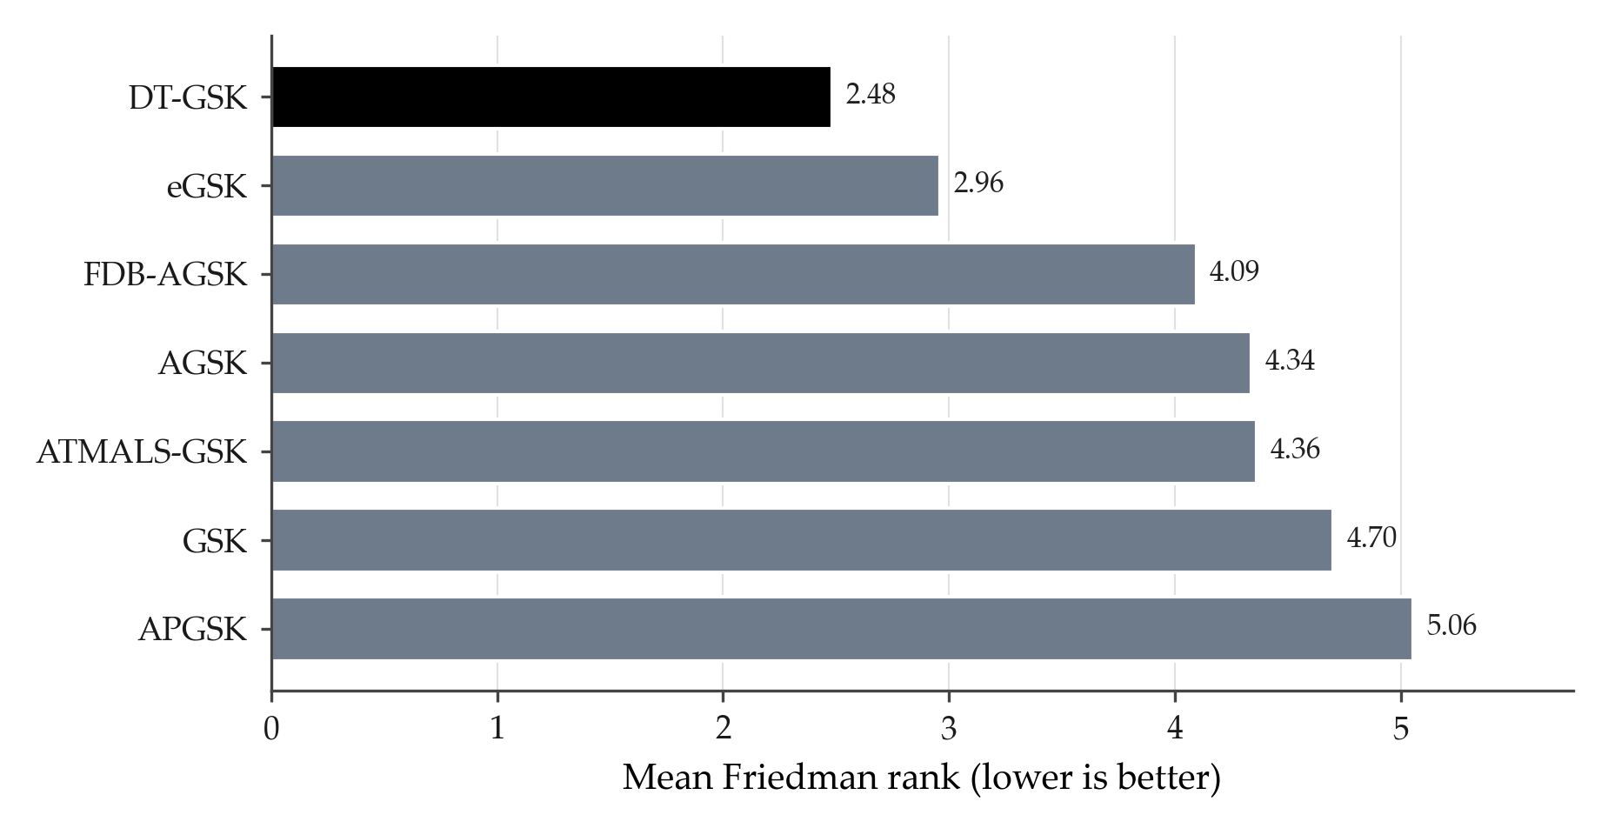
Figure B1. Overall (dimension-aggregated) Friedman mean rank of the seven GSK-family algorithms on CEC2017; lower is better. Same ranks, qualifications, and provenance as the main paper’s family-panel rank table.
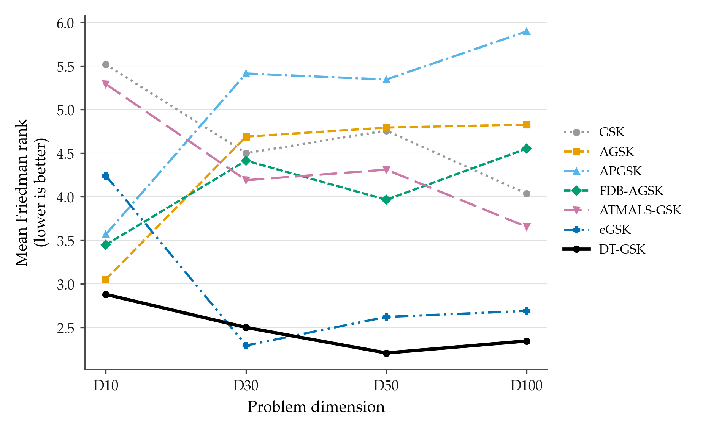
Figure B2. CEC2017 Friedman mean rank against problem dimension ($D∈\{10,30,50,100\}$) for the seven GSK-family algorithms (DT-GSK solid black); the plotted per-dimension values are exactly those of the main paper’s family-panel rank table.

S3. Convergence Figure Sets
This section provides the complete convergence record behind the main-text convergence subset: every scored function of the three suites whose convergence record this section carries — CEC2017 at all four dimensions, CEC2011 at native dimensions, and CEC2013 (bound-constrained) at the prespecified $D=30$ — one panel per function, with all 7 panel algorithms overlaid in every panel. The CEC2020 and CEC2013LSGO suites (Sections S8 and S7) carry no convergence figure set: their releases promote no curve files, an exclusion recorded in their manifests. The aggregation basis is identical for all curves in this section: each curve is the per-checkpoint mean across all runs for that algorithm (51 runs for CEC2017/CEC2013, 25 for CEC2011), with no smoothing and no interpolation.
Axes are log-error with a display-only floor of ${10}^{−14}$ for exact zeros; the floor never enters any reported statistic.
Line styles follow a fixed color/linestyle map (Okabe–Ito palette, DT-GSK solid black) with one shared legend per grid, and every panel carries the full 7/7 series (companion disclosure logs cec2017_missing.log, cec2011_missing.log, cec2013_missing.log record zero absences).

S3.1. CEC2017: All 29 Functions at Each Dimension
Figures B3–B18 cover all 29 CEC2017 functions at each of the four dimensions, split into four sub-grids per dimension (F1, F3–F9 / F10–F17 / F18–F25 / F26–F30). For $D=10$, $30$, and $50$ the APGSK checkpoint evidence derives from per-generation logs whose producing environment is unrecorded (the disclosed APGSK evidence limitation); the curves are shown with that qualification.
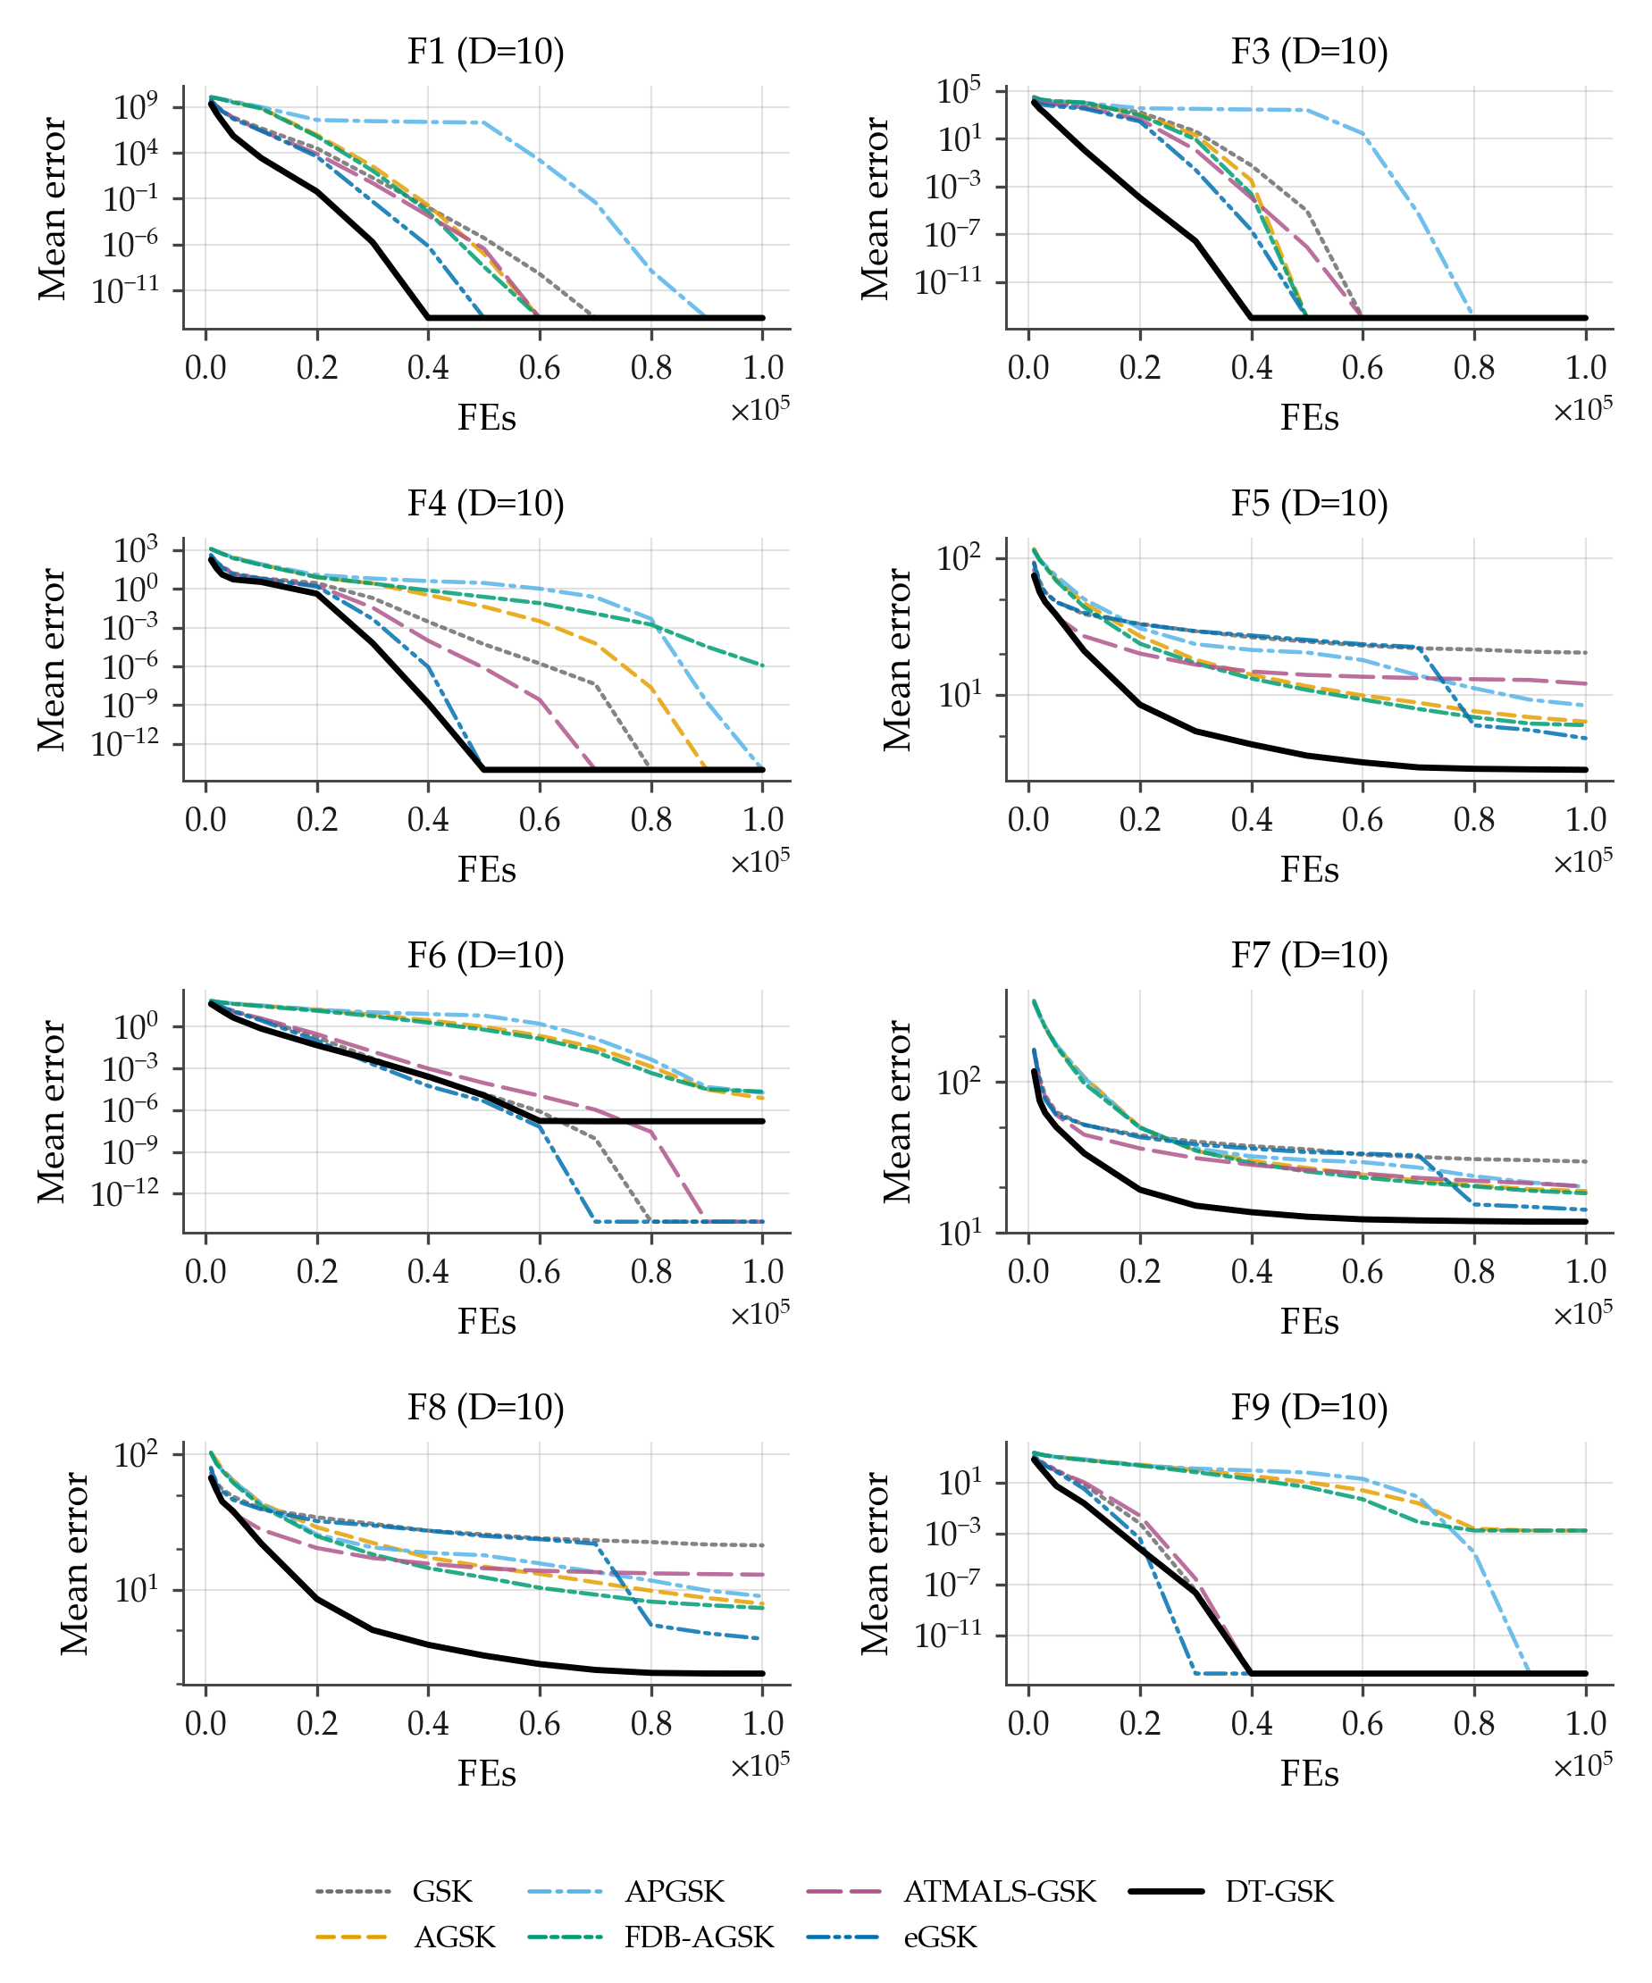
Figure B3. Family-overlay convergence on CEC2017 at $D=10$, functions F1, F3–F9 (sub-grid a of 4): per-checkpoint mean error across 51 runs per algorithm (identical basis for all 7 curves; no smoothing), fixed Okabe–Ito style map, DT-GSK solid black, one shared legend, log-error $y$-axis with display-only floor ${10}^{−14}$ for exact zeros. All panels carry the full 7/7 series. APGSK checkpoint evidence at this dimension derives from per-generation logs (disclosed limitation).
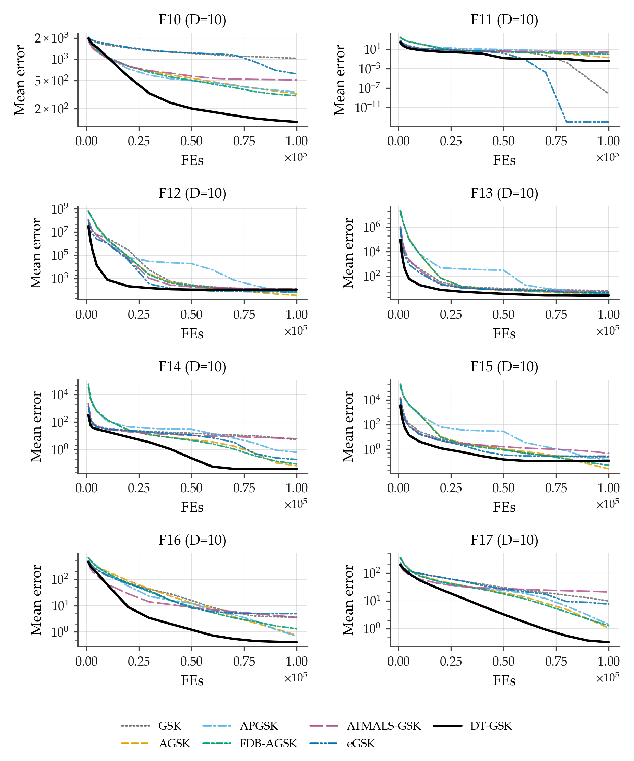
Figure B4. Family-overlay convergence on CEC2017 at $D=10$, functions F10–F17 (sub-grid b of 4): per-checkpoint mean error across 51 runs per algorithm, 7-curve overlay, log-error $y$-axis (display floor ${10}^{−14}$), one shared legend. APGSK checkpoint evidence at this dimension derives from per-generation logs (disclosed limitation).
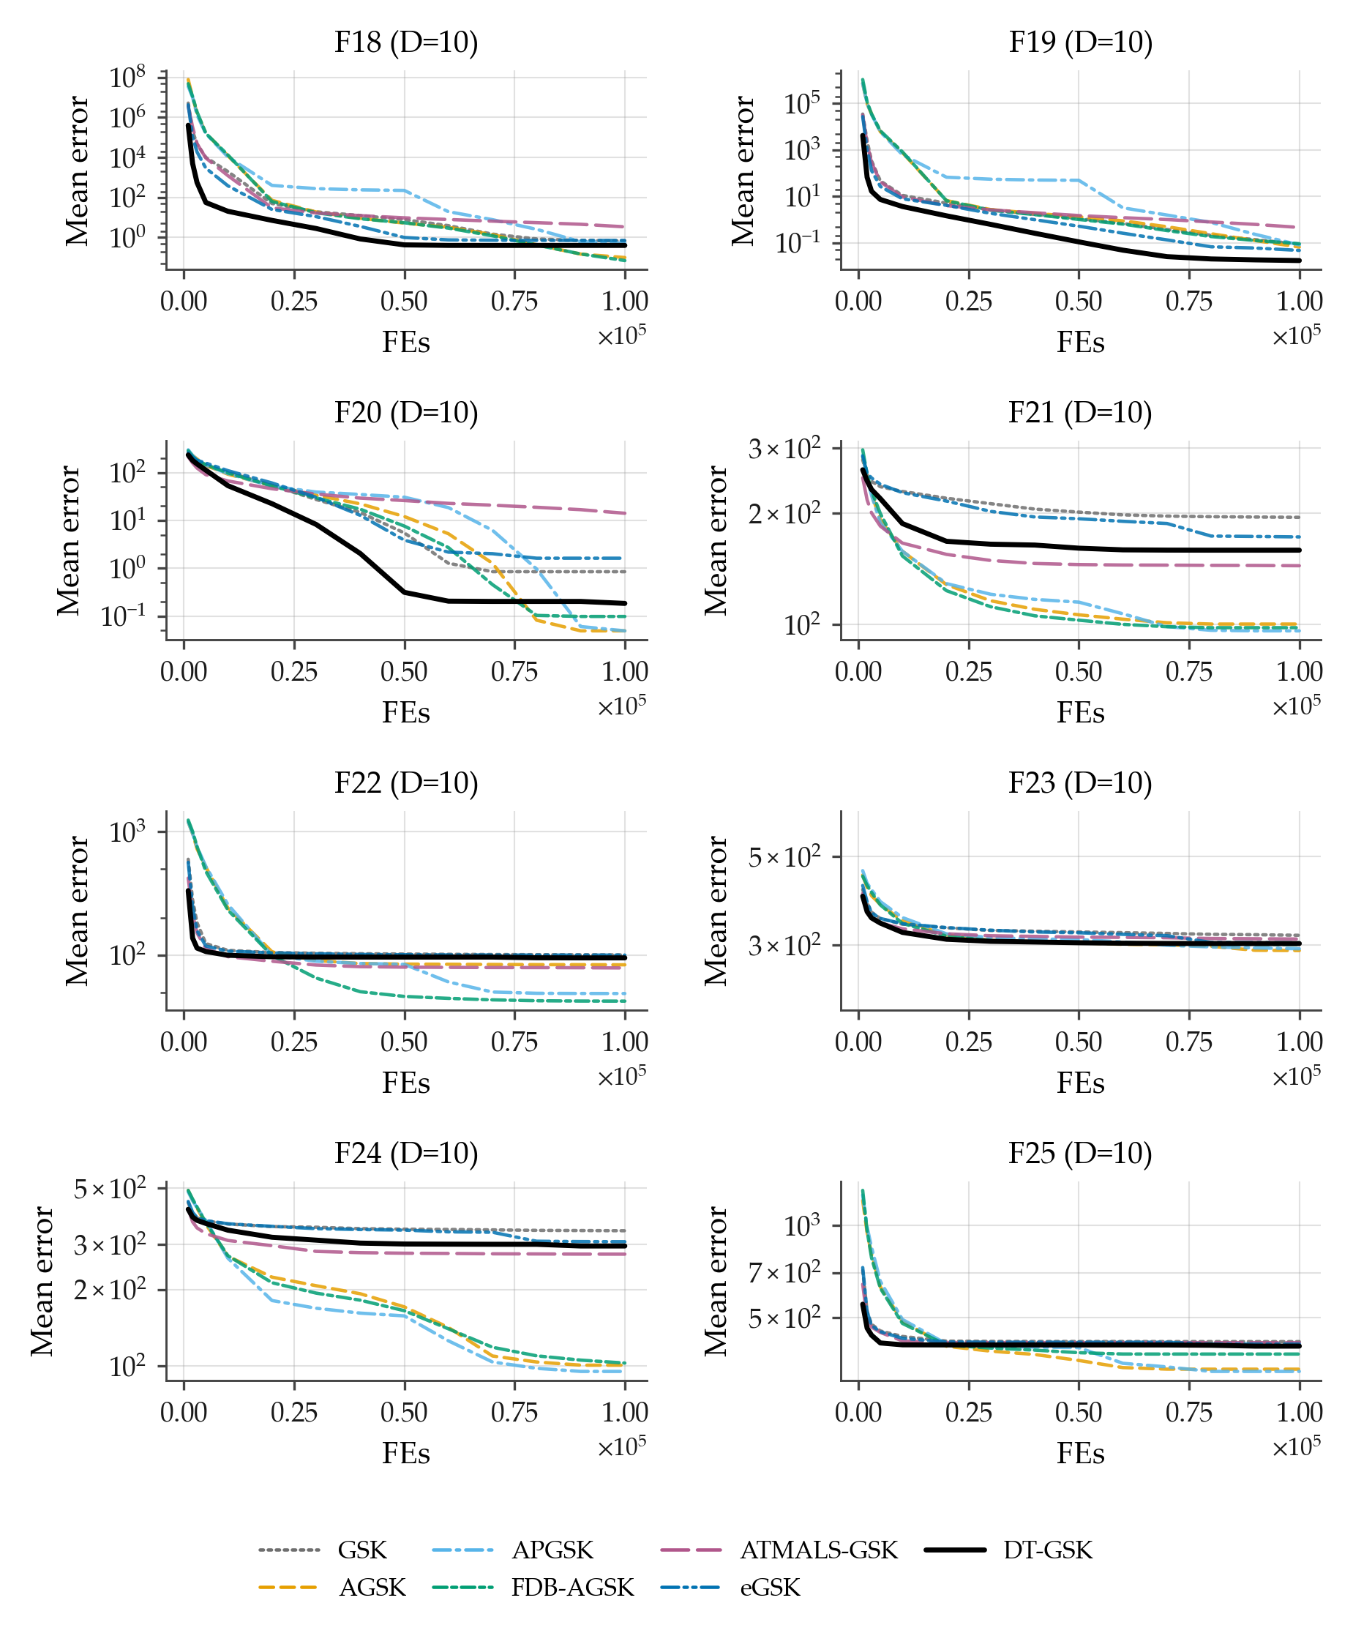
Figure B5. Family-overlay convergence on CEC2017 at $D=10$, functions F18–F25 (sub-grid c of 4): per-checkpoint mean error across 51 runs per algorithm, 7-curve overlay, log-error $y$-axis (display floor ${10}^{−14}$), one shared legend. APGSK checkpoint evidence at this dimension derives from per-generation logs (disclosed limitation).
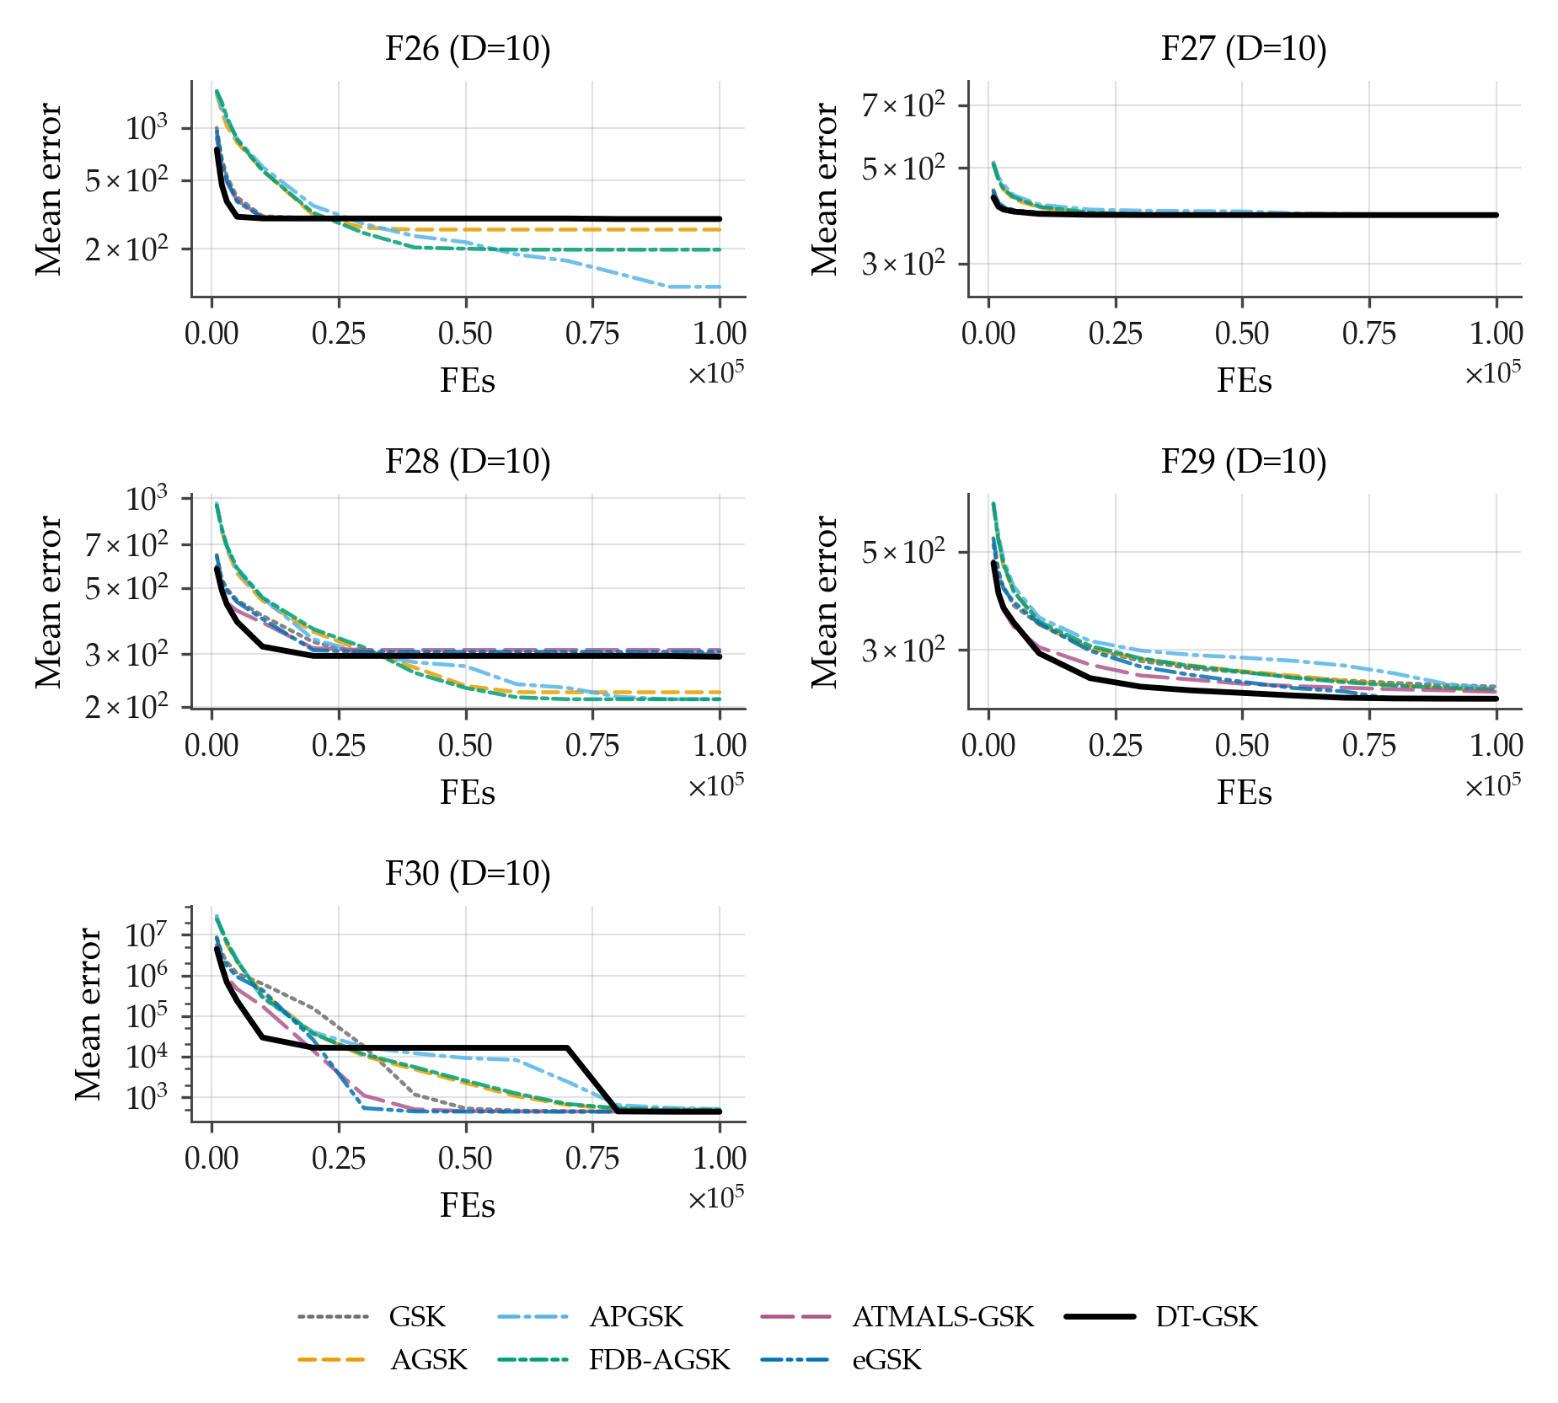
Figure B6. Family-overlay convergence on CEC2017 at $D=10$, functions F26–F30 (sub-grid d of 4): per-checkpoint mean error across 51 runs per algorithm, 7-curve overlay, log-error $y$-axis (display floor ${10}^{−14}$), one shared legend. APGSK checkpoint evidence at this dimension derives from per-generation logs (disclosed limitation).
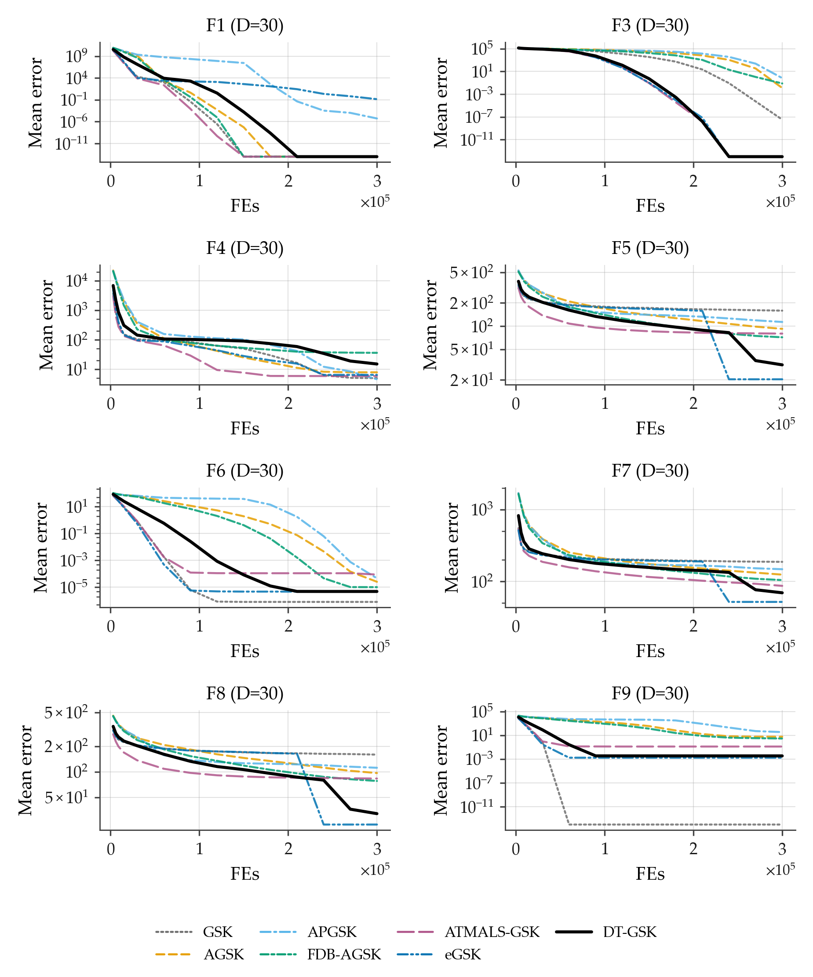
Figure B7. Family-overlay convergence on CEC2017 at $D=30$, functions F1, F3–F9 (sub-grid a of 4): per-checkpoint mean error across 51 runs per algorithm (identical basis for all 7 curves; no smoothing), fixed Okabe–Ito style map, DT-GSK solid black, one shared legend, log-error $y$-axis with display-only floor ${10}^{−14}$ for exact zeros. All panels carry the full 7/7 series. APGSK checkpoint evidence at this dimension derives from per-generation logs (disclosed limitation).
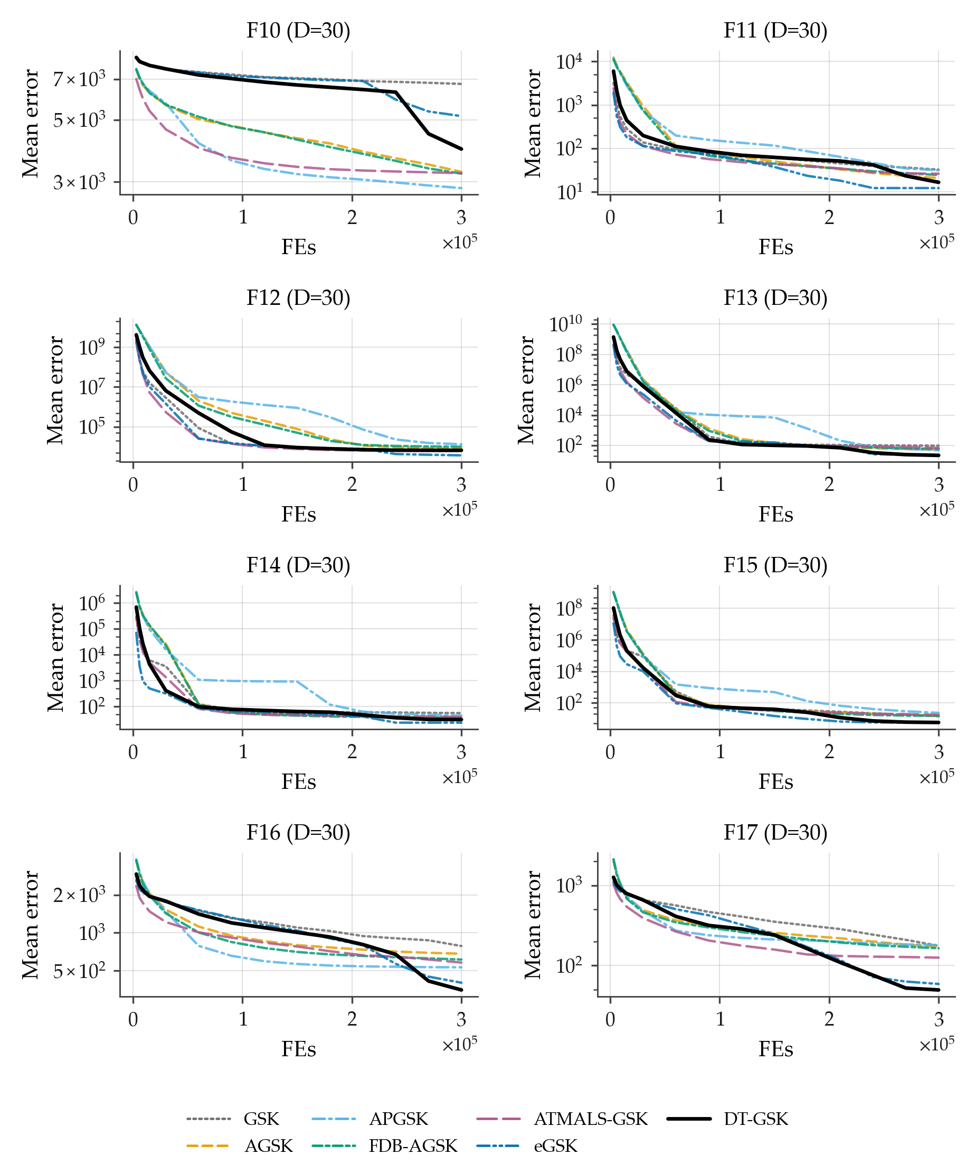
Figure B8. Family-overlay convergence on CEC2017 at $D=30$, functions F10–F17 (sub-grid b of 4): per-checkpoint mean error across 51 runs per algorithm, 7-curve overlay, log-error $y$-axis (display floor ${10}^{−14}$), one shared legend. APGSK checkpoint evidence at this dimension derives from per-generation logs (disclosed limitation).
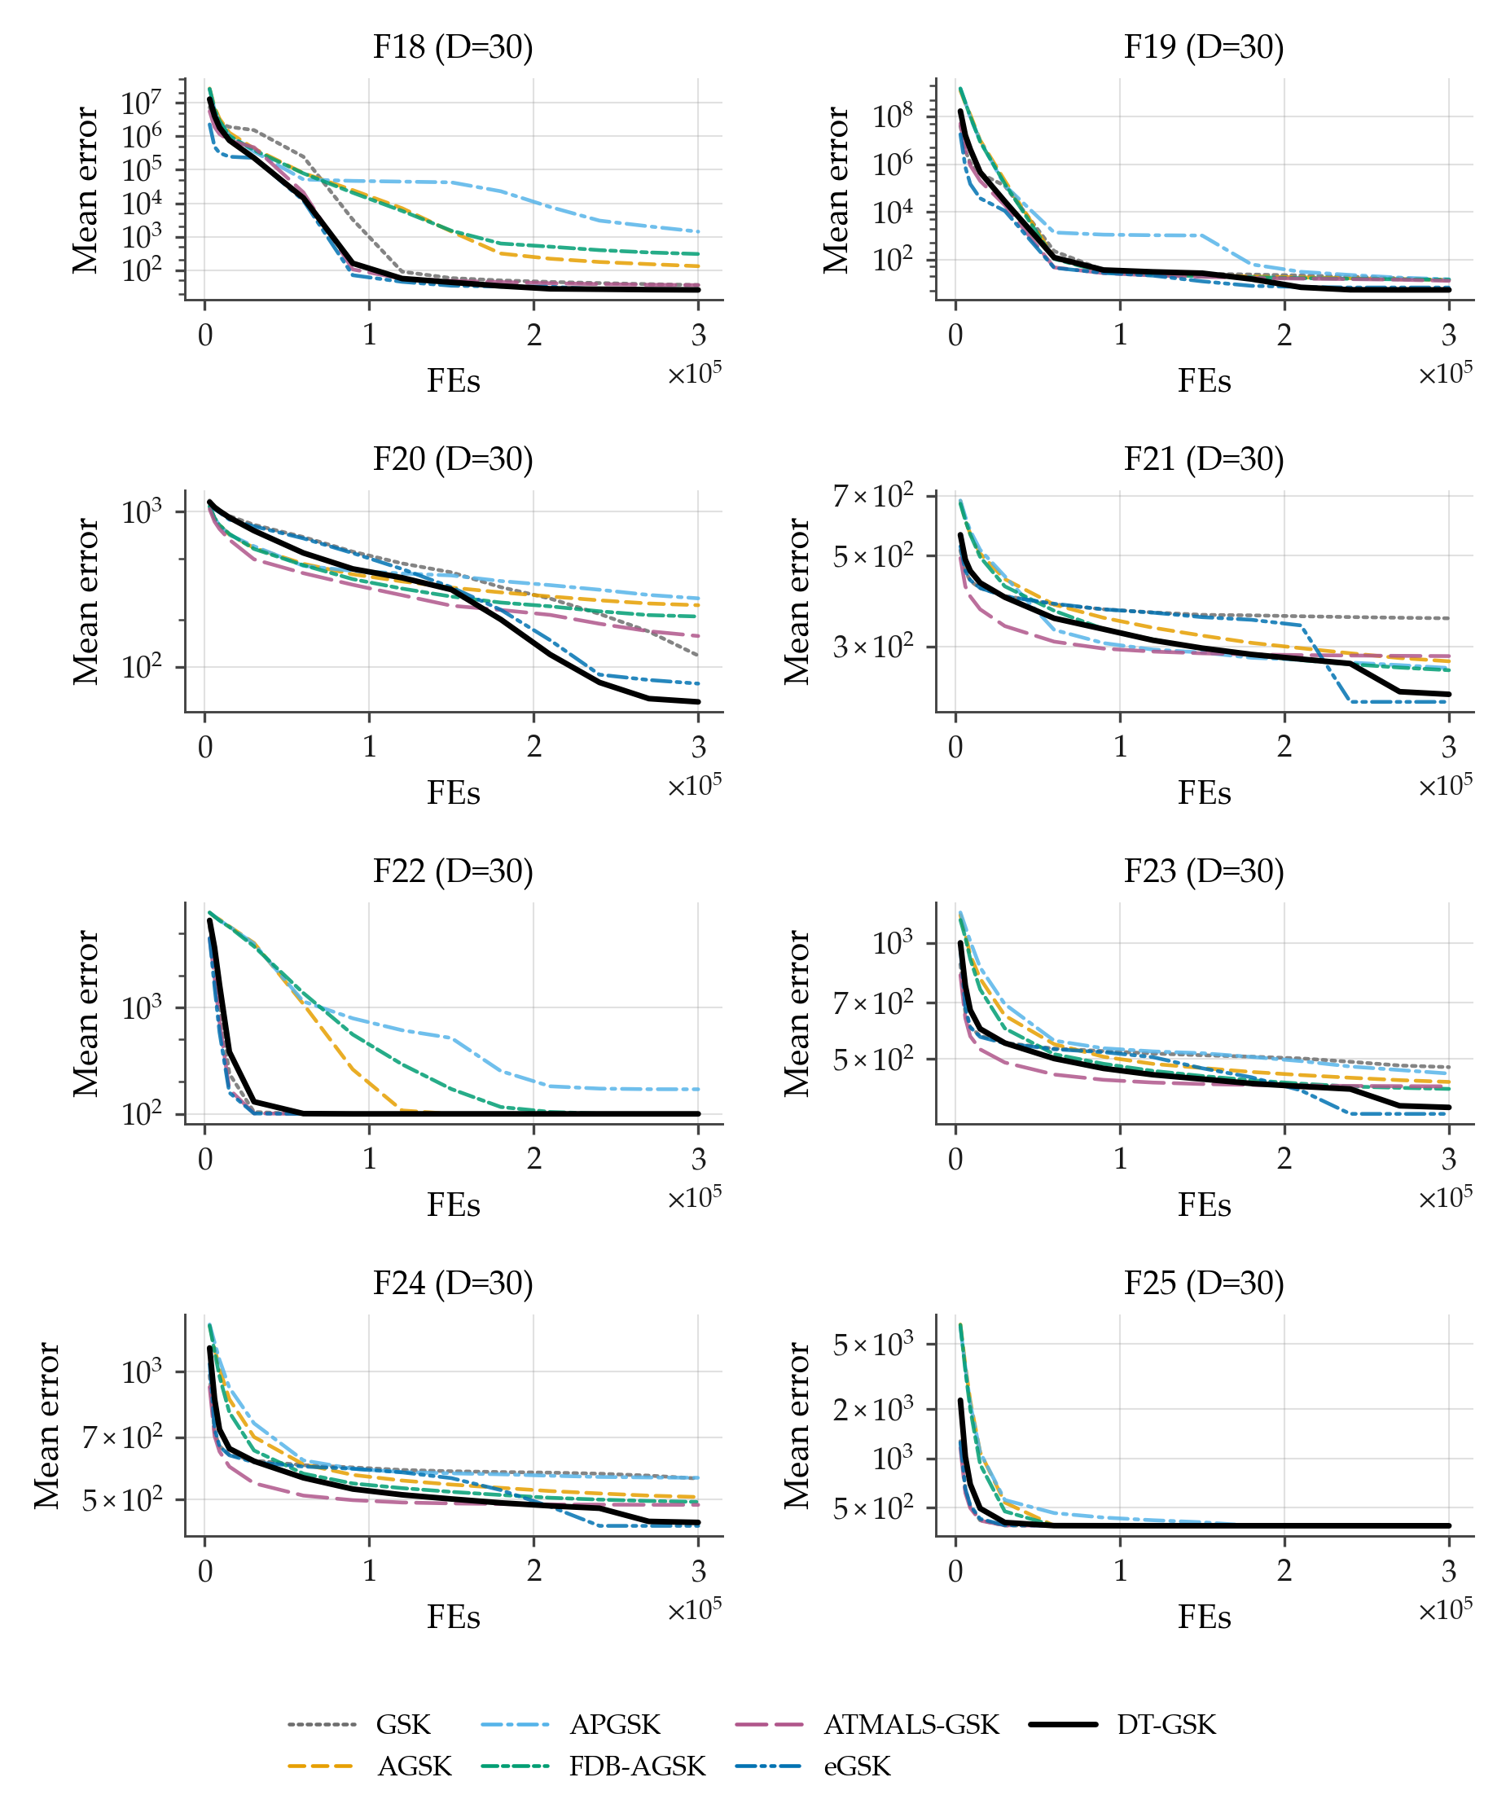
Figure B9. Family-overlay convergence on CEC2017 at $D=30$, functions F18–F25 (sub-grid c of 4): per-checkpoint mean error across 51 runs per algorithm, 7-curve overlay, log-error $y$-axis (display floor ${10}^{−14}$), one shared legend. APGSK checkpoint evidence at this dimension derives from per-generation logs (disclosed limitation).
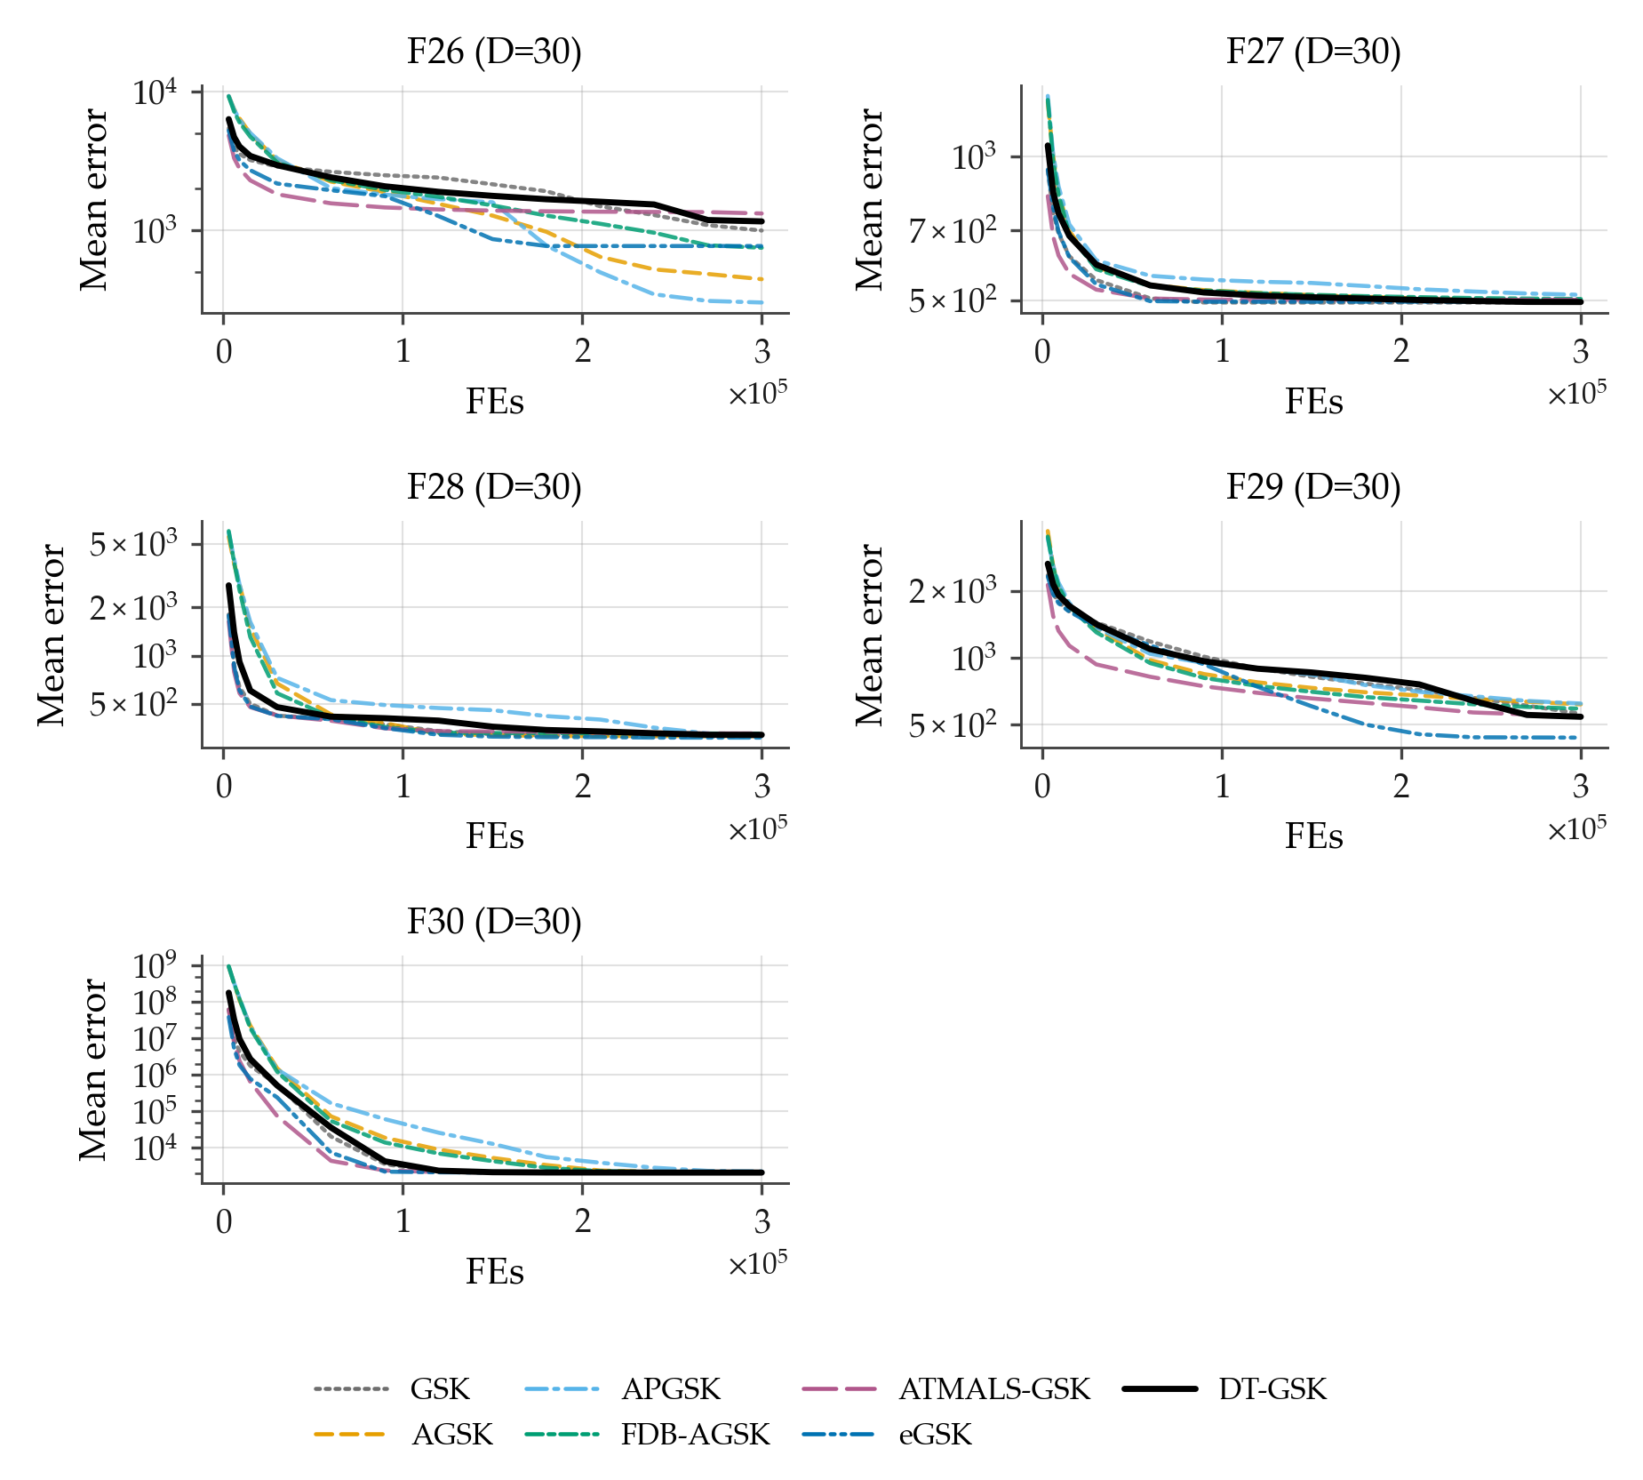
Figure B10. Family-overlay convergence on CEC2017 at $D=30$, functions F26–F30 (sub-grid d of 4): per-checkpoint mean error across 51 runs per algorithm, 7-curve overlay, log-error $y$-axis (display floor ${10}^{−14}$), one shared legend. APGSK checkpoint evidence at this dimension derives from per-generation logs (disclosed limitation).
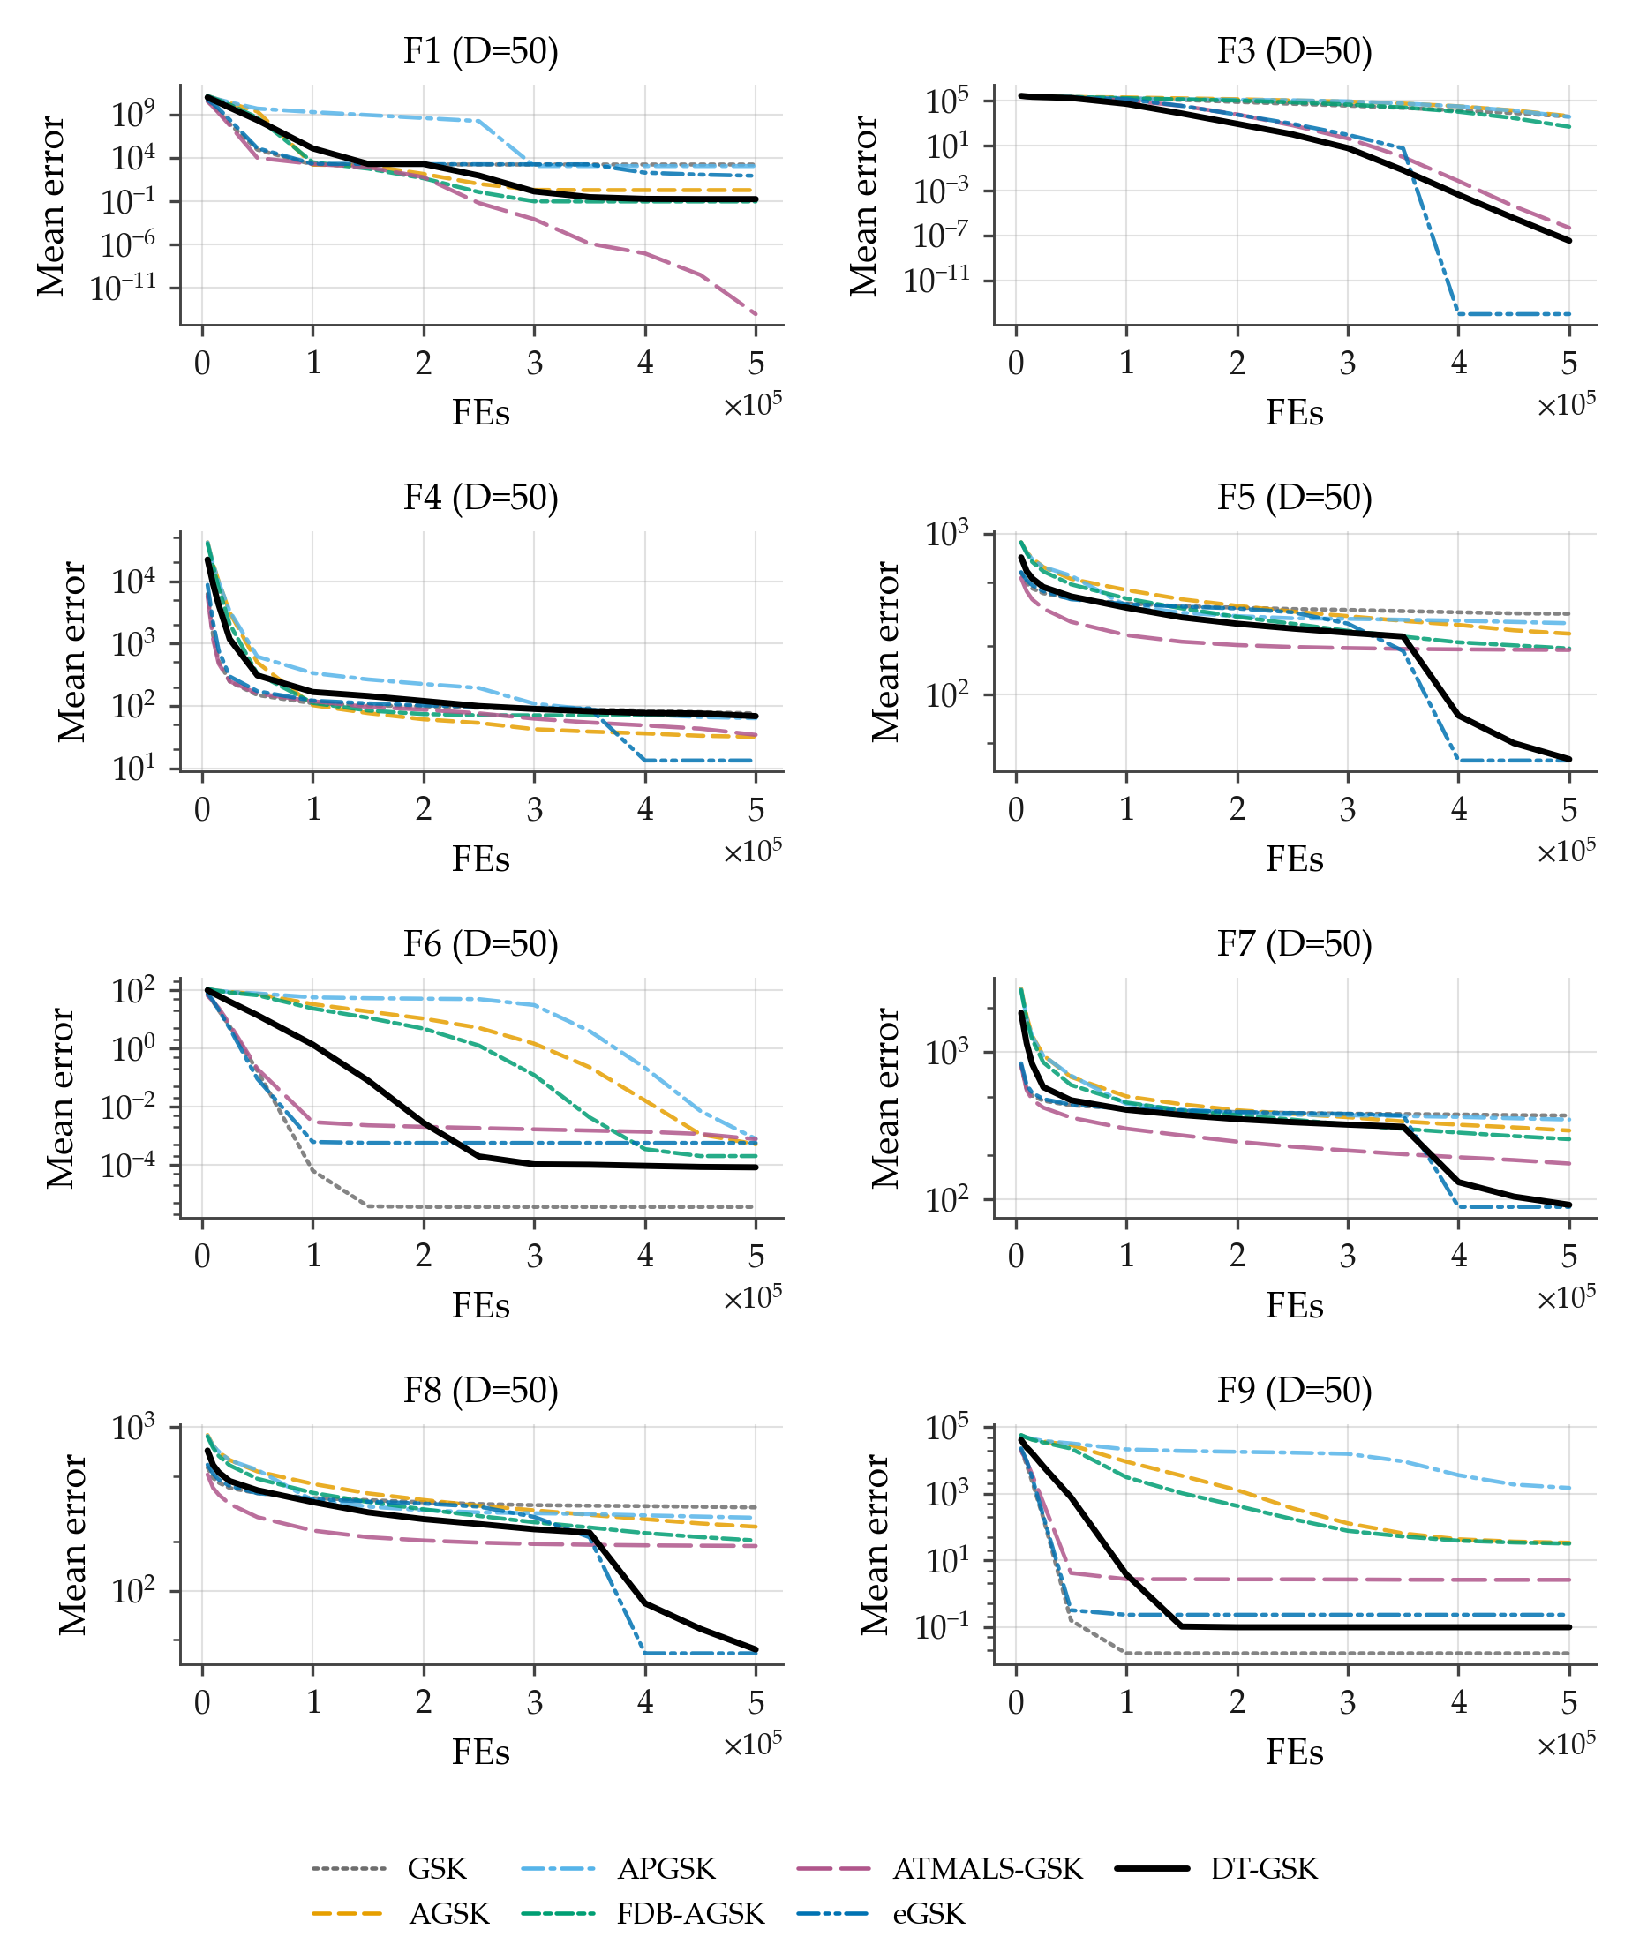
Figure B11. Family-overlay convergence on CEC2017 at $D=50$, functions F1, F3–F9 (sub-grid a of 4): per-checkpoint mean error across 51 runs per algorithm (identical basis for all 7 curves; no smoothing), fixed Okabe–Ito style map, DT-GSK solid black, one shared legend, log-error $y$-axis with display-only floor ${10}^{−14}$ for exact zeros. All panels carry the full 7/7 series. APGSK checkpoint evidence at this dimension derives from per-generation logs (disclosed limitation).
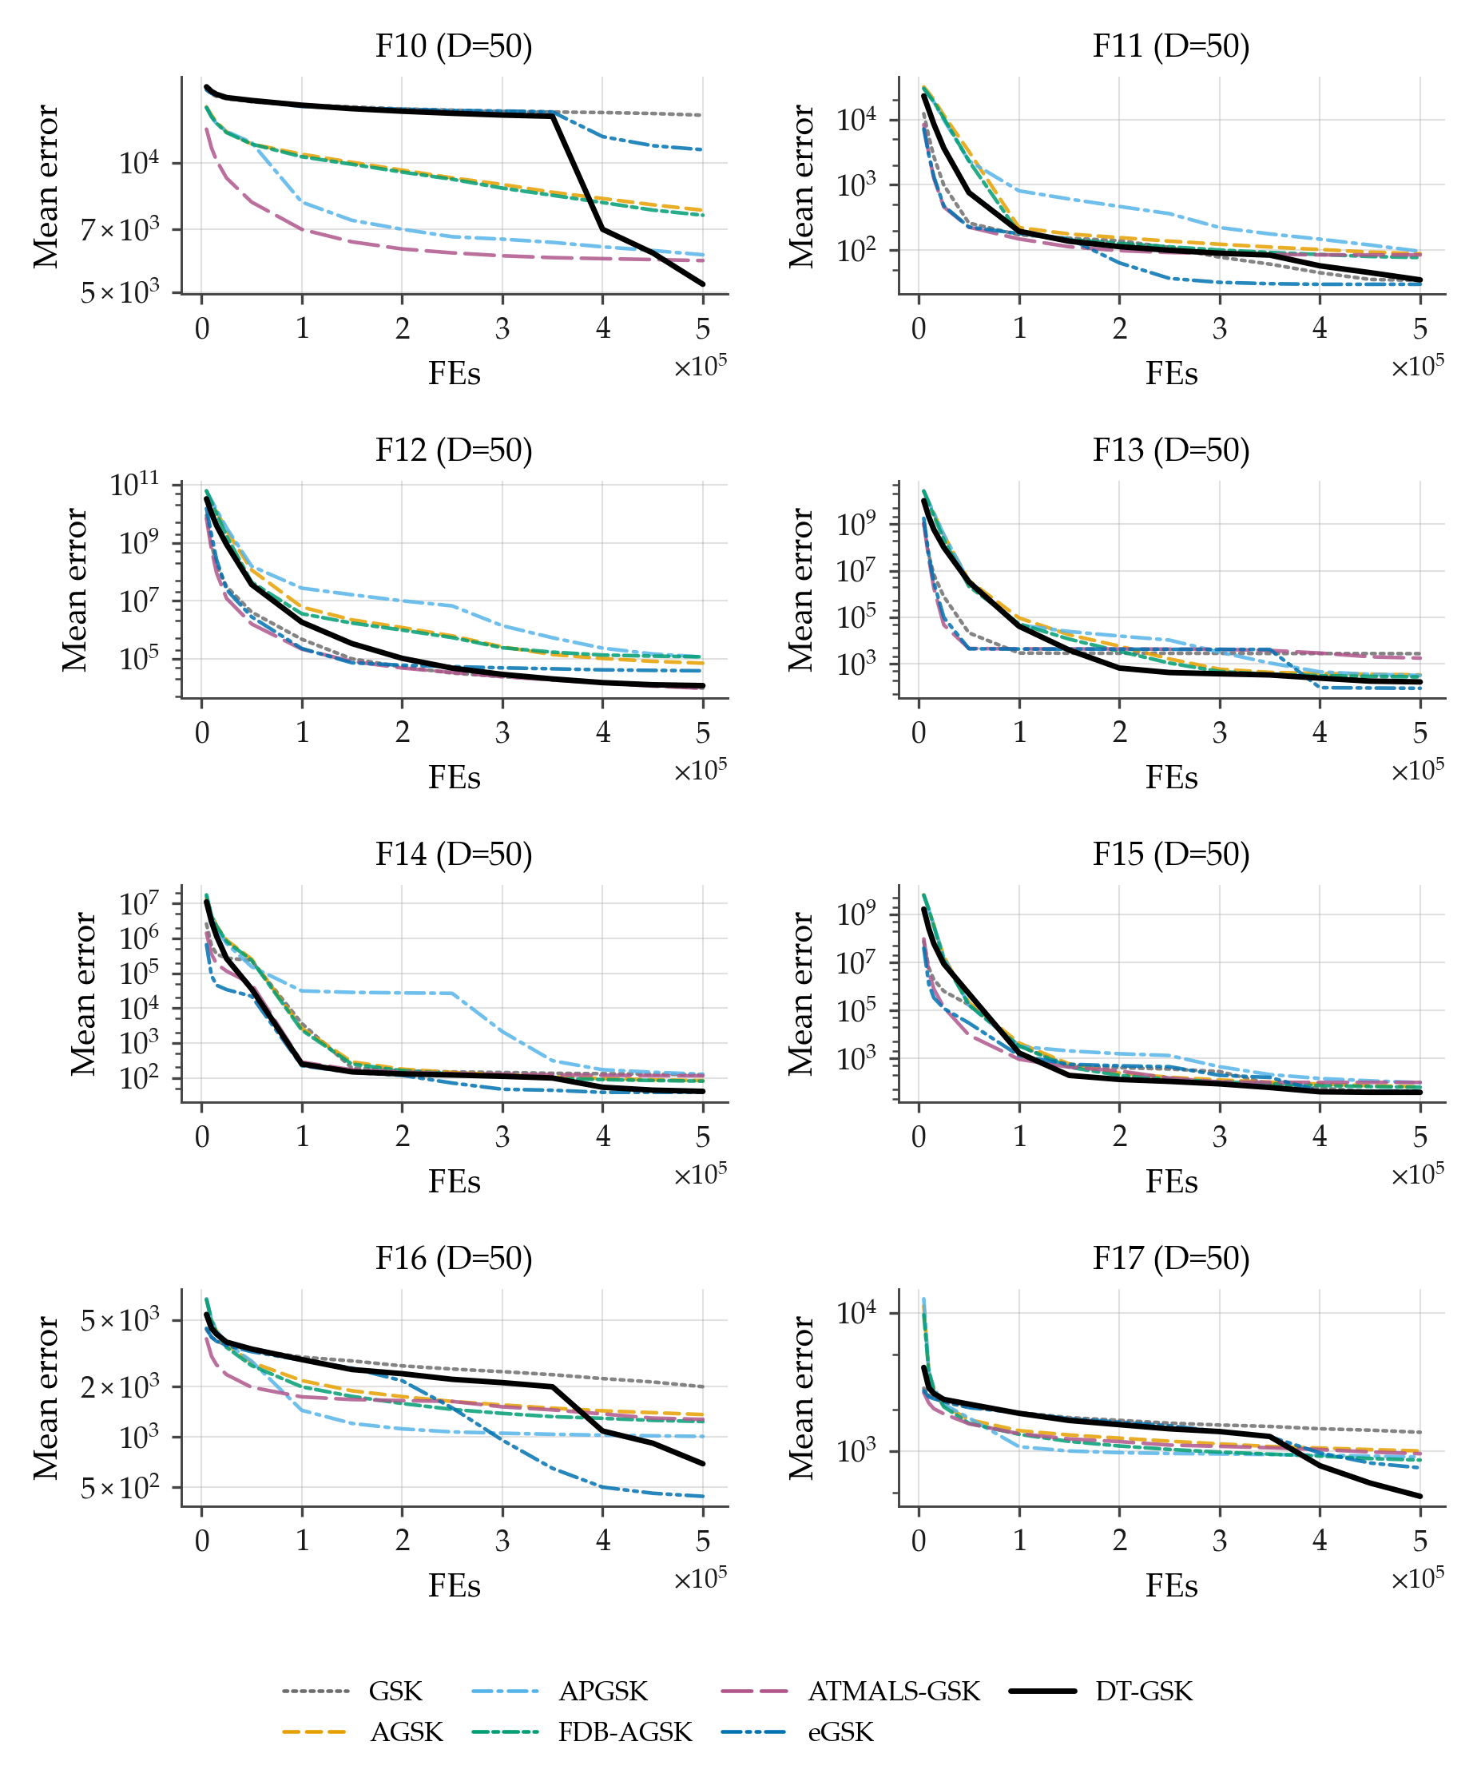
Figure B12. Family-overlay convergence on CEC2017 at $D=50$, functions F10–F17 (sub-grid b of 4): per-checkpoint mean error across 51 runs per algorithm, 7-curve overlay, log-error $y$-axis (display floor ${10}^{−14}$), one shared legend. APGSK checkpoint evidence at this dimension derives from per-generation logs (disclosed limitation).
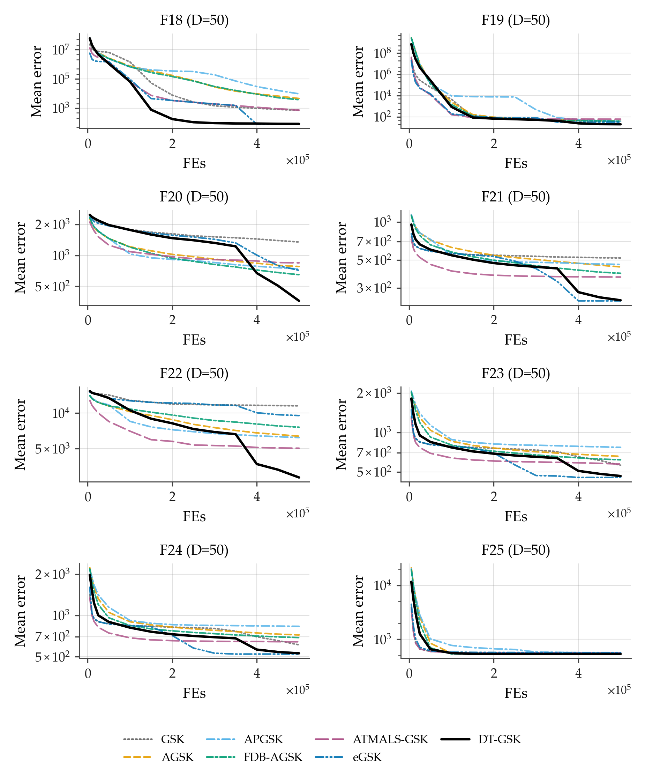
Figure B13. Family-overlay convergence on CEC2017 at $D=50$, functions F18–F25 (sub-grid c of 4): per-checkpoint mean error across 51 runs per algorithm, 7-curve overlay, log-error $y$-axis (display floor ${10}^{−14}$), one shared legend. APGSK checkpoint evidence at this dimension derives from per-generation logs (disclosed limitation).
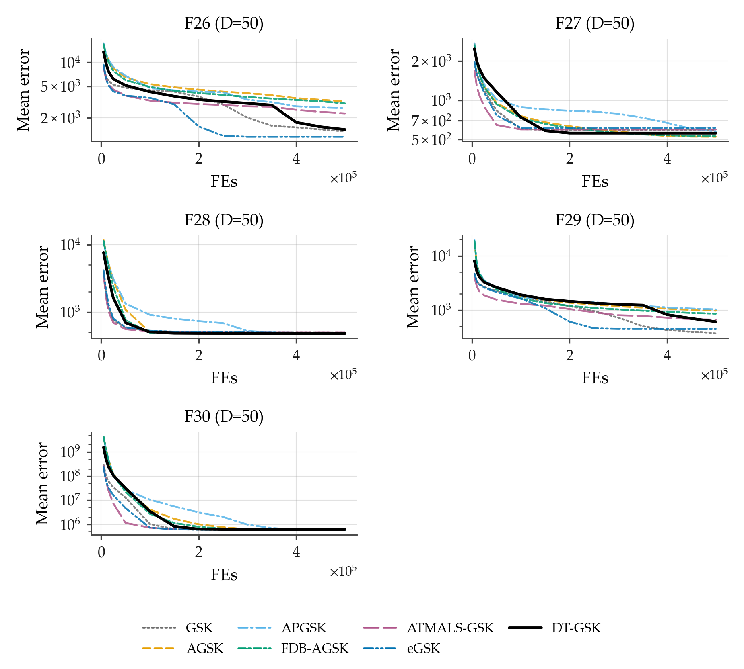
Figure B14. Family-overlay convergence on CEC2017 at $D=50$, functions F26–F30 (sub-grid d of 4): per-checkpoint mean error across 51 runs per algorithm, 7-curve overlay, log-error $y$-axis (display floor ${10}^{−14}$), one shared legend. APGSK checkpoint evidence at this dimension derives from per-generation logs (disclosed limitation).
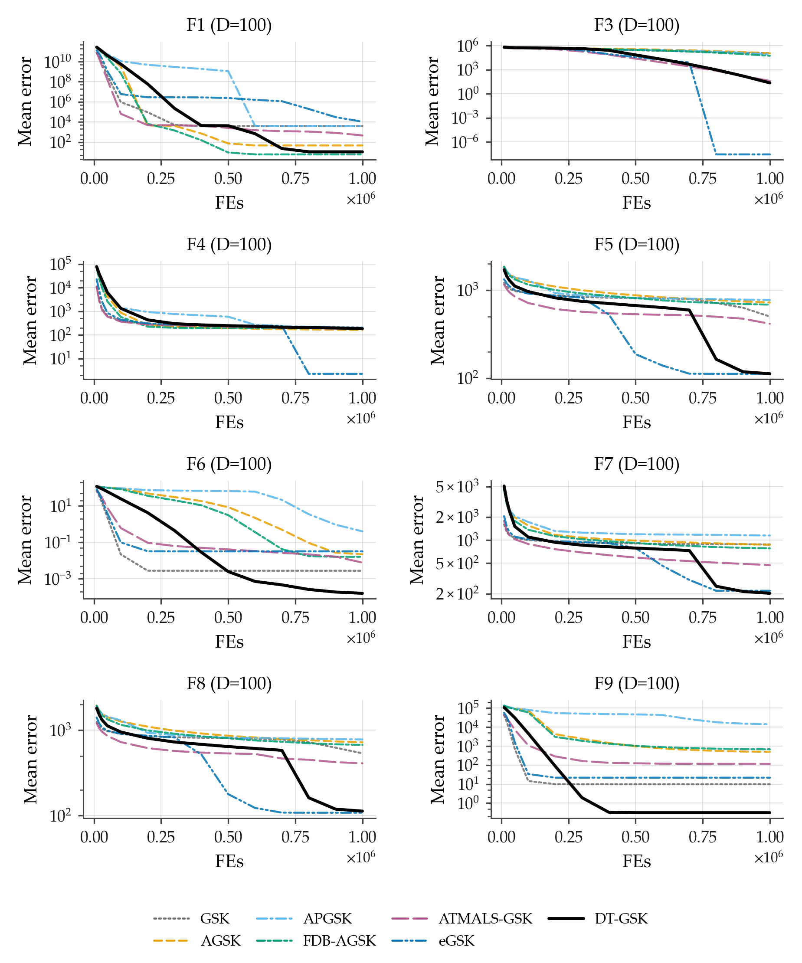
Figure B15. Family-overlay convergence on CEC2017 at $D=100$, functions F1, F3–F9 (sub-grid a of 4): per-checkpoint mean error across 51 runs per algorithm (identical basis for all 7 curves; no smoothing), fixed Okabe–Ito style map, DT-GSK solid black, one shared legend, log-error $y$-axis with display-only floor ${10}^{−14}$ for exact zeros. All panels carry the full 7/7 series. APGSK checkpoint evidence at this dimension derives from per-generation logs (disclosed limitation).
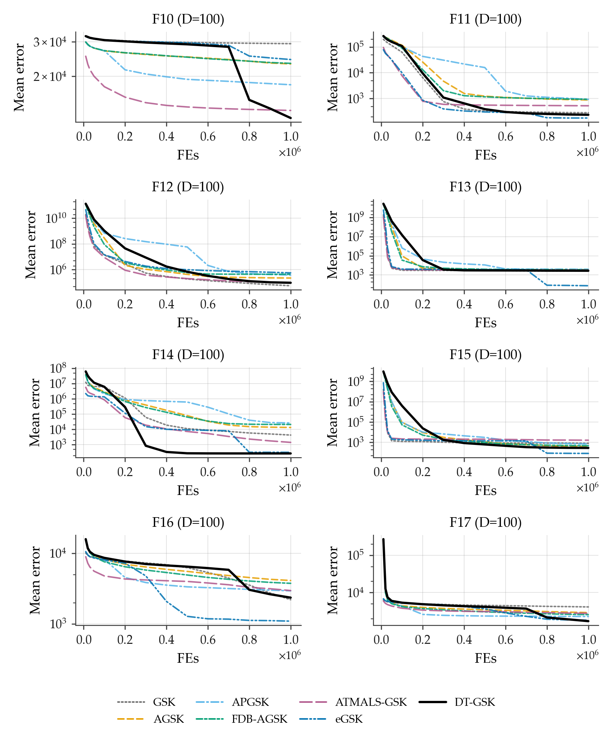
Figure B16. Family-overlay convergence on CEC2017 at $D=100$, functions F10–F17 (sub-grid b of 4): per-checkpoint mean error across 51 runs per algorithm, 7-curve overlay, log-error $y$-axis (display floor ${10}^{−14}$), one shared legend. APGSK checkpoint evidence at this dimension derives from per-generation logs (disclosed limitation).
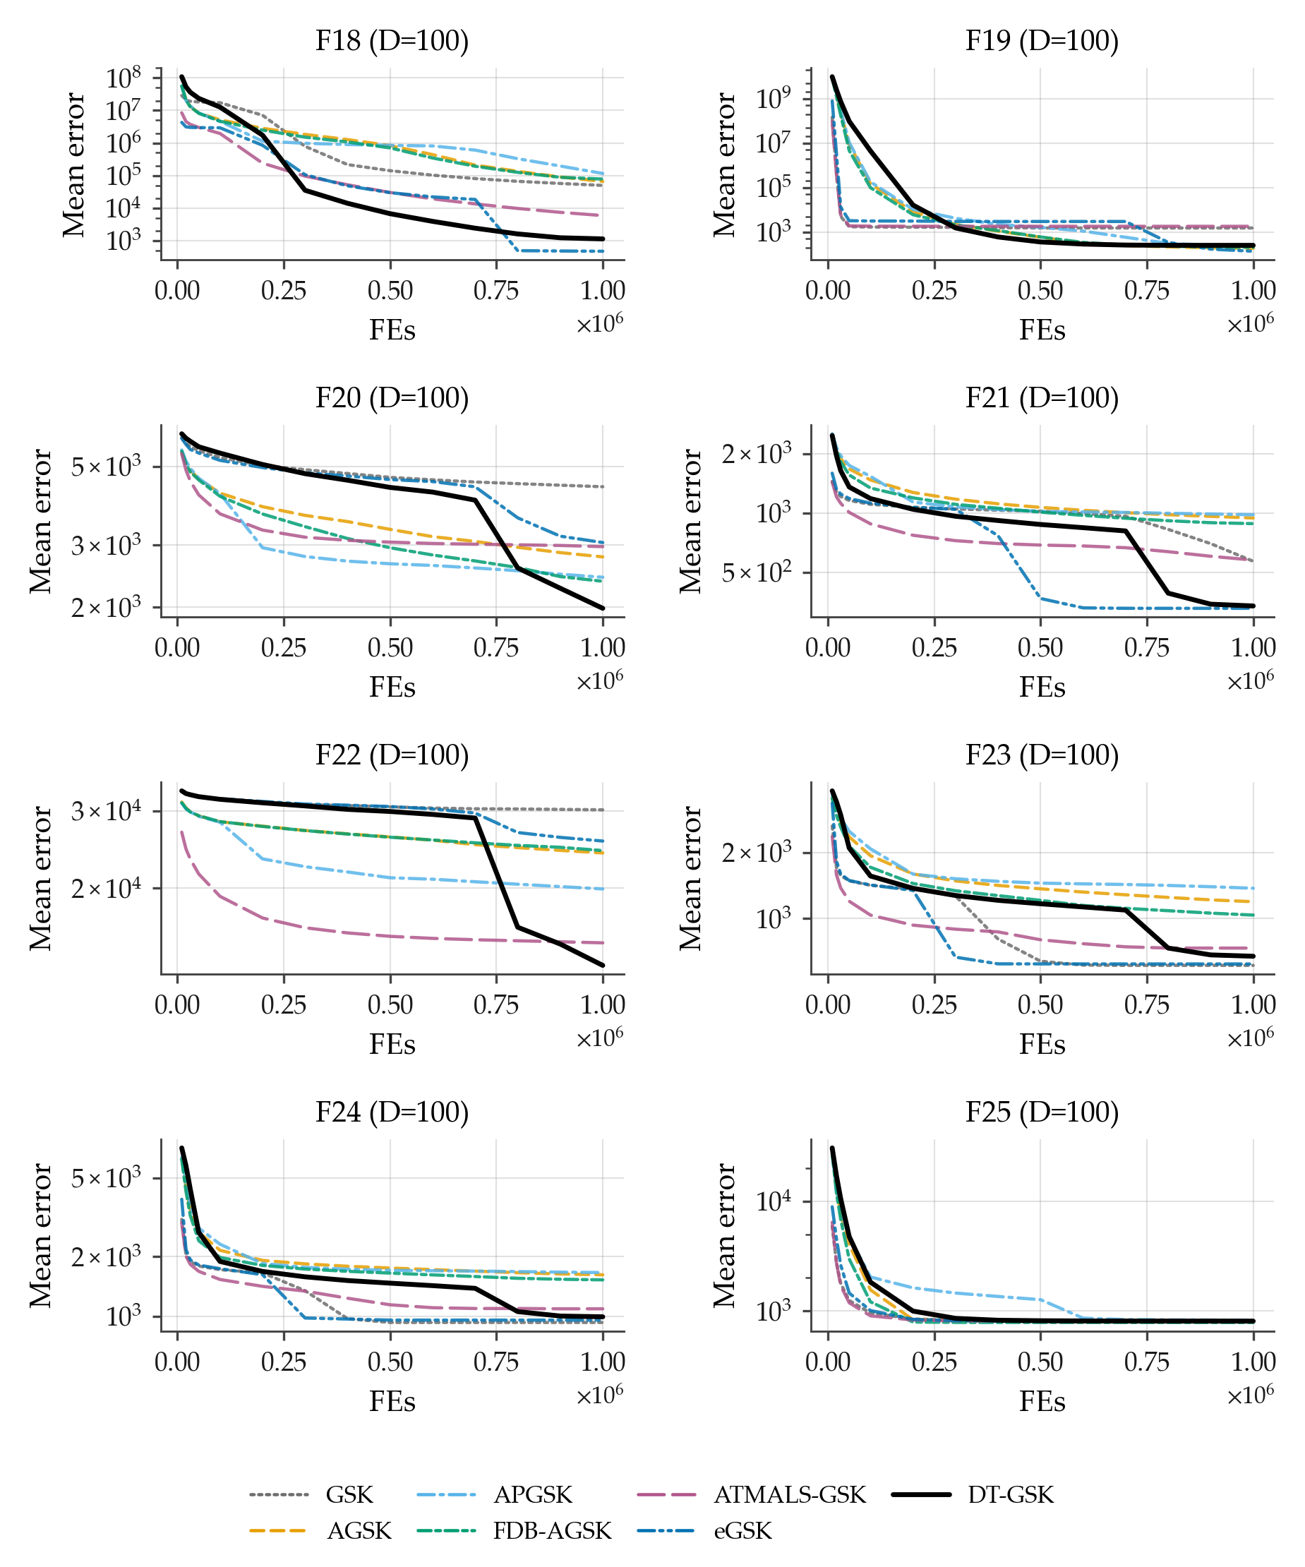
Figure B17. Family-overlay convergence on CEC2017 at $D=100$, functions F18–F25 (sub-grid c of 4): per-checkpoint mean error across 51 runs per algorithm, 7-curve overlay, log-error $y$-axis (display floor ${10}^{−14}$), one shared legend. APGSK checkpoint evidence at this dimension derives from per-generation logs (disclosed limitation).
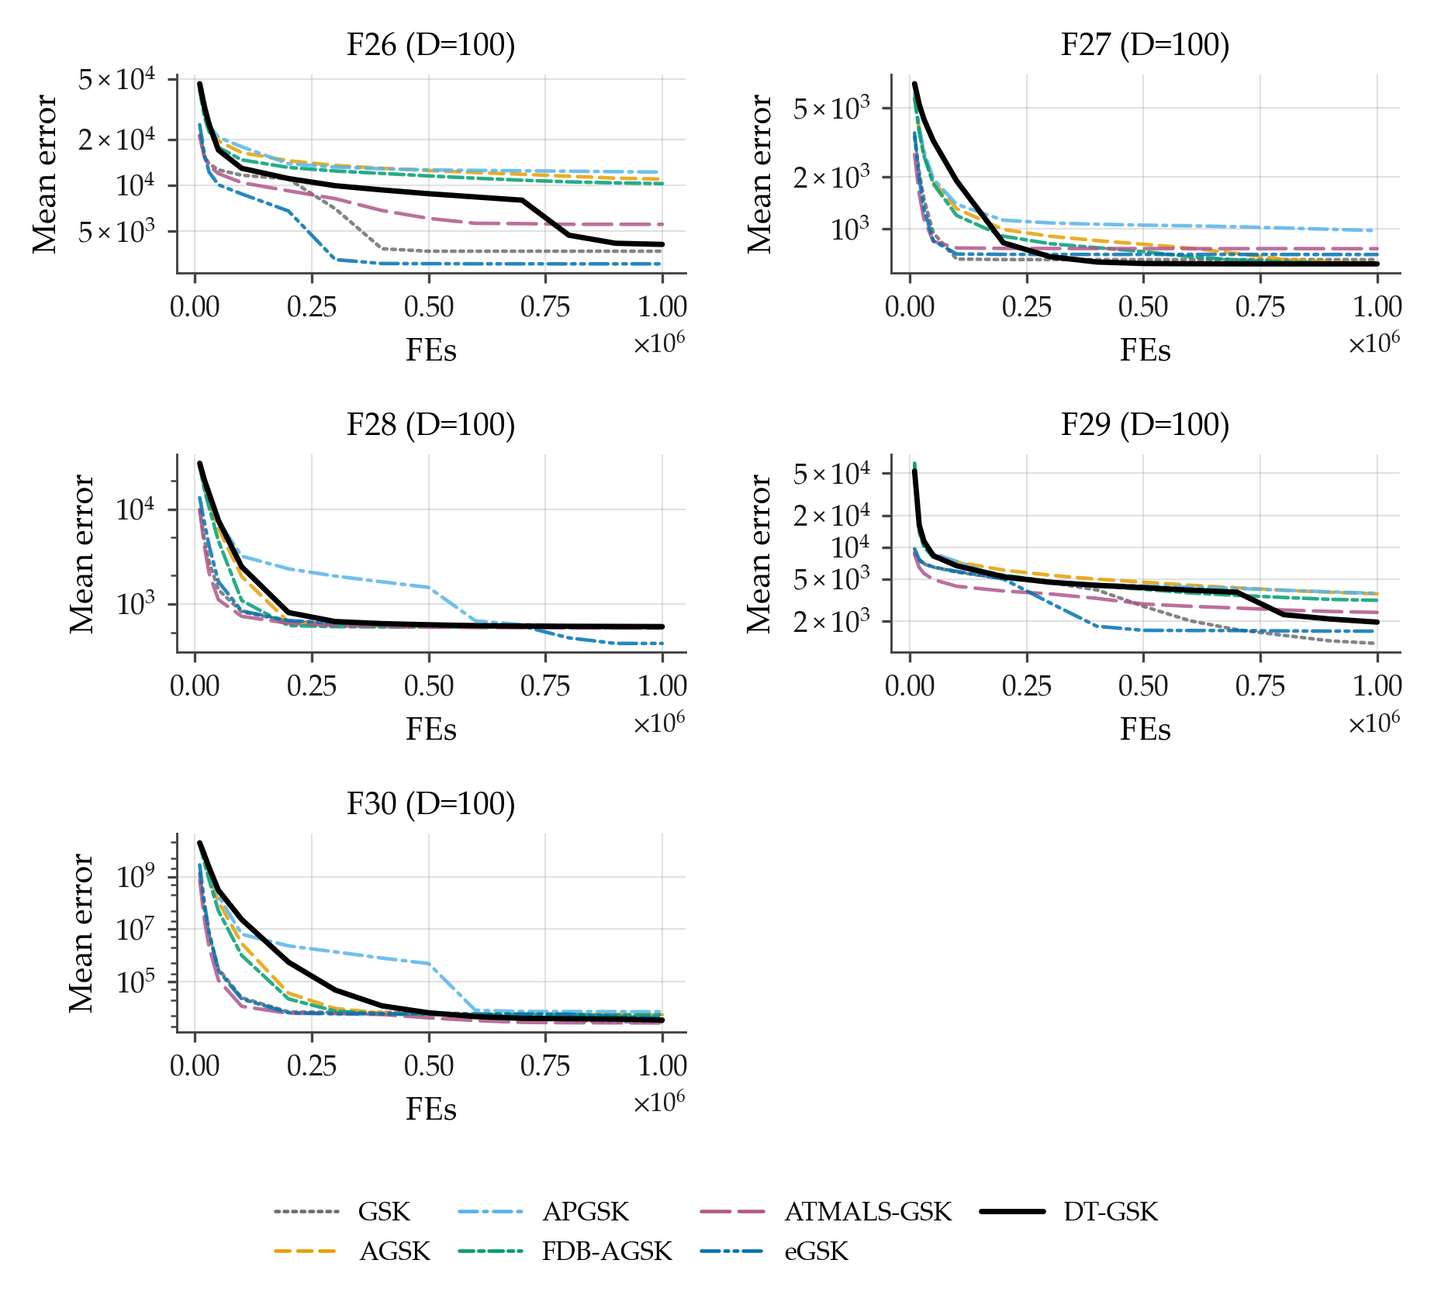
Figure B18. Family-overlay convergence on CEC2017 at $D=100$, functions F26–F30 (sub-grid d of 4): per-checkpoint mean error across 51 runs per algorithm, 7-curve overlay, log $y$-axis (display floor ${10}^{−14}$), one shared legend. APGSK checkpoint evidence at this dimension derives from per-generation logs (disclosed limitation).

S3.2. CEC2011: All 22 Real-World Problems
Figures B19–B21 cover all 22 CEC2011 real-world problems at their native dimensions, split into three sub-grids (problems P1–P8 / P9–P16 / P17–P22; each panel is titled by the suite’s function identifier and native dimension). Because several CEC2011 problems have negative optima, the plotted quantity is the per-checkpoint mean of the raw best objective across 25 runs, and four panels whose means are negative fall back from the log axis to a linear $y$-axis with an in-panel disclosure: P2, P5, and P6 in sub-grid a, and P10 in sub-grid b; all other panels use the log axis with display floor ${10}^{−14}$.
Outcome context for this suite (disclosed alongside the figures, not after them): within the family panel, DT-GSK’s across-problem Wilcoxon versus eGSK on CEC2011 is a statistically significant loss ($n=22$, Holm-corrected $p=4.2×{10}^{−2}$).
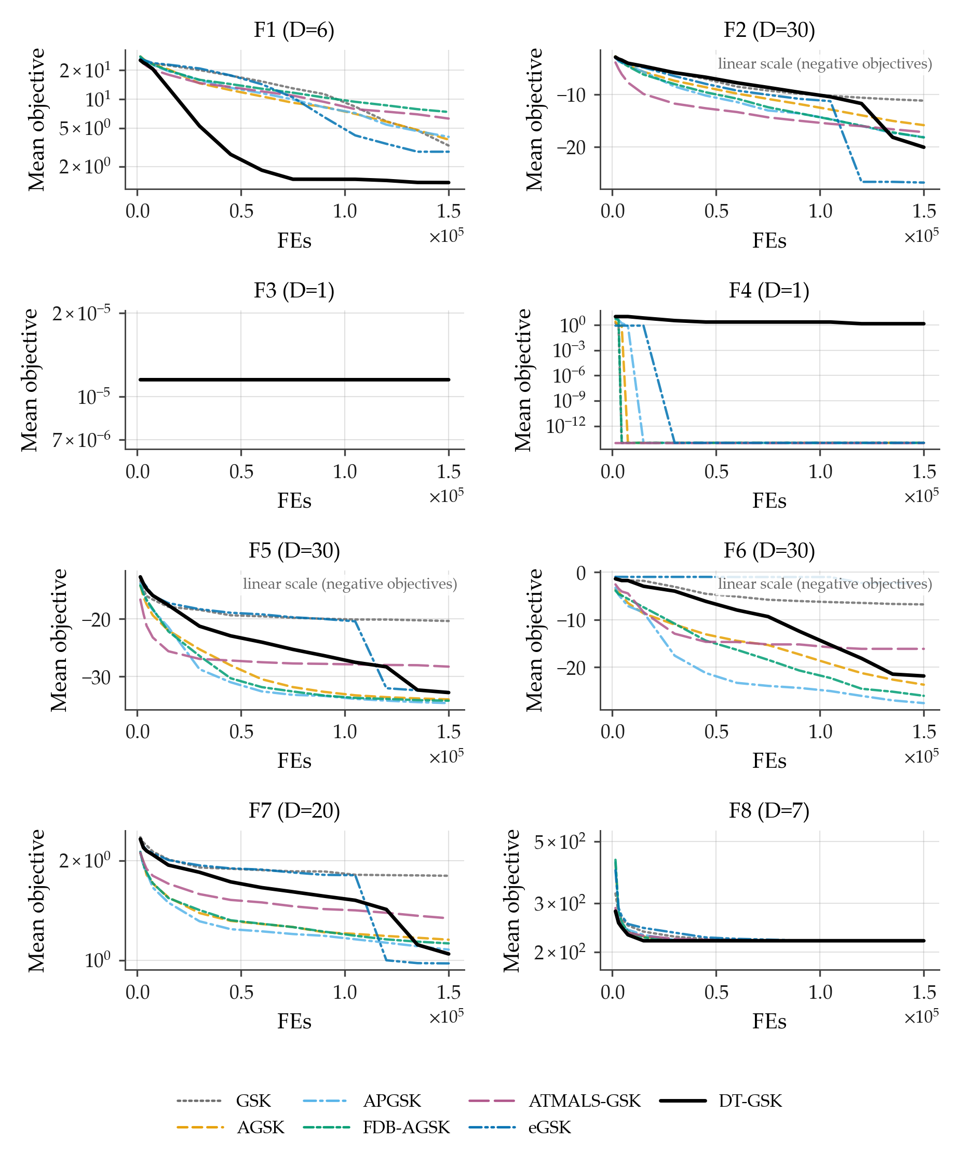
Figure B19. Family-overlay convergence on the CEC2011 real-world optimization benchmark suite, problems P1–P8 at native dimensions (sub-grid a of 3): per-checkpoint mean of the raw best objective across 25 runs per algorithm, 7-curve overlay, one shared legend. The three panels with negative means (P2, P5, P6) fall back to a linear $y$-axis with an in-panel disclosure; all other panels use the log axis with display floor ${10}^{−14}$. All panels carry 7/7 series. Suite-level outcome context: DT-GSK significantly loses to eGSK across problems on this suite (Holm-corrected $p=4.2×{10}^{−2}$).
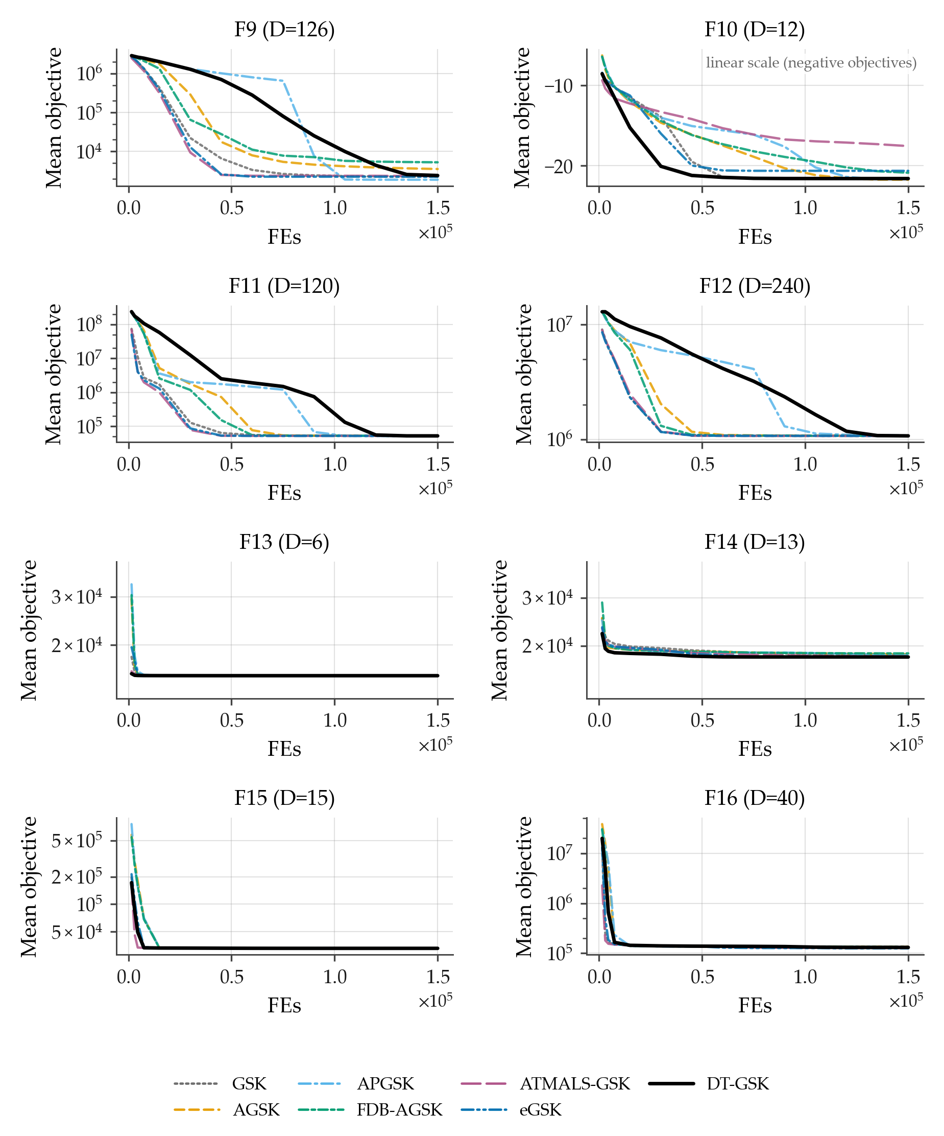
Figure B20. Family-overlay convergence on the CEC2011 real-world optimization benchmark suite, problems P9–P16 at native dimensions (sub-grid b of 3): per-checkpoint mean of the raw best objective across 25 runs per algorithm, 7-curve overlay, one shared legend. The panel with negative means (P10) falls back to a linear $y$-axis with an in-panel disclosure; all other panels use the log axis with display floor ${10}^{−14}$. All panels carry 7/7 series. Suite-level outcome context: DT-GSK significantly loses to eGSK across problems on this suite (Holm-corrected $p=4.2×{10}^{−2}$).
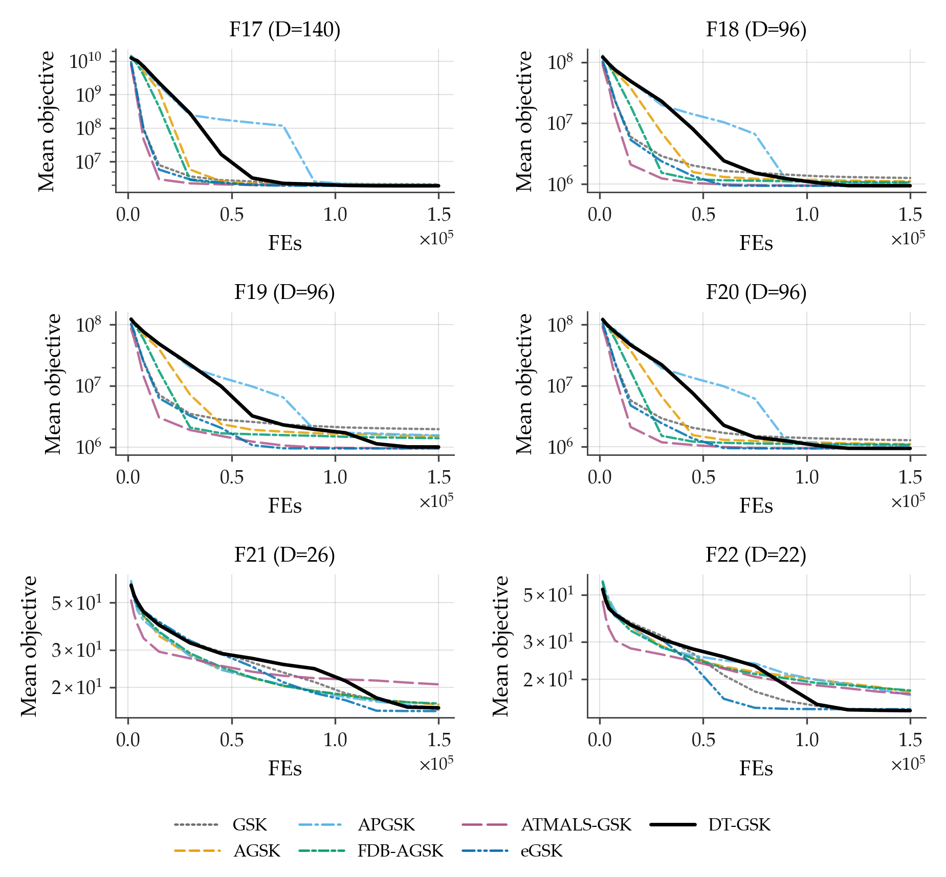
Figure B21. Family-overlay convergence on the CEC2011 real-world optimization benchmark suite, problems P17–P22 at native dimensions (sub-grid c of 3): per-checkpoint mean of the raw best objective across 25 runs per algorithm, 7-curve overlay, log-error $y$-axis with display floor ${10}^{−14}$, one shared legend. All panels carry 7/7 series. Suite-level outcome context: DT-GSK significantly loses to eGSK across problems on this suite (Holm-corrected $p=4.2×{10}^{−2}$).

S3.3. CEC2013 Second Comparison Suite: All 28 Functions at $D=30$
Figures B22–B25 cover all 28 functions of the CEC2013 second comparison suite at $D=30$ — the only prespecified CEC2013 convergence dimension — split into four sub-grids (F1–F8 / F9–F16 / F17–F24 / F25–F28).
The panel-level outcome disclosure for this suite and dimension applies here as in Section S2.3: DT-GSK places third by Friedman mean rank at $D=30$, behind eGSK and ATMALS-GSK.
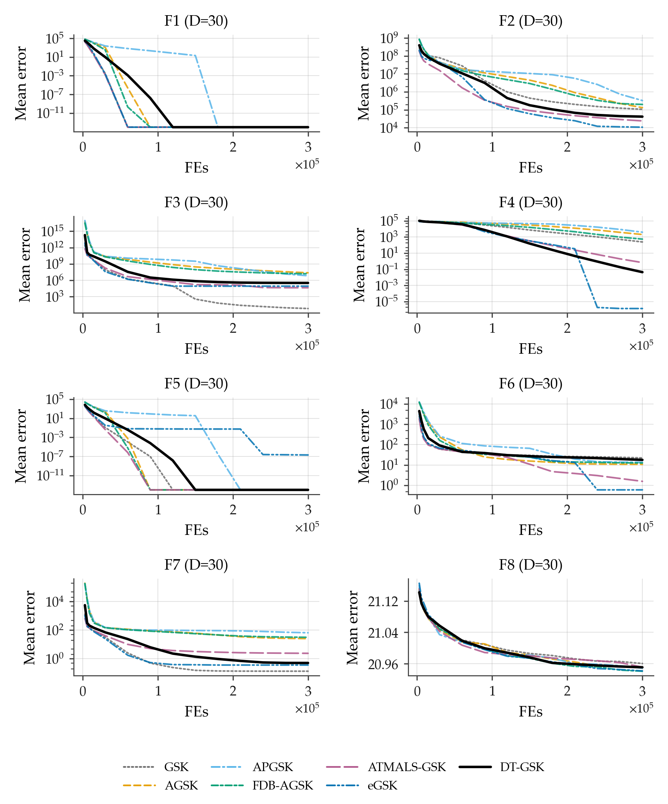
Figure B22. Family-overlay convergence on the CEC2013 second comparison suite at $D=30$, functions F1–F8 (sub-grid a of 4): per-checkpoint mean error across 51 runs per algorithm, 7-curve overlay, log-error $y$-axis (display floor ${10}^{−14}$), one shared legend. All panels carry 7/7 series. Panel-level context at this dimension: DT-GSK places third by Friedman mean rank behind eGSK and ATMALS-GSK.
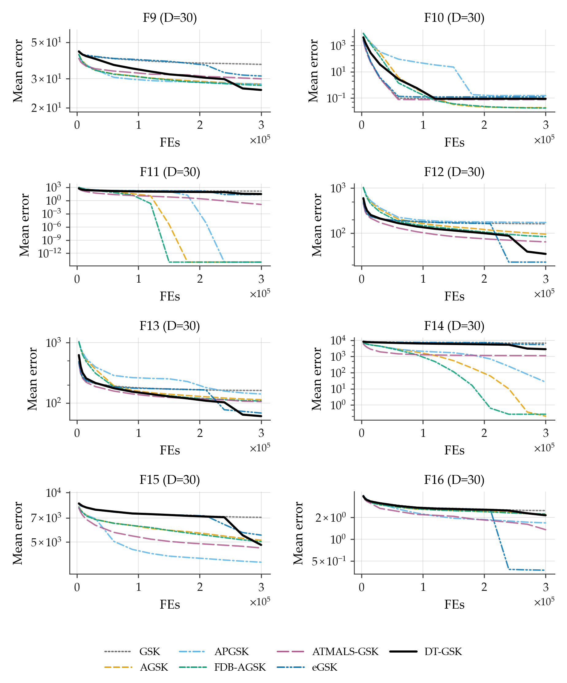
Figure B23. Family-overlay convergence on the CEC2013 second comparison suite at $D=30$, functions F9–F16 (sub-grid b of 4): per-checkpoint mean error across 51 runs per algorithm, 7-curve overlay, log-error $y$-axis (display floor ${10}^{−14}$), one shared legend. All panels carry 7/7 series.
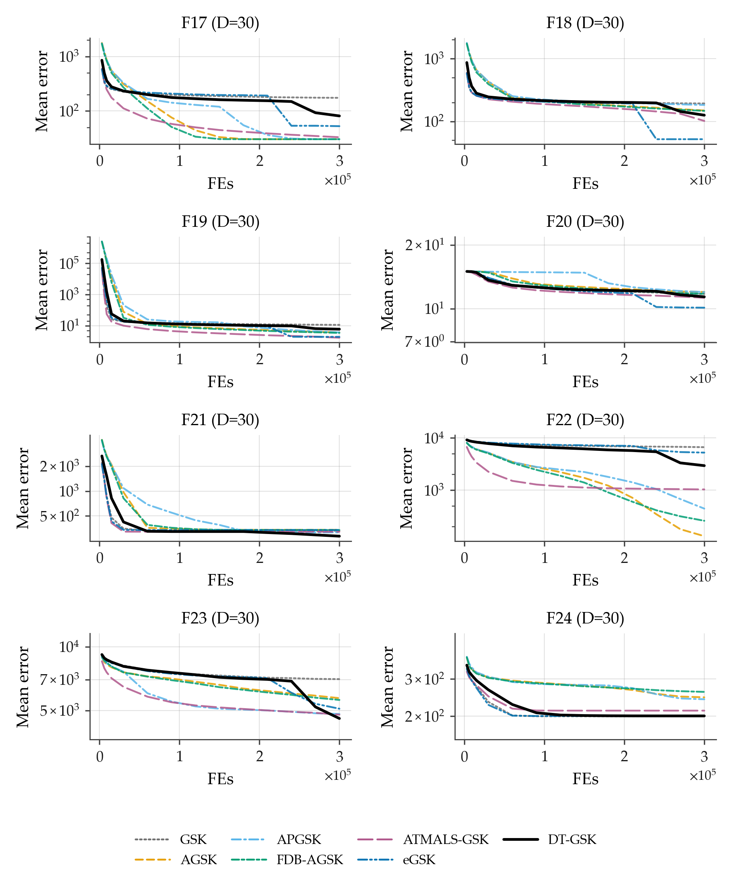
Figure B24. Family-overlay convergence on the CEC2013 second comparison suite at $D=30$, functions F17–F24 (sub-grid c of 4): per-checkpoint mean error across 51 runs per algorithm, 7-curve overlay, log-error $y$-axis (display floor ${10}^{−14}$), one shared legend. All panels carry 7/7 series.
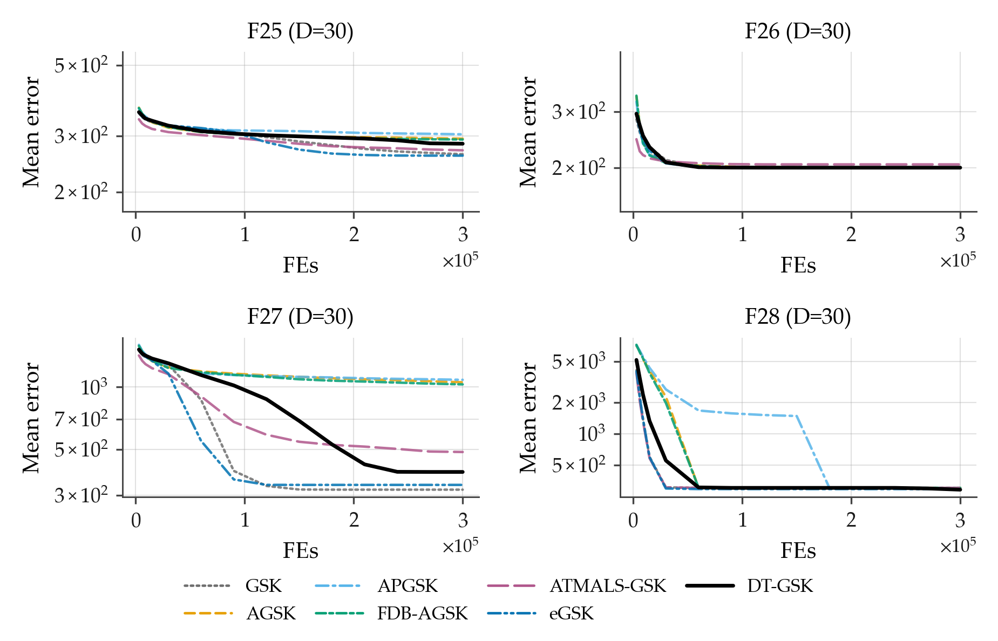
Figure B25. Family-overlay convergence on the CEC2013 second comparison suite at $D=30$, functions F25–F28 (sub-grid d of 4): per-checkpoint mean error across 51 runs per algorithm, 7-curve overlay, log-error $y$-axis (display floor ${10}^{−14}$), one shared legend. All panels carry 7/7 series.

S4. Population-Schedule Visualization and Diagnostic Availability
Figure B26 plots the analytic trajectory of the tier-floored Nonlinear Population-Size Reduction (NLPSR) schedule under the frozen configuration for all four dimension tiers ($NP_{\text{init}}=5D$; $N_{min}=12/12/25/25$ for $D=10/30/50/100$): population size versus consumed budget fraction.
This is an analytic evaluation of the frozen schedule formula and contains no empirical result values; it is included so that the population-size trajectory quoted in the main paper can be inspected without re-deriving the schedule.
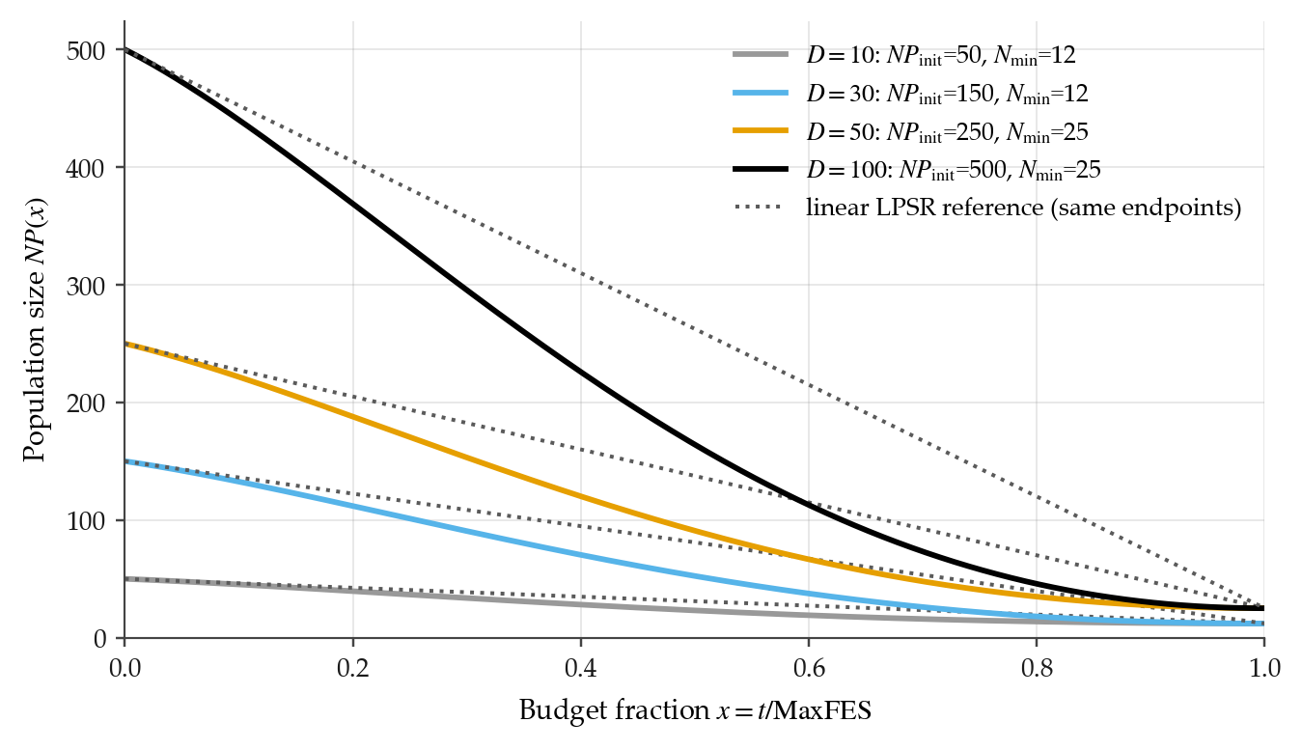
Figure B26. Analytic trajectory of the tier-floored nonlinear population size reduction schedule under the frozen configuration for all four dimension tiers ($NP_{\text{init}}=5D$; $N_{min}=12/12/25/25$): population size vs. consumed budget fraction. Analytic evaluation of the frozen formula — no empirical result values.
Per-generation mechanism-trace figures (interaction-structure-memory traces and the adaptive-parameter panel) are not included in this Supplementary Material: no promoted per-generation diagnostic release exists in the accompanying evidence release, so these exhibits cannot be produced under the strict-source rule of Section S5 and are disclosed as unavailable rather than substituted or fabricated.

S5. Reproducibility Appendix
This appendix documents the mechanisms that make every reported number re-derivable from the released artifacts: the paired optimizer-independent seed schedule, the hash-frozen configuration, the promoted read-only evidence release, and the deterministic RNG layer.
No byte-stability guarantee is extended to comparator reimplementations; the guarantees below are properties of the DT-GSK implementation and of the evidence pipeline.

S5.1. Seed Schedule and Pairing
Every run in the evidence release is seeded by one deterministic, optimizer-independent formula keyed on the (dimension, function, run) triple, with base seed $20240620$:
$seed(D,f,r) = \left(20240620+1000003 D+1000033 f+1000037 r\right) mod 2147483646 + 1.$ (1)
The generator is the counter-based threefry generator in every panel cell.
Because the formula contains no optimizer term, run $r$ of any two panel algorithms on the same (suite, function, dimension) cell consumes the same seed and starts from the same runner-generated shared initial population $X_{0}$; the single documented exception is DT-GSK self-initialization, which draws its own $5D$-point initial population from the same seed-paired stream.
The evidence audit recomputed every row of every stored seed schedule against Equation (1) — 70,813 stored schedule rows across the 21 (suite, optimizer) cells, plus the APGSK CEC2017 low-dimension seeds recovered and verified from the surviving generation logs after their single-file sidecars were overwritten by a later run — with zero mismatches, zero duplicate keys and, within each schedule, zero duplicate seed values (the schedule is intentionally optimizer-independent, so the same key maps to the same seed across all seven algorithms — the basis of the paired comparison), and verified pairing validity for every comparator pair on the primary release’s three suites.
Within a run, a 13-substream append-only, prefix-locked counter-based RNG layer child-seeds all subsystems from the one run seed (${stream}_{k}$ for $k∈\{0,…,12\}$, with stream 0 the run seed verbatim), so toggling any subsystem cannot disturb any other subsystem’s draw order — the property that makes exact reproduction byte-stable and test-enforced. Table A18 gives the substream key referenced by the main-text core notation table.
Table A18. RNG substream key. The 13 append-only, prefix-locked substreams of the counter-based (threefry) layer, child-seeded from the single run seed; stream 0 is the run seed verbatim (self-init).
Symbol | Meaning
13 substreams | init, core, ace, kexp, div, bse, arch, link, de, control, flow, basin, trust (append-only, prefix-locked)
$\text{init}=threefry(\text{seed})$ | stream 0 = run seed verbatim (self-init)
$M$ | maximum safe seed (child-seed modulus)
All objective evaluations, including polish and escape evaluations, are charged through a single strict budget-accounting path, so runs are budget-exact, monotone, and repeat-identical per the frozen deterministic trace.

S5.2. Frozen Configuration and Freeze Manifest
Table A19 lists the parameter settings of the six comparators — GSK [11], AGSK [12], APGSK [13], FDB-AGSK [14], ATMALS-GSK [15] and eGSK [16] — exactly as run here, so comparator fairness can be checked against stated values rather than inferred from six source publications. Every entry is read programmatically from the shipped optimizer modules; the frozen run_config.json records an empty optimizer_options for each comparator, so those module defaults are the settings of record.
Table A19. GSK-family comparator parameter settings as run in this study. Values are read from src/gsk_family/optimizers/ (module constants imported; _option_value and np.arange defaults extracted from source), never hand-transcribed. Pools are written first:step:last. DT-GSK is omitted here: its frozen tier-resolved configuration is given in full in the main-text parameter table.
Algorithm | Parameter settings as run
GSK | NP = 100; Kf = 0.5; Kr = 0.9; K = 10.0; p = 0.1
AGSK | NPinit = 100; NPmin = 12; Kf pool = [0.1, 1, 0.5, 1]; Kr pool = [0.2, 0.1, 0.9, 0.9]; Kw init = [0.85, 0.05, 0.05, 0.05]; p = 0.05
APGSK | NPinit = 100; NPmin = 12; Kf pool = [0.1, 1, 0.5, 1]; Kf pool (neg.) = [-0.15, -0.05, -0.05, -0.15]; Kr pool = [0.2, 0.1, 0.9, 0.9]; Kw init = [0.85, 0.05, 0.05, 0.05]; p = 0.05
FDB-AGSK | NPinit = 100; NPmin = 12; FDB case = 1; Kf pool = [0.1, 1, 0.5, 1]; Kr pool = [0.2, 0.1, 0.9, 0.9]; p = 0.05
ATMALS-GSK | NP = 100; Kf pool = 0.2:0.1:0.8 (7 values); Kr pool = 0.85:0.01:1 (16 values); K pool = 8:1:30 (23 values); p pool = 0.05:0.01:0.15 (11 values); PLS pool = 1:0.1:2 (11 values)
eGSK | NP = 100; Kf1, Kf2 = 0.5; Kr = 1; K = 10; p = 0.1; late-stage frac. = 0.75; IP budget frac. = 0.002
The complete shipped configuration of DT-GSK is the single dimension-aware configuration, tier-resolved over $D∈\{10,30,50,100\}$ and identical across the four bound-constrained suites (no per-suite tuning), with the single disclosed CEC2013LSGO linkage-block exception (Section S7).
The configuration and the implementing sources are hash-frozen in the committed algorithm freeze manifest (algorithm_freeze_manifest.json). Because the method was frozen before a post-freeze code audit found two implementation defects, the provenance of the shipped code is a short chain rather than a single freeze, and we record it in full.
- Original freeze (2026-07-10, anchor 708a927bf). The manifest pinned the core sources under their production filenames — ism_gsk.py a274e0f83b4efd3c, _ism_core.py 1ef815cee5d4c9c3, _ism_profiles.py c3dcdce3a3477dca, _ism_rng.py db1cc028b3ebc145 — with a Merkle digest over the subsystem sources (e532fc4435fd407cf585c5ee57ba3de8). The evidence produced under this freeze was release rel-2026-07-10-262fc16c9.
- Post-freeze audit. Two defects were found in the frozen core: a final-polish stale-incumbent fault (C006), which changes trajectories wherever the polish fires, and a wrong module path in the interaction graph’s guarded numba import (M038), which silently selected the NumPy fallback and affected wall-clock only. Both are described with their measured consequences in Section S6.7.
- Source fixes and locks. Both defects were fixed in the source and each is pinned by a regression test that fails on the pre-fix code (test_dt_polish_incumbent_consistent.py for C006; test_dt_graph_backend_parity.py for M038, which additionally asserts that the compiled and NumPy backends are bit-identical).
- Module rename. The shipped modules were renamed to dt_gsk.py, _dt_core.py, _dt_profiles.py and _dt_rng.py when the method was renamed to DT-GSK.
- Full regeneration. The primary-panel, scaffold and overlay evidence was regenerated end to end with the corrected binary at 51 runs per cell. Comparator cells were verified byte-identical to the prior release during minting, so the regeneration is scoped to DT-GSK.
- Intermediate release (anchor 78f075cb0). The regenerated evidence was first promoted as release rel-2026-07-16-78f075cb0 (3,403 files), superseding rel-2026-07-10-262fc16c9. It has since been superseded in turn (next item) and is retained here only as a link in the provenance chain.
- Current release (anchor 67d9345f9). The evidence accompanying this article is release rel-2026-07-20-67d9345f9 (anchor commit 67d9345f9502a9a584e645fa8948f60a61d70e29; 3,403 files), which supersedes rel-2026-07-16-78f075cb0. The remint re-timed DT-GSK with the compiled interaction-graph kernels active after the M038 fix: the scientific columns (error, best_fitness, seed, nfes, termination) are byte-identical to the prior release and only runtime_seconds changed. It also carries the regenerated tie-corrected Friedman statistics (M-026) and the paired rank-biserial effect sizes (M-027). Every number reported in this paper and in this Supplementary Material is drawn from rel-2026-07-20-67d9345f9.
The four SHA-256 prefixes recorded in the original freeze manifest are therefore historical: they pin the pre-fix sources under their pre-rename filenames and do not match the shipped modules. A current manifest, algorithm_freeze_manifest_2026-07-19.json, was minted from the post-fix source and records the full SHA-256 of each shipped module together with a Merkle digest over the subsystem sources; the original is retained, marked superseded, as the record of the 2026-07-10 freeze. The shipped modules’ current prefixes are dt_gsk.py 51b12194a3962a20, _dt_core.py 3ce5db5291dcda4d, _dt_profiles.py 7baadf228d356394 and _dt_rng.py 8a0fc27d7531b847. What the manifest continues to guarantee is that the shipped configuration is immutable and machine-checked: the repository’s configuration-lock validator and the byte-stability regression test enforce byte-identity of the current sources on every run, so the code that produced the current release cannot drift without failing the gate.
One source file has changed since the evidence release was promoted. _dt_core.py was modified after rel-2026-07-20-67d9345f9 by a performance campaign (change requests CR-0013 to CR-0018) that removed redundant memory traffic, dead computation and dead code from the per-generation loop; its prefix above is the post-campaign value, and the release was produced by dc2d59db91a288ee. Every one of those edits was certified bit-identical: the campaign introduced a pinned end-to-end regression matrix (seven optimizers across six benchmark suites, exact hexadecimal best-fitness values) and re-verified all eighty-four cells of a cross-suite measurement ledger against their pre-campaign values, with zero divergence, alongside the generator known-answer tests and the byte-stability pins. No reported number, rank, $p$-value or decision in this paper or this Supplementary Material depends on which of the two revisions is used; the release remains reproducible from either.
Any post-freeze change to the frozen sources, the configuration, or the mechanism inventory requires a recorded change request; the two corrections above are registered as CR-0007 in papers/governance/change_request_register.csv, together with the regeneration scope they forced.

S5.3. Configuration Selection and Development Protocol
The single dimension-aware configuration is fixed once and reused across all five suites, with the single disclosed CEC2013LSGO linkage-block exception (Section S7); this subsection discloses how it was selected, so the primary-suite comparison can be read with its selection exposure in view.
CEC2017 was the development suite: the tier-resolved parameter values were set against CEC2017 at the reported budget and run count ($n=51$), and no CEC2011 or CEC2013 result was consulted during configuration selection — those two suites are held out with respect to the tuning choices. No CEC2020 or CEC2013LSGO result existed when the configuration was frozen; the sole later configuration change — the two CEC2013LSGO linkage-block-size entries — is disclosed with its timing in Section S7. Before the final configuration was promoted, six full-panel candidate configurations — including the one ultimately selected — were compared against the complete seven-algorithm family panel on CEC2017. “Full panel” is the criterion that defines this count: each candidate was run against all seven algorithms on the full function set, not through a smoke test, a function or dimension subset, or an isolated component experiment. The count therefore excludes preliminary debugging and smoke runs, partial-function or partial-dimension pilots, single-component ablations and sensitivity checks, failed or incomplete configurations, and all post-selection validation, correction, and evidence-regeneration runs. This selection exposure is disclosed as an author-attested development-history note: the intermediate candidates predate the immutable evidence release and are not part of it, so the figure rests on the authors’ record rather than on a released artifact, and it is stated rather than absorbed silently. Consequently the CEC2017 headline (best overall Friedman mean rank) is a result on the development suite and should be read as such: the suites that did not inform selection place DT-GSK second on CEC2011 (a Holm-significant loss to eGSK), third on CEC2013 at $D=30$ but first overall (2.80), fourth on the pre-registered CEC2020, and tied-first descriptive on CEC2013LSGO; the non-development evidence is therefore mixed — strongest where the tiered subsystems are active and weakest where they are structurally off — rather than uniformly favorable or unfavorable. This tempers — without eliminating — the optimistic-selection concern and bounds how far the primary-suite standing should be generalized.

S5.4. Limitations in Full
The conclusions summarize the limitations that bound this study; they are stated here in full, with the numeric evidence for each. The wording follows the conclusions of the submitted manuscript, so that nothing is softened in transit.

Limitations.
Several limitations bound these findings. First, the mid-dimension tier favors eGSK. At CEC2017 $D=30$, DT-GSK is second (2.50 vs. 2.29) with an 11–2–16 head-to-head record; on CEC2013 at $D=30$ it is third, and eGSK also leads CEC2011. The rank deficit is real. It is not statistically separable at this dimension ($p_{Holm}=0.199$), which bounds how strongly either standing should be read, in both directions. Second, the structure memory and the polish are gated to $D≥50$ under the frozen configuration, so at $D≤30$ DT-GSK runs essentially the adaptive scaffold: low-dimension behavior reflects this structural gating rather than the tier-gated mechanisms, the memory itself depends on accepted moves — a stalled run feeds it no signal — and the polish fires at most once, with whatever basis has been learned. Third, every comparative finding is panel-relative by design: the study establishes standings within the seven-algorithm GSK family on the five suites at the stated budgets. The cost is external calibration — no claim is made relative to other metaheuristic families or to CEC competition winners, and none can be read from these results. What the scope does buy is attribution: one code base, one protocol and one harness, so within-panel deltas reflect algorithmic differences up to the port and initialization asymmetries disclosed below. Fourth, the eGSK panel cells derive from a port whose SLSQP polish substitutes the published fmincon-based solver. Cross-implementation runtime and environment comparability is therefore limited, and no runtime-superiority claim is made anywhere in this paper. The main-text runtime table reports DT-GSK’s own per-run cost only — comparator timings came from a separate measurement session, so no cross-algorithm runtime comparison is drawn. These costs were measured with the interaction graph’s compiled kernels active: an earlier release had silently executed the bit-for-bit-equivalent NumPy reference path, inflating wall-clock only, and the affected timings were re-measured in the 51-run regeneration (Supplementary Material, Section S6.7). Fifth, each suite’s evidence stops at its own tested dimensions: $D≤100$ on CEC2017 and CEC2013, native dimensions on CEC2011, $D≤20$ on CEC2020, and $D=1000$ (family-internal, post-hoc, 25 runs per cell) on CEC2013LSGO. The component-isolation evidence stops at $D≤100$: no component contrast was run at the CEC2013LSGO scale, so the large-scale standing attributes nothing to the memory or the polish in either direction. At $D=1000$ no member of the family, DT-GSK included, approaches the performance that dedicated large-scale specialists report in the literature; the family’s evidence of competitiveness therefore ends at the dimensionalities of the bound-constrained suites. Sixth, the study runs on a single host and environment: no independently verified second-environment cell exists, the run-time NumPy/SciPy versions behind eGSK’s SciPy-SLSQP polish are not captured in the evidence release (only the analysis bundle’s own environment is), and byte-identical reproduction at $D≥50$ requires single-threaded numerical kernels, which caps parallel speed-up at the high-$D$ tiers where DT-GSK’s per-run cost is largest.
Seventh, the comparison is entirely within the GSK family. As disclosed in the Conflicts of Interest, five of its six comparators were authored or co-authored by two of the present authors. No external, non-GSK baseline — an L-SHADE-class or CMA-ES method, or a structure-learning method such as differential grouping — is evaluated to calibrate the family against the broader state of the art, so the standings are interpretable only within this panel and not as a placement in the wider field. Relatedly, DT-GSK’s self-initialization (the documented shared-$X_{0}$ exception) means that no DT-GSK cell begins from the shared initial population — the self-init applies at every dimension — a disclosed fairness asymmetry that is not separately bounded and is most consequential at low dimension, where DT-GSK runs essentially the scaffold.
Eighth, three attribution gaps bound what the component evidence can say. The corroborative weight rests on the two suites held out from configuration selection, CEC2011 and CEC2013: CEC2017 is development-exposed — it informed the frozen configuration and is also the source of the headline rank — so its standing is a performance estimate on a tuned-against suite rather than an untouched confirmatory one. The final-polish isolation removes the entire deterministic compass endgame, so any effect it measures attaches to that phase as a whole, not to the learned eigenbasis it consumes: whether that basis beats coordinate axes or a matched random orthonormal basis is not isolated by any contrast reported here and remains open. And the evidence-bearing runs carry no component-level evaluation ledger or memory-activation trace, so we cannot report how many evaluations each modifier consumed, nor how often the learned structure was actually exposed to its consumers; the standalone null is therefore “no detectable benefit under this design” and not a demonstration that the memory was active and neutral.
Beyond these, the statistical scope is itself bounded: inference rests on 29-function and 22-problem blocks under rank-based tests; run-level records against APGSK on CEC2017 at $D≤50$ were unavailable at analysis freeze (recovered post-freeze), leaving function-level tests as the frozen basis there; and the single frozen configuration was applied with no per-suite tuning, whose protocol disclosure is in the Supplementary Materials.

S5.5. Sensitivity of the Win/Tie/Loss Tally to the Tie Band
The reported win/tie/loss counts use a fixed absolute tie band, $|Δ|<{10}^{−8}$, applied uniformly to every function. That band is deliberately conservative, but it is not scale-free: on functions whose error scale is of order ${10}^{3}$ it admits no ties at all, while on functions solved to the reporting floor it absorbs every difference. It is therefore worth asking whether the tally is an artifact of that choice.
Recomputing the CEC2017 counts from the same frozen per-function means under a relative band — a tie when $|a−b|≤ρmax(|a|,|b|)$, retaining the ${10}^{−8}$ floor — leaves the direction of every panel cell unchanged at $ρ=1\%$ except one, and changes two cells at $ρ=5\%$. Both are eGSK cells at the upper tiers: at $D=50$ the 13–0–16 record becomes 12–7–10, and at $D=100$ the 12–0–17 record becomes 12–5–12. No other comparator changes direction at either threshold.
This is consistent with, rather than contrary to, the result reported in the main text. Those are precisely the two cells whose Holm-corrected tests are not significant ($p_{Holm}=1.0$ and $0.795$), and where the paper already states that DT-GSK and eGSK are not separable. The sensitivity shows that the apparent margin in those cells depends on how a tie is defined, which is an argument for reading them as ties in both directions — not as evidence for DT-GSK. Every Holm decision, every Friedman rank, and every reported significance is computed from the tests themselves and is unaffected by the tie band, which enters only the descriptive counts.

S5.6. Legacy Identifiers
The method and its structure-memory subsystem were renamed during development, and the released artifacts retain the earlier identifiers wherever a hash or a directory name would otherwise change. Table A20 maps each current name to the legacy one, so a reader working directly with the evidence release can resolve a name that no longer appears in this paper. Only the identifiers changed; no algorithm, configuration value, or result is affected.
Table A20. Current names and the legacy identifiers retained in released artifacts.
Current | Legacy | Scope | Where the legacy form persists
ISM | SGSM | subsystem name | overlay-study cell IDs; some analysis column names
no_sgsm | — | ablation cell ID | the ISM-off cell in the overlay study; its ID embeds the legacy sgsm subsystem name, so it has no separate legacy form
_dt_core.py | _ism_core.py | source file | hashes recorded in the algorithm freeze manifest

S5.7. Acronyms
The main-text notation table defines every mathematical symbol. This list covers the acronyms that appear in prose but carry no symbol, so a reader meeting one out of order does not have to search for its first use.
Table A21. Acronyms used in the text that are not mathematical symbols.
Acronym | Expansion
ACE | Adaptive Control Engine (operator-configuration selector)
ARGP | Acceptance-Rate Gated Pruning
BSE | Budget-Safe Escape
CD | Critical Difference (Nemenyi post-hoc)
CMA-ES | Covariance Matrix Adaptation Evolution Strategy
DE | Differential Evolution
EWMA | Exponentially Weighted Moving Average
GSK | Gaining–Sharing Knowledge (the base algorithm)
ISM | Interaction-Structure Memory
JADE | Adaptive DE with optional external archive
MaxFES | Maximum number of function evaluations (the budget)
NLPSR | Nonlinear Population-Size Reduction
SHADE | Success-History based Adaptive DE
SLSQP | Sequential Least-Squares Programming (SciPy routine)
W/T/L | Win/Tie/Loss (tie: $|Δ|<{10}^{−8}$)

S5.8. Frozen Parameters: Per-Subsystem Detail
Table A22 completes the main-text frozen-parameter table. The main text carries the run-level settings, the core GSK operator and the population schedule; the per-subsystem constants are collected here, where they can be set at full size rather than compressed to fit a text block. Both halves derive from the same hash-frozen configuration and no value is omitted.
Table A22. Frozen run parameters of the shipped configuration (per-subsystem detail). Companion to the main-text frozen-parameter table, which carries the run-level and core-operator settings. Where a value varies by dimension tier the four tiers $D<20$ / $20$–$49$ / $50$–$99$ / $≥100$ are shown. No tuning is required or permitted at run time; hash-frozen in algorithm_freeze_manifest.json.
Parameter | Value | Notes
ACE / ARGP
arm pool | 5 arms $(KF,KR,K_{exp})$; arm 3 = GSK-pure $(0.5,0.9,10)$
init probs | $(0.05,0.05,0.45,0.05,0.40)$
learning rate $c$ | 0.10
probability floor $π_{min}$ | 0.05
memory mode | single ($D<20$) $→$ top_bottom ($D≥20$)
DE arm | off ($D<20$, $D≥100$) / on ($20≤D<100$)
ARGP window / threshold | 30 / 0.02 (0.010 at $D≥50$), warmup 0.15
Linkage crossover
block size | 5 ($D<50$) / 10 ($D≥50$)
mix probability | 0.70 ($D<20$) / 0.40 (mid) / 0.70 ($D≥50$)
refresh period | 20 gen. ($D<50$) / 10 ($D≥50$)
BSE / archive / deep-stall
trigger mode | stagnation ($D<20$) / triple ($D≥20$)
window $W$ | 50; signal window 10
$ϵ$ | ${10}^{−8}$
restart fraction $r_{\text{rst}}$ | $0.30$ ($D<50$) / $0.10$ ($D≥50$)
max restarts $R_{max}$ | 4 ($D<20$, $50≤D<100$) / 2 (otherwise)
acceptance / diversity floor | 0.10 / 0.35
archive size / distance | fixed cap 200 (all $D$), L2 0.05 | $1.5 NP_{\text{init}}$ fallback inert (cap set)
deep-stall | on; frac 0.25; min-budget 20 000; | cooldown 0.15; stop 0.9
ISM / eigenframe polish ($D≥50$)
enabled | $D≥50$ | interaction_graph_min_dim=50
decay $λ$ | 0.95 | interaction_graph_decay
learning rate $η$ | 1.0 | interaction_graph_lr
refresh period / warmup | 5 gen. ($D<100$) / 20 ($D≥100$); warmup 0.10
confidence gate $κ_{min}$ | 0.35 (linkage 0.35, LS 0.45) | adaptive at $D≥50$: window 30, percentile 0.50, floor 0.12
block size range | 2–10
final polish start | $0.96$ | final_polish_start_frac
restart response | matrix decay 0.50 (interaction_restart_decay); post-restart cooldown 5 gen. | applied on each BSE/deep-stall restart
$D≥100$ controllers
A1 late-accept clip | $τ$-floor 0.85; high-acc 0.30; log-drop $ϵ$ $−2.0$; streak $k=5$; strict $ϵ$ ${10}^{−3}$; log-drop EMA $α$ 0.30 | tightens elitist acceptance late in budget
A2 frozen-streak broaden | acc-floor 0.05; log-drop $ϵ$ $−3.0$; streak $k=10$; window/cooldown 20/10 gen.; $KR$ factor 1.5 | broadens $KR$ during frozen streaks
FC4 late linkage random-mix | $τ$-floor 0.50; negative-lift $−0.05$; severe-lift $−0.20$; strength 0.5; lift-EMA $α$ 0.20 | reverts to random linkage when learned-block lift turns negative
basin memory / subspace-sampling floor | enabled
trust-region budget policy | present, runtime-inert | redundant guard; not an active mechanism

S5.9. Complete Operator Specification
This subsection records the operator-level constants and update rules that the main-text equation registry (Equations (7), (10), (11), (12), and (13)) summarizes, so that DT-GSK is reproducible from the text. Every value is transcribed from the hash-frozen sources of Section S5.2 and is stated per dimension tier wherever the single dimension-aware configuration resolves it differently; the tier boundaries are $D<20$, $20≤D<50$ and $D≥50$ (with a further $D≥100$ extension), as in the main-text dimension-gating figure.

Knowledge-construction arms of ACE (main-text Equation (7)).
The adaptive credit-based selector samples one of five fixed arms, each a triple $(K_{F},K_{R},K_{exp})$ of the gaining–sharing rate, crossover rate and junior-dimension exponent, with the initial selection probabilities $π_{0}$:
arm | $K_{F}$ | $K_{R}$ | $K_{exp}$ | configuration | $π_{0}$
1 | 0.1 | 0.2 | 2.0 | cautious explorer | 0.05
2 | 1.0 | 0.1 | 15.0 | dimension-selective bold | 0.05
3 | 0.5 | 0.9 | 10.0 | GSK-canonical (baseline) | 0.45
4 | 1.0 | 0.9 | 5.0 | aggressive wide | 0.05
5 | 0.5 | 0.9 | 3.0 | extended-exploration GSK | 0.40
The credit is an exponential moving average at learning rate $c=0.10$, the probabilities are projected onto the simplex under the floor $π_{min}=0.05$, and updating begins once the consumed-budget fraction reaches $0.05$; the arm memory is a single pool for $D<20$ and a top/bottom split for $D≥20$. For $20≤D<100$ an optional sixth differential-evolution arm ($F=0.5$, $CR=0.9$) enters with initial probability $0.10$–$0.20$ by tier. When a generation yields no net improvement (its summed $f_{old}−f_{new}$ is non-positive) the credit target is restricted to the improving arms, as in main-text Equation (7); when the generation is net-improving the full-pool target is used with worsened arms floored at $π_{min}$. The restricted branch stabilizes learning on hard functions.

ACE/ARGP operating cycle (per generation).
The following states the order of operations, the timing conditions, and the edge cases of the selector and its pruning gate. Each step names the frozen source that implements it, so the specification can be checked line by line.
- Eligibility to update. No credit update is applied until the consumed-budget fraction reaches $0.05$; before that the probabilities remain at $π_{0}$. ace_start_frac, _dt_core.py:210–212
- Arm assignment. Each individual independently draws one arm from the current probability vector $π$ on the ACE substream; at $D≥20$ the draw uses the top/bottom memory that the individual’s fitness rank selects, and a single shared memory below that. _dt_core.py (ACE sampling), _dt_rng.py
- Optional differential-evolution arm. For $20≤D<100$ a sixth arm ($F=0.5$, $CR=0.9$) joins the pool with tier-dependent initial probability; it is excluded at $D<20$ and $D≥100$. ace_de_entry, _dt_profiles.py
- Credit accumulation. Every individual contributes its signed fitness delta to the arm that drew it, giving the per-arm aggregate $d_{m}$ of main-text Equation (7). Credit is an improvement magnitude, not an acceptance count. _ace_update_probs, _dt_core.py:1203
- Target selection (two branches). With S=m​dm: if $S>0$ the target is the full-pool share $d/S$; if $S<0$ and at least one arm improved, the target is restricted to the improving arms. If $S=0$, if $S$ is non-finite, or if no arm improved, no target is formed and $π$ is carried forward unchanged apart from its projection. _dt_core.py:1236–1264
- Mixing and projection. The target is projected, mixed into $π$ by an exponential moving average at rate $c=0.10$, and the result projected again. The projection is the Euclidean projection onto {πm≥πmin=0.05, m​πm=1} — not a floor followed by renormalization. _ace_project_probs, _dt_core.py:694
- ARGP freeze. After a warm-up fraction of the budget, an unfrozen arm whose rolling acceptance over the trailing window falls below the tier threshold is frozen and its mass redistributed. Freezing stops while only min_active arms remain unfrozen, so the pool can never collapse to a single arm. _argp_update_memory_probs, _dt_core.py:1271
- ARGP unfreeze (recoverable). A frozen arm that is sampled again and whose rolling acceptance recovers to the threshold is unfrozen. Pruning is therefore soft and reversible; no arm is permanently removed. _dt_core.py:1271
The selector consumes no objective evaluations of its own: credit is read from evaluations the generation has already spent.

Interaction-graph update (refinement of main-text Equation (11)).
The interaction-structure memory maintains an unsigned magnitude graph $G_{abs}$ and a signed graph $G_{signed}$ (with an auxiliary per-dimension self-weight and co-occurrence support used only for the confidence of Equation [eq:opspec-conf]). For each accepted move $i$ with strictly positive improvement $δ_{i}$, its displacement $Δx_{i}$ (restricted to its non-zero support) is $ℓ_{1}$-normalized,
$v_{i}^{abs}=\frac{|Δx_{i}|}{{\left\|Δx_{i}\right\|}_{1}}, v_{i}^{sig}=\frac{Δx_{i}}{{\left\|Δx_{i}\right\|}_{1}},$ (?)
and the accumulators receive an improvement-weighted rank-one scatter of weight $w_{i}=δ_{i} s_{i}$,
Gabs←λ Gabs+ηi​wi viabsviabs​⊤, Gsigned←λ Gsigned+ηi​wi visigvisig​⊤, (?)
after which each graph is symmetrized and its diagonal zeroed (the self-weight is tracked separately). The per-source weight $s_{i}$ is $0$ for differential-evolution-arm moves, $0.25$ for local-search moves and $1$ otherwise; the decay is $λ=0.95$ and the commit rate is $η=1.0$ (the $λ,η$ of main-text Equation (11)). Updates begin after budget fraction $0.10$ and, at $D≥100$, are thinned to every tenth generation and capped at the $24$ largest-improvement samples. Because the multiplicative decay $λ$ is applied every generation while evidence is injected only every tenth at this tier, the effective decay between injections is $λ^{10}≈0.60$ rather than $0.95$; correspondingly the per-update cost of $O(24 D^{2})$ is incurred once per ten generations, i.e. an amortized $≈O(2.4 D^{2})$ per generation, against the $O(NP D^{2})$ per-update worst case at $D=50$–$99$, where every accepted move contributes an uncapped rank-one scatter each generation. Event-driven updates. Two graph updates fall outside this steady cadence. First, whenever the charged coordinate local search improves at least one individual, that generation’s accepted local-search displacements are injected a second time — at the local-search source weight $0.25$ but without the usual $λ=0.95$ fade (an injection at decay $1$) — and the linkage blocks are re-extracted immediately rather than waiting for the next five-generation refresh. Second, after a deep-stall restart the retained graph is halved ($×0.50$) and a five-generation cooldown suppresses block re-use until the post-restart population has produced fresh evidence, after which blocks are re-extracted. Both transitions are frozen defaults of the shipped configuration.

Graph-to-block extraction and readiness.
At each linkage refresh the magnitude graph is max-normalized, $W=G_{abs}/maxG_{abs}$. A row-wise adjacency keeps, for each dimension $j$, the edges $W_{jk}≥max​\left(φ, 1/2\max_{k}W_{jk}\right)$ with floor $φ={10}^{−4}$ and at most $b_{max}−1$ neighbors; it is symmetrized and its connected components are taken. Components smaller than $b_{min}=2$ are discarded, those with at most $b_{max}=10$ members are kept whole, and larger components are split greedily (highest row-sum seed plus its strongest neighbors). A block feeds the linkage crossover only when the graph is ready: at least $10$ updates and $2$ refreshes have accrued, at least $4$ dimensions are non-trivial, and the overall confidence
κ(G)=b​|b| cbb​|b|cov, cb=ρb max​0, σb ωb 0.5+0.5 τb, (4)
reaches the floor $κ_{min}$ (the linkage gate: $0.55$ by default, $0.35$ at $D≥50$; the separate local-search gate uses $0.45$). Here $cov$ is the fraction of non-trivial dimensions, $ρ_{b}$ is the mean of the normalized block’s upper triangle, $σ_{b}=1−e^{−{\overset{‾}{m}}_{b}}$ and $ω_{b}=1−e^{−{\overset{‾}{s}}_{b}}$ measure the block’s mean raw magnitude and support, and $τ_{b}$ is the Jaccard stability of the block against the previous refresh. At $D≥50$ the fixed floor is replaced by an adaptive threshold: the median of the last $30$ recorded confidences, floored at $0.12$, with a static warm-up over the first $5$ refreshes. Because this adaptive floor is relative to the recent confidence history, it can settle below the static $κ_{min}$ — as low as the $0.12$ hard floor — and the separate absolute-minimum safeguard is disabled in the frozen configuration; at $D≥50$ a linkage block may therefore be committed at a lower nominal confidence than the $D<50$ gate would admit, trading precision for earlier structural commitment in the larger upper-tier populations.

Eigenframe polish (main-text Equation (12)) and residual constants.
The one-shot final polish (active at $D≥50$, armed at budget fraction $0.96$ under a budget cap of $0.02 MaxFES$; the base-configuration defaults are $0.985$, full budget and disabled) builds its basis $V$ from the eigenvectors of the symmetrized signed graph $G_{signed}$ ordered by descending $|\text{eigenvalue}|$ (coordinate axes when the graph carries no signal). Unlike the crossover and local-search consumers, this polish is gated only on the presence of a non-zero signed signal and does not require the graph-readiness condition of Equation [eq:opspec-conf], so it can act on $G_{signed}$ before the confidence gate $κ_{min}$ would admit a linkage block. It then runs a deterministic, RNG-free compass search along one basis direction per iteration: the step (initialized at $0.05$ of the box span, $0.02$ by default) grows by a factor $1.3$ after an improving probe — capped at half the box span — and halves after a full non-improving sweep, terminating at the budget cap or when the step falls below ${10}^{−12}$ of the span. The polish operates on the working incumbent, re-materialized atomically from the current population best at entry to the final slice, so the incumbent vector and its fitness always refer to the same individual; because a probe is accepted only when it is strictly better (greedy compass search), the stage cannot corrupt the returned solution, and the budget-exact evaluation accounting is unaffected. This endgame invokes no external solver; the SciPy SLSQP refinement used by the eGSK port and the optional SciPy Nelder–Mead local-search methods are distinct mechanisms and are not part of the eigenframe polish. The budget-safe escape of main-text Equation (10) perturbs the worst $round(0.10 NP)$ rows by $s⋅D^{−1/2}⋅span⋅C(0,1)$, with scale $s=0.04$ at $D≥20$ and $s=0.05$ at $D<20$; the escape is active at all tiers (the $D<20$ tier enables it through the low-dimension escape overrides). Finally, the RNG substream modulus of main-text Equation (13) is $M=2 147 483 646$: stream $0$ is the run seed verbatim and streams $1$–$12$ use $s_{k}=(\text{seed}+1 000 003 (k+1)) mod M+1$.

Junior/senior partition, crossover mask, and coverage floor (main-text Equations (3) and (5)).
The number of junior coordinates follows the decaying schedule $D_{jun}=clip​\left(⌈D (1−x)^{K_{exp}}⌉, 0, D\right)$ with $x$ the consumed-budget fraction, but it is applied as a per-coordinate probability $p_{jun}=D_{jun}/D$ rather than an exact count: each coordinate is independently assigned to the junior rule with probability $p_{jun}$ and to the senior rule otherwise, so the realized junior count is $Binomial(D, p_{jun})$ and equals $D_{jun}$ only in expectation. The crossover is then a two-stage composition rather than a single Bernoulli$(K_{R})$ mask: each junior (resp. senior) candidate is admitted only if it also passes an independent crossover draw at rate $K_{R}$ (separate uniform streams for the two partitions), and a coordinate failing its draw keeps its parent value. When a linkage-block mask is active for a row — the tier mix probability $0.70/0.40/0.70/0.70$ — the junior/senior choice and the $K_{R}$ gate are taken once for the whole block (block granularity), copying the block together; at $D≥50$ a blockwise row uses the learned partition with probability $0.5$ when the graph is ready, and the random partition otherwise; a force-nonzero guarantee sets one random coordinate whenever a row would otherwise be left unchanged. Finally $K_{R}$ is floored at $min​\left(1, κ_{dim}/D\right)$ with $κ_{dim}=0/20/40/40$ by tier, i.e. an effective floor of $0/0.667/0.80/0.40$; this raises the operative crossover rate of the low-$K_{R}$ arms (arms 1 and 2 of the ACE table) at $D≥20$, so those arms’ listed $K_{R}$ values are lower bounds, not the executed rates, above $D=20$.

Senior widening and the differential-evolution trial.
The senior mixing rate is $p_{sen}=0.05$ ($0.15$ at $20≤D<50$). At $D≥50$ it is subject to a conditional bottom-half widening: when the rolling mean acceptance over the last $10$ generations falls to at most the escape acceptance floor $0.10$, the population is partitioned by fitness rank and the worse-ranked half draws its senior partners at a widened $p=0.10$ while the better-ranked half keeps $0.05$; when acceptance is above the floor the single-rate call is used unchanged. When the optional differential-evolution arm introduced above is drawn for a row, its trial is built as DE/rand/1 from three distinct donors, $m=x_{r_{1}}+F (x_{r_{2}}−x_{r_{3}})$ with $F=0.5$, followed by binomial crossover at $CR=0.9$ with one forced coordinate; crucially the crossover base is not the parent but the GSK trial already constructed for that row, into which the surviving DE mutant coordinates are spliced, with midpoint bound repair. Because each arm’s credit is the summed (not averaged) accepted improvement of the individuals that drew it and the number of draws is proportional to the arm’s current probability, credit accrual is exposure-dependent: a widely drawn arm accumulates proportionally more total credit for the same per-capita effect — a positive-feedback coupling bounded only by the improving-arm credit restriction and the simplex floor $π_{min}=0.05$.

Arm retirement and recovery.
Beyond the credit update, the selector applies a recoverable retirement rule. After a warm-up of $0.15$ of the budget it maintains a rolling window of the last $30$ generations of per-arm acceptance (one row pushed per generation, not per decision). An arm whose windowed acceptance falls below the tier threshold $τ_{argp}$ ($0.02$ for $D<50$, $0.010$ for $D≥50$) is soft-frozen to the probability floor $p_{min}=0.05$ — not removed — provided at least two arms remain active, and the residual probability mass is renormalized over the active arms. A frozen arm is re-activated as soon as its windowed acceptance recovers to $τ_{argp}$ or above, so the retirement is reversible rather than a permanent prune.

Budget-safe escape (main-text Equation (10)), full trajectory.
The escape of main-text Equation (10) is armed by the triple stagnation condition (objective stall $∧$ low acceptance $∧$ low diversity, using the scale-aware $ε={10}^{−8}$ stall test) at $D≥20$, and by the objective-stall trigger alone below $D=20$, where the acceptance and diversity floors are inactive; in either case within the restart budget (at most $4$ restarts for $D<20$ and $50≤D<100$, else $2$), before the stop fraction $0.95$, and after a per-restart cooldown of $0.05 MaxFES$. It carries a further population module gate: it may fire only when the ACE probability mass on the module-active arms is at least $0.30$. Because the GSK-canonical arm (arm 3) and the differential-evolution arm are module-inactive, a selector that has concentrated on GSK-pure behavior suppresses the escape for that generation. When it does fire, the top $round(0.05 NP)$ rows by fitness are frozen and excluded from both rescue and restart. A Cauchy rescue then perturbs the worst $round(0.10 NP)$ non-frozen rows (scale $s=0.04$ at $D≥20$, $0.05$ at $D<20$, as above) and is accepted greedily per row; a successful rescue cancels the restart for that generation. Otherwise $round(0.30 NP)$ rows at $D<50$ ($round(0.10 NP)$ at $D≥50$; the parameter table’s $r_{\text{rst}}$) are reseeded, each drawn from the diversity archive with probability $0.5$ (jittered per coordinate by $0.1⋅D^{−1/2}⋅span$), else — where basin memory is enabled ($D≥100$) — from a basin-novelty pool holding $4×$ as many uniform candidates as the rows that fall through to it, else uniformly at random, all repaired to bounds; every row count is clamped to the remaining evaluation budget so that MaxFES is met exactly.

Charged coordinate local search.
The active local search uses the coordinate method (the subspace variant is implemented but not enabled in the frozen configuration). In the endgame it is admitted by the joint of a time gate (consumed fraction $≥$ start_frac), an evaluation-budget cap ($eval_budget_frac⋅MaxFES$), a call period, and a post-search cooldown. The coordinate branch carries no confidence gate; the local-search confidence gate ($κ_{ls}=0.45$ at $D≥50$, the static warm-up value, thereafter superseded by the same adaptive rolling-median rule as the linkage gate) governs only the dormant ISM-block subspace variant, not the shipped coordinate search. When it runs it selects the elite_count best individuals, orders axes by descending population standard deviation, and — round-robin from a cursor that persists across local-search generations — probes one coordinate per elite at $x_{0}±δ e_{\text{coord}}$ with $δ=step_scale⋅σ_{\text{coord}}⋅step_decay$, where step_decay shrinks linearly from $1.0$ to $0.25$ over the endgame window; probes are batch-evaluated and accepted greedily. The tier constants are:
constant | $D<20$ | $20≤D<50$ | $50≤D<100$ | $D≥100$
start_frac | 0.80 | 0.80 | 0.70 | 0.70
eval_budget_frac | 0.02 | 0.01 | 0.05 | 0.02
elite_count | 2 | 3 | 5 | 2
step_scale | 0.20 | 0.20 | 0.10 | 0.10
period | 1 | 1 | 1 | 2
post-search cooldown (gens) | 6 | 6 | 6 | 3
The per-coordinate scale $σ_{\text{coord}}$ is floored at ${10}^{−3} span$ (i.e. ${10}^{−3}$ of each coordinate’s box width $u_{j}−ℓ_{j}$), not its population scale, at all tiers.

Scale-dependent late-stage guards.
Two endgame guards share a single absolute-scale signal: the exponential moving average (rate $0.3$) of $\log_{10}$ of the raw best-fitness drop between successive generations. The late-accept clip activates once the consumed fraction is $≥0.85$ and the log-drop EMA falls below $−2.0$ while rolling acceptance stays $≥0.3$ for $5$ consecutive generations, after which accepted improvements are clipped to a relative ${10}^{−3}|f|$ band. The frozen-broaden guard activates when the log-drop EMA falls below $−3.0$ and acceptance stays below $0.05$ for $10$ generations, opening a $20$-generation window that multiplies $K_{R}$ by $1.5$. Because both activation gates read the absolute log-drop — not normalized by $|f|$, span, or the initial drop — they are objective-scale-dependent: rescaling $f↦c f$ shifts each trigger by $\log_{10}c$. This is a deliberate asymmetry with the escape stall test, which uses the scale-aware $ε={10}^{−8}$; on the shifted-and-scaled CEC functions these guards therefore act as tuned late-stage heuristics rather than scale-invariant rules.

Population-size floor and callback coupling.
The NLPSR population schedule carries a minimum-size floor governor (SPNlpsrState in the source): it raises the reduction floor $N_{min}$ (for example from $25$ to $32$ at $D=100$) until either the budget fraction reaches $0.70$ or $64$ linkage-commit generations have accrued. The quantity it counts is a per-generation linkage-commit decision, not an objective-evaluation sample, so despite the source label (“sample-protected”) it protects population diversity, not evaluation samples — it merely slows the L-SHADE-style population reduction. One reproducibility coupling is worth stating explicitly: the fitness-affecting link-lift EMA read-back that feeds the senior-widening and broaden gates is updated inside the per-generation callback path, and the released driver’s adapter always supplies that callback, so the read-back is active in every reported run; a callback-less direct invocation of the core would omit it and diverge at $D≥100$, but no released configuration does so.

S5.10. Evidence Release, Checksums, and Promotion Pipeline
All CEC2017, CEC2011 and CEC2013 values in the main paper and in this Supplementary Material derive from the promoted, read-only primary evidence release accompanying this article (release rel-2026-07-20-67d9345f9, anchor commit 67d9345f9502a9a584e645fa8948f60a61d70e29), whose manifest records a SHA-256 checksum for every one of its 3,403 files (per-run CSVs, seed schedules, per-generation checkpoint logs, summary CSVs, and environment/verification records for all 21 (suite, optimizer) cells); the CEC2013LSGO and CEC2020 values derive from the two separate, non-superseding releases identified in Sections S7 and S8 (lsgo-rel-2026-07-28-ff1a046ef, 173 files; cec2020-rel-2026-07-29-5867abe1e, 336 files), each carrying its own SHA-256 manifest; and the Section S6 component study derives from the immutable ablation release identified there.
The derived statistical artifacts behind every table and figure — descriptive statistics, Wilcoxon/Holm, Friedman/Iman–Davenport, Nemenyi, effect sizes, and bootstrap outputs — are versioned as checksummed analysis bundles in the repository, and every exhibit is bound to its authoritative CSV sources, generator command, and output checksum in the artifact-binding manifest (artifact_binding.csv).
Seeded stochastic analyses are themselves reproducible: the bootstrap BCa rank-stability intervals of Table A17 use $n_{\text{boot}}=10,000$ replicates under base seed $20,260,422$ and re-derive byte-identically.
The software state itself is attested rather than asserted. The full test suite (603 tests) and every release gate — build hygiene, provenance-claim consistency, cross-format parity, and both Word validators — were executed twice and completed with zero failures, on an interpreter (Python 3.10.11) and dependency set verified to lie inside the support envelope declared in pyproject.toml; a green suite on an out-of-envelope stack would attest nothing about the supported configuration. The record, with both JUnit XML reports and the resolved package versions, is papers/governance/environment_attestation/, and is regenerated by papers/scripts/make_environment_attestation.py, which refuses to emit a green record unless all three conditions hold.
Two pipeline rules govern what may be cited. First, the promotion rule: new or independently reproduced runs land in the results/ staging area, which is never citable; staging data enters evidence only through the controlled promotion tool (scripts/promote_evidence.py), which mints a new versioned release identifier, so the released tree is immutable and every number is traceable to exactly one release.
Second, the strict-source rule: per-run quantities may be read only from the release’s per_run.csv files, with a single sanctioned, audited exception — for APGSK on CEC2017 at $D=10/30/50$, where the per-run sidecar was overwritten by a later $D=100$-only invocation, the per-run source is the final-checkpoint column of the corresponding per-generation logs, whose equivalence was verified during the evidence audit (all 580 recomputed summary statistics and all 5,916 recomputed seeds match).
No missing value was ever imputed, and no measured quantity in any released file was ever edited by hand: every per-run CSV, summary table and seed schedule in every release is the machine-minted output of the run — or, in one recovered case, of the audited recovery tool — that produced it, re-hashed after promotion. Three released-file histories postdate their original emission and are named here rather than left implicit. First, the APGSK CEC2017 per-run file: its lost $D=10/30/50$ rows were restored by the validated deterministic recovery registered as change request CR-0006, and the restored rows reproduce the frozen summary statistics exactly. Second, two overlay documentation files of the ablation release were regenerated against the 51-run results under that release’s dated amendment A1 — a documentation-only amendment with zero data files changed. Third, the CEC2013LSGO release carries files authored at promotion rather than emitted by a run: the provenance sidecars recording the transformed Ackley variant used on F3, F6 and F10, and the promotion notes that replace that suite’s verification verdicts, where no reference bank exists to compare against, with an explicit not-verified/no-reference verdict rather than a vacuous consistent one, the staging originals being left unmodified. None of the three histories touches a measured value, and the current generation of every released file is minted by the pipeline’s own tools.
One provenance qualification is restated from the main paper: the eGSK panel cells are produced in-repository by the runnable eGSK port, whose late local polish substitutes a SciPy-SLSQP solver for the published MATLAB fmincon polish, with no numerical-equivalence claim between the two backends; cross-implementation runtime and environment comparability is therefore limited, and no runtime-superiority claim involving eGSK is made anywhere in this paper.

S6. Component-Contribution Study: Scaffold Remove-One Ablation
This section reports the component-level study that the main text reserves for a follow-up supplement after the final algorithm freeze. It is a deferred, supplement-only analysis: its design was prespecified before any ablation was run, and it is reported here only after the primary manuscript and its evidence release were frozen. It changes no primary number, claim, equation, label, or figure; it adds a new, separately released body of evidence. Every value below derives from the single immutable ablation release abl-rel-2026-07-20, whose manifest records a SHA-256 checksum for each of its 1,297 files, and which is distinct from — and held separately in the repository from — the primary evidence release, and is read under the same strict-source discipline.

S6.1. Remove-One Design
The study removes one scaffold component at a time from the full frozen configuration and measures the resulting change in performance, with the interaction-structure memory (ISM) held off in every cell. Seven cells are compared: a baseline full-scaffold cell and six remove-one cells that each disable exactly one component — ACE operator control (no_ace), NLPSR population reduction (no_psr), budget-safe escape (no_bse), linkage-aware block crossover (no_linkage), the charged coordinate local search (no_localsearch), and the distance-filtered diversity archive (no_arch).
All seven cells share one frozen protocol: CEC2017 with the 29 scored functions (F1, F3–F30; F2 excluded), $D∈\{10,30,50,100\}$, $MaxFES={10}^{4}⋅D$ [1], and $51$ runs per (cell, function, dimension), matching the primary panel’s run count. The base seed is $20240620$ under the unified/threefry schedule; because the seed schedule contains no cell or algorithm term, all seven cells share identical seeds and identical initial populations per (dimension, function, run), so every full-vs-cell contrast is paired by construction (common random numbers). Identical evaluator, environment, and floating-point regime hold across cells; equality of the objective-call budget across cells is a validity gate, not a result.

Scope: ISM is off in every cell.
The interaction-structure memory is disabled (interaction_graph_enabled = false) in all seven cells, including baseline. This study therefore cannot establish the effect of the ISM overlay; the direct ISM contribution is a separate design (Section S6.5). Every delta reported here is conditional on ISM off.

Mandatory coupling and exclusion disclosures.
Two documented couplings qualify the cells. First, disabling the archive (no_arch) also removes the archive-injection seed source that budget-safe escape draws on, although BSE still fires its Cauchy rescue; the no_arch delta is thus the archive together with its role as a restart seed pool, a real algorithmic dependency rather than a toggle leak. Second, disabling BSE (no_bse) does not disable the separate deep-stall restart, which remains active in that cell, so no_bse is not a “no-escape” condition. Three further frozen flags are prespecified exclusions from this matrix — the ARGP pool-pruning control, the ISM-dependent final polish (whose contribution belongs to the ISM-overlay design, Section S6.5), and the deep-stall restart (which overlaps BSE) — and no contribution of any sign is claimed for those three from this scaffold matrix.

S6.2. Statistical Treatment
Per dimension, the seven cells are ranked over the common 29-function set by the Friedman test [8,9] on the per-function mean final error (lower rank is better); Table A23 reports the resulting mean-rank matrix and Figure B27 the rank change from the baseline. The inferential weight is carried by the full-vs-cell paired Wilcoxon signed-rank test across functions [6], Holm-corrected [7] within each dimension’s family of six disabled-cell comparisons at $α=0.05$; Table A24 reports the raw and Holm-adjusted $p$-values.

Interpretation boundary.
Each delta is a conditional remove-one contribution: the effect of disabling one component given all other scaffold components enabled and ISM off. These are not independent causal effects, they do not decompose additively, and — because several mechanisms flip sign across dimensions — they are never averaged across dimensions. No result is generalized beyond CEC2017 or beyond the tested dimensions. A geometric-mean error ratio can be inflated by a few near-optimum functions and is read only alongside the win/tie/loss split and the rank delta.
Table A23. Scaffold remove-one ablation on CEC2017: mean Friedman rank of each cell per dimension, with the change $Δ$ versus the full-scaffold baseline in parentheses (positive $=$ removing the component degrades rank; lower rank is better). Seven cells, 29 functions, 51 runs per (cell, function, dimension), ISM off in every cell. Each $Δ$ is a conditional remove-one contribution (conditional on all other components enabled and ISM off), not an independent causal effect; signs differ across dimensions, so no value is averaged over dimensions. $​^{*}$ marks a contrast that is Holm-significant within its dimension ($α=0.05$; Table A24).
Configuration | D=10 | D=30 | D=50 | D=100
Full scaffold (baseline) | 3.22 (ref) | 3.00 (ref) | 3.26 (ref) | 3.64 (ref)
-ACE (bandit operator control) | 6.07 (+2.84)* | 3.28 (+0.28) | 4.45 (+1.19) | 3.52 (-0.12)
-NLPSR (population reduction) | 4.28 (+1.05) | 5.90 (+2.90)* | 4.66 (+1.40) | 4.59 (+0.95)
-BSE (budget-safe escape) | 4.09 (+0.86) | 4.31 (+1.31)* | 3.98 (+0.72) | 4.12 (+0.48)
-Linkage-aware block crossover | 3.24 (+0.02) | 3.34 (+0.34) | 3.28 (+0.02) | 3.41 (-0.22)
-Local search (coordinate) | 3.50 (+0.28) | 5.03 (+2.03)* | 4.95 (+1.69) | 5.02 (+1.38)
-Diversity archive | 3.60 (+0.38) | 3.14 (+0.14) | 3.43 (+0.17) | 3.71 (+0.07)
Friedman omnibus p | 1.8e-06 | 2.5e-08 | 5.8e-03 | 3.5e-02
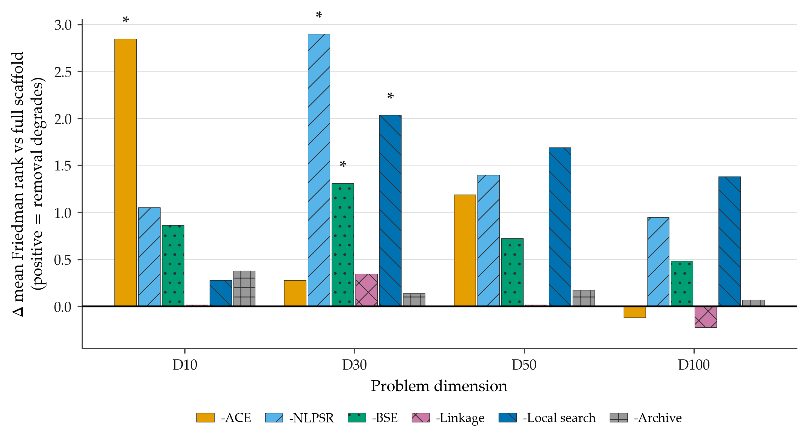
Figure B27. Conditional rank degradation from removing each scaffold component on CEC2017 (ISM off in every cell; 51 runs; 29 functions). Bars show the change in mean Friedman rank versus the full-scaffold baseline; positive means removing the component degrades rank. Colours follow the frozen per-cell palette; $*$ marks Holm-significant contrasts within a dimension ($α=0.05$). Each bar is a conditional remove-one contribution, not an independent causal effect, and bars are not averaged across dimensions.
Table A24. Scaffold remove-one ablation on CEC2017: full-vs-cell paired Wilcoxon signed-rank test across the 29 functions [6] with Holm correction [7] within each dimension’s six-comparison family ($α=0.05$), ordered by ascending raw $p$ within each dimension. $Δ$rank repeats the mean-rank change from Table A23. Every contrast is a conditional remove-one comparison with ISM off in both cells and 51 runs per cell; the four Holm-significant results are all favorable (removing the component degrades performance).
Dim | Component removed | Δrank | Wilcoxon p | Holm p | Holm sig.
D=10 | -ACE | +2.84 | 1.84e-04 | 0.0011 | yes
D=10 | -Local search | +0.28 | 0.044 | 0.219 | no
D=10 | -BSE | +0.86 | 0.071 | 0.286 | no
D=10 | -NLPSR | +1.05 | 0.226 | 0.678 | no
D=10 | -Archive | +0.38 | 0.310 | 0.678 | no
D=10 | -Linkage | +0.02 | 1.000 | 1.000 | no
D=30 | -Local search | +2.03 | 2.41e-04 | 0.0014 | yes
D=30 | -NLPSR | +2.90 | 8.77e-04 | 0.0044 | yes
D=30 | -BSE | +1.31 | 0.0085 | 0.034 | yes
D=30 | -Archive | +0.14 | 0.338 | 1.000 | no
D=30 | -Linkage | +0.34 | 0.343 | 1.000 | no
D=30 | -ACE | +0.28 | 0.648 | 1.000 | no
D=50 | -BSE | +0.72 | 0.018 | 0.109 | no
D=50 | -NLPSR | +1.40 | 0.025 | 0.123 | no
D=50 | -Local search | +1.69 | 0.025 | 0.123 | no
D=50 | -ACE | +1.19 | 0.054 | 0.163 | no
D=50 | -Archive | +0.17 | 0.237 | 0.475 | no
D=50 | -Linkage | +0.02 | 0.713 | 0.713 | no
D=100 | -BSE | +0.48 | 0.061 | 0.368 | no
D=100 | -Local search | +1.38 | 0.086 | 0.428 | no
D=100 | -NLPSR | +0.95 | 0.125 | 0.499 | no
D=100 | -Linkage | -0.22 | 0.697 | 1.000 | no
D=100 | -ACE | -0.12 | 0.829 | 1.000 | no
D=100 | -Archive | +0.07 | 0.856 | 1.000 | no

S6.3. Findings (Conditional, ISM Off)
Across the four dimensions, only four of the twenty-four (cell, dimension) contrasts survive Holm correction, and all four are favorable — removing the named component degrades performance: ACE at $D=10$ (Holm $p=1.1×{10}^{−3}$) and, at $D=30$, the local search (Holm $p=1.4×{10}^{−3}$), NLPSR (Holm $p=4.4×{10}^{−3}$), and the budget-safe escape (Holm $p=3.4×{10}^{−2}$). The per-mechanism reading is dimension-structured:
- ACE is the low-dimensional backbone: the dominant and only Holm-significant effect at $D=10$ (rank change $+2.84$), fading at mid dimension and mildly negative (non-significant) at $D=100$, where the conditional delta’s sign reverses.
- NLPSR is the mid/upper-tier population backbone: the largest and a Holm-significant degradation at $D=30$ (rank change $+2.90$) and the second-largest at $D=50$ and $D=100$, though not Holm-significant beyond $D=30$.
- Local search is the most consistent mid/upper-tier contributor: Holm-significant at $D=30$ and the single largest degradation at both $D=50$ and $D=100$ (non-significant at either), but negligible at $D=10$.
- BSE yields a positive delta at every dimension ($+0.48$ to $+1.31$), Holm-significant at $D=30$.
- Linkage and the archive are aggregate rank-neutral or sign-mixed across dimensions (removing the linkage slightly improves rank at $D=100$); their conditional contribution has no stable sign, which is why per-dimension reporting is mandatory and no dimension-averaged number is quoted.
At $D=100$ the Friedman omnibus signal is weakest ($p=3.5×{10}^{−2}$) and no contrast survives Holm; the $D=100$ ordering is descriptive only. All six disabled cells changed at least one function’s per-run trajectory at every dimension (active on 20–29 of 29 functions), so there are no null-contrast cells and every contrast is identifiable.

S6.4. What This Study Does Not Establish
The scaffold study is bounded on five axes, restated so that no reader over-extends it. (i) It is ISM-off throughout and says nothing about the interaction-structure memory. (ii) Its deltas are conditional, not causal, and not additive. (iii) It covers one suite (CEC2017) and the four tested dimensions only. (iv) The no_arch and no_bse couplings above qualify two cells, and ARGP, the final polish, and the deep-stall restart are untested here. (v) Aggregate ratios can be dominated by a few functions and are never read alone. Under the prespecified one-directional correction guard, every favorable component result here is supplement-only and does not upgrade, strengthen, or convert any frozen main-text claim (the main text defers all per-component attribution); no primary claim is contradicted, and none is amended.

S6.5. ISM-Overlay Isolation: Direct Component Study
The direct contribution of the interaction-structure memory — the isolation reviewers requested — is a separate experimental design from the scaffold matrix above, and is reported here. Four ISM-active configurations share one seed schedule (paired, common random numbers): the full overlay and three single-toggle variants that disable, in turn, the interaction-structure memory itself (no_sgsm), its adaptive confidence gate (no_adaptive), and the ISM-dependent final polish (no_finalpolish). Each cell runs $51$ paired repetitions — matching the primary panel’s run count — at the overlay’s active tiers, $D∈\{50,100\}$, on the primary CEC2017 suite (and, as a second suite, CEC2013 at $D=50$). Cells are compared on per-function mean final error by a paired Wilcoxon signed-rank test across functions, Holm-corrected over the prespecified three-comparison family, with Friedman ranks over the four cells and Vargha–Delaney $A_{12}$ effect sizes on the raw runs; the four cells differ overall (Friedman $p=2.4×{10}^{−3}$, $5.2×{10}^{−3}$, and $3.8×{10}^{−3}$ for CEC2017 $D50$, CEC2017 $D100$, and CEC2013 $D50$). These component-study omnibus $p$-values are the classical Friedman chi-square approximation (no tie-variance correction is applied in these component studies), not the Iman–Davenport $F$ that serves as the omnibus decision criterion for the primary suites in the main text. The two statistics are not interchangeable, so these figures should not be read against main-text omnibus values.
Table A25. Direct ISM-overlay isolation: the full overlay versus each single-toggle cell, paired across functions and Holm-corrected. $Δ$rank is the Friedman mean-rank change when the mechanism is removed (lower rank is better, so positive means removal hurts); $A_{12}>0.5$ favors the full overlay. Bold Holm $p<0.05$.
Suite ($D$) | Isolated mechanism | $Δ$rank vs full | Holm $p$ | mean $A_{12}$
CEC2017 ($50$) | interaction-structure memory | $+0.05$ | $0.983$ | $0.51$
 | adaptive confidence gate | $+0.47$ | $0.283$ | $0.51$
 | ISM-dependent final polish | $+1.14$ | $0.002$ | $0.59$
CEC2017 ($100$) | interaction-structure memory | $+0.16$ | $0.897$ | $0.50$
 | adaptive confidence gate | $+0.86$ | $0.079$ | $0.54$
 | ISM-dependent final polish | $+0.98$ | $0.005$ | $0.53$
CEC2013 ($50$) | interaction-structure memory | $+0.20$ | $0.647$ | $0.42$
 | adaptive confidence gate | $+0.48$ | $0.235$ | $0.52$
 | ISM-dependent final polish | $+1.18$ | $0.002$ | $0.64$
Two findings are consistent across both tiers of the primary suite and the second suite (Table A25). First, the interaction-structure memory shows no significant standalone benefit at its active tiers: disabling it moves the mean rank negligibly (CEC2017 $Δ$rank $=+0.05$ at $D50$ and $+0.16$ at $D100$), the paired test is far from significance (Holm $p=0.98$ and $0.90$), and the effect size is essentially null ($A_{12}=0.51$ and $0.50$); on CEC2013 the rank delta is similarly negligible ($+0.20$) while the raw-run effect size leans slightly toward the memory being off ($A_{12}=0.42$). Measured on the corrected compiled backend (Section S6.7), the memory’s wall-time cost is substantial at every active tier: $+57.3\%$ at CEC2017 $D50$, $+36.3\%$ at $D100$, and $+30.3\%$ on CEC2013 $D50$ — so it costs a third to well over half again in wall-clock and buys no measurable accuracy return. Second, removing the complete final-polish phase changed performance significantly in these cells (Holm $p=0.002$, $0.005$, $0.002$; $A_{12}=0.59$, $0.53$, $0.64$); the contrast removes the whole phase, so which of its parts carries the effect—and in particular whether the learned eigenbasis outperforms coordinate axes—remains unidentified, while the adaptive confidence gate helps directionally but not significantly. This corroborates the bundled-tier reading of the main text: the upper-tier behavior is a property of the full tier configuration rather than of the interaction-structure memory in isolation, and DT-GSK’s family-best standing rests on the complete dimension-tiered system — of whose added mechanisms only the final polish carries an isolated, statistically significant effect at these tiers (and the no_sgsm row, in which the polish runs on coordinate axes rather than the learned eigenbasis, is itself null, so the significant effect is the compass endgame, not the learned basis specifically). The interaction-structure memory’s isolated utility at $D≤100$ therefore remains unestablished; whether its structure-building role becomes decisive at larger scales is left to future work.

S6.6. Conditional-Benefit Analysis by Function Class (Post-Hoc)
The direct isolation above (Table A25) returns a null for the interaction-structure memory aggregated over the CEC2017 functions. Because a coordinate-pair interaction memory should, if it helps at all, help most on functions with genuine variable interaction, we ask post hoc (this analysis was not pre-registered) whether the aggregate null conceals a conditional benefit on those functions. We partition the 29 scored CEC2017 functions into the four standard CEC2017 classes [1] — unimodal (F1, F3), simple multimodal (F4–F10), hybrid (F11–F20), and composition (F21–F30) — and, within each class, count the per-function win/tie/loss of the full overlay against the memory-off (no_sgsm) cell (a win is a lower per-function mean error with the interaction-structure memory on; tie at $|Δ|<{10}^{−8}$). The hybrid and composition functions, whose sub-component and rotation structure make variable interaction explicit, are where such a memory should most plausibly help.
Table A26. Post-hoc conditional-benefit analysis: per-function win/tie/loss of the full overlay versus the memory-off (no_sgsm) cell, by CEC2017 function class, at $D=50$ and $D=100$ (51 paired runs; a win is a lower per-function mean error with the interaction-structure memory on). Exploratory; not part of the pre-registered isolation.
Function class | $n$ | $D=50$ W/T/L (win-rate) | $D=100$ W/T/L (win-rate)
Unimodal (F1, F3) | 2 | 2/0/0 (1.00) | 1/0/1 (0.50)
Simple multimodal (F4–F10) | 7 | 3/0/4 (0.43) | 4/0/3 (0.57)
Hybrid (F11–F20) | 10 | 7/0/3 (0.70) | 4/0/6 (0.40)
Composition (F21–F30) | 10 | 3/0/7 (0.30) | 5/0/5 (0.50)
Interacting (F11–F30) | 20 | 10/0/10 (0.50) | 9/0/11 (0.45)
Non-interacting (F1–F10) | 9 | 5/0/4 (0.56) | 5/0/4 (0.56)
All 29 (aggregate) | 29 | 15/0/14 (0.52) | 14/0/15 (0.48)
No class shows a benefit that survives even a nominal sign test (all subset $p>0.3$; the interacting-vs-non-interacting contrast is $0.50$ vs $0.56$ at $D=50$ and $0.45$ vs $0.56$ at $D=100$ — the interacting classes never lead). The only favorable lean is on the $D=50$ hybrids (win-rate $0.70$, median per-function $\log_{10}$-error gain $+0.026$), and it reverses at $D=100$ (win-rate $0.40$, median $−0.002$); the composition functions lean the other way at $D=50$ (win-rate $0.30$) and are flat at $D=100$. Together with the aggregate Vargha–Delaney $A_{12}≈0.50$, the point estimates cluster on no average effect rather than on a small one — though, absent a formal equivalence test, this evidence is consistent with zero rather than establishing it. The aggregate null is therefore not explained by the separable-problem subset: no standalone benefit is detected even on the categories where variable interaction is present by construction. This is a failure to detect an effect under this design, not a demonstration that none exists. We accordingly report the interaction-structure memory as a controlled negative result on cheap accepted-move structure-learning — a boundary we believe is itself informative for the GSK family.

S6.7. Implementation Caveats: Two Corrected Defects and Their Evidence Trail
A post-freeze code audit identified two implementation defects in the released optimizer. Both were disclosed, then fixed in the source (each locked by a regression test that fails on the pre-fix code), and the primary-panel, scaffold, and overlay evidence in this paper was fully regenerated with the corrected binary at 51 runs per cell; every number in the current release therefore reflects the corrected implementation. The two defects and their measured consequences are recorded here for provenance.

The interaction graph’s compiled kernels were silently disabled in the pre-fix runs.
The interaction graph ships compiled (numba) kernels alongside NumPy reference implementations, guarded by an import that silently falls back to NumPy if the compiled module is unavailable. In the pre-fix configuration that import named the wrong module path, so the earlier runs executed the NumPy path throughout. The compiled kernels are built without fast-math and without thread-parallel reduction precisely so that they reproduce the NumPy arithmetic exactly, and we confirmed bit-identical optimization results across both backends — the defect inflated wall-clock only. The overhead and runtime figures in this paper (Section S6.5 and the main-text runtime table) were re-measured with the compiled kernels active over the full 51-run overlay: the memory’s wall-time cost is $+57.3\%$ at CEC2017 $D50$, $+36.3\%$ at $D100$, and $+30.3\%$ on CEC2013 $D50$. These are close to the $+54\%$/$+37\%$ recorded before the backend fix, which is expected rather than surprising: the compiled kernels accelerated the memory-on and memory-off arms alike, so the ratio between them barely moved. The fix removed a wall-clock inflation common to both arms; it did not make the interaction-structure memory cheaper relative to running without it.

The final polish previously refined a one-generation-stale incumbent.
In the pre-fix binary, the eigenframe polish was invoked with the incumbent materialized at the end of the previous generation, and its accept test compared against that same stale value — so the polish could start from, and accept against, a point the current generation had already improved upon. Reported results were protected throughout by a best-ever shadow (no run could report a value worse than the best it found), so this was a loss of polish effectiveness, never a correctness defect. The fix re-materializes the incumbent atomically at polish entry. The isolation reported above therefore measures the polish un-handicapped; its contribution remains Holm-significant on every suite and tier, and the headline panel ranks are unchanged relative to the pre-fix release — the correction altered $D≥50$ trajectories without flipping any per-function panel ordering.

S7. CEC2013LSGO Large-Scale Suite

S7.1. Protocol, Evidential Tiers, and Scope
CEC2013LSGO is the large-scale suite of this study, reported as a family-internal comparison at the suite’s native scale: 15 functions at $D=1000$, with the two overlapping functions F13 and F14 at their native $D=905$; 25 runs per function; a budget of $3×{10}^{6}$ function evaluations per run; and the same seven-algorithm family panel and unified seed schedule (base seed 20240620) used throughout this paper [5]. Statistics on this suite use the raw best objective value (CEC2011-style; the suite’s error column is not populated), so magnitudes are not comparable across functions and no error floor is applied. One benchmark-implementation disclosure governs every F3, F6 and F10 value: those functions ran the transformed Ackley variant, so results on them are not comparable to published values obtained on the raw variant, and no such comparison is drawn anywhere in this paper. Every number in this section derives from the separate, non-superseding evidence release lsgo-rel-2026-07-28-ff1a046ef and its committed analysis bundle; the primary evidence release rel-2026-07-20-67d9345f9 is untouched by this suite.
Two evidential tiers apply, fixed by the pre-registered analysis-plan addendum (statistical_analysis_plan_addendum_cec2020_lsgo.md, signing commit 5c9bfae82) and binding on every sentence of this section. Before the addendum was signed, the family-only Friedman mean ranks, the omnibus, the Nemenyi view and the per-function win/loss descriptives of this suite had been informally inspected; the addendum’s Section 6 declares that exposure verbatim. Those quantities are therefore reported here as descriptive-after-inspection: they carry no confirmatory weight and enter no headline. The run-level paired Wilcoxon layer and the effect-size layer had never been computed when the addendum was signed; they were registered there, before computation, as the confirmatory LSGO layer, and their first computations are recorded in the addendum’s dated Amendments 1 and 2.
The CEC2013LSGO analysis in this paper is family-internal: it ranks the seven GSK-family variants against one another under a common protocol. Dedicated large-scale optimizers — for example SHADE-ILS [17] and MOS [18] — report substantially stronger published results on this suite than any GSK-family member, and no competitiveness with such specialists is claimed here; cross-paradigm comparison is outside this paper’s scope.

S7.2. Configuration Provenance on This Suite
DT-GSK runs the same hash-frozen configuration here as on the bound-constrained suites, with one disclosed exception that exists for no other suite: the shipped dimension-tier table does not extend to the suite’s native $D=905$ and $D=1000$, so two linkage-block-size entries ($905→50$ and $1000→50$) were added for this suite alone, while all six comparators ran with empty optimizer options. The value 50 follows a structural rule recorded in the configuration file at the time the entries were introduced: it matches the benchmark’s own declared group structure — the suite builds its partially separable functions from groups of 25, 50 and 100 variables, with F8–F11 using twenty groups of 50 and F13/F14 using 50-dimensional overlapping groups — rather than any observed result, and no parameter search was run. The timing is disclosed rather than glossed: the two entries were added on 2026-07-24, while DT-GSK CEC2013LSGO results had existed in the repository since 2026-07-21, so outcome-blindness is not asserted for them. What is asserted is the stated structural rule, its contemporaneous record in the configuration file, and the absence of any parameter search; the registered run-level layer below, which found no suite-level separation in DT-GSK’s favor against any comparator, is not inflated by this choice.

S7.3. Family Friedman and Nemenyi View (Descriptive After Inspection)
The registered standing statement for this suite is quoted from the addendum’s pre-committed wording bank: DT-GSK and AGSK share the best descriptive family mean rank (both 3.1333, tied-first); no member except eGSK (worse) is separable by the omnibus procedure; and DT-GSK is last on F7 and F15. Table A27 gives the full view. The tie-corrected Friedman omnibus over the 15 function blocks gives $χ^{2}=15.314$ (df 6, tie correction $C=1.0$, no tied blocks), Iman–Davenport $F(6,84)=2.8707$, $p=0.0136$; the Nemenyi critical distance at $α=0.05$ is $2.326$ ($k=7$, $N=15$), which separates only eGSK from the two tied-first members. Under the registered tier this entire subsection is descriptive-after-inspection: it carries no confirmatory weight, and the mandatory median-basis re-rank of the registered robustness family reproduces every ordinal, the registered relative-tie-band variant leaves every win/tie/loss split unchanged on the raw basis, while the leave-one-function-out variant — registered as exploratory because the F7/F15 deletions are inspection-informed — moves some ordinals and is recorded in full in the released robustness digest.
Table A27. CEC2013LSGO family-only tie-corrected Friedman mean ranks over the 15 function blocks (native $D=1000$; F13/F14 at $D=905$; 25 runs; raw best-objective basis) with the Nemenyi critical distance $CD=2.326$ ($k=7$, $N=15$, $α=0.05$). Lower rank is better; DT-GSK and AGSK are exactly tied-first. Evidential tier: descriptive-after-inspection (addendum Section 6) — these ranks were informally inspected before the analysis plan was signed, carry no confirmatory weight, and enter no confirmatory headline.
Algorithm | Mean rank | Ordinal
GSK | 3.8667 | 4
AGSK | 3.1333 | 1 (tied-first)
APGSK | 4.9333 | 6
FDB-AGSK | 3.9333 | 5
ATMALS-GSK | 3.5333 | 3
eGSK | 5.4667 | 7
DT-GSK | 3.1333 | 1 (tied-first)

S7.4. Across-Function Wilcoxon (Supporting, With Disclosure)
Table A28 reports the across-function Wilcoxon signed-rank layer: DT-GSK against each comparator on the 15 paired per-function means of the raw best objective, decided by exact sign-flip enumeration over all $2^{15}$ patterns, with the normal-approximation $p$ recorded alongside for continuity with the frozen suites and Holm correction over the $m=6$ comparators. No comparator separates from DT-GSK at $α=0.05$ after Holm — the smallest Holm-adjusted $p$ is 0.2875 (APGSK and eGSK) — so this layer demonstrates no separation in either direction; in particular, paired tests do not separate DT-GSK from AGSK (exact $p=0.8469$, Holm-adjusted $1.0$). Per the addendum’s pre-committed power disclosure, these $N=15$ across-function families are low-powered by construction (Nemenyi critical distance $2.326$ against $1.673$ at the $N=29$ CEC2017 families), so non-significance on this suite is read as no separation demonstrated, never as equivalence.
Table A28. Across-function Wilcoxon signed-rank layer on CEC2013LSGO, DT-GSK vs. each family comparator ($n=15$ paired per-function means of the raw best objective over 25 runs; zero differences $|Δ|<{10}^{−8}$ discarded before ranking — none occurred, $n_{eff}=15$ throughout). The decision $p$ is the exact two-sided sign-flip enumeration over all $2^{15}$ signed-rank patterns; the normal-approximation $p$ is recorded for continuity with the frozen suites; Holm step-down is applied over the six comparators. W–L is the per-function mean win–loss split for DT-GSK. No comparison is Holm-significant: this layer demonstrates no separation in either direction. Evidential tier: supporting-with-disclosure (addendum Section 4).
Comparator | W–L | $p$ (exact) | $p$ (normal) | $p$ (Holm) | Decision
GSK | 8–7 | 0.7615 | 0.7548 | 1.0000 | no separation
AGSK | 9–6 | 0.8469 | 0.8424 | 1.0000 | no separation
APGSK | 11–4 | 0.0554 | 0.0571 | 0.2875 | no separation
FDB-AGSK | 11–4 | 0.0833 | 0.0832 | 0.3330 | no separation
ATMALS-GSK | 8–7 | 0.1688 | 0.1641 | 0.5065 | no separation
eGSK | 11–4 | 0.0479 | 0.0501 | 0.2875 | no separation

S7.5. Run-Level Paired Wilcoxon (Registered Confirmatory Layer)
Table A29 reports the registered confirmatory layer: per-function run-level Wilcoxon over the 25 seed-paired runs (pairing key = run id; seed identity across all seven algorithms verified with zero mismatches), exact two-sided $p$, Holm-corrected across the 15 functions per comparator ($m=15$); as registered, no additional correction is applied across the six comparators, so the six columns are not jointly error-controlled and are never summed into one claim. Two cross-comparator regularities are stated in both directions: DT-GSK is Holm-significantly better than every family member on F4 and F8, and Holm-significantly worse than every family member on F7 and F15. Per comparator, the Holm-significant win/loss/no-separation counts are 8/6/1 vs. GSK; 9/6/0 vs. AGSK; 11/3/1 vs. APGSK; 11/4/0 vs. FDB-AGSK; 7/6/2 vs. ATMALS-GSK; 11/4/0 vs. eGSK. The binding suite-level wording, fixed by the addendum’s Section 9 before this layer was ever computed, applies verbatim: tied-first descriptive rank; paired tests do not separate DT-GSK from AGSK.
Table A29. Registered confirmatory layer on CEC2013LSGO: per-function run-level Wilcoxon over the 25 seed-paired runs, DT-GSK vs. each family comparator, exact two-sided $p$ Holm-corrected across the 15 functions per comparator ($m=15$; no correction across comparators, as registered). Cell entries are the Holm-significant outcome for DT-GSK (W = win, L = loss, n.s. = no separation demonstrated) with the Holm-adjusted $p$. Zero differences $|Δ|<{10}^{−8}$ are discarded ($n_{eff}=25$ in every cell). DT-GSK wins F4 and F8 against every comparator and loses F7 and F15 against every comparator. Evidential tier: confirmatory-with-disclosure (addendum Sections 3–4; never computed before registration).
Func. | GSK | AGSK | APGSK | FDB-AGSK | ATMALS-GSK | eGSK
F1 | L 0.0202 | L 3.02E-05 | W 8.94E-07 | W 8.94E-07 | L 8.94E-07 | W 8.94E-07
F2 | W 8.94E-07 | W 8.94E-07 | W 8.94E-07 | L 3.61E-04 | L 8.94E-07 | W 8.94E-07
F3 | W 8.94E-07 | W 8.94E-07 | W 8.94E-07 | W 4.17E-06 | L 8.94E-07 | W 0.0160
F4 | W 8.94E-07 | W 8.94E-07 | W 8.94E-07 | W 8.94E-07 | W 8.94E-07 | W 8.94E-07
F5 | L 8.94E-07 | W 8.94E-07 | W 8.94E-07 | W 8.94E-07 | W 3.27E-05 | L 1.07E-04
F6 | W 2.38E-06 | W 2.09E-06 | W 8.94E-07 | W 1.79E-06 | n.s. 0.1334 | W 1.62E-04
F7 | L 8.94E-07 | L 8.94E-07 | L 8.94E-07 | L 8.94E-07 | L 8.94E-07 | L 8.94E-07
F8 | W 8.94E-07 | W 8.94E-07 | W 8.94E-07 | W 8.94E-07 | W 8.94E-07 | W 8.94E-07
F9 | L 8.94E-07 | W 8.94E-07 | W 8.94E-07 | W 8.94E-07 | W 2.98E-06 | L 0.0029
F10 | W 8.94E-07 | W 0.0036 | n.s. 0.5424 | W 0.0056 | W 9.58E-05 | W 8.94E-07
F11 | n.s. 0.9158 | L 1.67E-05 | W 8.94E-07 | W 0.0056 | W 8.94E-07 | W 8.94E-07
F12 | W 8.94E-07 | W 8.94E-07 | W 8.94E-07 | W 8.94E-07 | L 8.94E-07 | W 8.94E-07
F13 | L 0.0473 | L 8.94E-07 | L 0.0023 | L 8.94E-07 | n.s. 0.8325 | W 8.94E-07
F14 | W 8.94E-07 | L 0.0038 | W 8.94E-07 | W 8.94E-07 | W 8.94E-07 | W 8.94E-07
F15 | L 8.94E-07 | L 8.94E-07 | L 9.83E-06 | L 1.67E-05 | L 8.94E-07 | L 8.94E-07

S7.6. Effect Sizes
Table A30 reports the registered effect-size layer: run-level $A_{12}$ and Cliff’s $δ$ over the 25 seed-paired runs per cell, with BCa 95% confidence intervals ($B=10,000$) on the paired mean differences released in the analysis bundle. All 90 cells are non-degenerate ($n_{eff}=25$ everywhere). Effects are bimodal rather than graded: 86 of 90 cells are large, and 52 are saturated at $A_{12}$ exactly $0$ or $1$ (complete sample separation); 85 of the 90 BCa intervals exclude zero. F4 and F8 are complete separations in DT-GSK’s favor against all six comparators; F7 and F15 are near-complete separations against it. Mean $A_{12}$ by comparator is 0.5885 vs. GSK, 0.6097 vs. AGSK, 0.7830 vs. APGSK, 0.7060 vs. FDB-AGSK, 0.4988 vs. ATMALS-GSK, 0.7261 vs. eGSK. Against ATMALS-GSK the mean effect favors the comparator (mean Cliff’s $δ=−0.0025$): no superiority over ATMALS-GSK on this suite is supportable from the effect layer. One divergence of estimand, not of direction, is disclosed rather than suppressed: on F1 vs. GSK, $A_{12}=0.1456$ (large, favoring GSK) while the BCa interval on the paired mean difference straddles zero (mean difference $2.40×{10}^{6}$, interval $[−1.80×{10}^{6},4.23×{10}^{6}]$), because F1’s raw distribution is heavy-tailed; both are reported.
Table A30. Run-level effect sizes on CEC2013LSGO: $A_{12}$/Cliff’s $δ$ for DT-GSK against each family comparator on each function (25 seed-paired runs; tie band $|Δ|<{10}^{−8}$ counted half; $A_{12}>0.5$ and $δ>0$ favor DT-GSK). BCa 95% intervals ($B=10,000$) on the paired mean differences accompany every cell in the released bundle; no cell is degenerate. Saturated cells ($A_{12}$ exactly $0.00$ or $1.00$) are complete sample separations.
Func. | GSK | AGSK | APGSK | FDB-AGSK | ATMALS-GSK | eGSK
F1 | 0.15/-0.71 | 0.12/-0.75 | 1.00/1.00 | 1.00/1.00 | 0.00/-1.00 | 1.00/1.00
F2 | 1.00/1.00 | 1.00/1.00 | 1.00/1.00 | 0.13/-0.73 | 0.00/-1.00 | 1.00/1.00
F3 | 1.00/1.00 | 1.00/1.00 | 1.00/1.00 | 0.90/0.80 | 0.00/-1.00 | 0.72/0.44
F4 | 1.00/1.00 | 1.00/1.00 | 1.00/1.00 | 1.00/1.00 | 1.00/1.00 | 1.00/1.00
F5 | 0.00/-1.00 | 1.00/1.00 | 1.00/1.00 | 1.00/1.00 | 0.89/0.79 | 0.11/-0.78
F6 | 0.96/0.92 | 0.95/0.90 | 0.95/0.90 | 0.98/0.96 | 0.34/-0.31 | 0.84/0.68
F7 | 0.00/-1.00 | 0.00/-1.00 | 0.00/-1.00 | 0.00/-1.00 | 0.00/-1.00 | 0.03/-0.94
F8 | 1.00/1.00 | 1.00/1.00 | 1.00/1.00 | 1.00/1.00 | 1.00/1.00 | 1.00/1.00
F9 | 0.00/-0.99 | 1.00/1.00 | 1.00/1.00 | 1.00/1.00 | 0.90/0.79 | 0.21/-0.57
F10 | 0.98/0.97 | 0.78/0.56 | 0.41/-0.17 | 0.81/0.62 | 0.86/0.71 | 0.97/0.95
F11 | 0.45/-0.10 | 0.06/-0.88 | 1.00/1.00 | 0.72/0.45 | 1.00/0.99 | 1.00/1.00
F12 | 1.00/1.00 | 1.00/1.00 | 1.00/1.00 | 1.00/1.00 | 0.00/-1.00 | 1.00/1.00
F13 | 0.28/-0.43 | 0.00/-1.00 | 0.25/-0.50 | 0.01/-0.98 | 0.49/-0.01 | 1.00/1.00
F14 | 1.00/1.00 | 0.23/-0.55 | 1.00/1.00 | 0.93/0.86 | 1.00/1.00 | 1.00/1.00
F15 | 0.00/-1.00 | 0.00/-1.00 | 0.13/-0.74 | 0.11/-0.78 | 0.00/-1.00 | 0.01/-0.99

S7.7. Per-Function Detail
Tables A31 and A32 report the five-statistic per-function record (best / median / mean / worst / SD of the raw best objective over the 25 runs) for all seven family algorithms on all 15 functions. As everywhere on this suite, the basis is the raw best objective; the F3, F6 and F10 rows are transformed-Ackley values, not comparable to published raw-Ackley numbers.
Table A31. CEC2013LSGO per-function detail (F1–F8): best / median / mean / worst / SD of the raw best objective over 25 runs for all 7 GSK-family algorithms at the native dimension ($D=1000$; F13/F14 at $D=905$); best mean per function in bold (ties all bold). F3, F6 and F10 ran the transformed Ackley variant and are not comparable to published raw-Ackley values.
Func. | Stat. | GSK | AGSK | APGSK | FDB-AGSK | ATMALS-GSK | eGSK | DT-GSK
F1 | Best | 6.70E+05 | 5.40E+05 | 1.52E+07 | 1.06E+07 | 1.01E+04 | 2.00E+07 | 4.39E+06
 | Median | 1.74E+06 | 2.25E+06 | 5.33E+07 | 3.62E+07 | 2.14E+04 | 9.23E+07 | 6.26E+06
 | Mean | 4.24E+06 | 3.00E+06 | 9.61E+07 | 5.96E+07 | 2.16E+04 | 3.26E+08 | 6.64E+06
 | Worst | 3.46E+07 | 7.58E+06 | 3.90E+08 | 3.14E+08 | 4.30E+04 | 1.40E+09 | 9.76E+06
 | SD | 7.22E+06 | 2.23E+06 | 1.01E+08 | 6.88E+07 | 8.18E+03 | 4.12E+08 | 1.63E+06
F2 | Best | 2.01E+04 | 1.25E+04 | 1.48E+04 | 6.46E+03 | 3.48E+02 | 2.45E+04 | 9.08E+03
 | Median | 2.15E+04 | 1.31E+04 | 1.59E+04 | 7.95E+03 | 4.08E+02 | 2.87E+04 | 9.79E+03
 | Mean | 2.16E+04 | 1.32E+04 | 1.59E+04 | 8.34E+03 | 4.11E+02 | 2.84E+04 | 9.70E+03
 | Worst | 2.31E+04 | 1.38E+04 | 1.68E+04 | 1.32E+04 | 4.61E+02 | 3.08E+04 | 1.01E+04
 | SD | 7.30E+02 | 3.39E+02 | 5.08E+02 | 1.38E+03 | 3.09E+01 | 1.80E+03 | 3.11E+02
F3 | Best | 2.16E+01 | 2.13E+01 | 2.13E+01 | 2.04E+01 | 2.00E+01 | 2.03E+01 | 2.05E+01
 | Median | 2.16E+01 | 2.13E+01 | 2.13E+01 | 2.11E+01 | 2.00E+01 | 2.06E+01 | 2.05E+01
 | Mean | 2.16E+01 | 2.13E+01 | 2.13E+01 | 2.10E+01 | 2.00E+01 | 2.06E+01 | 2.05E+01
 | Worst | 2.16E+01 | 2.14E+01 | 2.13E+01 | 2.13E+01 | 2.00E+01 | 2.08E+01 | 2.06E+01
 | SD | 8.06E-03 | 7.82E-03 | 6.12E-03 | 2.81E-01 | 8.36E-04 | 1.10E-01 | 2.29E-02
F4 | Best | 1.30E+10 | 3.44E+09 | 1.01E+10 | 7.48E+09 | 1.42E+10 | 5.28E+10 | 1.05E+09
 | Median | 2.88E+10 | 5.94E+09 | 1.66E+10 | 1.17E+10 | 3.68E+10 | 8.28E+10 | 1.36E+09
 | Mean | 3.34E+10 | 6.50E+09 | 1.71E+10 | 1.32E+10 | 3.98E+10 | 9.40E+10 | 1.41E+09
 | Worst | 7.77E+10 | 1.16E+10 | 3.39E+10 | 2.11E+10 | 8.69E+10 | 1.90E+11 | 1.91E+09
 | SD | 1.51E+10 | 2.14E+09 | 4.83E+09 | 4.18E+09 | 1.79E+10 | 3.92E+10 | 2.37E+08
F5 | Best | 1.32E+06 | 5.81E+06 | 9.89E+06 | 3.34E+06 | 2.53E+06 | 1.47E+06 | 2.29E+06
 | Median | 1.82E+06 | 6.79E+06 | 1.07E+07 | 6.75E+06 | 3.62E+06 | 2.23E+06 | 2.72E+06
 | Mean | 1.82E+06 | 6.83E+06 | 1.07E+07 | 6.54E+06 | 3.61E+06 | 2.14E+06 | 2.71E+06
 | Worst | 2.24E+06 | 7.82E+06 | 1.19E+07 | 8.57E+06 | 5.29E+06 | 3.03E+06 | 3.31E+06
 | SD | 2.66E+05 | 5.38E+05 | 5.47E+05 | 1.04E+06 | 6.93E+05 | 4.13E+05 | 2.62E+05
F6 | Best | 1.06E+06 | 1.06E+06 | 1.06E+06 | 1.06E+06 | 1.05E+06 | 1.05E+06 | 1.04E+06
 | Median | 1.06E+06 | 1.06E+06 | 1.06E+06 | 1.06E+06 | 1.05E+06 | 1.06E+06 | 1.06E+06
 | Mean | 1.06E+06 | 1.06E+06 | 1.06E+06 | 1.06E+06 | 1.05E+06 | 1.06E+06 | 1.05E+06
 | Worst | 1.06E+06 | 1.06E+06 | 1.06E+06 | 1.06E+06 | 1.06E+06 | 1.06E+06 | 1.06E+06
 | SD | 1.35E+03 | 1.12E+03 | 1.34E+03 | 1.14E+03 | 3.11E+03 | 1.93E+03 | 3.91E+03
F7 | Best | 9.42E+06 | 6.70E+06 | 3.07E+07 | 1.48E+07 | 2.44E+07 | 2.33E+07 | 1.11E+08
 | Median | 2.81E+07 | 1.30E+07 | 4.09E+07 | 2.59E+07 | 4.88E+07 | 4.33E+07 | 1.67E+08
 | Mean | 3.05E+07 | 1.47E+07 | 4.20E+07 | 2.85E+07 | 5.00E+07 | 5.21E+07 | 1.76E+08
 | Worst | 9.86E+07 | 2.77E+07 | 5.87E+07 | 5.01E+07 | 8.74E+07 | 1.86E+08 | 3.29E+08
 | SD | 1.85E+07 | 5.58E+06 | 8.22E+06 | 1.05E+07 | 1.68E+07 | 3.45E+07 | 4.41E+07
F8 | Best | 2.71E+11 | 8.47E+12 | 1.55E+13 | 1.11E+13 | 1.99E+13 | 2.29E+13 | 2.37E+10
 | Median | 6.98E+12 | 2.89E+13 | 5.33E+13 | 3.79E+13 | 4.01E+13 | 8.41E+13 | 3.43E+10
 | Mean | 9.69E+12 | 3.57E+13 | 6.04E+13 | 4.70E+13 | 5.41E+13 | 9.66E+13 | 3.42E+10
 | Worst | 3.35E+13 | 9.53E+13 | 1.23E+14 | 1.34E+14 | 2.46E+14 | 3.30E+14 | 4.51E+10
 | SD | 8.90E+12 | 2.24E+13 | 3.12E+13 | 2.90E+13 | 4.61E+13 | 6.28E+13 | 5.51E+09
Table A32. CEC2013LSGO per-function detail (F9–F15): best / median / mean / worst / SD of the raw best objective over 25 runs for all 7 GSK-family algorithms at the native dimension ($D=1000$; F13/F14 at $D=905$); best mean per function in bold (ties all bold). F3, F6 and F10 ran the transformed Ackley variant and are not comparable to published raw-Ackley values.
Func. | Stat. | GSK | AGSK | APGSK | FDB-AGSK | ATMALS-GSK | eGSK | DT-GSK
F9 | Best | 1.56E+08 | 4.91E+08 | 6.80E+08 | 3.85E+08 | 2.35E+08 | 1.37E+08 | 2.36E+08
 | Median | 1.91E+08 | 5.71E+08 | 7.84E+08 | 5.06E+08 | 3.45E+08 | 2.34E+08 | 2.69E+08
 | Mean | 1.98E+08 | 5.76E+08 | 7.92E+08 | 5.27E+08 | 3.48E+08 | 2.37E+08 | 2.68E+08
 | Worst | 2.53E+08 | 7.11E+08 | 9.18E+08 | 6.68E+08 | 5.02E+08 | 3.24E+08 | 3.05E+08
 | SD | 2.28E+07 | 4.87E+07 | 6.19E+07 | 8.32E+07 | 6.68E+07 | 3.93E+07 | 1.68E+07
F10 | Best | 9.34E+07 | 9.27E+07 | 9.21E+07 | 9.15E+07 | 9.29E+07 | 9.32E+07 | 9.16E+07
 | Median | 9.40E+07 | 9.34E+07 | 9.28E+07 | 9.34E+07 | 9.36E+07 | 9.39E+07 | 9.31E+07
 | Mean | 9.40E+07 | 9.34E+07 | 9.28E+07 | 9.34E+07 | 9.35E+07 | 9.39E+07 | 9.29E+07
 | Worst | 9.44E+07 | 9.41E+07 | 9.34E+07 | 9.39E+07 | 9.40E+07 | 9.42E+07 | 9.37E+07
 | SD | 2.84E+05 | 3.42E+05 | 3.08E+05 | 5.07E+05 | 3.09E+05 | 2.62E+05 | 5.36E+05
F11 | Best | 2.72E+08 | 1.86E+08 | 8.13E+08 | 3.00E+08 | 6.14E+08 | 2.46E+10 | 3.14E+08
 | Median | 4.25E+08 | 2.63E+08 | 1.82E+09 | 6.10E+08 | 3.80E+09 | 6.27E+10 | 4.36E+08
 | Mean | 4.51E+08 | 2.73E+08 | 3.30E+09 | 6.01E+08 | 1.06E+10 | 7.29E+10 | 4.51E+08
 | Worst | 7.67E+08 | 5.44E+08 | 1.97E+10 | 1.19E+09 | 3.95E+10 | 1.52E+11 | 6.93E+08
 | SD | 1.47E+08 | 8.12E+07 | 3.86E+09 | 2.15E+08 | 1.23E+10 | 3.64E+10 | 8.96E+07
F12 | Best | 2.90E+08 | 1.68E+07 | 2.61E+09 | 3.78E+08 | 5.21E+03 | 6.04E+09 | 2.22E+05
 | Median | 1.70E+09 | 8.10E+07 | 7.22E+09 | 9.35E+08 | 6.35E+03 | 1.06E+10 | 3.30E+05
 | Mean | 2.22E+09 | 1.16E+08 | 7.16E+09 | 1.11E+09 | 7.32E+03 | 1.24E+10 | 3.34E+05
 | Worst | 7.98E+09 | 3.91E+08 | 1.28E+10 | 4.42E+09 | 1.43E+04 | 2.36E+10 | 5.05E+05
 | SD | 1.92E+09 | 1.12E+08 | 2.71E+09 | 7.64E+08 | 2.45E+03 | 5.12E+09 | 7.26E+04
F13 | Best | 1.32E+09 | 1.75E+08 | 1.39E+09 | 4.24E+08 | 1.35E+09 | 4.26E+09 | 1.68E+09
 | Median | 1.99E+09 | 3.72E+08 | 1.97E+09 | 9.24E+08 | 2.52E+09 | 5.44E+09 | 2.46E+09
 | Mean | 2.06E+09 | 3.80E+08 | 2.02E+09 | 9.90E+08 | 2.70E+09 | 5.59E+09 | 2.49E+09
 | Worst | 3.37E+09 | 8.80E+08 | 3.13E+09 | 1.88E+09 | 5.53E+09 | 7.64E+09 | 4.26E+09
 | SD | 6.04E+08 | 1.74E+08 | 4.16E+08 | 3.95E+08 | 1.13E+09 | 9.08E+08 | 5.89E+08
F14 | Best | 2.30E+09 | 1.07E+08 | 1.00E+10 | 7.72E+08 | 2.83E+10 | 4.61E+10 | 2.46E+08
 | Median | 9.40E+09 | 3.13E+08 | 2.14E+10 | 1.74E+09 | 5.93E+10 | 9.58E+10 | 5.19E+08
 | Mean | 1.03E+10 | 3.48E+08 | 2.33E+10 | 1.99E+09 | 6.03E+10 | 1.00E+11 | 6.84E+08
 | Worst | 2.97E+10 | 7.97E+08 | 4.35E+10 | 5.92E+09 | 1.78E+11 | 1.41E+11 | 1.62E+09
 | SD | 7.03E+09 | 1.77E+08 | 8.34E+09 | 1.11E+09 | 3.08E+10 | 2.61E+10 | 4.26E+08
F15 | Best | 3.54E+06 | 4.28E+06 | 6.87E+06 | 9.79E+06 | 1.75E+06 | 5.28E+06 | 8.19E+06
 | Median | 4.19E+06 | 5.60E+06 | 1.16E+07 | 1.23E+07 | 2.15E+06 | 6.69E+06 | 1.87E+07
 | Mean | 4.62E+06 | 5.82E+06 | 1.22E+07 | 1.28E+07 | 2.24E+06 | 6.91E+06 | 1.85E+07
 | Worst | 9.26E+06 | 8.04E+06 | 2.12E+07 | 2.17E+07 | 3.26E+06 | 9.00E+06 | 2.51E+07
 | SD | 1.17E+06 | 9.46E+05 | 3.46E+06 | 2.34E+06 | 3.76E+05 | 9.91E+05 | 3.79E+06

S8. CEC2020 Bound-Constrained Suite
CEC2020 is reported as a pre-registered confirmatory suite: the statistical analysis plan for it was committed, with its SHA-256 recorded in the decision log, before a single result existed. The protocol is the competition’s own [4]: 10 functions at $D∈\{5,10,15,20\}$, with F6 and F7 undefined at $D=5$, giving 38 scored (function, dimension) cells; 30 runs per cell; and a dimension-dependent budget of $MaxFES=5×{10}^{4}$, ${10}^{6}$, $3×{10}^{6}$ and ${10}^{7}$ at $D=5,10,15,20$ respectively. Statistics are errors against the known optimum, floored to zero below ${10}^{−8}$, on the same seven-algorithm family panel and the same unified seed schedule (base seed 20240620) used throughout this paper, so runs are paired across algorithms within each (dimension, function, run). The registration is commit-level and auditable in the repository: the addendum’s signing commit precedes every CEC2020 datum, and its two dated, append-only amendments record the first computation of every registered family together with the outcome wording selected below. Every number in this section derives from the separate, non-superseding evidence release cec2020-rel-2026-07-29-5867abe1e and its committed analysis bundle; the primary evidence release rel-2026-07-20-67d9345f9 is untouched by this suite.

Declared adjacency.
AGSK was the runner-up of the CEC2020 competition [13], and the CEC2020 AGSK paper is a co-author’s work. This suite is therefore a comparator’s home regime, and is reported as such. Every dimension-gated DT-GSK subsystem is inactive at $D≤20$, so DT-GSK runs its adaptive scaffold tier only on this suite; a non-leading result here is a predicted boundary condition of the dimension-tiering thesis stated in the main text, and is reported as a finding rather than discounted.

Interim-inspection ledger.
Every inspection of CEC2020 data during the campaign is disclosed, with its exact scope, in the project decision log (entry D-0024) rather than left discoverable: a first comparator-only view of the four banks complete at the time, then four dated extensions as further banks finished. DT-GSK’s partial data was deliberately not inspected while the campaign ran, until the author surfaced the completed $D=5$ block and directed a comparison (the entry’s third extension, the first view touching the proposed method’s data). The registered analyses, tie rules and the Section 9 outcome sentences had been committed before any datum existed and could not be altered by any inspection, and the remaining campaign was mechanically determined (unified seeds, locked configuration, overwrite disabled), so no inspection could influence the data still being produced.

S8.1. Descriptive Standing
On AGSK’s strongest suite — the CEC2020 competition in which it was the runner-up [13] — DT-GSK places fourth; the family panel corroborates AGSK’s published strength in this regime, consistent with the tiering thesis: every dimension-gated DT-GSK subsystem is inactive at $D≤20$.
The descriptive aggregate behind that sentence is Table A33: AGSK attains the best unweighted mean of the four per-dimension mean ranks (2.0875) and DT-GSK places fourth of seven (4.1125). Two binding wording constraints follow from the inferential layers below and are honored throughout this paper: DT-GSK is Holm-separated in only five of the twenty-four across-function pairwise cells (three in its favor — ATMALS-GSK and eGSK at $D=15$, eGSK at $D=20$; two against — AGSK and FDB-AGSK at $D=20$), and no CEC2020 sentence claims superiority over AGSK or FDB-AGSK at any dimension.
Table A33. CEC2020 tie-corrected Friedman mean ranks per dimension and the descriptive across-dimension aggregate (unweighted mean of the four per-dimension mean ranks; lower is better; ordinal in parentheses). Descriptive only; no test is attached. The four per-dimension rank vectors are not on a common protocol: $D=5$ uses a reduced task set of 8 of the 10 functions (F6 and F7 are undefined at $D=5$), and MaxFES changes by dimension ($5×{10}^{4}$ / ${10}^{6}$ / $3×{10}^{6}$ / ${10}^{7}$ at $D=5/10/15/20$), so the aggregate mixes budget regimes.
Algorithm | $D=5$ | $D=10$ | $D=15$ | $D=20$ | Overall (ordinal)
GSK | 5.6250 | 6.2000 | 5.5000 | 4.5000 | 5.4562 (6)
AGSK | 2.7500 | 1.9000 | 2.1000 | 1.6000 | 2.0875 (1)
APGSK | 2.3750 | 3.0000 | 3.5000 | 3.5000 | 3.0938 (3)
FDB-AGSK | 2.7500 | 2.2000 | 2.3000 | 2.0000 | 2.3125 (2)
ATMALS-GSK | 5.3750 | 5.2000 | 5.6000 | 5.8000 | 5.4938 (7)
eGSK | 4.8750 | 5.4000 | 5.5000 | 6.0000 | 5.4437 (5)
DT-GSK | 4.2500 | 4.1000 | 3.5000 | 4.6000 | 4.1125 (4)

S8.2. Omnibus Tests by Dimension
Table A34 reports the registered omnibus family per dimension: tie-corrected Friedman with Iman–Davenport $F$, and the seeded within-block Monte-Carlo permutation $p$ ($B=100,000$) that governs boundary disagreements. All four dimensions separate the panel decisively, and the two registered criteria agree at every dimension, so no boundary disclosure is triggered. Fully tied blocks are retained with midranks to all (the tie correction $C$ absorbs them); no test discards a block.
The pre-committed power disclosure applies whether or not the omnibus reaches significance: at $k=7$ the Nemenyi critical distance at $α=0.05$ is $3.185$ at $N=8$ blocks ($D=5$) and $2.849$ at $N=10$ ($D=10/15/20$), against $1.673$ at the $N=29$ blocks of the CEC2017 families, so these families are low-powered by construction, and non-significance anywhere on this suite is worded as no separation demonstrated, never as equivalence.
Table A34. CEC2020 omnibus tests by dimension (error basis, floor ${10}^{−8}$, 30 runs per cell): tie-corrected Friedman $χ^{2}$ (df 6), Iman–Davenport $F(6,6(N−1))$, parametric $p$, seeded within-block Monte-Carlo permutation $p$ ($B=100,000$), tie correction $C$ and the number of fully tied blocks (retained, midrank to all). $N=8$ blocks at $D=5$ (reduced task set; F6/F7 undefined), $N=10$ otherwise. The two registered decision criteria agree at every dimension.
$D$ | $N$ | $χ^{2}$ | $F$ | $p$ | $p$ (perm.) | $C$ (tied blocks)
5 | 8 | 23.217 | 6.558 | 6.10E-05 | 7.00E-05 | 0.821 (3)
10 | 10 | 40.238 | 18.325 | 1.79E-11 | 1.00E-05 | 0.900 (1)
15 | 10 | 37.661 | 15.173 | 4.34E-10 | 1.00E-05 | 0.800 (2)
20 | 10 | 42.524 | 21.899 | 7.21E-13 | 1.00E-05 | 0.900 (1)

S8.3. Pairwise Comparisons Against DT-GSK
Two registered layers are reported, both Holm-corrected and two-sided at $α=0.05$. Table A35 is the across-function layer: Wilcoxon signed-rank on per-function mean errors ($n=8$ at $D=5$, $n=10$ otherwise), decided by exact sign-flip enumeration ($2^{n}$) with the normal-approximation $p$ recorded for continuity with the frozen suites, Holm over the $m=6$ comparators per dimension; zero differences $|Δ|<{10}^{−8}$ are discarded and $n_{eff}$ is reported per row. Every row is decidable under the registered decidability rule. Five of the twenty-four cells are Holm-separated (three wins, two losses, listed in Section S8.1); the remaining nineteen, including every comparison at $D=5$ and $D=10$, demonstrate no separation. Table A36 is the run-level layer: per-function Wilcoxon over the 30 paired runs, Holm across functions per (dimension, comparator) ($m=8$ at $D=5$, $m=10$ otherwise).
Table A35. Across-function Wilcoxon layer on CEC2020, DT-GSK vs. each family comparator per dimension (per-function mean errors; $n=8$ functions at $D=5$, $n=10$ otherwise; zero differences $|Δ|<{10}^{−8}$ discarded, effective $n$ reported). The decision $p$ is the exact two-sided sign-flip enumeration ($2^{n}$); the normal-approximation $p$ is recorded for continuity with the frozen suites; Holm step-down over the six comparators per dimension. W/T/L is the per-function mean win/tie/loss split for DT-GSK (tie $|Δ|<{10}^{−8}$). Decisions: W = Holm-significant win for DT-GSK, L = Holm-significant loss, n.s. = no separation demonstrated. Every row is decidable under the registered rule.
$D$ | Comparator | $n_{eff}$ | $p$ (exact) | $p$ (normal) | $p$ (Holm) | W/T/L | Decision
5 | GSK | 7 | 0.5781 | 0.5541 | 1.0000 | 4/1/3 | n.s.
5 | AGSK | 7 | 0.2188 | 0.2049 | 1.0000 | 2/1/5 | n.s.
5 | APGSK | 7 | 0.1562 | 0.1508 | 0.9375 | 1/1/6 | n.s.
5 | FDB-AGSK | 7 | 0.2188 | 0.2049 | 1.0000 | 2/1/5 | n.s.
5 | ATMALS-GSK | 7 | 0.6875 | 0.6726 | 1.0000 | 5/1/2 | n.s.
5 | eGSK | 7 | 0.4688 | 0.4469 | 1.0000 | 5/1/2 | n.s.
10 | GSK | 9 | 0.0273 | 0.0330 | 0.1641 | 8/1/1 | n.s.
10 | AGSK | 9 | 0.0742 | 0.0756 | 0.2227 | 1/1/8 | n.s.
10 | APGSK | 9 | 0.2031 | 0.1925 | 0.4062 | 2/1/7 | n.s.
10 | FDB-AGSK | 9 | 0.0547 | 0.0580 | 0.2188 | 1/1/8 | n.s.
10 | ATMALS-GSK | 9 | 0.3594 | 0.3433 | 0.4062 | 6/1/3 | n.s.
10 | eGSK | 9 | 0.0273 | 0.0330 | 0.1641 | 8/1/1 | n.s.
15 | GSK | 8 | 0.0781 | 0.0801 | 0.3125 | 7/2/1 | n.s.
15 | AGSK | 8 | 0.1953 | 0.1834 | 0.5859 | 2/2/6 | n.s.
15 | APGSK | 8 | 0.3125 | 0.2936 | 0.5859 | 2/2/6 | n.s.
15 | FDB-AGSK | 8 | 0.2500 | 0.2340 | 0.5859 | 2/2/6 | n.s.
15 | ATMALS-GSK | 8 | 0.0078 | 0.0143 | 0.0469 | 8/2/0 | W
15 | eGSK | 8 | 0.0078 | 0.0143 | 0.0469 | 8/2/0 | W
20 | GSK | 9 | 0.9102 | 0.9057 | 0.9102 | 4/1/5 | n.s.
20 | AGSK | 9 | 0.0039 | 0.0092 | 0.0234 | 0/1/9 | L
20 | APGSK | 9 | 0.0742 | 0.0756 | 0.1484 | 2/1/7 | n.s.
20 | FDB-AGSK | 9 | 0.0039 | 0.0092 | 0.0234 | 0/1/9 | L
20 | ATMALS-GSK | 9 | 0.0273 | 0.0330 | 0.0820 | 7/1/2 | n.s.
20 | eGSK | 9 | 0.0117 | 0.0178 | 0.0469 | 8/1/1 | W
Table A36. Run-level Wilcoxon layer on CEC2020: per-function paired Wilcoxon over the 30 seed-paired runs, DT-GSK vs. each family comparator, exact two-sided $p$ Holm-corrected across functions per (dimension, comparator) ($m=8$ at $D=5$, $m=10$ otherwise). Cell entries: Holm-significant outcome for DT-GSK (W = win, L = loss, n.s. = no separation demonstrated) with the Holm-adjusted $p$. Zero differences $|Δ|<{10}^{−8}$ are discarded per function; cells marked $​^{‡}$ have $n_{eff}<6$ after zero-discard and their released rows report verbatim: not decidable at alpha=0.05 (exact two-sided floor 2/2^5 = 0.0625).
$D$ | Func. | GSK | AGSK | APGSK | FDB-AGSK | ATMALS-GSK | eGSK
5 | F1 | n.s. 1.0000$​^{‡}$ | n.s. 1.0000$​^{‡}$ | n.s. 1.0000$​^{‡}$ | n.s. 1.0000$​^{‡}$ | n.s. 1.0000$​^{‡}$ | n.s. 1.0000$​^{‡}$
5 | F2 | W 2.24E-08 | W 7.74E-04 | W 2.27E-05 | W 4.15E-05 | W 2.76E-04 | W 1.39E-05
5 | F3 | W 1.49E-08 | L 0.0026 | L 5.28E-05 | L 1.49E-08 | W 5.94E-04 | W 8.11E-06
5 | F4 | W 1.49E-08 | n.s. 1.0000 | L 0.0088 | n.s. 1.0000 | W 0.0017 | n.s. 0.6318
5 | F5 | n.s. 1.0000$​^{‡}$ | n.s. 1.0000$​^{‡}$ | n.s. 1.0000$​^{‡}$ | n.s. 1.0000$​^{‡}$ | W 4.40E-04 | n.s. 0.6318
5 | F8 | n.s. 0.5000$​^{‡}$ | n.s. 0.5000$​^{‡}$ | n.s. 0.3750$​^{‡}$ | n.s. 0.5000$​^{‡}$ | n.s. 1.0000 | n.s. 0.6250$​^{‡}$
5 | F9 | n.s. 1.0000 | L 7.63E-05 | L 2.38E-07 | L 4.17E-07 | n.s. 1.0000 | n.s. 1.0000
5 | F10 | n.s. 0.1172 | L 0.0026 | L 8.34E-07 | L 4.77E-04 | n.s. 1.0000 | n.s. 0.3281
10 | F1 | n.s. 1.0000$​^{‡}$ | n.s. 1.0000$​^{‡}$ | n.s. 1.0000$​^{‡}$ | n.s. 1.0000$​^{‡}$ | n.s. 1.0000$​^{‡}$ | n.s. 1.0000$​^{‡}$
10 | F2 | W 1.86E-08 | W 6.63E-04 | W 9.62E-04 | W 0.0310 | W 3.19E-07 | W 3.47E-06
10 | F3 | W 1.86E-08 | n.s. 1.0000 | n.s. 0.2746 | L 0.0121 | W 3.73E-08 | n.s. 0.1311
10 | F4 | W 1.86E-08 | L 3.60E-05 | L 1.88E-05 | L 0.0073 | W 3.54E-05 | W 1.86E-07
10 | F5 | n.s. 1.0000 | n.s. 0.1539 | n.s. 1.0000 | n.s. 0.2092 | n.s. 1.0000 | n.s. 1.0000
10 | F6 | W 0.0029 | L 0.0016 | n.s. 1.0000 | n.s. 0.2066 | n.s. 0.1222 | n.s. 0.0558
10 | F7 | W 0.0193 | L 6.66E-06 | L 0.0010 | L 1.66E-04 | n.s. 1.0000 | W 0.0141
10 | F8 | W 0.0293 | n.s. 0.1384 | n.s. 0.3630 | n.s. 0.2066 | n.s. 1.0000 | W 0.0098
10 | F9 | n.s. 0.2111 | L 5.96E-07 | L 5.96E-07 | L 5.96E-07 | n.s. 0.7883 | n.s. 0.7379
10 | F10 | n.s. 1.0000 | L 2.15E-06 | L 1.07E-06 | L 1.07E-06 | n.s. 1.0000 | n.s. 0.2063
15 | F1 | n.s. 1.0000$​^{‡}$ | n.s. 1.0000$​^{‡}$ | n.s. 1.0000$​^{‡}$ | n.s. 1.0000$​^{‡}$ | n.s. 1.0000$​^{‡}$ | n.s. 1.0000$​^{‡}$
15 | F2 | W 6.52E-08 | W 0.0029 | W 3.73E-08 | W 0.0032 | W 1.86E-08 | W 3.03E-05
15 | F3 | W 1.86E-08 | n.s. 1.0000 | n.s. 0.0952 | n.s. 1.0000 | W 1.86E-08 | W 1.86E-08
15 | F4 | W 1.86E-08 | L 1.68E-07 | L 0.0087 | L 0.0040 | W 1.25E-04 | W 1.86E-08
15 | F5 | n.s. 1.0000 | n.s. 1.0000 | n.s. 0.3203 | n.s. 0.8517 | n.s. 0.0618 | n.s. 0.0773
15 | F6 | W 1.86E-08 | n.s. 1.0000 | W 0.0040 | W 2.49E-05 | W 1.49E-07 | W 0.0028
15 | F7 | n.s. 0.2363 | L 1.66E-04 | L 0.0056 | L 3.12E-04 | n.s. 0.9256 | n.s. 1.0000
15 | F8 | n.s. 0.3750 | n.s. 0.3710 | n.s. 0.3203 | n.s. 0.1990 | W 0.0055 | W 2.14E-04
15 | F9 | W 1.56E-07 | L 7.45E-08 | L 4.69E-07 | L 3.73E-08 | W 1.03E-04 | n.s. 0.3842
15 | F10 | n.s. 1.0000$​^{‡}$ | n.s. 1.0000$​^{‡}$ | n.s. 1.0000$​^{‡}$ | n.s. 1.0000$​^{‡}$ | n.s. 1.0000$​^{‡}$ | n.s. 1.0000$​^{‡}$
20 | F1 | n.s. 1.0000$​^{‡}$ | n.s. 1.0000$​^{‡}$ | n.s. 1.0000$​^{‡}$ | n.s. 1.0000$​^{‡}$ | n.s. 1.0000$​^{‡}$ | n.s. 1.0000$​^{‡}$
20 | F2 | n.s. 1.0000 | L 1.86E-08 | L 2.61E-08 | L 1.86E-08 | W 3.35E-08 | W 0.0017
20 | F3 | L 0.0049 | L 1.86E-08 | L 1.86E-08 | L 1.86E-08 | n.s. 0.5709 | n.s. 1.0000
20 | F4 | W 1.64E-06 | L 1.86E-08 | L 1.86E-08 | L 1.86E-08 | L 1.86E-08 | n.s. 0.0848
20 | F5 | n.s. 1.0000 | n.s. 0.1381 | n.s. 0.5174 | n.s. 0.7864 | n.s. 1.0000 | n.s. 1.0000
20 | F6 | n.s. 1.0000 | L 1.86E-08 | L 1.86E-08 | L 1.86E-08 | n.s. 1.0000 | n.s. 0.9198
20 | F7 | n.s. 0.6207 | L 2.79E-07 | L 2.65E-05 | L 1.83E-04 | n.s. 1.0000 | n.s. 0.9198
20 | F8 | W 6.87E-05 | n.s. 1.0000$​^{‡}$ | n.s. 1.0000$​^{‡}$ | n.s. 1.0000$​^{‡}$ | W 1.53E-05 | W 3.05E-04
20 | F9 | n.s. 0.4342 | n.s. 1.0000 | n.s. 0.6332 | n.s. 0.1869 | W 0.0057 | n.s. 0.1836
20 | F10 | W 0.0434 | L 0.0036 | L 0.0202 | L 0.0086 | W 2.73E-04 | n.s. 0.4395

S8.4. Effect Sizes
Table A37 reports the registered effect-size family: run-level $A_{12}$ and Cliff’s $δ$ over the 30 seed-paired runs per cell, with BCa 95% confidence intervals ($B=10,000$) on the paired mean-error differences released in the analysis bundle. Of the 228 cells, 198 carry a BCa interval and 30 are degenerate (all paired differences identical at the ${10}^{−8}$ floor); the degenerate cells are never silently omitted — each released row carries the registered SAP Section 7 disclosure string verbatim, no CI (degenerate cell), and those cells are marked $​^{†}$ in the table.
Table A37. Run-level effect sizes on CEC2020: $A_{12}$/Cliff’s $δ$ for DT-GSK against each family comparator on each (dimension, function) cell (30 seed-paired runs; tie band $|Δ|<{10}^{−8}$ counted half; $A_{12}>0.5$ and $δ>0$ favor DT-GSK). Cells marked $​^{†}$ are degenerate for the BCa interval (all paired differences identical at the floor); their released rows carry the registered disclosure string verbatim: no CI (degenerate cell).
$D$ | Func. | GSK | AGSK | APGSK | FDB-AGSK | ATMALS-GSK | eGSK
5 | F1 | 0.50/0.00$​^{†}$ | 0.50/0.00$​^{†}$ | 0.50/0.00$​^{†}$ | 0.50/0.00$​^{†}$ | 0.50/0.00$​^{†}$ | 0.50/0.00$​^{†}$
5 | F2 | 0.98/0.95 | 0.88/0.76 | 0.90/0.81 | 0.90/0.81 | 0.83/0.66 | 0.97/0.93
5 | F3 | 1.00/1.00 | 0.34/-0.33 | 0.24/-0.51 | 0.04/-0.92 | 0.93/0.86 | 0.87/0.74
5 | F4 | 0.99/0.97 | 0.51/0.02 | 0.21/-0.58 | 0.53/0.06 | 0.83/0.66 | 0.60/0.21
5 | F5 | 0.48/-0.03 | 0.47/-0.07 | 0.47/-0.07 | 0.47/-0.07 | 0.94/0.88 | 0.58/0.17
5 | F8 | 0.43/-0.13 | 0.43/-0.13 | 0.43/-0.13 | 0.43/-0.13 | 0.54/0.08 | 0.43/-0.13
5 | F9 | 0.54/0.08 | 0.17/-0.66 | 0.07/-0.87 | 0.08/-0.84 | 0.50/0.00 | 0.57/0.13
5 | F10 | 0.59/0.17 | 0.21/-0.59 | 0.08/-0.84 | 0.20/-0.60 | 0.59/0.18 | 0.57/0.14
10 | F1 | 0.50/0.00$​^{†}$ | 0.50/0.00$​^{†}$ | 0.50/0.00$​^{†}$ | 0.50/0.00$​^{†}$ | 0.50/0.00$​^{†}$ | 0.50/0.00$​^{†}$
10 | F2 | 1.00/1.00 | 0.88/0.75 | 0.85/0.69 | 0.75/0.49 | 0.96/0.91 | 0.83/0.66
10 | F3 | 1.00/1.00 | 0.64/0.28 | 0.73/0.46 | 0.35/-0.30 | 0.97/0.94 | 0.67/0.34
10 | F4 | 1.00/1.00 | 0.16/-0.68 | 0.11/-0.77 | 0.20/-0.61 | 0.86/0.73 | 0.94/0.88
10 | F5 | 0.50/0.01 | 0.35/-0.29 | 0.55/0.09 | 0.36/-0.28 | 0.44/-0.12 | 0.48/-0.04
10 | F6 | 0.77/0.54 | 0.30/-0.40 | 0.44/-0.12 | 0.39/-0.21 | 0.70/0.39 | 0.68/0.37
10 | F7 | 0.74/0.49 | 0.14/-0.72 | 0.21/-0.59 | 0.27/-0.47 | 0.43/-0.15 | 0.74/0.48
10 | F8 | 0.63/0.26 | 0.37/-0.26 | 0.43/-0.14 | 0.42/-0.15 | 0.56/0.11 | 0.70/0.41
10 | F9 | 0.70/0.40 | 0.07/-0.85 | 0.07/-0.85 | 0.08/-0.84 | 0.48/-0.05 | 0.67/0.35
10 | F10 | 0.37/-0.26 | 0.09/-0.81 | 0.10/-0.81 | 0.10/-0.80 | 0.46/-0.08 | 0.54/0.08
15 | F1 | 0.50/0.00$​^{†}$ | 0.50/0.00$​^{†}$ | 0.50/0.00$​^{†}$ | 0.50/0.00$​^{†}$ | 0.50/0.00$​^{†}$ | 0.50/0.00$​^{†}$
15 | F2 | 0.93/0.86 | 0.86/0.72 | 0.94/0.88 | 0.82/0.65 | 1.00/1.00 | 0.90/0.80
15 | F3 | 1.00/1.00 | 0.58/0.16 | 0.85/0.69 | 0.59/0.19 | 1.00/1.00 | 1.00/1.00
15 | F4 | 1.00/1.00 | 0.08/-0.85 | 0.34/-0.32 | 0.27/-0.45 | 0.77/0.55 | 1.00/1.00
15 | F5 | 0.67/0.34 | 0.67/0.34 | 0.77/0.54 | 0.72/0.44 | 0.79/0.59 | 0.76/0.52
15 | F6 | 1.00/1.00 | 0.55/0.09 | 0.77/0.53 | 0.87/0.73 | 0.91/0.83 | 0.76/0.52
15 | F7 | 0.73/0.45 | 0.16/-0.67 | 0.32/-0.37 | 0.16/-0.67 | 0.58/0.17 | 0.50/0.00
15 | F8 | 0.56/0.13 | 0.34/-0.31 | 0.40/-0.19 | 0.38/-0.25 | 0.71/0.43 | 0.77/0.53
15 | F9 | 0.95/0.90 | 0.04/-0.91 | 0.12/-0.77 | 0.02/-0.97 | 0.91/0.82 | 0.63/0.26
15 | F10 | 0.50/0.00$​^{†}$ | 0.50/0.00$​^{†}$ | 0.50/0.00$​^{†}$ | 0.50/0.00$​^{†}$ | 0.50/0.00$​^{†}$ | 0.50/0.00$​^{†}$
20 | F1 | 0.50/0.00$​^{†}$ | 0.50/0.00$​^{†}$ | 0.50/0.00$​^{†}$ | 0.50/0.00$​^{†}$ | 0.50/0.00$​^{†}$ | 0.50/0.00$​^{†}$
20 | F2 | 0.52/0.03 | 0.00/-1.00 | 0.02/-0.97 | 0.00/-1.00 | 0.94/0.88 | 0.75/0.51
20 | F3 | 0.22/-0.55 | 0.00/-1.00 | 0.00/-1.00 | 0.00/-1.00 | 0.61/0.22 | 0.52/0.03
20 | F4 | 0.91/0.83 | 0.00/-1.00 | 0.00/-1.00 | 0.00/-1.00 | 0.00/-1.00 | 0.25/-0.50
20 | F5 | 0.38/-0.23 | 0.34/-0.31 | 0.62/0.25 | 0.41/-0.19 | 0.59/0.19 | 0.59/0.18
20 | F6 | 0.44/-0.12 | 0.00/-1.00 | 0.00/-1.00 | 0.00/-1.00 | 0.43/-0.14 | 0.38/-0.24
20 | F7 | 0.39/-0.21 | 0.06/-0.88 | 0.15/-0.70 | 0.13/-0.75 | 0.41/-0.18 | 0.55/0.10
20 | F8 | 0.79/0.58 | 0.50/-0.00 | 0.50/0.00 | 0.50/-0.00 | 0.82/0.65 | 0.76/0.52
20 | F9 | 0.38/-0.24 | 0.64/0.29 | 0.60/0.20 | 0.52/0.04 | 0.76/0.52 | 0.68/0.37
20 | F10 | 0.69/0.37 | 0.16/-0.68 | 0.23/-0.54 | 0.19/-0.63 | 0.78/0.55 | 0.57/0.15

S8.5. Robustness
All three registered robustness variants were computed. The binding instability rule of the analysis plan — if either across-dimension aggregate variant flips DT-GSK’s ordinal relative to the primary aggregate, the main-text headline carries an instability disclosure — did not fire: under both registered variants (the $D=10/15/20$-only mean and the common-8-function-subset mean at all four dimensions) DT-GSK’s ordinal is stable at fourth (Table A38), so the headline carries no instability disclosure. The mean-vs-median re-rank does move several per-dimension ordinals among the comparators (including the $D=15$ DT-GSK ordinal, third on the mean basis and second on the median basis); every movement is recorded in full in the released robustness digest, and none touches the aggregate standing. The floor-sensitivity variant (${10}^{−6}$ against the registered ${10}^{−8}$) reproduces every per-dimension rank and ordinal exactly.
Table A38. CEC2020 registered across-dimension aggregate robustness: the primary descriptive aggregate (unweighted mean of the four per-dimension mean ranks) against the two registered variants — the $D=10/15/20$-only mean and the common-8-function-subset mean at all four dimensions (ordinals in parentheses). DT-GSK’s ordinal is stable across both variants, so the binding instability rule does not fire.
Algorithm | Primary | $D=10/15/20$ only | Common-8 subset
GSK | 5.4562 (6) | 5.4000 (5) | 5.4375 (6)
AGSK | 2.0875 (1) | 1.8667 (1) | 2.2188 (1)
APGSK | 3.0938 (3) | 3.3333 (3) | 3.1250 (3)
FDB-AGSK | 2.3125 (2) | 2.1667 (2) | 2.3125 (2)
ATMALS-GSK | 5.4938 (7) | 5.5333 (6) | 5.4688 (7)
eGSK | 5.4437 (5) | 5.6333 (7) | 5.3438 (5)
DT-GSK | 4.1125 (4) | 4.0667 (4) | 4.0938 (4)

S8.6. Per-Function Detail
Tables A39–A42 report the five-statistic per-function record (best / median / mean / worst / SD of the final error over the 30 runs, floor ${10}^{−8}$) for all seven family algorithms on all 38 scored cells, one table per dimension (8 functions at $D=5$; 10 at $D=10/15/20$).
Table A39. CEC2020 at $D=5$: best / median / mean / worst / SD of the final error over 30 runs for all 7 GSK-family algorithms on the reduced 8-function task set (F6/F7 undefined at $D=5$); $MaxFES$ per the dimension-dependent budget; success floor ${10}^{−8}$; best mean per function in bold (ties all bold).
Func. | Stat. | GSK | AGSK | APGSK | FDB-AGSK | ATMALS-GSK | eGSK | DT-GSK
F1 | Best | 0.00E+00 | 0.00E+00 | 0.00E+00 | 0.00E+00 | 0.00E+00 | 0.00E+00 | 0.00E+00
 | Median | 0.00E+00 | 0.00E+00 | 0.00E+00 | 0.00E+00 | 0.00E+00 | 0.00E+00 | 0.00E+00
 | Mean | 0.00E+00 | 0.00E+00 | 0.00E+00 | 0.00E+00 | 0.00E+00 | 0.00E+00 | 0.00E+00
 | Worst | 0.00E+00 | 0.00E+00 | 0.00E+00 | 0.00E+00 | 0.00E+00 | 0.00E+00 | 0.00E+00
 | SD | 0.00E+00 | 0.00E+00 | 0.00E+00 | 0.00E+00 | 0.00E+00 | 0.00E+00 | 0.00E+00
F2 | Best | 4.20E+01 | 4.79E-01 | 0.00E+00 | 9.75E-01 | 1.69E-01 | 6.95E+00 | 2.10E-01
 | Median | 9.56E+01 | 7.75E+00 | 1.28E+01 | 1.03E+01 | 1.05E+01 | 3.21E+01 | 7.62E-01
 | Mean | 1.06E+02 | 1.41E+01 | 2.72E+01 | 1.68E+01 | 2.20E+01 | 4.28E+01 | 5.99E+00
 | Worst | 2.80E+02 | 1.24E+02 | 1.43E+02 | 8.84E+01 | 1.24E+02 | 1.22E+02 | 1.26E+02
 | SD | 5.07E+01 | 2.23E+01 | 3.83E+01 | 2.17E+01 | 2.85E+01 | 3.19E+01 | 2.28E+01
F3 | Best | 5.94E+00 | 0.00E+00 | 0.00E+00 | 1.75E-07 | 1.95E+00 | 5.15E+00 | 2.28E+00
 | Median | 7.07E+00 | 2.11E+00 | 2.12E+00 | 1.43E+00 | 6.12E+00 | 5.61E+00 | 5.15E+00
 | Mean | 7.01E+00 | 2.76E+00 | 2.56E+00 | 1.65E+00 | 6.09E+00 | 5.66E+00 | 5.00E+00
 | Worst | 8.47E+00 | 5.53E+00 | 5.92E+00 | 5.27E+00 | 8.69E+00 | 6.35E+00 | 5.40E+00
 | SD | 6.67E-01 | 2.32E+00 | 2.12E+00 | 1.39E+00 | 1.39E+00 | 4.14E-01 | 6.55E-01
F4 | Best | 1.12E-01 | 1.00E-02 | 0.00E+00 | 1.01E-02 | 1.00E-02 | 5.80E-08 | 2.94E-05
 | Median | 3.43E-01 | 9.44E-02 | 4.92E-02 | 1.05E-01 | 1.67E-01 | 1.20E-01 | 1.02E-01
 | Mean | 3.39E-01 | 9.97E-02 | 5.21E-02 | 1.06E-01 | 1.63E-01 | 1.23E-01 | 9.57E-02
 | Worst | 4.96E-01 | 1.98E-01 | 2.11E-01 | 2.20E-01 | 3.22E-01 | 2.83E-01 | 1.78E-01
 | SD | 1.02E-01 | 4.93E-02 | 4.74E-02 | 7.01E-02 | 6.87E-02 | 8.25E-02 | 3.87E-02
F5 | Best | 0.00E+00 | 0.00E+00 | 0.00E+00 | 0.00E+00 | 8.82E-03 | 0.00E+00 | 0.00E+00
 | Median | 0.00E+00 | 0.00E+00 | 0.00E+00 | 0.00E+00 | 6.35E-02 | 0.00E+00 | 0.00E+00
 | Mean | 2.08E-02 | 0.00E+00 | 0.00E+00 | 0.00E+00 | 1.53E-01 | 1.46E-01 | 4.16E-02
 | Worst | 6.24E-01 | 0.00E+00 | 0.00E+00 | 0.00E+00 | 7.50E-01 | 6.24E-01 | 6.24E-01
 | SD | 1.14E-01 | 0.00E+00 | 0.00E+00 | 0.00E+00 | 2.20E-01 | 2.68E-01 | 1.58E-01
F8 | Best | 0.00E+00 | 0.00E+00 | 0.00E+00 | 0.00E+00 | 0.00E+00 | 0.00E+00 | 0.00E+00
 | Median | 0.00E+00 | 0.00E+00 | 0.00E+00 | 0.00E+00 | 0.00E+00 | 0.00E+00 | 0.00E+00
 | Mean | 0.00E+00 | 0.00E+00 | 0.00E+00 | 0.00E+00 | 3.37E+00 | 0.00E+00 | 7.24E+00
 | Worst | 0.00E+00 | 0.00E+00 | 0.00E+00 | 0.00E+00 | 1.01E+02 | 0.00E+00 | 1.00E+02
 | SD | 0.00E+00 | 0.00E+00 | 0.00E+00 | 0.00E+00 | 1.84E+01 | 0.00E+00 | 2.54E+01
F9 | Best | 1.00E+02 | 0.00E+00 | 0.00E+00 | 0.00E+00 | 1.00E+02 | 5.28E+01 | 0.00E+00
 | Median | 1.00E+02 | 0.00E+00 | 0.00E+00 | 0.00E+00 | 1.00E+02 | 1.00E+02 | 1.00E+02
 | Mean | 1.00E+02 | 2.67E+01 | 3.33E+00 | 6.67E+00 | 1.00E+02 | 9.84E+01 | 1.03E+02
 | Worst | 1.03E+02 | 1.00E+02 | 1.00E+02 | 1.00E+02 | 1.00E+02 | 1.00E+02 | 3.00E+02
 | SD | 6.02E-01 | 4.50E+01 | 1.83E+01 | 2.54E+01 | 1.83E-09 | 8.62E+00 | 5.57E+01
F10 | Best | 3.35E+02 | 0.00E+00 | 0.00E+00 | 0.00E+00 | 1.19E+00 | 3.00E+02 | 0.00E+00
 | Median | 3.47E+02 | 3.00E+02 | 2.99E+02 | 3.00E+02 | 3.47E+02 | 3.47E+02 | 3.47E+02
 | Mean | 3.47E+02 | 2.23E+02 | 1.92E+02 | 2.61E+02 | 3.28E+02 | 3.44E+02 | 3.28E+02
 | Worst | 3.47E+02 | 3.47E+02 | 3.47E+02 | 3.47E+02 | 3.47E+02 | 3.47E+02 | 3.47E+02
 | SD | 2.25E+00 | 1.35E+02 | 1.29E+02 | 1.02E+02 | 6.43E+01 | 1.20E+01 | 6.45E+01
Table A40. CEC2020 at $D=10$: best / median / mean / worst / SD of the final error over 30 runs for all 7 GSK-family algorithms on all 10 functions; $MaxFES$ per the dimension-dependent budget; success floor ${10}^{−8}$; best mean per function in bold (ties all bold).
Func. | Stat. | GSK | AGSK | APGSK | FDB-AGSK | ATMALS-GSK | eGSK | DT-GSK
F1 | Best | 0.00E+00 | 0.00E+00 | 0.00E+00 | 0.00E+00 | 0.00E+00 | 0.00E+00 | 0.00E+00
 | Median | 0.00E+00 | 0.00E+00 | 0.00E+00 | 0.00E+00 | 0.00E+00 | 0.00E+00 | 0.00E+00
 | Mean | 0.00E+00 | 0.00E+00 | 0.00E+00 | 0.00E+00 | 0.00E+00 | 0.00E+00 | 0.00E+00
 | Worst | 0.00E+00 | 0.00E+00 | 0.00E+00 | 0.00E+00 | 0.00E+00 | 0.00E+00 | 0.00E+00
 | SD | 0.00E+00 | 0.00E+00 | 0.00E+00 | 0.00E+00 | 0.00E+00 | 0.00E+00 | 0.00E+00
F2 | Best | 2.43E+02 | 3.73E+00 | 5.47E+00 | 2.50E-01 | 3.66E+00 | 3.79E+00 | 2.64E-01
 | Median | 6.29E+02 | 2.84E+01 | 3.26E+01 | 1.82E+01 | 2.62E+02 | 1.33E+02 | 1.04E+01
 | Mean | 6.07E+02 | 4.06E+01 | 5.04E+01 | 3.23E+01 | 2.99E+02 | 1.58E+02 | 1.69E+01
 | Worst | 8.52E+02 | 1.35E+02 | 1.97E+02 | 1.75E+02 | 8.08E+02 | 6.26E+02 | 2.02E+02
 | SD | 1.55E+02 | 3.82E+01 | 5.02E+01 | 3.81E+01 | 1.97E+02 | 1.57E+02 | 3.56E+01
F3 | Best | 1.49E+01 | 1.99E+00 | 1.99E+00 | 5.09E-01 | 1.09E+01 | 1.04E+01 | 3.49E+00
 | Median | 1.85E+01 | 1.16E+01 | 1.34E+01 | 7.79E+00 | 1.60E+01 | 1.15E+01 | 1.10E+01
 | Mean | 1.88E+01 | 1.00E+01 | 1.22E+01 | 7.95E+00 | 1.57E+01 | 1.16E+01 | 1.08E+01
 | Worst | 2.19E+01 | 1.41E+01 | 1.66E+01 | 1.29E+01 | 2.13E+01 | 1.35E+01 | 1.23E+01
 | SD | 1.80E+00 | 3.83E+00 | 3.99E+00 | 3.73E+00 | 2.65E+00 | 7.73E-01 | 1.70E+00
F4 | Best | 8.57E-01 | 2.73E-04 | 1.20E-02 | 1.13E-02 | 1.40E-01 | 1.54E-01 | 1.00E-01
 | Median | 1.28E+00 | 8.84E-02 | 1.00E-01 | 1.02E-01 | 2.94E-01 | 3.89E-01 | 2.02E-01
 | Mean | 1.25E+00 | 1.08E-01 | 1.03E-01 | 1.23E-01 | 3.19E-01 | 3.86E-01 | 1.89E-01
 | Worst | 1.53E+00 | 2.83E-01 | 2.61E-01 | 3.12E-01 | 6.98E-01 | 7.04E-01 | 2.52E-01
 | SD | 1.77E-01 | 7.16E-02 | 5.94E-02 | 8.53E-02 | 1.23E-01 | 1.19E-01 | 3.50E-02
F5 | Best | 0.00E+00 | 0.00E+00 | 0.00E+00 | 0.00E+00 | 0.00E+00 | 0.00E+00 | 0.00E+00
 | Median | 4.16E-01 | 4.16E-01 | 4.16E-01 | 2.08E-01 | 4.16E-01 | 4.16E-01 | 4.16E-01
 | Mean | 7.68E-01 | 2.97E-01 | 5.47E-01 | 2.76E-01 | 1.11E+00 | 1.81E+00 | 2.40E+00
 | Worst | 1.16E+01 | 1.20E+00 | 1.62E+00 | 9.24E-01 | 1.14E+01 | 1.14E+01 | 3.90E+01
 | SD | 2.05E+00 | 2.43E-01 | 4.23E-01 | 2.17E-01 | 2.81E+00 | 3.82E+00 | 7.46E+00
F6 | Best | 2.11E-01 | 8.01E-03 | 2.09E-02 | 1.67E-02 | 2.11E-02 | 1.96E-02 | 3.70E-04
 | Median | 4.44E-01 | 4.15E-02 | 2.07E-01 | 1.35E-01 | 4.36E-01 | 4.39E-01 | 2.38E-01
 | Mean | 4.82E-01 | 1.07E-01 | 2.25E-01 | 1.83E-01 | 4.61E-01 | 4.37E-01 | 2.74E-01
 | Worst | 9.28E-01 | 3.65E-01 | 9.20E-01 | 4.97E-01 | 1.43E+00 | 9.06E-01 | 6.48E-01
 | SD | 2.03E-01 | 1.12E-01 | 2.07E-01 | 1.49E-01 | 3.23E-01 | 2.31E-01 | 2.05E-01
F7 | Best | 1.04E-05 | 3.34E-07 | 1.90E-06 | 5.96E-05 | 1.21E-04 | 8.31E-04 | 9.22E-06
 | Median | 5.90E-01 | 4.17E-04 | 4.89E-04 | 1.83E-03 | 1.48E-02 | 4.99E-01 | 3.14E-01
 | Mean | 5.81E-01 | 8.58E-04 | 2.31E-02 | 2.54E-03 | 1.43E-01 | 5.60E-01 | 2.96E-01
 | Worst | 1.12E+00 | 4.02E-03 | 3.13E-01 | 8.55E-03 | 6.35E-01 | 1.12E+00 | 1.12E+00
 | SD | 3.12E-01 | 1.01E-03 | 7.88E-02 | 2.40E-03 | 1.96E-01 | 2.78E-01 | 3.16E-01
F8 | Best | 1.00E+02 | 0.00E+00 | 0.00E+00 | 0.00E+00 | 0.00E+00 | 1.00E+02 | 0.00E+00
 | Median | 1.00E+02 | 4.64E+01 | 7.01E+01 | 4.59E+01 | 1.00E+02 | 1.00E+02 | 1.00E+02
 | Mean | 1.00E+02 | 5.79E+01 | 6.08E+01 | 5.74E+01 | 8.75E+01 | 1.00E+02 | 7.94E+01
 | Worst | 1.00E+02 | 1.00E+02 | 1.00E+02 | 1.01E+02 | 1.00E+02 | 1.01E+02 | 1.00E+02
 | SD | 5.28E-02 | 3.90E+01 | 4.08E+01 | 4.22E+01 | 3.27E+01 | 1.60E-01 | 3.58E+01
F9 | Best | 1.00E+02 | 0.00E+00 | 0.00E+00 | 0.00E+00 | 1.00E+02 | 1.00E+02 | 1.00E+02
 | Median | 3.27E+02 | 1.00E+02 | 1.00E+02 | 1.00E+02 | 3.00E+02 | 3.27E+02 | 3.19E+02
 | Mean | 3.13E+02 | 9.00E+01 | 9.00E+01 | 9.33E+01 | 2.20E+02 | 2.86E+02 | 2.80E+02
 | Worst | 3.32E+02 | 1.00E+02 | 2.00E+02 | 1.00E+02 | 3.34E+02 | 3.33E+02 | 3.30E+02
 | SD | 4.23E+01 | 3.05E+01 | 4.03E+01 | 2.54E+01 | 1.14E+02 | 8.52E+01 | 8.27E+01
F10 | Best | 3.98E+02 | 1.00E+02 | 1.00E+02 | 1.00E+02 | 3.98E+02 | 3.98E+02 | 3.98E+02
 | Median | 3.98E+02 | 3.98E+02 | 3.98E+02 | 3.98E+02 | 3.98E+02 | 3.99E+02 | 3.98E+02
 | Mean | 4.03E+02 | 3.38E+02 | 3.48E+02 | 3.58E+02 | 4.03E+02 | 4.02E+02 | 4.00E+02
 | Worst | 4.46E+02 | 3.98E+02 | 3.98E+02 | 3.98E+02 | 4.43E+02 | 4.43E+02 | 4.43E+02
 | SD | 1.41E+01 | 1.21E+02 | 1.13E+02 | 1.03E+02 | 1.38E+01 | 1.14E+01 | 8.29E+00
Table A41. CEC2020 at $D=15$: best / median / mean / worst / SD of the final error over 30 runs for all 7 GSK-family algorithms on all 10 functions; $MaxFES$ per the dimension-dependent budget; success floor ${10}^{−8}$; best mean per function in bold (ties all bold).
Func. | Stat. | GSK | AGSK | APGSK | FDB-AGSK | ATMALS-GSK | eGSK | DT-GSK
F1 | Best | 0.00E+00 | 0.00E+00 | 0.00E+00 | 0.00E+00 | 0.00E+00 | 0.00E+00 | 0.00E+00
 | Median | 0.00E+00 | 0.00E+00 | 0.00E+00 | 0.00E+00 | 0.00E+00 | 0.00E+00 | 0.00E+00
 | Mean | 0.00E+00 | 0.00E+00 | 0.00E+00 | 0.00E+00 | 0.00E+00 | 0.00E+00 | 0.00E+00
 | Worst | 0.00E+00 | 0.00E+00 | 0.00E+00 | 0.00E+00 | 0.00E+00 | 0.00E+00 | 0.00E+00
 | SD | 0.00E+00 | 0.00E+00 | 0.00E+00 | 0.00E+00 | 0.00E+00 | 0.00E+00 | 0.00E+00
F2 | Best | 3.33E-01 | 5.16E+00 | 8.99E+00 | 1.31E+00 | 1.53E+02 | 4.64E+00 | 1.25E-01
 | Median | 1.33E+03 | 2.55E+01 | 1.28E+02 | 2.04E+01 | 5.03E+02 | 1.36E+02 | 2.74E+00
 | Mean | 8.99E+02 | 4.54E+01 | 1.03E+02 | 3.75E+01 | 4.97E+02 | 2.16E+02 | 1.63E+01
 | Worst | 1.71E+03 | 1.37E+02 | 1.60E+02 | 1.45E+02 | 9.45E+02 | 1.13E+03 | 1.27E+02
 | SD | 6.83E+02 | 4.48E+01 | 5.23E+01 | 4.44E+01 | 2.26E+02 | 2.70E+02 | 3.63E+01
F3 | Best | 1.65E+01 | 1.99E+00 | 2.16E+00 | 0.00E+00 | 1.71E+01 | 1.67E+01 | 1.56E+01
 | Median | 3.66E+01 | 1.56E+01 | 1.70E+01 | 1.56E+01 | 2.50E+01 | 1.91E+01 | 1.56E+01
 | Mean | 3.27E+01 | 1.52E+01 | 1.56E+01 | 1.40E+01 | 2.48E+01 | 2.01E+01 | 1.56E+01
 | Worst | 4.54E+01 | 1.65E+01 | 2.00E+01 | 1.68E+01 | 3.11E+01 | 2.62E+01 | 1.62E+01
 | SD | 1.05E+01 | 2.51E+00 | 4.49E+00 | 5.03E+00 | 3.68E+00 | 2.44E+00 | 1.62E-01
F4 | Best | 7.80E-01 | 4.15E-02 | 7.26E-02 | 2.28E-02 | 2.35E-01 | 4.03E-01 | 2.13E-01
 | Median | 2.99E+00 | 1.34E-01 | 2.38E-01 | 2.25E-01 | 4.39E-01 | 7.32E-01 | 3.31E-01
 | Mean | 2.86E+00 | 1.59E-01 | 2.36E-01 | 2.29E-01 | 4.36E-01 | 7.64E-01 | 3.16E-01
 | Worst | 3.46E+00 | 3.90E-01 | 5.03E-01 | 4.20E-01 | 8.60E-01 | 1.47E+00 | 3.77E-01
 | SD | 6.20E-01 | 8.38E-02 | 1.23E-01 | 1.07E-01 | 1.34E-01 | 2.34E-01 | 3.90E-02
F5 | Best | 3.12E-01 | 4.68E-01 | 3.12E-01 | 1.59E+00 | 2.15E+00 | 3.12E-01 | 1.56E-01
 | Median | 3.45E+00 | 5.29E+00 | 1.25E+01 | 7.76E+00 | 1.25E+01 | 1.06E+01 | 1.31E+00
 | Mean | 1.28E+01 | 5.48E+00 | 1.37E+01 | 9.04E+00 | 3.33E+01 | 3.97E+01 | 2.24E+01
 | Worst | 1.25E+02 | 1.27E+01 | 4.25E+01 | 3.45E+01 | 2.53E+02 | 1.59E+02 | 1.35E+02
 | SD | 3.01E+01 | 3.43E+00 | 9.39E+00 | 6.92E+00 | 5.69E+01 | 5.53E+01 | 4.58E+01
F6 | Best | 4.98E-01 | 7.35E-03 | 8.48E-02 | 8.12E-02 | 1.62E-01 | 1.11E-04 | 1.52E-03
 | Median | 1.06E+00 | 2.56E-01 | 4.29E-01 | 6.26E-01 | 1.12E+00 | 4.69E-01 | 2.80E-01
 | Mean | 3.43E+00 | 3.25E-01 | 9.53E-01 | 6.39E-01 | 3.91E+00 | 3.20E+00 | 2.54E-01
 | Worst | 1.73E+01 | 1.21E+00 | 8.73E+00 | 1.53E+00 | 1.68E+01 | 3.02E+01 | 6.39E-01
 | SD | 4.85E+00 | 2.91E-01 | 2.10E+00 | 3.24E-01 | 4.60E+00 | 6.16E+00 | 1.46E-01
F7 | Best | 3.57E-02 | 2.10E-02 | 6.52E-02 | 3.29E-02 | 1.69E-01 | 2.39E-04 | 4.68E-02
 | Median | 7.46E-01 | 2.29E-01 | 3.56E-01 | 2.49E-01 | 5.87E-01 | 5.17E-01 | 4.88E-01
 | Mean | 5.72E+00 | 2.42E-01 | 3.76E-01 | 2.54E-01 | 1.68E+01 | 1.73E+01 | 4.84E+00
 | Worst | 1.20E+02 | 7.17E-01 | 9.04E-01 | 6.24E-01 | 1.30E+02 | 1.19E+02 | 1.19E+02
 | SD | 2.19E+01 | 1.59E-01 | 2.17E-01 | 1.51E-01 | 4.21E+01 | 4.06E+01 | 2.17E+01
F8 | Best | 1.00E+02 | 0.00E+00 | 1.58E+01 | 0.00E+00 | 1.00E+02 | 1.00E+02 | 1.24E+01
 | Median | 1.00E+02 | 1.00E+02 | 1.00E+02 | 1.00E+02 | 1.00E+02 | 1.00E+02 | 1.00E+02
 | Mean | 1.00E+02 | 7.05E+01 | 8.06E+01 | 7.69E+01 | 1.00E+02 | 1.04E+02 | 9.27E+01
 | Worst | 1.01E+02 | 1.00E+02 | 1.00E+02 | 1.00E+02 | 1.01E+02 | 1.51E+02 | 1.01E+02
 | SD | 1.77E-01 | 3.72E+01 | 3.31E+01 | 3.44E+01 | 3.75E-01 | 1.05E+01 | 2.28E+01
F9 | Best | 3.00E+02 | 1.00E+02 | 0.00E+00 | 0.00E+00 | 1.00E+02 | 3.00E+02 | 1.00E+02
 | Median | 3.90E+02 | 1.00E+02 | 1.00E+02 | 1.00E+02 | 3.92E+02 | 3.00E+02 | 3.00E+02
 | Mean | 3.87E+02 | 1.13E+02 | 1.32E+02 | 9.67E+01 | 3.77E+02 | 3.35E+02 | 3.11E+02
 | Worst | 3.94E+02 | 3.00E+02 | 3.91E+02 | 1.00E+02 | 4.03E+02 | 3.95E+02 | 3.90E+02
 | SD | 1.67E+01 | 5.07E+01 | 9.55E+01 | 1.83E+01 | 5.76E+01 | 4.26E+01 | 5.33E+01
F10 | Best | 4.00E+02 | 4.00E+02 | 4.00E+02 | 4.00E+02 | 4.00E+02 | 4.00E+02 | 4.00E+02
 | Median | 4.00E+02 | 4.00E+02 | 4.00E+02 | 4.00E+02 | 4.00E+02 | 4.00E+02 | 4.00E+02
 | Mean | 4.00E+02 | 4.00E+02 | 4.00E+02 | 4.00E+02 | 4.00E+02 | 4.00E+02 | 4.00E+02
 | Worst | 4.00E+02 | 4.00E+02 | 4.00E+02 | 4.00E+02 | 4.00E+02 | 4.00E+02 | 4.00E+02
 | SD | 0.00E+00 | 0.00E+00 | 0.00E+00 | 0.00E+00 | 0.00E+00 | 0.00E+00 | 0.00E+00
Table A42. CEC2020 at $D=20$: best / median / mean / worst / SD of the final error over 30 runs for all 7 GSK-family algorithms on all 10 functions; $MaxFES$ per the dimension-dependent budget; success floor ${10}^{−8}$; best mean per function in bold (ties all bold).
Func. | Stat. | GSK | AGSK | APGSK | FDB-AGSK | ATMALS-GSK | eGSK | DT-GSK
F1 | Best | 0.00E+00 | 0.00E+00 | 0.00E+00 | 0.00E+00 | 0.00E+00 | 0.00E+00 | 0.00E+00
 | Median | 0.00E+00 | 0.00E+00 | 0.00E+00 | 0.00E+00 | 0.00E+00 | 0.00E+00 | 0.00E+00
 | Mean | 0.00E+00 | 0.00E+00 | 0.00E+00 | 0.00E+00 | 0.00E+00 | 0.00E+00 | 0.00E+00
 | Worst | 0.00E+00 | 0.00E+00 | 0.00E+00 | 0.00E+00 | 0.00E+00 | 0.00E+00 | 0.00E+00
 | SD | 0.00E+00 | 0.00E+00 | 0.00E+00 | 0.00E+00 | 0.00E+00 | 0.00E+00 | 0.00E+00
F2 | Best | 6.99E+00 | 6.25E-02 | 1.88E-01 | 9.43E-02 | 1.68E+02 | 7.81E+00 | 9.46E+00
 | Median | 8.24E+01 | 1.81E+00 | 3.53E+00 | 2.06E+00 | 6.27E+02 | 4.43E+02 | 1.32E+02
 | Mean | 3.54E+02 | 1.90E+00 | 4.78E+00 | 2.45E+00 | 6.20E+02 | 4.33E+02 | 1.60E+02
 | Worst | 2.51E+03 | 7.99E+00 | 1.68E+01 | 7.50E+00 | 1.33E+03 | 1.03E+03 | 6.43E+02
 | SD | 7.01E+02 | 2.01E+00 | 3.97E+00 | 2.14E+00 | 2.69E+02 | 3.12E+02 | 1.75E+02
F3 | Best | 2.26E+01 | 2.04E+01 | 5.57E+00 | 9.95E-01 | 2.24E+01 | 2.42E+01 | 2.34E+01
 | Median | 2.48E+01 | 2.04E+01 | 2.14E+01 | 2.04E+01 | 2.78E+01 | 2.69E+01 | 2.71E+01
 | Mean | 2.60E+01 | 2.04E+01 | 2.10E+01 | 1.93E+01 | 2.85E+01 | 2.77E+01 | 2.71E+01
 | Worst | 5.94E+01 | 2.07E+01 | 2.32E+01 | 2.08E+01 | 3.63E+01 | 4.10E+01 | 3.14E+01
 | SD | 6.43E+00 | 7.82E-02 | 2.97E+00 | 4.25E+00 | 3.55E+00 | 3.41E+00 | 2.23E+00
F4 | Best | 1.05E+00 | 6.62E-02 | 1.26E-01 | 7.66E-02 | 2.87E-01 | 4.83E-01 | 8.92E-01
 | Median | 4.91E+00 | 2.17E-01 | 3.69E-01 | 2.58E-01 | 6.48E-01 | 1.10E+00 | 1.38E+00
 | Mean | 4.31E+00 | 2.33E-01 | 3.50E-01 | 2.76E-01 | 6.38E-01 | 1.11E+00 | 1.63E+00
 | Worst | 5.72E+00 | 4.40E-01 | 5.02E-01 | 5.33E-01 | 9.17E-01 | 1.82E+00 | 4.21E+00
 | SD | 1.38E+00 | 9.24E-02 | 1.05E-01 | 1.28E-01 | 1.44E-01 | 3.16E-01 | 8.26E-01
F5 | Best | 4.16E-01 | 1.10E+00 | 7.89E+00 | 1.04E-01 | 2.01E+01 | 1.31E+00 | 6.58E+00
 | Median | 1.21E+02 | 1.22E+02 | 1.36E+02 | 1.04E+02 | 1.32E+02 | 1.38E+02 | 1.27E+02
 | Mean | 1.05E+02 | 8.17E+01 | 1.44E+02 | 9.32E+01 | 1.42E+02 | 1.36E+02 | 1.16E+02
 | Worst | 2.59E+02 | 1.78E+02 | 3.03E+02 | 2.60E+02 | 3.64E+02 | 2.52E+02 | 2.48E+02
 | SD | 8.99E+01 | 6.60E+01 | 7.64E+01 | 7.44E+01 | 7.61E+01 | 8.02E+01 | 5.30E+01
F6 | Best | 4.82E-01 | 8.57E-02 | 6.11E-02 | 6.34E-02 | 2.04E-01 | 2.46E-01 | 3.68E-01
 | Median | 8.36E-01 | 1.60E-01 | 1.95E-01 | 1.76E-01 | 1.15E+00 | 7.20E-01 | 9.04E-01
 | Mean | 1.15E+00 | 1.69E-01 | 1.90E-01 | 1.76E-01 | 1.44E+00 | 1.94E+00 | 1.44E+00
 | Worst | 7.02E+00 | 2.98E-01 | 4.22E-01 | 3.29E-01 | 1.17E+01 | 1.30E+01 | 7.21E+00
 | SD | 1.19E+00 | 4.91E-02 | 8.03E-02 | 6.24E-02 | 2.29E+00 | 3.21E+00 | 1.55E+00
F7 | Best | 2.04E-01 | 6.81E-02 | 1.95E-01 | 2.40E-01 | 3.01E-02 | 4.88E-01 | 6.75E-01
 | Median | 9.05E+00 | 4.81E-01 | 6.74E-01 | 5.79E-01 | 8.80E+00 | 2.92E+01 | 1.24E+01
 | Mean | 2.69E+01 | 2.45E+00 | 4.96E+00 | 4.28E+00 | 4.26E+01 | 5.94E+01 | 4.25E+01
 | Worst | 1.55E+02 | 2.98E+01 | 1.71E+01 | 2.98E+01 | 1.65E+02 | 2.15E+02 | 1.43E+02
 | SD | 4.63E+01 | 5.78E+00 | 5.75E+00 | 7.07E+00 | 5.92E+01 | 6.67E+01 | 5.13E+01
F8 | Best | 1.00E+02 | 5.91E+01 | 8.24E+01 | 6.98E+01 | 1.00E+02 | 1.00E+02 | 7.83E+01
 | Median | 1.01E+02 | 1.00E+02 | 1.00E+02 | 1.00E+02 | 1.01E+02 | 1.01E+02 | 1.00E+02
 | Mean | 1.01E+02 | 9.86E+01 | 9.94E+01 | 9.90E+01 | 1.01E+02 | 1.12E+02 | 9.93E+01
 | Worst | 1.03E+02 | 1.00E+02 | 1.00E+02 | 1.00E+02 | 1.03E+02 | 4.29E+02 | 1.00E+02
 | SD | 8.81E-01 | 7.48E+00 | 3.21E+00 | 5.52E+00 | 8.45E-01 | 5.99E+01 | 3.95E+00
F9 | Best | 3.00E+02 | 1.00E+02 | 1.00E+02 | 1.00E+02 | 3.00E+02 | 3.00E+02 | 3.00E+02
 | Median | 3.81E+02 | 4.07E+02 | 4.22E+02 | 4.01E+02 | 4.04E+02 | 4.02E+02 | 3.88E+02
 | Mean | 3.59E+02 | 3.09E+02 | 3.04E+02 | 2.72E+02 | 3.98E+02 | 3.99E+02 | 3.79E+02
 | Worst | 4.05E+02 | 4.31E+02 | 4.61E+02 | 4.28E+02 | 4.36E+02 | 4.93E+02 | 4.09E+02
 | SD | 4.44E+01 | 1.51E+02 | 1.70E+02 | 1.58E+02 | 2.51E+01 | 4.49E+01 | 2.92E+01
F10 | Best | 3.99E+02 | 3.99E+02 | 3.99E+02 | 3.99E+02 | 4.01E+02 | 3.99E+02 | 3.99E+02
 | Median | 4.14E+02 | 3.99E+02 | 3.99E+02 | 3.99E+02 | 4.14E+02 | 4.08E+02 | 4.10E+02
 | Mean | 4.15E+02 | 4.03E+02 | 4.04E+02 | 4.04E+02 | 4.21E+02 | 4.19E+02 | 4.09E+02
 | Worst | 4.53E+02 | 4.14E+02 | 4.14E+02 | 4.14E+02 | 4.92E+02 | 5.03E+02 | 4.14E+02
 | SD | 1.09E+01 | 5.74E+00 | 6.36E+00 | 6.26E+00 | 1.98E+01 | 2.52E+01 | 5.70E+00

References
1. Awad, N.H.; Ali, M.Z.; Liang, J.J.; Qu, B.Y.; Suganthan, P.N. Problem Definitions and Evaluation Criteria for the CEC 2017 Special Session and Competition on Single Objective Real-Parameter Numerical Optimization. Technical report, Nanyang Technological University, Singapore, 2016.
2. Das, S.; Suganthan, P.N. Problem Definitions and Evaluation Criteria for the CEC 2011 Competition on Testing Evolutionary Algorithms on Real World Optimization Problems. Technical report, Jadavpur University and Nanyang Technological University, 2011.
3. Liang, J.J.; Qu, B.Y.; Suganthan, P.N.; Hernández-Díaz, A.G. Problem Definitions and Evaluation Criteria for the CEC 2013 Special Session on Real-Parameter Optimization. Technical report, Zhengzhou University and Nanyang Technological University, 2013.
4. Yue, C.T.; Price, K.V.; Suganthan, P.N.; Liang, J.J.; Ali, M.Z.; Qu, B.Y.; Awad, N.H.; Biswas, P.P. Problem Definitions and Evaluation Criteria for the CEC 2020 Special Session and Competition on Single Objective Bound Constrained Numerical Optimization. Technical Report 201911, Computational Intelligence Laboratory, Zhengzhou University, Zhengzhou China and Nanyang Technological University, Singapore, 2019.
5. Li, X.; Tang, K.; Omidvar, M.N.; Yang, Z.; Qin, K. Benchmark Functions for the CEC’2013 Special Session and Competition on Large-Scale Global Optimization. Technical report, RMIT University, Melbourne, Australia, 2013.
6. Wilcoxon, F. Individual Comparisons by Ranking Methods. Biometrics Bulletin 1945, 1, 80–83. doi:10.2307/3001968.
7. Holm, S. A Simple Sequentially Rejective Multiple Test Procedure. Scandinavian Journal of Statistics 1979, 6, 65–70. The 1979 issue predates CrossRef DOI assignment for this journal; the canonical stable identifier is the JSTOR record at https://www.jstor.org/stable/4615733.
8. Friedman, M. The Use of Ranks to Avoid the Assumption of Normality Implicit in the Analysis of Variance. Journal of the American Statistical Association 1937, 32, 675–701. doi:10.1080/01621459.1937.10503522.
9. Demšar, J. Statistical Comparisons of Classifiers over Multiple Data Sets. Journal of Machine Learning Research 2006, 7, 1–30. JMLR volumes from 2006 predate formal DOI assignment; the canonical publisher-hosted record is at https://www.jmlr.org/papers/v7/demsar06a.html.
10. Efron, B.; Tibshirani, R.J. An Introduction to the Bootstrap; Chapman & Hall: New York, 1993. doi:10.1201/9780429246593.
11. Mohamed, A.W.; Hadi, A.A.; Mohamed, A.K. Gaining-Sharing Knowledge Based Algorithm for Solving Optimization Problems: A Novel Nature-Inspired Algorithm. International Journal of Machine Learning and Cybernetics 2020, 11, 1501–1529. doi:10.1007/s13042-019-01053-x.
12. Mohamed, A.W.; Hadi, A.A.; Mohamed, A.K.; Awad, N.H. Evaluating the Performance of Adaptive Gaining-Sharing Knowledge Based Algorithm on CEC 2020 Benchmark Problems. Proceedings of the 2020 IEEE Congress on Evolutionary Computation (CEC). IEEE, 2020, pp. 1–8. doi:10.1109/CEC48606.2020.9185901.
13. Mohamed, A.W.; Abutarboush, H.F.; Hadi, A.A.; Mohamed, A.K. Gaining-Sharing Knowledge Based Algorithm With Adaptive Parameters for Engineering Optimization. IEEE Access 2021, 9, 65934–65946. doi:10.1109/ACCESS.2021.3076091.
14. Bakır, H.; Duman, S.; Guvenc, U.; Kahraman, H.T. Improved Adaptive Gaining-Sharing Knowledge Algorithm with FDB-Based Guiding Mechanism for Optimization of Optimal Reactive Power Flow Problem. Electrical Engineering 2023, 105, 3121–3160. doi:10.1007/s00202-023-01803-9.
15. Alfadli, N.M.; Oun, E.M.; Mohamed, A.W. Auto-Tuning Memory-Based Adaptive Local Search Gaining–Sharing Knowledge-Based Algorithm for Solving Optimization Problems. Algorithms 2025, 18, 398. doi:10.3390/a18070398.
16. Jawad, M.A.; Roshdy, H.S.M.; Mohamed, A.W. Enhanced Gaining-Sharing Knowledge-Based Algorithm. Results in Control and Optimization 2025, 19, 100542. doi:10.1016/j.rico.2025.100542.
17. Molina, D.; LaTorre, A.; Herrera, F. SHADE with Iterative Local Search for Large-Scale Global Optimization. 2018 IEEE Congress on Evolutionary Computation (CEC). IEEE, 2018, pp. 1–8. doi:10.1109/CEC.2018.8477755.
18. LaTorre, A.; Muelas, S.; Peña, J.M. Large Scale Global Optimization: Experimental Results with MOS-based Hybrid Algorithms. Proceedings of the 2013 IEEE Congress on Evolutionary Computation. IEEE, 2013, pp. 2742–2749. doi:10.1109/CEC.2013.6557901.

