**TEAM**

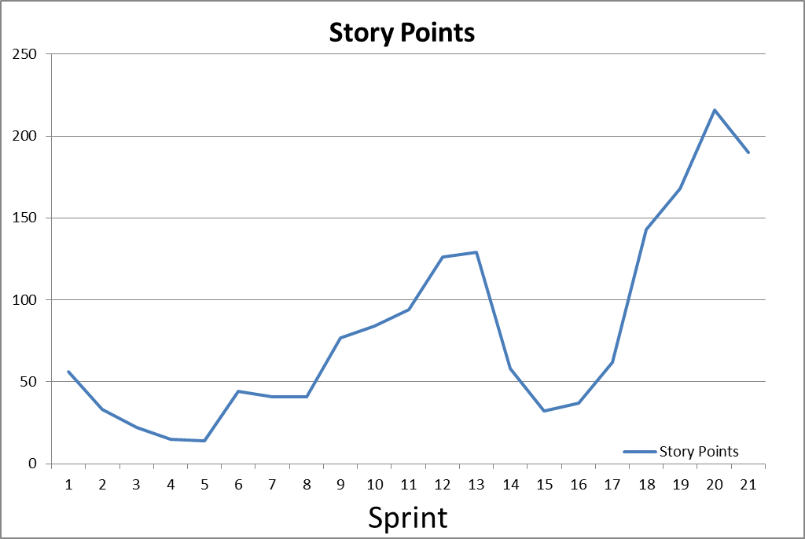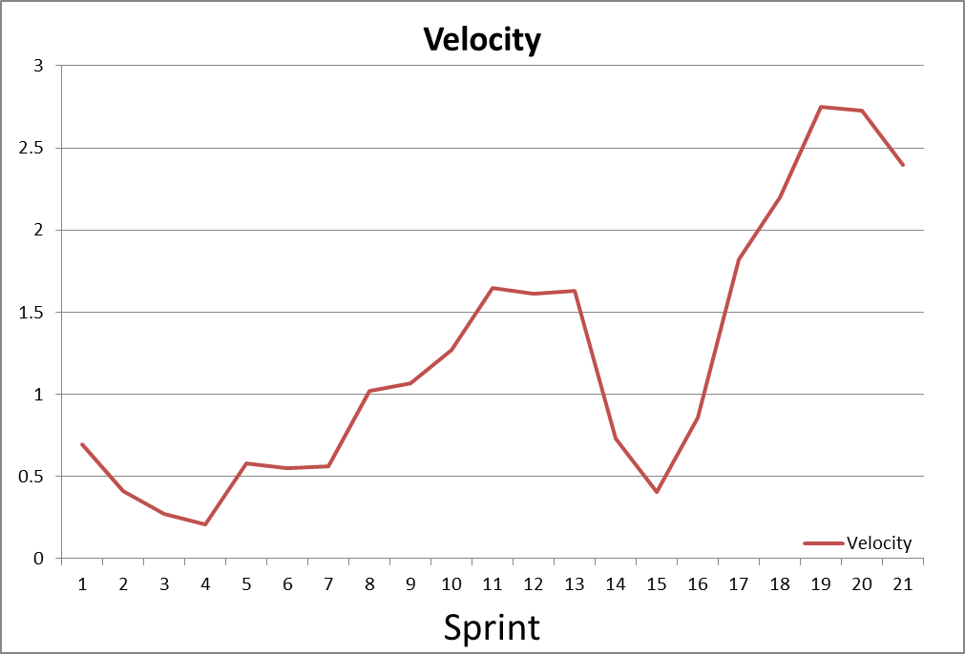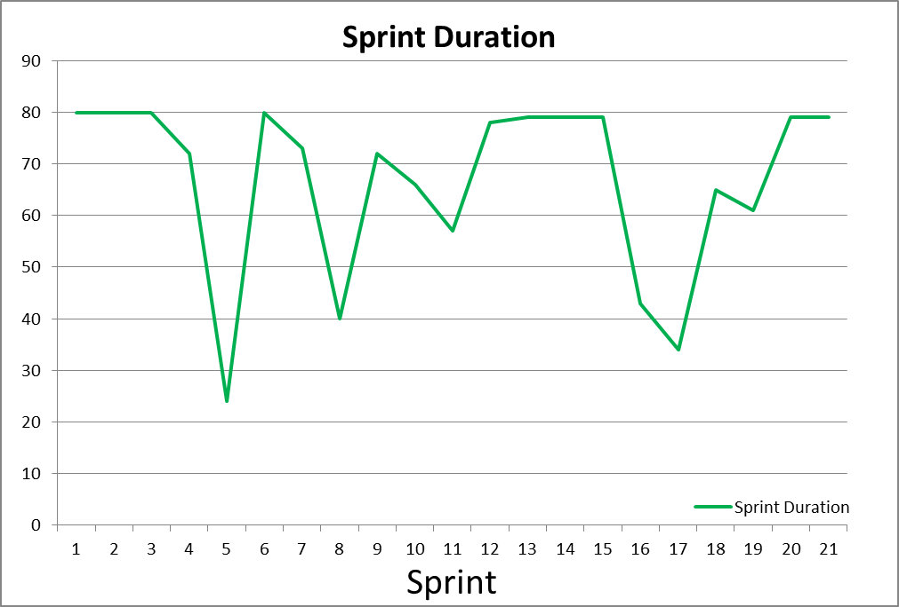

**MEMBER 1**

**MEMBER 2**

**MEMBER 3**

**MEMBER 4**

**MEMBER 6**

**MEMBER 7**