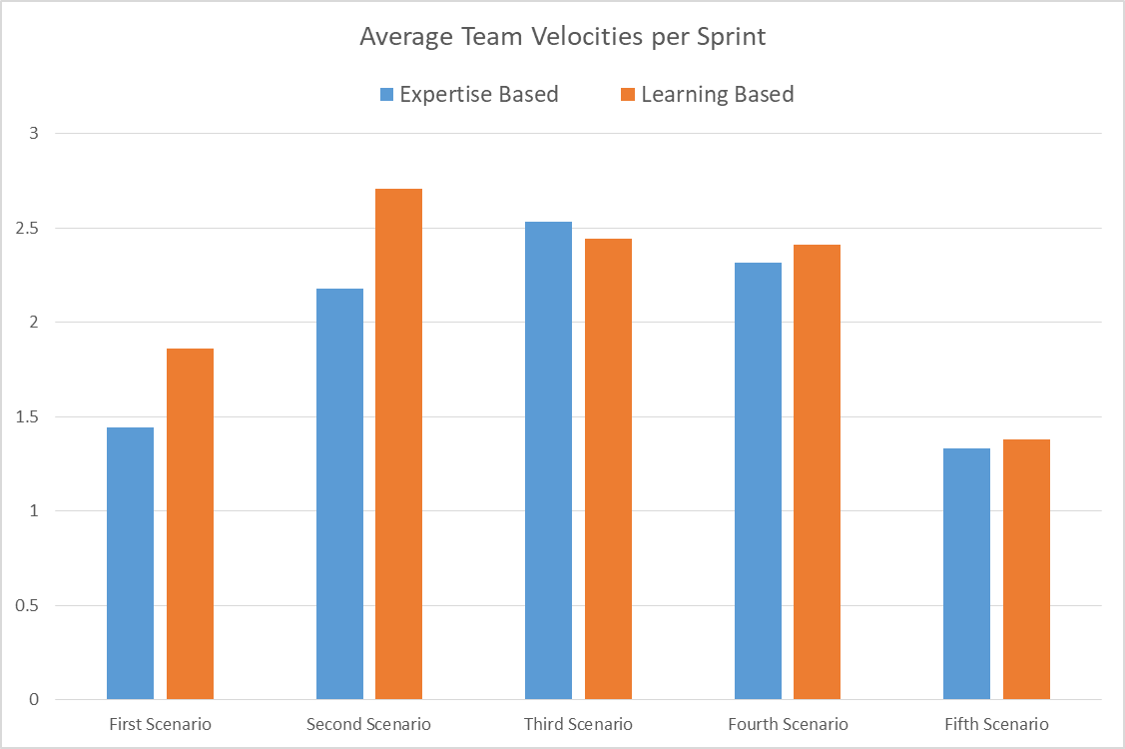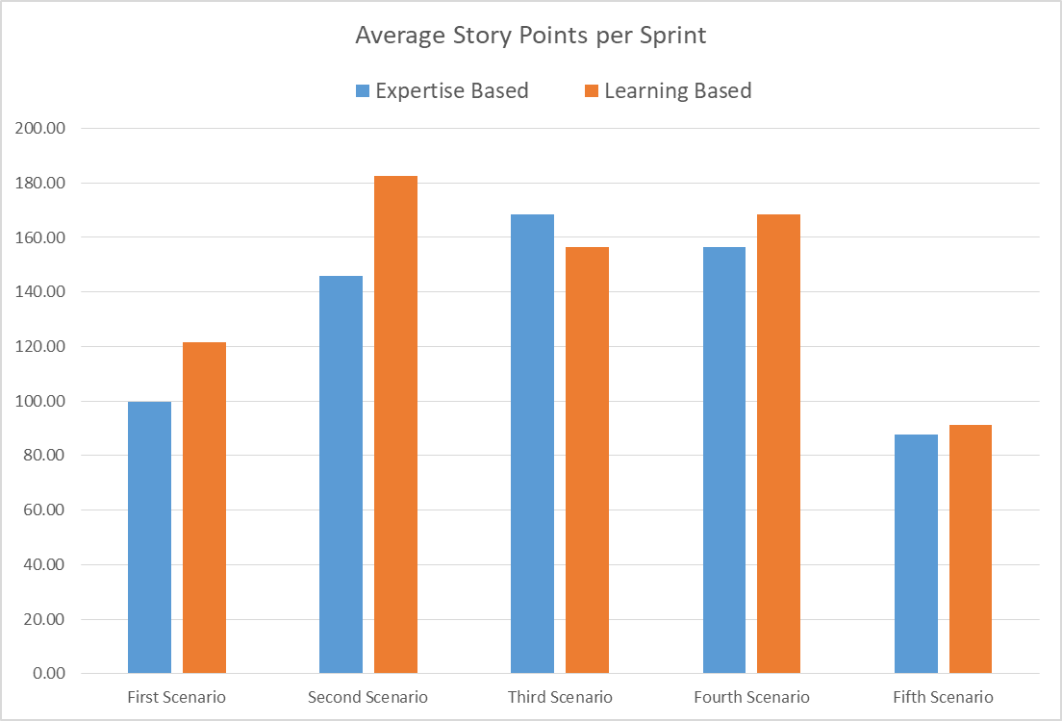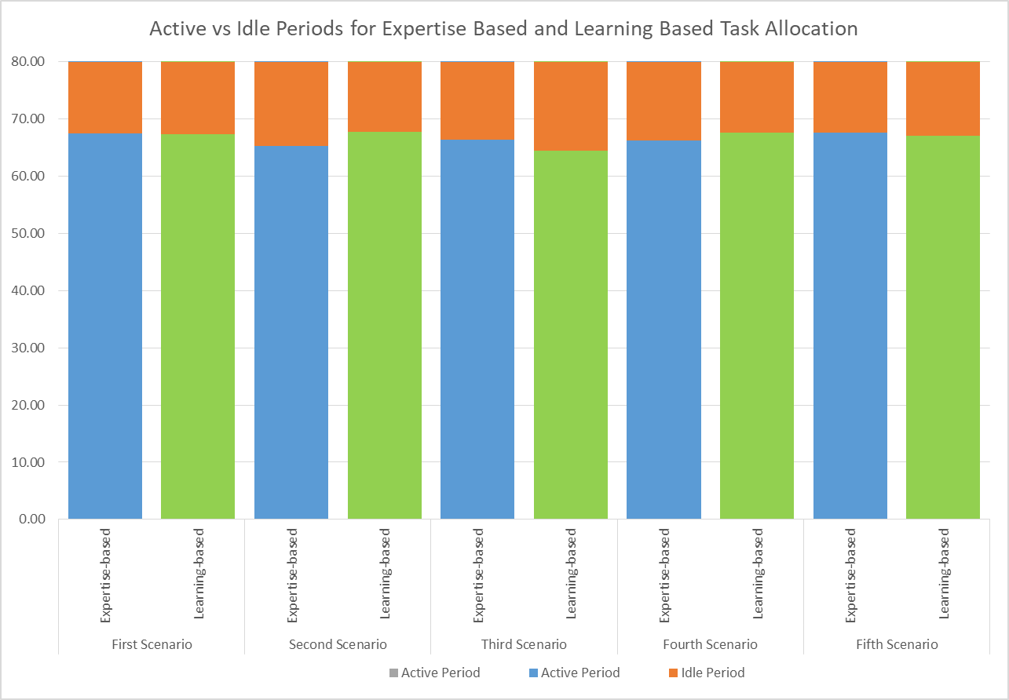

**First Scenario – Everyone starts with low expertise in every skill area**

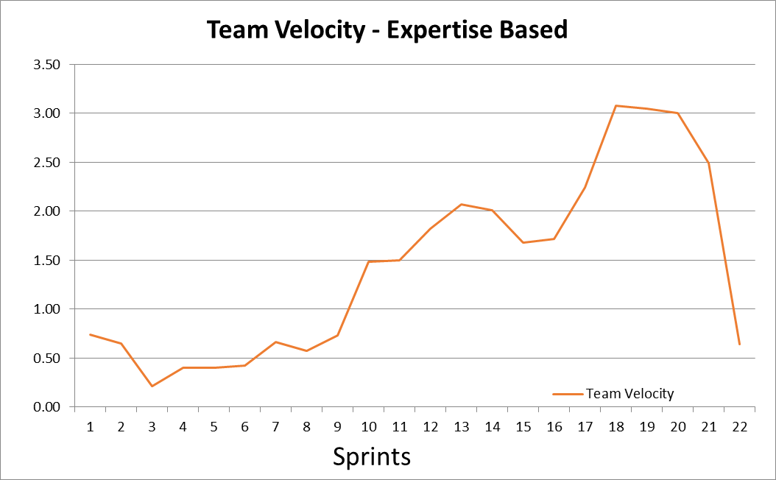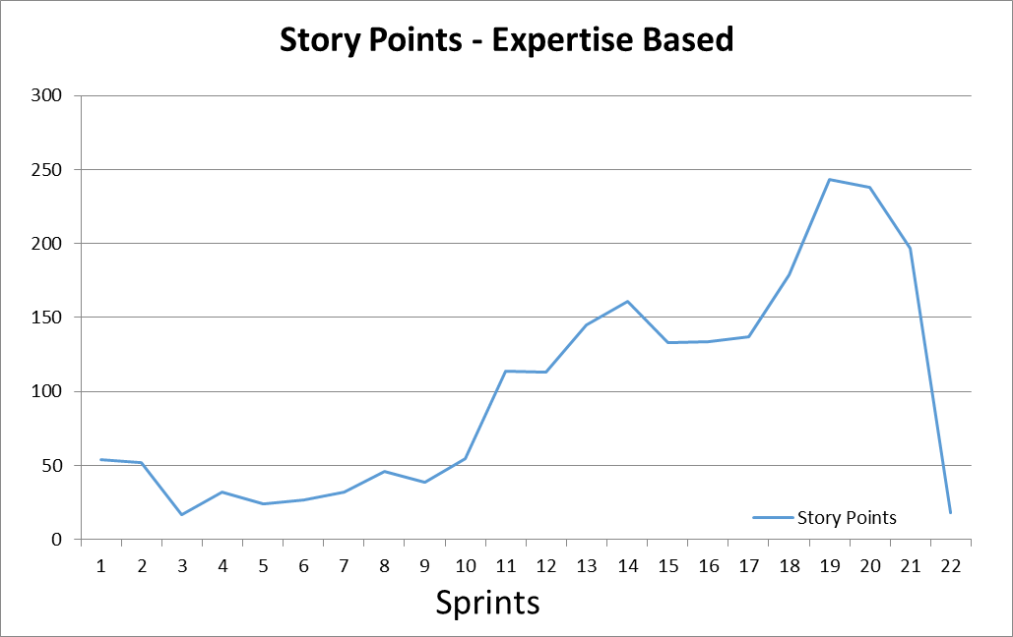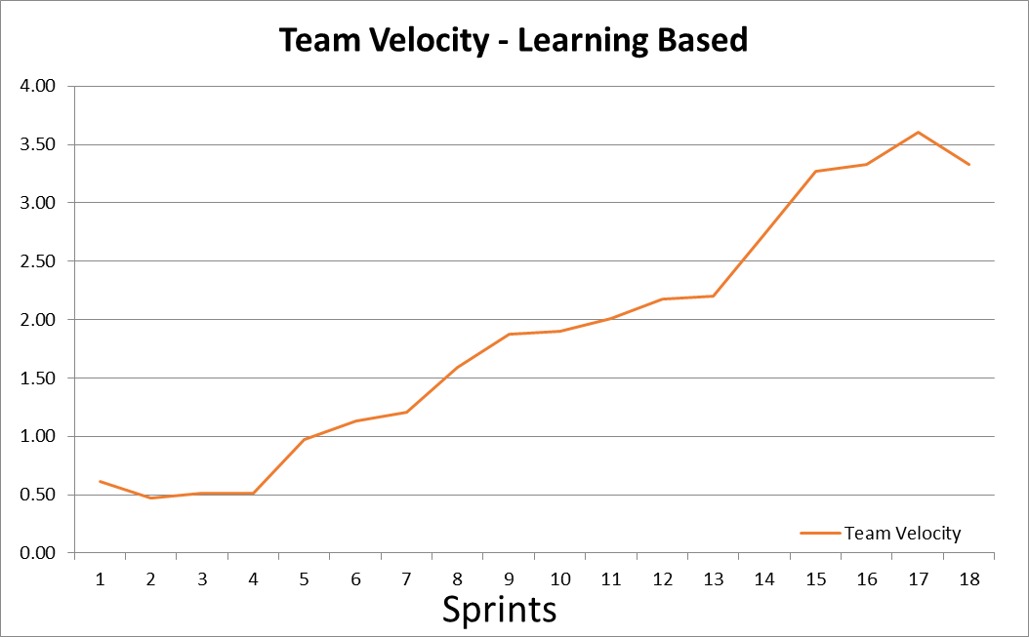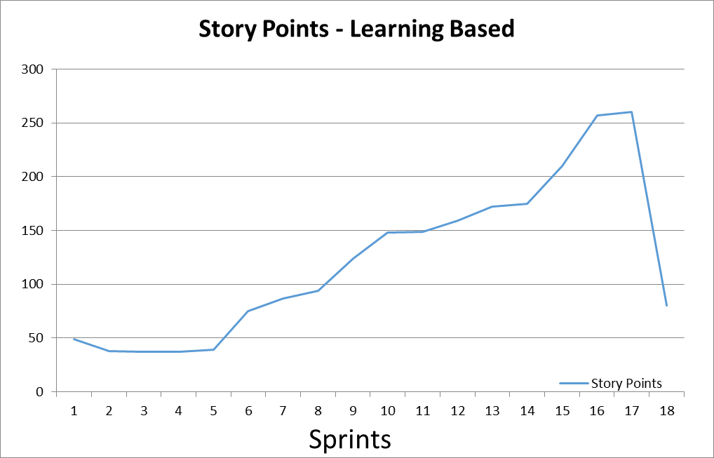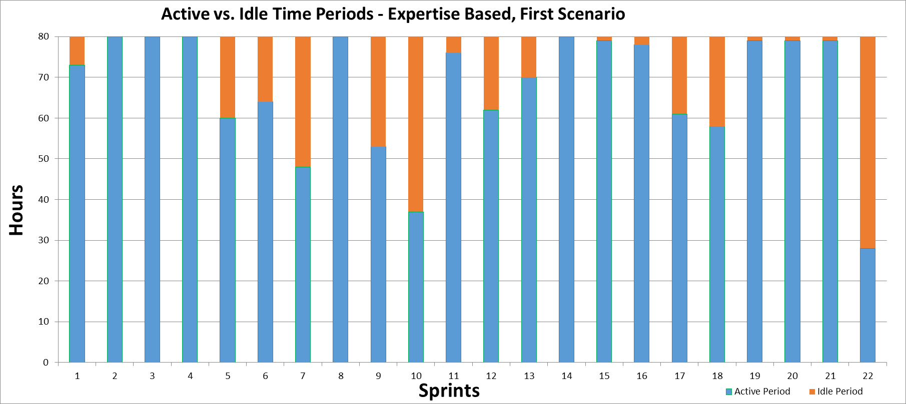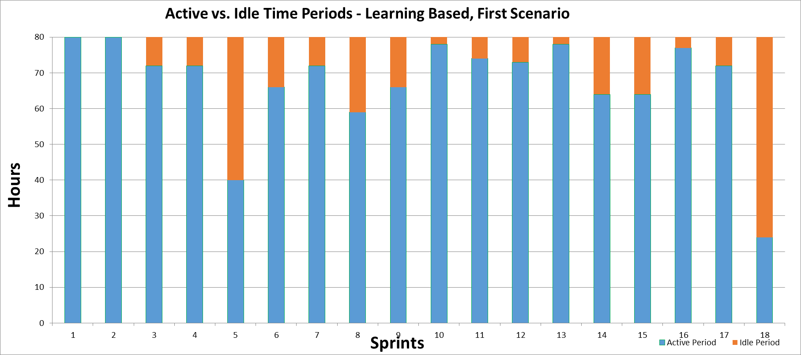

**Second Scenario – Two skills have three employees high and three employees low, other skill has all employees at medium level**

**Third Scenario – Two Skills have three employees at medium, and three employees at low expertise, and one skill has all employees with high expertise**

**Fourth Scenario – Two skill areas have two employees at high expertise and two employees at medium expertise, the other skill area all employees are low expertise**

**Fifth Scenario – Every employee starts with nearly zero expertise in all skill areas**