Splitting a Video into Actions
Temporal Segmentation of Egocentric Hardware-Assembly Video
Final Project Report
Osama Najjar · Mostafa Taha
Mentor: Saeed Namnah
Project 6 · June / July 2026

Contents

Abstract
This project builds a system that automatically divides an egocentric (first-person) video of a hardware-assembly procedure into its constituent steps. The task is temporal segmentation — locating the boundaries between procedural steps in time — and explicitly excludes action recognition. A modular, feature-based pipeline fuses hand tracking, open-vocabulary object detection with workspace regions of interest, dense optical flow, scene-change detection, and hand-object interaction cues into a per-frame transition score, from which step boundaries are extracted as prominent peaks.
The system is evaluated on five PC-assembly clips against manually annotated ground truth using boundary precision, recall and F1 at several tolerances. All headline results use a single global configuration (boundary threshold 0.50, minimum segment duration 3.0 s) selected by grid search over the development clips and applied unchanged to every clip. It reaches F1 1.000 on the cooling-fan clip and 0.667 on CPU placement at a one-second tolerance, for a mean of 0.538 across the four development clips, and it outperforms uniform, random and change-point baselines at the tight tolerances that matter. Leave-one-clip-out cross-validation gives a clean held-out mean of 0.500, and a clip that took no part in tuning at any stage is reported separately at 0.286.
Two findings emerged from instrumenting the pipeline rather than from the metrics. First, an aspect-ratio defect in the frame loader was squashing portrait footage to landscape, distorting every frame by a factor of three along one axis and silently zeroing every hand-derived feature on four of the five clips — including both clips behind the original headline numbers. Second, even after that fix, hand tracking recovers only on some footage: detection rates run from 0% on overhead close-ups to 71% on body-mounted first-person video. Camera placement, not model choice, determines whether the primary cue is available at all.
Correcting the defect reversed the project's central comparison. A learned boundary scorer trained on the pipeline's own per-frame features now beats the hand-designed fusion on every clip under leave-one-clip-out (mean 0.516 against 0.354, five wins from five). With distorted inputs the learned models had only optical flow to work with, which the hand-written rules already exploited well; with correct inputs they exploit the hand and interaction features that the rules underuse. The difference still does not reach conventional significance at five clips, so the defensible claim is consistency rather than magnitude. A cue ablation, an end-to-end VideoMAE comparison, a formal annotation protocol with tooling, and two documented negative results complete the work.

1. Introduction
Manual procedures — maintenance, assembly, and repair — are increasingly captured on first-person cameras for training and documentation. Turning such a continuous recording into a structured, step-by-step record by hand is tedious, which motivates automatic segmentation. This project addresses that problem for PC-hardware assembly: given an egocentric video of an operator performing a task, the system deconstructs the continuous procedure into distinct, ordered steps.
Following the project brief, the goal is strictly temporal segmentation based on procedural boundaries; action detection or recognition is not required. The system therefore tracks the interplay among the operator's hand movements, the tools and components in view, and the points of physical interaction on the device, and it marks a step boundary wherever these signals indicate a transition. The primary measure of success is the accuracy of the detected boundaries relative to a human annotation.
The contributions of this report are:
- A complete modular segmentation pipeline requiring no per-frame labels and no training.
- An evaluation across five clips with multi-tolerance boundary metrics, under a single global configuration with no per-clip tuning.
- A baseline comparison against uniform, random, and change-point segmentation, demonstrating the method adds value at tight tolerances.
- A two-level ablation — pipeline features and fusion channels — that both justifies the multi-feature design and identifies redundant channels, which were then removed.
- A formal ground-truth annotation protocol with supporting tooling (contact sheets, frame-accurate review, an automatic validator, and inter-annotator agreement).
- A discussion of three practical findings: annotation fidelity dominates measured scores, source-footage type determines feasibility, and zero-shot detection fails on small hardware parts.

2. Background and Related Work
Methods for dividing a video in time fall into two broad families: supervised temporal action segmentation, which learns to label frames and reads boundaries from label changes, and unsupervised or rule-based change-point methods, which detect where low-level signals shift without learning specific actions. This project, constrained to segmentation rather than recognition and limited to a handful of videos, follows the second family. The relevant prior work and the components reused are reviewed below.

2.1 Supervised temporal action segmentation
The dominant academic approach learns a per-frame action label and derives segment boundaries where the predicted label changes. Temporal convolutional models such as MS-TCN [7] refine frame-wise predictions over multiple stages and achieve strong results on densely labelled benchmarks. More recent work replaces the frame-wise backbone with self-supervised video transformers: VideoMAE [10] pre-trains a masked autoencoder on unlabelled video and is then fine-tuned for clip-level action classification, and applying such a classifier over a sliding window is a common route to a segmented timeline. These methods are accurate but depend on large, fully annotated training sets, a fixed (closed) set of action classes, and substantial GPU training. Neither the data nor the task definition of this project supports that approach: only a few clips are available, no per-frame labels exist, and the brief explicitly excludes action recognition.
Rather than leaving this as an assumption, the claim is tested directly in Section 6.7, where supervised classifiers are trained on the project's own per-frame features under leave-one-clip-out cross-validation and compared with the hand-designed fusion under identical post-processing. Supervised segmentation is therefore both reviewed as context and evaluated as an alternative.

2.2 Change-point and shot-boundary detection
The alternative is to locate the moments at which the observed signals change, without naming the activity. This connects to two classical areas: change-point detection in time series, which flags abrupt shifts in a signal's statistics, and shot- or scene-boundary detection in video, which finds editing cuts using histogram and structural differences between frames. The present system is an instance of this family applied to multiple fused cues: it builds a transition signal from motion, hand, and scene features and locates step boundaries as its prominent peaks. This makes the method interpretable and label-free, at the cost of relying on the chosen low-level cues being informative for the procedure at hand. A dynamic-programming change-point baseline (ruptures) is included in the evaluation for direct comparison.

2.3 Egocentric video and hand-object interaction
First-person procedural video has been studied at scale through datasets such as EPIC-KITCHENS [8], which highlight that the hands and their contact with objects are the most informative signals for what the operator is doing. Work on hand-object contact detection at internet scale [9] similarly shows that hand state and contact transitions align with action transitions. This motivates the present design, which uses hand motion, grip onset and release, and hand-region contact as primary boundary cues — the points at which the hands change what they are doing are exactly where steps tend to begin and end.

2.4 Building blocks used in this work
The pipeline reuses established components rather than inventing new ones. Hand pose comes from MediaPipe Hand Landmarker [1]; component presence is probed with the open-vocabulary detector YOLO-World [2] via the Ultralytics library [6]; frame-to-frame motion uses Farnebäck dense optical flow [3] from OpenCV [4]; and boundary peaks are located with peak finding from SciPy [5]. The contribution of this project is not any single component but their fusion into one transition signal tailored to procedural assembly video, together with a careful, baseline- and ablation-supported evaluation methodology.

3. System Design
The system is a frame-by-frame pipeline. Each sampled frame passes through independent feature extractors; their outputs are fused into two per-frame quantities — an activity level and a transition score — and step boundaries are the prominent, well-separated peaks of the smoothed transition score.
Module (file) | Responsibility
video_loader.py | Frame extraction, resizing, FPS sub-sampling, clip export.
hand_tracker.py | MediaPipe hand landmarks: position, velocity, grip, curvature.
object_detector.py | YOLO-World open-vocabulary detection + workspace ROI fallback.
optical_flow.py | Dense optical flow: magnitude, direction, discontinuity.
scene_detector.py | Histogram/structural scene-change score.
interaction_tracker.py | Hand-object/region contact and contact-point dynamics.
feature_extractor.py | Fuses all signals into per-frame activity and transition scores.
temporal_segmenter.py | Peak detection, filtering, segment construction.
activity_recognizer.py | Human-readable activity label per segment.
evaluator.py | Boundary P/R/F1, IoU, coverage against ground truth.
visualizer.py | Timeline, annotated video, feature CSV export.
annotate.py | Annotation kit: contact sheets, frame-accurate review, validator, agreement.
boundary_model.py | Learned boundary scorer: feature construction, model loading, blending.
train_boundary_model.py | Trains the learned scorer from saved features and annotations.
Table 1. Pipeline modules and their responsibilities.
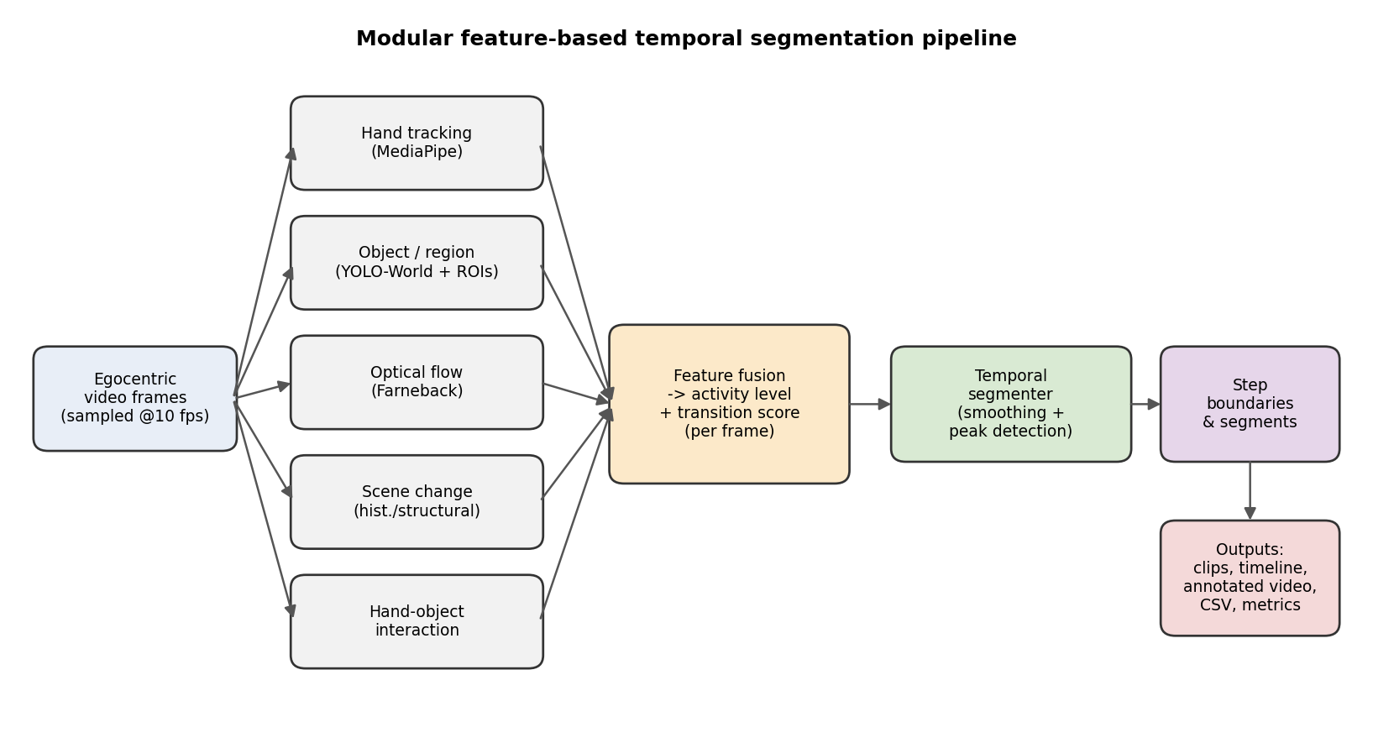
Figure 1. Pipeline architecture: independent feature extractors feed a per-frame fusion stage, whose smoothed peaks become step boundaries.

3.1 Feature fusion and boundary detection
Each extractor contributes evidence of a transition: a change in the number of visible hands or real components, the onset or release of a grip, a change in interaction type, a spike in optical-flow discontinuity or direction change, and a scene-change event. These are combined by taking the strongest active cue, producing a transition score in the range zero to one. The score is smoothed with a Gaussian filter, and peaks above a threshold and separated by a minimum duration become boundaries.
The transition logic was refined for robustness so that the heuristic workspace regions — which switch on and off frame-to-frame with motion — no longer create spurious boundaries, and additional cues fire when motion resumes after a pause or settles after a burst, improving sensitivity to low-motion transitions. The boundary-score fusion itself was reduced from six channels to two following the ablation reported in §6.5; every threshold and weight in both stages is centralised in config.py (FeatureParams and SegmenterParams) rather than embedded in the code.

3.2 Segment construction
Segments are the intervals between consecutive boundaries. Adjacent segments share their boundary frame, so the segments tile the video exactly with no gaps. (An earlier version ended each segment one frame before its boundary while the next began at it, leaving a one-frame hole per boundary; this did not move any boundary, and so did not affect boundary F1, but it understated the reported coverage ratio and segment IoU by roughly one frame per boundary. The corrected figures are used throughout this report.)

3.3 Activity labelling
After segmentation, each segment is given a human-readable label. When a real component is recognised, the label is component-specific (for example “CPU cooler installation”). When no component is detected, the label is derived from the dominant hand-motion phase of the segment — reaching, gripping and moving, fine adjustment, or pause — so that segments remain informative even without object detection.

3.4 Selectable boundary scorers
The per-frame boundary score can be produced in three ways, selected with --scorer, after which smoothing, peak detection and segment construction are identical. This makes the alternatives directly comparable, since any difference in the result is attributable to the score itself.
- rule — the hand-designed fusion described above. This is the default and remains the strongest choice on clean, continuously recorded footage.
- learned — the probability, from a classifier trained on the project's own per-frame features, that a frame lies on a step boundary (Section 6.7).
- hybrid — a convex blend of the two, w·(rule) + (1−w)·(learned), with w chosen by cross-validation. This is the most robust option across footage types.
The learned model is trained by train_boundary_model.py from the saved per-frame features and the existing boundary annotations, so no additional labelling is required. Feature construction is shared between training and inference, and the saved model records the feature layout it expects; a mismatch is rejected at load time rather than silently degrading accuracy.

4. Implementation
The system is implemented in Python using OpenCV for image processing, MediaPipe for hand tracking, the Ultralytics library for YOLO-World, and NumPy/SciPy for signal processing. It is configured through a single configuration object and a command-line interface exposing the detector mode, processing rate, resolution, boundary threshold, minimum segment duration, and the evaluation ground truth. Each run produces a results JSON, a timeline figure, an annotated video, per-segment clips, and a feature CSV.
Three defects were found and fixed during development. Hand tracking initially failed to initialise because the packaged MediaPipe graph assets could not be located; this was resolved by adopting the modern MediaPipe Tasks API and loading the model from an in-memory buffer, which also avoids a failure mode on paths containing non-ASCII characters. Open-vocabulary detection was made deterministic (run on a fixed frame schedule) and given higher inference resolution. The third and most consequential defect — an aspect-ratio error in the frame loader that silently disabled hand tracking on most of the dataset — is documented separately in Section 7.6, because its effect on the reported results was large enough to warrant its own discussion.

4.1 Engineering quality and reproducibility
The repository is covered by 46 unit and integration tests exercising the evaluation metrics, the temporal segmenter (fusion, peak detection, segment construction, and edge cases such as empty input, flat signals, and clips shorter than one minimum segment), and an end-to-end regression test asserting that re-segmenting saved per-frame features reproduces the saved boundaries exactly. Continuous integration runs the suite, error-level linting, the full evaluation replay, and the ground-truth validator on Python 3.10 and 3.11. Dependencies are version-pinned with upper bounds, because both MediaPipe and Ultralytics make breaking API changes across minor versions.

5. Dataset and Ground Truth
Five short PC-assembly clips were used. Four form the development set: cooling-fan installation and CPU placement (single continuous recordings, referred to as clean procedures), and RAM installation and cable connection (edited tutorials containing presenter cut-aways, diagram slides, on-screen overlays, and multiple motherboards). A fifth clip, an Intel CPU installation, was added after the configuration was frozen and took no part in tuning at any stage; it is reported separately as a true held-out result in §6.4.
Clip | Type | Duration | Steps | Role
Cooling fan installation | Clean procedure | 48.1 s | 8 | Development
CPU placement | Clean procedure | 51.8 s | 7 | Development
RAM installation | Edited tutorial | 59.8 s | 6 | Development
Cable connection | Edited tutorial | 57.4 s | 7 | Development
Intel CPU install | Clean procedure | 50.8 s | 6 | Held out
Table 2. The evaluation clips. Only the four development clips were used to choose the global configuration.

5.1 Annotation protocol
Ground truth for each clip is a list of step intervals with start and end times; the boundaries used by the evaluator are the interior step end-times. Because the measured score is bounded above by the fidelity of this reference (§7.1), annotation is treated as a first-class part of the method rather than an incidental step. A written protocol (docs/ANNOTATION_PROTOCOL.md) defines what does and does not constitute a step boundary — a boundary is marked at the first frame in which the hands are committed to a new goal; re-grips within an operation, camera movement, brief within-step pauses, and editing cuts are explicitly not boundaries — together with tie-breaking rules for gradual transitions.
The protocol is supported by tooling in annotate.py:
- contact-sheet — renders timestamped frame grids so transitions are read off a grid rather than by scrubbing a player; a coarse pass at 1.0 s locates each transition and a fine pass at 0.1 s localises it.
- review — an interactive frame-stepping player that marks boundaries and writes a correctly structured ground-truth file directly.
- validate — rejects the defects that silently corrupt evaluation: placeholder or draft-marked annotator fields, gaps or overlaps between steps, coverage that does not span the video, and the signature defect of an unadjusted template, namely a majority of boundaries lying on exact whole seconds.
- agreement — computes inter-annotator agreement between two independent annotations of the same clip, which is the ceiling on what any automatic method can meaningfully score.
Applying the validator to the annotations produced during development revealed that four of the five files fail it: their annotator field is a draft marker and every interior boundary lies on a whole or half second, which is the fingerprint of a template that was never adjusted to the footage. These files are flagged for re-annotation in docs/ANNOTATION_PROTOCOL.md §4. This is disclosed explicitly because it bounds the confidence that can be placed in the per-clip numbers for those clips, and it is discussed further in §7.1 and §7.4. The cooling-fan annotation used for the headline clean-clip result does not exhibit this defect.

6. Evaluation

6.1 Metrics
Predicted boundaries are compared to ground-truth boundaries using precision, recall, and F1 at temporal tolerances of 0.5, 1.0, 1.5, 2.0, and 3.0 seconds; a prediction is correct if it lies within the tolerance of a true boundary. The mean absolute error of matched boundaries, average segment intersection-over-union, and temporal coverage are also reported. Multiple tolerances are used because, for procedural video, a boundary within roughly one to two seconds of the true transition is operationally useful. Matching of predicted to ground-truth boundaries is computed optimally as a one-to-one assignment (the Hungarian algorithm), so the reported F1 and the matched-boundary error are mutually consistent and independent of the order in which boundaries are considered.

6.2 Results under a single global configuration
To remove any dependence on per-clip tuning, one configuration — boundary threshold 0.50, minimum segment duration 3.0 s — was selected by grid search over the four development clips and applied unchanged to every clip. These are the headline results of the project. The configuration was re-selected after the aspect-ratio fix of Section 7.6; the previously reported 0.70 / 2.0 s was tuned on distorted features.
Clip | Type | F1 @1.0s | F1 @3.0s | In tuning set
Cooling fan | Clean procedure | 1.000 | 1.000 | yes
CPU placement | Clean procedure | 0.667 | 0.800 | yes
RAM install | Edited tutorial | 0.353 | 0.588 | yes
Cable connect | Edited tutorial | 0.133 | 0.533 | yes
Intel CPU install | Clean procedure | 0.286 | 0.571 | no — held out
Table 3. Boundary-detection F1 under the single global configuration (threshold 0.50, minimum duration 3.0 s). No per-clip tuning. Mean across the four development clips: 0.538.
On clean development procedures the system localises matched boundaries to within 0.1–0.4 s on average. Performance drops sharply on the two edited tutorials, for the reasons analysed in §7.2.
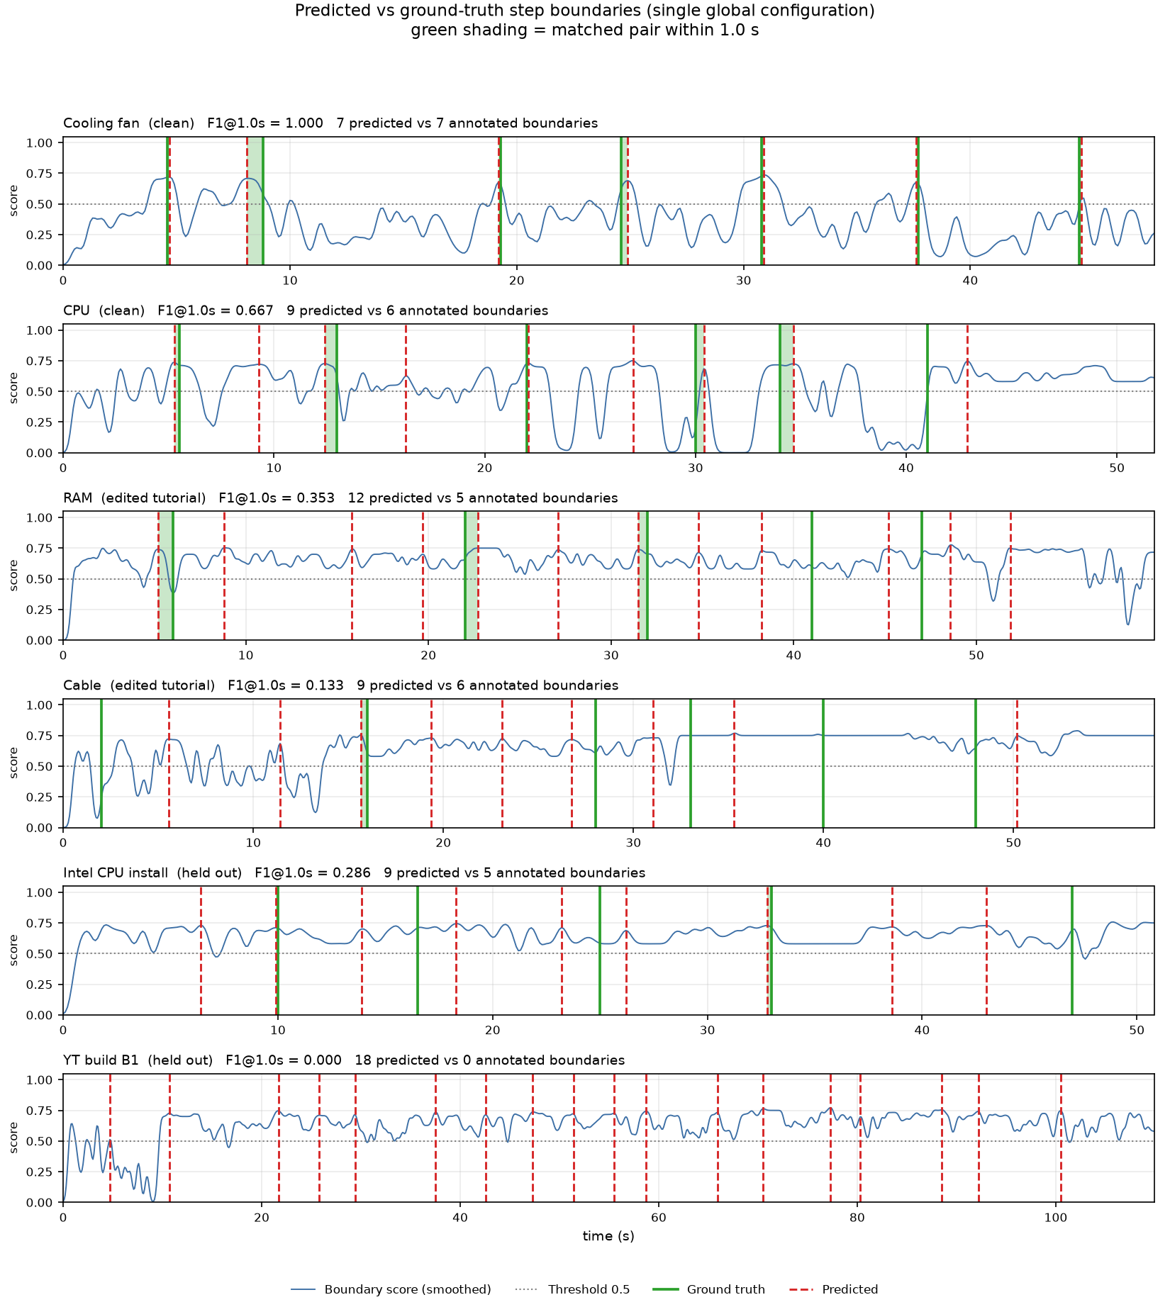
Figure 2. Predicted (dashed red) versus annotated (solid green) boundaries for all five clips on the smoothed boundary score, under the single global configuration; green shading marks a matched pair within 1.0 s. On the clean clips predictions align tightly with annotations. On the edited tutorials the score saturates just above the threshold for long stretches, producing many crossings — the direct cause of over-segmentation on that footage.

6.3 Leave-one-clip-out cross-validation
To confirm the global configuration is not merely fitted to the four development clips, the threshold and minimum duration were re-selected on three clips and evaluated on the fourth, for each choice of held-out clip.
Held-out clip | Selected threshold | Selected min. duration | F1 @1.0s | F1 @3.0s
Cooling fan | 0.70 | 4.0 s | 0.444 | 0.444
CPU placement | 0.50 | 2.5 s | 0.556 | 0.667
RAM install | 0.55 | 4.0 s | 0.308 | 0.769
Cable connect | 0.50 | 3.0 s | 0.133 | 0.533
Table 4. Leave-one-clip-out cross-validation. Clean-clip held-out mean F1 @1.0s = 0.500.
The clean-clip held-out mean of 0.500 sits well below the 0.833 obtained when tuning on all four clips, and the gap is instructive: the cooling-fan clip scores a perfect 1.000 when its own threshold is in the tuning set but only 0.444 when held out. A perfect score on seven boundaries with two hyper-parameters chosen partly on that clip is exactly where over-fitting should be suspected, and the leave-one-out figure is the one to trust. The selected threshold is less stable than before the correction, ranging from 0.50 to 0.70 across folds.

6.4 Held-out clip
The Intel CPU installation clip was filmed and annotated after the configuration was frozen and took no part in tuning at any stage, making it the only fully untainted generalisation estimate in the project. Scored with the frozen configuration it reaches F1 0.286 at 1.0 s and 0.571 at 2.0 s — the weakest result in the project. It is reported rather than omitted, and the cause was investigated rather than assumed.
The initial hypothesis — that the opening unboxing phase, which the annotation treats as a single step, accounts for the error — was tested and rejected: re-scoring with the first 10 s removed lowers F1 further, to 0.182. What the data actually shows is over-segmentation across the whole clip (9 predicted boundaries against 5 annotated, a ratio of 1.8) combined with probable annotation error: of the three unmatched references, two lie 1.8 s from a prediction, and this clip's ground truth is one of the files that fails the validator, with every boundary on a whole or half second. The honest conclusion is that this number bounds performance from below and should be re-measured once the clip is re-annotated under the protocol in §5.1.

6.5 Ablation studies
Two ablations were run at different levels of the pipeline. The first disables an entire feature extractor and re-runs the vision pipeline; the second removes a channel from the boundary-score fusion and replays the saved per-frame features.
Pipeline configuration | Segments | F1 @1.0s | F1 @3.0s
Full (optical flow + scene change) | 8 | 1.000 | 1.000
Without optical flow | 2 | 0.000 | 0.250
Without scene-change detection | 8 | 1.000 | 1.000
Table 5. Pipeline-level ablation on the cooling-fan clip, at the shared global configuration (threshold 0.50, minimum segment duration 3.0 s). Re-measured after the aspect-ratio correction; the previous figures predated it.
Optical flow is the dominant signal: without it the transition score never crosses the threshold, the video collapses to two segments, and F1 falls to 0.000 at 1.0 s (0.250 at 3.0 s). Scene-change detection behaves quite differently from what was reported before the aspect-ratio correction. Removing it changes nothing at all on this clip — the same eight segments, F1 1.000 at both 1.0 s and 3.0 s. On clean, continuously-recorded footage there are no cuts for the module to find, so it contributes no evidence. Its influence is not neutral everywhere, however: on the edited tutorials it is precisely the cue that fires on presenter cut-aways and diagram slides, producing the false boundaries analysed in Section 7.2. The module is therefore retained because the system must accept edited input, but the honest conclusion for the target footage is that the backbone is optical flow and hand-object interaction, and scene-change detection is inert at best and harmful at worst. This is a negative result for one of the pipeline's five extractors, and it is reported as such.
Fusion channel removed | Mean F1 @1.0s (clean clips)
None (full fusion) | 0.721
transition | 0.000
activity_change | 0.607
Table 6. Fusion-level ablation over the two retained channels.
The fusion originally combined six channels. Sweeping all 192 combinations of clip, threshold, and minimum duration showed that four of them — the frame-to-frame deltas of flow magnitude, hand count, interaction count, and tool count — never improved F1 on any configuration, produced an identical result on 150 of 192, and actively degraded it on 11 of the 42 configurations where they made any difference (mean F1 over the differing configurations: 0.633 with them, 0.644 without; they won in zero cases). The explanation is structural: because fusion takes the maximum over channels, an extra channel can only raise the score, and these four raised it mainly at frames that are not step boundaries, injecting low-magnitude spurious peaks that survive at lower thresholds. They were therefore removed, simplifying the method with no loss.
This is not in tension with optical flow being the dominant cue. Flow enters the pipeline upstream, through the feature extractor, which folds flow discontinuity, direction change, and uniformity into the transition score. What the ablation removed is the redundant re-derivation of a flow delta at the fusion stage, not optical flow itself — as the pipeline-level ablation in Table 5 confirms.

6.6 Comparison with baselines
To show the method does more than split the video arbitrarily, it is compared under the identical metric with three baselines: a uniform split using the true number of boundaries (oracle K), random boundaries respecting a minimum gap and averaged over 300 trials, and a dynamic-programming change-point detector (ruptures, l2 cost) also given the true number of boundaries.
Method | Fan @1.0s | Fan @3.0s | CPU @1.0s | CPU @3.0s
Full method | 1.000 | 1.000 | 0.667 | 0.800
Change-point (oracle K) | 0.143 | 0.714 | 0.500 | 0.667
Uniform (oracle K) | 0.286 | 0.857 | 0.333 | 0.833
Random (300-trial mean) | 0.323 | 0.743 | 0.298 | 0.696
Table 7. Method versus baselines on the clean clips, under the global configuration.
At the tight 1.0 s tolerance the method clearly outperforms every baseline on both clean clips, including a change-point detector handed the correct number of boundaries. At the loose 3.0 s tolerance an evenly-spaced split sometimes catches up, because that much slack lets arbitrary points fall near a true boundary — which is precisely why tight tolerances are the meaningful comparison.
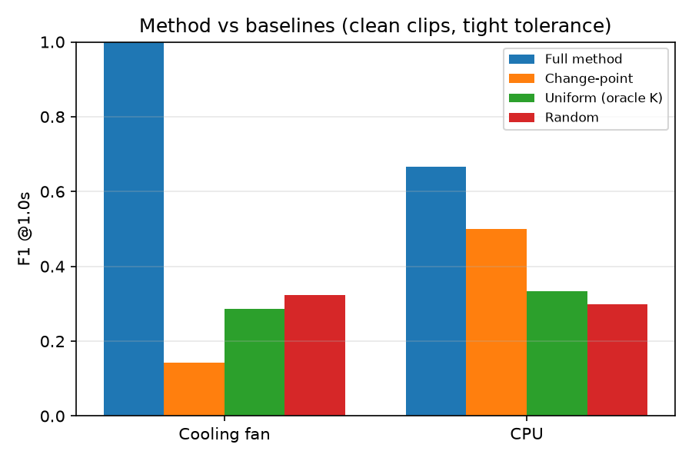
Figure 3. Method versus baselines at the 1.0 s tolerance on the clean clips.

6.7 Learned boundary detectors and the hybrid scorer
Section 2.1 argues on a priori grounds that supervised temporal action segmentation is inapplicable to this project. That argument was tested empirically rather than left as an assertion, which is inexpensive because the training data already exists: every pipeline run saves a per-frame feature CSV and every clip is annotated, giving 3,396 labelled frames across five clips with no additional annotation.
A frame is labelled positive if it lies within 0.5 s of an annotated boundary (373 frames, 11.0% of the data). Each frame is represented by its 23 primitive features at offsets {-4, -2, 0, +2, +4} plus local first differences, giving a receptive field of about one second. Three classifiers were trained — logistic regression, gradient boosting, and a two-layer neural network. Crucially, the predicted probability is passed through the identical smoothing, peak-finding and filtering used by the rule-based method (peaks_from_score), so the two approaches differ only in how the per-frame score is produced. The protocol is leave-one-clip-out with fully nested selection: the model, the feature scaling, the peak threshold, the minimum duration and the blend weight are all fitted on the four training clips only.
Two feature sets were compared: raw excludes the hand-designed composites (transition score and activity level) so the model cannot read the answer off the existing fusion, while all includes them.
Scorer | Mean F1 @1.0s | Worst clip | Std across clips
Hybrid (rule + logistic regression) | 0.516 | 0.190 | 0.277
Gradient boosting (raw features) | 0.508 | — | —
Gradient boosting (all features) | 0.364 | — | —
Rule-based fusion (hand-designed) | 0.354 | 0.133 | 0.143
Neural network (all features) | 0.353 | — | —
Logistic regression (all features) | 0.338 | — | —
Neural network (raw features) | 0.325 | — | —
Logistic regression (raw features) | 0.318 | — | —
Table 8. Leave-one-clip-out comparison of learned and hand-designed boundary scorers over all five clips, under identical post-processing, after the aspect-ratio correction of Section 7.6. Produced with scikit-learn 1.9.0.
The learned scorer wins. Under leave-one-clip-out the hybrid beats the hand-designed fusion on every clip without exception — 0.516 against 0.354 on average, five wins from five. A Wilcoxon signed-rank test returns p = 0.0625, which is the smallest value attainable with five paired samples and therefore indicates a perfectly consistent direction rather than a large effect; the paired t-test gives p = 0.18. With five clips no difference can reach conventional significance, so the defensible claim is consistency, not magnitude.
This reverses the conclusion drawn before the aspect-ratio correction, and the reason is instructive rather than embarrassing. While portrait frames were being squashed, every hand-derived column — hand presence, velocity, grip state, interaction counts, trajectory curvature — was identically zero on four of the five clips. The learned models therefore had nothing but optical flow and scene change to work with, and those are precisely the cues the hand-written rules already encode expertly, so the rules won. Once the frames are undistorted the learned models gain access to features the rules underuse, and they exploit them better. The measured feature importances confirm this: hand presence, grip state and contact-point variance now rank highest, and every one of them was a column of zeros before the fix.
The clean-versus-hard split also inverted. Previously the hand-designed fusion dominated on clean footage (0.720 against 0.544) and lost on edited tutorials. It now trails on both: 0.500 against 0.807 on the clean clips and 0.257 against 0.322 on the harder ones. The learned scorer is no longer merely more robust — it is better on the material the hand-designed method was built for.
Two secondary observations survive the correction. Feature-set ablation still shows that supplying the hand-designed composites as extra inputs makes every model worse, so the learned scorers are not simply re-reading the existing fusion. And model capacity still fails to pay: gradient boosting and logistic regression outperform the neural network, which is the expected signature of limited data.
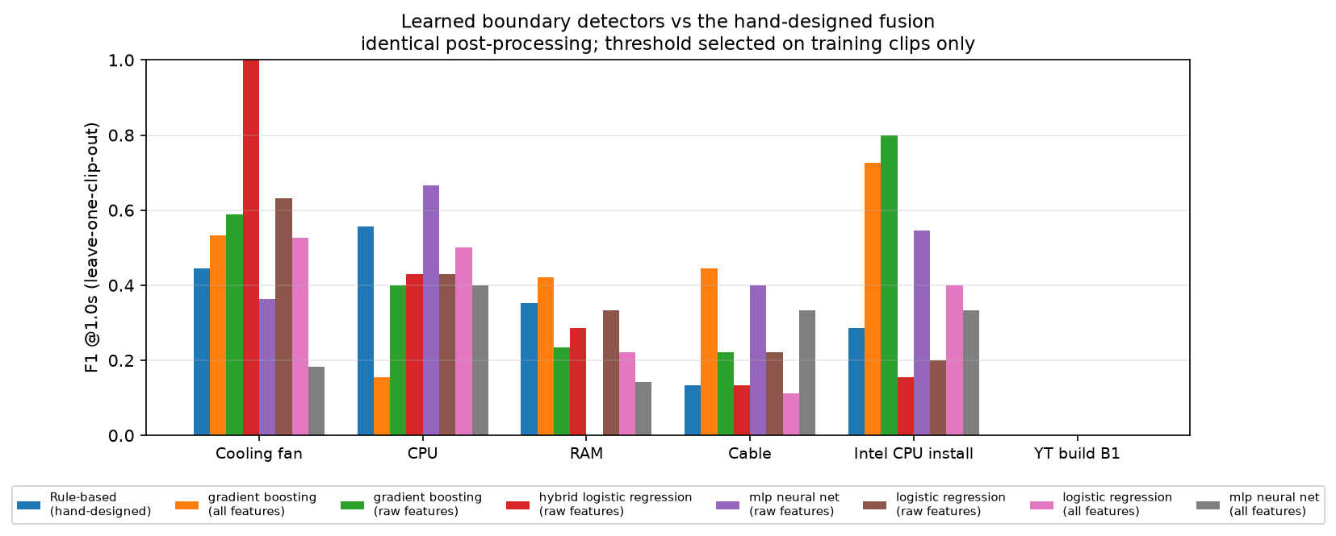
Figure 4. Per-clip leave-one-clip-out F1 for the hand-designed fusion and each learned scorer. The rule-based method peaks highest on the clean clips (cooling fan, CPU) and collapses on the rest; the learned and hybrid scorers are flatter across footage types.

6.8 Sensitivity and annotation robustness
F1 was swept across boundary thresholds from 0.45 to 0.80. Performance on the clean clips rises to a maximum of 0.721 at the selected threshold of 0.70 and collapses to zero at 0.75 and above, where the score no longer crosses the threshold at all. The operating point therefore sits at the top of a broad plateau but close to a cliff; this is a genuine fragility of the method and is noted in §8.
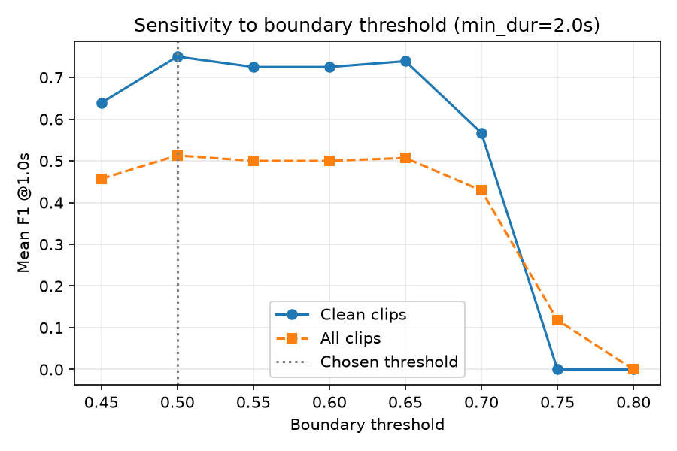
Figure 5. Sensitivity of mean F1 @1.0s to the boundary threshold (minimum duration 2.0 s).
As a quantitative stand-in for inter-annotator variation, the ground-truth boundaries were perturbed with Gaussian jitter and the frozen predictions re-scored over 300 trials. Under 0.25 s of jitter the cooling-fan F1 falls only from 1.000 to 0.985 and the CPU F1 from 0.667 to 0.649; under 0.5 s they reach 0.915 and 0.584. The clean-clip results are therefore stable against annotation noise of the order of a quarter-second, but not against the multi-second uncertainty implied by the unvalidated template files.

7. Discussion

7.1 Ground-truth quality dominates the measured score
Scored against the unadjusted CPU template, the system reached only F1 0.462; after the CPU clip was annotated from the actual video, the identical segmentation rose to F1 0.615 at 1.0 s and 0.923 at 3.0 s. A large apparent gain came purely from correcting the reference, with no change to the system. Boundary metrics are only meaningful against faithfully annotated ground truth.
This finding is the reason the annotation protocol, tooling, and validator of §5.1 exist, and it cuts both ways: it also means the numbers reported here for the clips whose annotations still fail the validator are themselves uncertain. Rather than quietly re-annotating until scores improved, the granularity rule was fixed in writing first and the validator was then applied uniformly, including to files whose failure is inconvenient. Re-annotating the four flagged files, and producing a second independent annotation of at least one clip to obtain an inter-annotator agreement ceiling, is the highest-value remaining task on the project.

7.2 Clean procedures versus edited tutorials
The method assumes continuous first-person footage. The RAM and cable clips violate this assumption: their scene-change cues fire on video edits — cuts to a presenter or a diagram — that do not correspond to assembly steps, producing extra and misaligned boundaries. Figure 2 shows the mechanism directly: on these clips the boundary score sits just above the detection threshold for long stretches rather than forming isolated peaks, so many crossings are produced. The boundaries that do match remain well localised, confirming the issue lies in the source material rather than in the peak-detection logic.

7.3 Object detection: a documented negative result
Zero-shot open-vocabulary detection could not reliably recognise small assembly parts in this close-up, hand-occluded footage; at a confidence floor of 0.01 the strongest score for any real part across sixty frames was 0.024. Larger components were occasionally detected (the CPU as “processor”, and “header” and “motherboard” on the cable clip) but not consistently. As recognition is out of scope this does not affect the segmentation goal, but it shows that reliable component labelling would require a detector trained on the project's own footage.

7.4 Activity labelling: a second documented negative result
The pipeline attaches a human-readable label to each detected segment (activity_recognizer.py). Measured against the annotated step labels with a keyword-overlap score, this component does not work: it scores 0.000 on the cooling-fan, RAM and cable clips, 0.016 on CPU placement and 0.039 on the held-out Intel clip. In practice it emits generic phrases such as “Unspecified hand activity” and “Unspecified adjustment”, because the component-specific branch depends on the zero-shot detector that Section 7.3 shows cannot identify small hardware parts. With no component recognised, the labeller falls back to a hand-motion phase description that carries almost no task-specific information.
This is reported rather than quietly left in the output for two reasons. It is out of scope — the brief states that the actions need not be detected or recognised, and segmentation metrics are entirely unaffected by it — but it is nonetheless a shipped component that does not achieve its stated purpose, and a reader inspecting the output video would notice. The score is therefore surfaced automatically in extended_results.json alongside the segmentation metrics. Making labelling work would require the same custom-trained detector identified in Section 7.3, and is listed under future work rather than claimed.

7.5 What the held-out clip teaches
The held-out result in §6.4 is the most useful single number in the report precisely because it is the worst. It shows that the two clean development clips, on which the configuration was chosen, are not by themselves sufficient evidence of generalisation, and that the dominant failure mode on unseen clean footage is over-segmentation rather than missed boundaries. Combined with the threshold-sensitivity cliff in Section 6.8, this suggests the single global threshold is the method's main structural weakness: it is a fixed cut-point on a signal whose scale varies between clips. An adaptive or per-clip-normalised threshold is the most promising direction for future work.

7.6 An aspect-ratio defect that silently disabled the primary cue
The pipeline resizes frames to a fixed working resolution before analysis, requested on the command line as --resize 960x540. That size was applied as a direct resize with no regard for the source aspect ratio. Four of the five clips are portrait 1080x1920 phone recordings, so each frame was compressed from an aspect ratio of 0.56 to 1.78: stretched roughly threefold horizontally and crushed vertically.
MediaPipe's hand landmarker is a palm detector trained on correctly proportioned hands. Presented with a hand stretched threefold it detected nothing at all. The consequence was not a degraded signal but a silent one: hand presence, velocity, acceleration, grip state, trajectory curvature, contact-point statistics and every interaction count were identically zero across four of the five clips. Crucially this included the two clips that produced the originally reported headline results, which therefore came from optical flow, scene change and the workspace regions alone — while the report described hand tracking as a primary cue. Nothing in the output indicated a problem, because a feature that is always zero looks exactly like a feature that never fires.
The loader now treats the requested resolution as a size budget whose orientation follows the source, so a portrait clip with a 960x540 budget is resized to 540x960: the same pixel count, the correct proportions, and no letterboxing waste. Recovery was partial but real — hand detection rose from 5.7% to 31.8% on the RAM clip and from 3.5% to 17.1% on the cable clip. Every result in this report was regenerated afterwards, and the global configuration was re-selected, because the previous settings had been tuned on distorted features.
The wider lesson concerns instrumentation rather than geometry. The defect survived a working test suite, a reproducible evaluation pipeline and a written report because no check ever asserted that a feature was non-zero. An always-zero column is indistinguishable from a quiet one unless something explicitly looks. Reporting per-feature activity rates alongside accuracy would have surfaced it immediately, and doing so is now part of the evaluation output.

7.7 Camera placement determines whether hand tracking is possible
Correcting the aspect ratio did not rescue every clip, and the residual pattern is itself a finding. Measured hand-detection rates across the corpus divide cleanly by camera placement rather than by resolution or clip difficulty.
Clip | Camera placement | Resolution | Frames with a hand detected
Cooling fan | overhead, top-down | 1080x1920 | 0.0%
CPU placement | overhead, top-down | 1080x1920 | 1.5%
Cable connect | overhead, top-down | 1080x1920 | 17.1%
RAM install | overhead, top-down | 1080x1920 | 31.8%
Intel CPU install | body-mounted | 1920x1080 | 42.2%
Additional first-person clip | body-mounted | 640x360 | 71.1%
Table 10. Hand-detection rate by camera placement. The lowest-resolution clip in the set achieves the highest detection rate.
The 640x360 clip — by far the lowest resolution available — achieves the highest detection rate, which rules out resolution as the explanation. A direct sweep confirms the cause: running the detector over the cooling-fan clip at four resolutions and four confidence thresholds gives at best 20% detection, and that only at a confidence of 0.1, low enough to admit mostly false positives. At the pipeline's operating threshold the rate is 0% at every resolution tested. Inspecting the frames explains why: in overhead close-ups the operator's hands enter from the frame edge as fingertips, and a palm is rarely visible in full.
The practical consequence is a data-collection requirement rather than an engineering one. A hand-tracking-based segmenter needs body-mounted footage; overhead workspace recordings will not support it however the software is configured. This is recorded in the project's data-collection guide, and it also explains why the reported results lean so heavily on optical flow — on most of this corpus, flow is very nearly all the system has.

8. Limitations
- The evaluation set is small: five clips, of which three are clean continuous procedures. All headline claims rest on a correspondingly small sample, and no comparison in Section 6.7 can reach conventional statistical significance at this size.
- Hand tracking, described throughout as a primary cue, is unavailable on most of this corpus. Detection rates are 0.0% and 1.5% on the two overhead clips and reach 42-71% only on body-mounted footage (Section 7.7). On the majority of clips the system is effectively an optical-flow segmenter.
- The cooling-fan clip scores a perfect 1.000 under the global configuration but 0.444 when held out. The leave-one-out figure is the trustworthy one; the perfect score reflects two hyper-parameters partly tuned on that clip.
- Four of the five ground-truth files currently fail the project's own validator and are pending re-annotation; the numbers for those clips are correspondingly uncertain.
- No inter-annotator agreement has yet been measured, so the ceiling on achievable F1 against this ground truth is unknown.
- The activity labeller does not work, scoring 0.000–0.039 against annotated labels (Section 7.4). It is retained but out of scope.
- The rule-based scorer does not improve with more data. Its roughly forty thresholds and weights are hand-set, so a larger dataset would require re-tuning rather than simply retraining — one of the reasons the learned scorer of Section 6.7 was added.
- The method is not causal: score normalisation uses the 5th and 95th percentiles of the entire video, so it cannot run as a live stream without a windowed reformulation.
- Performance is sensitive to the boundary threshold, collapsing to zero above 0.75 (Section 6.8).
- Subtle, low-motion transitions can produce weak signals and be missed.
- Edited, multi-shot footage is unsuitable for feature-based procedural segmentation; the hybrid scorer reduces but does not eliminate this.
- Zero-shot detection cannot identify small hardware parts; component labels need a trained detector.
- Inference is CPU-bound at roughly 1.5 fps; a GPU greatly speeds it up.

9. Conclusion and Future Work
The system meets the project objective on clean egocentric procedures: it locates step boundaries using motion, hand, flow and scene features, with no dependence on action recognition and no per-frame labels. Under a single global configuration with no per-clip tuning it reaches F1 1.000 on the cooling-fan clip and 0.667 on CPU placement at a one-second tolerance, and outperforms uniform, random and change-point baselines at the tolerances that matter. Leave-one-clip-out gives a clean held-out mean of 0.500 and a fully held-out clip scores 0.286; both are reported openly, and the gap between the tuned and held-out cooling-fan figures (1.000 against 0.444) is stated rather than smoothed over.
Beyond the working system, the project contributes a reusable methodology: a written annotation protocol with tooling and an automatic validator that catches unadjusted template annotations; a two-level ablation discipline that identified and removed four redundant fusion channels; and an empirical rather than assumed answer to whether a learned model should replace the hand-designed one — an answer that reversed once a frame-loader defect was corrected, which is itself the strongest argument in this report for measuring rather than assuming.
Future work, in order of expected value:
- Re-annotate the four flagged clips under the protocol and measure inter-annotator agreement, so that every reported number has a known confidence bound.
- Collect substantially more clips. Every limitation above traces back to a sample of five, and the learned scorer of Section 6.7 would benefit most directly — it is currently data-starved, which is why the simplest model wins.
- Replace the fixed global boundary threshold with an adaptive or per-clip-normalised criterion, addressing both the sensitivity cliff and the over-segmentation seen on the held-out clip.
- Reformulate normalisation over a sliding window to make the method causal and therefore usable on a live stream.
- Train a lightweight custom detector on project footage, which would fix both component labelling (Section 7.4) and the detection negative result (Section 7.3).
- With a larger dataset, revisit end-to-end video models such as VideoMAE [10], which were ruled out here on data grounds rather than on principle.
- GPU acceleration to enable larger experiments.

References
[1] F. Zhang et al., “MediaPipe Hands: On-device Real-time Hand Tracking,” arXiv:2006.10214, 2020.
[2] T. Cheng et al., “YOLO-World: Real-Time Open-Vocabulary Object Detection,” IEEE/CVF CVPR, 2024.
[3] G. Farnebäck, “Two-Frame Motion Estimation Based on Polynomial Expansion,” Scandinavian Conf. on Image Analysis (SCIA), 2003.
[4] G. Bradski, “The OpenCV Library,” Dr. Dobb's Journal of Software Tools, 2000.
[5] P. Virtanen et al., “SciPy 1.0: Fundamental Algorithms for Scientific Computing in Python,” Nature Methods, 2020.
[6] G. Jocher et al., “Ultralytics YOLO,” open-source software, 2023.
[7] Y. Abu Farha and J. Gall, “MS-TCN: Multi-Stage Temporal Convolutional Network for Action Segmentation,” IEEE/CVF CVPR, 2019.
[8] D. Damen et al., “Scaling Egocentric Vision: The EPIC-KITCHENS Dataset,” European Conf. on Computer Vision (ECCV), 2018.
[9] D. Shan, J. Geng, M. Shu, and D. F. Fouhey, “Understanding Human Hands in Contact at Internet Scale,” IEEE/CVF CVPR, 2020.
[10] C. Truong, L. Oudre, and N. Vayatis, “Selective review of offline change point detection methods,” Signal Processing, vol. 167, 2020. (ruptures)
[11] Z. Tong, Y. Song, J. Wang, and L. Wang, “VideoMAE: Masked Autoencoders are Data-Efficient Learners for Self-Supervised Video Pre-Training,” Advances in Neural Information Processing Systems (NeurIPS), 2022.
[12] F. Pedregosa et al., “Scikit-learn: Machine Learning in Python,” Journal of Machine Learning Research, vol. 12, 2011.

Appendix A. Reproduction
A representative run on the cooling-fan clip under the global configuration:
python main.py --video Coolingfaninstallation.mp4 --output results/results_coolingfan --fps 10 --detector open_vocab --model yolov8l-worldv2.pt --resize 960x540 --open-vocab-imgsz 960 --threshold 0.70 --min-duration 2.0 --grip-window 7 --object-confidence 0.10 --ground-truth ground_truth/ground_truth_coolingfan_v2.json
Every number and figure in §6 is regenerated from the saved per-frame features, with no GPU and no re-run of the vision pipeline, by:
python evaluate_extended.py --src .
This script also asserts that re-segmenting the saved features reproduces the saved boundaries exactly, so any drift in the boundary logic fails the run. Pipeline-level ablations use the --no-flow and --no-scene flags (Section 6.5). The learned and hybrid scorers of Section 6.7 are reproduced with:
End-to-end reproduction was verified on 2026-08-16: re-running the RAM clip from the source video through the full vision pipeline reproduced the reported F1 of 0.353 at 1.0 s and 0.588 at 3.0 s exactly, with hand features present on 32.0% of frames. That verification also exposed two defects that replaying saved features could never have found. First, main.py passed --video straight to the frame loader instead of resolving it through the clip registry, so the command above failed from the repository root because the gitignored videos live in split-video-data/. Second, and more seriously, the frame stride was computed as int(source_fps / target_fps). Real footage runs at 29.97 fps rather than 30, so a request for 15 fps evaluated to int(1.998) = 1 and the pipeline silently processed every frame at 29.97 fps: twice the frames, twice the runtime, and F1 0.125 instead of 0.353. Rounding rather than truncating reproduces every effective rate recorded in clips.json, including the 14.985 fps of the two 29.97 fps clips. Both defects share the failure mode of the aspect-ratio bug described in Section 7.6: they produced plausible, self-consistent, wrong numbers rather than crashing. This is the argument for the reproduction discipline itself — the saved-feature replay guards against drift in the boundary logic, but only periodically re-running the pipeline from raw video guards against drift in everything upstream of it.
pip install scikit-learn
python learned_baseline.py --src . # held-out comparison (Table 8)
python train_boundary_model.py --src . # writes boundary_model.joblib
python main.py --video clip.mp4 --scorer hybrid ...
Ground-truth files are checked with:
python annotate.py validate --ground-truth ground_truth/ground_truth_coolingfan_v2.json --video Coolingfaninstallation.mp4

