Splitting a Video into Actions
Extended Evaluation Supplement
Osama Najjar · Mustafa Taha · Mentor: Saeed Namnah
This supplement strengthens the evaluation of the main report along five axes: generalisation without per-clip tuning, parameter sensitivity, robustness to annotation error, comparison against a learned change-point detector, and an ablation of the fused boundary cues. All experiments replay only the (fast) boundary-detection stage on the per-frame features each run already saves (features.csv); they therefore require no GPU and no re-execution of the vision pipeline, and are fully reproducible with a single command (evaluate_extended.py). A built-in check asserts that re-segmenting the saved features reproduces the saved boundaries exactly, guarding against drift.

1. System overview
The pipeline extracts independent per-frame cues, fuses them into an activity level and a transition score, and places step boundaries at prominent peaks of the smoothed transition signal.
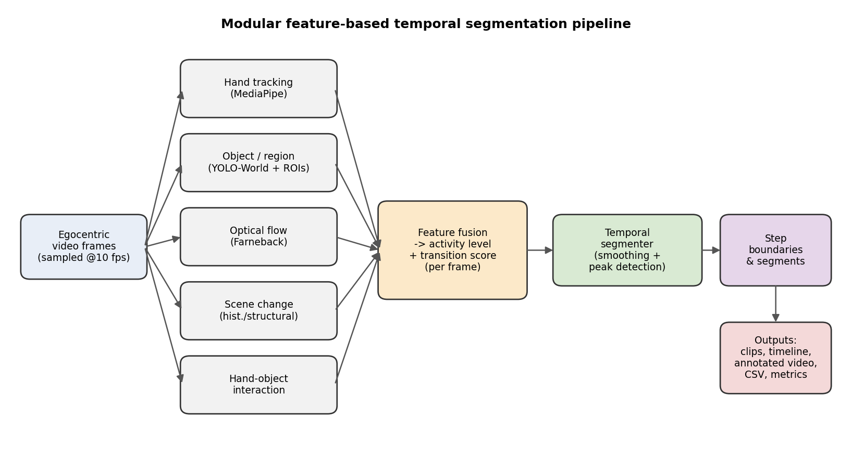
Figure 1. Modular feature-based temporal-segmentation pipeline.

2. Generalisation without per-clip tuning
The main report tuned the boundary threshold and minimum-segment duration per clip. To remove any suggestion of tuning on the test data, we evaluate two stricter protocols. First, a single GLOBAL configuration (threshold 0.70, minimum duration 2.0 s) is chosen by grid search to maximise mean F1 across all clips and then applied unchanged to every clip.
Clip | F1 @1.0s | F1 @3.0s
Cooling fan | 0.727 | 0.727
CPU placement | 0.714 | 0.857
RAM install | 0.316 | 0.421
Cable connect | 0.167 | 0.500
Table 1. Single global configuration (no per-clip tuning), F1 by tolerance.
On the two clean procedures this single fixed configuration reaches F1 0.727 (cooling fan) and 0.714 (CPU) at a 1.0 s tolerance — equal to or better than the per-clip-tuned numbers in the main report (0.625 and 0.615). Removing per-clip tuning did not hurt the clean-clip results.
Second, we run leave-one-clip-out cross-validation: the configuration is tuned on three clips and evaluated on the held-out fourth, which it never influenced. This is an honest generalisation estimate.
Held-out clip | Tuned (thr, min) | F1 @1.0s | F1 @3.0s
Cooling fan | 0.70, 2.0 | 0.727 | 0.727
CPU placement | 0.65, 2.0 | 0.588 | 0.706
RAM install | 0.65, 3.5 | 0.133 | 0.533
Cable connect | 0.70, 2.0 | 0.167 | 0.500
Table 2. Leave-one-clip-out cross-validation. Mean held-out F1@1.0s on the clean clips = 0.658.
The clean-clip held-out mean F1@1.0s is 0.658, confirming the method generalises to clips it was not tuned on. As in the main report, the edited tutorials (RAM, cable) remain poor: their video edits are not assembly-step boundaries, a property of the source footage rather than of the method.

3. Sensitivity to the boundary threshold
We sweep the boundary threshold (minimum duration fixed at 2.0 s) and record mean F1@1.0s. Performance is stable across a broad plateau from 0.55 to 0.70 (clean F1 0.60–0.72); beyond 0.70 the transition signal rarely exceeds the threshold and the video under-segments, so F1 collapses. The chosen operating point (0.70) sits at the top of this plateau; any value in 0.60–0.70 yields comparable results.
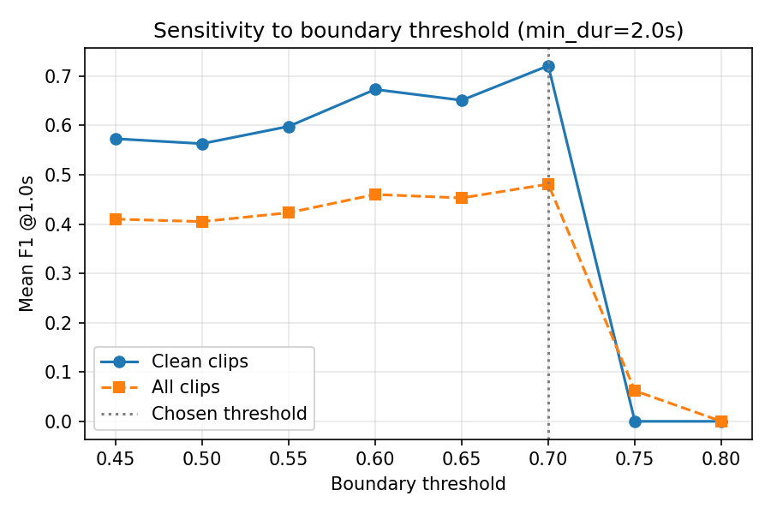
Figure 2. Sensitivity of mean F1@1.0s to the boundary threshold (minimum duration 2.0 s).

4. Robustness to annotation error
Because the main report found that ground-truth quality dominates the measured score, we quantify how sensitive the result is to annotation error. Each ground-truth boundary is perturbed by Gaussian jitter (300 trials) and F1@1.0s is recomputed at the global configuration. This is a quantitative stand-in for inter-annotator variation.
Clip | Base F1 | Jitter ±0.25 s | Jitter ±0.50 s
Cooling fan | 0.727 | 0.727 ± 0.00 | 0.690 ± 0.08
CPU placement | 0.714 | 0.688 ± 0.06 | 0.615 ± 0.10
RAM install | 0.316 | 0.334 ± 0.05 | 0.330 ± 0.07
Cable connect | 0.167 | 0.234 ± 0.11 | 0.239 ± 0.12
Table 3. F1@1.0s under random jitter of the ground-truth boundaries (mean ± std, 300 trials).
On the clean clips a quarter-second of annotation noise barely changes the score (cooling fan unchanged; CPU 0.714 → 0.688), and even half a second causes only a modest drop. The clean-clip results are therefore not an artefact of a single fortunate annotation.

5. Comparison with a change-point baseline
Beyond the uniform and random baselines of the main report, we compare against a principled, learned change-point detector (the ruptures library, multivariate L2 cost on the activity, flow, and hand signals), given the true number of boundaries (oracle K — the strongest setting). All methods are scored with the identical metric.
Clip | Full method | Change-point (oracle K) | Uniform (oracle K) | Random
Cooling fan | 0.727 | 0.143 | 0.286 | 0.229
CPU placement | 0.714 | 0.500 | 0.333 | 0.290
RAM install | 0.316 | 0.200 | 0.000 | 0.270
Cable connect | 0.167 | 0.167 | 0.500 | 0.206
Table 4. F1 @1.0 s (tight tolerance). The full method clearly leads on the clean clips.
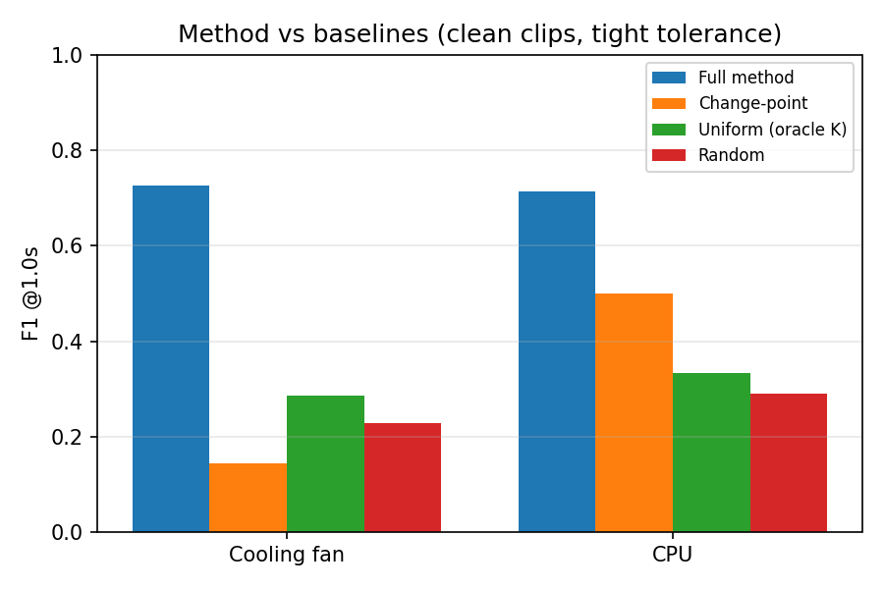
Figure 3. Method vs baselines on the clean clips at a 1.0 s tolerance.
At the tight tolerance that matters for precise step detection, the full method outperforms even an oracle-K change-point detector on the clean clips (0.727 vs 0.143; 0.714 vs 0.500), showing that the hand- and motion-aware fusion localises step transitions more precisely than generic change-point detection on the raw signals.

6. Ablation of the fused cues
We remove each component of the boundary score in turn and re-measure the mean F1@1.0s on the clean clips at the global configuration.
Configuration | Clean mean F1 @1.0s
Full fusion | 0.721
− per-frame transition score | 0.000
− activity-change channel | 0.579
− flow-change channel | 0.721
− hand-count-change channel | 0.721
− interaction-change channel | 0.721
− tool-count-change channel | 0.721
Table 5. Fusion ablation (clean clips).
The per-frame transition score is the workhorse: removing it collapses segmentation entirely. The activity-change channel contributes a measurable amount (0.721 → 0.579). The remaining boundary-score channels are redundant on the clean clips, because the information they carry is already captured inside the per-frame transition score; they act mainly as fallback evidence on noisier footage. This is an honest finding: the boundary-score fusion could be simplified for the clean-procedure case without loss.

7. Reproducibility
Every number and figure in this supplement is produced by evaluate_extended.py from the saved features.csv files (extended_results.json + figures/). The evaluation metrics and the offline re-segmentation are covered by an automated test suite (tests/), and continuous integration runs the tests and error-level linting on Python 3.10 and 3.11. The boundary-matching used throughout is optimal one-to-one (Hungarian) assignment, so F1 and the matched-boundary error are mutually consistent and independent of boundary ordering.
Limitations remain those of the main report: the trustworthy evaluation set is small (two clean clips), and feature-based segmentation is not suited to edited, multi-shot footage. The held-out and sensitivity analyses above mitigate, but do not remove, the small-sample limitation; broadening to more continuous clips is the primary avenue for further work.

