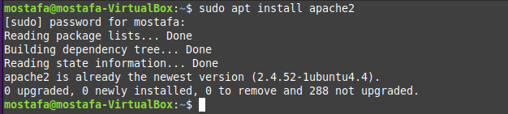

sudo nano myFile.html

sudo mv myFile.html index.html

sudo system restart apache2



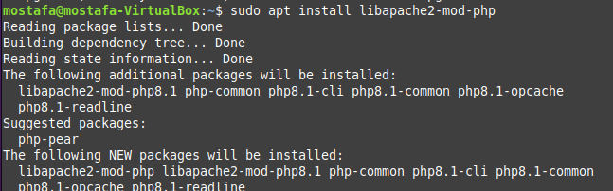

sudo nano /etc/apache2/sites-available/admin_lab4.conf

sudo a2ensite admin_lab4.conf

sudo systemctl reload apache2