Part 1:

1-open mongo shell and view the help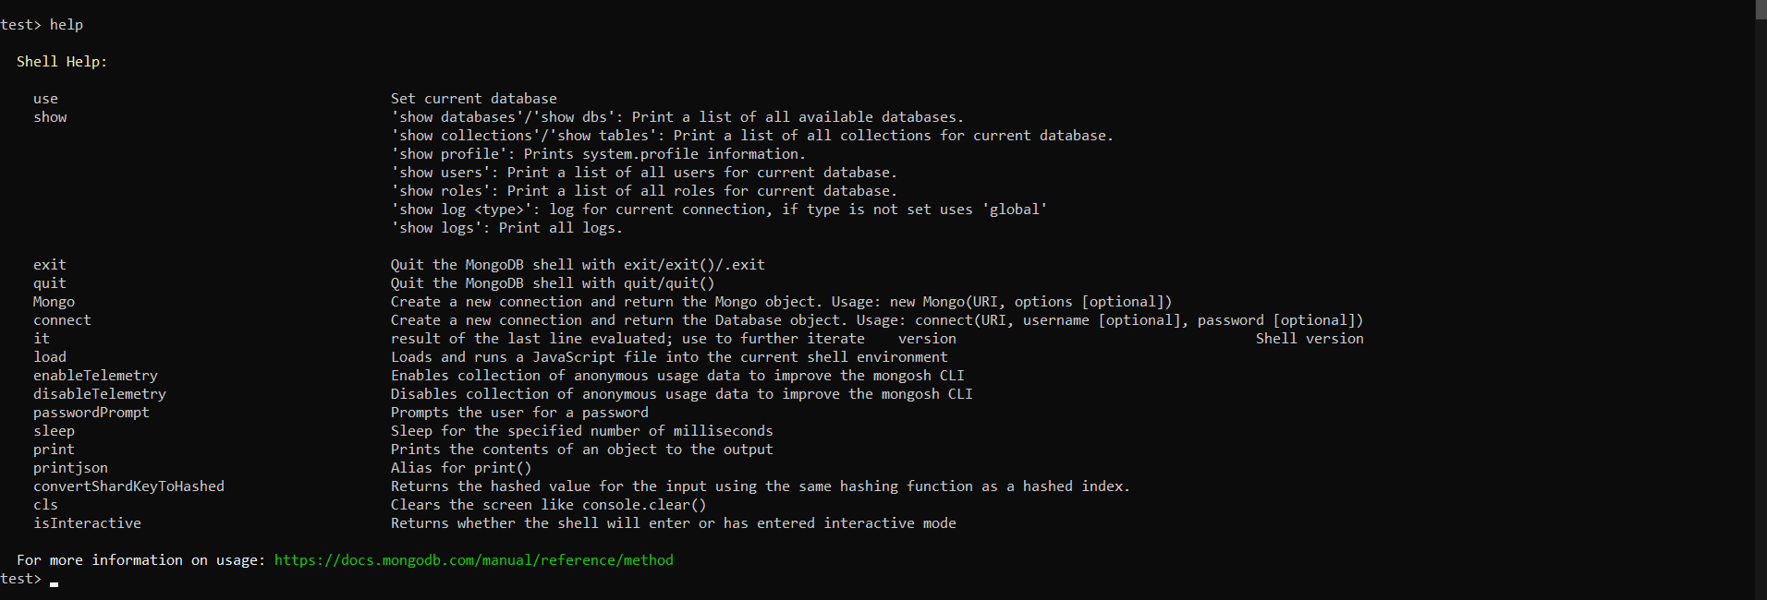

2-identify your current working database and show list of available databases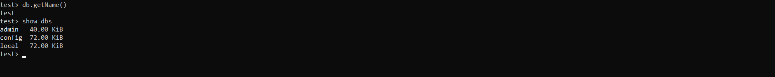

3-create a new database called iti and create a collection named “students”. Insert whatever data you want about yourself (include name and age in your details).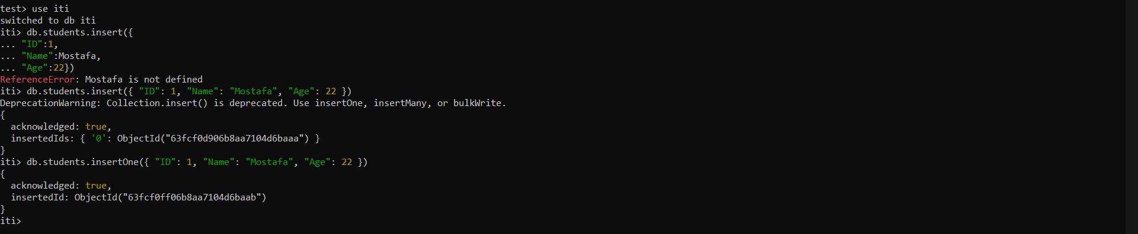

4-show list of available databases. What did you notice ? 

5-Insert un-structured or semi-structured data for 10 of your friends (include name and age in your details. The documents should have different types of data i.e. arrays, strings, documents, integers).

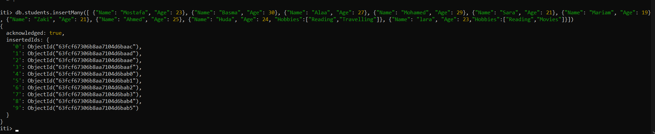

6-Search for your object by name.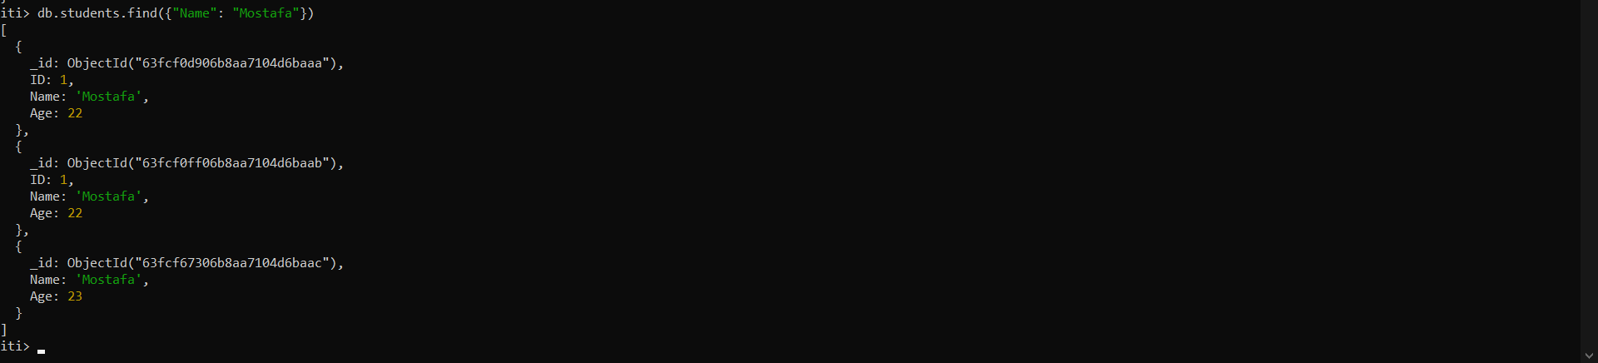

7-Search for your friend(s) by age.

8-Search for all of your friends whose age is older than yours. 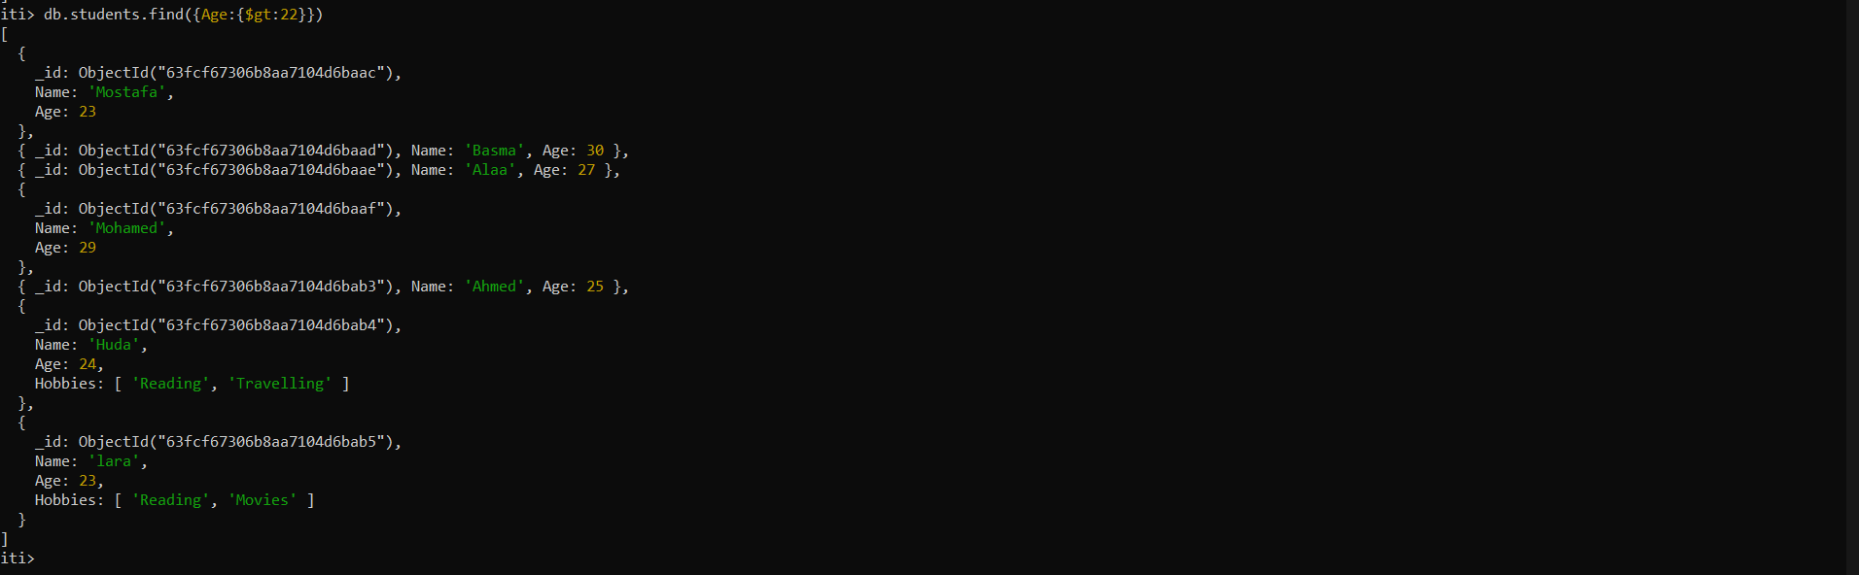

9-delete any of your friends by id.



10-view all documents in students collection in a prettified format.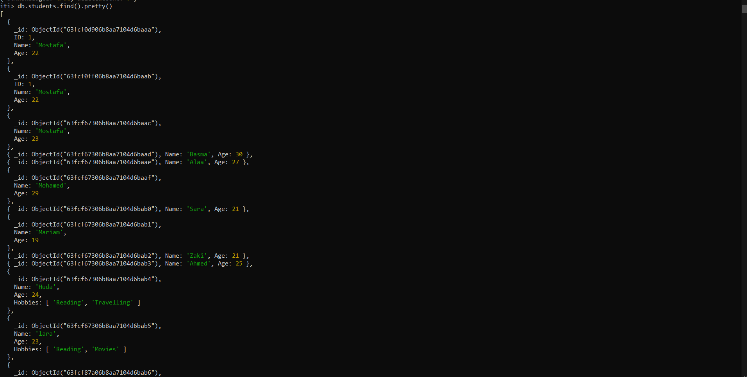

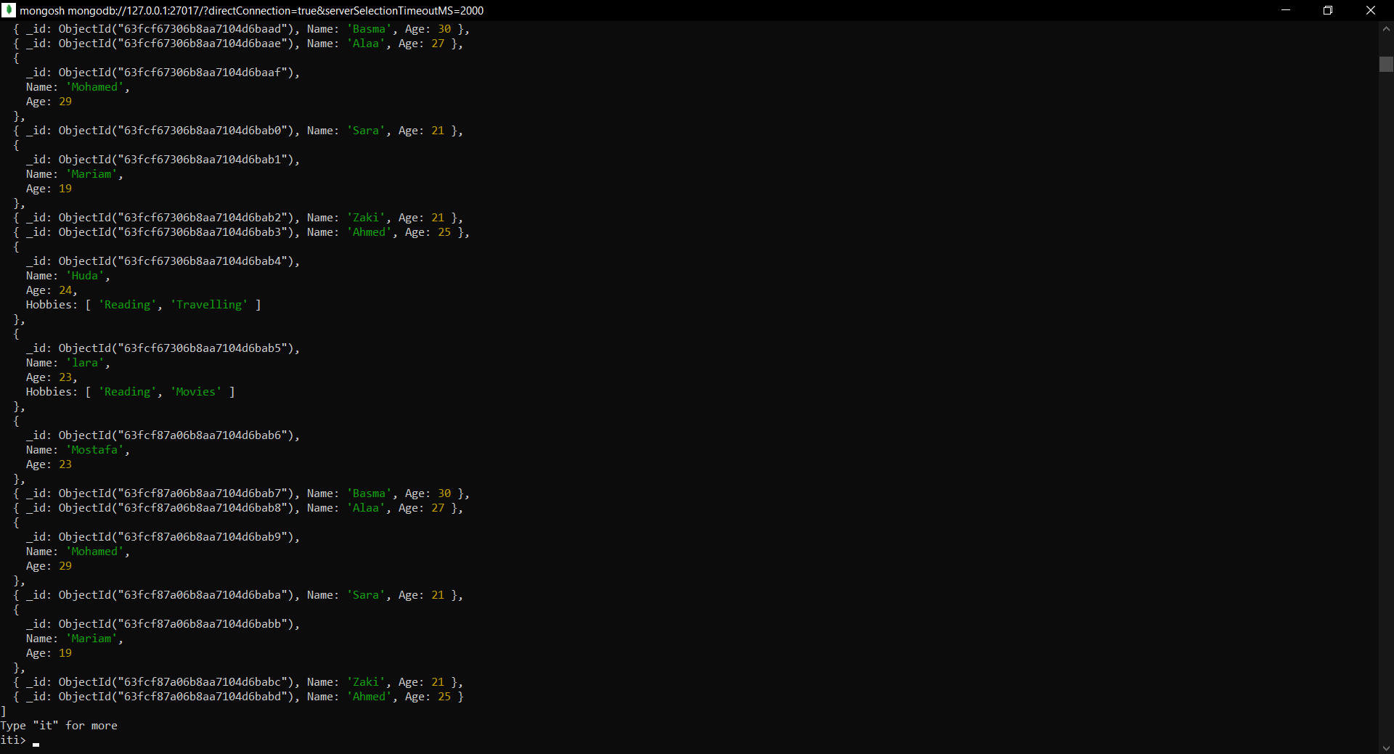

11-count all documents in students collection.

Part 2:

1-Create database with name ems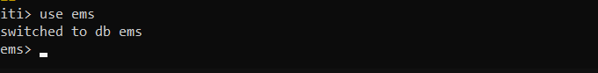

2-Insert the following data into "faculty" collection.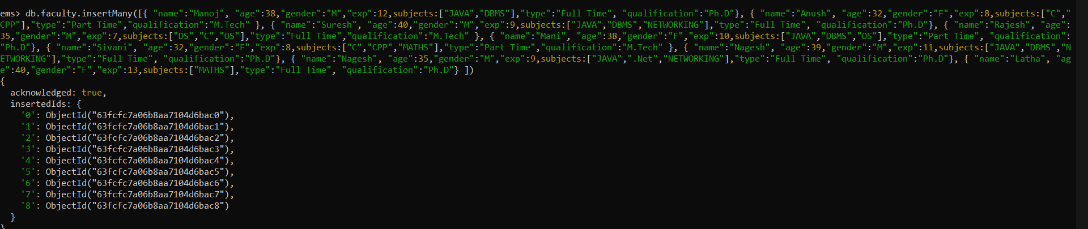

2.1-Get the details of all the faculty.

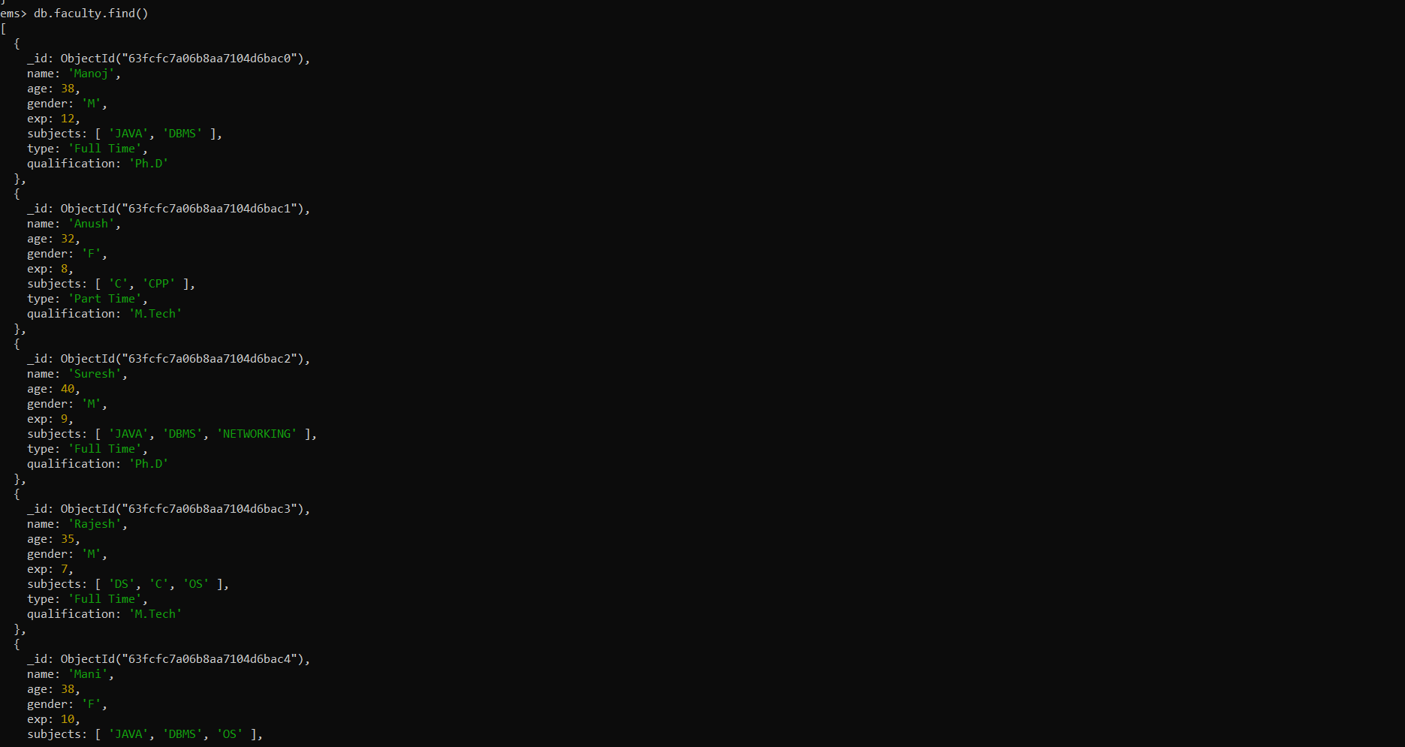

2.2-Get the count of all faculty members. 

2.3-Get all the faculty members whose qualification is “Ph.D”. 

2.4-Get all the faculty members whose experience is between 8 to 12 years.

2.5-Get all the faculty members who teach “MATHS” or “NETWORKING”. 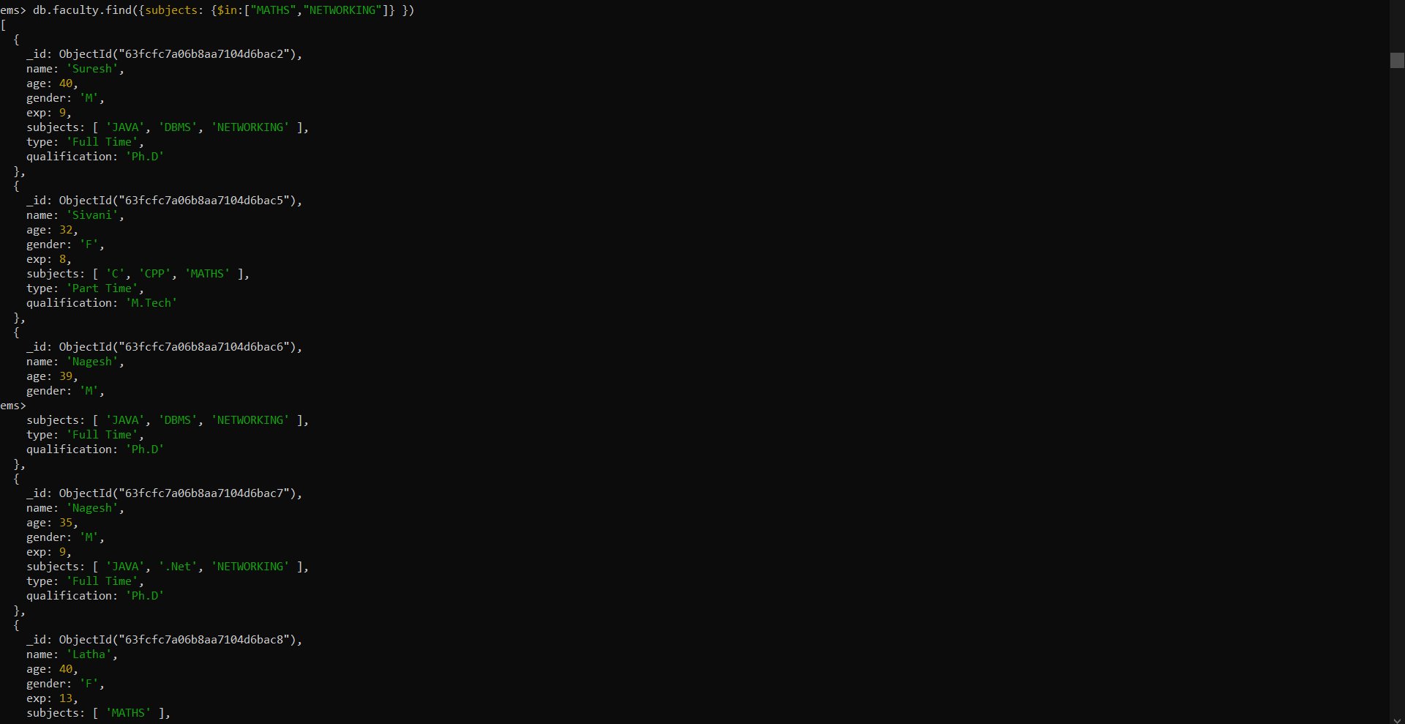

2.6-Get all the faculty members who teach “MATHS” and whose age is more than 30 years and qualification must be “Ph.D”.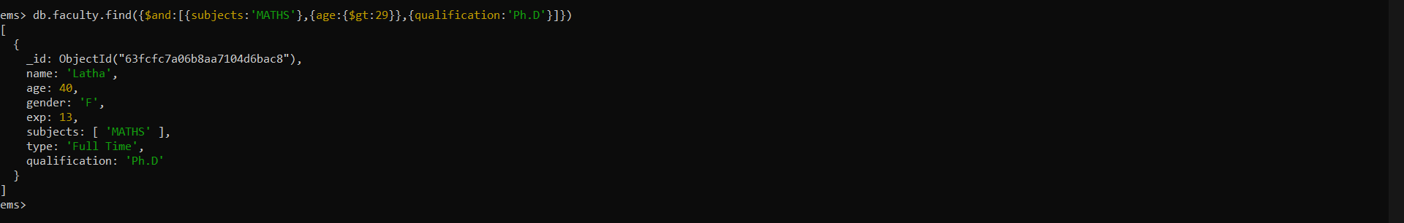

2.7-Get all the faculty members who are working part-time or who teach “JAVA”.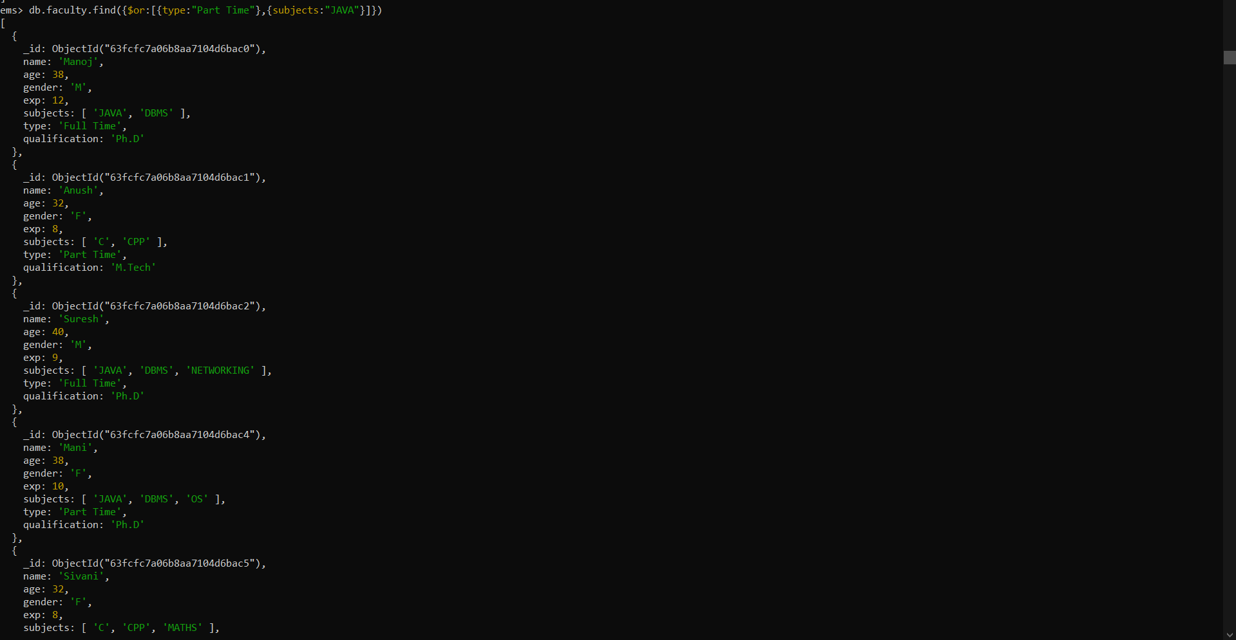

2.8-Add the following new faculty members:{ "name":"Suresh Babu", "age":55,"gender":"M","exp":25,subjects:["MATHS","DE"],"type":"Full Time", "qualification":"Ph.D"}



2.9-Update the data of all faculty members by incrementing their age and exp by one year.

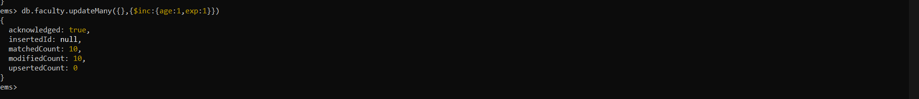

2.10-Update the faculty “Sivani” with the following data: update qualification to “Ph.D” and type to “Full Time”.

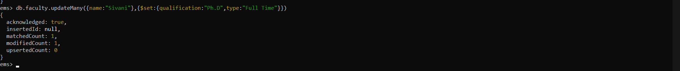

2.11-Update all faculty members who are teaching “MATHS” such that they should now also teach “PSK”.

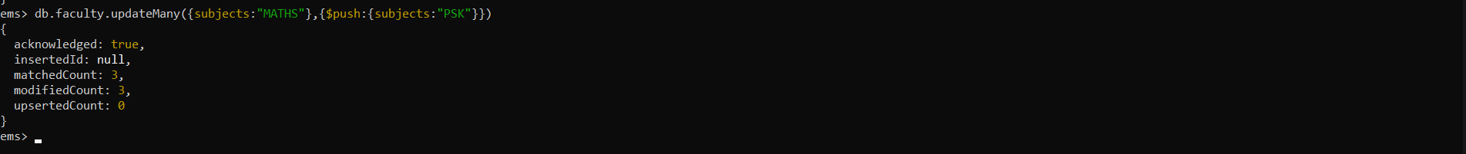

2.12-Delete all faculty members whose age is more than 55 years.



2.13-Get only the name and qualification of all faculty members.

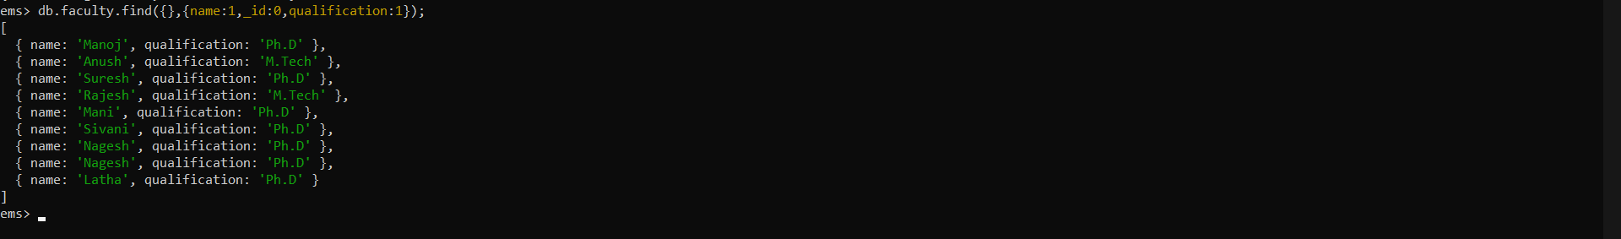

2.14-Get the name, qualification and exp of all faculty members and display the same in ascending order of exp.

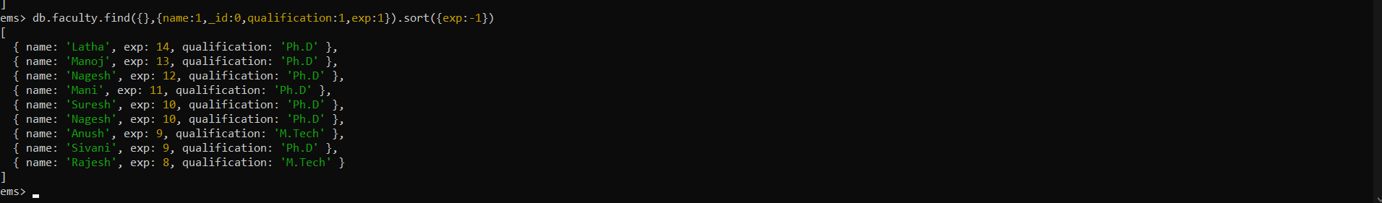

2.15-Sort the faculty details by their age (descending order) and get the details of the first five faculty members only.

