**Geographical Information Systems**

**Assignment 1**

Student Name: Mostafa Mohamed Mostafa Elgendy

Student ID: 20190543

Group No.: IS-S1

**Q1:**  This graphic represents the *Tools* toolbar. Hover your mouse pointer over each tool to see what it is named. Match the name with each tool’s icon.

|  |  |  |
| --- | --- | --- |
| A) Zoom In  B) Fixed Zoom In  C) Pan  D) Go Back To Previous Extent  E) Select Features  F) Select Elements  G) Find  H) Measure  I) HTML Popup |  | J) Zoom Out  K) Fixed Zoom Out  L) Full Extent  M) Go To Next Extent  N) Clear Selected Features  O) Identify  P) Go To XY  Q) Hyperlink  R) Create Viewer Window |

**Q2:** According to the Identify tool, what is the area of El Dokki and what is your location in Degrees Minutes, Seconds and in Meters?

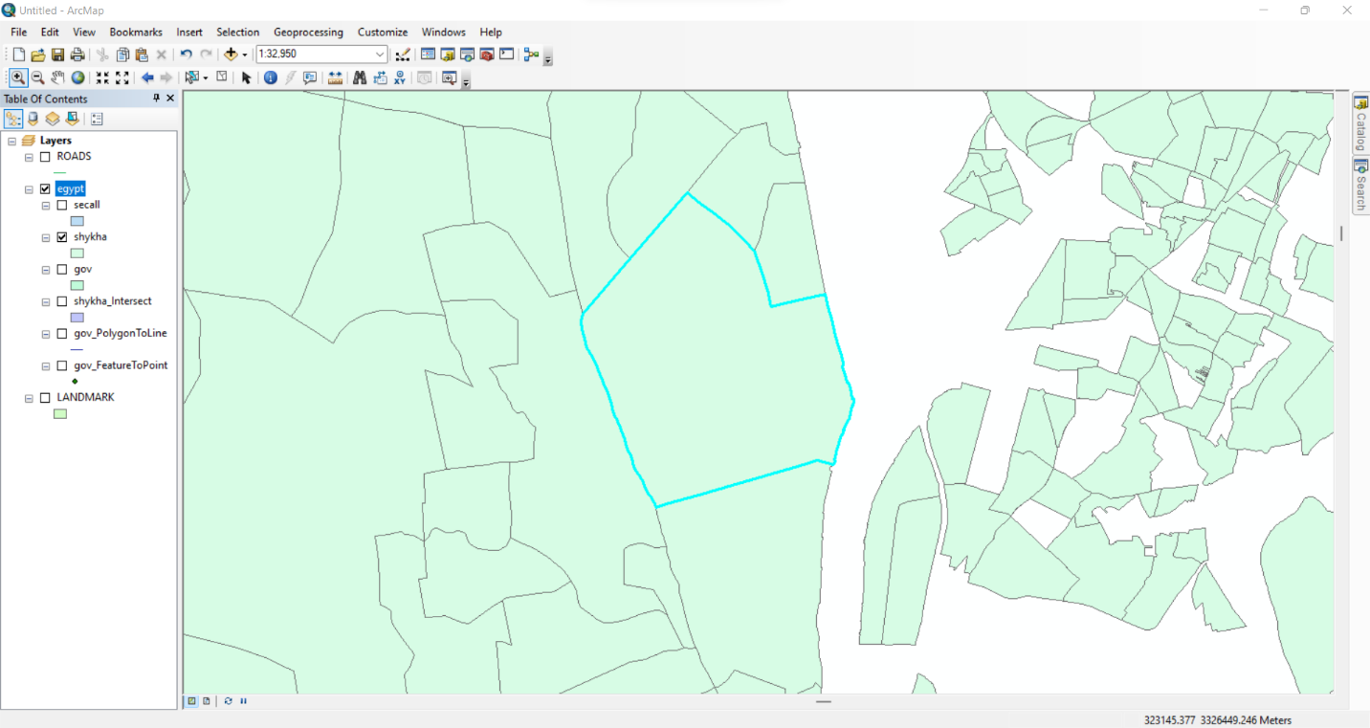Answer:

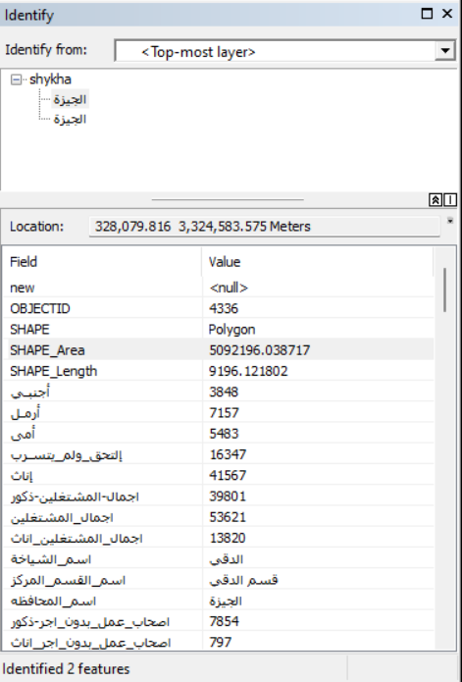SHAPE_Area: 5092196.038717

Location in Meters : 327,609.039 3,324,574.857 Meters

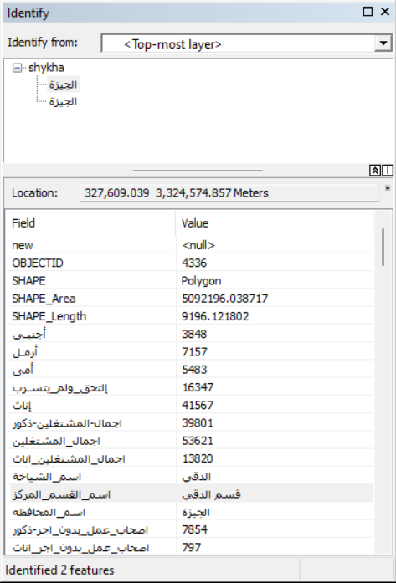

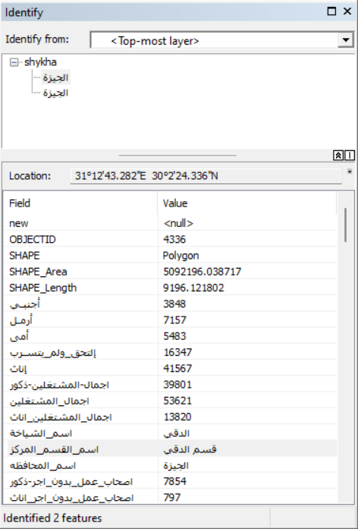Location Degree,Minutes and Seconds : 31°12'43.282"E 30°2'24.336"N

**Q3** Using the line measurement tool, how long is Eltahrir street in Km?

Answer:

Length for **ALL ELTahrir Street** IN KM : 16.719969 KM

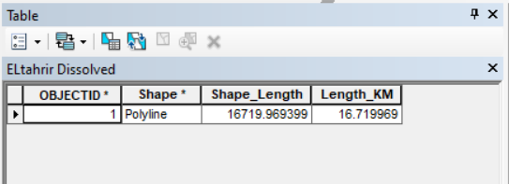

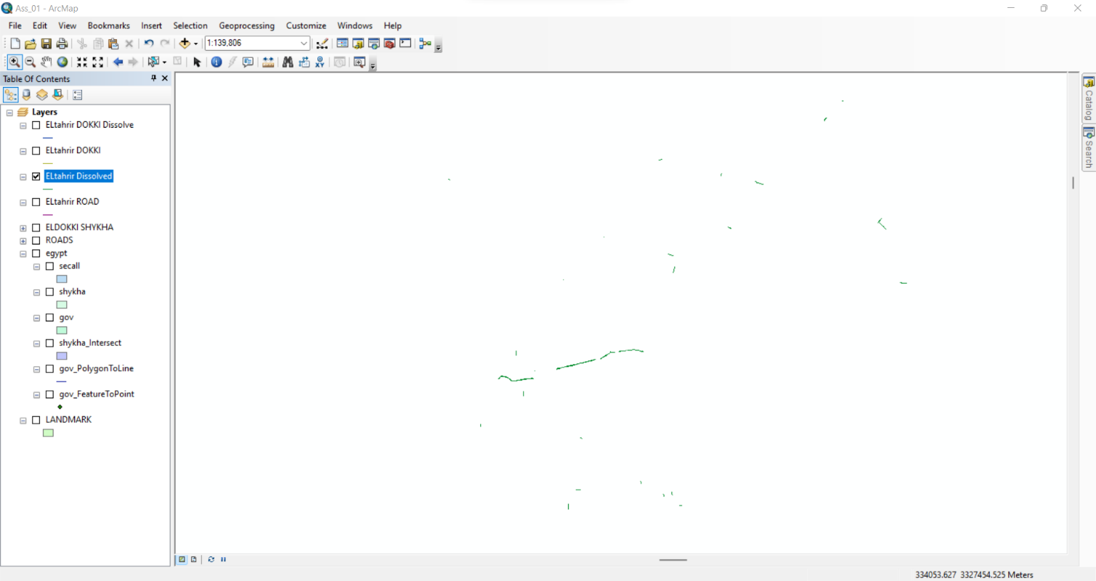

Length of ELTahrir Street in **DOKKI ONLY** IN KM : 4.455219 KM

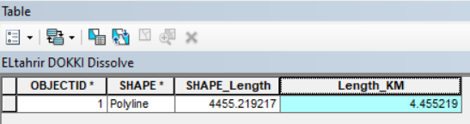  
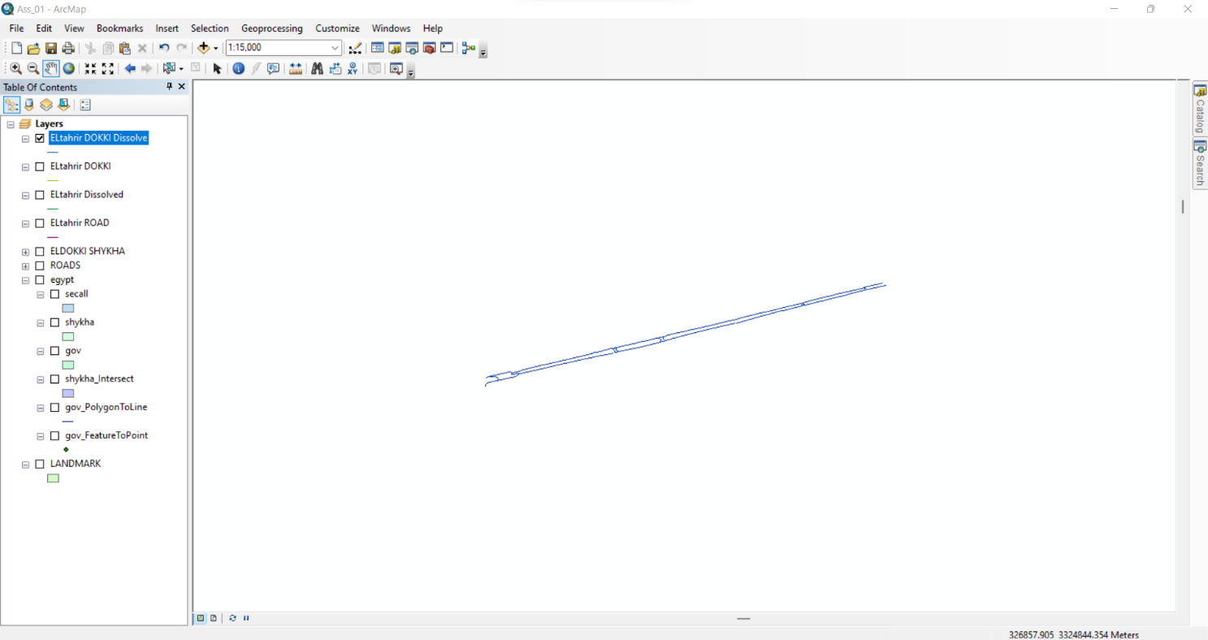

**Q4** Using the polygon measurement tool, what is the Area of “نادى الصيد” in Km square?

Answer:

Area of “نادى الصيد” in Km square : 0.060533 Square KM

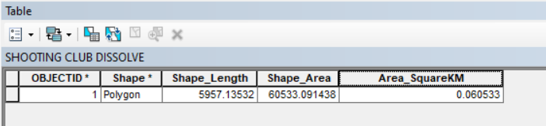

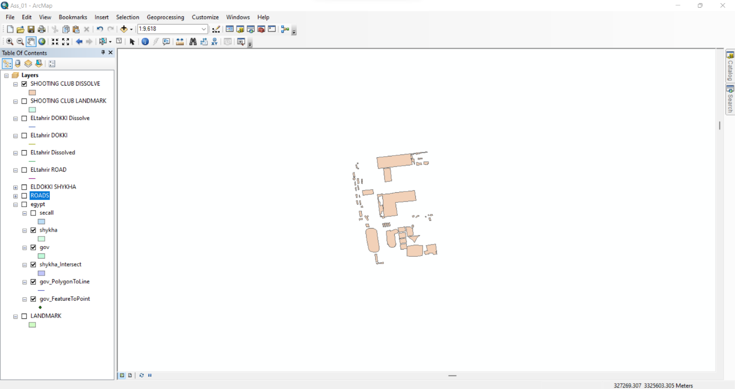

**Q5** The “Shape_area” Field explains the area of each bank in eldokki. How many Banks Located in Eldokki?

Answer:

There are 52 Banks in DOKKI

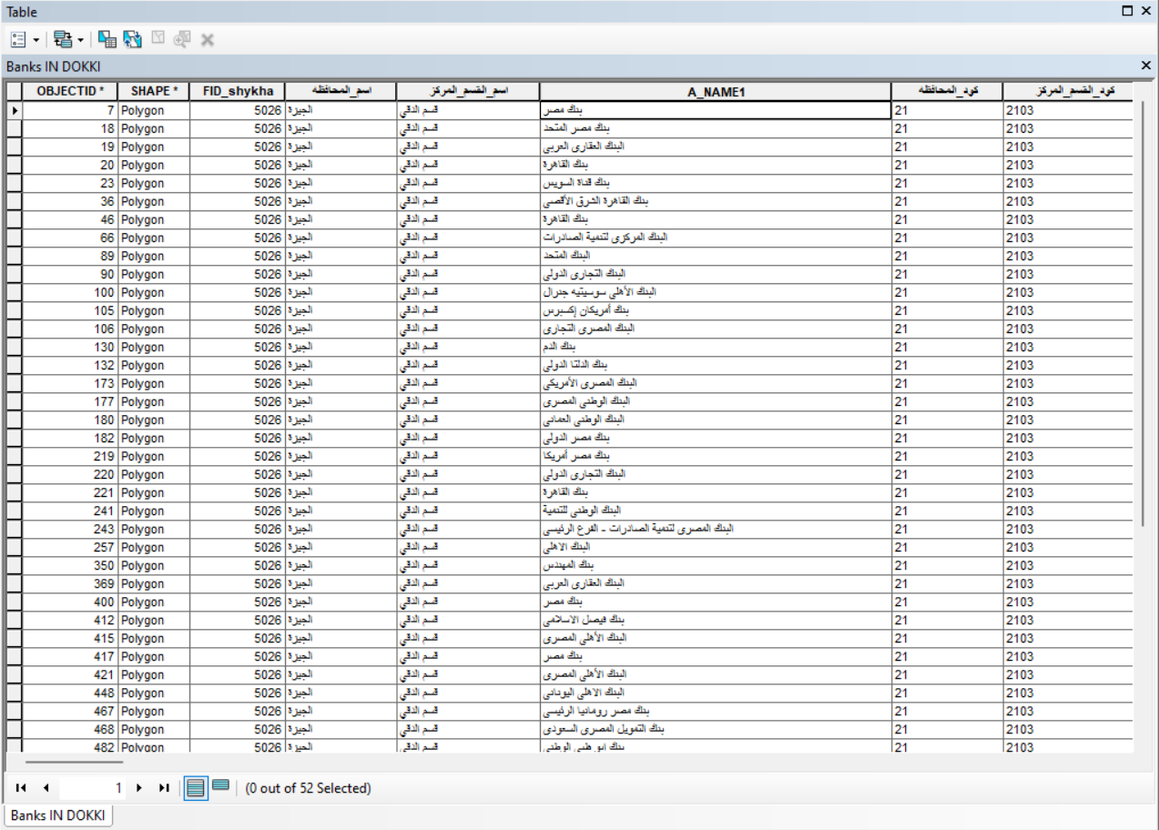

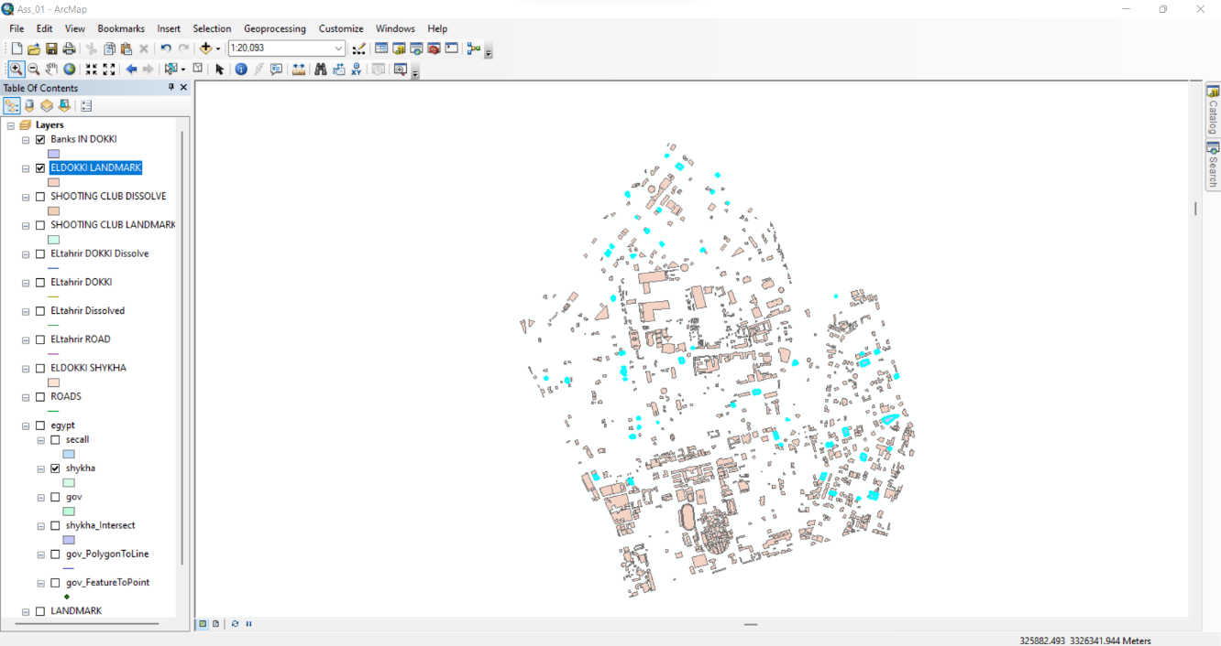

**Q6:** Using the Select Features tool, click on some of the schools on Eldokki. Notice that selected features appear outlined in cyan. Make print screen for this selected school

Answer:

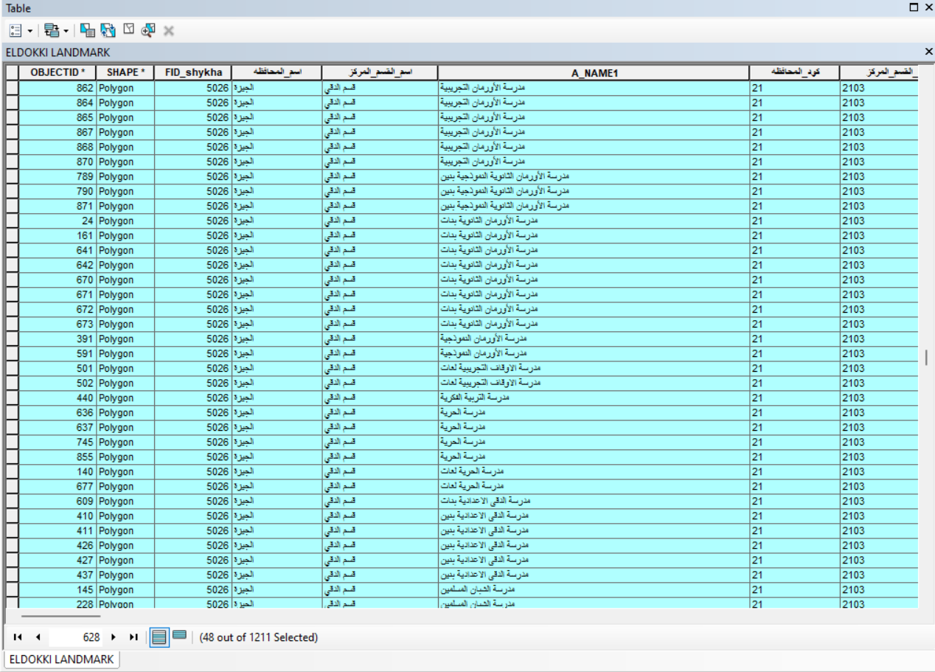Selected Schools From LandMarks of DOKKI:

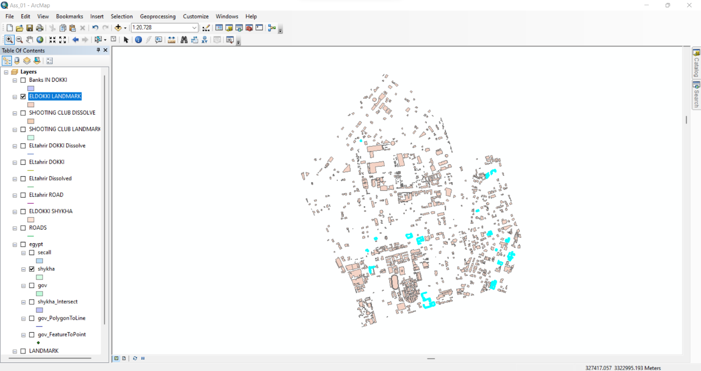Selected Schools On tha Map:

**Q7:** Select all hotels from Landmark layers where the area is >1500m square Print screen of the map with the selecting feature

Answer:

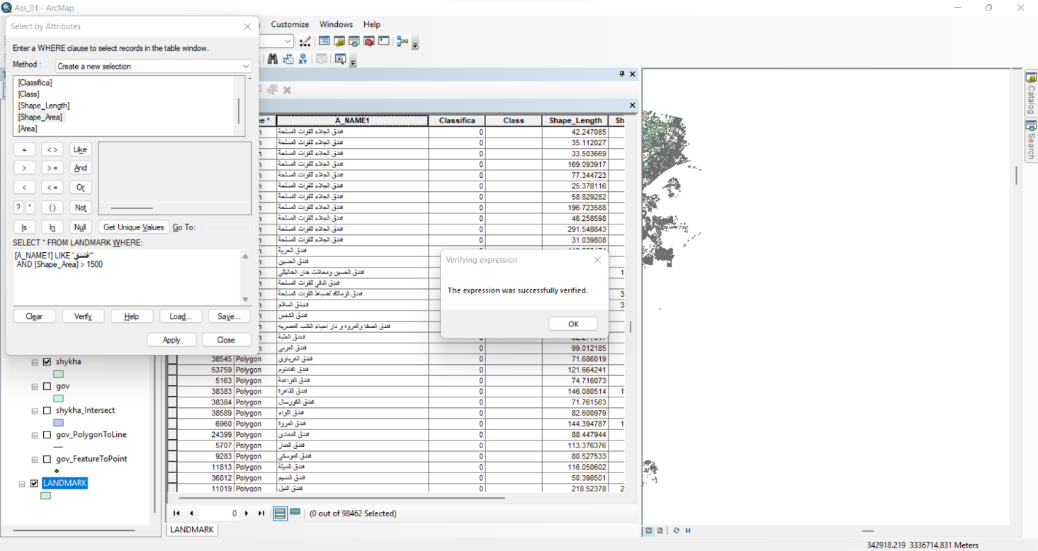

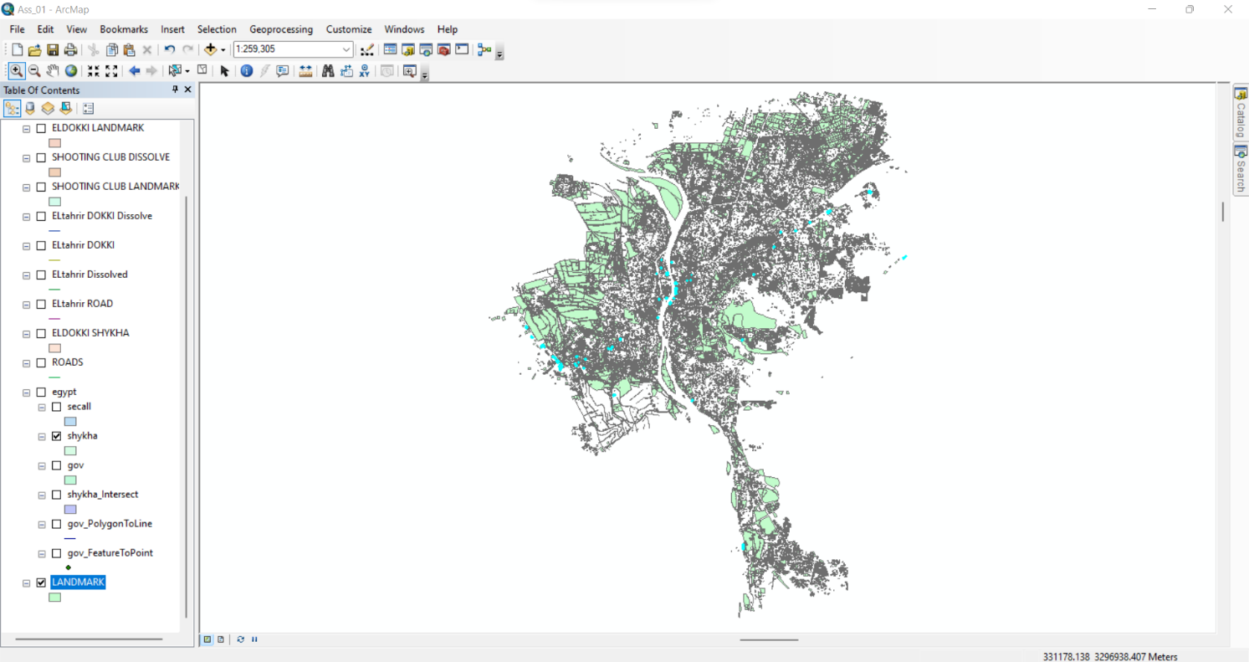

**Q8:** Export your images in JPEG format with resolution 700dpi after putting all map components (verbal scale- north arrow – legend- date of production-Inset and locator map-Neat line-projection-and cartographer)

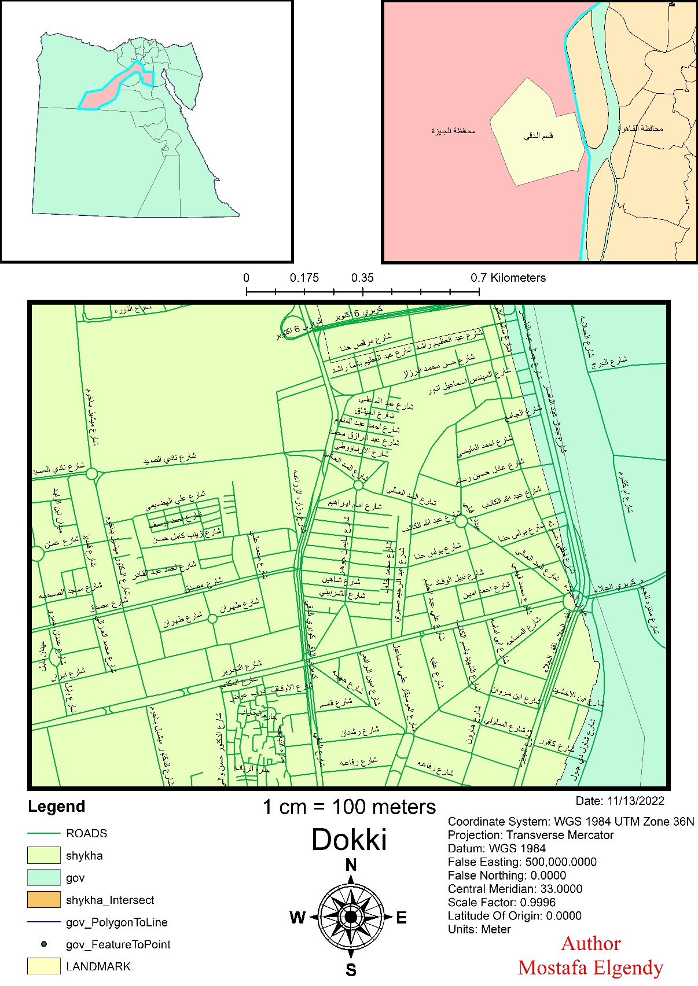Answer:

**Q9:** Using ArcToolbox select all school and export it into Do_school layer convert the Do_school layer into point layer and export your map in PDF format with nominal representation

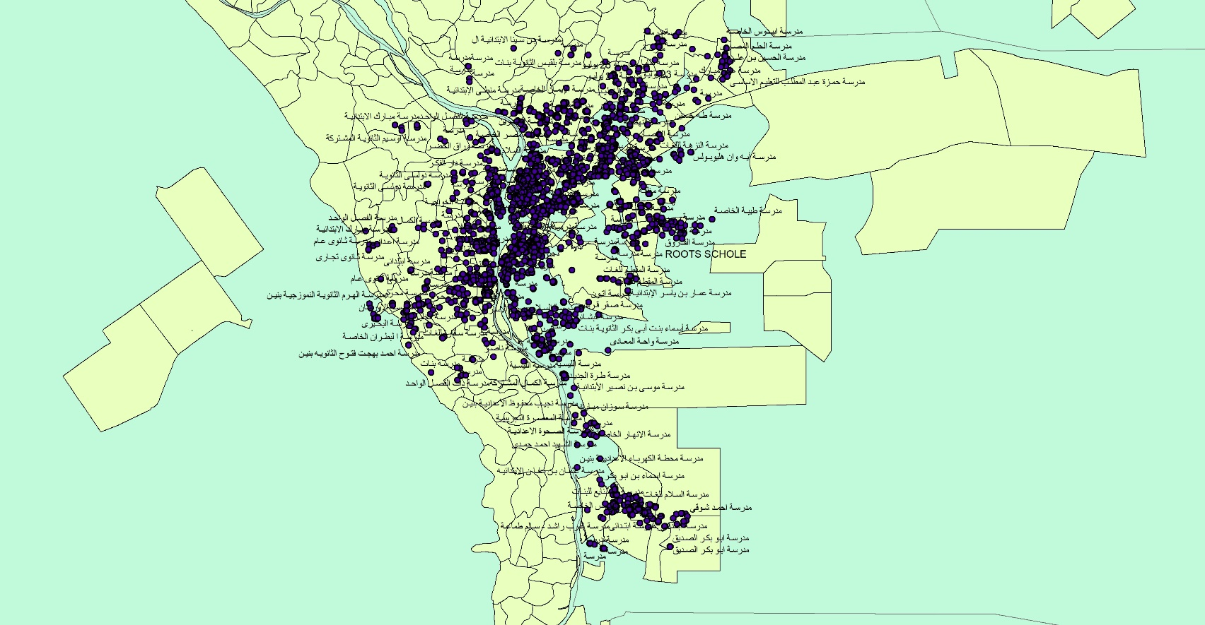Answer: