**Geographical Information Systems**

**Assignment 2**

Student Name: Mostafa Mohamed Mostafa Elgendy

Student ID: 20190543

Group No.: IS-S1

**Intro to Mapping and GIS**

**Lab Exercise #2 Introduction to ArcMap and data query**

**ASSIGNMENT**

**Objective**

The objective of this assignment is to identify an area "أرض فضاء"in which to build new high school in El Dokki District.  This new school must be in an area

1. not within 100 meters of the existing schools
2. not within 500 meters of the existing hospitals
3. not within 500 meters of the existing Clubs
4. within 50 meters of a street
5. with an area of at least 5,000 square meters

**Deliverables**

Turn in a report addressing this objective.  This report should include a map of the potential area(s) in which to build the high school.  A second map should be used to illuminate your methodology, such as the buffers generated in the course of the analysis.

1. **Getting Dokki Shykha**

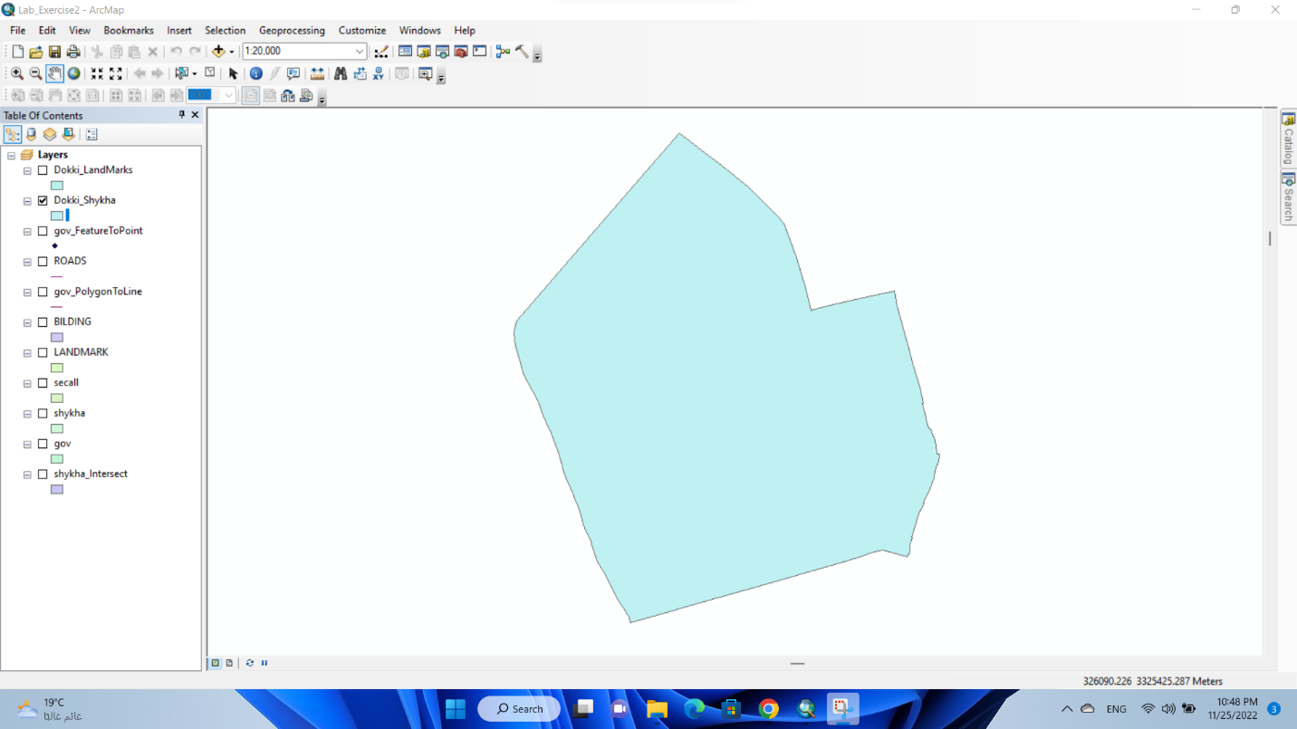

1. **Getting Dokki LandMarks**

By Intersect Layer of LandMarks, Dokki Shykha

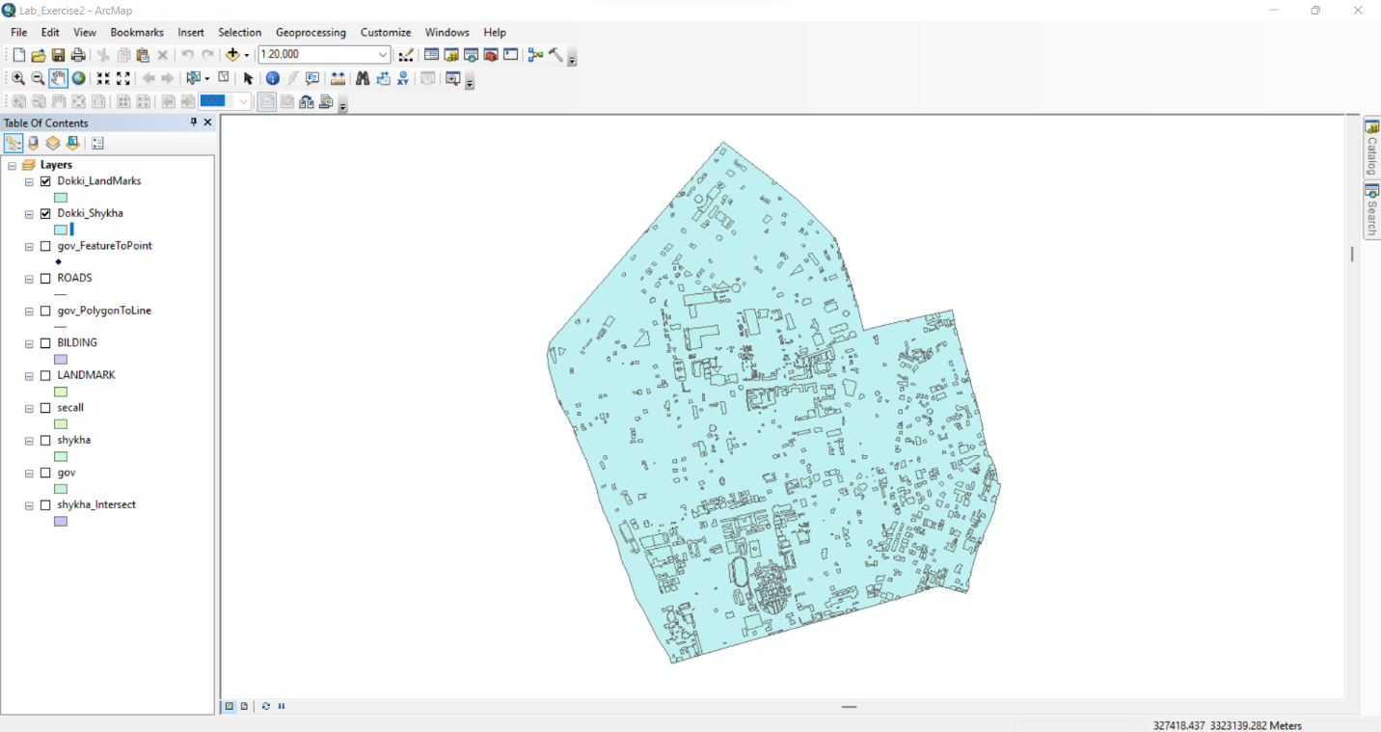

1. **Getting Dokki Schools Layer**

By selection from Layer Dokki LandMarks

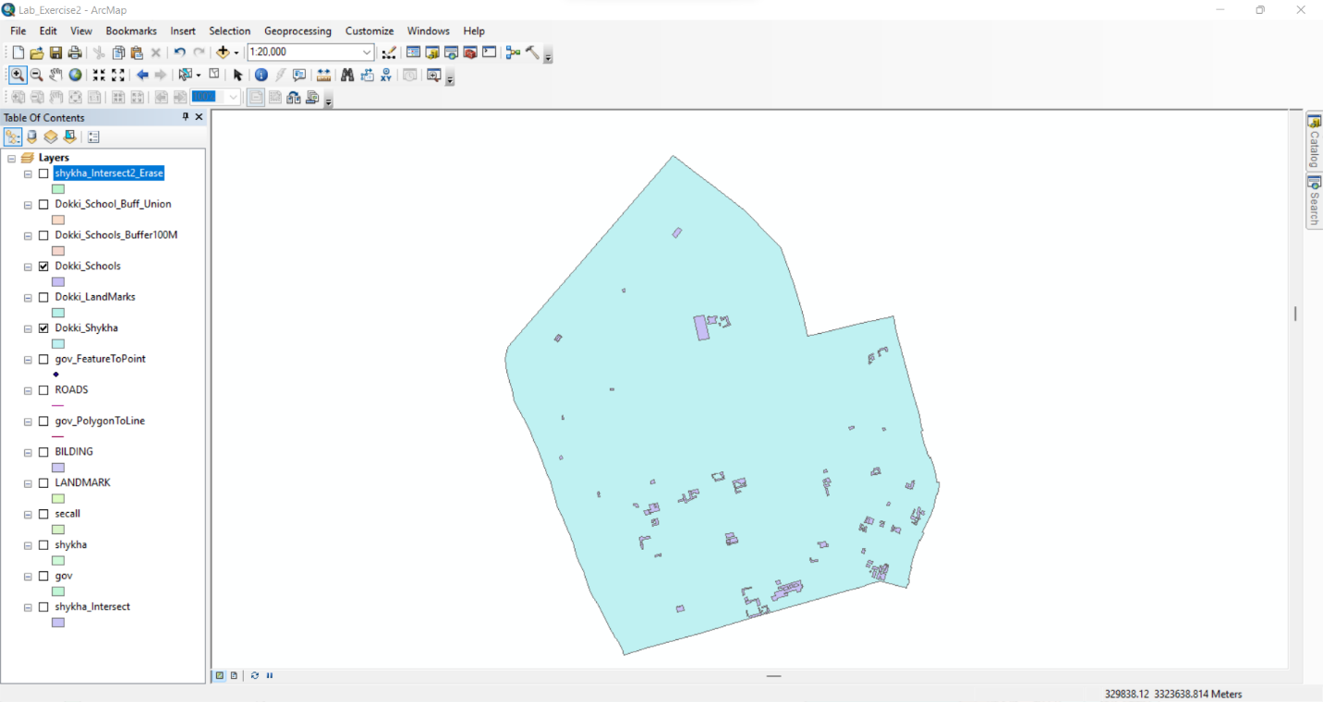

1. **Getting Buffer of Schools with 100 Meters**

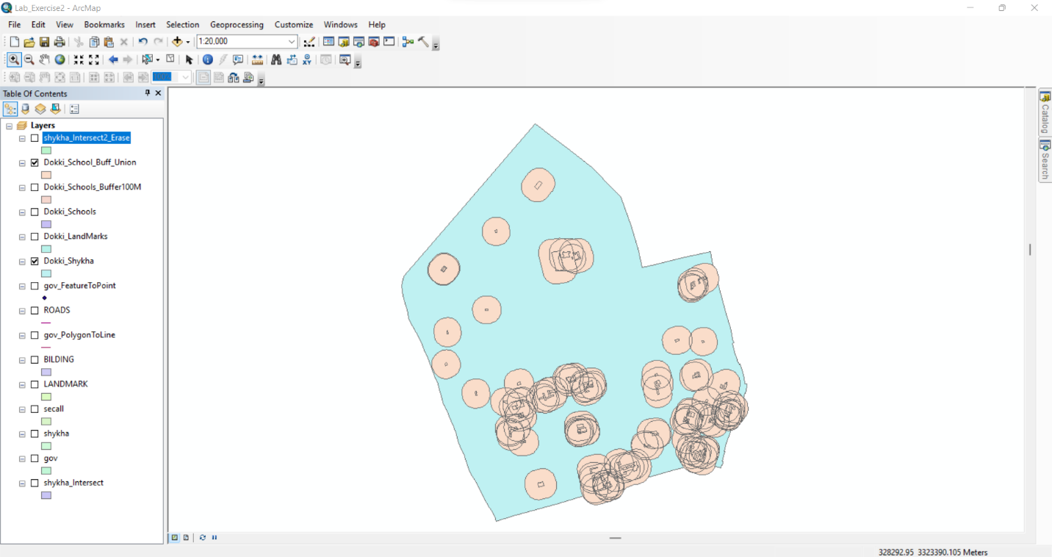

1. **Getting Dokki LandMarks Without Schools Layer**

By Erasing School Buffer from Dokki LandMarks

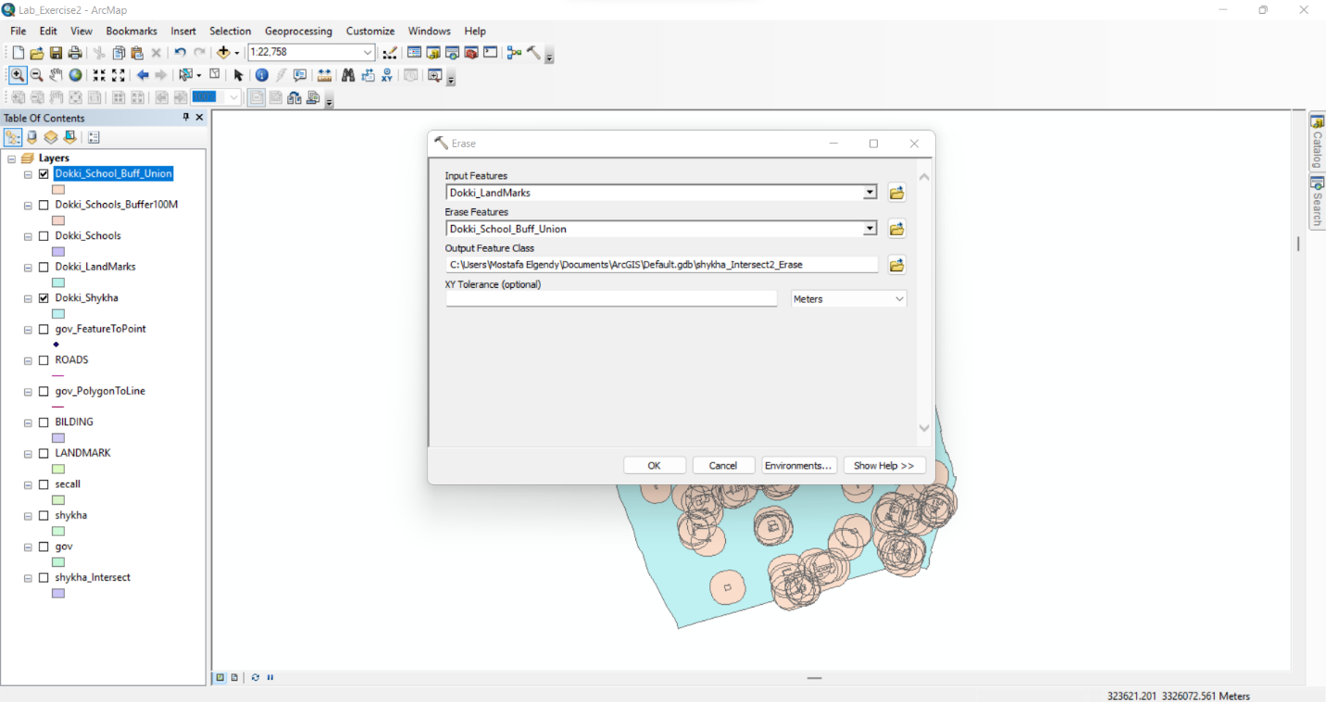

LandMarks After Erasing School Buffer from Dokki LandMarks

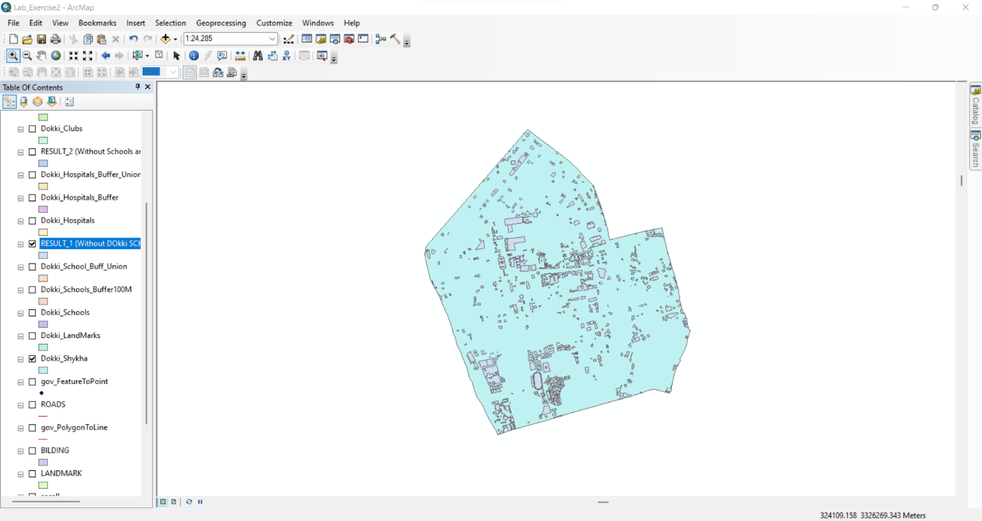

1. **Getting Dokki Hospitals Layer**

By selection from Layer Dokki LandMarks

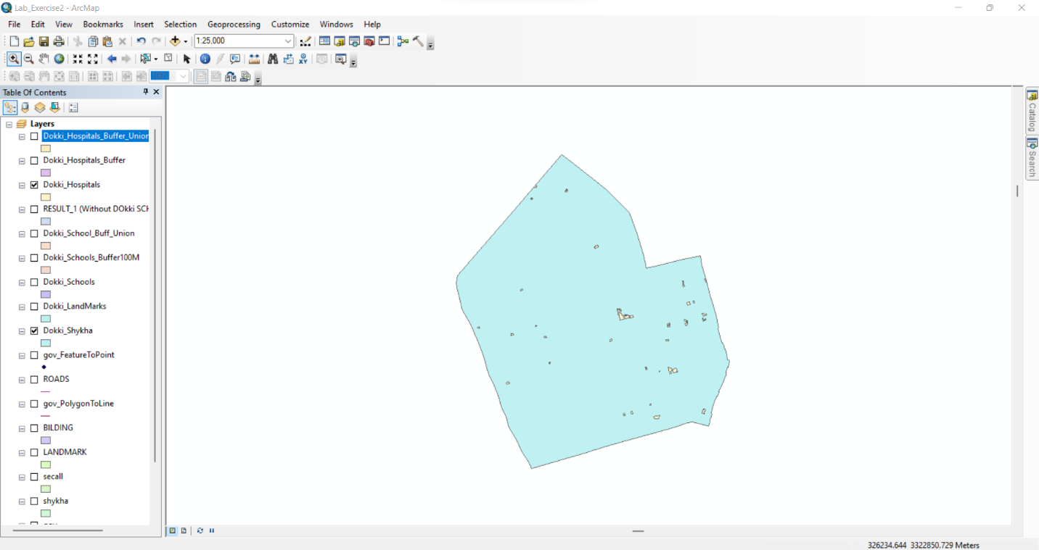

1. **Getting Dokki Hospitals Buffer 500 Meters**

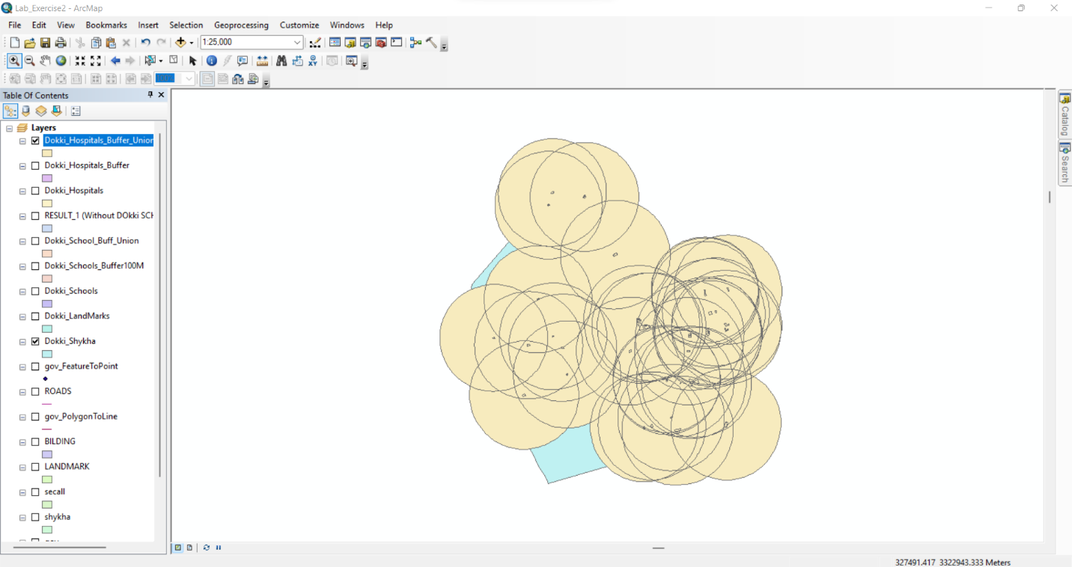

1. **Getting Dokki LandMarks Without Schools and Hospitals Areas**

By Erasing Hospital Buffer from Dokki LandMarks Without Schools Buffer

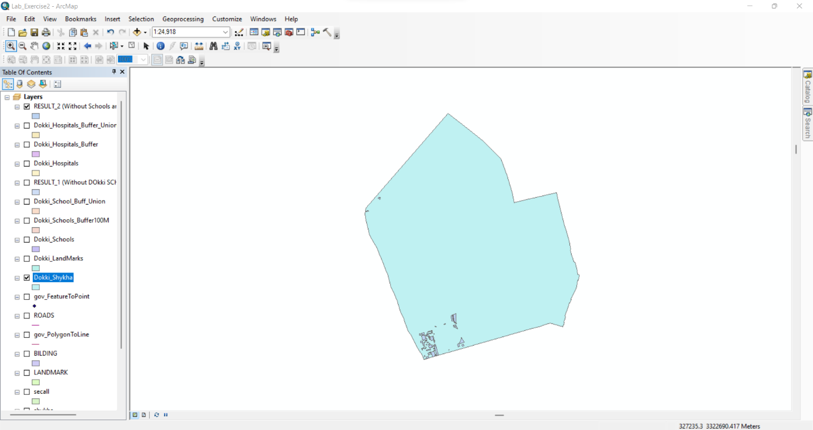

1. **Getting Dokki Clubs**

By selection from Layer Dokki LandMarks

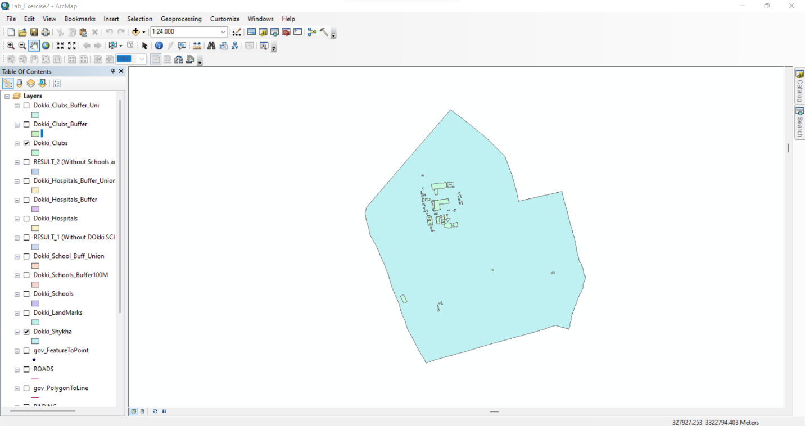

1. **Getting Dokki Clubs Buffer 500 Meters**

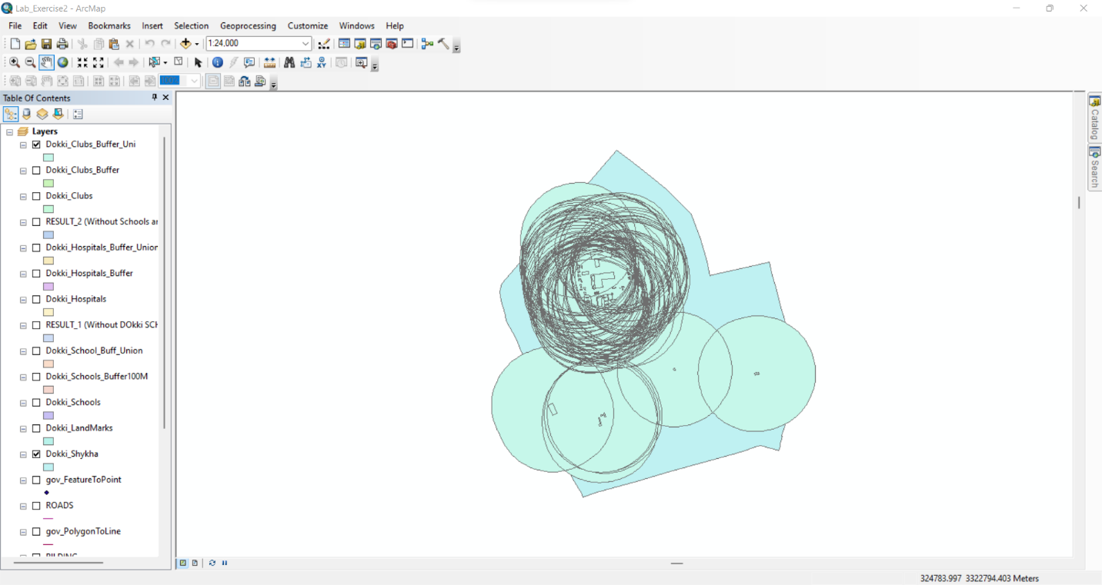

1. **Getting Dokki LandMarks Without Schools and Hospitals, Clubs**

By Erasing Clubs Buffer from Dokki LandMarks Without Schools and Hospitals Buffers

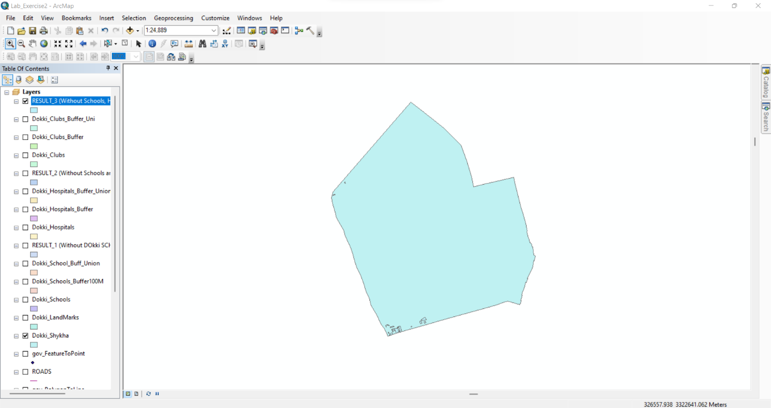

1. **Getting Dokki Roads**

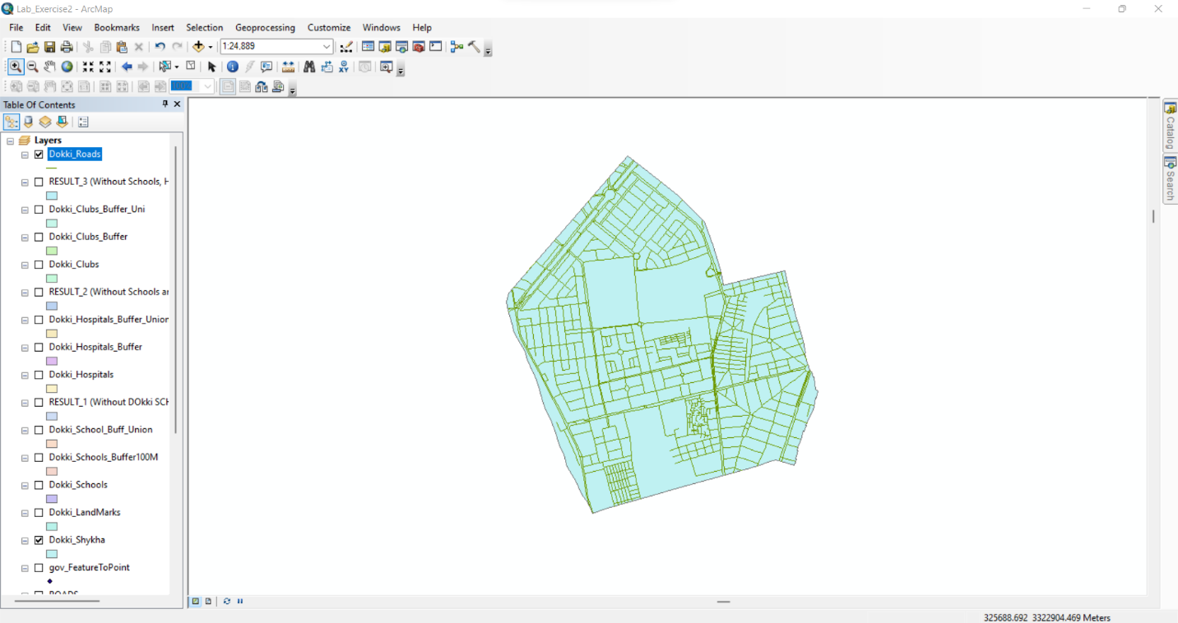

1. **Getting Dokki Roads Buffer 50 Meters**

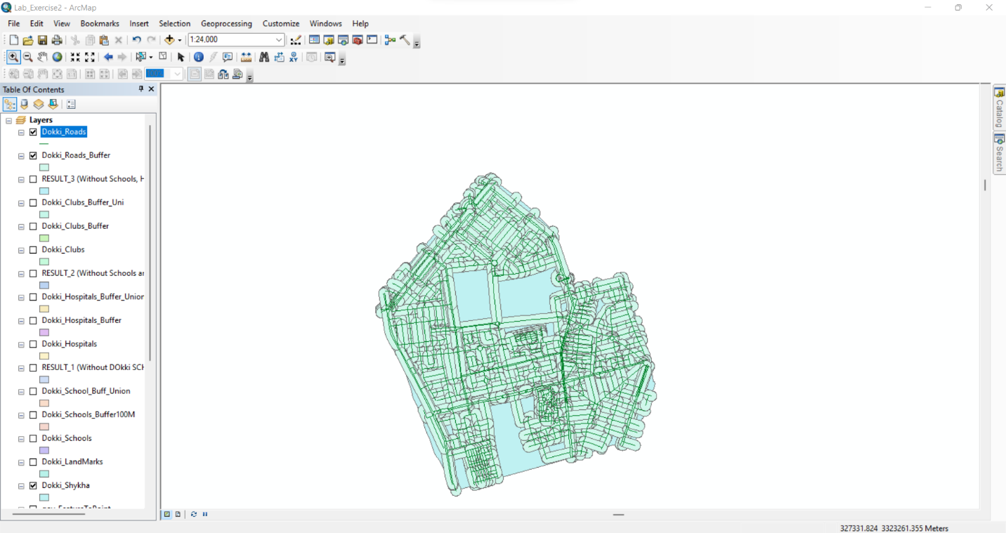

1. **Getting Dokki LandMarks Without Schools and Hospitals, Clubs within 50 Meters of Dokki Roads Buffer**

By intersect Dokki Roads Buffer with Dokki LandMarks Without Schools and Hospitals, Clubs Buffers

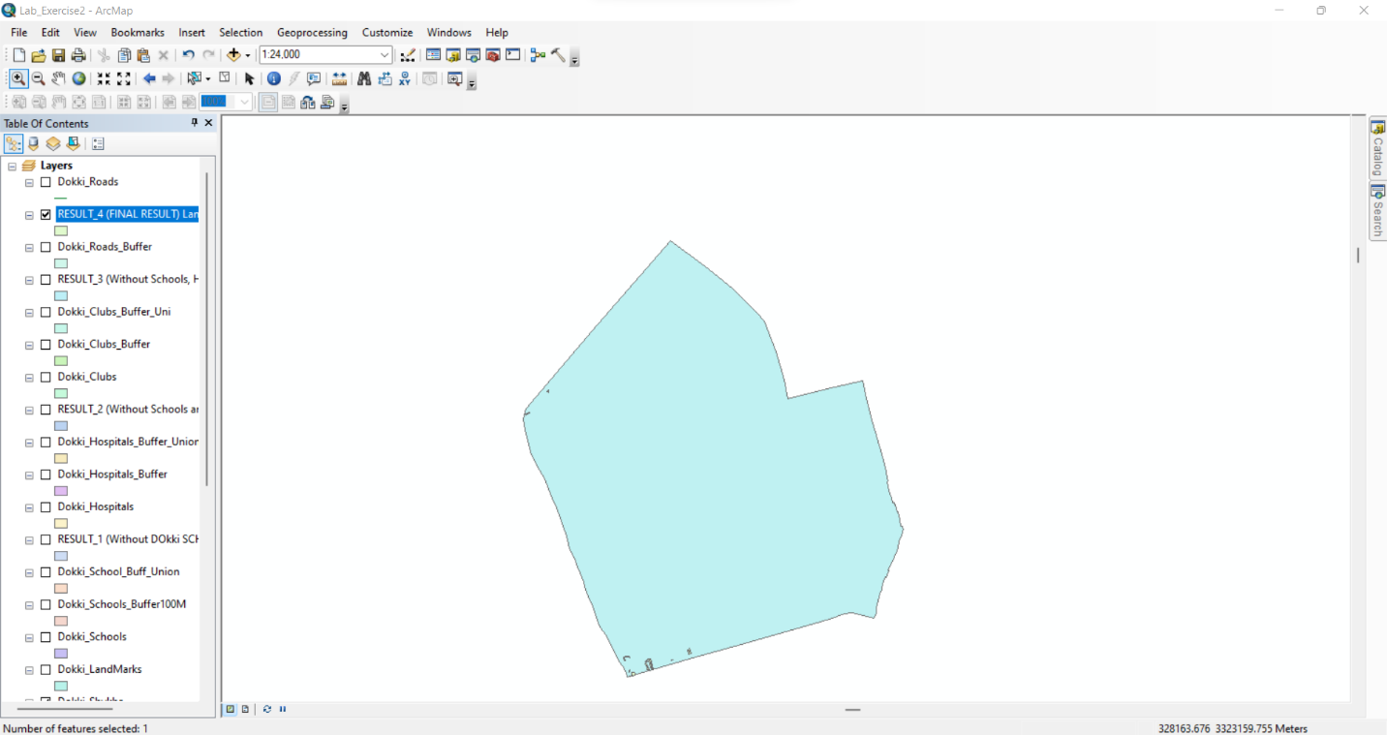

1. **Searching About LandMark ‘أرض فضاء’ whose area >= 5000**

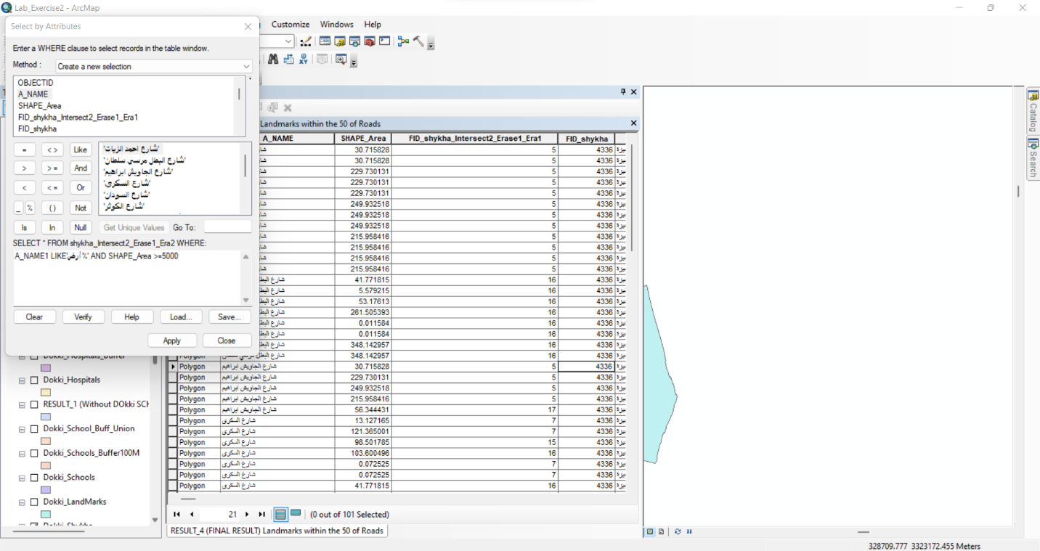

**But the Landmark isn’t found**