**Geographical Information Systems**

Assignment 4

**Student Name:** Mostafa Mohamed Mostafa Elgendy

**Student ID:** 20190543

**Group No.:** IS-S1

**Exercise 1: Create a tool to obtain a feature class with preclusive areas.**

* **“royal_tombs”** buffered with **3000 m**

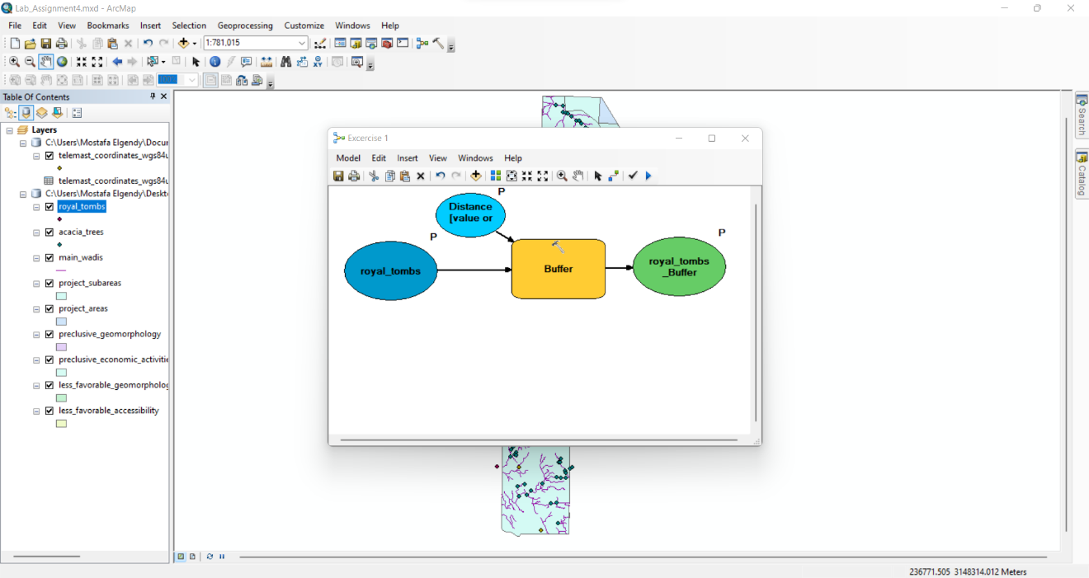

* **“telemasts_PointsToLine”** buffered with **300 m**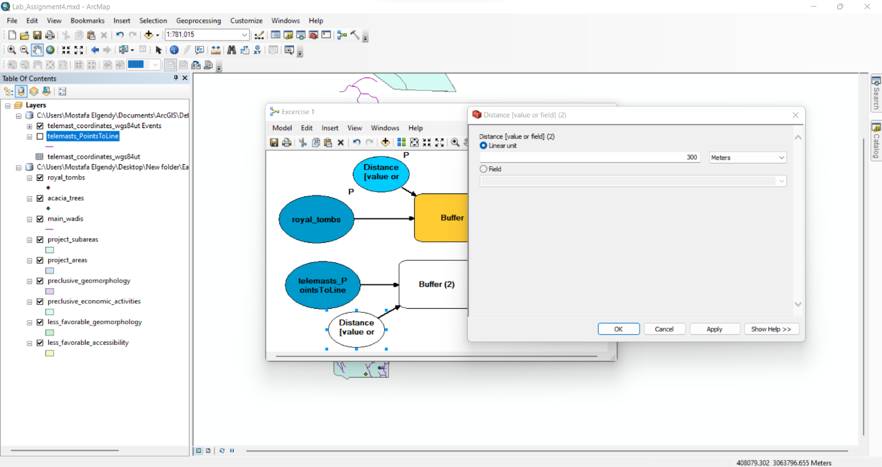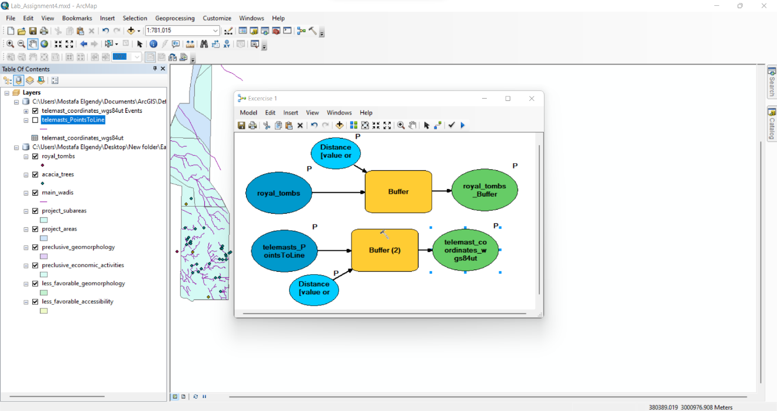
* the both **Output Datasets** should be overlayed with the **“*Merge*”** tool together with the datasets **“preclusive_geomorphology”** and **“preclusive_economic_activities”**

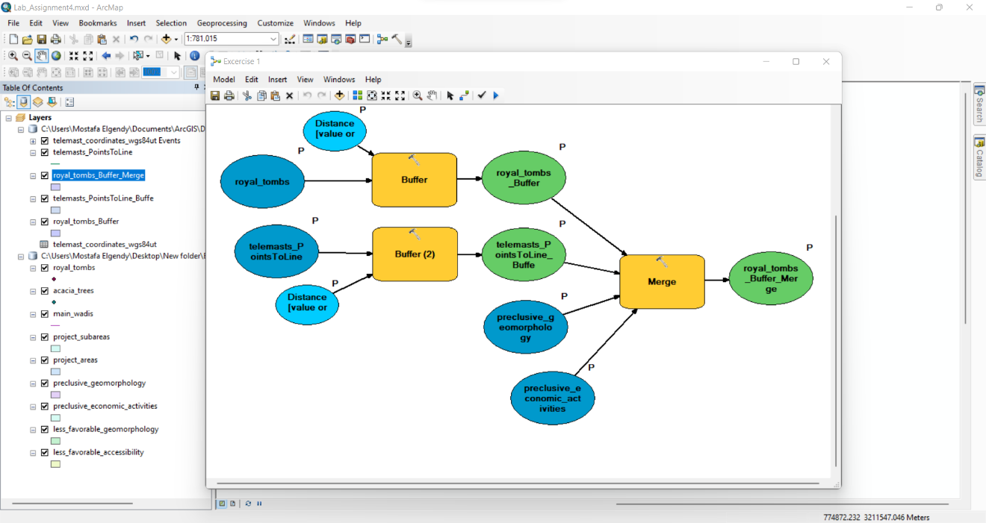

* ***Add Field*** to the Merge Output Dataset named **“Zone”**
* Use the ***“Calculate Field”*** function to **attribute all features** with **“preclusive”** (field “Zone”). 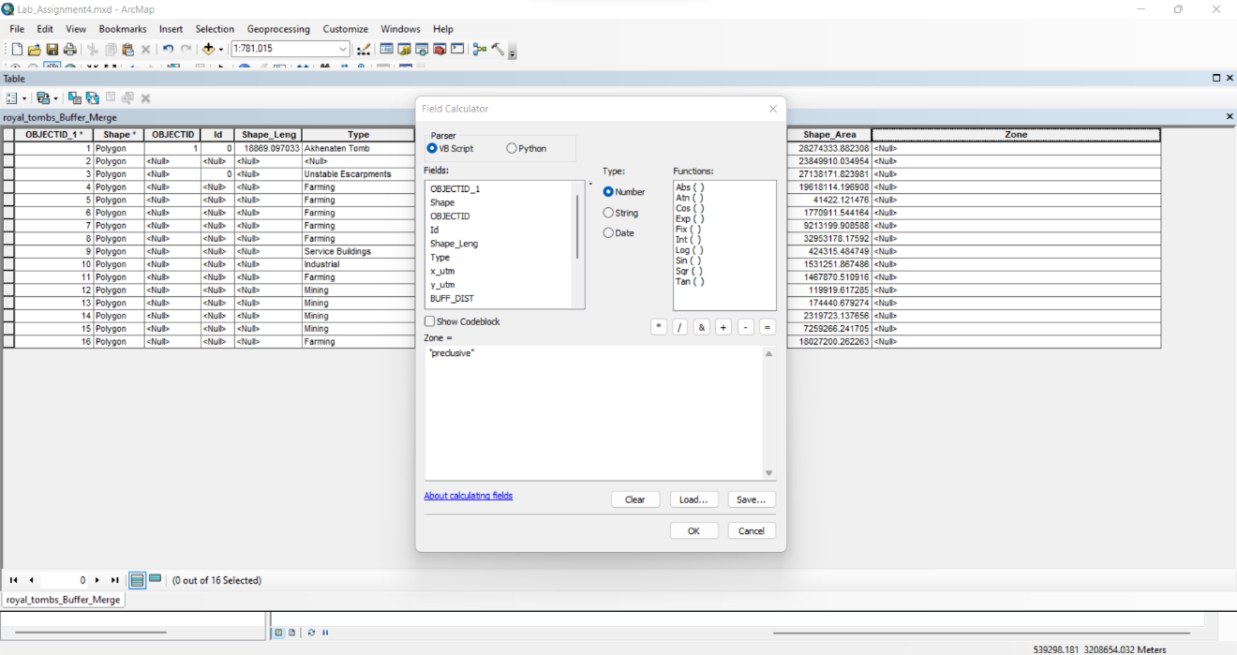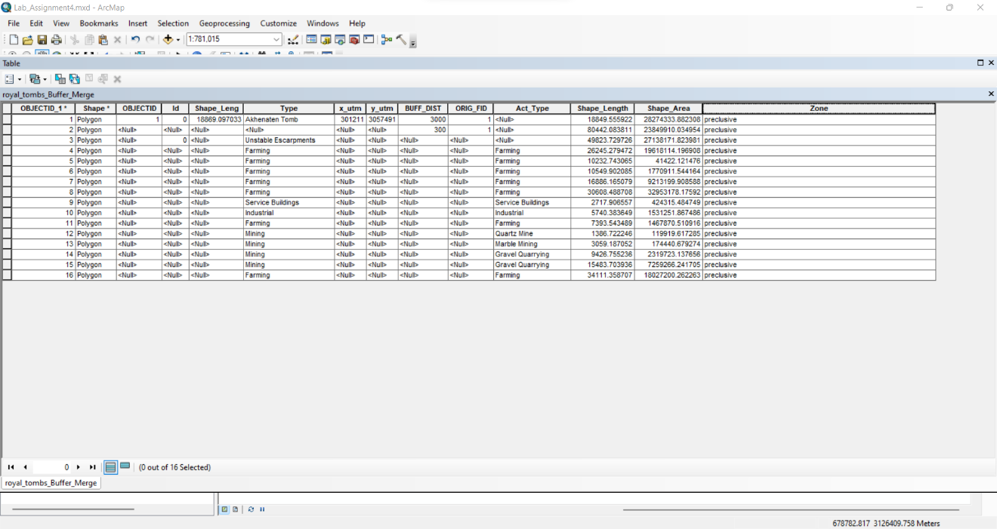

**Exercise 2: Create a tool to obtain a feature class with unfavorable areas**

* “main_wadis_of_importance” buffered with 100 m

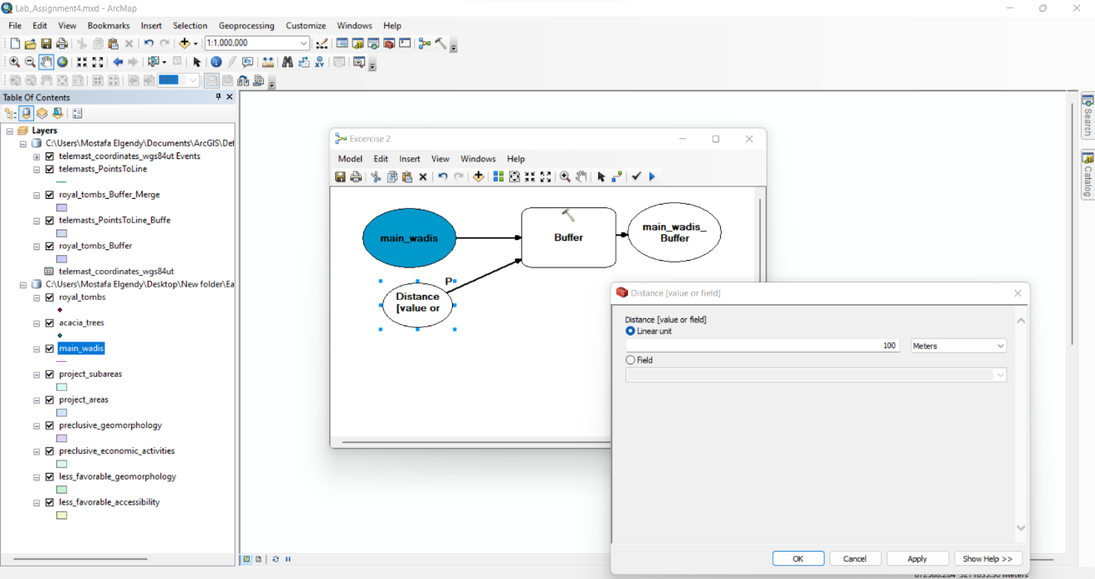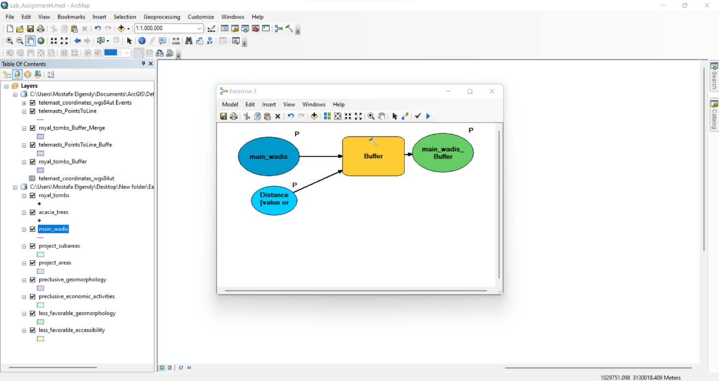

* “Merge” the Output Dataset with the datasets “less_favorable_geomorphology” and “less_favorable_accessibility”

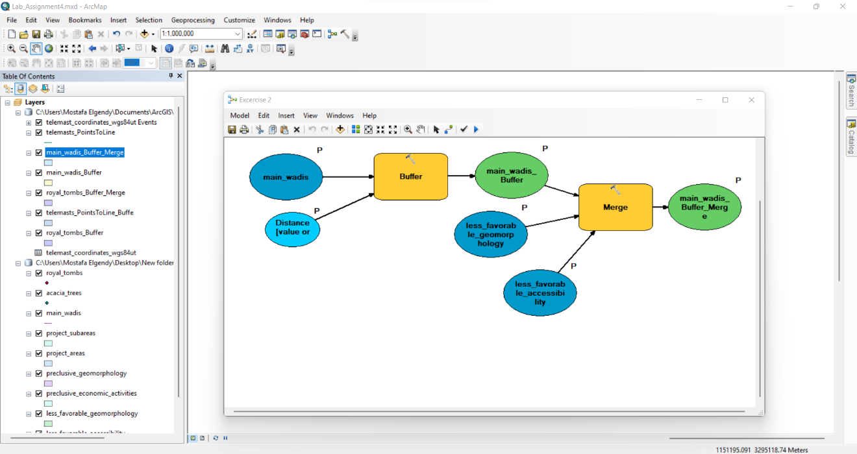

* Add Field to the Merge Output Dataset named “Zone”
* Use the “Calculate Field” function to attribute all features with “unfavorable” (field “Zone”)

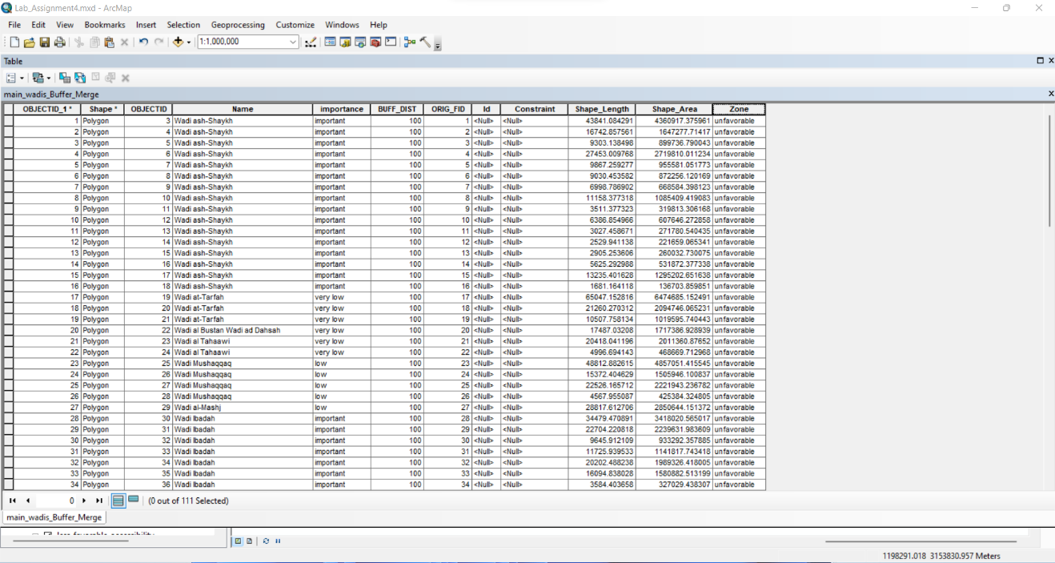

**Exercise 3: Integrating a model within a model Create a tool to obtain a feature class with all preclusive & unfavorable areas:**

* Overlay the Output Datasets of both previous models using the tool “Union”

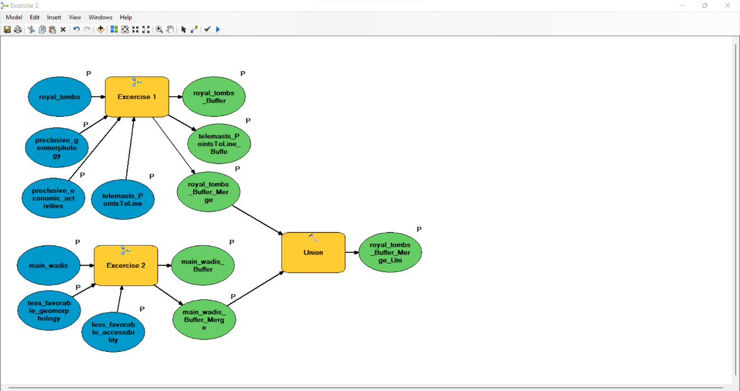

* Clip the Union Output Dataset to the “project_subareas”

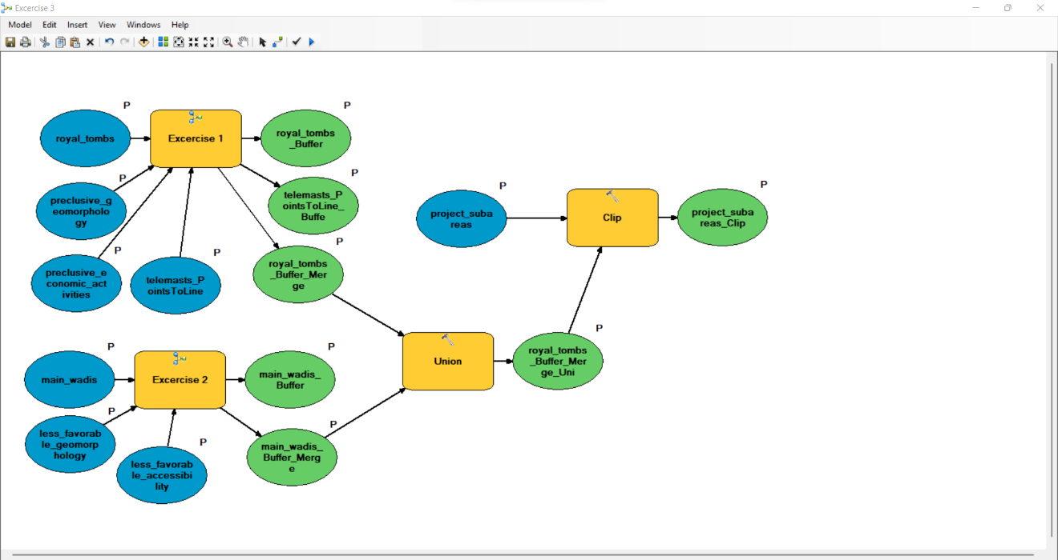

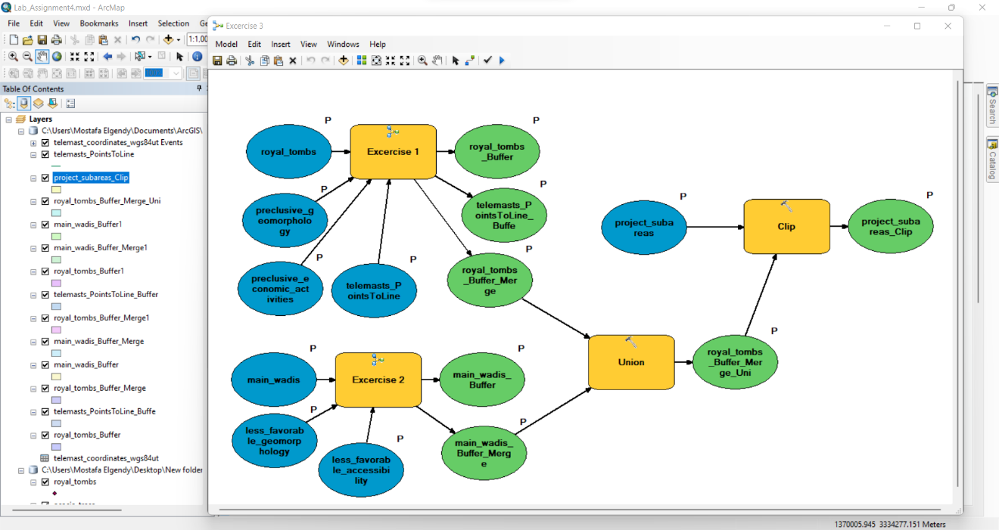

* Erase

