**Name : مصطفى عبدالحكيم السيد محمد عبدربه**

**B.N: 914**

**Topic: Programing languages**

**Github link :** [**https://github.com/Mostafahakim15/ECE001-mostafahakim-githup-io**](https://github.com/Mostafahakim15/ECE001-mostafahakim-githup-io)

**Github page :** https://mostafahakim15.github.io/ECE001-mostafahakim-githup-io/

**Application brief :**

Modern computers are incredibly fast, and getting faster all the time. However, computers also have some significant constraints: they only natively understand a limited set of commands, and must be told exactly what to do. A computer program (also commonly called an application) is a set of instructions that the computer can perform in order to perform some task. The process of creating a program is called programming. Programmers typically create programs by producing source code (commonly shortened to code), which is a list of commands typed into one or more text files.

The collection of physical computer parts that make up a computer and execute programs is called the hardware. When a computer program is loaded into memory and the hardware sequentially executes each instruction, this is called running or executing the program.

**Screeshots :**

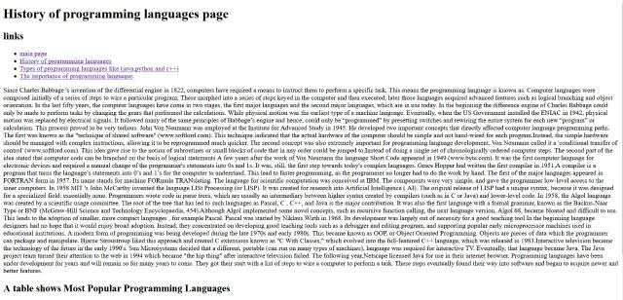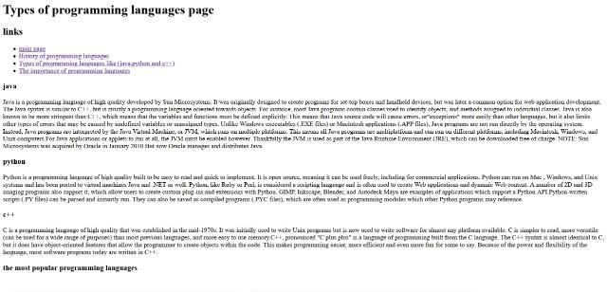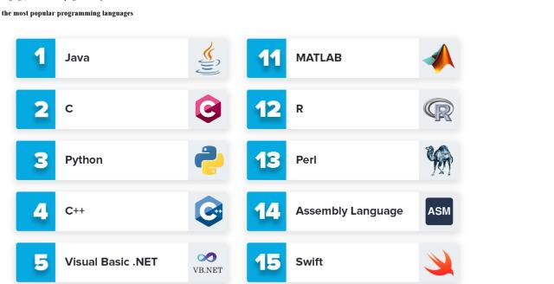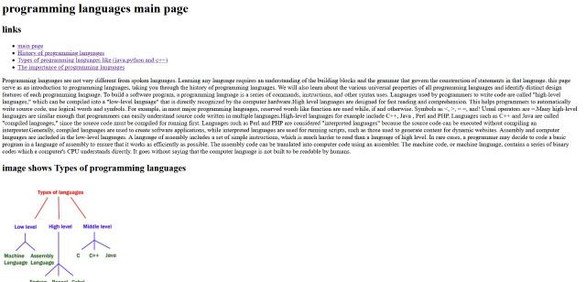C:\Users\pc\AppData\Local\Microsoft\Windows\INetCache\Content.Word\179555.jpg

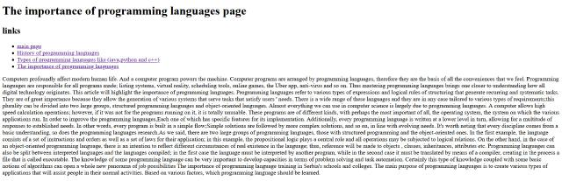

**Code Source:**

