**BdTour Web Application**

**Submitted by:**

**Mostafijur Rahman**

**Sahabub Alam**

**Md. Sagor Sarkar**

**Table of Contents**

**Abstract .........................................................................................................................................3**

**Introduction ..................................................................................................................................3**

**Aim of the software ...................................................................................................................... 3**

**Background and Related Work ................................................................................................. 4**

**Program Requirements ............................................................................................................... 5**

**Implementation ............................................................................................................................ 6**

**Conclusions and Future Work .................................................................................................. 10**

**Reference…................................................................................................................................ 11**

**Appendices .................................................................................................................................. 12**

* **Abstract**

Bangladesh Travel Agency System is an online management System. This provide us various kinds of opportunity to find Bangladesh biggest hotel easily. For this system any one can find best tourist place in our country and the way of travel those place. People can booked their favourite hotel through our projects. All above us this more helpful for people and reduce their travel obstacle.

* **Introduction**

BdTours Private Tour Guides is the largest online network of qualified local guides. Travelers can use this site to plan their tour and find the tour guide(s) that will fit their criteria most by reviewing individual tour guide profiles, their qualification information and guide reviews. For an even more customized experience, travelers can also contact the guide with questions, requests and any other thoughts they wish to address by using the onsite messaging system.   
  
With the help of expert local guides, travelers can gain insider access to their destination with customized, unique tours that address their interests and provide a richer travel experience.

Founded in 2017, Private Tour Guides (formerly BdTours) was acquired by BdTours, Inc. in 2018 and is part of the BdTours, Inc. family of tours and things to do websites.

A person who guides visitors in the language of their choice and interprets the cultural and natural heritage of an area which person normally possesses an area-specific qualification usually issued and/or recognized by the appropriate authority.

**Aim of the Software**

This software is developed to help computer science students to learn about the Web application designing using JSP and HTML from their basic capabilities to build a complete working application from scratch. Further, it gives insight about how GUI interacts with server-side language, Java, and finally with the MySQL database.

* **Background and Related Work**

Your departure is approaching; you’ve bought your tickets, dug out your travel guide and found a great hotel. You’re excited to embark on this new journey of discovery, but don’t have the time to plan what you want to do for each day of your trip… Never mind, you can work it out when you get there.

The problem is, guides are hard to find, especially during low season, and most guides aren’t available at the last minute.

And during high season, most guided tours are either fully booked, aren’t your ideal choice, or aren't even offered in your language!

Why not find a great tour, and a guide to match, before leaving? Think it'll be too much of a hassle?

At Meetrip, we search for and select only the best professional tourist guides and tours from across the globe, in order to ensure you have an unforgettable experience. Thanks to their knowledge and experience, these guides can show you everything from the top attractions to those hidden gems and secret places, that you would never have been able to find on your own.

Anticipated Benefits are:

- Marketing initiatives/programs to promote you online

- Dedicated BdTours Teams from Engineering through to Customer Service

- Easy and quick registration to the site

- No registration fee

- Low commissions

* **Program Requirements**

**Product Perspective:**

The Online BdTours application is a web-based system. It can be accessed using IE 10.0 and above, Fire Fox 31 and above and Google Chrome.

**System Model:**

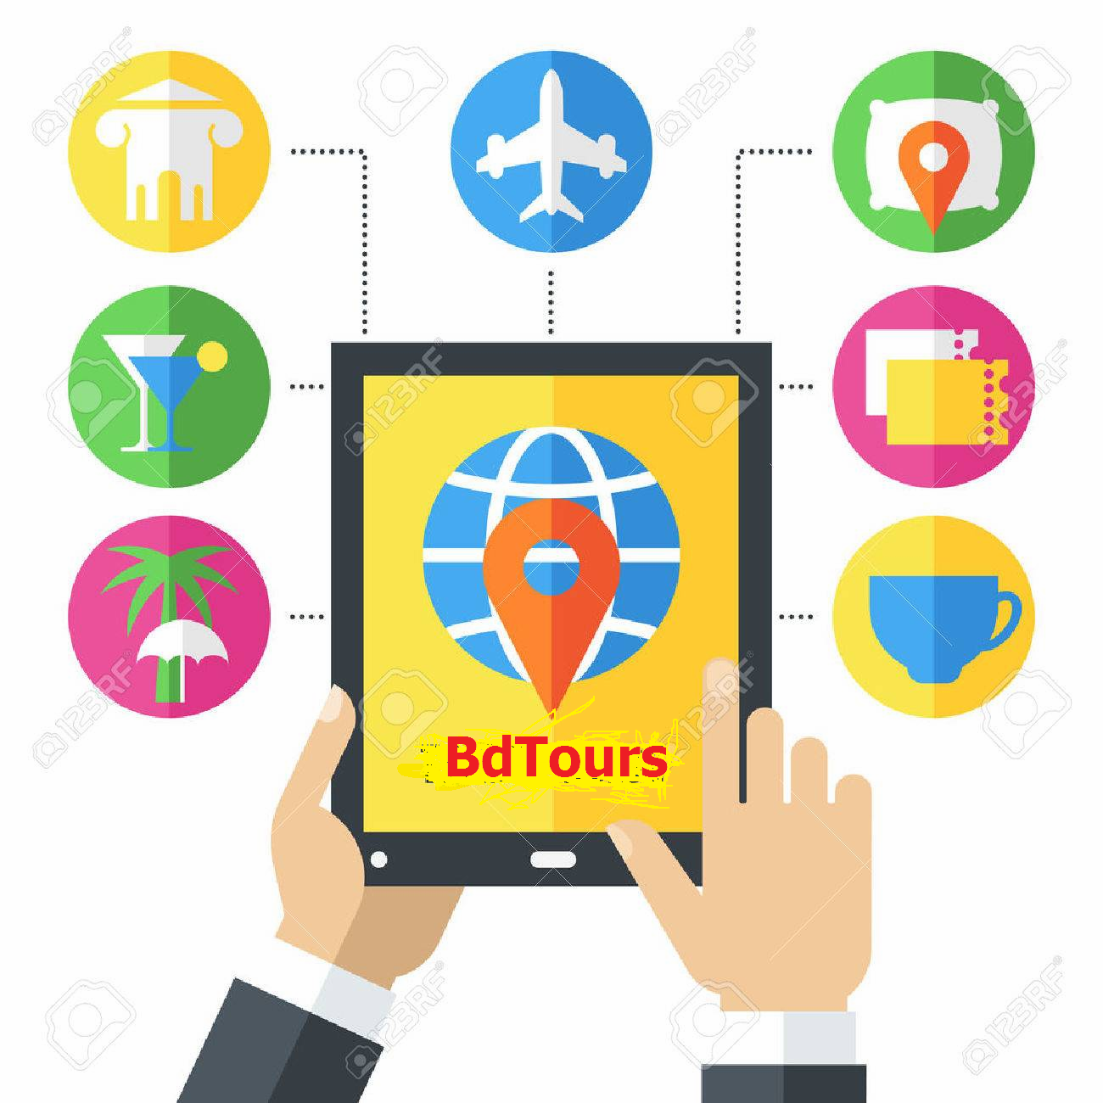

Figure : BdTours Diagram.

**Product Function:**

BdTours application would have the following basic functions:

**Web Accessing System Module**

This module provides the functionality for customers to place their order and supply necessary

details. Users of the system, namely restaurant customers, must be provided the following functionality:

• Create an account.

• Manage their account.

• Log in to the system.

• Navigate best hotels menu.

• Select a hotel from the menu.

• Review systems current packages.

• Remove a package all items from their current packages.

• Provide payment details.

• Receive confirmation in the form of an order number.

• View order placed.

**Menu Management System Module**

This module provides functionality for the power user-Administrator only. It will not be available to any other users of the system like guidence Employees or Customers. Using a graphical interface, it will allow an Admin to manage the hotels packages that is displayed to users of the web package system:

• Add/update/delete food category to/from the web.

• Add /update/delete food item to/from the web.

• Update additional information (description, photo, etc.) for a given hotel packages.

Before customers can actually use this system, functionality provided by this component will have to be configured first. Once the initial configuration is done, this will be the least likely used component as menu updates are mostly seasonal and do not occur frequently.

* **Implementation**

**Hardware/Software Interface:**

This section lists the minimum hardware and software requirements needed to run the system efficiently.

**Hardware Interface:**

• Intel Core i3 Processor

• 500GB of hard-drive space

• 4 GB of RAM

**Software Interface:**

• Operating System: Windows (7 or above)

• Web Browser: IE 10 or above, Mozilla FF 31 and above or Google Chrome

• Drivers: Java Runtime Environment

• Integrated Development Environment: Netbeans IDE and Apache Tomcat 9.0,GlassFish

**Functional Requirement Specifications:**

**Activity Diagram:**

This section lists the activity diagram and describes the flow of the activiJLjjjjllDPOUIIIIIIIIIIIIIIIIIIIIIIIIIIIIIIIIIIIIIIIIIIIIIIIIIIIIIIIIIIIIties in the system. A detailed description is then given after the figure for each activity. Figure 2 provides the overview of the activity of the BdTours application.

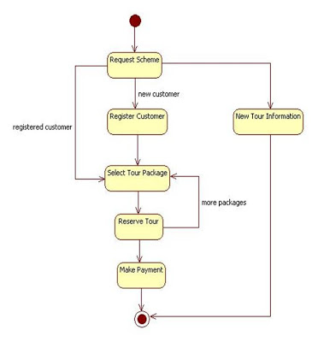

**Figure 2**

**All users of the system, are provided with below menu options:**

Home, Best Value Tour, Hotel, Destination Information, Book Your Own Tour, About Us and Contact Us.

**Web Booking System Module**

Customers of the Web Booking system will interact with the application through an easy to use top navigation menu.

• “Home” menu option: allows the users to see all food items offered with nice images as well as select an item to place an order.

• “Best Value tour” option: ’ menu, allows users to see all best hotels per category. Hotel can then be added to the book using a single button click.

• “Hotels ”menu option:

- Allows users to see details of the hotel placed in cart. Details include

- Once, book now, button is selected, user will be prompted for the Sign In/Sign Up process if not logged in else user will be presented with a simple “Payment Information” form. User will be asked to provide all required details in displayed text boxes and make appropriate Dropdown selections. Then, all this information can be saved using a ‘Save’ button.

- Once a hotel is Booked , user will be presented with appropriate Booked confirmation success/failure message.

**Menu Management System Module**

Similar to Web booking system, this module presents Admin with below additional options under “Login” Drop down menu:

• Add Category: Allows to add a hotel name in a simple form.

• Modify Hotels name and details Allows updating or deleting hotel details.

**Non-functional Requirements**

All of the application data is stored in a MySQL database, and therefore a MySQL Database must also be installed on the host computer. As with Apache 9.0, this software is freely available and can be installed and run under most operating systems. The server hardware can be any computer capable of running both the web and database servers and handling the expected traffic. For a small scale restaurant that is not expecting to see much web traffic, an average personal computer may be appropriate. Once the site starts generating more hits, though, it will likely be necessary to upgrade to a dedicated host to ensure proper performance. The exact cutoffs will need to be determined through a more thorough stress testing of the system.

**Constraints**

1. Hardware Limitations: The minimum hardware requirement for the system is 512 MB of Ram and a 60 GB hard-disc drive.

2. Others: The application should be built using Java and JavaScript inscribed in HTML, and it should, initially, be accessible through the Netbeans IDE and later published on a server

**System Evolution**

The heart of the entire ordering system is the Database. Currently the system is only available for small scale restaurants. For Large restaurants, performance considerations should be taken into account in terms of Hardware/Software capacity/Page load time etc. Also, security vulnerabilities should be evaluated or large scale systems.

In future this can also be available as a Mobile application and can be integrated with in store Touch Screen Order devices.

We are also certain that if this system goes into actual use, many requests will arise for additional features which I had not previously considered, but would be useful to have. For this reason, I feel as though the application can be constantly evolving, which I consider a very good thing.

* **Conclusions and Future Work**

**Conclusion:**

The main objective of the application is to help Computer Science students understands the basics of Java, JavaScript and HTML. The following results have been achieved after completing the system and relate back to the system’s objective.

**Should allow Computer Science students to browse through the code and application:**

This can be achieved when students are able to run and install the application. When they run the application, they can browse through the implementation of different objects.

**Should allow users to browse through different product categories:**

This is achieved through an easy to use graphical interface menu options.

**Should allow the user to Booked the Hotels(s):**

This is achieved using the “Proceed to Book now button” in the cart initially and then “booked” button at last .Button is disabled when there are no items in the cart.

**Should allow the user to process the payment:**

This is achieved when user selects “book now” button and fill up the Payment information details.

**Should allow the user to see Success message after placing an order:**

This is achieved when user successfully places an order. The user is given the order conformation number along with success message.

**Future Work:**

The following section describes the work that will be implemented with future releases of the software.

• Customize booking: Allow customers to customize hotels booking.

• Enhance User Interface by adding more user interactive features. Provide Deals and promotional Offer details to home page. Provide Recipes of the Week/Day to Home Page

• Payment Options: Add different payment options such as PayPal, Cash, Gift Cards etc. Allow to save payment details for future use.

• Allow to process an order as a Guest

• Integrate with In store touch screen devices like iPad

* **Reference**

1. http://getbootstrap.com/

2. http://www.javazoom.net/jzservlets/uploadbean/uploadbean.html

3. https://javabrains.io/

4. <http://www.java2s.com/Tutorial/Java/0360__JSP/toursystem.htm13>

5. <https://www.javatpoint.com/>

* **Appendices**

This section includes figures for ER Diagram and various Web application images.

**ER Diagram:**

