**North South University**

**Department of Electrical & Computer Engineering**

**Junior Project Proposal**

**Title of the Project:**

# Smart Health Care Monitoring System Based on IoT

**Group:**

**Names and IDs of the students:**

**Name: ID:**

Ibrahim Khalil1520775042

Mashruf Mahabub 1510501042

Mostafijur Rahman 1611633042

**Faculty’s Name:** Intisar Tahmid Naheen

**Index**

1. **Abstract 3**
2. **Introduction and background 3**
3. **Objectives 4**
4. **Scope 4**
5. **Methodology And Approach 4**
6. **Block Diagram 5**
7. **Software Used 6**
8. **Budget 6**
9. **Application Construction 6**

**10. System Flow 7**

**11. Simulation 7**

**12. Result Analysis 7**

**13. Expected Outcomes 8**

**14. Future Work 8**

**15. Conclusion 8**

**16. References 8**

# Abstract:

Healthy eating and regular physical activity plays a substantial role in preventing diseases like heart disease, high blood pressure, cancer, diabetes and stroke etc. As mobile devices have become an integral part of our lives, it can alter the way we look after our health. Seeing the increase in adoption of mobile in our daily lives, we have used mobile as a platform for a healthcare, so that people can get factual information about their health and can have command on their health. It will help them to learn about their health and understand their illness. In this paper Mobile based healthcare application ‘Balance and Breath’ has been proposed. Application which will suggest diet and physical activity based on six input parameters. The input parameters are BMI (Body Mass Index), BMR (Basal Metabolic Rate), working hours and user current body conditions (i.e. Body Temperature, Heart rate via Sensors). Decision-Tree is being used to make all suggestions. The application supports continuous monitoring of user health. The proposed system is scalable for all Android Based Mobile Devices.

Introduction and Background:

Obesity, diabetes, high blood pressure are some common diseases which lead people to different health related issues. This issues are rising every year. People are not always able to take care of these health issues because of their busy life schedule. Thousands of people die because of these health issues. Healthy life style keep these diseases away to maintain a healthy life. If we can develop a personal health care monitoring system then it will be easy for individuals to maintain a healthy lifestyle and will also reduce the regular visit to physician.

Smart phones are playing an important role in our daily life. And it will be really great idea to build an application based on smart phone for daily monitoring of our health because of its portability, storage capacity, faster computing speeds and ease of use. We can develop an application which can calculate BMI, read pulse rate, read body temperature and provide individuals necessary health tips. Exercise can be recommended on the basis of rule based algorithm. We can use various wireless devices which will be connected to our smartphones.

# Objectives:

Our application will be an android based project. It will provide users necessary diet tips and remind for regular exercise. It will also help users to calculate BMI to make them aware whether they are underweight or overweight. This application will also be able to read body temperature, bpm through wearable wireless devices which will be connected to an android device. After reading all these data, our application will be able to provide necessary diet tips and exercise to keep body healthy and fit.

**Scope:**

Following tasks will be undertaken as a part of the proposed research-

Task 1- This project mainly finds it use in the field of medical diagnosis, in a country like Bangladesh where rural population and remote areas play an important role.

Task 2- It is important to have an effective and on-time diagnosis system. We can make the whole diagnosis process better by introducing this idea.

Task 3- We can also add many other devices like ECG sensor.

**Methodology and Approach**

What is our research problem and solution?

- Using internet all the time to store the Arduino data into database through wi-fi module. Internet may not be available everywhere in our country.

Solution of our problem?

-We will use Bluetooth module (HC-05) to read the Arduino data and pass those data to the android device to show the real time health condition.

What are the constraints?

-Some of the Arduino sensors are expensive. That’s why Funding is one of the major barrier in our project to use more sensor to read body condition.

**Block Diagram**

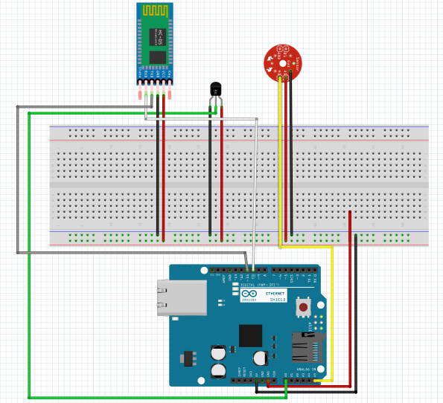

# 

# Software Used:

1, MIT App Inventor 2,

2. Arduino C/C++

3.Kotlin Programming Language

**Budget:**

The total estimated budget to complete the thesis/project is provided in Table 2.

|  |  |
| --- | --- |
| **Item** | **Cost** |
| Arduino Uno | BDT 400 |
| HC-05 Bluetooth Module | BDT 250 |
| LM35 Temperature Sensor | BDT 100 |
| Pulse Rate Sensor | BDT 600 |
| Male-Female Wires | BDT 50 |
| Jumper Wires | BDT 50 |
| Breadboard | BDT 85 |
| LED | BDT 5 |
| **Total** | **BDT 1540** |

**Table 2:** Budget for the project/thesis

**Application Construction:** Our application will take the basic input from user which will be height, weight, gender, age, activity level and working hour. In the first phase after getting all the basic input, it will calculate the BMI and BMR of the user. BMI will help the application to determine whether the user is underweight or overweight. BMR is used to calculate the number of calorie a person need per day to stay alive.

In the second phase, further basic inputs will be taken such as body temperature and pulse rate. Input taken from the sensor along with BMI, BMR and working hours produced from the basic inputs collectively suggest the diet and physical activity required by the user and also suggest the possibilities of health risks.

**System Flow:** All data taken from the sensors like body temperature, pulse rate are stored and when the application get started some basic data will be inserted by the user and the BMI and BMR will be calculated.

When all output are calculated and the currently monitored value of user is transfer to application then the final results are generated i.e. Physical activity suggestion, Diet suggestion and possibility of developing health risk.

**Simulation:** When our app gets started it will take five primary data from the user which are weight (kg), height (cm), age, gender, and activity level. After getting all these data it will give show the user his/her BMI and BMR. Then the user will measure his/her BPM and Body Temperature. And after combining the BMI,BMR, and the sensor data, the application will provide the user necessary diet tips, exercise list with probable health risk depending on his/her body condition.

**BMI calculation:**

BMI: weight / (height) ^ 2

**BMR Calculation:**

BMR for men: (10 * weight in kg) + (6.25 * height in cm) - (5 * age) + 5)

BMR for women: (10 * weight in kg) + (6.25 * height in cm) - (5 * age) - 161)

**Result Analysis:** We faced a little bit noise value during taking value from the sensor. Temperature and Bpm was almost accurate. Sometimes these values were little bit less or more than the actual value. Comparison of actual and sensor value are given below:

|  |  |
| --- | --- |
| **Actual Value** | **Tested Value** |
| 32.0’C | 29.0’C |
| 31.0’C | 33.0’C |
| 33.0’C | 31.0’C |

**Table:** Comparison of actual and tested Temperature value

|  |  |  |  |  |  |
| --- | --- | --- | --- | --- | --- |
| **User1-Actual Value** | **User2-Actual Value** | **User3-Actual Value** | **User1-Compared Value** | **User2-Compared Value** | **User3-Compared Value** |
| 96 | 92 | 82 | 99 | 96 | 87 |
| 97 | 93 | 85 | 101 | 96 | 87 |
| 97 | 93 | 79 | 102 | 89 | 81 |

**Table:** Comparison of actual and tested BPM value

# Expected Outcomes:

1. No need to monitor from relay room.
2. Save time.
3. Save money.
4. Save men work.

**Future Work:** It is a suggestion system we can enhance it by making it a recommendation system and lifesaving system in future. We can establish some more features to the application such as SMS alert while the person is in health risk state; so that his/her doctors and pre-assigned people get aware that there is some emergency and ambulance send to his/her house immediately. We can make the application available for other platform too.

**Conclusion:** Knowledge about health risk can help in taking adequate precautions to protect once health. This application will motivate the user for having a good and balanced nutritional state, ideal weight and motivates the user to increase the physical activity in daily life, so that the user can live a healthy life style without any disease.

**References:**

- <https://ieeexplore.ieee.org/abstract/document/7019406>

- <https://ieeexplore.ieee.org/abstract/document/6897199>

- <https://ieeexplore.ieee.org/abstract/document/7808313>