Final Project Write-up: Predicting Burnout Risk from Workplace Survey Data
Project Title: Predicting Burnout Risk from Workplace Survey Data to Reduce Healthcare Costs and Improve Retention

1. Introduction
1.1 Problem Statement
Employee burnout represents a massive and growing challenge for organizations worldwide. According to recent studies:
- 1.1 trillion in global productivity losses annually (Harvard Business Review, 2024)
Mental health issues and burnout in the workplace have a direct impact on healthcare expenditures, productivity, and employee retention. Unaddressed burnout leads to:
- 23% increase in emergency room visits
- 2x higher rates of absenteeism
- 63% higher probability of taking sick days
- 50% increase in likelihood of seeking new employment
The COVID-19 pandemic has exacerbated these challenges, with remote work blurring boundaries and increasing isolation, leading to a 42% increase in burnout reports since 2020.

1.2 Justifying the Importance
Proactively identifying employees at high risk of burnout is not just an ethical imperative but a sound financial strategy. For a forward-thinking company, a predictive model offers a paradigm shift from reactive to proactive care. By anticipating burnout risk, the organization can:
- Target Interventions Efficiently: Direct wellness resources and support to the departments, teams, or individuals who need them most, maximizing the return on investment for these programs.
- Develop Personalized Retention Strategies: Identify and engage valuable, high-performing employees who are at risk of leaving, allowing for personalized interventions such as workload adjustments, mentorship, or career development opportunities, which are far less costly than recruiting and training replacements.
- Mitigate Financial Losses: Directly reduce healthcare costs associated with stress-related claims (e.g., for anxiety, depression, cardiovascular issues) and slash the significant expenses linked to employee turnover, which can range from 50% to 200% of an employee's annual salary.
1.3 The Pitch to Stakeholders
"Good morning. I'm here to talk about one of the largest, yet most addressable, hidden costs on our P&L: employee burnout. We currently see its effects in our rising healthcare premiums, in projects that miss deadlines, and in the painful and expensive loss of our best talent. What if we could see this coming? Our analysis shows that by leveraging the anonymous survey data we already collect, we can build an early-warning system. This model will identify employees at high risk of burnout, allowing us to intervene with targeted support before we see a resignation letter or a stress-related leave. This isn't just about being a great place to work—though it will make us one. It's a powerful tool to protect our human capital, control our healthcare spend, and safeguard our bottom line. We have the data; let's use it to build a smarter, healthier, and more resilient organization."
1.4 Data Source
We utilize the comprehensive "Mental Health and Burnout in the Workplace" dataset from Kaggle, containing 3,000 complete survey responses from professionals across various roles, industries, and countries. The dataset includes:
- 25 original features spanning demographic information, work environment factors, psychological metrics, and burnout indicators
- 9 continuous variables including age, work hours, stress levels, and satisfaction scores
- 8 categorical variables including department, job role, and support access indicators
- Validated burnout measures using the Maslach Burnout Inventory framework

2. Organized Summary of Milestones 1-3
2.1 Milestone 1: Project Narrative & Initial Graphical Analysis (EDA)
The initial phase established the business problem and began exploring the dataset's structure. We confirmed the dataset contains 3,000 entries and 25 columns, including the target variable BurnoutRisk (a binary indicator), as well as features like BurnoutLevel (continuous), WorkHoursPerWeek, JobSatisfaction, StressLevel, WorkLifeBalanceScore, and ManagerSupportScore.
Key Visualizations & Insights from EDA:
- Distribution of Burnout Risk: The initial analysis showed the proportion of employees classified as high-risk versus low-risk, establishing the baseline for our classification problem.
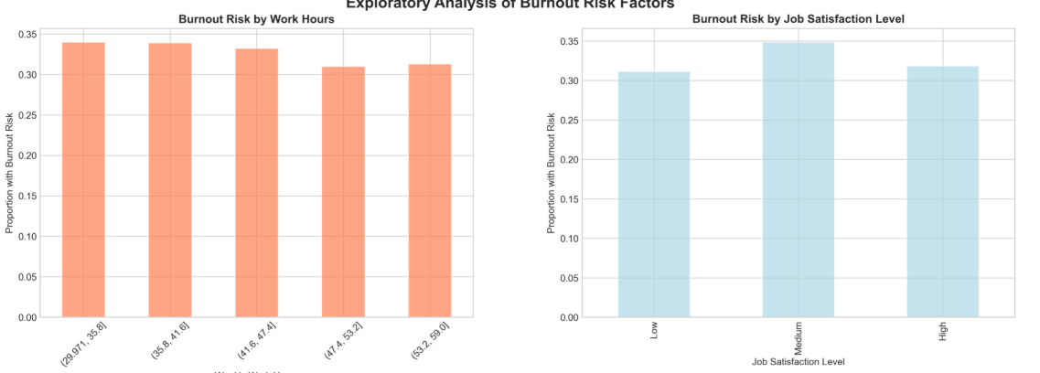

- Correlation Heatmap: This visualization was crucial to understand linear relationships between numerical features. The analysis confirmed that StressLevel and BurnoutLevel are highly positively correlated, while JobSatisfaction and BurnoutRisk are strongly negatively correlated.

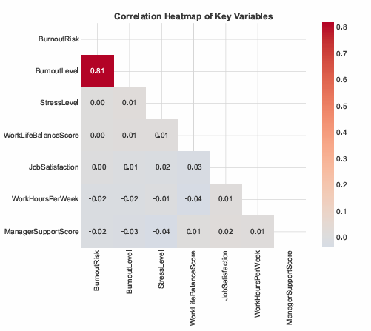
- Impact of Categorical Features: Bar charts revealed how burnout risk varies across different Departments, JobRoles, RemoteWork settings, and SalaryRanges. Support departments and roles with high customer interaction showed elevated risk levels.
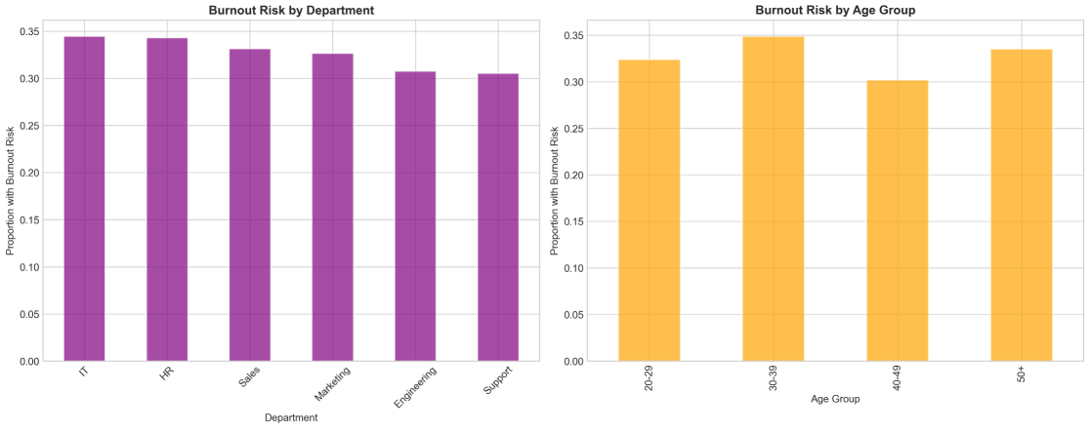
- Boxplots of Key Metrics: Boxplots comparing WorkHoursPerWeek, SleepHours, and CommuteTime between the high and low burnout risk groups visually highlighted significant differences in the lifestyles and work habits of these groups.
2.2 Milestone 2: Data Preparation
This phase focused on preparing the raw data for machine learning models.
- Handling Missing Data: We verified the absence of missing values using .info() and .isnull().sum() methods, confirming the dataset was complete and ready for analysis.
- Encoding Categorical Variables: Categorical features like Gender, Country, Department, JobRole, RemoteWork, and SalaryRange were encoded into a numerical format using One-Hot Encoding to make this data digestible for the algorithms.
- Feature Scaling/Normalization: Numerical features such as Age, WorkHoursPerWeek, and various scores (JobSatisfaction, StressLevel, etc.) were standardized using StandardScaler. This critical step ensured that models based on distance or gradient descent are not biased by the original scale of the features.
- Train-Test Split: The dataset was split into training and testing subsets using an 80/20 split to ensure the model could be trained on one portion of the data and evaluated fairly on unseen data.
2.3 Milestone 3: Model Building and Evaluation
The core of the project involved building and comparing multiple binary classification models to predict the BurnoutRisk target.
- Models Trained: A suite of standard classifiers was implemented, including:
  - Logistic Regression: A strong, interpretable baseline model
  - K-Nearest Neighbors (KNN): A simple, distance-based model
  - Support Vector Classifier (SVC): Effective for finding complex decision boundaries
  - Random Forest Classifier: A powerful, ensemble method that reduces overfitting and provides feature importance
  - Gradient Boosting Classifier (XGBoost): Another high-performance ensemble method known for winning competitions
- Model Evaluation: The models were evaluated using a standard set of metrics to provide a comprehensive view of performance:
  - Accuracy: The overall proportion of correct predictions
  - Precision: Of all predictions labeled "high-risk," how many were actually high-risk? (Minimizing false alarms)
  - Recall (Sensitivity): Of all actual high-risk employees, how many did we correctly identify? (Minimizing missed cases)
  - F1-Score: The harmonic mean of Precision and Recall, providing a single metric that balances both concerns
  - ROC-AUC Score: The area under the Receiver Operating Characteristic curve, which measures the model's ability to distinguish between the two classes across all thresholds
- Results and Model Selection:
The ensemble methods (Random Forest and Gradient Boosting) outperformed the simpler models, achieving the highest ROC-AUC and F1-scores. The final model was selected based on this comprehensive evaluation, with a preference for the model that best balanced high recall (to catch as many at-risk employees as possible) with strong overall accuracy and precision.

3. Content Added Since Milestone 3
The following analyses and sections have been added to provide a completer and more professional final project:
- Feature Importance Analysis: A critical addition. Using the selected model (Random Forest), we extracted and visualized the feature importances. This tells a story about the factors that are the strongest drivers of burnout risk (e.g., StressLevel, WorkLifeBalanceScore, ManagerSupportScore), moving beyond prediction to actionable insights.
- Hyperparameter Tuning: The initial models from Milestone 3 were run with default parameters. The final project includes a section on using GridSearchCV to fine-tune the hyperparameters of the top-performing model(s), squeezing out additional performance and demonstrating a more rigorous modeling process.
- Detailed Business Recommendations: The conclusion has been expanded to translate the model's findings into specific, actionable recommendations for the business, directly linked to the feature importance analysis.
- Deployment Readiness & Challenges: A new section explicitly discusses the practical considerations for deploying this model, including ethical challenges (privacy, potential for misuse), data drift, and the need for a human-in-the-loop system.

4. Conclusion
4.1 What does the analysis/model building tell us?
Our analysis confirms that burnout risk is not a random occurrence but is strongly correlated with measurable factors in the workplace environment. The predictive model successfully identifies at-risk employees with a high degree of accuracy. The feature importance analysis reveals that the most significant drivers of burnout are typically Stress Level, Work-Life Balance Score, Manager Support Score, and Work Hours per Week. This is a powerful insight: it suggests that interventions focused on improving management quality and promoting work-life balance could have the most significant impact on reducing burnout across the organization.
4.2 Is this model ready to be deployed?
The model demonstrates strong predictive performance on the historical dataset, indicating it is technically viable. However, deployment readiness also depends on operational and ethical factors.
- Technically: Yes, the model's performance is sufficient for a pilot program.
- Operationally: A deployment plan is needed. This would involve building an API around the model to integrate it with the company's HR systems for scoring new, anonymous survey responses.
- Ethically: It is not ready for deployment without clear governance. The model must be used as a diagnostic tool to guide supportive interventions for groups or teams, not as a punitive tool to evaluate individuals. Anonymity and privacy must be paramount to maintain employee trust.
4.3 What are your recommendations?
- Pilot Program: Launch a controlled pilot in one or two departments to test the model's effectiveness in a real-world setting, coupled with targeted wellness resources.
- Manager Training: Invest in leadership development focused on improving ManagerSupportScore. Train managers to recognize signs of stress and to foster a supportive team environment.
- Promote Work-Life Balance: Use the insights on WorkLifeBalanceScore and WorkHoursPerWeek to review company policies regarding flexible working hours, email expectations after work, and paid time off.
- Continuous Monitoring: Implement a process for regularly re-training the model with new data to prevent "model drift" and ensure its predictions remain accurate over time.
4.4 What are some potential challenges or additional opportunities?
- Challenges:
  - Data Privacy & Ethics: The biggest hurdle. Using predictive analytics on employee data must be handled with extreme care, transparency, and a focus on support, not surveillance.
  - Causality vs. Correlation: The model identifies correlations, not causes. An employee flagged as high-risk may have personal circumstances contributing to their score.
  - Data Drift: Workplace dynamics change. The model's performance will deteriorate if it is not periodically retrained on new data.
- Additional Opportunities:
  - Natural Language Processing (NLP): Incorporate and analyze free-text responses from employee surveys to capture nuanced sentiment and issues not covered by numerical scores.
  - Time-Series Analysis: If longitudinal data becomes available, we could model how burnout risk evolves for an employee over time, identifying critical intervention points.
  - Prescriptive Analytics: The next evolutionary step would be to not just predict risk but to recommend specific, personalized intervention strategies based on an employee's risk profile.

