Fall 2025
CSE110 Section 2
Assignment # 1 (Unmarked) The whole idea is to learn

Whether you will cheat to win or fail to learn is completely your decision.

1. Below is a code snippet. For the given set of input trace and write the output.

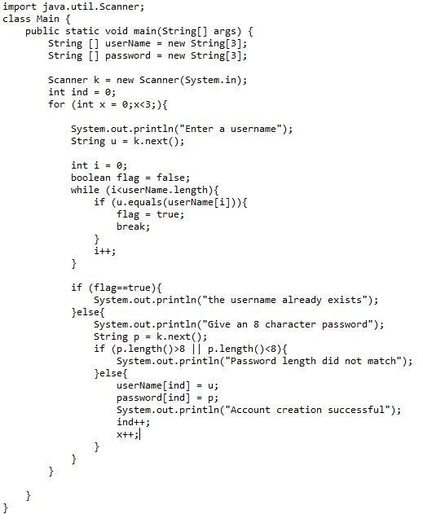

Username | Password | Output
Batman | batcave
Batman | batcave1
Superman | krypton1
Batman | rich12345
Flash | fastestmanalive
Barry | flash123
Superman | imposter

2. Based on the code snippet and your output answer the following questions.
A. What is the maximum number of users this code can accommodate and why?

B. If I increase the length of the arrays to 50, what will be the max number of users?

C. If your answer to question B is not 50, what change(s) should I make?

D. What is the purpose of the ind variable?

E. Why the x++ not included inside the for loop?

F. What is work of .equals?

G. If I had not used flag, what would be the problem?

H. Why is the ind variable declared outside the loop?

I. Why is flag declared inside the loop?

J. What is the difference between .length and length( ) ?

2. Using the given code, program the “log in” part of the problem.

