ALGORA: A MULTIPURPOSE MODULAR MICROALGAE PHOTOBIOREACTOR LAMP WITH A SELF-MAINTAINED SYSTEM BASED ON AIoT



COMPILED BY
NAURA PRASHANTI
ANABELLA MERCYA WIDIANTO
SHAFIYA GHAISANI ALTHAFUNNISA
KAYLA AULIA KHAIRUNNISA
TSAQIF ALFARIZQI W
NAUFAL DZAKY HAMDHANI

SMP MUHAMMADIYAH PROGRAM KHUSUS (PK) KOTTABARAT SURAKARTA
2026
TABLE OF CONTENTS
ABSTRACT 3
CHAPTER 1 4
Introduction 4
CHAPTER 2 6
Literature Review 6
CHAPTER 3 8
Research Methods 8
CHAPTER 4 10
Results and Discussion 10
CHAPTER 5 12
Conclusion 12
REFERENCES 13

ABSTRACT
Indoor spaces such as classrooms often lack plants and active air renewal, while conventional microalgae photobioreactors are bulky laboratory devices. This study designs ALGORA, a modular hexagonal photobioreactor lamp that cultivates the microalga Chlorella vulgaris to absorb carbon dioxide (CO2) and produce oxygen while also serving as a room lamp. The research follows a Research and Development (R&D) approach: literature study, a preliminary field study at a Spirulina cultivation site (Albitec), design, fabrication, testing, evaluation and finalization. One module is a flat-panel reactor 300 mm across flats and 40 mm thick, built from five CNC-cut acrylic layers (5 + 3 x 10 + 5 mm) that enclose a 30 mm culture chamber of 2.0 L, filled to about 1.7 L. Thirty-one addressable LEDs on the frame provide red-blue grow light by day and warm white room light in the evening. An ESP32 microcontroller reads water temperature, ambient light, culture optical density (OD) and CO2 concentration, schedules aeration and nutrient dosing, and publishes the data as JSON over Wi-Fi every 60 s. The design was verified with a dimensioned CAD drawing in LibreCAD, CNC path calculation and simulation. The cutting path is 8.24 m (about 37 min) for 1.32 kg of acrylic. A 24-hour simulation of the control logic gives an average power of 5.2 W and 126 Wh per day. A logistic growth model (growth rate 0.20-0.50 per day) predicts 0.46-0.98 g/L of biomass after 14 days, fixing 1.3-2.9 g of CO2, and a CO2 drop of 190-460 ppm in a 60 L closed box within 2 hours, versus 10 ppm without algae. Physical tests are prepared to validate these values. calibration, a 14-day integrated run and a closed-box CO2 test against a control without algae. ALGORA shows that a compact, self-maintaining photobioreactor can be built with school-level tools and can serve as both an air-quality aid and a learning medium.
Keywords: microalgae, Chlorella vulgaris, photobioreactor, Internet of Things, ESP32, carbon dioxide

CHAPTER 1

Introduction

1.1 Background
Carbon dioxide (CO2) is the main greenhouse gas produced by human activity, and its concentration is also a practical indicator of indoor air quality. In closed rooms with many occupants, such as classrooms, exhaled CO2 accumulates well above the outdoor level of about 420 ppm when ventilation is poor. Plants help, but most indoor plants grow slowly and need space and care that schools and small houses often cannot provide.
Microalgae are single-celled photosynthetic organisms that grow much faster than terrestrial plants and fix CO2 efficiently because every cell is in direct contact with the CO2-carrying medium [1], [2]. Producing 1 kg of dry algal biomass fixes about 1.83 kg of CO2 [1]. Microalgae are normally cultivated in open ponds or in closed photobioreactors that control light, temperature, mixing and gas supply [3], [4]. Closed photobioreactors give cleaner cultures and better control, but most designs are large, technical and placed in laboratories or factories, not in living spaces.
Low-cost microcontrollers and the Internet of Things (IoT) now make it possible to monitor and automate small cultivation systems [8]. Combining a thin, well-lit photobioreactor with LED lighting and IoT control could turn a culture of microalgae into an everyday object: a lamp that also cleans the air and can be maintained largely by itself.
Based on this idea, the team designed ALGORA, a modular hexagonal photobioreactor lamp. The hexagon shape lets several modules be joined like a honeycomb on a wall, while each module carries its own lighting, sensors and automatic care. This paper reports the design and the first prototype module.

1.2 Research Problems
1. How is the ALGORA modular photobioreactor lamp designed and built?
2. What is the expected performance of the ALGORA prototype in growing microalgae, reducing CO2 and using energy?

1.3 Research Objectives
1. To design and build one ALGORA module that cultivates Chlorella vulgaris with automatic lighting, aeration and nutrient dosing.
2. To evaluate the expected performance of the prototype by calculation and simulation, including culture growth, CO2 reduction and energy use.
3. To provide a learning medium about photosynthesis, microalgae and IoT for students.

1.4 Benefits
• Students: a hands-on medium for learning biology, physics and programming.
• Schools: an additional, decorative source of oxygen and a demonstration of green technology.
• Community: a compact way to help keep indoor air fresh in homes and offices.
• Government: an example of CO2 absorption that does not require additional land.

1.5 Scope of the Study
This study covers one prototype module (the main module with all sensors) cultivated with Chlorella vulgaris indoors. Connecting several modules, sharing water between modules and the cloud-based mobile application are outside the scope of this stage. Performance is evaluated by calculation and simulation; physical tests are the next validation step.

CHAPTER 2

Literature Review

2.1 Microalgae and Chlorella vulgaris
Microalgae are microscopic photosynthetic organisms that live in fresh or salt water. Chlorella vulgaris is a spherical green microalga, 2-10 um in diameter, that grows rapidly, tolerates a wide range of conditions and is widely used for food, feed and research [6]. Its robustness and easy availability make it suitable for a small reactor maintained by students. Spirulina (Arthrospira platensis), a filamentous cyanobacterium cultivated commercially in alkaline media, was studied as a comparison during the preliminary field study.

2.2 Photosynthesis and CO2 Fixation
In photosynthesis, light energy converts CO2 and water into glucose and oxygen [7]:
6 CO2 + 6 H2O + light → C6H12O6 + 6 O2
Because microalgae grow in suspension, CO2 dissolved in the medium reaches every cell, giving higher CO2 fixation rates per unit area than land plants [2]. Bubbling air through the culture supplies CO2, keeps cells suspended and removes accumulated oxygen [3], [4].

2.3 Photobioreactors
A photobioreactor (PBR) is a closed, transparent vessel for growing phototrophic microorganisms under controlled conditions [3]. Common types are tubular, column and flat-panel reactors. Flat-panel reactors have a short light path, so light penetrates the whole culture, and they are easy to mix by aeration [4]. Light path, mixing, temperature and contamination control are the key design principles [4]. ALGORA uses a flat-panel geometry with a 30 mm light path.

2.4 Light for Microalgae
Chlorophyll absorbs mainly blue (about 430-450 nm) and red (about 640-680 nm) light [7]. Light-emitting diodes (LEDs) can deliver these wavelengths efficiently with little heat, and their intensity and photoperiod can be controlled electronically. A photoperiod with a dark phase is commonly used in microalgae cultivation.

2.5 Optical Density as a Growth Indicator
As algal cells multiply, the culture absorbs and scatters more light. Optical density (OD) expresses this attenuation as the logarithm of the ratio between incident and transmitted light, so OD increases with cell concentration and is widely used to follow culture growth.

2.6 Internet of Things and Sensors
The IoT connects physical devices to networks so that data can be monitored and devices controlled remotely. The ESP32 is a low-cost microcontroller with integrated Wi-Fi and Bluetooth [8]. Digital sensors used in this study include the DS18B20 waterproof temperature sensor with +/-0.5 °C accuracy, the BH1750 digital light sensor (lux) and the MH-Z19B non-dispersive infrared CO2 sensor [9]. WS2812B addressable LEDs allow the color and brightness of each LED to be set through a single data line [9].

2.7 Research and Development Method
Research and Development (R&D) is a research method used to produce and test a product [10], [11]. Its typical stages are information gathering, design, product development, testing, revision and final product, which are adapted in this study.

CHAPTER 3

Research Methods

3.1 Research Design, Time and Place
This study uses a six-stage R&D design: literature study, preliminary field study (observation and interview at Albitec on 29 October 2026), design, fabrication, testing and evaluation, and finalization. The work was carried out at Mersif Academy, Sukoharjo, Central Java, in October-November 2026.

3.2 Tools and Materials
Table 1. Main tools and materials of one ALGORA module
Part | Specification | Qty
Front sheet (A) | Clear acrylic, 5 mm, hexagon 300 mm across flats | 1
Frame rings (C) | Clear acrylic, 10 mm, outer 300 mm, inner 278 mm, inner corners R4 | 3
Back sheet (B) | Frosted acrylic, 5 mm, holes P1 Ø15.2 mm and P2-P4 Ø12.5 mm | 1
Electronics | ESP32 DevKit V1; DS18B20, 2 x BH1750, MH-Z19B; WS2812B strip (31 LEDs); 12 V air pump and peristaltic pump; 2 x MOSFET D4184; 12 V 3 A adapter, 3 A fuse, LM2596 | 1 set
Others and tools | Aquarium silicone, PG7/PG9 glands, air stone, tubing, C. vulgaris starter, Walne medium; CNC router, multimeter, pH pen, thermometer | 1 set

3.3 Mechanical Design
The module is a vertical flat-panel reactor with a flat side on top (Figure 1). Five acrylic layers are bonded with aquarium silicone: a clear front sheet, three 10 mm frame rings and a frosted back sheet, giving a 40 mm module with a 30 mm culture chamber. The parts were cut on a CNC router from 1:1 DXF files; the inner ring corners have a 4 mm radius because a round end mill cannot cut sharp internal corners. Back-sheet holes hold cable glands for filling and venting (P1), the air tube (P2), the temperature probe (P3) and draining (P4); P1-P3 lie 25 mm below the top edge, above the water line.

Figure 1. Exploded view: front sheet A, rings C1-C3 with the culture, and back sheet B

3.4 Electronic and Control Design
The 12 V adapter drives the pumps through MOSFET modules, and an LM2596 converter supplies 5 V to the ESP32, LEDs and CO2 sensor (Figure 2). Every 60 s the ESP32 reads all sensors and applies the schedule in Figure 3: red-blue grow light at 06:00-18:00 (dimmed above 2,000 lux of ambient light), warm white at 18:00-22:00, aeration 10 minutes every 30 minutes, nutrient dosing at 08:00, a warning outside 20-32 °C, and JSON data on the local Wi-Fi. Culture density is read by a second BH1750 facing a red LED across the chamber, where E0 is the illuminance through clear water and E through the culture:
OD = log10 (E0 / E)
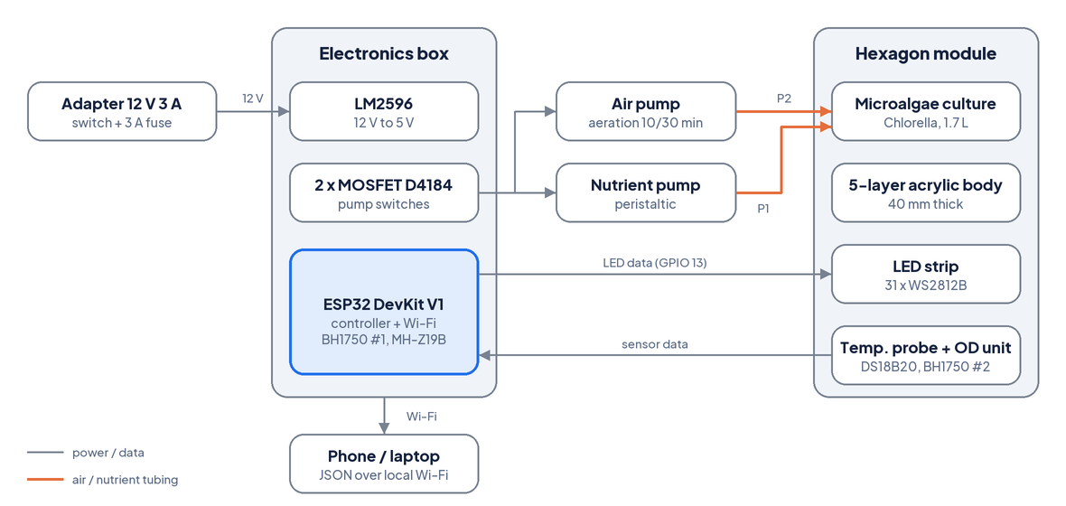
Figure 2. System architecture of the ALGORA prototype
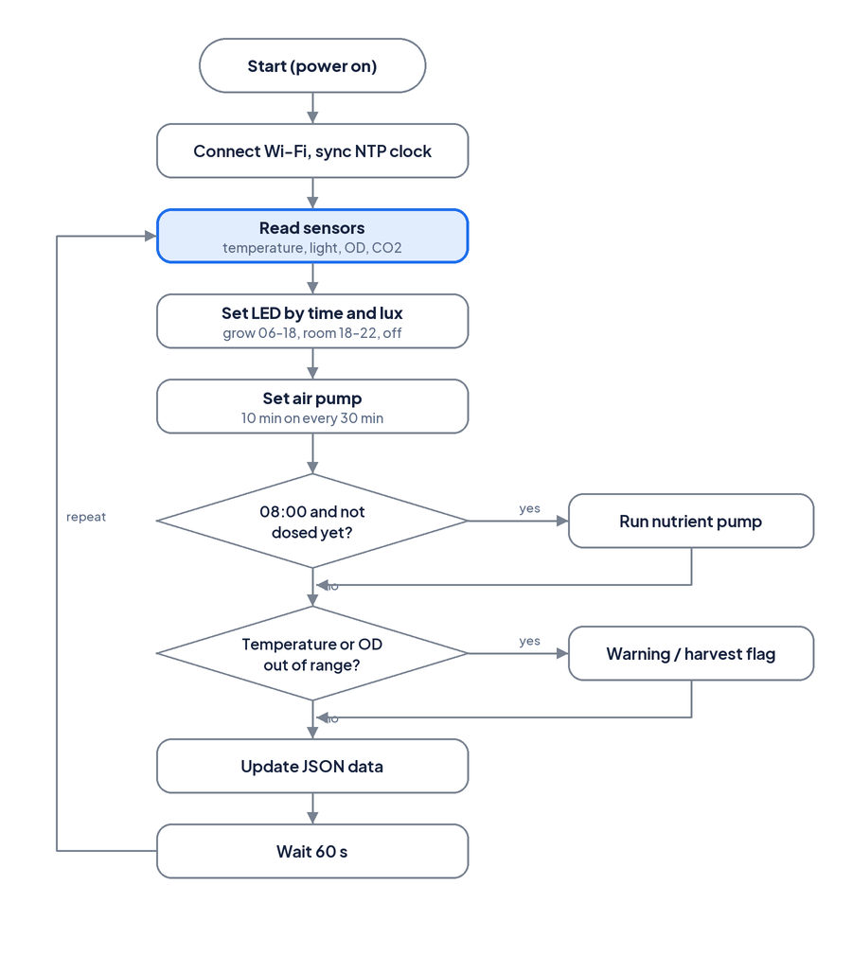
Figure 3. Control flowchart of the 60-second cycle

3.5 Verification by CAD, Calculation and Simulation
• CAD: all parts were drawn as dimensioned DXF files and plotted in LibreCAD; CNC path length and time were calculated from the geometry (feed 1,000 mm/min, 2 mm per pass, assumed).
• Control simulation: the firmware rules were run minute by minute for 24 h with a power model (ESP32 1.3 W, sensors 0.5 W, WS2812B 20 mA per channel at full scale with 50% brightness, converter 85%, air pump 3.6 W, indoor light below 2,000 lux).
• Growth and CO2 model: X(t) = Xmax / (1 + (Xmax/X0 - 1) e^(-μt)) with X0 = 0.05 g/L, Xmax = 1.0 g/L and μ = 0.20, 0.35 and 0.50 per day (assumed range); fixed CO2 = 1.83 x biomass gain x 1.7 L [1]. Closed box: 60 L, 1,000 ppm, 25 °C, 5 ppm/h leakage for both boxes, uptake at the fastest growth phase during the light period.

CHAPTER 4

Results and Discussion

4.1 Detailed Design
Figure 4 shows the detailed design drawn as a DXF file and plotted with LibreCAD. All dimensions match the CNC cutting files: 300 mm across flats, 346.4 mm across corners, 40 mm thickness in five layers, an 11 mm ring wall and four gland holes. The 30 mm light path is typical of flat-panel reactors, so light reaches the whole culture [4]. The hydrostatic pressure at the bottom is only about 3 kPa, which aquarium silicone can hold if the bottom joint and the drain gland P4 are sealed carefully.
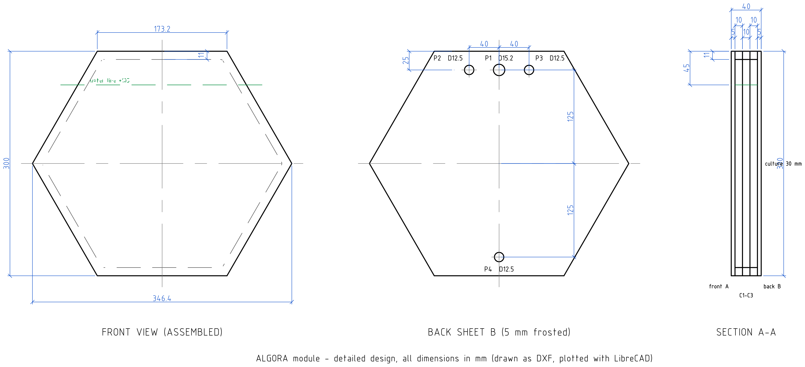
Figure 4. Detailed design of one module plotted with LibreCAD (dimensions in mm)

4.2 CNC Fabrication Calculation
Table 2. Calculated CNC cutting data (feed 1,000 mm/min, 2 mm per pass)
Part | Qty | t (mm) | Area (cm2) | Cut (m) | Passes | Time (min) | Mass (g)
A front sheet | 1 | 5 | 779 | 1.04 | 3 | 3.1 | 464
B back sheet | 1 | 5 | 774 | 1.20 | 3 | 3.6 | 460
C frame ring | 3 | 10 | 110 | 6.00 | 5 | 30.0 | 393
Total | 5 | - | - | 8.24 | - | 36.7 | 1318

Cutting the five parts needs 8.24 m of tool path and about 37 minutes of machine time, of which the three 10 mm rings take 30 minutes. Each ring leaves a 278 mm hexagonal offcut of 669 cm2, which can be reused, for example as a mounting plate. The acrylic body weighs 1.32 kg, or about 3.1 kg when filled.

4.3 Control Logic Simulation
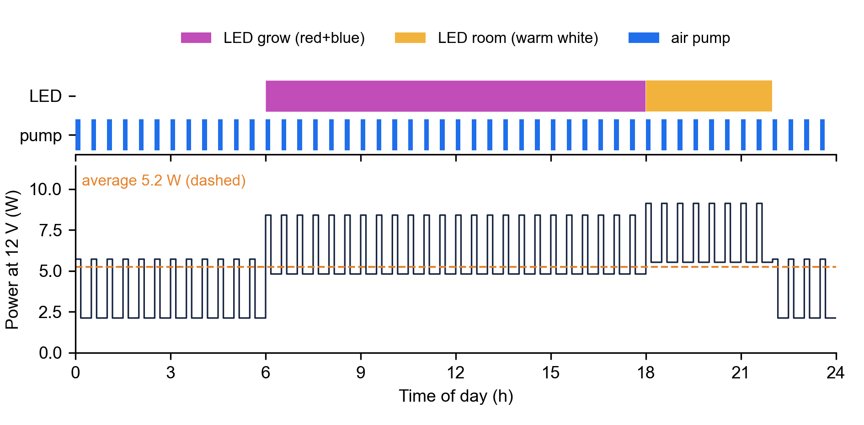
Figure 5. Simulated 24-hour LED and pump schedule and power at 12 V
The simulation confirms that the firmware produces 16 hours of light (12 h grow light and 4 h room light) and 8 hours of aeration per day (Figure 5). Power ranges from 2.1 W at night to 9.1 W when the room light and the air pump run together, with an average of 5.2 W. Daily energy is 126 Wh, about 3.8 kWh per month, so one module costs less to run than a typical 10 W LED bulb used for the same hours.

4.4 Growth and CO2 Simulation
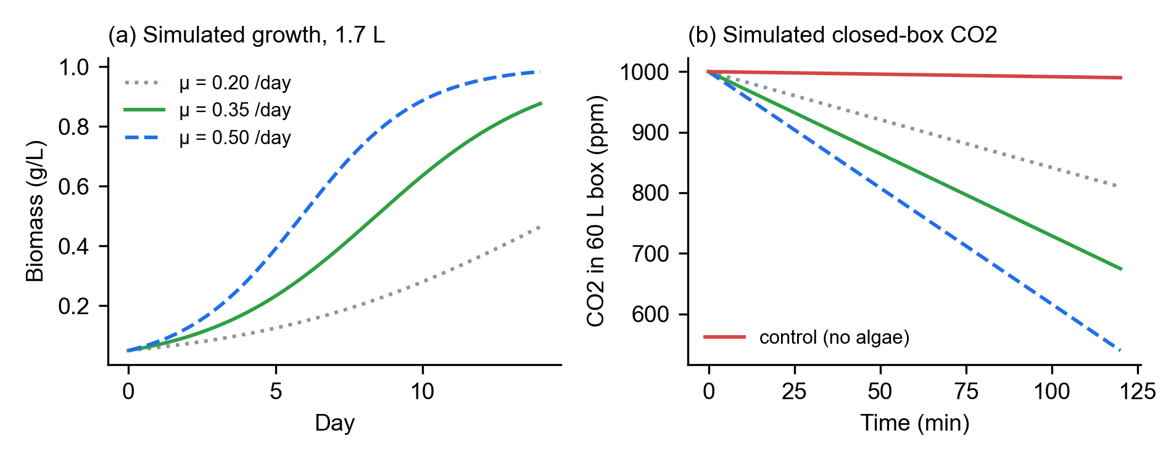
Figure 6. Simulated (a) biomass growth and (b) CO2 in a 60 L closed box for three growth rates
With growth rates of 0.20, 0.35 and 0.50 per day, the culture reaches 0.46, 0.88 and 0.98 g/L after 14 days and fixes 1.3, 2.6 and 2.9 g of CO2 (Figure 6a). In the closed-box test, CO2 is predicted to fall by 190, 325 and 460 ppm in 2 hours, compared with 10 ppm in the control (Figure 6b), so the effect of the algae is clearly measurable with the MH-Z19B sensor.
At room scale the effect of one module is small: its peak uptake of about 0.27 g CO2 per day is far below the roughly 1 kg exhaled daily by one person. ALGORA is therefore best seen as a modular demonstrator and lamp; a honeycomb wall of many modules, larger volumes or a higher growth rate would be needed for a noticeable change in a classroom. The model assumes no nutrient or light limitation, so its values are upper estimates that must be confirmed by the planned physical tests.

CHAPTER 5

Conclusion
1. ALGORA was designed as a modular hexagonal flat-panel photobioreactor lamp 300 mm across flats and 40 mm thick, made of five CNC-cut acrylic layers that hold about 1.7 L of Chlorella vulgaris. An ESP32 with temperature, light, optical density and CO2 sensors controls 31 LEDs, aeration and nutrient dosing and shares data over Wi-Fi. The parts need 8.24 m of CNC path (about 37 min) and weigh 1.32 kg.
2. Simulation shows that the control program provides 16 h of light and 8 h of aeration per day at an average power of 5.2 W (126 Wh per day). The growth model predicts 0.46-0.98 g/L of biomass and 1.3-2.9 g of CO2 fixed in 14 days, and a CO2 drop of 190-460 ppm in a 60 L closed box within 2 h.
ALGORA can be applied as an energy-efficient room lamp and as a learning medium for photosynthesis and IoT. Future work should validate the simulation with the planned physical tests, connect several modules into a honeycomb wall, add a pH sensor, calibrate the OD sensor and build the cloud-connected mobile application.

REFERENCES
[1] Y. Chisti, Biodiesel from microalgae, Biotechnology Advances, 25 (2007) 294-306.
[2] B. Wang, Y. Li, N. Wu and C.Q. Lan, CO2 bio-mitigation using microalgae, Applied Microbiology and Biotechnology, 79 (2008) 707-718.
[3] C.U. Ugwu, H. Aoyagi and H. Uchiyama, Photobioreactors for mass cultivation of algae, Bioresource Technology, 99 (2008) 4021-4028.
[4] C. Posten, Design principles of photo-bioreactors for cultivation of microalgae, Engineering in Life Sciences, 9 (2009) 165-177.
[5] A. Richmond and Q. Hu (Eds.), Handbook of Microalgal Culture: Applied Phycology and Biotechnology, 2nd ed., Wiley-Blackwell, 2013.
[6] C. Safi, B. Zebib, O. Merah, P.-Y. Pontalier and C. Vaca-Garcia, Morphology, composition, production, processing and applications of Chlorella vulgaris: A review, Renewable and Sustainable Energy Reviews, 35 (2014) 265-278.
[7] N.A. Campbell, J.B. Reece et al., Biology, 8th ed., Pearson Benjamin Cummings, 2008.
[8] Espressif Systems, ESP32 Series Datasheet, Espressif Systems, Shanghai.
[9] Maxim Integrated, DS18B20 Datasheet; ROHM, BH1750FVI Datasheet; Winsen, MH-Z19B Datasheet; Worldsemi, WS2812B Datasheet.
[10] Sugiyono, Metode Penelitian Kuantitatif, Kualitatif, dan R&D, Alfabeta, Bandung, 2013.
[11] M.D. Gall, J.P. Gall and W.R. Borg, Educational Research: An Introduction, 7th ed., Allyn and Bacon, Boston, 2003.

