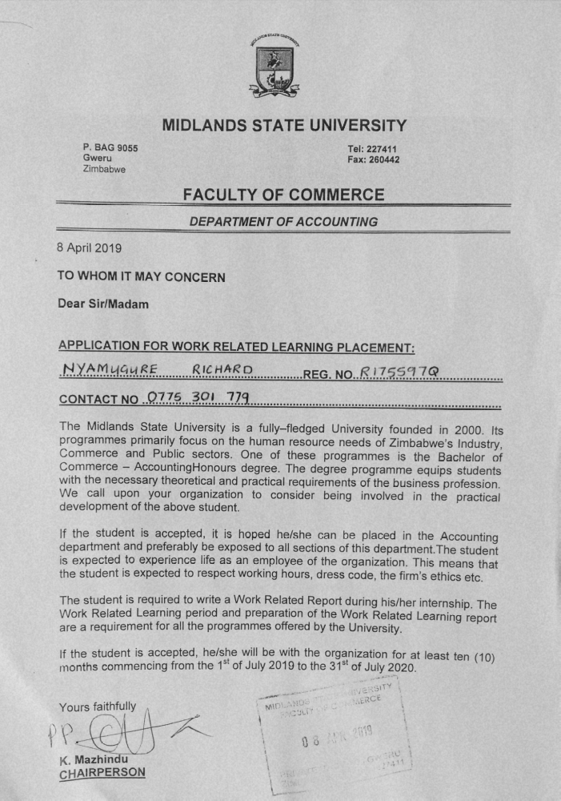
CURRICULUM VITAE
FOR
RICHARD NYAMUGURE
867 Porti Road
Kambuzuma Section 3
Harare
Cell: +263 775 301 779/719 301 779
E-mail: richardnyamugure6@gmail.com

PERSONAL DETAILS
Name: | Richard
Surname: | Nyamugure
Gender: | Male
Date of Birth: | 3 July 1997
National ID Number: | 63-1571971-X-47
Nationality: | Zimbabwean
Religion: | Christian
Marital Status: | Single
PERSONAL ATTRIBUTES

Team worker
Hardworking
Initiative
Good Communicator
Able to work with minimum supervision

CAREER OBJECTIVE
To find a challenging position to meet my competencies, capabilities, skills, education and experience.

ACADEMIC PROFILE
Program: HACC-Bachelor of Commerce Accounting Honours Degree (August 2017- February 2021)
Institution: Midlands State University

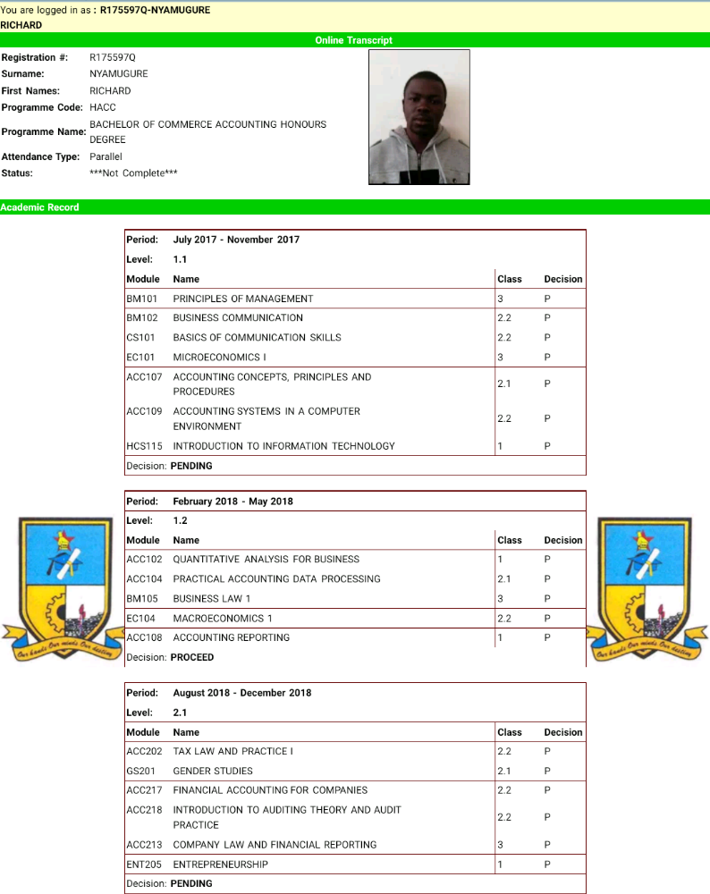

G.C.E Advanced Level [2016]
Subject | Grade
Accounting | C
Mathematics | E
Business Studies | C
English Communication Skill | Pass
[7 Points]

G.C.E Ordinary Level [2013]
Nine “O” Levels [Mathematics and English included]

REFEREES
Midlands State University
P. Bag 9055
Gweru
Zimbabwe
Tel: +263 8677 000234
Fax: +263 2 54 2260233
infoandpr@msu.ac.zw
.

Midlands State University
Senga,Gweru
Accounting Department
Mr. K Mazhindu
mazhinduk@staff.msu.ac.zw
Cell: +236 772 251 404

The Senior Master
Mr. Linachi
Kambuzuma 1High School
P.O Box 10
Kambuzuma,
Harare
+263 773220471

