CURRICULUM

VITAE

FOR

FARAI

NDARUKWA

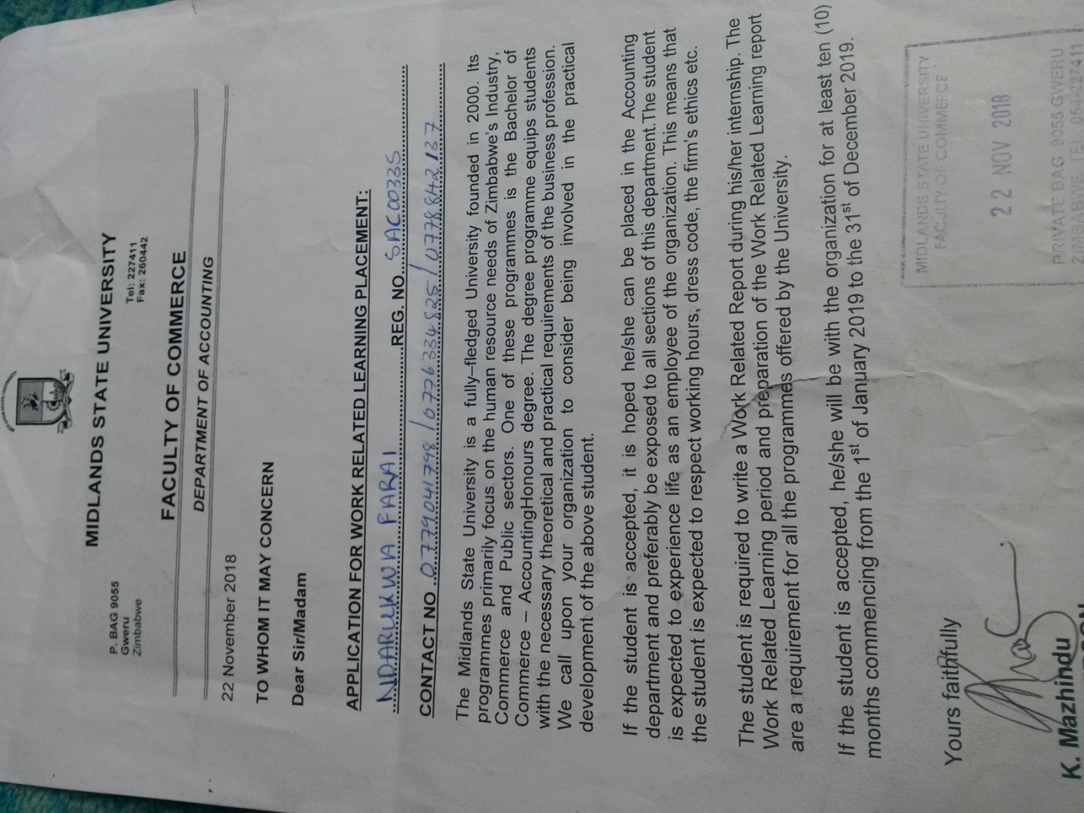PERSONAL INFORMATION

Name : FARAI

Surname : NDARUKWA

Date of birth : 01 JANUARY 1994

National ID : 29-283029 D07

Sex : Male

Marital status : Single

Nationality : Zimbabwean

Religion : Christianity

Languages : English and Shona

**CONTACT DETAILS**

ADDRESS : No 12 MBUYISA ROAD ASCOT GWERU

CELL : 0779041798/0776334825/0778842137

Email : fndarukwa@gmail.com

**Leadership and Position rating**

* Prefect BOOMS CHRISTIAN COLLEGE (2011-2013).

**Personal Attributes**

* Team player
* Innovation and hard-working
* Result oriented and able to meet deadlines
* Willing and Quick to learn new things
* Honest
* Able to work under pressure

**Hobbies**

* Playing football
* Listening to music (Gospel music)
* Athletics

**SKILLS**

* Good communication skills
* Inter personal relationing skills
* Computer literate

# Academic qualifications

**Schoolattended Level Year Passes**

Booms Christian college Ordinary level 2013 7 “O” Level passes including Mathematics and English

Mambo High School Advanced level 2015 3 “A” Levels passes.

|  |  |  |  |  |  |  |  |  |  |  |  |  |  |  |  |  |  |
| --- | --- | --- | --- | --- | --- | --- | --- | --- | --- | --- | --- | --- | --- | --- | --- | --- | --- |
| **PROFESSIONAL QUALIFICATION** MIDLANDS STATE UNIVERSITY **FACULTY OF COMMERCE**   |  |  |  | | --- | --- | --- | | **Registration #:** | SAC0033S |  | | **Surname:** | NDARUKWA | | **First Names:** | FARAI | | **Programme Code:** | HACC | | **Programme Name:** | BACHELOR OF COMMERCE ACCOUNTING HONOURS DEGREE | | **Attendance Type:** | Convectional | | **Status:** | ***Not Complete*** | |  |  | |
| **Academic Record** |
| |  |  |  |  |  |  |  |  |  |  |  |  |  |  |  |  |  |  |  |  |  |  |  |  |  |  |  |  |  |  |  |  |  |  |  |  |  |  |  |  |  |  |  |  |  |  |  |  |  |  |  |  |  |  |  |  |  |  |  |  |  |  |  |  |  |  |  |  |  |  |  |  |  |  |  |  |  |  |  |  |  |  |  |  |  |  | | --- | --- | --- | --- | --- | --- | --- | --- | --- | --- | --- | --- | --- | --- | --- | --- | --- | --- | --- | --- | --- | --- | --- | --- | --- | --- | --- | --- | --- | --- | --- | --- | --- | --- | --- | --- | --- | --- | --- | --- | --- | --- | --- | --- | --- | --- | --- | --- | --- | --- | --- | --- | --- | --- | --- | --- | --- | --- | --- | --- | --- | --- | --- | --- | --- | --- | --- | --- | --- | --- | --- | --- | --- | --- | --- | --- | --- | --- | --- | --- | --- | --- | --- | --- | --- | --- | | |  |  |  |  |  |  |  |  | | --- | --- | --- | --- | --- | --- | --- | --- | | **Period:** | | **February 2017 - June 2017** | | | | | | | **Level:** | | **1.1** | | | | | | | **Module** | **Name** | | **Class** | **Decision** | | BM101 | | PRINCIPLES OF MANAGEMENT | | | | 3 | P | | BM102 | | BUSINESS COMMUNICATION | | | | 3 | P | | CS101 | | BASICS OF COMMUNICATION SKILLS | | | | 2.2 | P | | EC101 | | MICROECONOMICS I | | | | 3 | P | | ACC107 | | ACCOUNTING CONCEPTS, PRINCIPLES AND PROCEDURES | | | | 2.1 | P | | ACC109 | | ACCOUNTING SYSTEMS IN A COMPUTER ENVIRONMENT | | | | 3 | P | | HCS115 | | INTRODUCTION TO INFORMATION TECHNOLOGY | | | | 2.1 | P | | Decision: **PENDING** | | | | | | | | | | |  |  |  |  |  |  |  |  | | --- | --- | --- | --- | --- | --- | --- | --- | | **Period:** | | **July 2017- November 2017** | | | | | | | **Level:** | | **1.2** | | | | | | | **Module** | **Name** | | **Class** | **Decision** | | ACC102 | | QUANTITATIVE ANALYSIS FOR BUSINESS | | | | 2.1 | P | | ACC104 | | PRACTICAL ACCOUNTING DATA PROCESSING | | | | 3 | P | | BM105 | | BUSINESS LAW 1 | | | | 2.1 | P | | EC104 | | MACROECONOMICS 1 | | | | 2.1 | P | | ACC108 | | ACCOUNTING REPORTING | | | | 2.1 | P | | Decision: **PROCEED** | | | | | | | | | | |  |  |  |  |  |  |  |  |  | | --- | --- | --- | --- | --- | --- | --- | --- | --- | | **Period:** | | **February 2018 - May 2018** | | | | | | | | **Level:** | | **2.1** | | | | | | | | **Module** | **Name** | | **Class** | **Decision** | | ACC202 | | TAX LAW AND PRACTICE I | | | | 2.1 | | P | | | GS201 | | GENDER STUDIES | | | | 2.1 | | P | | | ACC217 | | FINANCIAL ACCOUNTING FOR COMPANIES | | | | 2.1 | | P | | | ACC218 | | INTRODUCTION TO AUDITING THEORY AND AUDIT PRACTICE | | | | 3 | | P | | | ACC213 | | COMPANY LAW AND FINANCIAL REPORTING | | | | 2.2 | | P | | | ENT205 | | ENTREPRENEURSHIP I | | | | 2.1 | | P | | | Decision: **PENDING** | | | | | | | | |

|  |  |
| --- | --- |
| **Registration Period:** | JULY 2018 – NOVEMBER 2018 |
| **Level:** | 2.2 |

|  |  |  |  |  |
| --- | --- | --- | --- | --- |
| **Modules Registered** | | | | |
|  | **Code** | **Description** | **DECISION** |  |
| 1 | ACC212 | TAX LAW AND PRACTICE II | Pending |  |
| 2 | ACC219 | GROUP STATEMENTS, TIME VALUE OF MONEY AND THE VALUATION OF FINANCIAL INSTRUMENTS | Pending |  |
| 3 | ACC214 | INTRODUCTION TO THE PERFORMING OF THE AUDIT PROCESS | Pending |  |
| 4 | ACC215 | COST ACCOUNTING AND CONTROL | Pending |  |
| 5 | ACC216 | FINANCIAL MANAGEMENT FOR ACCOUNTANTS | Pending |  |

Decision: Pending.**REFERENCES**

**MR MUGOZHI**

MIDLANDS STATE UNIVERSITY

GWERU

ZIMBABWE

CELL-0772548483

**MR K MAZHINDU**

ACCOUNTING CHAIRPERSON

MIDLANDS STATE UNIVERSITY

GWERU

ZIMBABWE

CELL-0772251404