In-Class Activity 1

One lap around a standard high-school running track is exactly 0.25 miles. Define a function named laps_to_miles that takes a number of laps as a parameter, and returns the number of miles. Then, write a main program that takes a number of laps as an input, calls function laps_to_miles() to calculate the number of miles, and outputs the number of miles.

Output each floating-point value with two digits after the decimal point, which can be achieved as follows:

print(f'{your_value:.2f}')

Case1

Ex: If the input is:

7.6

the output is:

1.90

Case2

Ex: If the input is:

2.2

the output is:

0.55

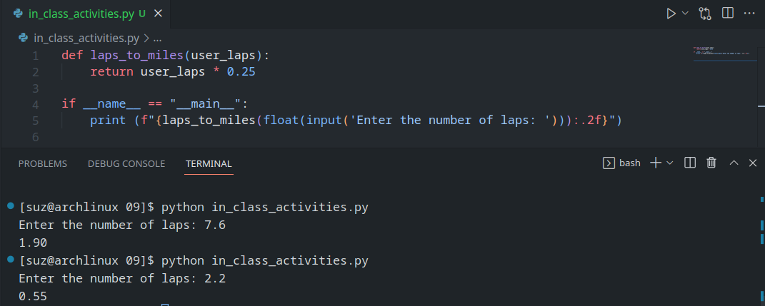

In-Class Activity 2

Define that function in a program whose inputs are the car's miles per gallon and the price of gas in dollars per gallon (both float). Output the gas cost for 10 miles, 50 miles, and 400 miles, by calling your driving_cost() function three times.

Output each floating-point value with two digits after the decimal point, which can be achieved as follows:

print(f'{your_value:.2f}')

Ex: If the input is:

20.0

3.1599

the output is:

1.58

7.90

63.20

