My Orange

My Orange

Assessment Date: 2022-05-30T15:36:25

Mobile application

|  |  |
| --- | --- |
| Main Domain | {main_domain} |
| Sub-domain | {sub_domain} |

TSC IT Cloud (Dream Team)

2022-05-30T15:36:25

Proprietary notice

Copyright © Orange Brand Services Limited 2022. All rights reserved.

Confidentiality

All information contained in this document is strictly confidential and is the property of Orange. It is provided for the sole purpose of responding to the request from {client} and shall not be used for any other purpose.

{client} shall not publish or disclose this information, in whole or in part, to any other party without the prior written permission of Orange.

Obligations and conditions

This document is subject to contract and does not constitute a binding offer from Orange. In the event that any assumption on which Orange has based its proposal or any information provided by {client} changes or is incorrect, Orange reserves the right to revise any portion of this document accordingly.

Implementation of any services detailed in this document is subject to applicable regulations in force on the date the services are to be implemented.

Orange, the Orange logo and related marks are trademarks of Orange Brand Services Limited. Many of the products, services, and company names referred to in this document are registered trademarks of third parties. They are all hereby acknowledged.

Orange is a trading name of the Orange Group.

Point of contact

|  |  |  |  |
| --- | --- | --- | --- |
| Name: | Messaoud FERKIOUI | | |
| Title: | Architecture and Support for IS in Countries | | |
| Tel: | +33 1 57 39 71 59 | Email: | messaoud.ferkioui@orange.com |
| Address: | Orange Gardens  44 avenue de la République  CS 50010  92326 Châtillon Cedex  France | | |
| Website: | [innovation.com.intraorange](https://innovation.com.intraorange) | | |

Contact

|  |  |  |  |
| --- | --- | --- | --- |
| Name | Title | Department | Email |
| ff | ff | ff | ff |

Table Of Content

1 Technical informations 6

1.1 Servers 6

1.2 Interfaces 8

1.3 Databases 10

2 Business informations 12

2.1 Application Overview **Erreur ! Signet non défini.**

2.2 Product & Vendor Information **Erreur ! Signet non défini.**

2.3 Requirements & Constraints **Erreur ! Signet non défini.**

2.4 End User Information **Erreur ! Signet non défini.**

2.5 Availability & Business Continuity **Erreur ! Signet non défini.**

2.6 Non-Production Information **Erreur ! Signet non défini.**

2.7 Infrastructure Supporting Components 14

3 Cloud Strategy Migration 22

4 Business Case 25

# Technical informations

## Servers

|  |  |  |  |  |  |  |  |  |  |
| --- | --- | --- | --- | --- | --- | --- | --- | --- | --- |
| Environment | Data Center Name | Role | Server Name | Type | IP Address | Operating System | CPU Core Count | RAM Size | Disk Size |
|  | DC 1 | None | g | rt | 1 | A | 3 | 3 | None |
|  | test dc | None | ff | 34 | 12 | OS | 5 | 3 | None |
|  |  | None | g | rt | 1 | A | 3 | 3 | None |
| test | DC 1 | None | test | hh | 1.1.1.1 | OS | 3 | 3 | None |
|  | DC 1 | None | ZZZZ | ZZZZ | 1111 | ZZZZ | 3 | 3 | None |
| hh | DC 1 | None | ZZZZZZZZ | ZZZZZZ | ZZZZZZZZ | ZZZZ | 3 | 4 | None |
|  | DC 1 | None | ffff | fffff | fffff | fffffff | 3 | 3 | None |
|  | test dc | None | xx | xx | 1 | xx | 3 | 3 | None |
| hh | tt | None | jjj | dd | 111 | 22 | 2 | 2 | None |
|  | DC 1 | None | dd | zz | 12 | dd | 12 | 12 | None |
|  | DC 1 | None | h | hh | 12 | linx | 122 | 12 | None |
| hh | test dc | None | d | d | d | 2 | 2 | 2 | None |
| hh | test dc | None | d | d | d | 2 | 2 | 2 | None |
|  |  | None | ddddddddddddddddddddddddddddddddddd | dd | dd | zz | 2 | 2 | None |
|  | DC 1 | None | dd | zz | 12 | dd | 12 | 12 | None |
| hh | test dc | None | d | d | d | 2 | 2 | 2 | None |
|  | DC 1 | None | dd | zz | 12 | dd | 12 | 12 | None |
|  | DC 1 | None | Archimaster 3 | None | None | None | None | None | None |
| hh | DC 1 | None | g | rt | 1 | A | 3 | 3 | None |
|  | test dc | None | Archimaster 2 | None | None | None | None | None | None |
| hh | DC 1 | None | Archimaster 1 | None | None | None | None | None | None |

## Interfaces

|  |  |  |  |  |  |
| --- | --- | --- | --- | --- | --- |
| Source | Target | Protocol | Internal Or External | Batch Or Real Time | Frequency |
| My Orange | Archimaster | AA | EXTERNAL | REAL_TIME | DAILY |
| My Orange | Archimaster | qqqq | EXTERNAL | REAL_TIME | HOURLY |
| testExcel | My Orange | aa | EXTERNAL | REAL_TIME | DAILY |
| testExcel | My Orange | aa | EXTERNAL | REAL_TIME | DAILY |
| Archimaster | My Orange | AA | EXTERNAL | REAL_TIME | HOURLY |

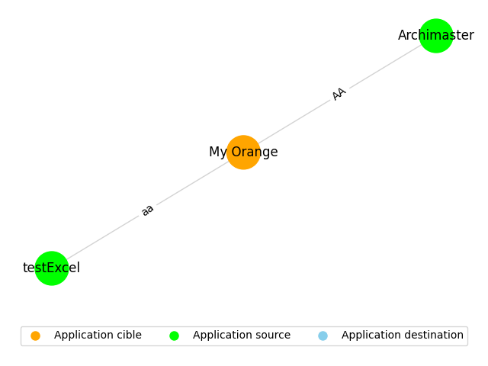

## Databases

|  |  |
| --- | --- |
| Server Name | Database Technology |
| jjj | Mongo |
| jjj | Db 3 |
| jjj | DB 3 |
| jjj | DB 4 |
| jjj | None |
| jjj | hh |
| jjj | ffff |
| Archimaster 3 | None |
| Archimaster 2 | None |
| Archimaster 2 | HH |
| Archimaster 2 | test |
| Archimaster 1 | DB 3 |
| Archimaster 1 | DB 4 |
| Archimaster 1 | None |
| Archimaster 1 | DB 44 |
| Archimaster 1 | ss |
| Archimaster 1 | vv |

# Business informations

2.1 Application Overview

|  |  |
| --- | --- |
| Question | Response |
| What is the cloud migration strategy for this application? | Global Default (Cloud Native) |
| What are your plans for this application over the next 6-12 months? | Sell - stop using now or in the near future |
| Has a replacement solution/application been identified? | No |
| What is the data classification for this application? | Orange Confidential |
| Who is the audience for this application? | External Only (Partners) |
| How critical is this application to your organisation? | Medium - Commercial |
| What is the category of this application (Application or Infrastructure)? | Application |
| Which Business Unit or Department uses this application? (If not applicable please state N/A) | test |
| Application description - What is this application used for? E.g. our core accounting package, CRM, HR etc. | None |

2.2 Product Vendor Information

|  |  |
| --- | --- |
| Question | Response |
| Application vendor type | Third Party Developed |
| Is a SaaS version of this application available? | Yes |
| What is the current Application delivery model? | SaaS |
| Is there vendor support for virtualised infrastructure and/or cloud services? | No |
| What development language is the application written in? | COTS |
| When was the application last updated? | 0-12 months |
| What is the Architecture type for this application | 2 Tier Application (Logic built-in to either Data or Presentation Layer) |
| What is the version number of the application currently deployed | None |
| What is the licensing model for this application? Per user, per server, per CPU etc? | None |
| What is the vendors name of the application | None |
| Is the application internally or externally (vendor) supported? | None |
| Please provide the application vendor contact details | aaaaaa |

2.3 Requirements Constraints

|  |  |
| --- | --- |
| Question | Response |
| What is the application profile (flat, spikes)? | Flat |
| Does the application have a batch processing demand? | Yes |
| Is the application subject to compliance or regulatory processes (i.e. - PCI, SOX, ITAR, GDPR etc)? | Yes |
| Is the application data required to be located within a particular country? | Yes |
| Does the application require Encryption at Rest and/or Encryption in Transit? | Yes |
| Does the application have any hardware dependencies in order to function? | None |
| Does the application have any pre-existing operational issues (performance, stability, etc)? | None |
| Are there any in-flight projects that could impact the migration/transformation of the application? | None |
| Does the application have any bespoke remote access requirements? | None |
| Is there an application refresh policy in place? | None |
| Are there any specific licensing dependencies for the application to run? | None |

2.4 End User Information

|  |  |
| --- | --- |
| Question | Response |
| What type of end-user interface does the application have? | Web Client |
| How many users does the application have? | 500 - 999 |
| What is the total inbound interface count? | None |
| What is the total outbound interface count? | None |

2.5 Availability Business Continuity

|  |  |
| --- | --- |
| Question | Response |
| DR type | None |
| When is the application in use? | 24 x 7 |
| What is the Application Recovery Target Objective (RTO)? | None |
| What is the Applications Recovery Point Objective (RPO)? | None |

2.6 Non-Production Information

|  |  |
| --- | --- |
| Question | Response |
| Can Non-Production environments be taken off-line during non-working hours? | Yes |
| How many days per month is the development environment is use? | Working hours only |
| How many days per month is the test environment is use? | Working hours only |

2.7 Infrastructure Supporting Components

|  |  |
| --- | --- |
| Question | Response |
| Is the application configured to run in a high availability/resilient configuration? | Yes |
| Is there a load balancer used for this application? | Yes |
| Is this application public facing and protected by a firewall? | Yes |
| How does the Application scale? | Automated Scaling |
| Does the Application have a requirement for Low Latency? | No |

# Cloud Strategy Migration

Recommanded stategy : retain

The 'retain' migration strategy focuses on keeping the current system as it is, without any significant changes, while moving it to the cloud infrastructure.

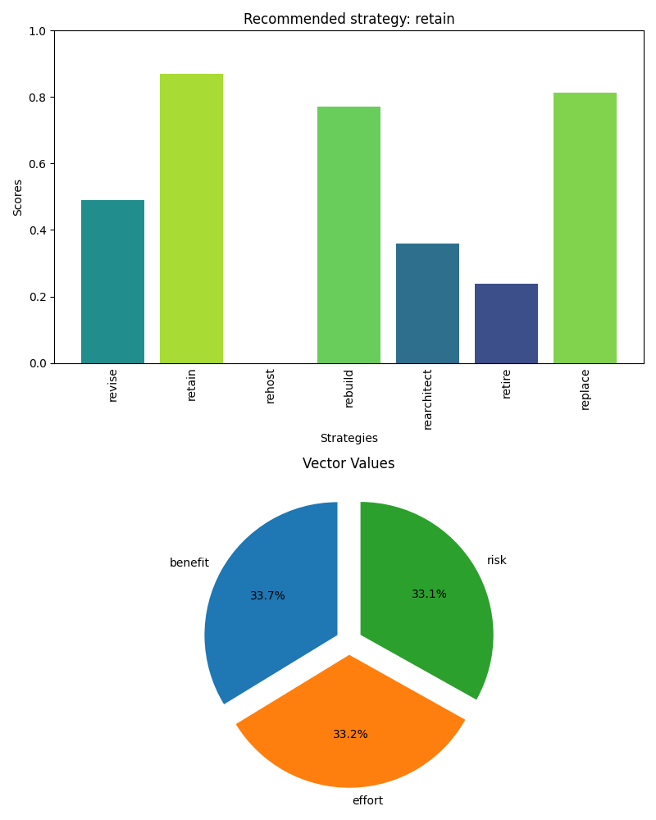

# Business Case

|  |  |
| --- | --- |
|  | As we support the transformation, we need to setup relevant business cases. In this business case at least 30 is about the Total Cost OwnerShip TCO. |