Heroes Gym is a Gym-Membership-manager web app having all the important features. admins will be able to add, delete and modify members info and their status. Website is user-friendly interface, quick response times which will result in having good experience with customers Having the CRUD operations implanted in it, as well as using ajax in the creating of the site for search member bar, this site is a representation of everything we have been taught through our journey in Axsos academy. So let us take you step by step through our web app.

Using the log in and registration to get admins account and proceed to the site

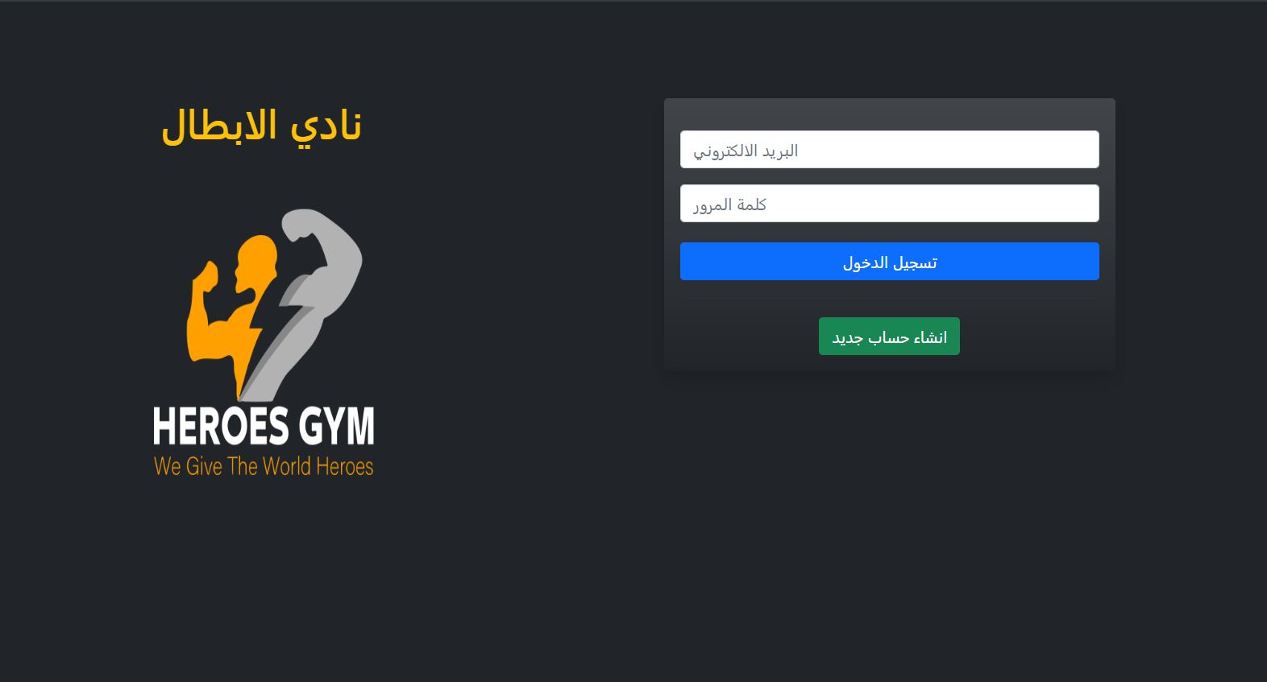

However, validation is added for logging in and registration meaning the password should match and meet.

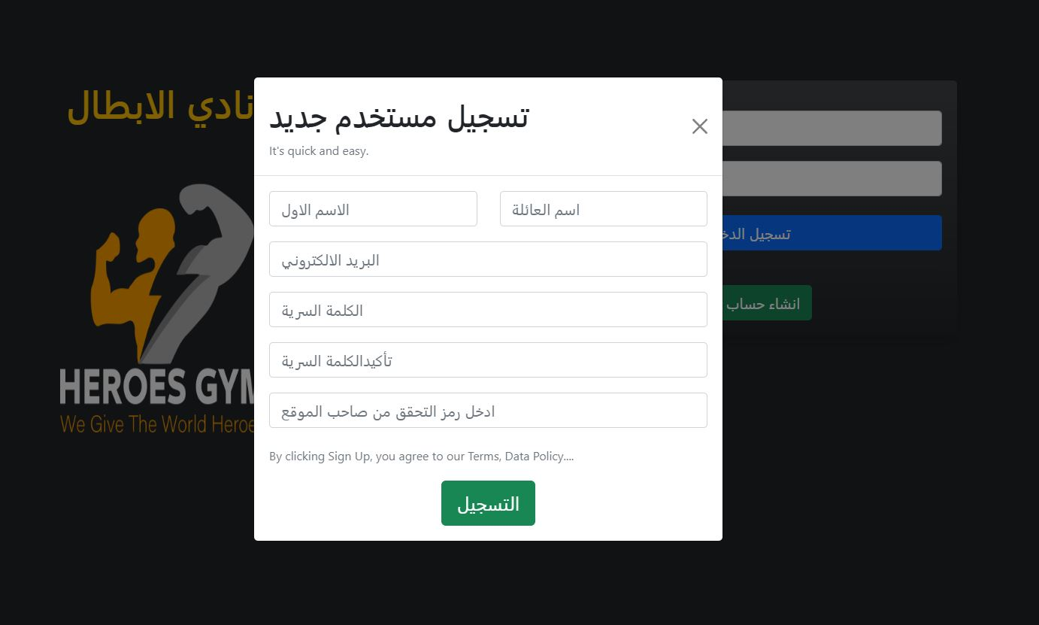

Once the user is logged on or registered, they can then navigate through the Site

Using the main page of the website and the navigation menu bar, when pressing on the menu you can view several options such as main page, add new member, member list, notifications, view products and log out.

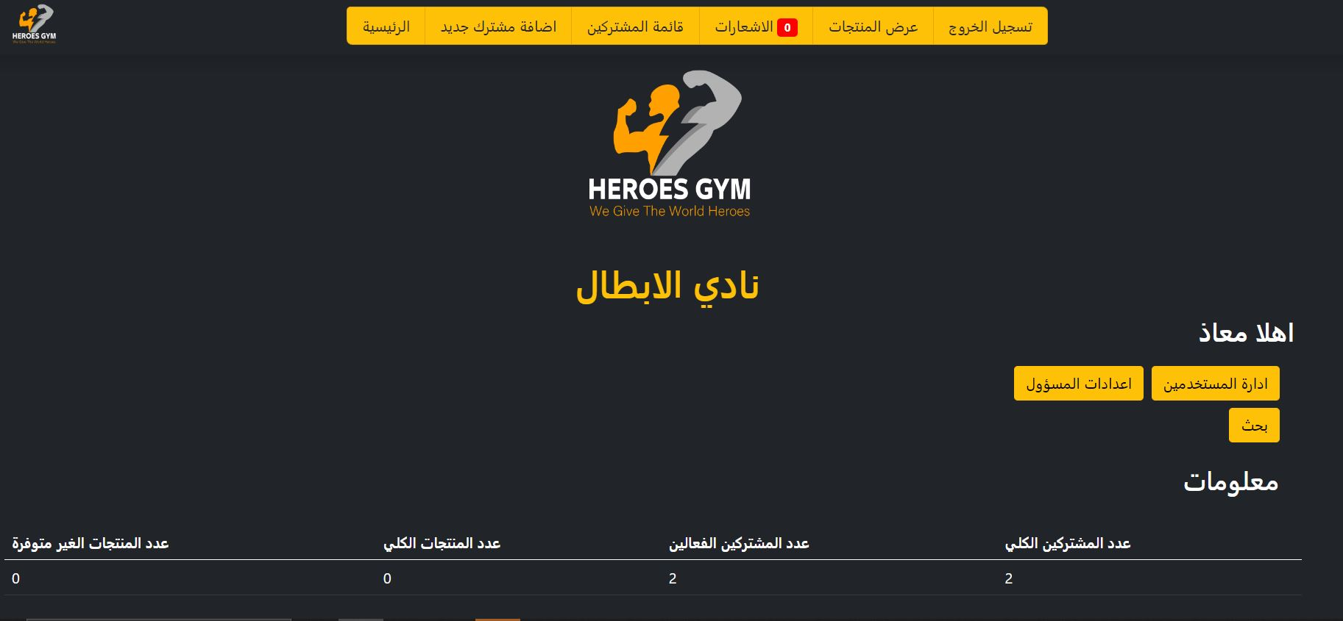

Main page consist of Gym logo, welcome message to the signed user, buttons for manage users, change settings (prices and entry code for new users registration) and search button (to search for gym members using their names.

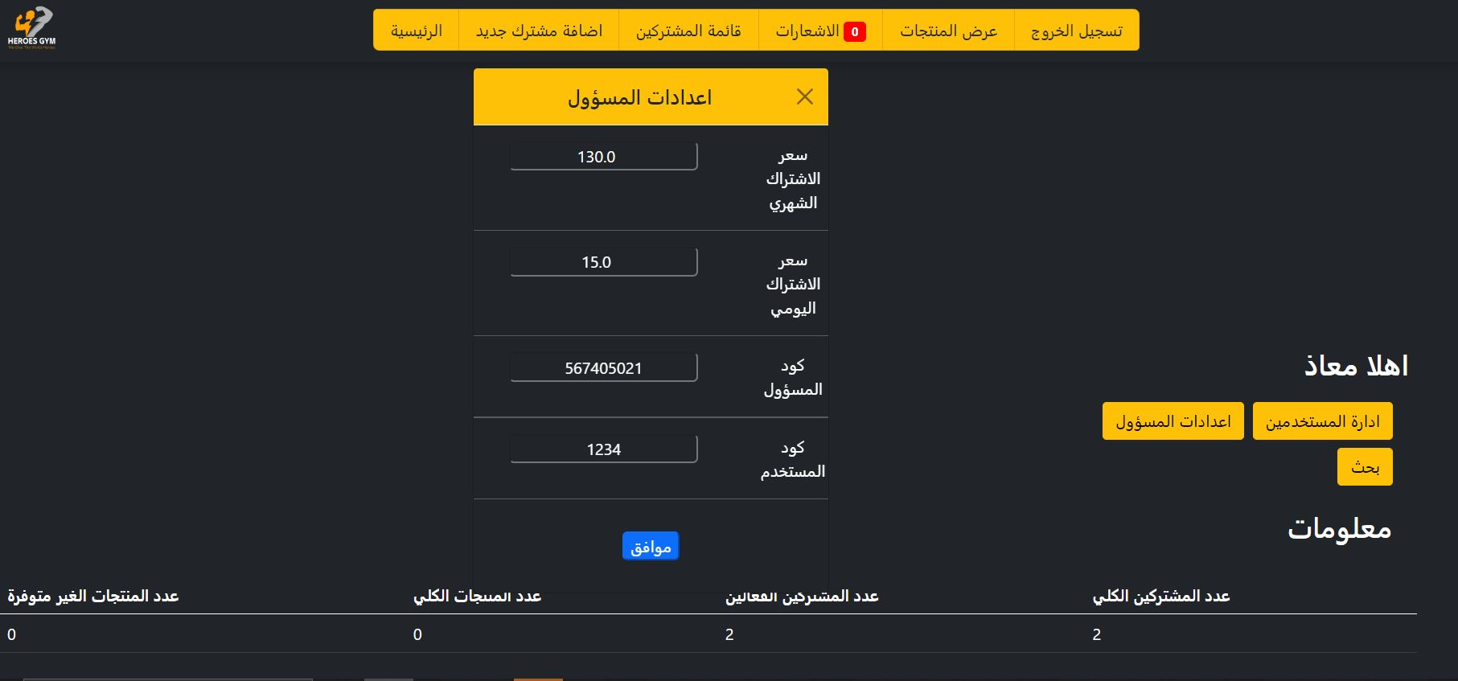

Add new member page, where you can and new member details such as first name, last name, mobile number, address, amount paid, membership type and we can upload each member avatar.

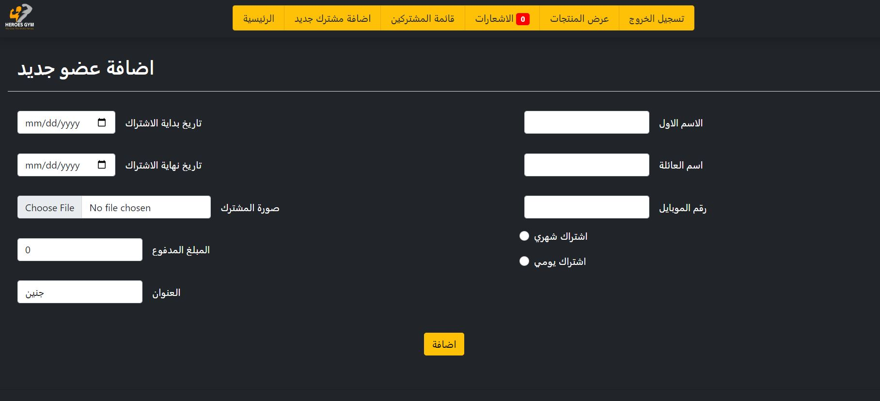

Member list page, where you can see a list of all members along with their details and payment status active status.

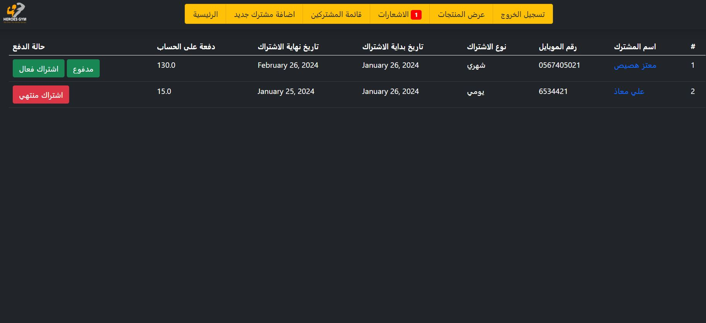

Notifications page, where you can see a list of all the members that are not active or not paid their membership fees.

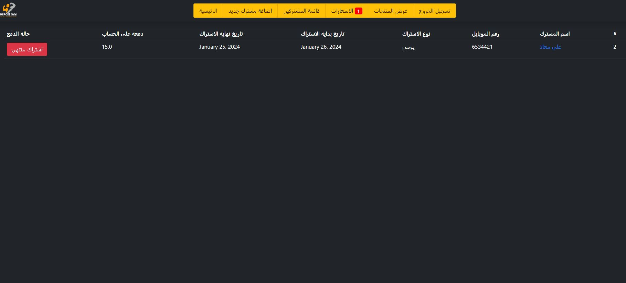

Show items page, where you can see a list of all items that you provide for gym members and you add more items by add items button

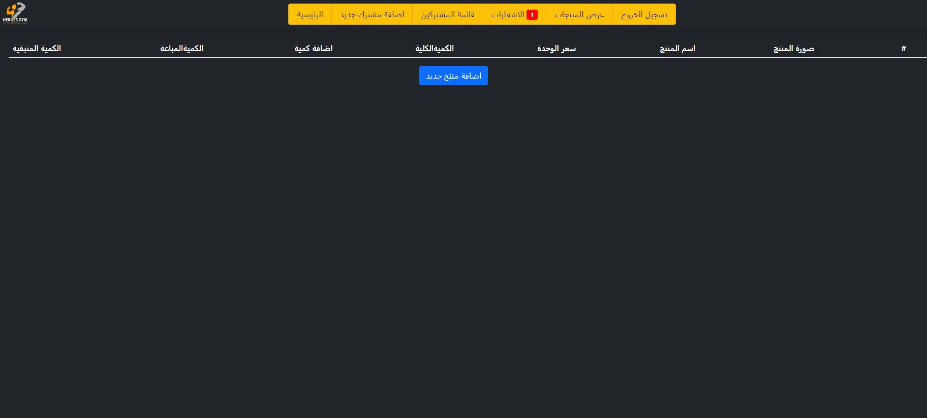

And last we have log out button redirect to the login page.

This project has been done by Django framework.

The requirements.txt file included in the project folder.