**Name:** *Matthew Chu*

**Program:** *Computer Engineering Technology*

**Year:** *1st Year*

**Assignment:** *Design Project #2*

**Problem Statement:**

Create a program that allows the user to play a game of tic-tac-toe with the computer. The program should demonstrate our ability to solve problems using procedural C++ programming focusing on loops, functions, random numbers, and global variables.

**Requirements Analysis:**

Certain key elements were identified from the start of the project: half of the game would be played by the user through additional code received from the user’s input. The program would then follow up with a move corresponding to the user’s prompt before checking for a winner. Then, the computer would go next with a random choice of spots, check for a winner, and then repeat the loop.

INPUTS: (9) positions on the board to be selected by a player

OUTPUTS: The tic-tac-toe board and error messages corresponding to incorrect inputs

SPECIAL FACTORS: Additional code pointing to corresponding points on the tic-tac-toe board available for the user to select

**Program File(s):**

**TicTacToe-main-mc.cpp**

/*********************************************************************************/

/*** Title: TicTacToe-main-mc.cpp ***/

/*** Course: Computational Problem Solving CPET-121 ***/

/*** Developer: Matthew Chu ***/

/*** Data: Feb 22, 2018 ***/

/*** Description: Tic Tac Toe Game (Without Arrays T_T) ***/

/*********************************************************************************/

**#include** <iostream>

**#include** <iomanip>

**#include** <stdlib.h>

**#include** <ctime>

**#include** "GlobalVar-tictactoe-mc.h"

**#include** "Draw-tictactoe-mc.h"

**#include** "Available-tictactoe-mc.h"

**#include** "InputCheck-tictactoe-mc.h"

**#include** "ComputerTurn-tictactoe-mc.h"

**#include** "CheckWinner-tictactoe-mc.h"

**#include** "Marker-tictactoe-mc.h"

**#include** "First-tictactoe-mc.h"

//#include "" name of header file

**using** **namespace** std;

**char** pos1='1';

**char** pos2='2';

**char** pos3='3';

**char** pos4='4';

**char** pos5='5';

**char** pos6='6';

**char** pos7='7';

**char** pos8='8';

**char** pos9='9';

**char** user='X';

**char** comp='O';

**int** position;

**char** winner;

**bool** gameOver=**false**;

**int** **main**(){

cout << "Welcome to the game of Tic Tac Toe."

"\nBelow you will indicate your position (1-9) as shown in the table.\n" << **endl**;

Marker();

First();

Draw();

**do**{

InputCheck();

gameOver=CheckWinner();

**if**(gameOver==**true**)

**break**;

ComputerTurn();

Draw();

gameOver=CheckWinner();

}**while**(gameOver!=**true**);

**if**(winner==user){

Draw();

cout << "Player 1 wins the game!" << **endl**;

}

**if**(winner==comp)

cout << "Computer wins the game!" << **endl**;

**if**(winner=='t'){

Draw();

cout << "Draw" << **endl**;

}

**return** (0);

}

/*********************************************************************************/

**GlobalVar-tictactoe-mc.h**

/*

* GlobalVar-tictactoe-mc.h

*

* Created on: Feb 25, 2018

* Author: Batman

*/

**#ifndef** GLOBALVAR_TICTACTOE_MC_H_

**#define** GLOBALVAR_TICTACTOE_MC_H_

**extern** **char** pos1;

**extern** **char** pos2;

**extern** **char** pos3;

**extern** **char** pos4;

**extern** **char** pos5;

**extern** **char** pos6;

**extern** **char** pos7;

**extern** **char** pos8;

**extern** **char** pos9;

**extern** **char** user;

**extern** **char** comp;

**extern** **int** position;

**extern** **char** winner;

**extern** **bool** gameOver;

**#endif** /* GLOBALVAR_TICTACTOE_MC_H_ */

**Draw-tictactoe-mc.h**

/*

* Draw-tictactoe-mc.h

*

* Created on: Feb 25, 2018

* Author: Batman

*/

**#ifndef** DRAW_TICTACTOE_MC_H_

**#define** DRAW_TICTACTOE_MC_H_

**void** **Draw**();

**#endif** /* DRAW_TICTACTOE_MC_H_ */

**DrawBody-tictactoe-mc.cpp**

/*

* DrawBody-tictactoe-mc.cpp

*

* Created on: Feb 25, 2018

* Author: Batman

*/

**#include** <iostream>

**#include** <iomanip>

**#include** "GlobalVar-tictactoe-mc.h"

**#include** "Draw-tictactoe-mc.h"

**using** **namespace** std;

**void** **Draw**(){

cout << left << "User (" << user << ") - Computer (" << comp << ")\n\n" << **endl**; **for**(**int** i=0; i<9; i++){

**if**(i==0 || i==3 || i==6 || i==8)

cout << " | | " << **endl**;

**if**(i==1)

cout << " " << pos1 << " | " << pos2 << " | " << pos3 << " " << **endl**;

**if**(i==4)

cout << " " << pos4 << " | " << pos5 << " | " << pos6 << " " << **endl**;

**if**(i==7)

cout << " " << pos7 << " | " << pos8 << " | " << pos9 << " " << **endl**;

**if**(i==2 || i==5)

cout << "_____|_____|_____" << **endl**;

}

}

/*********************************************************************************/

**InputCheck-tictactoe-mc.h**

/*

* InputCheck-tictactoe-mc.h

*

* Created on: Feb 25, 2018

* Author: Batman

*/

**#ifndef** INPUTCHECK_TICTACTOE_MC_H_

**#define** INPUTCHECK_TICTACTOE_MC_H_

**void** **InputCheck**();

**#endif** /* INPUTCHECK_TICTACTOE_MC_H_ */

**InputCheckBody-tictactoe-mc.cpp**

/*

* InputCheckBody-tictactoe-mc.cpp

*

* Created on: Feb 25, 2018

* Author: Batman

*/

**#include** <iostream>

**#include** <iomanip>

**#include** "GlobalVar-tictactoe-mc.h"

**#include** "Draw-tictactoe-mc.h"

**#include** "Available-tictactoe-mc.h"

**#include** "InputCheck-tictactoe-mc.h"

**using** **namespace** std;

**void** **InputCheck**(){

**bool** notValid=**false**;

**bool** move;

**while**(notValid!=**true**){

cout << "Enter your position: ";

cin >> position;

**if**(position==999){

gameOver=**true**;

**break**;

}

**if**(position<=0||position>=10){

cout << "Invalid input: the position indicator has to be in the range of 1 to 9" << **endl**;

}

**else**{

move=Available(position, user);

**if**(move==**false**)

**continue**;

**else**

notValid=**true**;

}

}

}

/*********************************************************************************/

**Available-tictactoe-mc.h**

/*

* Available-tictactoe-mc.h

*

* Created on: Feb 25, 2018

* Author: Batman

*/

**#ifndef** AVAILABLE_TICTACTOE_MC_H_

**#define** AVAILABLE_TICTACTOE_MC_H_

**bool** **Available**(**int**, **char**);

**#endif** /* AVAILABLE_TICTACTOE_MC_H_ */

**AvailableBody-tictactoe-mc.cpp**

/*

* AvailableBody-tictactoe-mc.cpp

*

* Created on: Feb 25, 2018

* Author: Batman

*/

**#include** <iostream>

**#include** <iomanip>

**#include** "GlobalVar-tictactoe-mc.h"

**#include** "Draw-tictactoe-mc.h"

**#include** "Available-tictactoe-mc.h"

**using** **namespace** std;

**bool** **Available**(**int** spot, **char** player){

**bool** unavailable=**false**;

**if**(spot==1){

**if**(pos1==user || pos1==comp){

**if**(player==user)

cout << "Invalid input: position already occupied." << **endl**;

**return** unavailable;

}

**else**{

**if**(player==comp)

cout << "Computer chose position " << pos1 << **endl**;

pos1=player;

**return** !unavailable;

}

}

**if**(spot==2){

**if**(pos2==user || pos2==comp){

**if**(player==user)

cout << "Invalid input: position already occupied." << **endl**;

**return** unavailable;

}

**else**{

**if**(player==comp)

cout << "Computer chose position " << pos2 << **endl**;

pos2=player;

**return** !unavailable;

}

}

**if**(spot==3){

**if**(pos3==user || pos3==comp){

**if**(player==user)

cout << "Invalid input: position already occupied." << **endl**;

**return** unavailable;

}

**else**{

**if**(player==comp)

cout << "Computer chose position " << pos3 << **endl**;

pos3=player;

**return** !unavailable;

}

}

**if**(spot==4){

**if**(pos4==user || pos4==comp){

**if**(player==user)

cout << "Invalid input: position already occupied." << **endl**;

**return** unavailable;

}

**else**{

**if**(player==comp)

cout << "Computer chose position " << pos4 << **endl**;

pos4=player;

**return** !unavailable;

}

}

**if**(spot==5){

**if**(pos5==user || pos5==comp){

**if**(player==user)

cout << "Invalid input: position already occupied." << **endl**;

**return** unavailable;

}

**else**{

**if**(player==comp)

cout << "Computer chose position " << pos5 << **endl**;

pos5=player;

**return** !unavailable;

}

}

**if**(spot==6){

**if**(pos6==user || pos6==comp){

**if**(player==user)

cout << "Invalid input: position already occupied." << **endl**;

**return** unavailable;

}

**else**{

**if**(player==comp)

cout << "Computer chose position " << pos6 << **endl**;

pos6=player;

**return** !unavailable;

}

}

**if**(spot==7){

**if**(pos7==user || pos7==comp){

**if**(player==user)

cout << "Invalid input: position already occupied." << **endl**;

**return** unavailable;

}

**else**{

**if**(player==comp)

cout << "Computer chose position " << pos7 << **endl**;

pos7=player;

**return** !unavailable;

}

}

**if**(spot==8){

**if**(pos8==user || pos8==comp){

**if**(player==user)

cout << "Invalid input: position already occupied." << **endl**;

**return** unavailable;

}

**else**{

**if**(player==comp)

cout << "Computer chose position " << pos8 << **endl**;

pos8=player;

**return** !unavailable;

}

}

**if**(spot==9){

**if**(pos9==user || pos9==comp){

**if**(player==user)

cout << "Invalid input: position already occupied." << **endl**;

**return** unavailable;

}

**else**{

**if**(player==comp)

cout << "Computer chose position " << pos9 << **endl**;

pos9=player;

**return** !unavailable;

}

}

**else** **return** unavailable;

}

/*********************************************************************************/

**ComputerTurn-tictactoe-mc.h**

/*

* ComputerTurn-tictactoe-mc.h

*

* Created on: Feb 25, 2018

* Author: Batman

*/

**#ifndef** COMPUTERTURN_TICTACTOE_MC_H_

**#define** COMPUTERTURN_TICTACTOE_MC_H_

**void** **ComputerTurn**();

**#endif** /* COMPUTERTURN_TICTACTOE_MC_H_ */

**ComputerTurnBody-tictactoe-mc.cpp**

/*

* ComputerTurnBody-tictactoe-mc.cpp

*

* Created on: Feb 25, 2018

* Author: Batman

*/

**#include** <iostream>

**#include** <stdlib.h>

**#include** <ctime>

**#include** "GlobalVar-tictactoe-mc.h"

**#include** "Draw-tictactoe-mc.h"

**#include** "Available-tictactoe-mc.h"

**#include** "ComputerTurn-tictactoe-mc.h"

**using** **namespace** std;

**void** **ComputerTurn**(){

**bool** notValid=**false**;

**bool** move;

**srand**(**time**(NULL));

**while**(notValid!=**true**){

**int** num=(**rand**()%10);

move=Available(num, comp);

**if**(move==**false**)

**continue**;

**else**

notValid=**true**;

}

}

/*********************************************************************************/

**CheckWinner-tictactoe-mc.h**

/*

* CheckWinner-tictactoe-mc.h

*

* Created on: Feb 25, 2018

* Author: Batman

*/

**#ifndef** CHECKWINNER_TICTACTOE_MC_H_

**#define** CHECKWINNER_TICTACTOE_MC_H_

**bool** **CheckWinner**();

**#endif** /* CHECKWINNER_TICTACTOE_MC_H_ */

**CheckWinnerBody-tictactoe-mc.cpp**

/*

* CheckWinnerBody-tictactoe-mc.cpp

*

* Created on: Feb 25, 2018

* Author: Batman

*/

**#include** <iostream>

**#include** "GlobalVar-tictactoe-mc.h"

**#include** "Draw-tictactoe-mc.h"

**#include** "CheckWinner-tictactoe-mc.h"

**using** **namespace** std;

**bool** **CheckWinner**(){

**if**(pos1==pos2 && pos2==pos3){

**if**(pos1==user){

winner=user;

}

**else**{

winner=comp;

}

**return** **true**;

}

**if**(pos4==pos5 && pos5==pos6){

**if**(pos4==user){

winner=user;

}

**else**{

winner=comp;

}

**return** **true**;

}

**if**(pos7==pos8 && pos8==pos9){

**if**(pos7==user){

winner=user;

}

**else**{

winner=comp;

}

**return** **true**;

}

**if**(pos1==pos4 && pos4==pos7){

**if**(pos1==user){

winner=user;

}

**else**{

winner=comp;

}

**return** **true**;

}

**if**(pos2==pos5 && pos5==pos8){

**if**(pos2==user){

winner=user;

}

**else**{

winner=comp;

}

**return** **true**;

}

**if**(pos3==pos6 && pos6==pos9){

**if**(pos7==user){

winner=user;

}

**else**{

winner=comp;

}

**return** **true**;

}

**if**(pos1==pos5 && pos5==pos9){

**if**(pos5==user){

winner=user;

}

**else**{

winner=comp;

}

**return** **true**;

}

**if**(pos7==pos5 && pos5==pos3){

**if**(pos7==user){

winner=user;

}

**else**{

winner=comp;

}

**return** **true**;

}

**if**(pos1!='1' && pos2!='2' && pos3!='3' && pos4!='4' && pos5!='5'

&& pos6!='6' && pos7!='7' && pos8!='8' && pos9!='9'){

winner='t';

**return** **true**;

}

**else** **return** **false**;

}

/*********************************************************************************/

**First-tictactoe-mc.h**

/*

* First-tictactoe-mc.h

*

* Created on: Feb 25, 2018

* Author: Batman

*/

**#ifndef** FIRST_TICTACTOE_MC_H_

**#define** FIRST_TICTACTOE_MC_H_

//extra credit

**void** **First**();

**#endif** /* FIRST_TICTACTOE_MC_H_ */

**FirstBody-tictactoe-mc.cpp**

/*

* FirstBody-tictactoe-mc.cpp

*

* Created on: Feb 25, 2018

* Author: Batman

*/

**#include** <iostream>

**#include** <iomanip>

**#include** <stdlib.h>

**#include** <ctime>

**#include** "GlobalVar-tictactoe-mc.h"

**#include** "Draw-tictactoe-mc.h"

**#include** "ComputerTurn-tictactoe-mc.h"

**#include** "First-tictactoe-mc.h"

**using** **namespace** std;

//extra credit

**void** **First**(){

**srand**(**time**(NULL));

**int** num=(**rand**()%2);

**int** coin;

**char** choice;

**bool** validChoice=**false**;

**while**(validChoice!=**true**){

cout << "Who will go first? Enter 'h' or 't' to determine who will go first.\n";

cin >> choice;

**if**(choice=='h')

coin=0;

**if**(choice=='t')

coin=1;

**if**(coin==num){

cout << "You win the toss. You will go first." << **endl**;

validChoice=**true**;

}

**if**(coin!=num){

cout << "You lose the toss. You will not go first." << **endl**;

ComputerTurn();

validChoice=**true**;

}

}

}

/*********************************************************************************/

**Marker-tictactoe-mc.h**

/*

* Marker-tictactoe-mc.h

*

* Created on: Feb 25, 2018

* Author: Batman

*/

**#ifndef** MARKER_TICTACTOE_MC_H_

**#define** MARKER_TICTACTOE_MC_H_

//extra credit

**void** **Marker**();

**#endif** /* MARKER_TICTACTOE_MC_H_ */

**MarkerBody-tictactoe-mc.cpp**

/*

* MarkerBody-tictactoe-mc.cpp

*

* Created on: Feb 25, 2018

* Author: Batman

*/

**#include** <iostream>

**#include** <iomanip>

**#include** "GlobalVar-tictactoe-mc.h"

**#include** "Draw-tictactoe-mc.h"

**#include** "Marker-tictactoe-mc.h"

**using** **namespace** std;

//extra credit

**void** **Marker**(){

**bool** validChoice=**false**;

**while**(validChoice!=**true**){

**char** choice;

cout << "But first, would you like to be X? or O?\n";

cin >> choice;

**if**(choice==user || choice=='x'){

cout << "Player is X | Computer is O\n" << **endl**;

**break**;

}

**if**(choice==comp || choice=='o'){

**char** tmp=comp;

comp=user;

user=tmp;

cout << "Player is O | Computer is X\n" << **endl**;

validChoice=**true**;

}

}

}

/*********************************************************************************/

**Problems Encountered:**

One main issue was the loops. Any slight error anywhere in the loops threw back an error. This was solved by printing results after each line of code to isolate where the errors began. The other major issue was modifying the function that checks the slot indicated by the player to see if the spot is available. Since it seemed redundant to create a new function to check available positions, the Available function had to be modified to take in either player, which meant any loose characters in the function had to be subbed in with a character variable. And since the Available() function returned a value into another function, that led to a string of errors. That was resolved when all loose variables in the *entire* program were changed into their respective character variables.

**Testing:**

Using a set of expected results, the program was tested through two types of test cases *four* times each for consistency. The first was to check for wins, losses, and draws assuming the player was “X” and the second was the same, except this time the player was “O”.

Test Set 1 (4X)

Player: “X” Computer: “O”

Win: 3 in a row Lose: Player 3 in a row

Lose: Computer 3 in a row Win: 3 in a row

Draw: All spaces filled Draw: All spaces filled

Test Set 2 (4X)

Player: “O” Computer: “X”

Win: 3 in a row Lose: Player 3 in a row

Lose: Computer 3 in a row Win: 3 in a row

Draw: All spaces filled Draw: All spaces filled

Program Results:

Test Case 1: Player = “X”

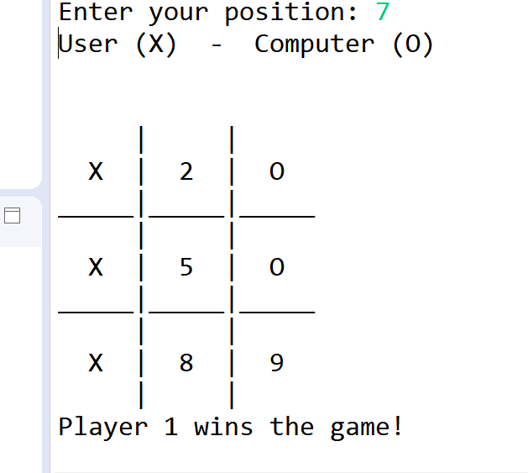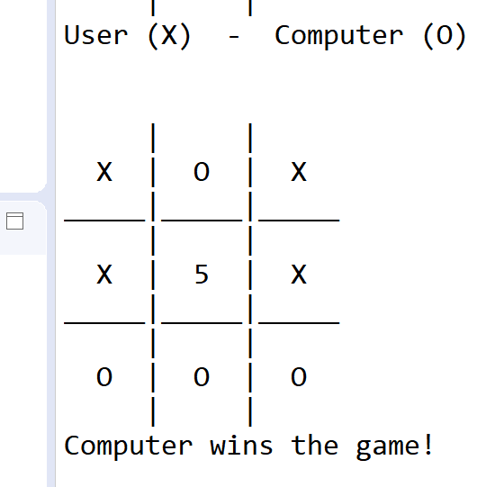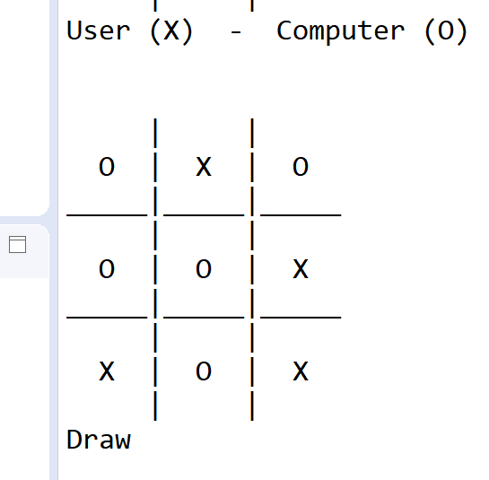

Test Case 2: Player = “O”

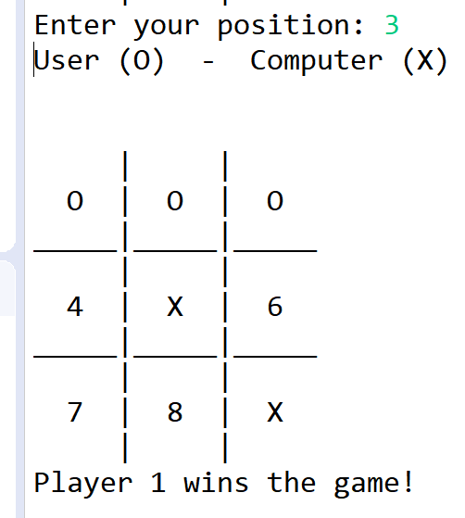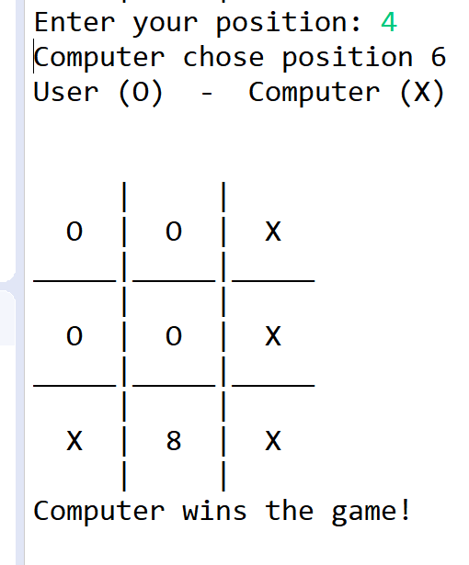 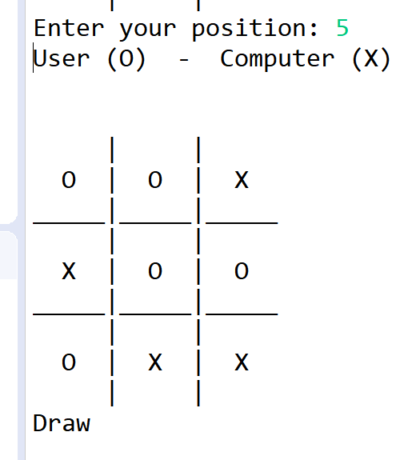

**Discussion:**

The tic-tac-toe game proved to be quite repetitive to code without the use of arrays. A lot of the code that repeated consistently had to do with implementing the same code for each of the nine squares in the table. There were no issues observed between the test cases and expected outcomes, since the project was built to run for only one game at a time. Also, while programming the game, it turned out to be more efficient to use a do-while loop in the main function instead of a while loop, which turned out to be helpful in learning the benefits of using alternative loops.