**JAVASCRIPT**

JavaScript is a programming language used to make websites interactive and dynamic. It runs in the browser and can respond to user actions like clicks, typing, or mouse movements.

* 1995: Created by Brendan Eich at Netscape (originally Live Script, later renamed JavaScript to ride Java's popularity wave) in December.

**🔹 Key Features of JavaScript:**

1. Client-Side Language: Mostly runs in the web browser (like Chrome, Firefox).

2. Dynamically Typed: You don’t need to declare data types.

3. Event-Driven: Reacts to user actions (e.g., button clicks).

4. Lightweight & Fast: Executes quickly in browsers.

5. Used with HTML & CSS: Forms the core trio of web development.

6. Supports OOP & Functional Programming: Flexible coding styles. **----Paradigm Language.**

**Example Use Cases:**

1. Form validation (checking user input)
2. Creating sliders, pop-ups, modals
3. Interactive maps or animations
4. Real-time updates (like chat or notifications)
5. Games or calculators in a browser.

* JavaScript is used for both frontend and backend also.
* Core JavaScript also called as “**Vanilla JavaScript**”.

**To Run JS Program Use (JS Engine):**

**Browser JS Engine**

Chrome V8 Engine (convert Human-level to machine Language)

Microsoft V8 Engine

Opera V8 Engine

Fire Fox Spydermonkey

**v8 engine architecture in JavaScript:**

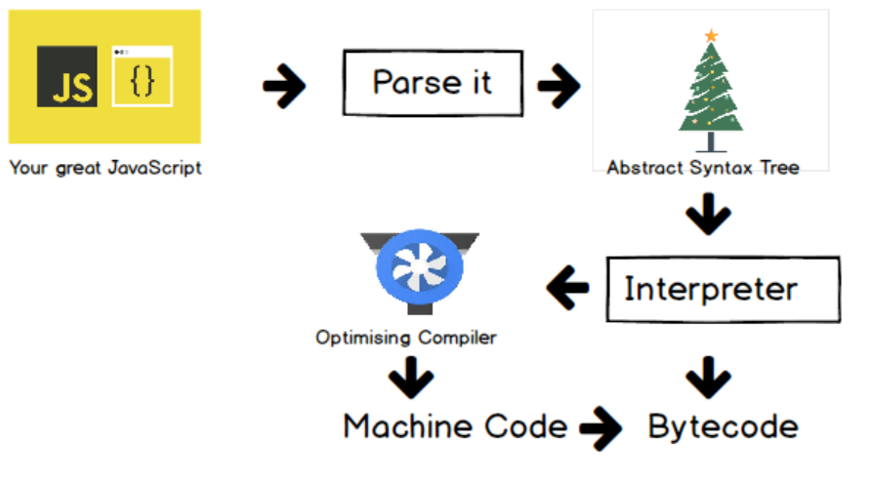

* **JIT Compiler:** In the context of JavaScript, JIT compilation is a feature of modern JavaScript engines like V8 (used by Chrome and Node.js) and Spider Monkey (used by Firefox). These engines use JIT to convert JavaScript code into machine code on the fly, which leads to faster execution and better optimization over time.