CMPG 325 — Computer Networks
Individual Semester Project
Milestone 1 — Client Design Review

Student | Motheo Motsumi
Student number | 41961366
Project ID | CMPG325-2026-089
Client ID | CLI-089
Assigned organisation | Kamogelo Insurance Brokers (Vryburg)
Industry | Professional Services
Addressing block | 192.168.40.0/24
Networking challenge | Wireless LAN (AP integration & coverage)

1. Client Requirements
The following table outlines the core requirements established in the approved project brief (CMPG325-2026-089). It serves as the foundational reference point for the network design presented in this document.
Assigned organisation | Kamogelo Insurance Brokers (Vryburg)
Industry | Professional Services
Assigned addressing block | 192.168.40.0/24 (single block, subnetted internally via VLSM)
Connectivity & services | Provide appropriate connectivity and network services for the assigned scenario—specifically a segmented LAN with inter-VLAN routing, a DHCP-ready address plan, and reliable Internet access.
Design constraint | The boardroom requires dedicated wired and wireless presentation ports.
Change request (CR15) | A second Internet connection must be integrated for network resilience.
Assigned networking challenge | Wireless LAN (AP integration & coverage) — Foundational difficulty.
Deliverable | A fully working, testable Cisco Packet Tracer implementation.

1.1 Assumptions
While the brief specifies the client type, design constraints, and the addressing block, it does not detail the internal departmental structure of the brokerage. To ensure a practical and realistic design, the following structural assumption has been made:
The brokerage consists of four functional groups:
• Sales/Brokers: The largest, client-facing group responsible for selling policies.
• Admin & Management: Reception, administrative support, and management staff.
• Boardroom: Based directly on the brief’s design constraint.
• Server/Infrastructure: A small segment for shared resources like file and print services.
This interpretation aligns well with the typical structure of a small 'Professional Services' firm and provides a concrete framework for designing the VLANs without overstepping the scope of the brief. If this conflicts with the Project Handbook, it can be adjusted before Milestone 2 without derailing the rest of the design.

2. Physical Topology
The physical topology maps out the actual hardware devices, port connections, and cable runs to be simulated in Packet Tracer. A standard three-tier layout (edge, core, access) was chosen. This structure cleanly separates the WAN-facing edge from the internal inter-departmental routing, keeping the design straightforward while successfully meeting the Foundational-level challenge requirements.
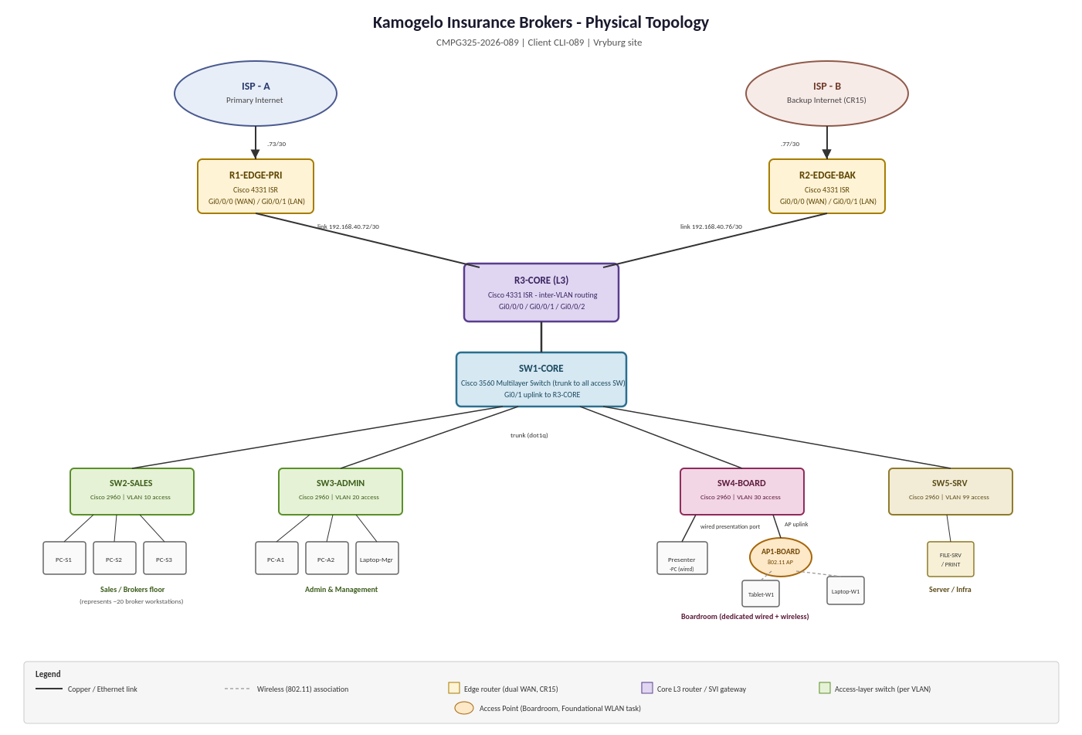

2.1 Device Roles
• R1-EDGE-PRI & R2-EDGE-BAK: Two separate edge routers, one for each ISP. Using a single router with two WAN interfaces would create a single point of failure. Deploying two independent routers properly addresses the true resilience required by CR15.
• R3-CORE: Handles all inter-VLAN routing and acts as the convergence point for both edge routers (and thus both internet paths).
• SW1-CORE: A Layer 2/3 switch that trunks (802.1Q) down to all the access-layer switches.
• SW2-SALES, SW3-ADMIN, SW4-BOARD, SW5-SRV: Individual access switches for each department, ensuring each VLAN remains isolated on its respective hardware.
• AP1-BOARD: A standalone access point connected to SW4-BOARD. While an enterprise environment might use a WLC with lightweight APs, a standalone AP is highly practical here and perfectly scales to the Foundational-rated task for a single room.

2.2 Meeting the Boardroom Constraint
To satisfy the requirement for dedicated wired and wireless presentation ports, the boardroom is assigned its own switch (SW4-BOARD). This switch supports two distinct paths: a wired port connecting directly to a presenter PC, and a separate port feeding AP1-BOARD for wireless devices. Crucially, both paths terminate on the exact same dedicated boardroom VLAN (see Section 3), ensuring true isolation from the rest of the network.

3. Logical Topology
While the physical diagram illustrates hardware and cabling, the logical topology defines the network at the IP level—detailing VLANs, subnets, gateways, and traffic flow. Mapping out the IP addressing plan against this logical view before starting the Packet Tracer build is an effective way to catch routing or subnetting errors early.
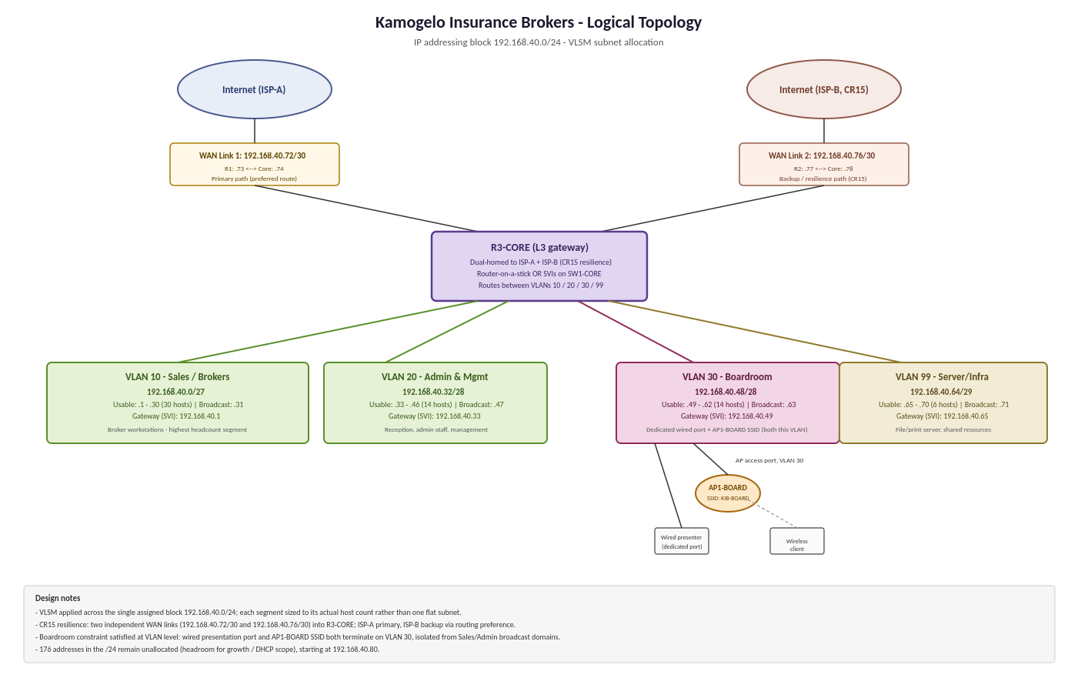

3.1 VLAN Breakdown
• VLAN 10 (Sales / Brokers) – 192.168.40.0/27: The largest VLAN, accommodating the highest headcount department.
• VLAN 20 (Admin & Management) – 192.168.40.32/28: Dedicated to reception, admin, and management staff.
• VLAN 30 (Boardroom) – 192.168.40.48/28: Hosts both the wired presentation port and the AP1-BOARD SSID. This isolates boardroom traffic from the Sales and Admin broadcast domains, fulfilling the 'dedicated' constraint.
• VLAN 99 (Server / Infrastructure) – 192.168.40.64/29: Isolates the file and print servers from general user traffic.

3.2 CR15 at the Logical Level
Two independent point-to-point links feed into R3-CORE: one to ISP-A through R1 (192.168.40.72/30), and the other to ISP-B through R2 (192.168.40.76/30). ISP-A serves as the primary path, while ISP-B acts as the failover backup. At this design stage, the goal is to prove the topology and addressing can accommodate CR15. The actual failover logic (likely using floating static routes or route tracking) will be configured during the implementation phase.

4. IP Addressing Plan
To efficiently utilize the provided 192.168.40.0/24 block, Variable Length Subnet Masking (VLSM) was applied. An even split would have either wasted addresses on smaller segments or starved the Sales department. Subnet masks are listed in dotted-decimal format alongside their prefixes for direct use in Packet Tracer.
Segment | Network | Subnet Mask | Prefix | Usable Range | Gateway (SVI)
VLAN 10 – Sales / Brokers | 192.168.40.0 | 255.255.255.224 | /27 | .1 – .30 (30) | .1
VLAN 20 – Admin & Mgmt | 192.168.40.32 | 255.255.255.240 | /28 | .33 – .46 (14) | .33
VLAN 30 – Boardroom | 192.168.40.48 | 255.255.255.240 | /28 | .49 – .62 (14) | .49
VLAN 99 – Server / Infra | 192.168.40.64 | 255.255.255.248 | /29 | .65 – .70 (6) | .65
WAN Link 1 (ISP-A) | 192.168.40.72 | 255.255.255.252 | /30 | .73 – .74 (2) | n/a
WAN Link 2 (ISP-B) | 192.168.40.76 | 255.255.255.252 | /30 | .77 – .78 (2) | n/a
Broadcast addresses: VLAN 10 – .31, VLAN 20 – .47, VLAN 30 – .63, VLAN 99 – .71, WAN Link 1 – .75, WAN Link 2 – .79.

4.1 Allocation Reasoning
• Sales/Brokers was allocated first as the largest segment; a /27 provides 30 usable addresses.
• Admin & Mgmt and the Boardroom each received a /28 (14 usable addresses), comfortably meeting current needs while allowing room for growth.
• Server/Infra only required a /29 (6 usable addresses), enough for the file/print server and potential minor additions.
• Both WAN links were assigned a /30 (2 usable addresses), the most efficient subnet size for a point-to-point link.
• Gateways: To maintain consistency, the gateway address is consistently assigned to the first usable IP in each subnet.

5. Initial GitHub Repository
A GitHub repository has been established to track the project's progress and reliably store evidence. For Milestone 1, it houses all design-stage materials, including requirements, topology diagrams, and the addressing plan. Configuration exports, Packet Tracer files, and testing documentation will be committed as the build unfolds in Milestone 2. https://github.com/MotheoMotsumi/CMPG325-Project-CLI-089.git
Commits are intentionally kept small and scoped to specific deliverables, perfectly aligning with the brief’s request for 'meaningful commits'.

Summary
This document addresses the five core deliverables for Milestone 1. It translates the Kamogelo Insurance Brokers brief into a practical three-tier physical topology, a detailed logical topology with a structured VLSM IP addressing plan, and establishes a version-controlled repository for project evidence. The specific constraints regarding the boardroom and dual-ISP resilience have been fully integrated into the design. The foundation is solidly set for the Packet Tracer build, configuration, and testing phase in Milestone 2.

