CMPG 325 – Computer Networks
Client Implementation Review
Milestone 2 – Kamogelo Insurance Brokers
Student | Motheo Motsumi – student number 41961366
Project ID / Client ID | CMPG325-2026-089 / CLI-089
Client | Kamogelo Insurance Brokers (Vryburg) – Professional Services
Assigned addressing block | 192.168.40.0/24
Assigned networking challenge | Wireless LAN (AP integration & coverage) – Foundational
Change request | CR15 – second Internet connection added for resilience
Milestone | Milestone 2 – Client Implementation Review (due 2 October 2026, 23:55)
GitHub portfolio | https://github.com/MotheoMotsumi/CMPG325-Project-CLI-089

1. Submission overview
This document accompanies the Milestone 2 submission. It describes what was implemented in Packet Tracer, how it follows the Milestone 1 design, and the evidence that it works. The four items required for review are listed below.
# | Required item | Status | Where to find it
1 | Working Packet Tracer file | Submitted | 41961366_CMPG325_M2.pkt (uploaded to eFundi and stored in the repository under packet-tracer/)
2 | Assigned feature implemented | Complete | Wireless LAN – AP integration & coverage: Section 4
3 | Testing evidence | Complete | Section 7 of this document; full screenshots in Milestone2_Testing_Evidence_41961366.docx and in the repository under evidence/screenshots/
4 | Updated GitHub portfolio | Updated | https://github.com/MotheoMotsumi/CMPG325-Project-CLI-089

2. Implementation summary
The network was built exactly as a three-tier design: two edge routers (one per ISP), a core router, a core switch and four access switches. The table maps each Milestone 1 design element to what was built.
Milestone 1 design element | Milestone 2 implementation
Departmental segmentation | VLANs 10 (Sales), 20 (Admin), 30 (Boardroom) and 99 (Server), subnetted from 192.168.40.0/24 with VLSM.
Inter-VLAN routing on R3-CORE | Router-on-a-stick: subinterfaces Gi0/0.10, .20, .30 and .99 on an 802.1Q trunk to SW1-CORE. Milestone 1 left the gateway placement open (router-on-a-stick or SVIs on SW1-CORE; its address table labels the gateways "SVI"). Router-on-a-stick on R3-CORE was implemented, using the same gateway addresses.
SW1-CORE as the core switch | Cisco 3650-24PS used for trunking to the four access switches; routing is done on R3-CORE.
Boardroom: dedicated wired and wireless presentation ports | SW4-BOARD Fa0/1 is the wired presentation port (Board-Presenter-PC) and Fa0/2 connects AP1-BOARD. Both are in VLAN 30.
Assigned challenge: Wireless LAN (AP integration & coverage) | AP1-BOARD with SSID KAMOGELO-BOARD (WPA2-PSK, AES), wireless laptop, phone and tablet receiving DHCP from the boardroom pool (Section 4).
CR15: second Internet connection | R2-EDGE-BAK and ISP-B added beside R1-EDGE-PRI and ISP-A, with floating static default routes on R3-CORE (Section 5).
Address plan | DHCP pools on R3-CORE for Sales, Admin and Boardroom; static addresses for the servers and the presenter PC; /30 links for the WAN side.
Two items go beyond the Milestone 1 text and are documented here for completeness: the addressing of the two ISP links (outside the client block) and the boardroom isolation ACL (Section 6).

2.1 Differences from the Milestone 1 diagrams
The implementation keeps every subnet, VLAN, role and link of the Milestone 1 design. The differences below are implementation details that the diagrams showed differently.
Item | Milestone 1 diagrams | Implemented in Packet Tracer
Router model and ports | Cisco 4331 ISR (Gi0/0/x) | Cisco 2911 (Gi0/x): provides the three gigabit ports R3-CORE needs; roles unchanged
Core switch | Catalyst 3560 multilayer switch | 3650-24PS, used for 802.1Q trunking to the access switches
WAN link host addresses | Logical diagram: R1 .73 and core .74; R2 .77 and core .78 | R3-CORE .73 and .77; R1 .74 and R2 .78. The subnets (192.168.40.72/30 and .76/30) are unchanged; only the host assignment inside each /30 differs
Boardroom SSID | KIB-BOARD (label on the logical diagram) | KAMOGELO-BOARD
Gateway placement | Router-on-a-stick or SVIs left open | Router-on-a-stick on R3-CORE
End devices | Three Sales PCs, two Admin PCs plus a manager laptop, one file/print server, one tablet and one laptop on Wi-Fi | Two PCs per department, a File-Server and a Print-Server, and a wireless laptop, phone and tablet (a representative sample)

3. Topology and addressing
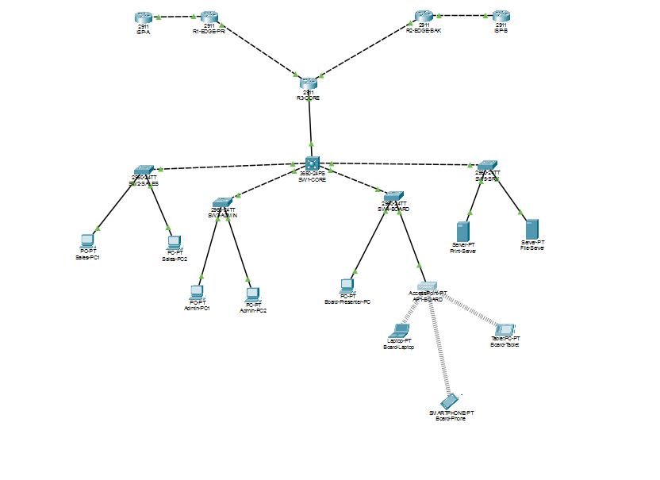
Figure 1 – Implemented topology (full-size screenshot in the evidence document, figure T16)

3.1 Devices
Device | Model | Role
R1-EDGE-PRI | 2911 | Primary edge router (ISP-A), NAT overload
R2-EDGE-BAK | 2911 | Backup edge router (ISP-B), NAT overload
R3-CORE | 2911 | Inter-VLAN routing, DHCP server, default routes, boardroom ACL
SW1-CORE | 3650-24PS | Core switch; trunks to the access switches
SW2-SALES, SW3-ADMIN, SW4-BOARD, SW5-SRV | 2960-24TT | Access switches (Sales, Admin, Boardroom, Server)
AP1-BOARD | Access Point-PT | Boardroom wireless access point
ISP-A, ISP-B | 2911 | Simulated ISPs; each has loopback 8.8.8.8 as a stand-in Internet host
Sales-PC1/2, Admin-PC1/2, Board-Presenter-PC, File-Server, Print-Server | PC / Server | Wired end devices
Board-Laptop, Board-Phone, Board-Tablet | Laptop / Smartphone / Tablet | Wireless boardroom clients

3.2 Cabling
From | To
R3-CORE Gi0/0 | SW1-CORE Gi1/0/1 (trunk)
SW1-CORE Gi1/0/2, 3, 4, 5 | SW2-SALES, SW3-ADMIN, SW4-BOARD, SW5-SRV – each on Gi0/1 (trunks)
R3-CORE Gi0/1 | R1-EDGE-PRI Gi0/0 (192.168.40.72/30)
R3-CORE Gi0/2 | R2-EDGE-BAK Gi0/0 (192.168.40.76/30)
R1-EDGE-PRI Gi0/1 | ISP-A Gi0/0 (203.0.113.0/30)
R2-EDGE-BAK Gi0/1 | ISP-B Gi0/0 (198.51.100.0/30)
SW2-SALES Fa0/1–2 | Sales-PC1, Sales-PC2
SW3-ADMIN Fa0/1–2 | Admin-PC1, Admin-PC2
SW4-BOARD Fa0/1 / Fa0/2 | Board-Presenter-PC / AP1-BOARD (Port 0)
SW5-SRV Fa0/1–2 | File-Server, Print-Server

3.3 Addressing
Segment | Network | Mask | Gateway | Assignment
VLAN 10 Sales | 192.168.40.0/27 | 255.255.255.224 | .1 (Gi0/0.10) | DHCP
VLAN 20 Admin | 192.168.40.32/28 | 255.255.255.240 | .33 (Gi0/0.20) | DHCP
VLAN 30 Boardroom | 192.168.40.48/28 | 255.255.255.240 | .49 (Gi0/0.30) | DHCP .51–.62; presenter PC static .50
VLAN 99 Server | 192.168.40.64/29 | 255.255.255.248 | .65 (Gi0/0.99) | Static: File-Server .66, Print-Server .67
WAN R3–R1 | 192.168.40.72/30 | 255.255.255.252 | R3 .73, R1 .74 | Static
WAN R3–R2 | 192.168.40.76/30 | 255.255.255.252 | R3 .77, R2 .78 | Static
ISP-A link | 203.0.113.0/30 | 255.255.255.252 | ISP-A .1, R1 .2 | Static (outside client block)
ISP-B link | 198.51.100.0/30 | 255.255.255.252 | ISP-B .1, R2 .2 | Static (outside client block)

3.4 DHCP pools (R3-CORE)
Pool | Network | Excluded | Leases issued from
SALES | 192.168.40.0/27 | .1 (gateway) | .2 – .30
ADMIN | 192.168.40.32/28 | .33 (gateway) | .34 – .46
BOARD | 192.168.40.48/28 | .49 (gateway), .50 (presenter PC) | .51 – .62
All pools hand out the gateway of their own VLAN and DNS server 8.8.8.8.

4. Assigned feature: Wireless LAN (AP integration & coverage)

4.1 Design
One access point serves the boardroom. It is connected to the boardroom access switch on a port in VLAN 30, so wireless clients share the same VLAN, gateway and DHCP pool as the wired presentation port. This satisfies the design constraint that the boardroom has both a dedicated wireless and a dedicated wired presentation connection.

4.2 Access point configuration
Setting | Value
Device | AP1-BOARD (Access Point-PT)
Wired uplink | Port 0 to SW4-BOARD Fa0/2 (access port, VLAN 30)
Wireless interface | Port 1, port status on
SSID | KAMOGELO-BOARD
Authentication / encryption | WPA2-PSK / AES
2.4 GHz channel | 1
Passphrase | Set on the AP and on each client; not reproduced in this document

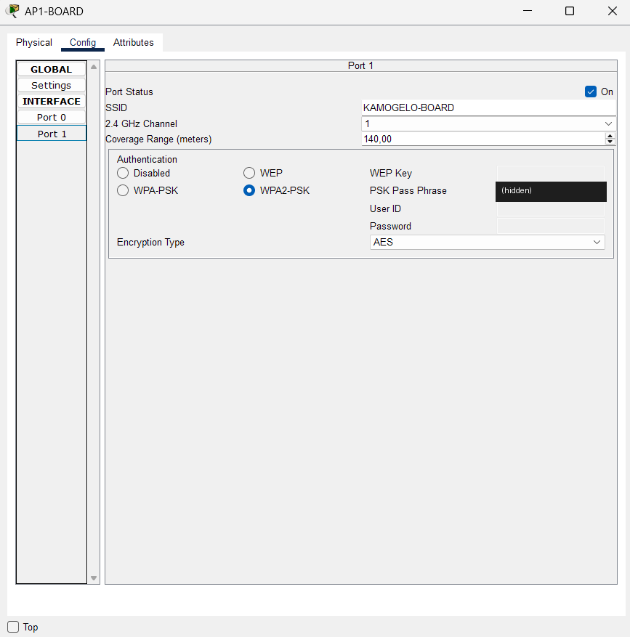
Figure 2 – AP1-BOARD wireless settings (passphrase masked)

4.3 Clients
Client | Address (DHCP) | Gateway | Notes
Board-Tablet | 192.168.40.51/28 | 192.168.40.49 | Wireless0, WPA2-PSK
Board-Phone | 192.168.40.52/28 | 192.168.40.49 | Wireless0, WPA2-PSK
Board-Laptop | 192.168.40.53/28 | 192.168.40.49 | Wireless module fitted, WPA2-PSK
Board-Presenter-PC (wired) | 192.168.40.50/28 (static) | 192.168.40.49 | SW4-BOARD Fa0/1

4.4 Results
- Association and addressing (T03, T05, T16): all three wireless clients associate with AP1-BOARD and receive addresses from the BOARD pool with gateway 192.168.40.49.
- Wired/wireless integration (T06): the wireless laptop reaches the wired presenter PC with TTL 128, which shows the traffic stayed inside VLAN 30 and was not routed.
- Reachability beyond the VLAN (T07, T08): the laptop reaches the File-Server (routed by R3-CORE) and the Internet host 8.8.8.8 through the primary ISP.
- Security (T04b): a client configured with a wrong WPA2 passphrase fails to associate (IPv4 0.0.0.0) and reconnects with 192.168.40.51 as soon as the correct passphrase is entered.
- Coverage: the three clients are placed in the boardroom area of the workspace and each holds an active wireless link to the AP (T16). Packet Tracer’s range setting is a simulation parameter, not an RF survey.

5. Second Internet connection (CR15)

5.1 Design
A second edge router, R2-EDGE-BAK, connects to ISP-B and to R3-CORE through its own /30 link. Both edge routers translate the internal block with NAT overload on their ISP-facing interface. R3-CORE has two default routes: the primary via R1 with the default administrative distance, and a floating static route via R2 with administrative distance 10 that only enters the routing table when the primary route is withdrawn.
Route on R3-CORE | Next hop | Purpose
0.0.0.0/0 (AD 1) | 192.168.40.74 (R1-EDGE-PRI) | Primary Internet path via ISP-A
0.0.0.0/0 (AD 10) | 192.168.40.78 (R2-EDGE-BAK) | Backup Internet path via ISP-B (floating static)

5.2 Failover test
Step | Action | Observed result (evidence)
1 | Baseline: tracert 8.8.8.8 from Sales-PC1 | Path 192.168.40.1, 192.168.40.74, 8.8.8.8 (T11)
2 | Bring the primary path down (R1-EDGE-PRI Gi0/0 shut down; R3-CORE Gi0/1 line protocol drops) | R3 default route becomes [10/0] via 192.168.40.78 (T12)
3 | tracert 8.8.8.8 from Sales-PC1; ping from R2 | Path via 192.168.40.78; R2 reaches ISP-B and 8.8.8.8 (T13)
4 | Restore the primary path (no shutdown) | Default route returns to [1/0] via 192.168.40.74 (T14)
5 | NAT table on R1 after traffic from Sales-PC1 | Translations to 203.0.113.2 (T15)

5.3 Scope and limitation
Floating static routes withdraw the primary route when the R3–R1 link or R1 itself fails. They do not detect an outage further upstream (for example, ISP-A failing while R1 stays up). Route tracking with IP SLA was not available in the Packet Tracer version used (the show track and show ip sla commands were rejected), so this limitation is accepted and recorded in Section 8.

6. Boardroom isolation (ACL)
Milestone 1 describes the boardroom as isolated from the rest of the network, but plain inter-VLAN routing would leave it reachable. An extended ACL on R3-CORE enforces the isolation while still letting boardroom devices use the server VLAN and the Internet.
ip access-list extended BOARD-IN
deny ip 192.168.40.48 0.0.0.15 192.168.40.0 0.0.0.31
deny ip 192.168.40.48 0.0.0.15 192.168.40.32 0.0.0.15
permit ip any any
interface gigabitEthernet 0/0.30
ip access-group BOARD-IN in
- Boardroom to Sales or Admin: blocked; the router answers "Destination host unreachable" (T09).
- Sales to boardroom: times out, because the boardroom’s replies are dropped by the same ACL (T09).
- Boardroom to its own VLAN, the File-Server and 8.8.8.8: still works (T09).
- Sales to Admin: unaffected (T09).
- The ACL hit counters (8, 4 and 8 matches) match the traffic generated during the test (T09).

7. Testing summary
Every test below passed. A single lost packet on the first ping to a new destination is normal: it is spent on ARP resolution. The matching screenshots, with explanations, are in Milestone2_Testing_Evidence_41961366.docx and in the repository under evidence/screenshots/.
ID | Test | Expected result | Result
T01 | VLANs created and access ports assigned on all five switches | VLANs 10/20/30/99 exist; access ports sit in the correct VLAN | Pass
T02 | Trunks between SW1-CORE and the access switches | Gi0/1 trunking on each access switch; Gi1/0/2–5 trunking on SW1-CORE | Pass
T03 | DHCP leases issued by R3-CORE to wired and wireless clients | Leases inside the Sales, Admin and Boardroom pools | Pass
T04a | AP1-BOARD wireless security configuration | SSID KAMOGELO-BOARD, WPA2-PSK, AES, channel 1 | Pass
T04b | Client with a wrong passphrase is rejected, then reconnects with the correct one | No association (0.0.0.0), then 192.168.40.51 after correction | Pass
T05 | Wireless clients addressing | 192.168.40.51–53, mask 255.255.255.240, gateway 192.168.40.49 | Pass
T06 | Wireless laptop to wired presenter PC (192.168.40.50) | Reachable inside VLAN 30 (TTL 128, no routing) | Pass
T07 | Wireless laptop to File-Server (192.168.40.66) | Reachable, routed once by R3-CORE (TTL 127) | Pass
T08 | Wireless laptop to Internet host 8.8.8.8 | Reachable through the primary ISP path | Pass
T09 | Boardroom isolation ACL BOARD-IN | Boardroom blocked to/from Sales and Admin; server and Internet still reachable | Pass
T10 | Inter-VLAN routing from Sales-PC1 (before the ACL) | Reaches Admin, server and boardroom hosts (TTL 127) | Pass
T11 | Internet path under normal operation | tracert 8.8.8.8 via 192.168.40.1, 192.168.40.74 (R1) | Pass
T12 | Failover: default route when the primary path is down | S* 0.0.0.0/0 [10/0] via 192.168.40.78 | Pass
T13 | Traffic carried by the backup path | tracert via 192.168.40.78; R2 reaches ISP-B and 8.8.8.8 | Pass
T14 | Restore: default route returns to the primary | S* 0.0.0.0/0 [1/0] via 192.168.40.74 | Pass
T15 | NAT overload on the primary edge router | Translations to 203.0.113.2 on R1-EDGE-PRI | Pass
T16 | Wireless clients associated with AP1-BOARD in the boardroom | Laptop, phone and tablet each show an active wireless link | Pass
Separate screenshots of the edge-router link checks and of the R2 NAT table are not included; backup-path NAT is shown to work by T13 (the Internet host is reachable through R2), and NAT overload is shown on R1 by T15.

8. Limitations
- Failover relies on floating static routes: it detects local link or router failure but not an ISP outage beyond R1 (Section 5.3).
- A single standalone access point covers the boardroom; there is no wireless LAN controller.
- Packet Tracer’s wireless range is a simulation setting and not a radio-frequency survey.
- The Internet is simulated by a loopback address (8.8.8.8) on each ISP router.
- No device hardening (enable secrets, SSH) was applied for this milestone.

9. GitHub portfolio
Repository: https://github.com/MotheoMotsumi/CMPG325-Project-CLI-089
Folder / file | Contents
README.md | Project summary, addressing, feature description and test summary
docs/ | Milestone 1 design review, this implementation review, the testing evidence document
packet-tracer/ | 41961366_CMPG325_M2.pkt
configs/ | Final-state configuration, one file per router and switch
evidence/screenshots/ | All test screenshots, named by test ID (T01 … T16)

Appendix A – Configuration reference
The commands below are the configuration applied to each device in its final state. The same configuration is stored as one file per device in configs/ in the repository.

R3-CORE
hostname R3-CORE
no ip domain-lookup
interface gigabitEthernet 0/0
description Trunk to SW1-CORE
no shutdown
interface gigabitEthernet 0/0.10
encapsulation dot1Q 10
ip address 192.168.40.1 255.255.255.224
interface gigabitEthernet 0/0.20
encapsulation dot1Q 20
ip address 192.168.40.33 255.255.255.240
interface gigabitEthernet 0/0.30
encapsulation dot1Q 30
ip address 192.168.40.49 255.255.255.240
ip access-group BOARD-IN in
interface gigabitEthernet 0/0.99
encapsulation dot1Q 99
ip address 192.168.40.65 255.255.255.248
interface gigabitEthernet 0/1
ip address 192.168.40.73 255.255.255.252
no shutdown
interface gigabitEthernet 0/2
ip address 192.168.40.77 255.255.255.252
no shutdown
ip dhcp excluded-address 192.168.40.1
ip dhcp excluded-address 192.168.40.33
ip dhcp excluded-address 192.168.40.49 192.168.40.50
ip dhcp pool SALES
network 192.168.40.0 255.255.255.224
default-router 192.168.40.1
dns-server 8.8.8.8
ip dhcp pool ADMIN
network 192.168.40.32 255.255.255.240
default-router 192.168.40.33
dns-server 8.8.8.8
ip dhcp pool BOARD
network 192.168.40.48 255.255.255.240
default-router 192.168.40.49
dns-server 8.8.8.8
ip route 0.0.0.0 0.0.0.0 192.168.40.74
ip route 0.0.0.0 0.0.0.0 192.168.40.78 10
ip access-list extended BOARD-IN
deny ip 192.168.40.48 0.0.0.15 192.168.40.0 0.0.0.31
deny ip 192.168.40.48 0.0.0.15 192.168.40.32 0.0.0.15
permit ip any any

R1-EDGE-PRI
hostname R1-EDGE-PRI
no ip domain-lookup
interface gigabitEthernet 0/0
ip address 192.168.40.74 255.255.255.252
ip nat inside
no shutdown
interface gigabitEthernet 0/1
ip address 203.0.113.2 255.255.255.252
ip nat outside
no shutdown
ip route 0.0.0.0 0.0.0.0 203.0.113.1
ip route 192.168.40.0 255.255.255.0 192.168.40.73
access-list 1 permit 192.168.40.0 0.0.0.255
ip nat inside source list 1 interface gigabitEthernet 0/1 overload

R2-EDGE-BAK
hostname R2-EDGE-BAK
no ip domain-lookup
interface gigabitEthernet 0/0
ip address 192.168.40.78 255.255.255.252
ip nat inside
no shutdown
interface gigabitEthernet 0/1
ip address 198.51.100.2 255.255.255.252
ip nat outside
no shutdown
ip route 0.0.0.0 0.0.0.0 198.51.100.1
ip route 192.168.40.0 255.255.255.0 192.168.40.77
access-list 1 permit 192.168.40.0 0.0.0.255
ip nat inside source list 1 interface gigabitEthernet 0/1 overload

ISP-A and ISP-B
! ISP-A
hostname ISP-A
interface gigabitEthernet 0/0
ip address 203.0.113.1 255.255.255.252
no shutdown
interface loopback 0
ip address 8.8.8.8 255.255.255.255

! ISP-B
hostname ISP-B
interface gigabitEthernet 0/0
ip address 198.51.100.1 255.255.255.252
no shutdown
interface loopback 0
ip address 8.8.8.8 255.255.255.255

Switches
All five switches carry the same VLAN definitions:
vlan 10
name SALES
vlan 20
name ADMIN
vlan 30
name BOARDROOM
vlan 99
name SERVER
SW1-CORE (3650-24PS)
hostname SW1-CORE
interface range gigabitEthernet 1/0/1-5
switchport trunk encapsulation dot1q
switchport mode trunk
SW2-SALES (2960-24TT) – SW3-ADMIN is identical with VLAN 20 and SW5-SRV with VLAN 99
hostname SW2-SALES
interface range fastEthernet 0/1-2
switchport mode access
switchport access vlan 10
interface gigabitEthernet 0/1
switchport mode trunk
SW4-BOARD (2960-24TT)
hostname SW4-BOARD
interface fastEthernet 0/1
description Wired presentation port - Board-Presenter-PC
switchport mode access
switchport access vlan 30
interface fastEthernet 0/2
description Wireless presentation - AP1-BOARD
switchport mode access
switchport access vlan 30
interface gigabitEthernet 0/1
switchport mode trunk

End-device settings
Device | Address / mask | Gateway
Sales-PC1, Sales-PC2, Admin-PC1, Admin-PC2 | DHCP | From the DHCP pool
Board-Presenter-PC | 192.168.40.50 / 255.255.255.240 (static) | 192.168.40.49
File-Server | 192.168.40.66 / 255.255.255.248 (static) | 192.168.40.65
Print-Server | 192.168.40.67 / 255.255.255.248 (static) | 192.168.40.65
Board-Laptop, Board-Phone, Board-Tablet | DHCP (BOARD pool) | 192.168.40.49

