CMPG 325 – Computer Networks
Testing Evidence
Milestone 2 – Kamogelo Insurance Brokers
Student | Motheo Motsumi – student number 41961366
Project ID / Client ID | CMPG325-2026-089 / CLI-089
Client | Kamogelo Insurance Brokers (Vryburg) – Professional Services
Assigned addressing block | 192.168.40.0/24
Assigned networking challenge | Wireless LAN (AP integration & coverage) – Foundational
Change request | CR15 – second Internet connection added for resilience
Milestone | Milestone 2 – Client Implementation Review (due 2 October 2026, 23:55)
GitHub portfolio | https://github.com/MotheoMotsumi/CMPG325-Project-CLI-089

About this document
This document contains every test screenshot for Milestone 2, in test-ID order. Each figure has a short explanation of what it proves. The same images are stored individually in the repository under evidence/screenshots/ using the file names shown in each caption. The passphrase field in figure T04a is masked.
Reading hint: the first ping to a new destination often loses one packet to ARP resolution, so "3 of 4 replies" on a first ping is expected. TTL values show the path: 255 for the router itself, 128 for a host in the same VLAN, 127 for a host one router hop away, and 253 for the simulated Internet host.

Test summary
ID | Test | Expected result | Result
T01 | VLANs created and access ports assigned on all five switches | VLANs 10/20/30/99 exist; access ports sit in the correct VLAN | Pass
T02 | Trunks between SW1-CORE and the access switches | Gi0/1 trunking on each access switch; Gi1/0/2–5 trunking on SW1-CORE | Pass
T03 | DHCP leases issued by R3-CORE to wired and wireless clients | Leases inside the Sales, Admin and Boardroom pools | Pass
T04a | AP1-BOARD wireless security configuration | SSID KAMOGELO-BOARD, WPA2-PSK, AES, channel 1 | Pass
T04b | Client with a wrong passphrase is rejected, then reconnects with the correct one | No association (0.0.0.0), then 192.168.40.51 after correction | Pass
T05 | Wireless clients addressing | 192.168.40.51–53, mask 255.255.255.240, gateway 192.168.40.49 | Pass
T06 | Wireless laptop to wired presenter PC (192.168.40.50) | Reachable inside VLAN 30 (TTL 128, no routing) | Pass
T07 | Wireless laptop to File-Server (192.168.40.66) | Reachable, routed once by R3-CORE (TTL 127) | Pass
T08 | Wireless laptop to Internet host 8.8.8.8 | Reachable through the primary ISP path | Pass
T09 | Boardroom isolation ACL BOARD-IN | Boardroom blocked to/from Sales and Admin; server and Internet still reachable | Pass
T10 | Inter-VLAN routing from Sales-PC1 (before the ACL) | Reaches Admin, server and boardroom hosts (TTL 127) | Pass
T11 | Internet path under normal operation | tracert 8.8.8.8 via 192.168.40.1, 192.168.40.74 (R1) | Pass
T12 | Failover: default route when the primary path is down | S* 0.0.0.0/0 [10/0] via 192.168.40.78 | Pass
T13 | Traffic carried by the backup path | tracert via 192.168.40.78; R2 reaches ISP-B and 8.8.8.8 | Pass
T14 | Restore: default route returns to the primary | S* 0.0.0.0/0 [1/0] via 192.168.40.74 | Pass
T15 | NAT overload on the primary edge router | Translations to 203.0.113.2 on R1-EDGE-PRI | Pass
T16 | Wireless clients associated with AP1-BOARD in the boardroom | Laptop, phone and tablet each show an active wireless link | Pass

Figure index
Figure | Test | File
1 | T01 / T02 | T01_T02_SW1-CORE.png
2 | T01 / T02 | T01_T02_SW2-SALES.png
3 | T01 / T02 | T01_T02_SW3-ADMIN.png
4 | T01 / T02 | T01_T02_SW4-BOARD.png
5 | T01 / T02 | T01_T02_SW5-SRV.png
6 | T03 | T03_R3_dhcp_binding.png
7 | T04a | T04a_AP1-BOARD_wireless_config.png
8 | T04b | T04b_1_Tablet_wrong_passphrase_config.png
9 | T04b | T04b_2_Topology_tablet_disconnected.png
10 | T04b | T04b_3_Tablet_ipconfig_disconnected.png
11 | T04b | T04b_4_Tablet_ipconfig_reconnected.png
12 | T05 | T05_Board-Laptop_ipconfig.png
13 | T05 | T05_Board-Phone_ipconfig.png
14 | T05 | T05_Board-Tablet_ipconfig.png
15 | T06 / T07 | T06_T07_Board-Laptop_pings_1.png
16 | T07 / T08 | T07_T08_Board-Laptop_pings_2.png
17 | T09 | T09_1_R3_BOARD-IN_acl_applied.png
18 | T09 | T09_2_Board-Laptop_blocked_to_Sales_Admin.png
19 | T09 | T09_3_Board-Laptop_allowed_destinations.png
20 | T09 | T09_4_SalesPC1_blocked_to_boardroom.png
21 | T09 | T09_5_R3_acl_hit_counters.png
22 | T10 | T10_0_SalesPC1_gateway_ping.png
23 | T10 | T10_1_SalesPC1_interVLAN_pings_1.png
24 | T10 | T10_2_SalesPC1_interVLAN_pings_2.png
25 | T11 | T11_SalesPC1_tracert_primary_path.png
26 | T12 | T12_R3_default_route_primary_then_backup.png
27 | T13 | T13_1_SalesPC1_tracert_primary_then_backup.png
28 | T13 | T13_2_R2_reaches_ISP-B_and_Internet.png
29 | T14 | T14_R3_default_route_restored_primary.png
30 | T15 | T15_R1_nat_translations.png
31 | T16 | T16_Topology_all_clients_associated.png

Screenshots

Figure 1 – T01 / T02: SW1-CORE – VLANs and trunks
show vlan brief lists VLANs 10 (SALES), 20 (ADMIN), 30 (BOARDROOM) and 99 (SERVER). show interfaces trunk shows Gi1/0/2 to Gi1/0/5 trunking (802.1q, native VLAN 1) towards the four access switches. Gi1/0/1 (the uplink to R3-CORE) was not yet active when this was captured; it is verified functionally by T10.
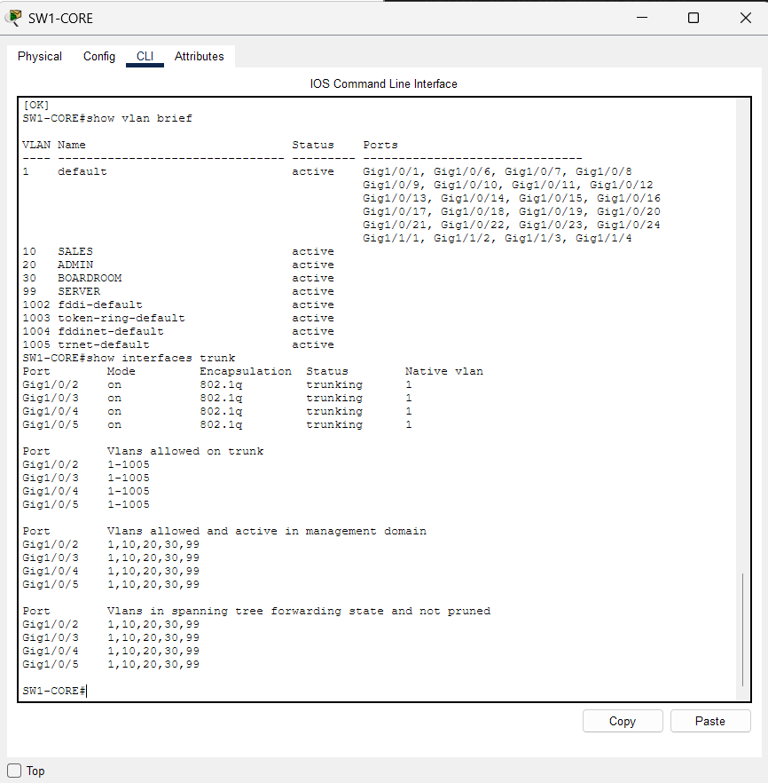
File: T01_T02_SW1-CORE.png

Figure 2 – T01 / T02: SW2-SALES – VLANs and trunk
Fa0/1 and Fa0/2 are in VLAN 10 SALES. Gi0/1 is trunking towards SW1-CORE, carrying VLANs 1, 10, 20, 30 and 99.
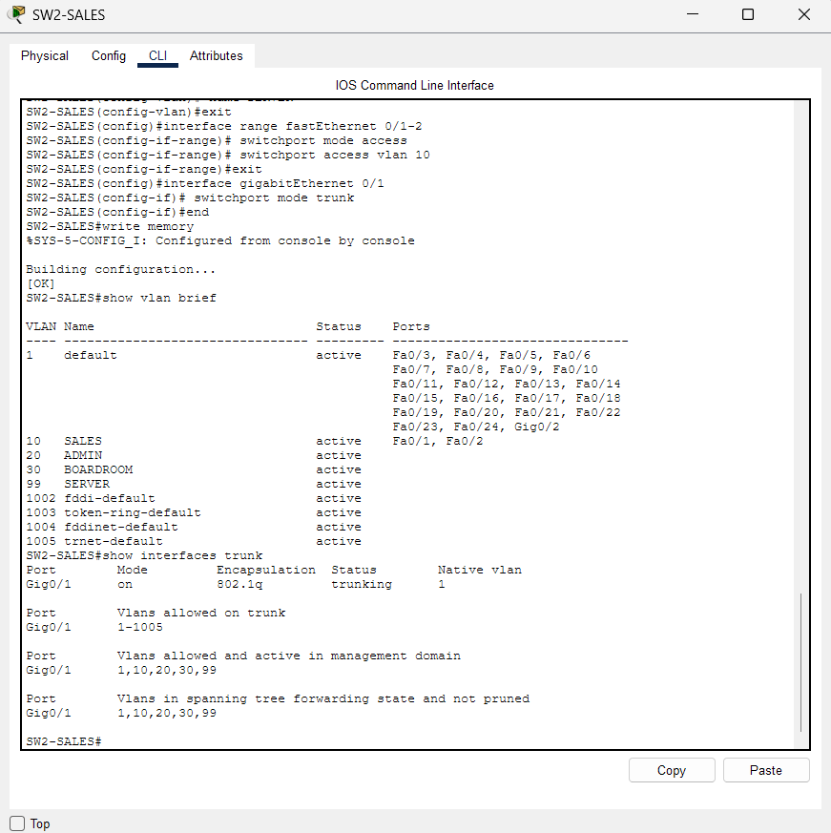
File: T01_T02_SW2-SALES.png

Figure 3 – T01 / T02: SW3-ADMIN – VLANs and trunk
Fa0/1 and Fa0/2 are in VLAN 20 ADMIN. Gi0/1 is trunking towards SW1-CORE.
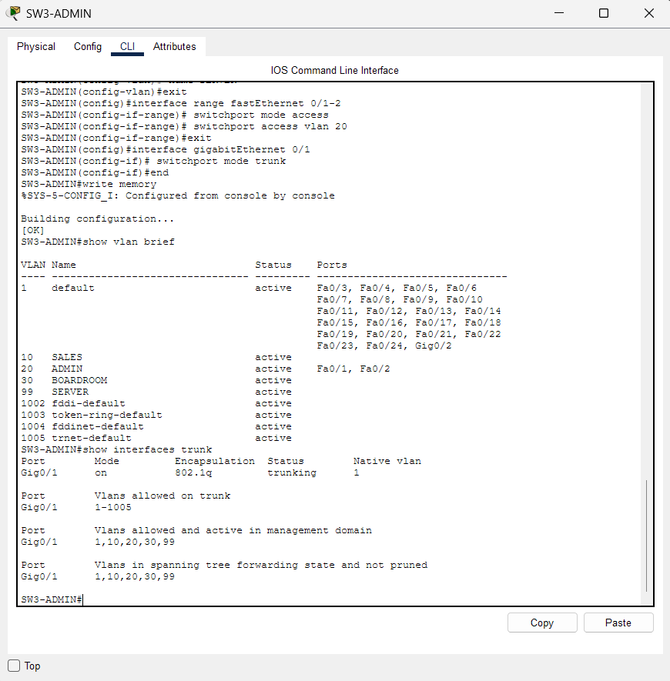
File: T01_T02_SW3-ADMIN.png

Figure 4 – T01 / T02: SW4-BOARD – VLANs and trunk
Fa0/1 (wired presentation port) and Fa0/2 (AP1-BOARD) are both in VLAN 30 BOARDROOM. Gi0/1 is trunking towards SW1-CORE.
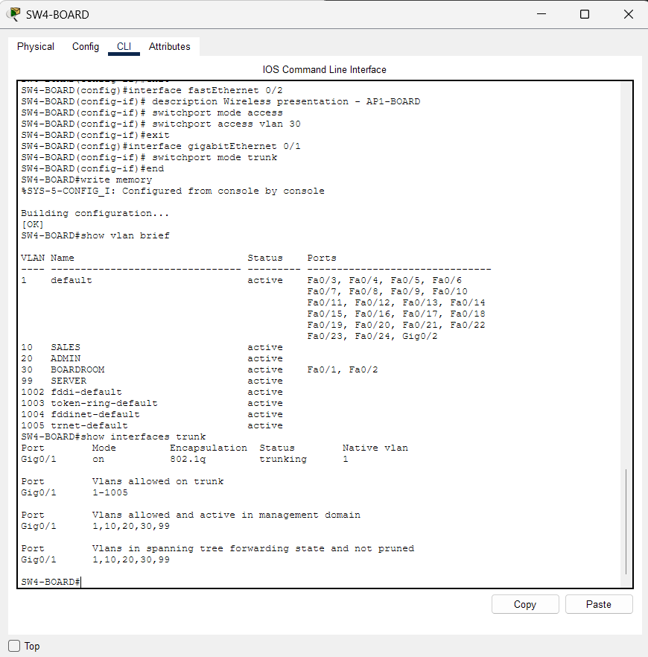
File: T01_T02_SW4-BOARD.png

Figure 5 – T01 / T02: SW5-SRV – VLANs and trunk
Fa0/1 and Fa0/2 are in VLAN 99 SERVER (File-Server and Print-Server). Gi0/1 is trunking towards SW1-CORE.
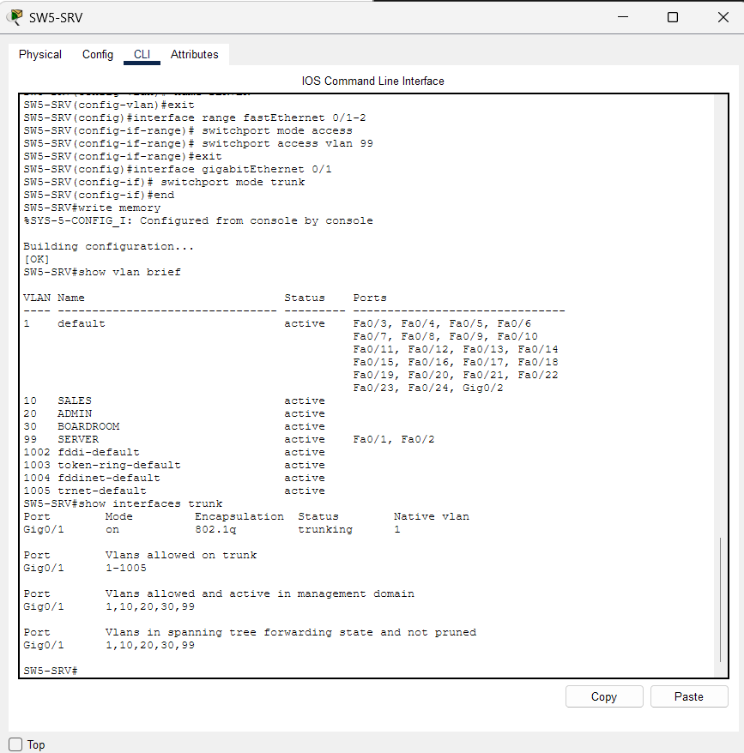
File: T01_T02_SW5-SRV.png

Figure 6 – T03: R3-CORE – DHCP bindings
show ip dhcp binding lists seven leases: 192.168.40.2 and .3 (Sales), .34 and .35 (Admin), and .51, .52 and .53 (the three wireless boardroom clients). The access-list output above it is covered under T09.
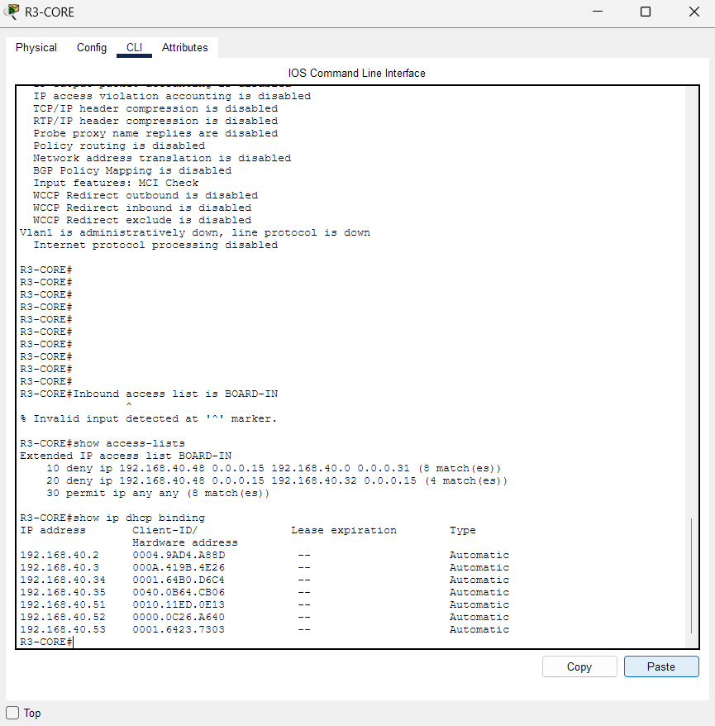
File: T03_R3_dhcp_binding.png

Figure 7 – T04a: AP1-BOARD – wireless configuration
Port 1 (wireless): SSID KAMOGELO-BOARD, 2.4 GHz channel 1, WPA2-PSK with AES encryption. The passphrase field is masked in this document.
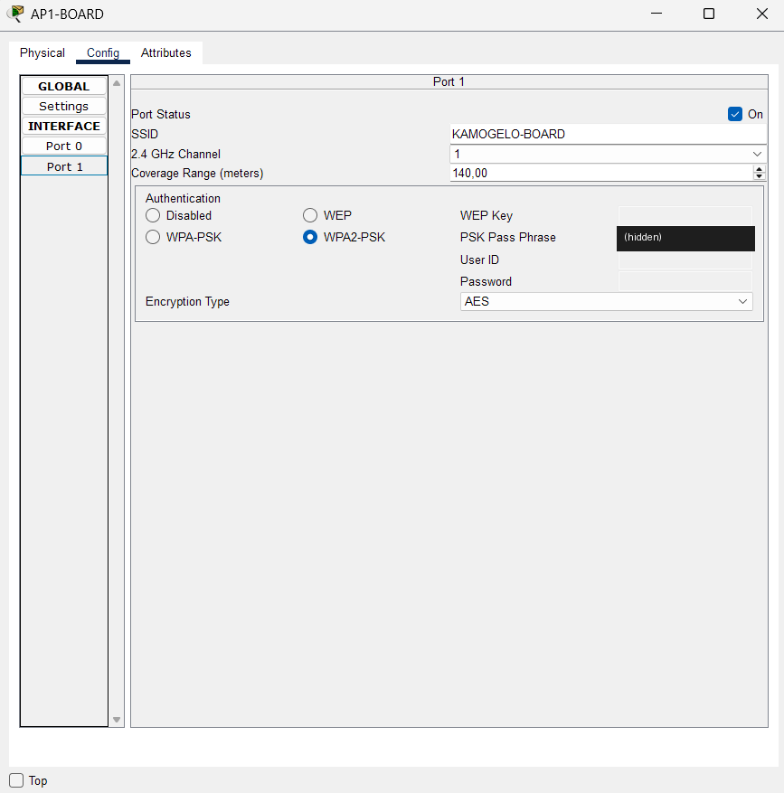
File: T04a_AP1-BOARD_wireless_config.png

Figure 8 – T04b: Board-Tablet – wrong passphrase entered
Board-Tablet Wireless0 with the correct SSID but a deliberately incorrect WPA2 passphrase. The IPv4 field still shows the previous lease; the ipconfig output in the next figures shows the real state.
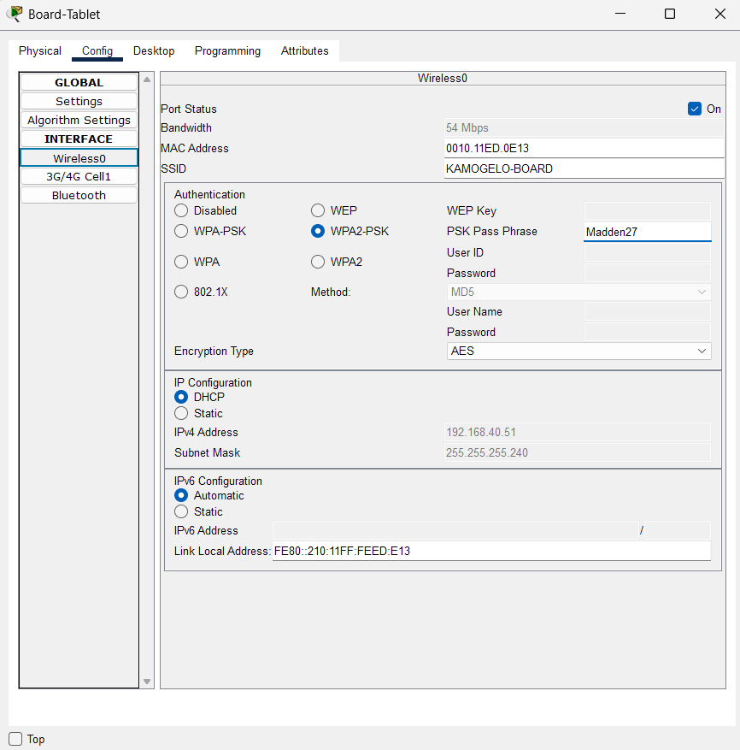
File: T04b_1_Tablet_wrong_passphrase_config.png

Figure 9 – T04b: Topology – tablet loses its wireless link
Board-Laptop and Board-Phone remain connected to AP1-BOARD; Board-Tablet has no wireless link.
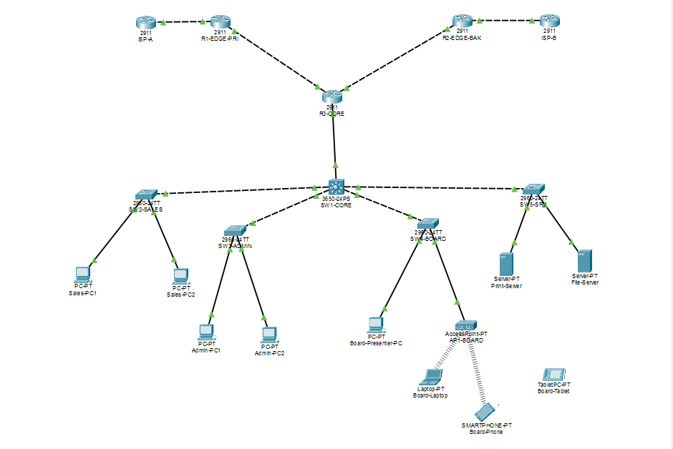
File: T04b_2_Topology_tablet_disconnected.png

Figure 10 – T04b: Board-Tablet – ipconfig while disconnected
Wireless0 shows IPv4 address 0.0.0.0 and no default gateway: association was rejected.
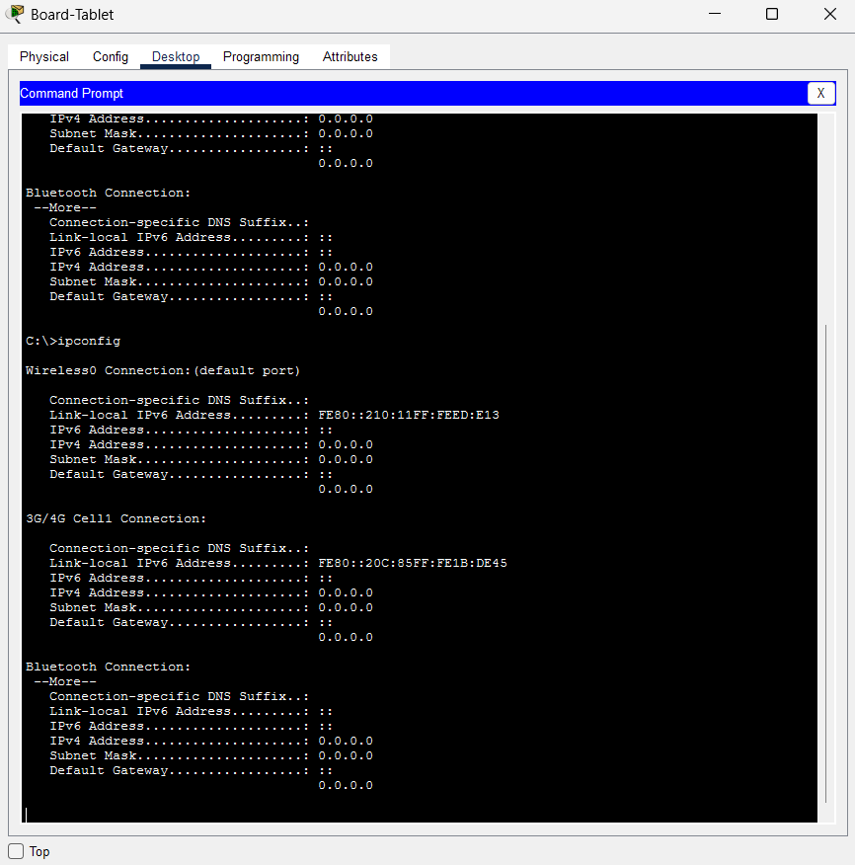
File: T04b_3_Tablet_ipconfig_disconnected.png

Figure 11 – T04b: Board-Tablet – ipconfig after the correct passphrase
After the correct passphrase is restored the tablet receives 192.168.40.51, mask 255.255.255.240, gateway 192.168.40.49.
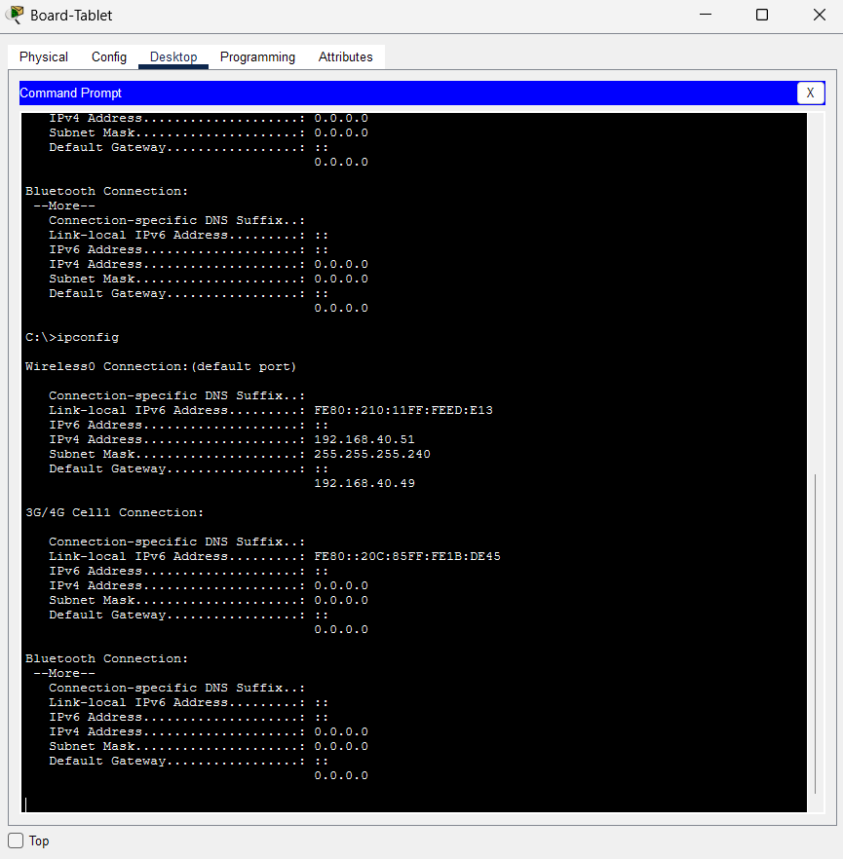
File: T04b_4_Tablet_ipconfig_reconnected.png

Figure 12 – T05: Board-Laptop – ipconfig
Wireless0: 192.168.40.53, mask 255.255.255.240, gateway 192.168.40.49 (DHCP, BOARD pool).
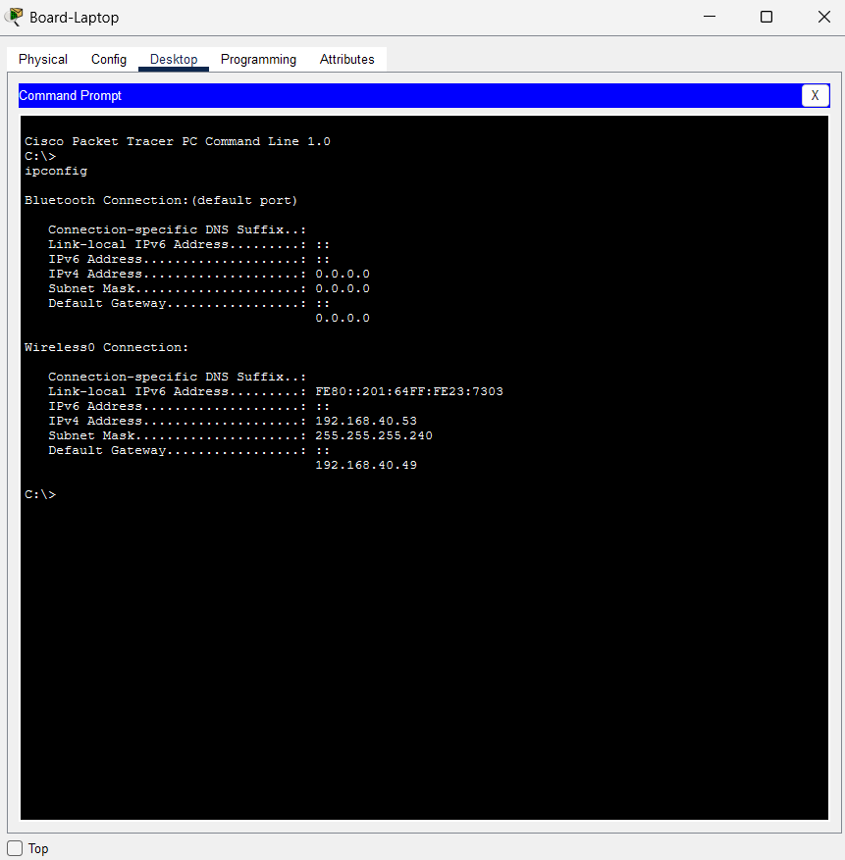
File: T05_Board-Laptop_ipconfig.png

Figure 13 – T05: Board-Phone – ipconfig
Wireless0: 192.168.40.52, mask 255.255.255.240, gateway 192.168.40.49 (DHCP, BOARD pool).
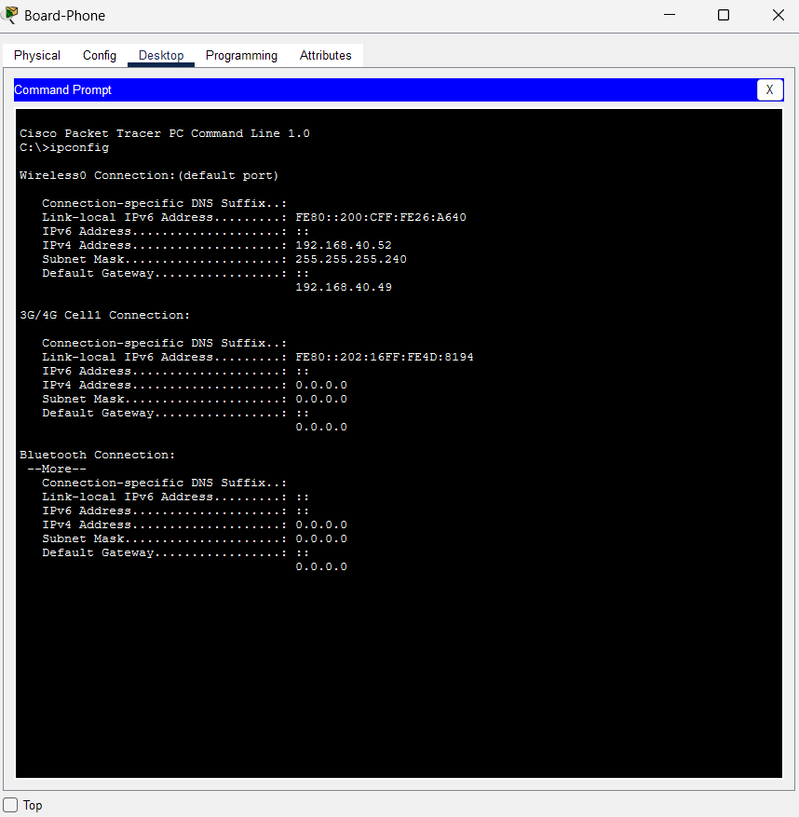
File: T05_Board-Phone_ipconfig.png

Figure 14 – T05: Board-Tablet – ipconfig
Wireless0: 192.168.40.51, mask 255.255.255.240, gateway 192.168.40.49 (DHCP, BOARD pool).
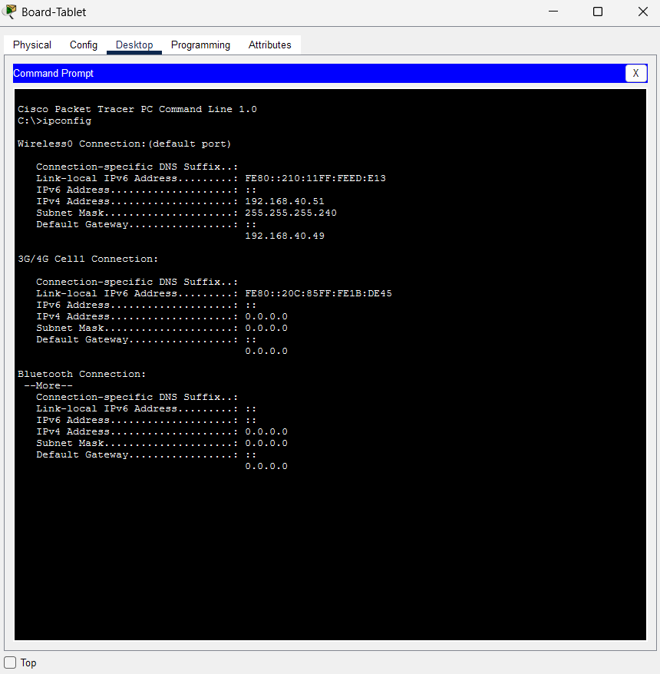
File: T05_Board-Tablet_ipconfig.png

Figure 15 – T06 / T07: Board-Laptop – connectivity (1 of 2)
Ping to the gateway 192.168.40.49: 4/4, TTL 255. Ping to the wired Board-Presenter-PC 192.168.40.50: 4/4, TTL 128, meaning it was delivered inside VLAN 30 without routing. Ping to File-Server 192.168.40.66: 4/4, TTL 127, routed once by R3-CORE.
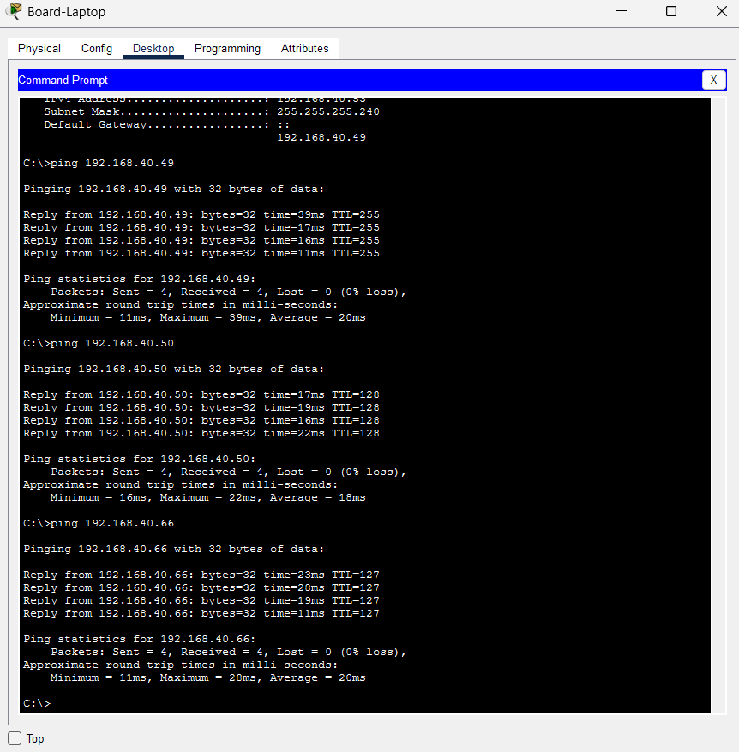
File: T06_T07_Board-Laptop_pings_1.png

Figure 16 – T07 / T08: Board-Laptop – connectivity (2 of 2)
Ping to File-Server 192.168.40.66: 4/4. Ping to 8.8.8.8: 4/4, TTL 253, via R1-EDGE-PRI and ISP-A.
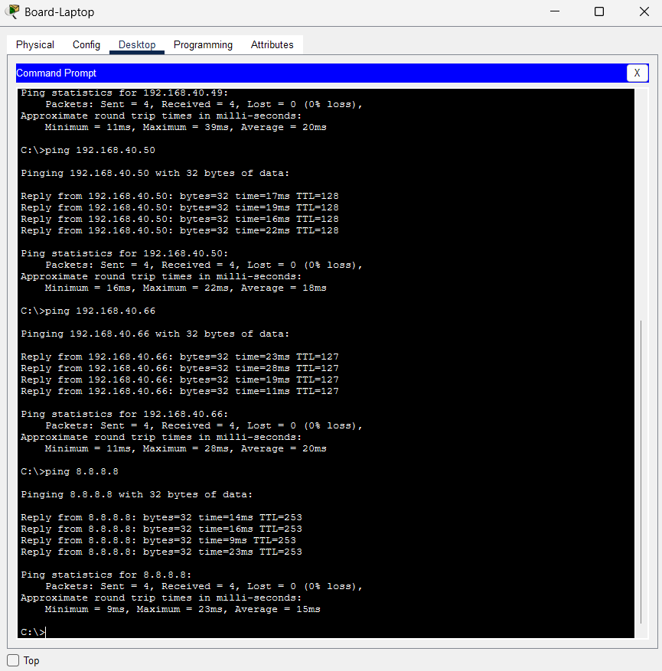
File: T07_T08_Board-Laptop_pings_2.png

Figure 17 – T09: R3-CORE – ACL BOARD-IN applied
show access-lists shows the two deny rules (boardroom to Sales and to Admin) and the final permit. show ip interface gigabitEthernet 0/0.30 confirms "Inbound access list is BOARD-IN".
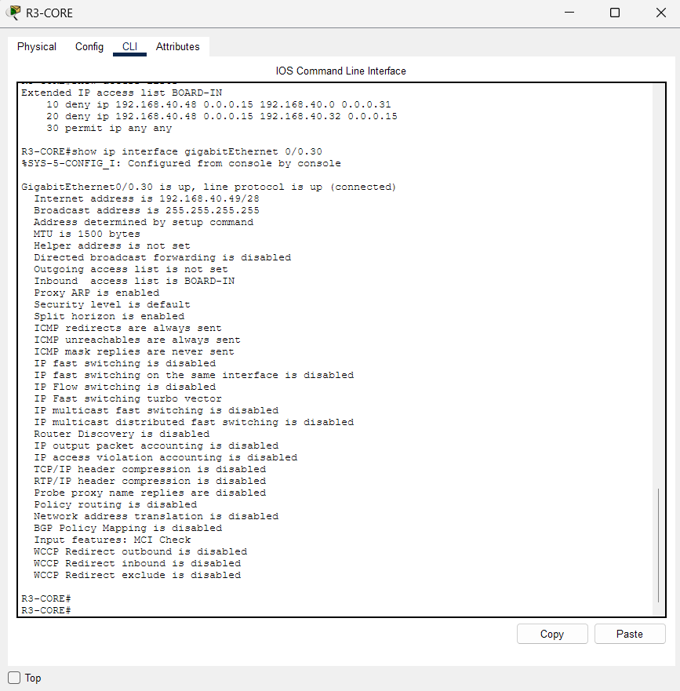
File: T09_1_R3_BOARD-IN_acl_applied.png

Figure 18 – T09: Board-Laptop – blocked to Sales and Admin
Pings to Sales-PC1 (192.168.40.2) and Admin-PC1 (192.168.40.34) fail with "Destination host unreachable" returned by 192.168.40.49 (R3-CORE): 0 of 4 received.
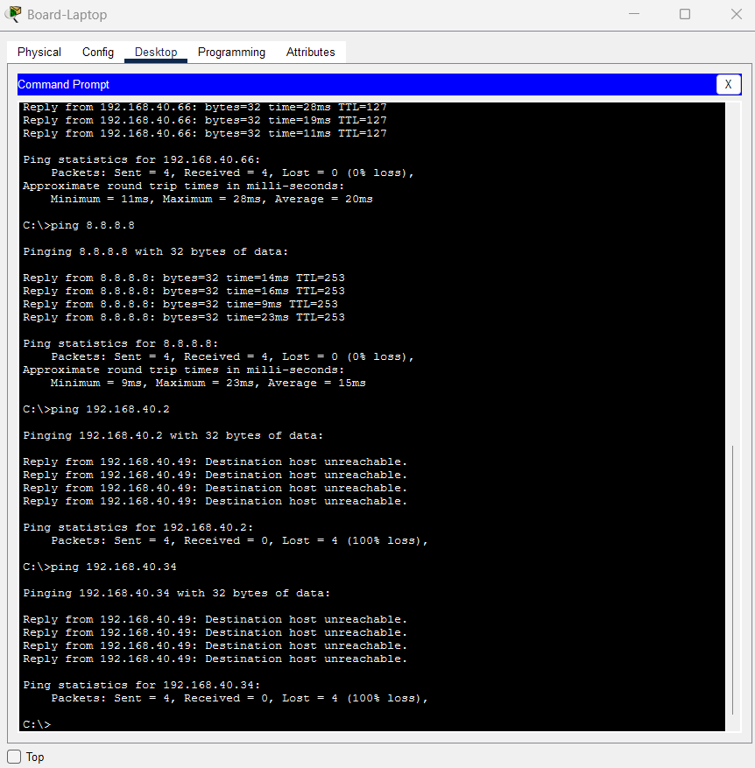
File: T09_2_Board-Laptop_blocked_to_Sales_Admin.png

Figure 19 – T09: Board-Laptop – still reaches its VLAN, the servers and the Internet
With the ACL active, the wireless laptop still reaches 192.168.40.50 (same VLAN), 192.168.40.66 (File-Server) and 8.8.8.8: 4/4 each.
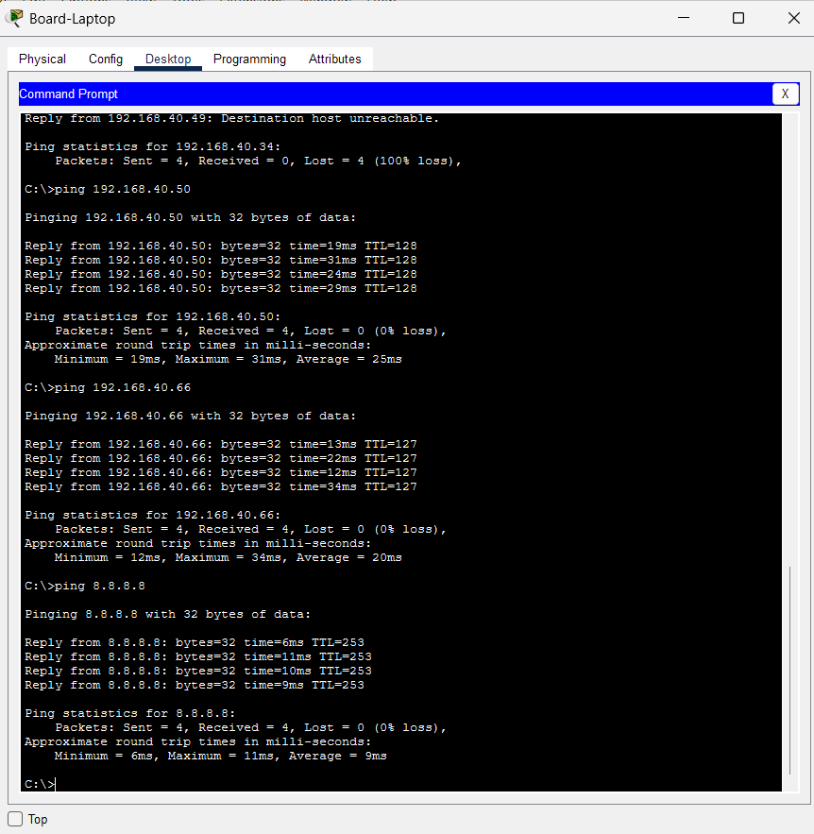
File: T09_3_Board-Laptop_allowed_destinations.png

Figure 20 – T09: Sales-PC1 – blocked to the boardroom, Admin still reachable
Ping to 192.168.40.50 (boardroom): 4 timeouts, because the boardroom’s replies are dropped by BOARD-IN. Ping to Admin-PC1 192.168.40.34: 4/4, TTL 127, so the ACL affects only the boardroom. (The ping to 192.168.40.2 is Sales-PC1’s own address and is not part of the test.)
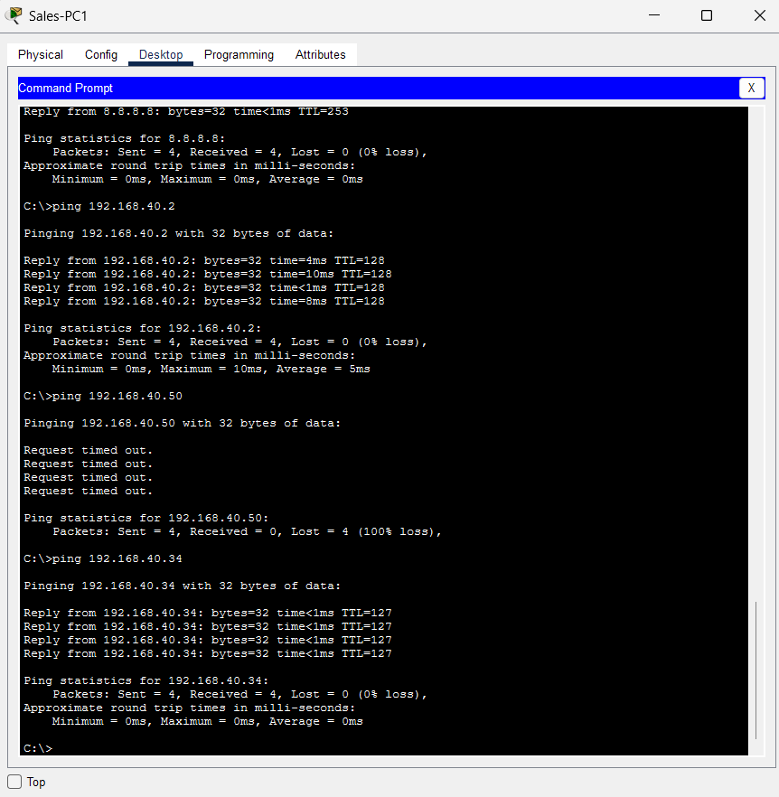
File: T09_4_SalesPC1_blocked_to_boardroom.png

Figure 21 – T09: R3-CORE – ACL hit counters
show access-lists counters: rule 10 (to Sales) 8 matches, rule 20 (to Admin) 4 matches, rule 30 (permit) 8 matches. Rule 10’s eight matches are the laptop’s four pings to Sales plus the presenter PC’s four blocked replies to Sales-PC1.
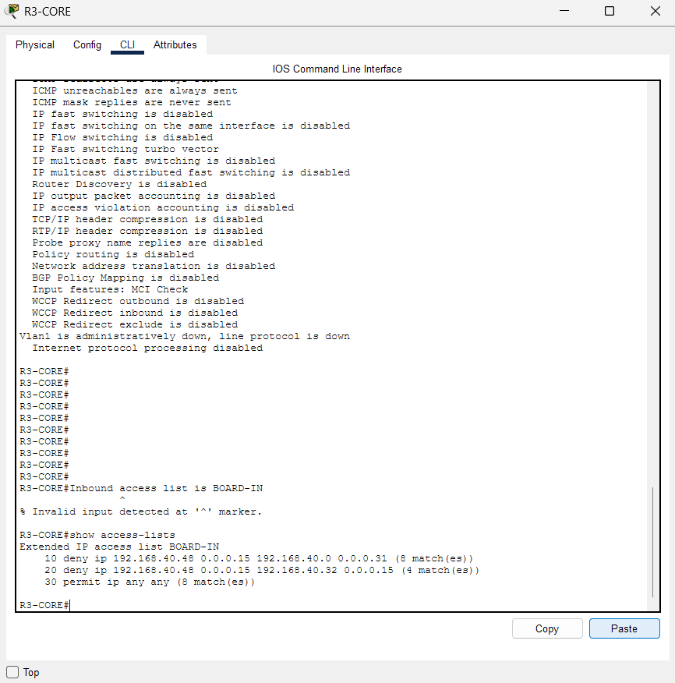
File: T09_5_R3_acl_hit_counters.png

Figure 22 – T10: Sales-PC1 – gateway reachable
Ping to the VLAN 10 gateway 192.168.40.1 (R3-CORE subinterface Gi0/0.10): 4/4, TTL 255.
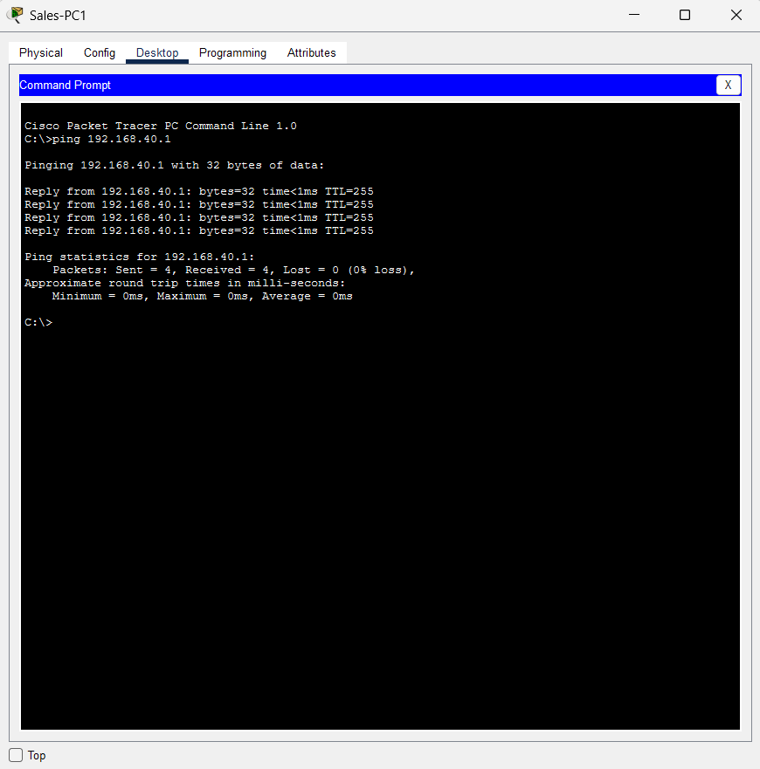
File: T10_0_SalesPC1_gateway_ping.png

Figure 23 – T10: Sales-PC1 – inter-VLAN routing (1 of 2)
Pings to Admin-PC1 192.168.40.34, Admin-PC2 192.168.40.35 and File-Server 192.168.40.66: three replies each with TTL 127 (one router hop). The first packet is lost to ARP resolution, which is expected. Captured before the boardroom ACL was applied.
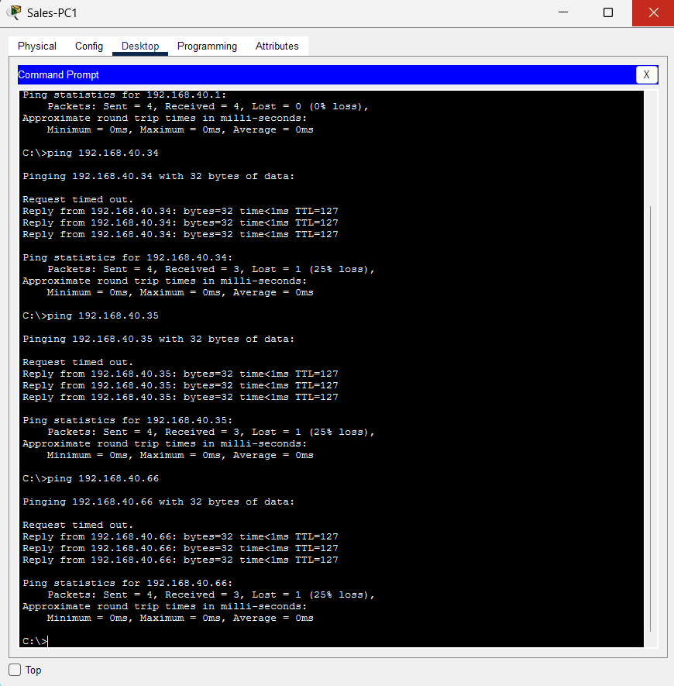
File: T10_1_SalesPC1_interVLAN_pings_1.png

Figure 24 – T10: Sales-PC1 – inter-VLAN routing (2 of 2)
Pings to File-Server 192.168.40.66, Board-Presenter-PC 192.168.40.50 and Print-Server 192.168.40.67: three replies each, TTL 127. Captured before the boardroom ACL was applied.
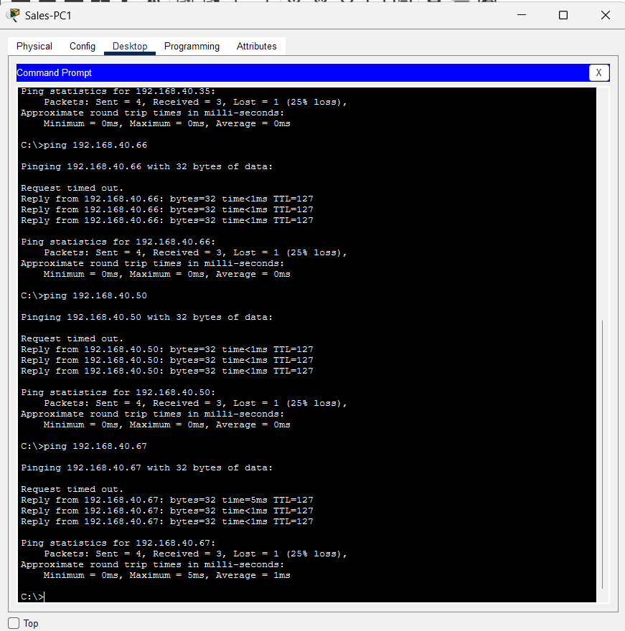
File: T10_2_SalesPC1_interVLAN_pings_2.png

Figure 25 – T11: Sales-PC1 – Internet path under normal operation
ping 8.8.8.8 succeeds (first packet lost to ARP). tracert 8.8.8.8 shows 192.168.40.1 (R3-CORE), 192.168.40.74 (R1-EDGE-PRI) and then 8.8.8.8, which is a loopback on the ISP router.
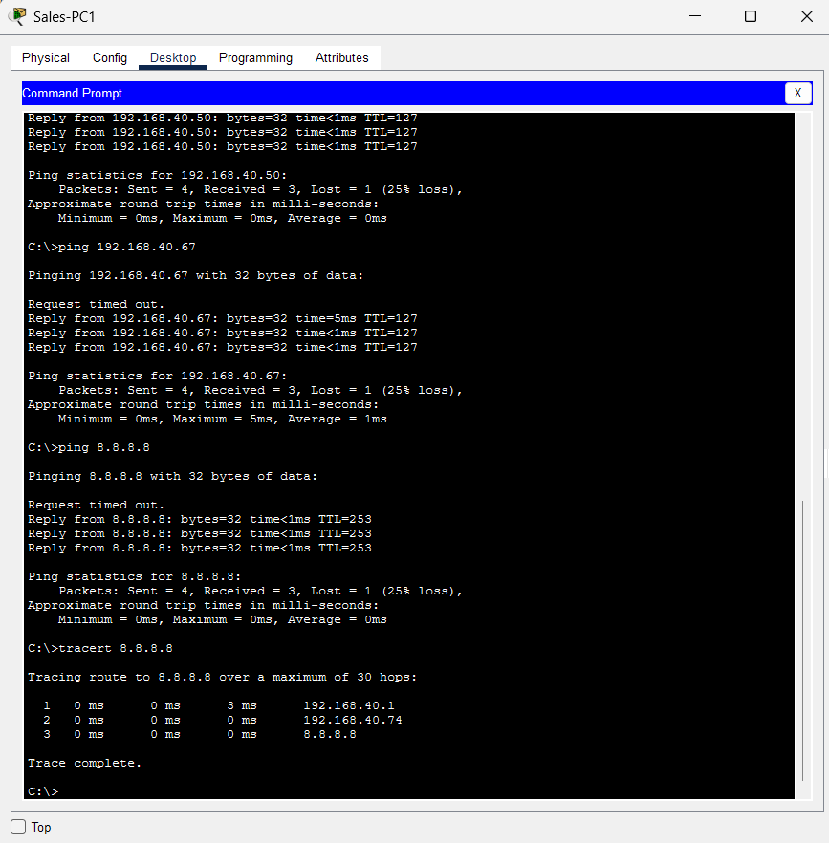
File: T11_SalesPC1_tracert_primary_path.png

Figure 26 – T12: R3-CORE – default route before and after the primary path fails
Before the failure: S* 0.0.0.0/0 [1/0] via 192.168.40.74. After the primary link goes down (Gi0/1 line protocol down) the route table shows the gateway of last resort 192.168.40.78 and S* 0.0.0.0/0 [10/0] via 192.168.40.78 (R2-EDGE-BAK).
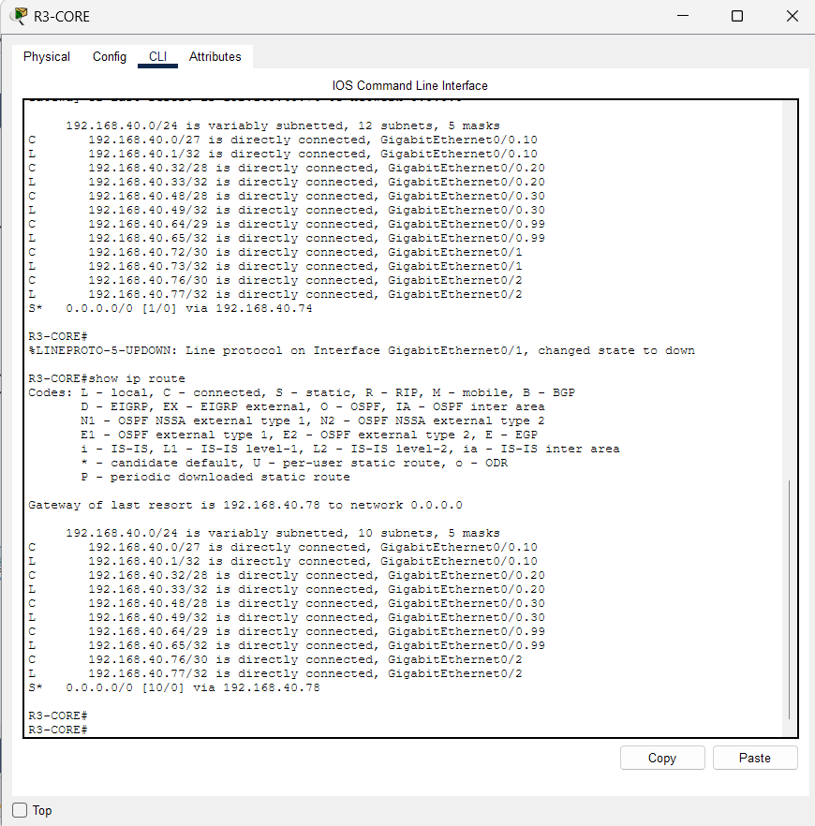
File: T12_R3_default_route_primary_then_backup.png

Figure 27 – T13: Sales-PC1 – tracert before and after failover
The first tracert goes via 192.168.40.74 (R1). After failover the second goes via 192.168.40.78 (R2) and still reaches 8.8.8.8.
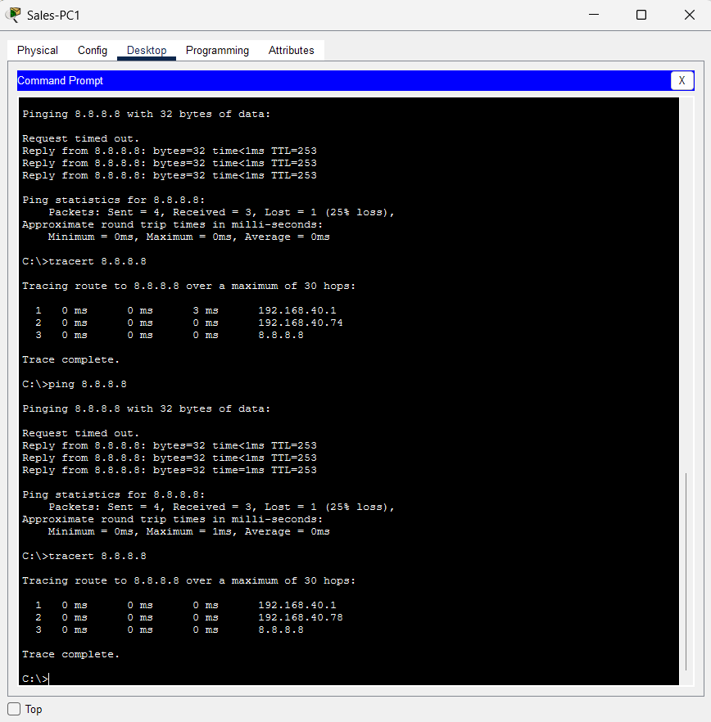
File: T13_1_SalesPC1_tracert_primary_then_backup.png

Figure 28 – T13: R2-EDGE-BAK – backup edge router reaches ISP-B and the Internet host
Ping to ISP-B 198.51.100.1: 5/5. Ping to 8.8.8.8: 5/5.
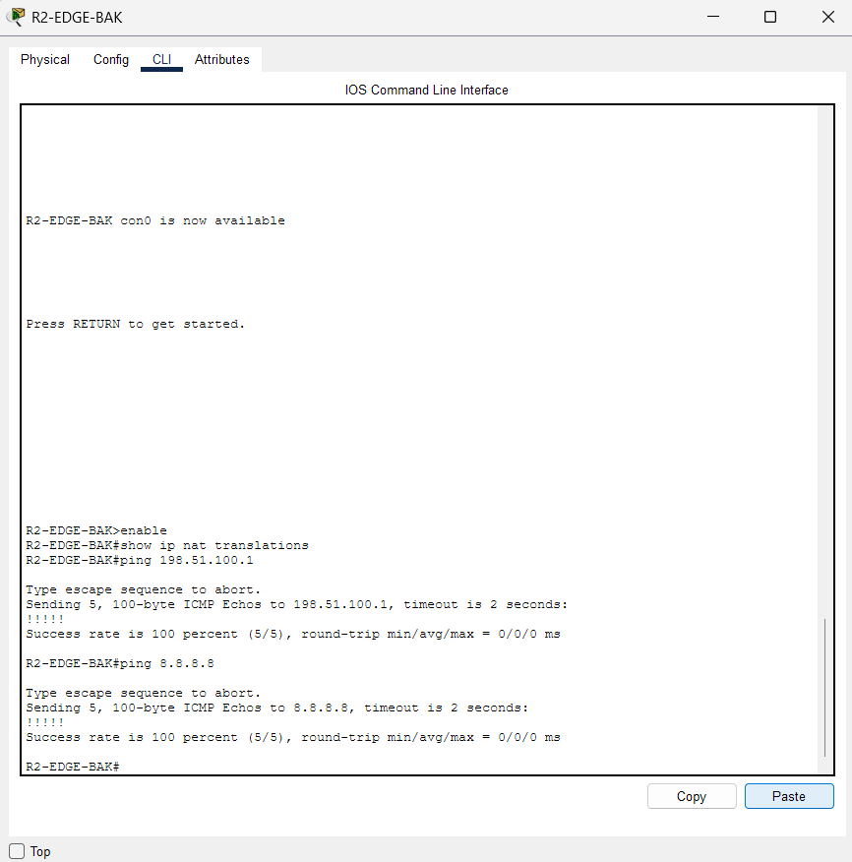
File: T13_2_R2_reaches_ISP-B_and_Internet.png

Figure 29 – T14: R3-CORE – primary route restored
While the primary was down the default was [10/0] via 192.168.40.78. After the link returns (Gi0/1 line protocol up) the default is back to S* 0.0.0.0/0 [1/0] via 192.168.40.74.
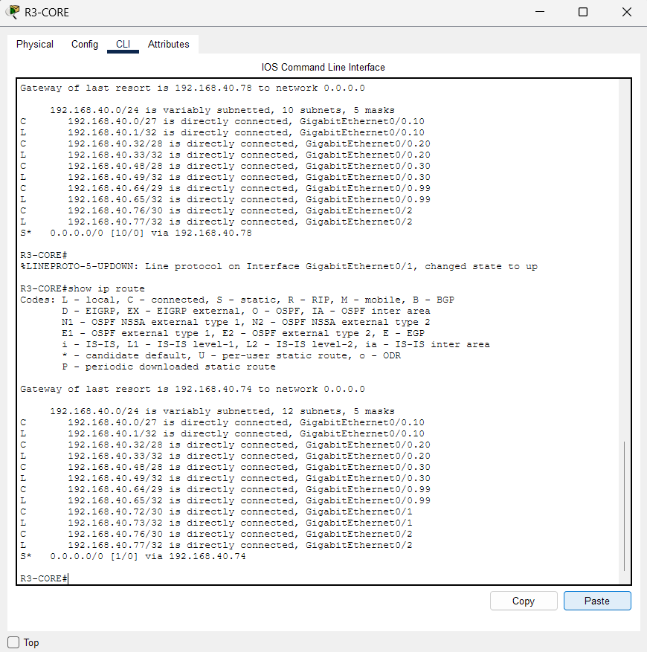
File: T14_R3_default_route_restored_primary.png

Figure 30 – T15: R1-EDGE-PRI – NAT translations
show ip nat translations shows ICMP translations from inside local 192.168.40.2 (Sales-PC1) to inside global 203.0.113.2 (NAT overload on Gi0/1) towards 8.8.8.8.
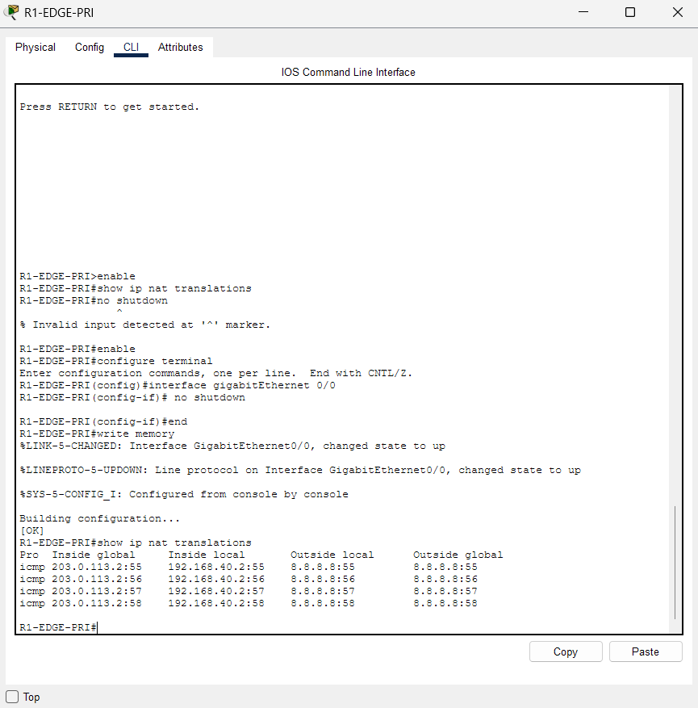
File: T15_R1_nat_translations.png

Figure 31 – T16: Topology – all wireless clients associated
Board-Laptop, Board-Phone and Board-Tablet each show an active wireless link to AP1-BOARD. The wired Board-Presenter-PC and the AP are both connected to SW4-BOARD.
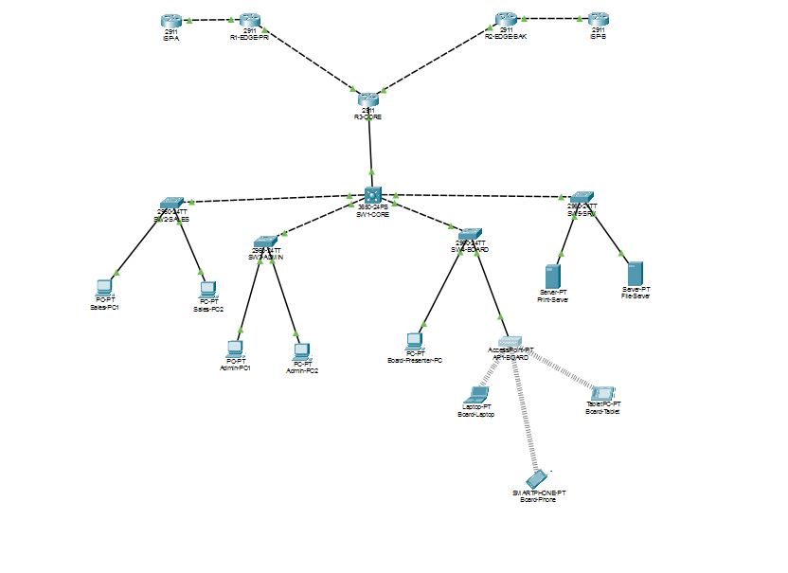
File: T16_Topology_all_clients_associated.png

