HW Accelerator Design Doc

Overview
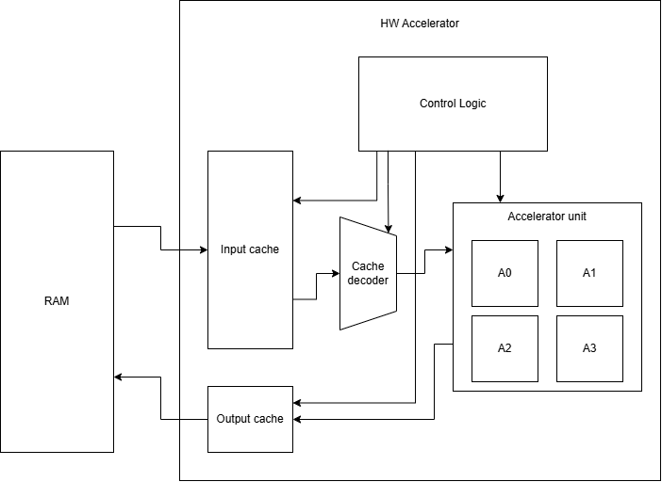
The RAM can only send 32-bit words of data that contains 4 pixels(px) worth of data, each px being 8 bits. This also means that when writing, we need a 32-bit word worth of data to get the most out of the write bandwidth. For that, four accelerators in parallel are used to get 4 calculated px to write back into RAM. This provides some challenges but it is actually easier than trying to only use one acceleration algorithm.

Signal Overview
Signal name | Name | Function | Routing | Bit size
Rd_Cnt | Read Counter | 2 bit counter, adds one each clock cycle | Internal Control signal | 2 bit
X_Cnt | Column Counter | Counts from 0 -> 87, adds one when Rd_Cnt = 2 | Internal Control signal | 8 bit
Y_Cnt | Row Counter | Counts from 0 -> 287, adds one when X_Cnt = 87 | Internal Control signal | 9 bit
WCh_Cnt | Write Chunk Counter | Keeps track of which chunk is selected for processing, adds one when writing | Control Logic  Decoder | 2 bit
RCh_Cnt | Read Chunk Counter | Keeps track of which chunk is being read, adds one when Rd_Cnt = 3 | Control Logic  Input cache | 2 bit
RAddr_Cnt | Read Address Counter | Counts from 0 -> 25343 | Internal Control Logic | 16 bit
WAddr_Cnt | Write Address Counter | Counts from (0 -> 25434) + 25343 | Internal Control Logic | 16 bit
px_Sel | Pixel Select | Selects which pixel is valid depending on X and Y counter values | Control Logic  |  V  Accelerator | 2 bit
W_Sel | Write Select | Selects which registers are written to RAM  1 bit signal | Control Logic  Output Cache | 1 bit
R_Sel | Read Select | Selects which registers in the input cache are read to.  2 bit signal | Control  Input cache | 2 bit
R_En | Read Enable | Enables the input cache to read from RAM | Control  Input cache | 1 bit
W_En | Write Enable | Enables the Accelerator output to write to output cache | Control  Output cache | 1 bit

Input Cache
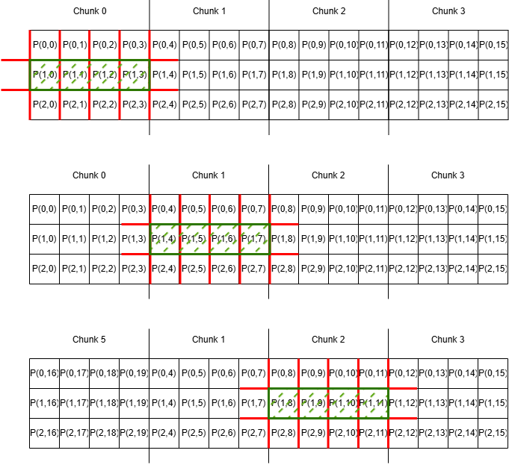
Cache is made up of 4 Chunks of 3 32-bit words each. In total 12 words. Each word takes two clock cycles to read. When all chunks are loaded, the first two chunks have to be written back to RAM before the running cycle can begin which take two clock cycles. So in total, the system takes 12 reads and two writes on startup before the continuous run operation can execute.
So the pre-loading consists of:
- AddrCnt++ = N
- Load AddrN
- N + 88 = N
- Load AddrN
- N + 88 = N
- Load AddrN
- ChunkCnt++
- When ChunkCnt = 3 -> Write Chunk 1 & 2
Then when the first two chunk results have been written to memory, then we can append the first chunk and load the next chunk of pixels. The Chunk counter is a 2 bit counter so it wraps around each fourth time.
Running cycle:
- AddrCnt++ = N
- Load AddrN
- N + 88 = N
- Load AddrN
- N + 88 = N
- Load AddrN
- Write Chunk
- Chunk++
Each Row of pixels is 352px long and 288px wide, and each word contains 4 pixels. So after reading 88 times one row has been completed. And after reading 88 times 288 the image is complete. We can also use this to index when a pixel is on the boundary and shouldn’t count in the final result that we write to RAM. In other words, we have two counters. One counts up to 88(Cnt1) and the other to 288(Cnt2).
Discard:
- left px when Cnt1 = 0
- right px when Cnt1 = 87
- top row when Cnt2 = 0
- bottom row when Cnt2 = 287

Decoder
Each Accelerator module needs a 3x3 px matrix for calculation. We can use four Accelerators for each chunk but this requires some extra logic to decode each 4x3 chunk to a wider 6x3 to send to the accelerators because of the two to the far sides of the chunk need an extra column each to fill the matrix.
Cache Address | Pixels | Decoder
A0 | P(0,0)P(0,1)P(0,2)P(0,3) | P(0,15)P(0,0)P(0,1)P(0,2)P(0,3)P(0,4)
A88 | P(1,0)P(1,1)P(1,2)P(1,3) | P(1,15)P(1,0)P(1,1)P(1,2)P(1,3)P(1,4)
A176 | P(2,0)P(2,1)P(2,2)P(2,3) | P(2,15) P(2,0)P(2,1)P(2,2)P(2,3)P(2,4)
A1 | P(0,4)P(0,5)P(0,6)P(0,7) | P(0,3)P(0,4)P(0,5)P(0,6)P(0,7)P(0,8)
A89 | P(1,4)P(1,5)P(1,6)P(1,7) | P(1,3)P(1,4)P(1,5)P(1,6)P(1,7)P(1,8)
A177 | P(2,4)P(2,5)P(2,6)P(2,7) | P(2,3)P(2,4)P(2,5)P(2,6)P(2,7)P(2,8)
A2 | P(0,8)P(0,9)P(0,10)P(0,11) | P(0,7)P(0,8)P(0,9)P(0,10)P(0,11)P(0,12)
A90 | P(1,8)P(1,9)P(1,10)P(1,11) | P(1,7)P(1,8)P(1,9)P(1,10)P(1,11)P(1,12)
A178 | P(2,8)P(2,9)P(2,10)P(2,11) | P(2,7)P(2,8)P(2,9)P(2,10)P(2,11)P(2,12)
A3 | P(0,12)P(0,13)P(0,14)P(0,15) | P(0,11)P(0,12)P(0,13)P(0,14)P(0,15)P(0,0)
A91 | P(1,12)P(1,13)P(1,14)P(1,15) | P(1,11)P(1,12)P(1,13)P(1,14)P(1,15)P(1,0)
A179 | P(2,12)P(2,13)P(2,14)P(2,15) | P(2,11)P(2,12)P(2,13)P(2,14)P(2,15)P(2,0)

Datapath (Accelerator)


