SRM INSTITUTE OF SCIENCE AND TECHNOLOGY, TIRUCHIRAPPALLI

COMPUTER NETWORKS
COURSE CODE : 21CSC302J

Submitted By
MOTHI SAGAR M V
RA2411030050050

Under the guidance of
Dr. Mallikka
(Assistant Professor, School of Computing)
in partial fulfilment for the award of the degree
of
BACHELOR OF TECHNOLOGY
in
DEPARTMENT OF COMPUTER SCIENCE AND ENGINEERING WITH CYBER SECURITY
Of
FACULTY OF ENGINEERING AND TECHNOLOGY

Abstract
Two two-host networks were built in Cisco Packet Tracer: one around a switch with straight-through cables, and one using a cross-over cable that was afterwards replaced by a switch. Static IPv4 addresses were configured and ping tests were run in each case. Every test finished with zero packet loss.

1. Introduction
Checking connectivity is the first step when building any network; routing and services come later. The two arrangements tested here are the two commonest ways to link end devices in a wired LAN, and the report records how each one is cabled, addressed and verified.

2. Hardware and Software
- Two PC-PT end devices (PC0 and PC1)
- Switch-PT (Part I) and Catalyst 2960-24TT (Part II)
- Copper Straight-Through and Copper Cross-Over cables
- Cisco Packet Tracer in Logical view, Realtime and Simulation modes

3. Concepts Required
Switching. A switch keeps a MAC address table and sends each frame only to the port leading to its destination; a hub, by contrast, repeats every frame on all ports.
Cabling. A straight-through cable is wired the same at both ends (pin 1 to pin 1, pin 2 to pin 2) and joins unlike devices. A cross-over cable swaps the transmit pair (pins 1, 2) with the receive pair (pins 3, 6) and joins like devices. Many modern ports detect this automatically (Auto-MDIX), but the simulator expects the traditional choice.
Addressing. With mask 255.255.255.0 the first 24 bits identify the network. Two hosts whose first three octets match are on the same link and exchange packets directly.
Testing. Ping sends ICMP echo requests and prints, for each reply, its size, round-trip time and TTL, followed by a summary of packets sent, received and lost.

4. Part I: Switch-Based LAN (192.168.1.0/24)
(1) Place two PCs and a switch on the workspace, the switch in between.
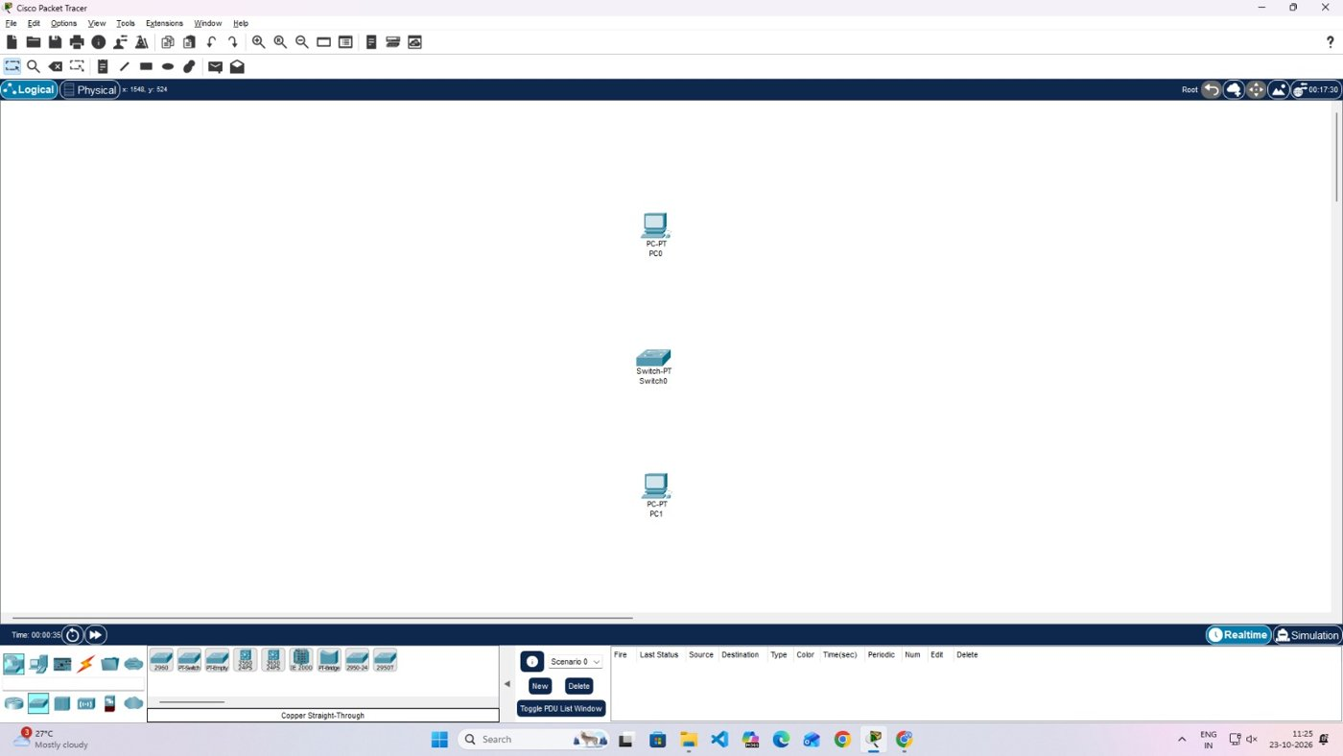
Screenshot 1: Devices on the workspace before cabling
(2) Choose Copper Straight-Through from the Connections palette.
(3) Join PC0 and PC1 to Switch0 through FastEthernet0 of each PC. The ports initially show orange dots.
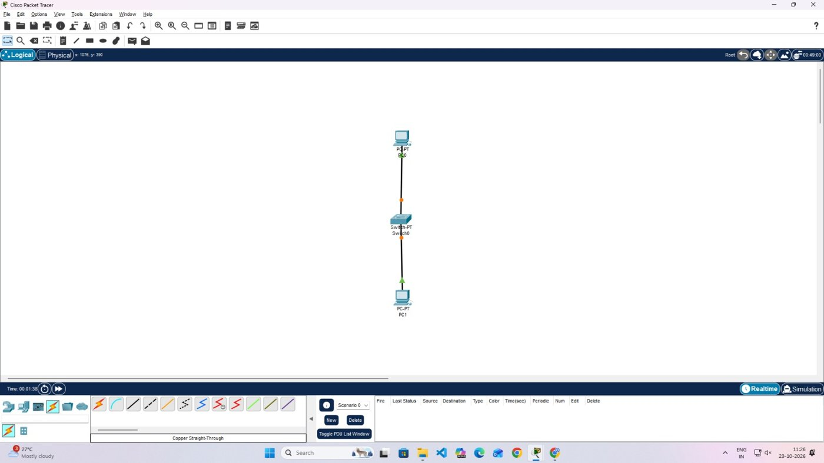
Screenshot 2: Links created; orange dots show the ports starting up
(4) Wait until the dots change to green triangles, which means both links are operational.
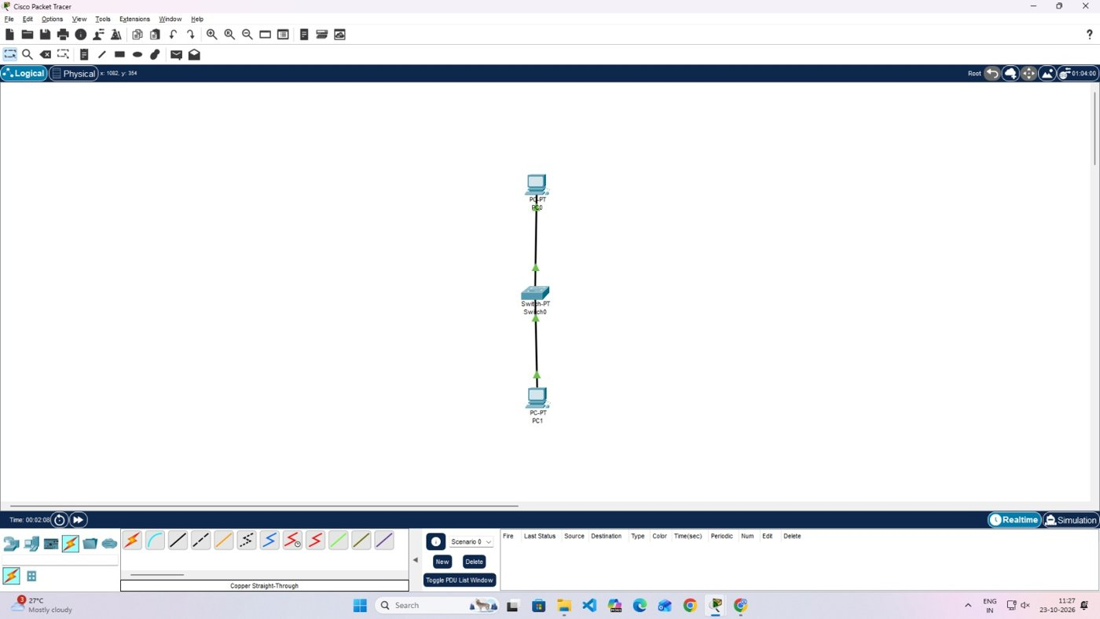
Screenshot 3: Both links operational
(5) Configure PC0 statically as 192.168.1.1 / 255.255.255.0 (Desktop, IP Configuration).
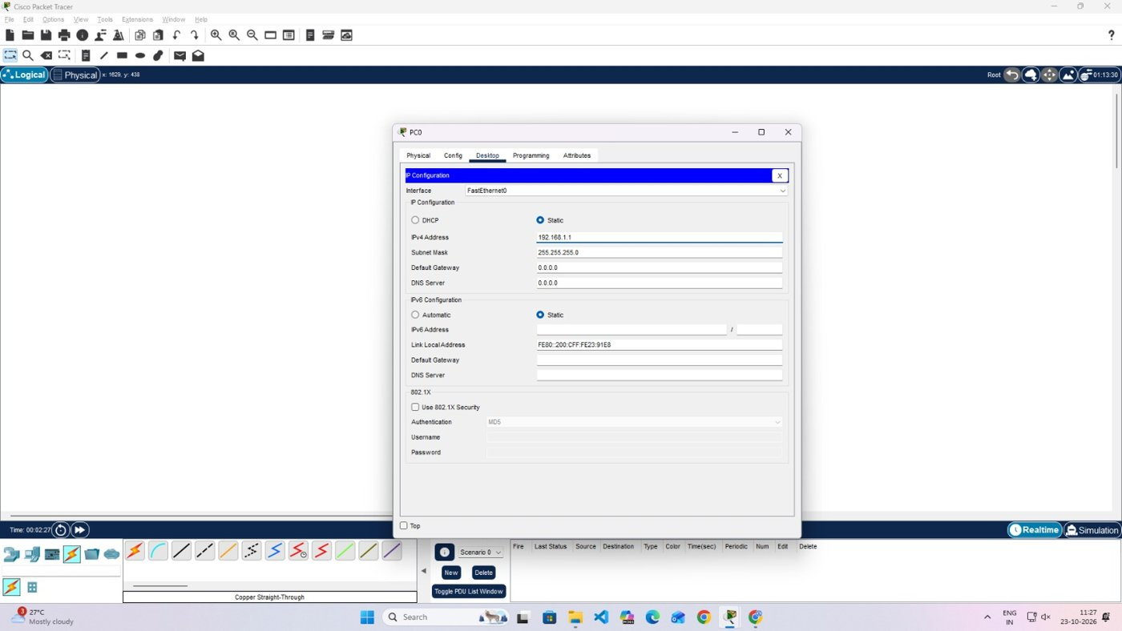
Screenshot 4: Static address on PC0
(6) Configure PC1 statically as 192.168.1.2 / 255.255.255.0.
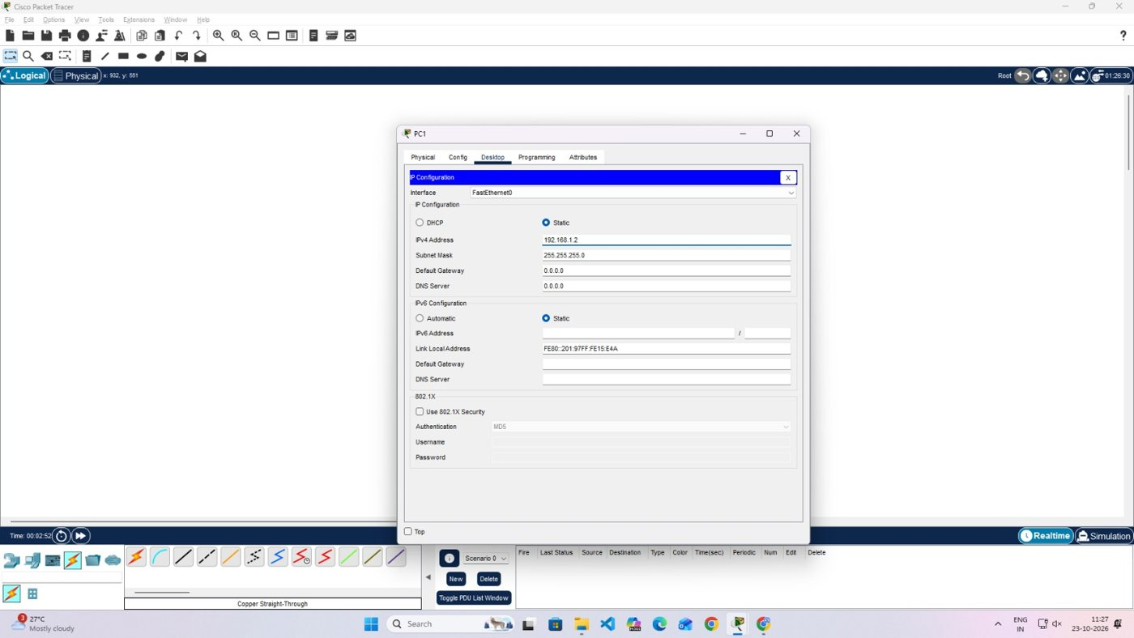
Screenshot 5: Static address on PC1
(7) Open the Command Prompt of PC1 and run ping 192.168.1.1.
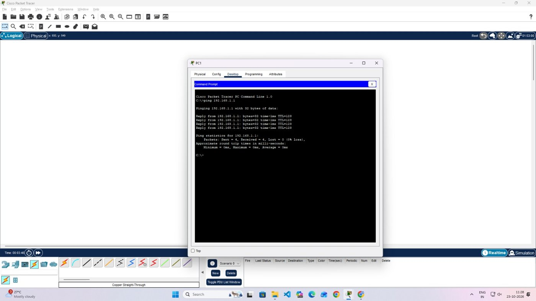
Screenshot 6: Ping from PC1
(8) Open the Command Prompt of PC0 and run ping 192.168.1.2.
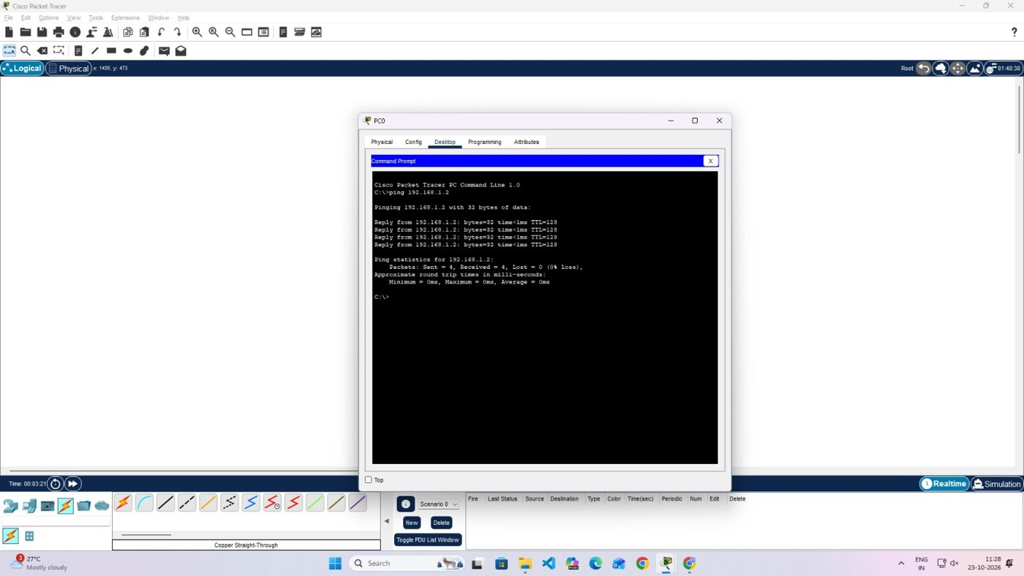
Screenshot 7: Ping from PC0
(9) Use Simulation mode with a test PDU to watch the packet pass through the switch.
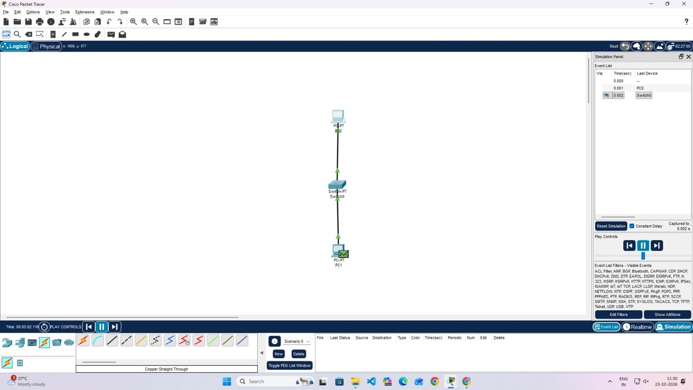
Screenshot 8: Event list and packet position in Simulation mode
Observation: Sent = 4, Received = 4, Lost = 0 in both directions, with reply times below 1 ms and TTL 128. The switch therefore carries traffic between the hosts without loss.

5. Part II: Cross-Over Link, then Switch (192.168.10.0/24)
(1) Place two PCs on a new workspace.
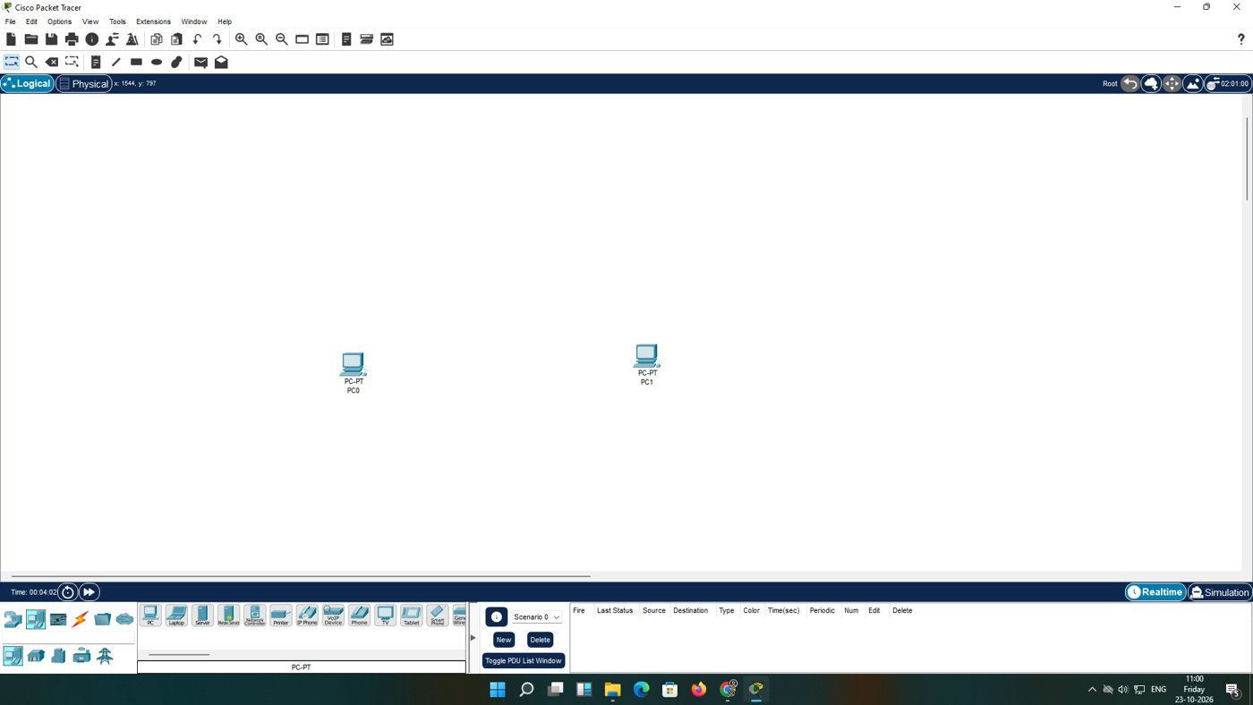
Screenshot 9: PC0 and PC1 before cabling
(2) Choose Copper Cross-Over, since both devices are PCs.
(3) Click PC0 and choose FastEthernet0 from its interface list.
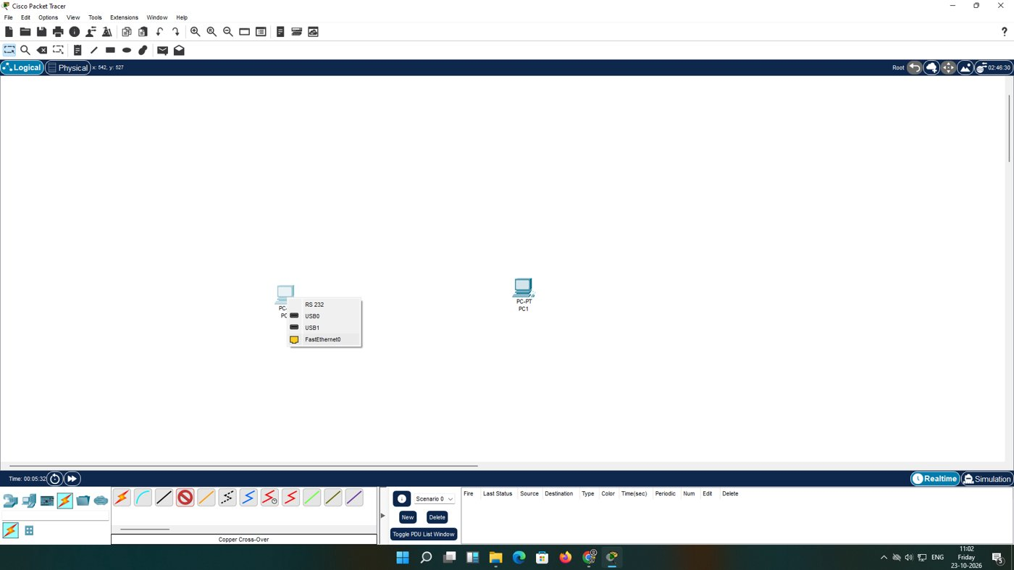
Screenshot 10: Interface list of PC0
(4) Click PC1 and choose FastEthernet0; green triangles at both ends show the link is up.
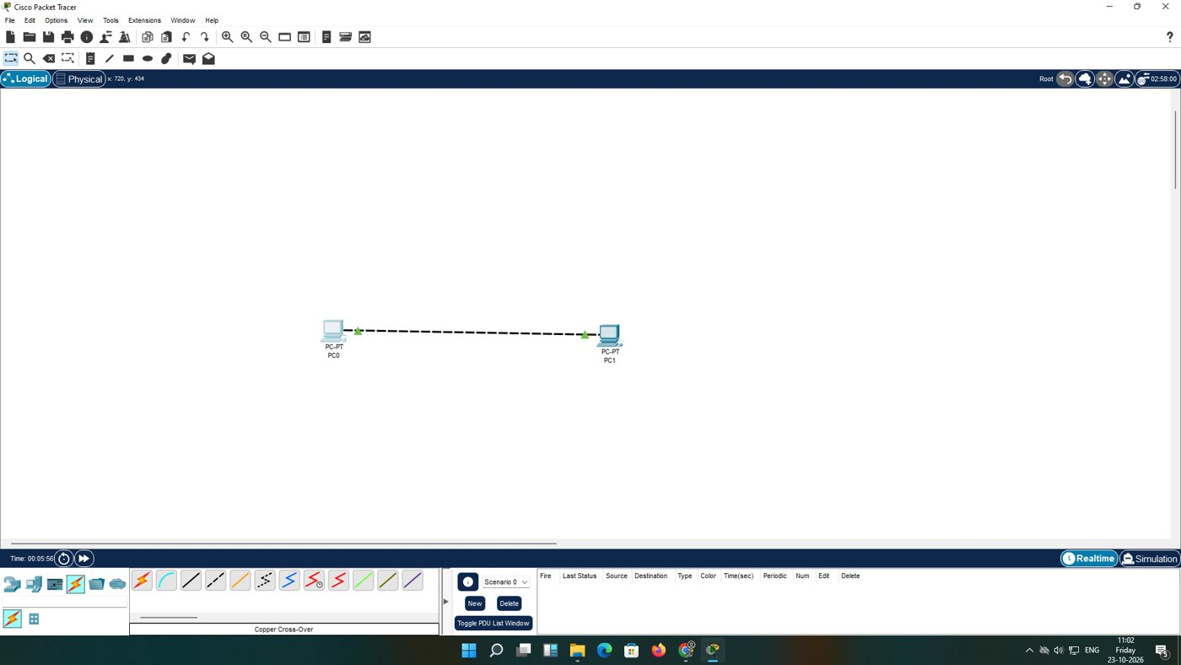
Screenshot 11: PC0 and PC1 joined directly
(5) Configure PC0 as 192.168.10.1 / 255.255.255.0.
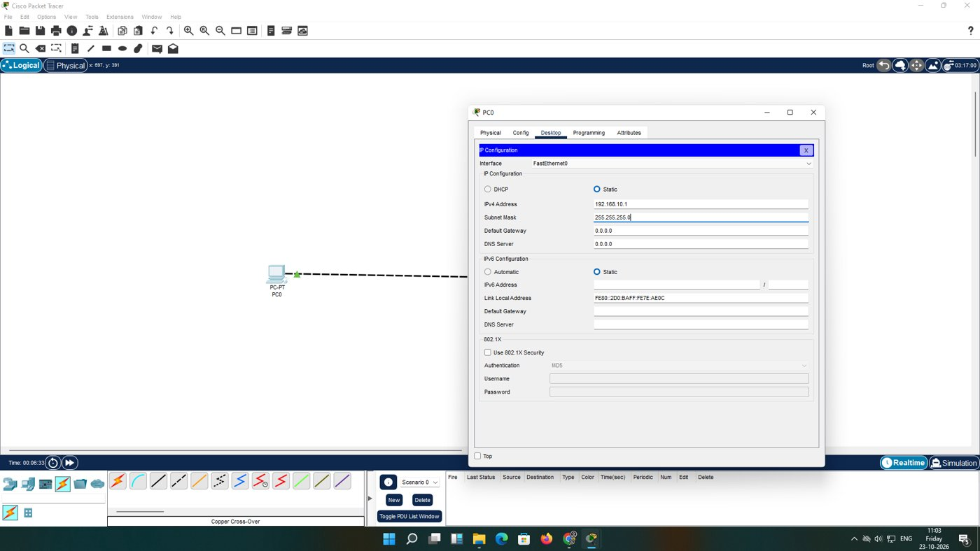
Screenshot 12: Static address on PC0
(6) Configure PC1 as 192.168.10.2 / 255.255.255.0.
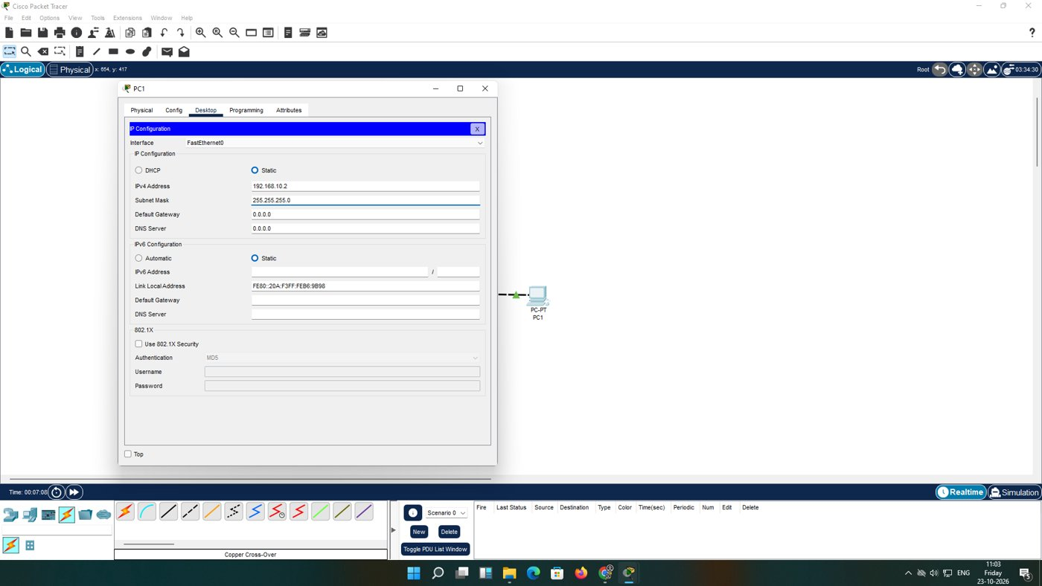
Screenshot 13: Static address on PC1
(7) Run ping 192.168.10.2 from PC0.
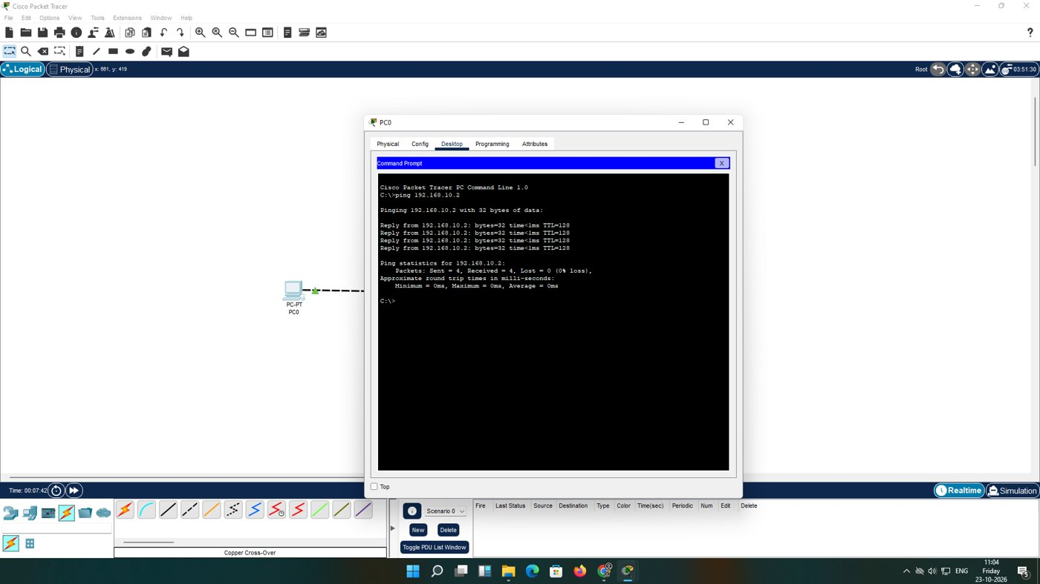
Screenshot 14: Ping over the cross-over cable
(8) Place a Catalyst 2960-24TT switch on the workspace.
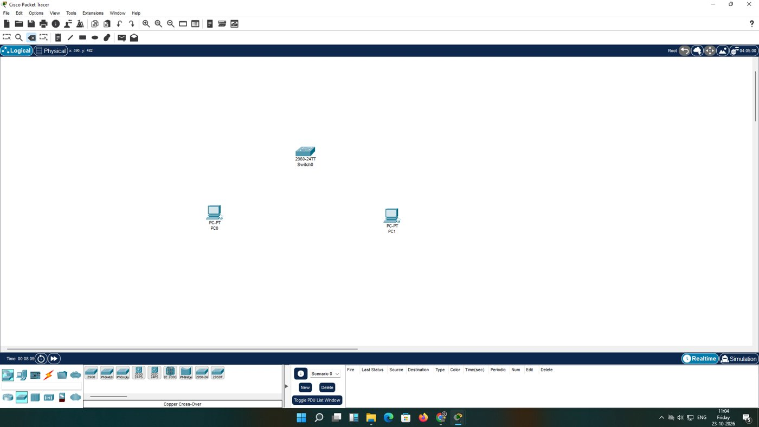
Screenshot 15: Switch placed
(9) Replace the cross-over cable with two straight-through cables running to the switch.
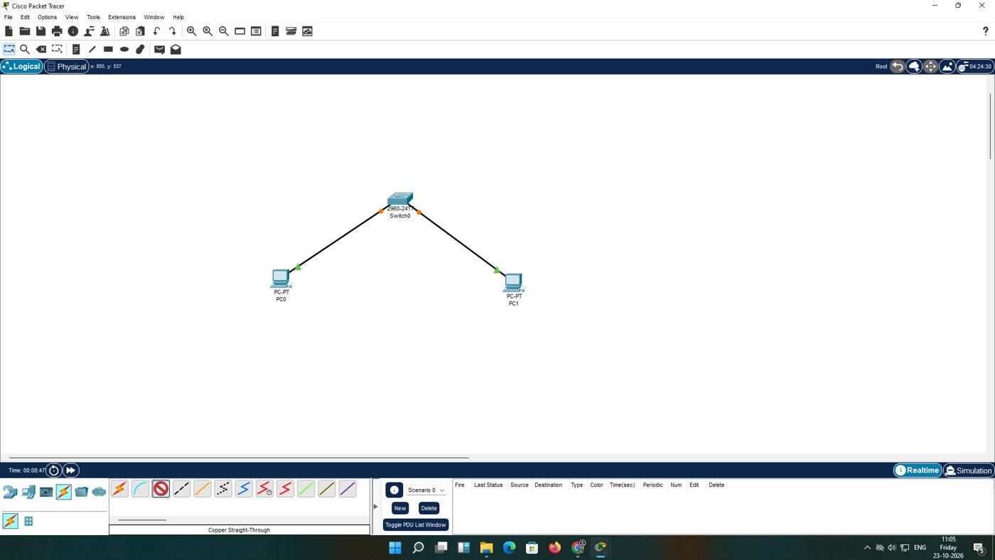
Screenshot 16: Hosts cabled to the switch
(10) Run ping 192.168.10.1 from PC1.
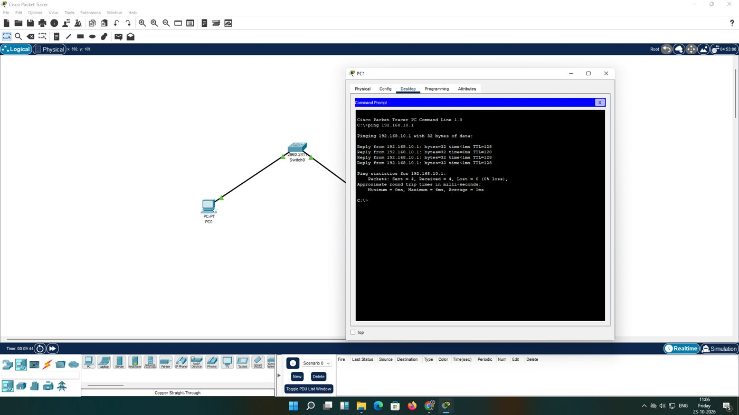
Screenshot 17: Ping through the switch
Observation: The direct link answered all four requests in under 1 ms. Through the switch all four were also answered; the minimum was 0 ms, the maximum 6 ms and the average 1 ms. The 6 ms value belongs to the first packet, which waited for ARP and for MAC learning.

6. Results and Discussion
Set-up | Network | Cable | Sent / Received | Loss | Time
Part I | 192.168.1.0/24 | Straight-through | 4 / 4 (each test) | 0% | <1 ms
Part II direct | 192.168.10.0/24 | Cross-over | 4 / 4 | 0% | <1 ms
Part II switch | 192.168.10.0/24 | Straight-through | 4 / 4 | 0% | avg 1 ms

Correct cable selection and a common subnet were sufficient for complete connectivity. The direct link suits two machines only; the switch costs a little extra time on the first packet but allows more hosts to be added later.

7. Conclusion
Two-host networks were implemented with both a switch and a cross-over cable. Static addresses in one subnet and the right cable gave fully successful ping tests, confirming the basic LAN rules on which routing and VLANs are built later.

