
PRODUCT & TECHNICAL DOCUMENTATION

StudySync
  - Smart Student Collaboration Platform

Version 1.0 | 30 June 2026
Architecture, user guide, deployment and release acceptance

Prepared for the StudySync project team

Document control
This manual describes the current StudySync codebase and the collaboration release added on 30 June 2026. Interface figures are implementation-based illustrations rather than live screenshots.
Field | Value
Document | StudySync Project Documentation
Release | Collaboration update - version 1.0
Audience | Project owners, developers, testers, administrators and assessors
Application stack | PHP 8.2+, MySQL/MariaDB, responsive HTML/CSS/JavaScript
Primary deployment | Railway/Nixpacks with public as the web document root
Database migration | public/database/2026_06_29_collaboration_features.sql

How to use this guide
- Product owners can begin with Sections 1-4 for capabilities and user workflows.
- Developers should use Sections 5-8 for architecture, data, deployment and security controls.
- Testers should use Section 9 as the release acceptance checklist.
- Operations teams should review the production notes before enabling uploads or password email delivery.

Contents
- 1. Executive summary
- 2. Product overview and user roles
- 3. Functional feature guide
- 4. Collaboration workflows
- 5. Technical architecture
- 6. Data model and application routes
- 7. Installation, migration and deployment
- 8. Security and operations
- 9. Release acceptance checklist
- 10. Limitations and recommended roadmap

1. Executive summary
StudySync is a compact collaboration workspace for students. It brings groups, tasks, deadlines, shared resources and conversation into one responsive application, reducing the need to coordinate study work across unrelated tools.
Release outcome The collaboration update adds chat attachments, an in-chat file panel, secure group invitations, profile pages with photos, password recovery and in-app notifications. The changes are backed by a database migration and updated deployment configuration.

1.1 Release objectives
- Make files part of the conversation, not a separate afterthought.
- Let group owners bring people into private workspaces through controlled invitations.
- Give every student an identifiable profile with useful academic context.
- Provide recoverable accounts without exposing whether an email address exists.
- Surface important group events through a persistent notification centre.

1.2 Capability map
Area | What StudySync provides | Primary user value
Groups | Public/private workspaces, join requests and member controls | A defined home for each study team
Tasks | Due dates, completion status and group filtering | Clear ownership and deadline visibility
Calendar | Month view of group tasks | One view of upcoming workload
Files | Validated uploads and member-only downloads | Shared notes remain available to the group
Chat | Messages, image previews, attachments and recent files | Conversation and resources stay in context
People | Profiles, invitations and notifications | Teams are easier to recognise and grow
Accounts | Registration, sign-in and one-time reset links | Safer, recoverable access

2. Product overview and user roles

2.1 Intended users
StudySync is designed for students who need a lightweight workspace for coursework, revision groups and shared academic projects. It also supports platform administrators and group creators who manage access and collaboration activity.
Role | Permissions and responsibilities
Student | Create or join groups, participate in chat, share files, manage assigned tasks, maintain a profile and receive notifications.
Group creator | All student capabilities plus join-request review, member removal, invitations and group deletion.
Administrator | Platform-level access, group management authority and administrative reporting.
Invite recipient | Open a seven-day link, authenticate with the invited account and accept membership.

2.2 Information architecture
- Dashboard - personal overview of tasks, groups and shared activity.
- Study Groups - discovery, creation and group workspaces.
- Tasks - status, deadline and group filters.
- Files - shared group libraries with upload and download actions.
- Calendar - month-based deadline view.
- Notifications - unread events and navigation to the relevant context.
- Profile - identity, academic information and contribution statistics.

3. Functional feature guide

3.1 Group chat and the + attachment control
The group Chat tab now supports text-only messages, file-only messages, or a combination of both. The round + control opens the system file picker. After selection, the chosen filename appears beneath the message field before sending.
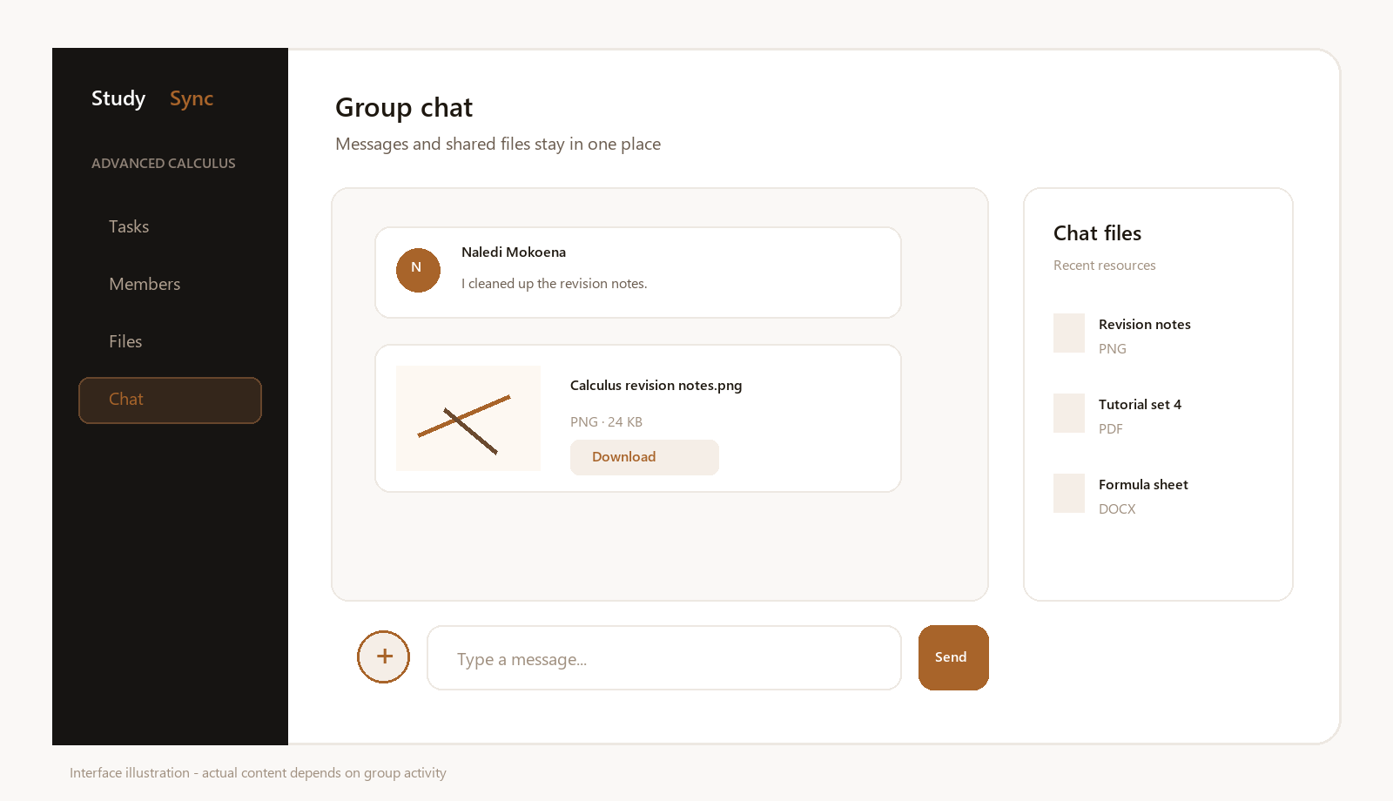
Figure 1. Implementation-based illustration of chat attachments and the Chat files panel.
- Images render as a bounded preview inside the message and remain downloadable.
- Documents and archives render as compact attachment cards with file type and size.
- The side panel lists the eight most recent group files and links to the complete library.
- A message is accepted when it contains text, an attachment, or both.

3.2 File library and downloads
The file library remains available as a dedicated page and as a group tab. Uploads are validated, recorded against a group and uploader, and downloaded through an authenticated endpoint. Direct database identifiers are checked against current membership before any file is streamed.
Category | Supported formats | Limit
Documents | PDF, DOCX, PPTX, XLSX, TXT and CSV | 25 MB
Archives | ZIP | 25 MB
Images | PNG, JPG/JPEG, GIF and WebP | 25 MB
Profile photo | PNG, JPG/JPEG and WebP | 5 MB

3.3 Profiles
Every active user has a profile page. A user can upload a photo, edit their name, institution, course and biography, and review contribution statistics. Other signed-in members can open a profile from the group member list or from a chat message.
- Activity statistics include joined groups, uploaded files and completed assigned tasks.
- Email addresses are not presented on another student's public profile page.
- The global navigation uses the profile photo when one is available.

3.4 Notifications
A global bell displays the unread count. The notification centre lists recent activity, highlights unread items and allows users to mark one or all events as read. Opening an item takes the user to its relevant group or feature page.
- Group invitation created for a registered user.
- Join request submitted to a group creator.
- Join request approved or declined.
- Invitation accepted by a new member.

4. Collaboration workflows

4.1 Invite a person to a group
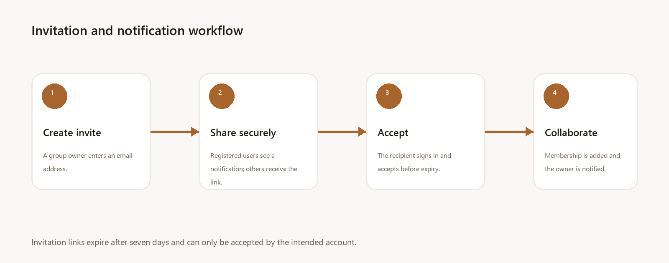
Figure 2. Invitation and in-app notification workflow.
- Open the group and select the Members tab.
- Choose Invite people and enter the recipient's email address.
- Create the invitation. A registered user receives an in-app notification; otherwise copy the generated link.
- The recipient signs in or registers using the invited email account.
- The recipient accepts before the seven-day expiry. Membership is inserted once and the group owner is notified.
Access rule Only the invited user ID or an account with the invited email address can accept the link. Expired, previously used and mismatched invitations are rejected.

4.2 Recover a forgotten password
- Choose Forgot password? on the sign-in page and submit the account email address.
- StudySync creates a random token, stores only its SHA-256 hash and sets a 60-minute expiry.
- The user opens the reset link, enters a new password of at least eight characters and confirms it.
- StudySync updates the password hash and marks the token as used so it cannot be replayed.
Production requirement Configure APP_URL, MAIL_FROM and a working PHP mail transport or SMTP bridge. Development mode can display the generated link for testing; production mode never does.

4.3 Share a file in chat
- Open a group Chat tab and choose the round + button.
- Select a supported file no larger than 25 MB.
- Optionally type a message and choose Send.
- The upload is saved to the group library and its database ID is linked to the new message.
- Group members can preview images and download the attachment from the message or Chat files panel.

5. Technical architecture
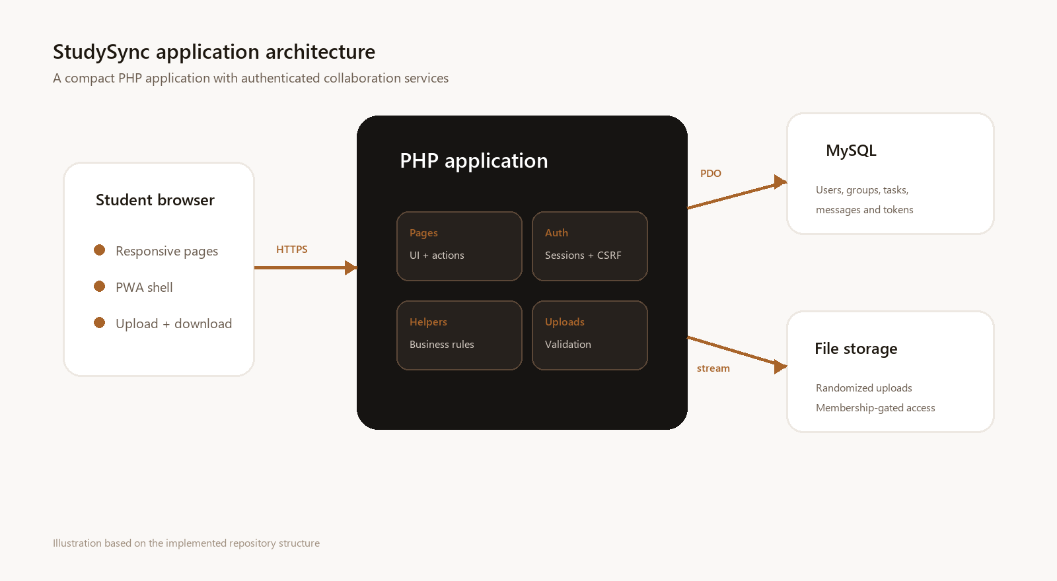
Figure 3. StudySync logical architecture.
The application uses page-level PHP controllers and shared helper modules. Sessions provide authentication state, PDO prepared statements provide database access, and the layout component supplies common navigation and responsive styling.
Layer | Key files | Responsibility
Presentation | public/*.php and layout.php | Page rendering, forms, tabs, modals and responsive navigation
Authentication | config/auth.php and csrf.php | Session lifecycle, route guards, roles and CSRF verification
Business/data | config/db_helpers.php | Group, task, file, chat, profile, invitation, notification and reset operations
Upload service | config/uploads.php | Size/type checks, random filenames, image validation and cleanup
Database | database/init.sql and migration SQL | Relational data, foreign keys, uniqueness and lifecycle constraints
PWA | manifest.json and service-worker.php | Install metadata and offline shell behaviour

5.1 Request path
- A browser requests a PHP route beneath the public document root.
- The route loads shared database, authentication and helper modules.
- Mutating routes validate the session, permissions and a CSRF token.
- Prepared statements read or change MySQL data; uploads also pass through the upload service.
- The page captures content and renders it through the shared layout.

6. Data model and application routes

6.1 Core tables
Table | Purpose | Important relationships
users | Accounts and profile fields | Referenced by memberships, files, tasks, messages, invitations and notifications
study_groups | Group identity, privacy and creator | Owns members, tasks, files, messages, requests and invitations
group_members | Many-to-many group membership | Unique group_id + user_id
group_join_requests | Approval queue for public groups | Unique pending group/user pair
tasks | Assigned work and due dates | Belongs to a group and assigned user
files | Upload metadata and storage path | Belongs to a group and uploader
messages | Group conversation | Optionally references one file; file deletion sets the reference to null
group_invitations | Expiring, recipient-bound invite links | Belongs to group, inviter and optional registered user
notifications | Per-user event inbox | Unread state and optional internal link
password_reset_tokens | One-time password recovery | Hashed token, expiry and used timestamp

6.2 New and updated routes
Route | Audience | Purpose
group.php?tab=chat | Group members | Conversation, + attachment upload, previews and recent files
group.php?tab=members | Members/managers | Profiles, join requests and invitation creation
download.php?id= | Group members | Membership-gated file stream or image preview
profile.php | Signed-in users | View profiles and edit the current user's profile
invite.php?token= | Invite recipient | Validate and accept a group invitation
notifications.php | Signed-in users | Read event history and clear unread state
forgot-password.php | Signed-out users | Request a reset link without account enumeration
reset-password.php | Token holder | Consume a valid token and set a new password

7. Installation, migration and deployment

7.1 Runtime requirements
- PHP 8.2 or newer with PDO MySQL and mbstring.
- MySQL 8 or MariaDB 10.4 or newer.
- A web server configured with public as its document root.
- Write access to public/uploads for the PHP process.

7.2 Environment variables
Variable | Required | Use
MYSQLHOST | Yes | Database host
MYSQLPORT | Yes | Database port
MYSQLDATABASE | Yes | Database name
MYSQLUSER | Yes | Database user
MYSQLPASSWORD | Yes | Database password
APP_URL | Recommended | Canonical base URL for reset links
APP_ENV | Recommended | Set to production to suppress development reset links
MAIL_FROM | Email delivery | Sender address used by PHP mail()

7.3 Fresh database
- Create an empty database and a least-privilege database user.
- Import public/database/init.sql.
- Set the environment variables and verify the public document root.
- Ensure the upload directory is writable, then start the application through the chosen server process.

7.4 Existing database upgrade
- Take and verify a database backup.
- Run public/database/2026_06_29_collaboration_features.sql exactly once.
- Deploy the PHP changes after the migration completes.
- Confirm that messages.file_id and the three new tables are present before opening the site to users.
Ordering matters The updated code queries profile and notification columns during sign-in and layout rendering. Apply the migration before deploying the release to an existing database.

7.5 Railway/Nixpacks
The repository's Nixpacks, Procfile and nginx configuration now serve /app/public. Set Railway's MySQL variables, APP_URL, APP_ENV=production and mail configuration. The upload directory must be backed by a persistent volume or replaced with object storage because an ephemeral application filesystem can discard user files during redeployments.

8. Security and operations

8.1 Implemented controls
Risk | Implemented control
Cross-site request forgery | CSRF tokens on new account, recovery, profile, invite, notification, file and chat attachment actions
Unauthorised file access | Download route verifies current membership before resolving and streaming a stored path
Upload abuse | Allowlisted extensions, byte-size limits, random stored names and image-content validation
Path traversal | Stored paths must resolve inside public/uploads before reading or deletion
Invite misuse | Random 64-character token, seven-day expiry, pending state and recipient identity/email match
Reset token disclosure | Only a SHA-256 token hash is stored; tokens expire in 60 minutes and are single-use
Account enumeration | Forgot-password response is identical whether or not the address exists
Privilege escalation | New registrations always receive the student role; no hard-coded administrator email remains
SQL injection | User-provided values are passed through PDO prepared statements

8.2 Operational responsibilities
- Store database credentials as platform secrets, never in the repository.
- Use HTTPS in production so sessions, reset links and invitations are protected in transit.
- Back up both MySQL data and persistent file storage.
- Configure a dependable transactional-email provider for password recovery.
- Review upload storage growth and establish retention or quota policies.
- Keep PHP, MySQL and third-party CDN dependencies patched.

8.3 Privacy guidance
Profiles are visible to authenticated users who encounter them through group and chat contexts. Avoid placing private contact details in the biography. Administrators should define retention expectations for messages, uploads, notifications and expired tokens.

9. Release acceptance checklist
Run this checklist against a staging database after applying the migration. Record evidence and defects in the final two columns.
Area | Acceptance check | Result | Evidence / notes
Authentication | Register, sign in, sign out and recover a password with a one-time token | Pending
Profile | Update name, academic fields, bio and a valid profile image | Pending
Invite | Create, copy, notify, accept and reject an expired/mismatched invitation | Pending
Chat | Send text-only, file-only, image and combined messages | Pending
Files | Download as a member; confirm a non-member receives no file | Pending
Notifications | Unread badge, single open and mark-all-read work correctly | Pending
Groups | Join request, approval, decline and member removal generate expected state | Pending
Responsive UI | Verify desktop, tablet and phone layouts including the chat file panel | Pending
Persistence | Redeploy without losing database records or uploaded files | Pending
Regression | Dashboard, tasks, calendar, admin and PWA install remain functional | Pending

9.1 Static verification completed
- Every PHP file passed PHP 8.2 syntax lint after the release changes.
- The repository diff passed git's whitespace error check.
- The database model includes foreign keys and indexes for all new collaboration tables.
Scope note Application startup and deployment are intentionally left to the project owner. Complete the staging checklist before treating the release as production-ready.

10. Limitations and recommended roadmap

10.1 Current limitations
- PHP mail() depends on server configuration and is not a complete transactional-email solution by itself.
- Uploaded files are stored on the application filesystem; Railway deployments need persistent storage or object storage.
- Notifications are in-app only; browser push notifications are not implemented.
- Chat uses page refresh rather than WebSockets or live polling.
- Invitation delivery is in-app for existing users and link-based for everyone else.

10.2 Recommended next increments
- Move uploads to S3-compatible object storage and add per-group quotas.
- Integrate a transactional-email provider for invitations and password recovery.
- Add near-real-time chat updates and notification polling.
- Add antivirus scanning, content-type verification and configurable retention for uploads.
- Add automated integration tests for role boundaries, token expiry and authenticated downloads.
- Add an administrator-controlled role-management workflow with an auditable change log.
Definition of done The collaboration release is ready for owner-led staging when the database migration is applied, production secrets are configured, persistent upload storage is selected and every acceptance check in Section 9 has evidence.

