Sprint 1

Why ISNs are random, not 0.
There’s less of a chance of multiple nodes having the same ISN.

What happens if the SYN|ACK is lost.
The server retransmits.

Why `recv()` on a UDP socket returns 0 bytes in some cases but means something different from TCP.
In TCP, a 0 means the connection has been closed. In UDP, it could mean the datagram received was 0 bytes long.

Why the server uses `recvfrom()` instead of `recv()`.
UDP does not maintain a connection like TCP, so it needs to be told where its receiving from and sending to.

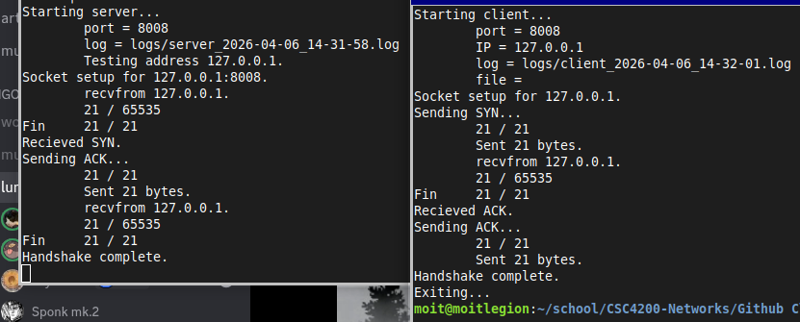Demonstration
Sprint 2 - 1

Why sequence numbers are byte-based.
Because packets may be different lengths, seen below.

What a duplicate ACK means and when the server sends one.
A duplicate ACK tells the client that its sent the packets in the wrong order.

What happens if the client retries more than `MAX_RETRIES` times.
It’s hard-coded not to, but all it would do is waste time on a possible dead connection.

Why you must loop on `recvfrom()` — what if you get an out-of-order packet while waiting for a specific ACK?
We may accidentally get the next packet before the ACK, so we keep listening for the ACK.

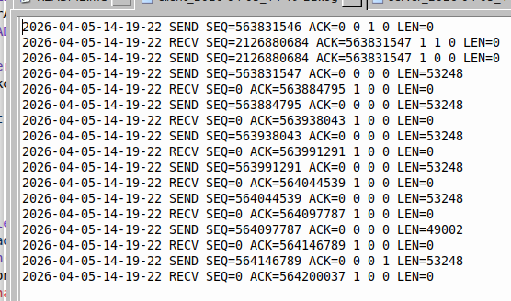Client Log
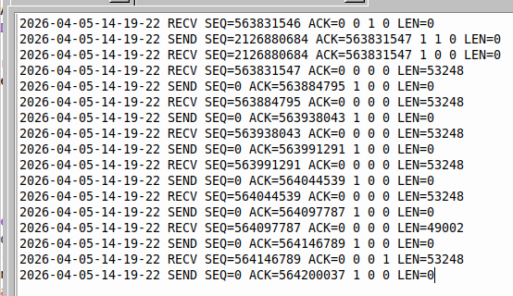Server Log
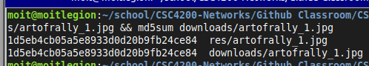Checksum Verification
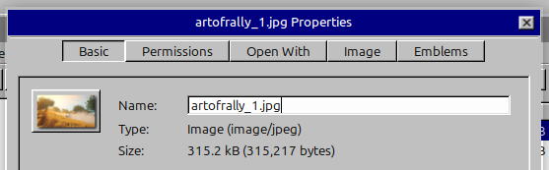File Properties

Sprint 2 – 2
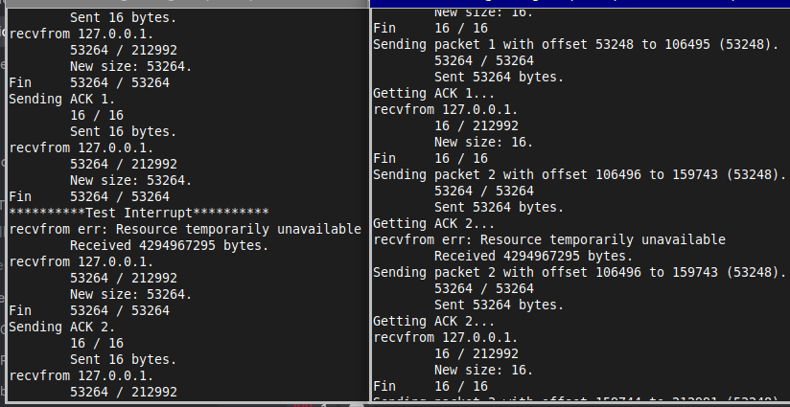Interrupt Test

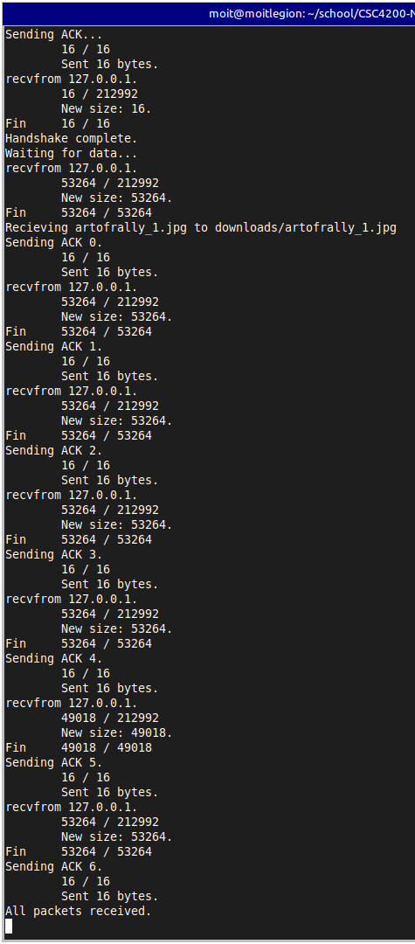Server Console
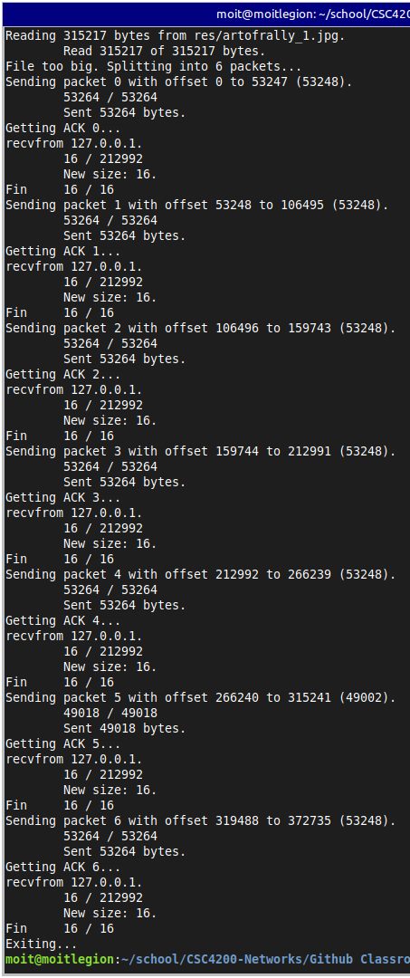Client Console

