Results for all attempts

## Progress Chart for Shoulder Rotation over time

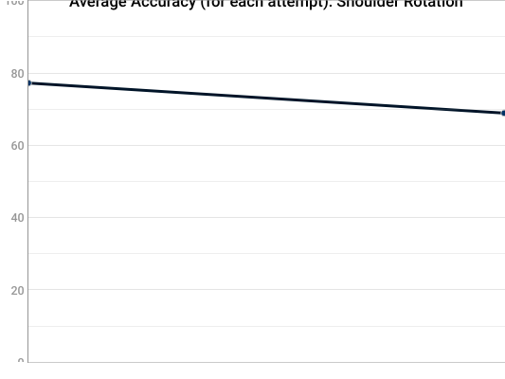

## Exercise Name: Shoulder Rotation

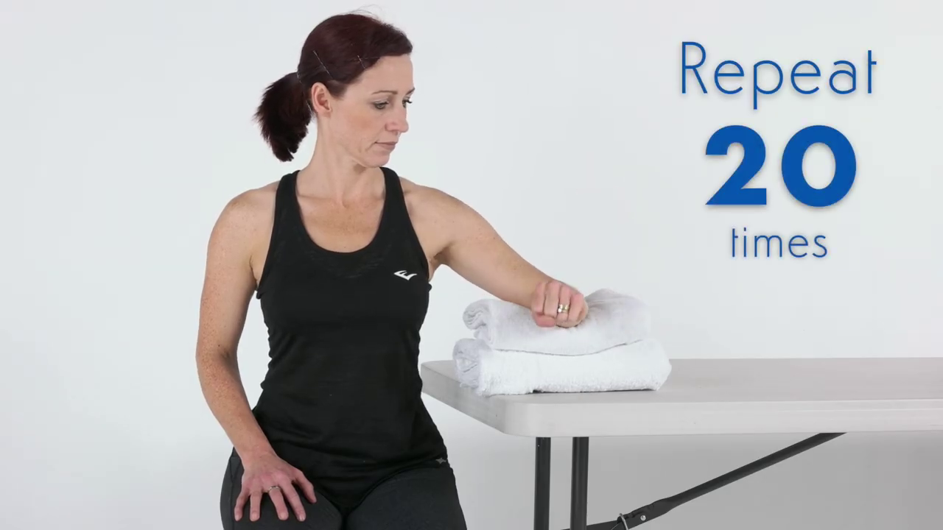

Description: Sit next to a table with your elbow supported just below shoulder height on a rolled up towel.  
Now make a gentle fist, keep your elbow bent and then rotate your forearm to point upwards.  
Return to the start position and relax. Make sure you sit up tall whilst you do this.  
When it is easy for you to do this you can add a light weight – start with half kilo or a small 500ml water bottle.  
As the exercise gets easier you can increase the weight:  
• First to 1 kilo  
• Then to 1 and a half kilos  
• Then to 2 kilos  
Other Tips:  
Be patient! It may be 6 -12 weeks before you see a big change in your pain so you need to stick with it.

## Quantitative

|  |  |
| --- | --- |
| Repetitions | Duration |
| 1 | 30.89 Seconds |

## Qualitative

|  |
| --- |
| Avg. Accuracy |
| 77.24% |

### Accuracy graph for attempt

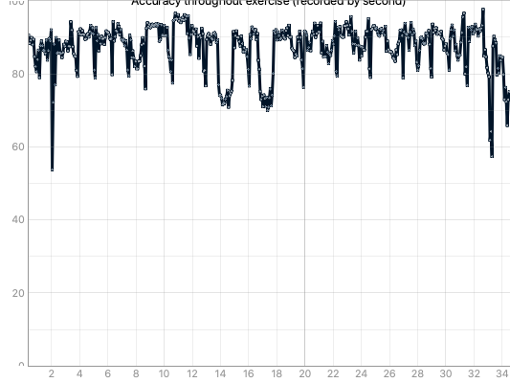

## Exercise Name: Shoulder Rotation



Description: Sit next to a table with your elbow supported just below shoulder height on a rolled up towel.  
Now make a gentle fist, keep your elbow bent and then rotate your forearm to point upwards.  
Return to the start position and relax. Make sure you sit up tall whilst you do this.  
When it is easy for you to do this you can add a light weight – start with half kilo or a small 500ml water bottle.  
As the exercise gets easier you can increase the weight:  
• First to 1 kilo  
• Then to 1 and a half kilos  
• Then to 2 kilos  
Other Tips:  
Be patient! It may be 6 -12 weeks before you see a big change in your pain so you need to stick with it.

## Quantitative

|  |  |
| --- | --- |
| Repetitions | Duration |
| 0 | 1.79 Seconds |

## Qualitative

|  |
| --- |
| Avg. Accuracy |
| 68.92% |

### Accuracy graph for attempt

