Results for all attempts

## Progress Chart for Push-ups against a wall over time

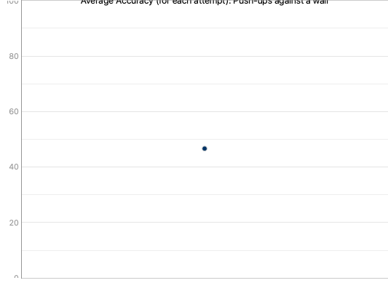

## Progress Chart for Shoulder Rotation over time

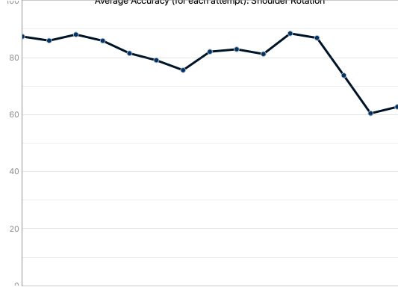

## Exercise Name: Push-ups against a wall



Description: Now put your hands on the wall as if you are going to do a push-up. Make sure your hands are placed a little wider than the width of your shoulders, your hands are turned out slightly and your elbows are below your shoulders.  
Now lower your body towards the wall keeping your body nice and tall.  
• Repeat this 8 times  
• Rest for a minute  
• Repeat 8 times  
• Rest for a minute  
• Repeat 8 times.  
When you can do this exercise easily you can progress and increase load by moving your feet further from the wall.

## Quantitative

|  |  |
| --- | --- |
| Repetitions | Duration |
| 0 | 1.91 Seconds |

## Qualitative

|  |
| --- |
| Avg. Accuracy |
| 51.58% |

### Accuracy graph for attempt

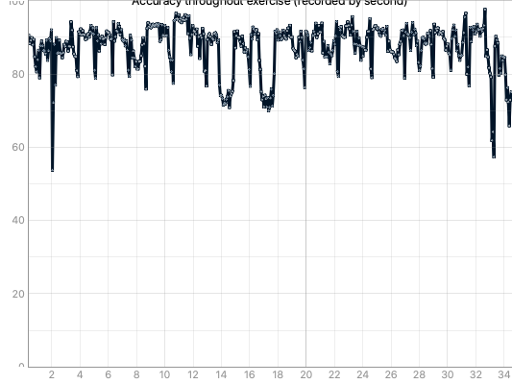

## Exercise Name: Shoulder Rotation

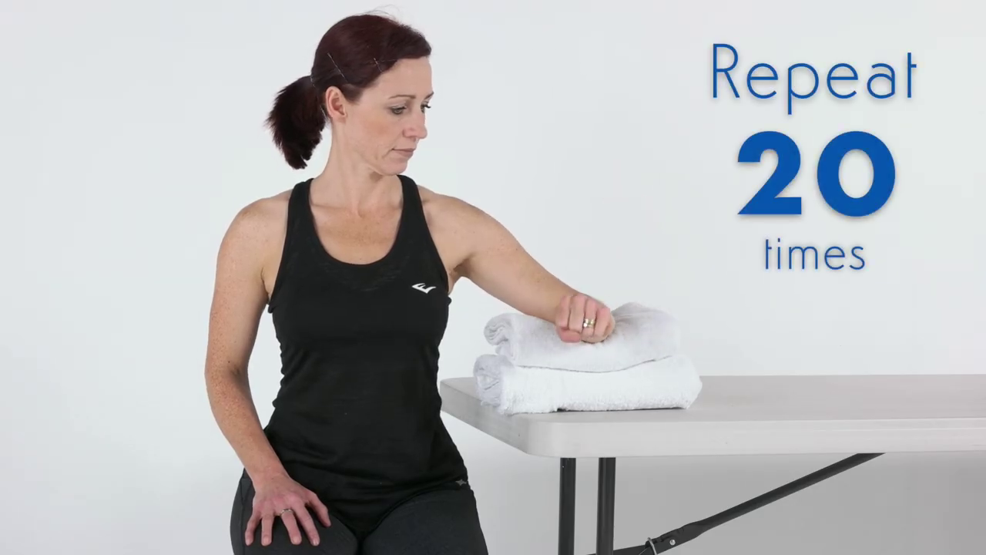

Description: Sit next to a table with your elbow supported just below shoulder height on a rolled up towel.  
Now make a gentle fist, keep your elbow bent and then rotate your forearm to point upwards.  
Return to the start position and relax. Make sure you sit up tall whilst you do this.  
When it is easy for you to do this you can add a light weight – start with half kilo or a small 500ml water bottle.  
As the exercise gets easier you can increase the weight:  
• First to 1 kilo  
• Then to 1 and a half kilos  
• Then to 2 kilos  
Other Tips:  
Be patient! It may be 6 -12 weeks before you see a big change in your pain so you need to stick with it.

## Quantitative

|  |  |
| --- | --- |
| Repetitions | Duration |
| 18 | 85.14 Seconds |

## Qualitative

|  |
| --- |
| Avg. Accuracy |
| 78.53% |

### Accuracy graph for attempt

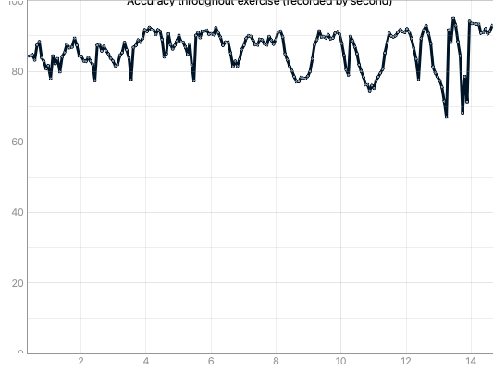

## Exercise Name: Push-ups against a wall



Description: Now put your hands on the wall as if you are going to do a push-up. Make sure your hands are placed a little wider than the width of your shoulders, your hands are turned out slightly and your elbows are below your shoulders.  
Now lower your body towards the wall keeping your body nice and tall.  
• Repeat this 8 times  
• Rest for a minute  
• Repeat 8 times  
• Rest for a minute  
• Repeat 8 times.  
When you can do this exercise easily you can progress and increase load by moving your feet further from the wall.

## Quantitative

|  |  |
| --- | --- |
| Repetitions | Duration |
| 0 | 35.4 Seconds |

## Qualitative

|  |
| --- |
| Avg. Accuracy |
| 41.83% |

### Accuracy graph for attempt

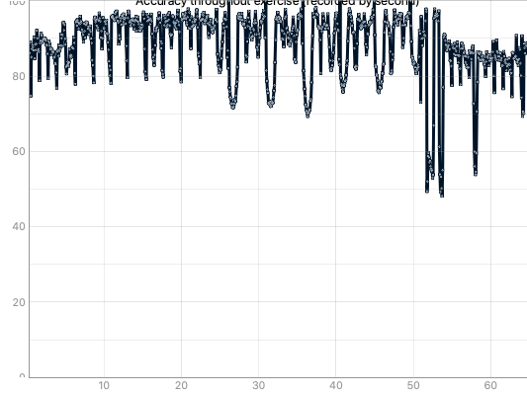

## Exercise Name: Shoulder Rotation



Description: Sit next to a table with your elbow supported just below shoulder height on a rolled up towel.  
Now make a gentle fist, keep your elbow bent and then rotate your forearm to point upwards.  
Return to the start position and relax. Make sure you sit up tall whilst you do this.  
When it is easy for you to do this you can add a light weight – start with half kilo or a small 500ml water bottle.  
As the exercise gets easier you can increase the weight:  
• First to 1 kilo  
• Then to 1 and a half kilos  
• Then to 2 kilos  
Other Tips:  
Be patient! It may be 6 -12 weeks before you see a big change in your pain so you need to stick with it.

## Quantitative

|  |  |
| --- | --- |
| Repetitions | Duration |
| 1 | 27.23 Seconds |

## Qualitative

|  |
| --- |
| Avg. Accuracy |
| 59.12% |

### Accuracy graph for attempt

