vtkESqui

Quick Start Guide

This document describes the use of the vtkESQui environment. It will show how to load an scene, control the surgical scene tools, etc... If an haptic device is not available, the tools will be controlled with mouse and keyboard .

To start using the ESQUI environment just run the “main.tcl” script located at:

vtkESQui/Examples/Simulation/Tcl
$vtk main.tcl

Click on the “File” menu and select the “Open” command.

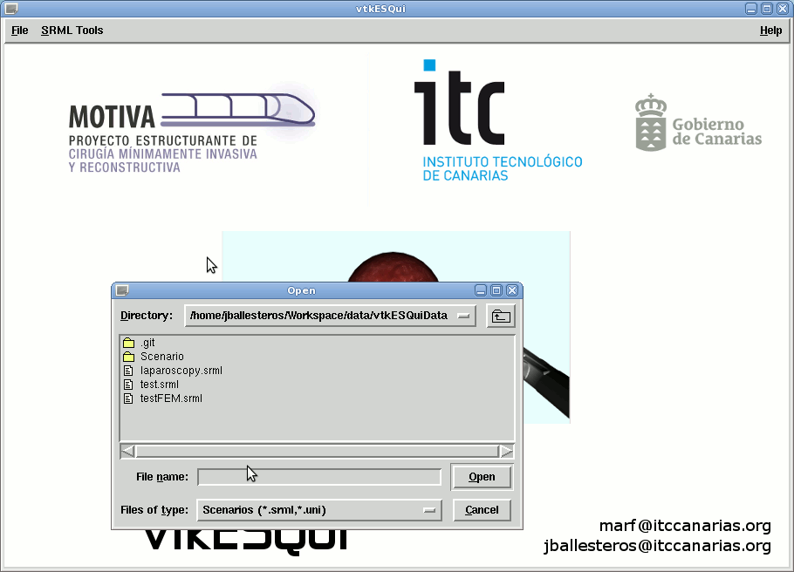
Select the SRML file located in:

vtkESQuiData/laparoscopy.srml
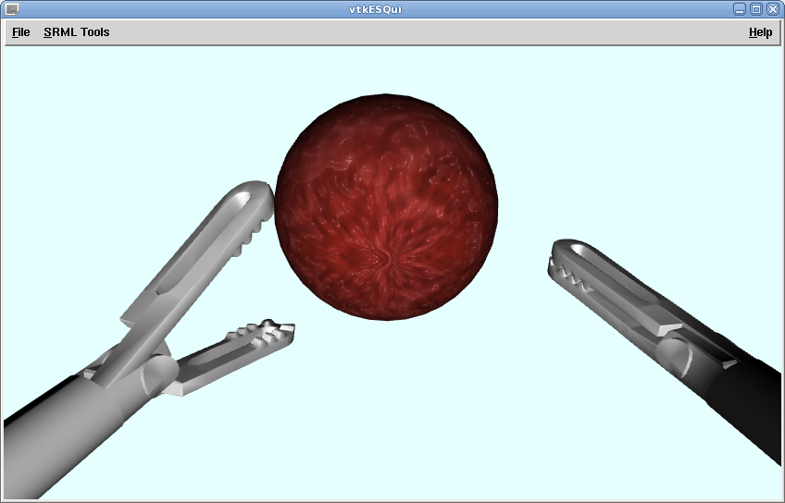
This will open the scene decribed in the srml file and start the simulation.

Controlling the tools with the keyboard and the mouse

The following keyboard layout allows the user to select the tool and move it along the scenario:

- Press “c” key to set/unset the camera control
- The tool will activate whenever the camera is not
- If the camera is unselected and you want to set the left or right tool you have to:
  - Press “d” after “c” to select the right tool.
  - Press “i” after “c” to select the left tool.

In order to toogle between the right and left tool just press “d” to select the rigth tool and “i” to select the left tool.

- Press “z” or “x” keys to rotate the selected tool.
- Press “a” key to open the selected tool.
- Press “s” key to close the selected tool.

- Click and drag right button to control the depth of the selected tool.
- Click and drag left button to change the lateral orientation of the selected tool.

Using Blender with ESQUI

At /vtkESQui/Utilities/vtk2Blender, you can find the Python scripts needed to export mesh, modelled using Blender, to vtkPolyData.

