
Center for Tecnology in Medicine
www.ctm.ulpgc.es
ESQUI Quick Start

This document describes the use of the ESQUI environment to load an scene and the the control of the surgical scene tools from the mouse and keyboard (when an haptic device is not available).

To start using the ESQUI environment just run the “main.tcl” script wich you can find at: /ESQUI/TCL folder.

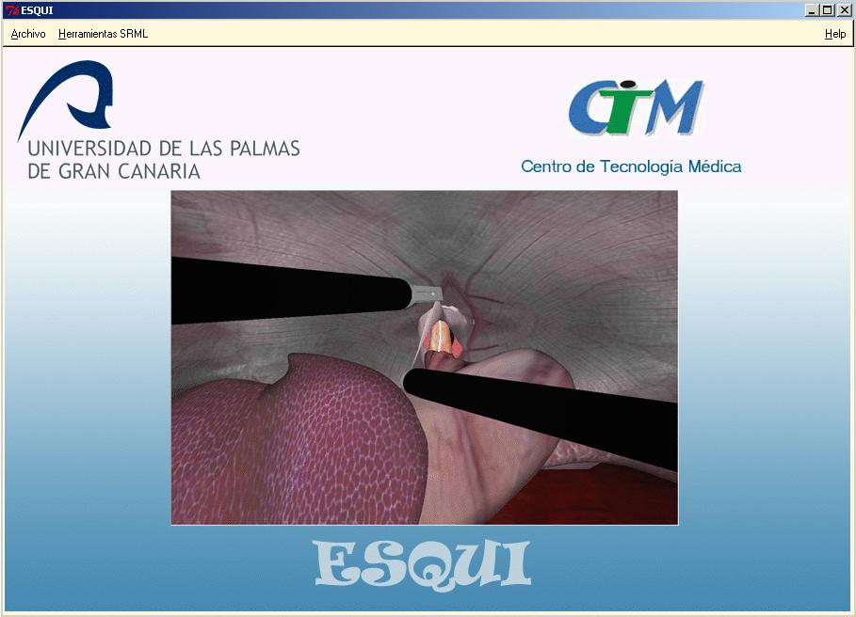
Click on the “File” menu and select the “Open” command.

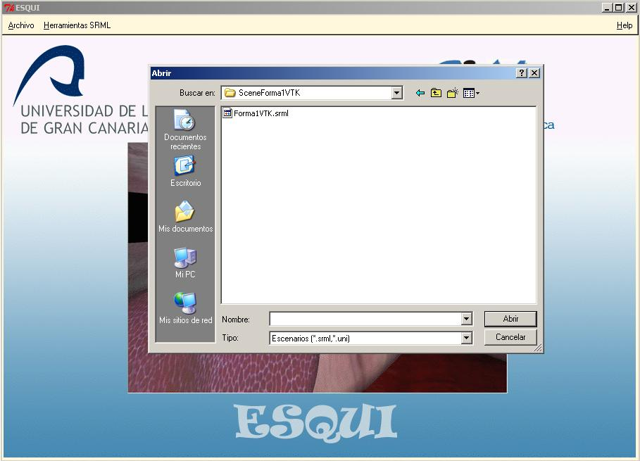

And open the SRML file /ESQUI/TCL/Scenes/SceneFormVTK/FormVTK.srml.

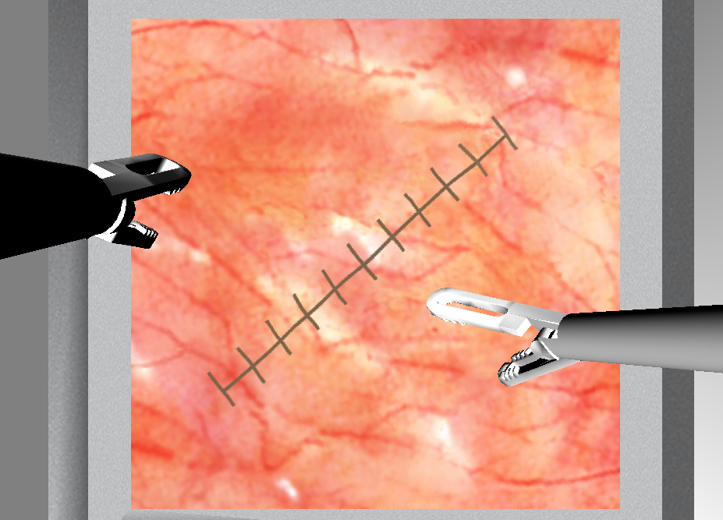

This will open the scene decribed in the srml file and start the simulation exercise.

Controlling the tools with the keyboard and the mouse

Whith the key board you can select the tool to move as follow:

- Press “C” key to set the camera the active tool

- If the camera is selected and you want to set the left or rigth tool you have to:
- Press “D” after “C” to select the rigth tool
- Press “I” after “C” to select the left tool

In order to toogle between the rigth and left tool just press “D” to select the rigth tool and “I” to select the left tool.

- Press “Z” or “X” keys to rotate the selected tool.
- Press “A” key to open the selected tool.
- Press “S” key to close the selected tool.

- Clic rigth button and drag to control the deep position of the selected tool.
- Clic left button and drag to control the lateral orientation of the selected tool.

Using Blender with ESQUI

At /ESQUI/misc, you can find the Python scripts needed to export mesh modelled using Blender to vtk PolyData.

