Submitted to
Miss Anaum hamid
Compiler Construction Project
Operator Precedence Parser

Contents
Group Members 1
Project Report: Operator Precedence Parser 2
1. Problem Description 2
2. Selected Compiler Phase: Syntactic Analysis (Parsing) 2
3. Design and Implementation Overview 2
3.1. CFG Parser / Reader 3
3.2. Precedence Table Builder 3
3.3. Parsing Engine 3
3.4. GUI Layer 3
4. Sample Inputs 3
5. Manual Working/Example 4
6. Results and Screenshots 5
6.1. Parsing Steps and Input/Output 5
6.2. Precedence Table 6
6.3. Grammar Information 7
6.4. Parse Tree Visualization 8
7. Challenges and Observations 8
7.1. Challenges We Faced 8
7.2. What We Learned 8
8. Conclusion 9
9. References 9

Group Members
- Muhammad Isbah (SP22-BSCS-0108)
- Chaahat Fatima (SP22-BSCS-0125)

Project Report: Operator Precedence Parser

1. Problem Description
When we started learning about compiler design, we quickly realized that the parsing phase—where the compiler checks if our code actually makes grammatical sense—is one of the trickiest parts to implement. Specifically, when dealing with math or logic expressions, the compiler needs to know which operations to perform first. For example, in 2 + 3 * 4, it needs to know that multiplication happens before addition.

Our project tackles this exact problem by building an Operator Precedence Parser. This is a specific type of bottom-up parser that looks at the operators in an expression and uses their precedence (which one is more important) and associativity (left-to-right or right-to-left) to figure out the structure of the code.

We wanted to build more than just a script that spits out "Accepted" or "Rejected." Our goal was to create an interactive, visual tool that actually shows how the parsing happens. We set out to build a system where a user can type in a grammar, enter an expression, and watch the parser build the precedence table, trace through the stack step-by-step, and finally draw the parse tree.

2. Selected Compiler Phase: Syntactic Analysis (Parsing)
Our project focuses entirely on the Syntactic Analysis phase of a compiler. In a real compiler, this phase sits right after the lexical analyzer (which chops the raw code into tokens). The parser's job is to take those tokens and see if they fit together according to the rules of the language.

We chose to implement an operator precedence parser, which is a flavor of shift-reduce parsing. We found this approach really interesting because it doesn't need a massive, complicated state machine like an LR parser. Instead, it just looks at the terminals (the operators) and decides what to do based on three simple relationships: does the operator on the stack yield to the incoming one (<·), do they have equal precedence (=·), or does the stack operator take priority (·>)? If it yields, we shift the new token onto the stack. If it takes priority, we reduce what's already on the stack.

3. Design and Implementation Overview
We decided to write the parser in Python and used tkinter to build the graphical interface. We broke the code down into four main modules to keep things organized:

3.1. CFG Parser / Reader
Before we can parse anything, we need to understand the rules. This module takes the Context-Free Grammar (CFG) typed in by the user and turns it into a dictionary that our code can actually use. We wrote functions to check that the rules are formatted correctly (like making sure there's an -> arrow) and to split the right side of the rules into individual symbols.

3.2. Precedence Table Builder
This was probably the most mathematically heavy part of the project. To figure out which operators take priority, we had to write algorithms to compute the LEADING and TRAILING sets for every non-terminal in the grammar. Once we had those sets, we applied Floyd's standard rules to figure out the <·, =·, and ·> relationships between every pair of operators. We also had to add special boundary rules for the $ symbol, which acts as the bottom of our stack and the end of our input.

3.3. Parsing Engine
This is the brain of the operation. We implemented the classic shift-reduce loop. It keeps track of a stack and the remaining input. In every step, it looks at the top terminal on the stack and the next token in the input, checks the precedence table we built in the previous step, and decides whether to shift or reduce. We also added logic to keep track of the nodes so we could build a parse tree along the way.

3.4. GUI Layer
We wanted the tool to be genuinely useful for studying, so we spent a lot of time on the tkinter interface. We designed a dark-themed window with four main tabs:
- Parsing Steps: A table that updates row by row, showing exactly what's on the stack, what's left in the input, and what action the parser just took.
- Precedence Table: A grid showing the relationships between all the operators.
- Grammar Info: A screen that lists the parsed rules and shows the LEADING and TRAILING sets we calculated.
- Parse Tree: A canvas that actually draws the final tree structure if the input is accepted.

4. Sample Inputs
To test our parser, we used a standard arithmetic grammar. This is the classic example we used throughout our development:

Context-Free Grammar (CFG):
E -> E+E | E*E | (E) | id

Sample Input String:
id + id * id - id / id

We like this input because it forces the parser to deal with operators of different precedences (multiplication and division vs. addition and subtraction) to prove that our table builder and shift-reduce logic are working correctly.

5. Manual Working/Example
To show how our logic works, here is a manual trace of a simpler expression: id + id * id. We'll assume the table knows that * has higher precedence than +.

Starting out:
- Stack: $
- Input: id + id * id $

How the parser steps through it:

- The stack has $, input has id. $ always yields (<·), so we Shift.
  - Stack: $ id | Input: + id * id $
- Stack has id, input has +. Identifiers take priority (·>), so we Reduce id to E.
  - Stack: $ E | Input: + id * id $
- Stack top terminal is $, input is +. $ yields (<·), so we Shift.
  - Stack: $ E + | Input: id * id $
- Stack has +, input has id. + yields to identifiers (<·), so we Shift.
  - Stack: $ E + id | Input: * id $
- Stack has id, input has *. Identifiers take priority (·>), so we Reduce id to E.
  - Stack: $ E + E | Input: * id $
- Stack top terminal is +, input is *. Multiplication has higher precedence, so + yields (<·). We Shift.
  - Stack: $ E + E * | Input: id $
- Stack has *, input has id. * yields to identifiers (<·), so we Shift.
  - Stack: $ E + E * id | Input: $
- Stack has id, input is $. We've reached the end, so everything on the stack needs to reduce. id takes priority (·>), so we Reduce id to E.
  - Stack: $ E + E * E | Input: $
- Stack top terminal is *, input is $. * takes priority (·>), so we Reduce E * E to E.
  - Stack: $ E + E | Input: $
- Stack top terminal is +, input is $. + takes priority (·>), so we Reduce E + E to E.
  - Stack: $ E | Input: $
- Stack has $ E, input is $. We are done! Accept.

6. Results and Screenshots
We are really proud of how the visual output turned out. Here are some screenshots of our application running the sample input.

6.1. Parsing Steps and Input/Output
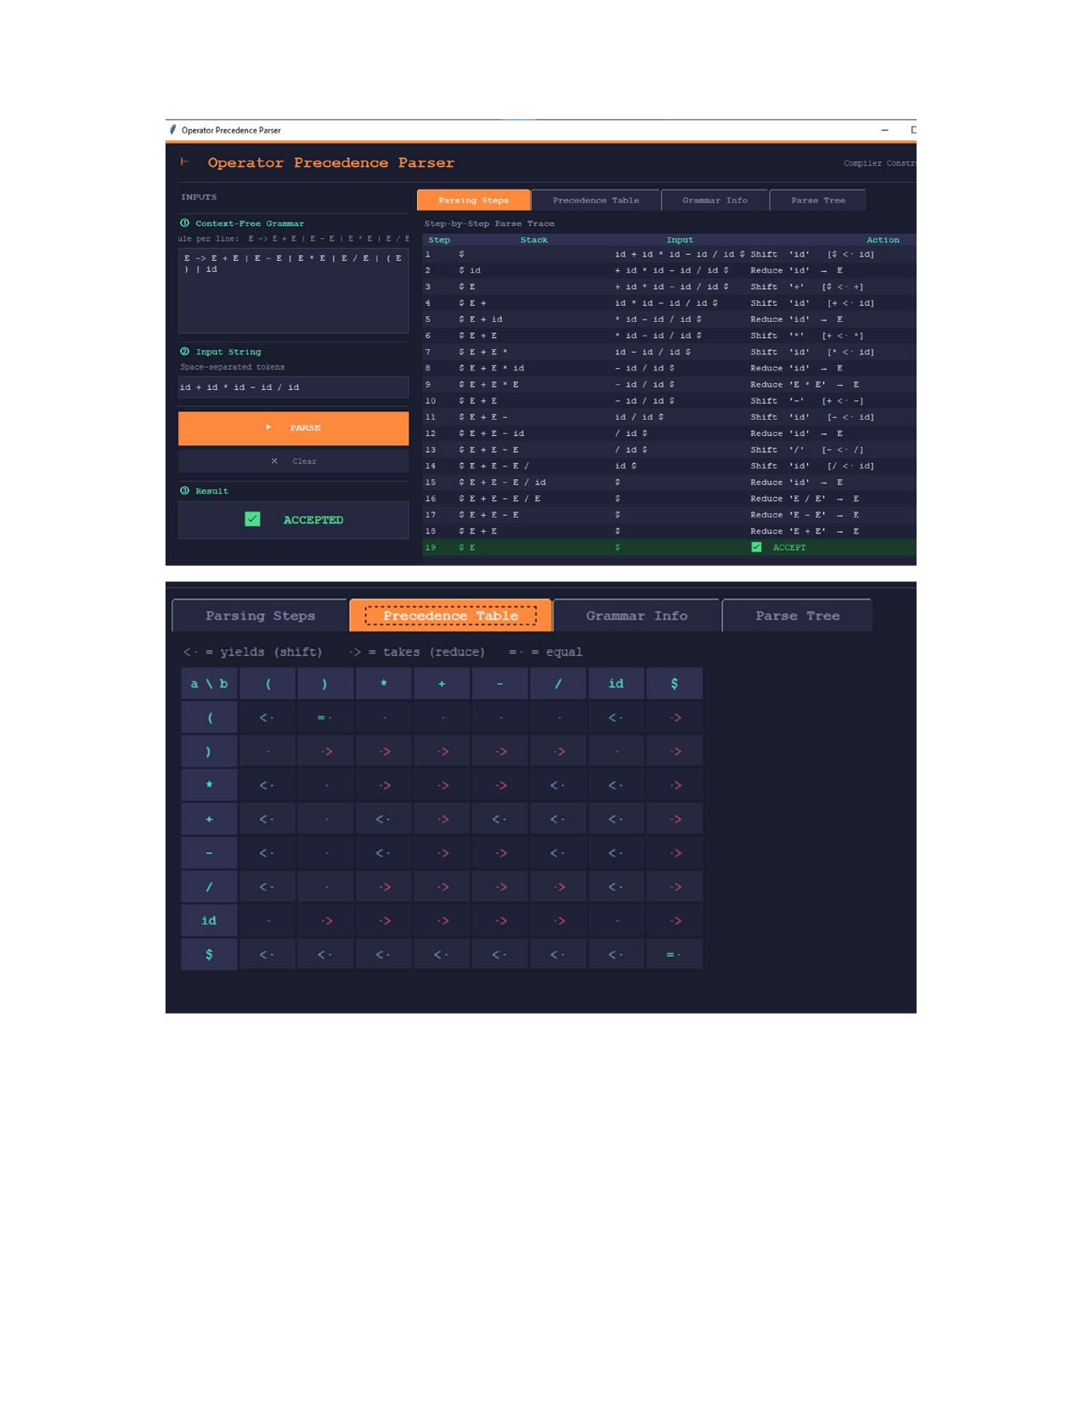

This is our main screen. You can see the grammar we typed in on the left, and the big table on the right shows the exact shift and reduce steps the parser took to process the string.

6.2. Precedence Table


This tab shows the matrix our code generated. It's really satisfying to see the <·, =·, and ·> symbols populated correctly based on the LEADING and TRAILING sets.

6.3. Grammar Information
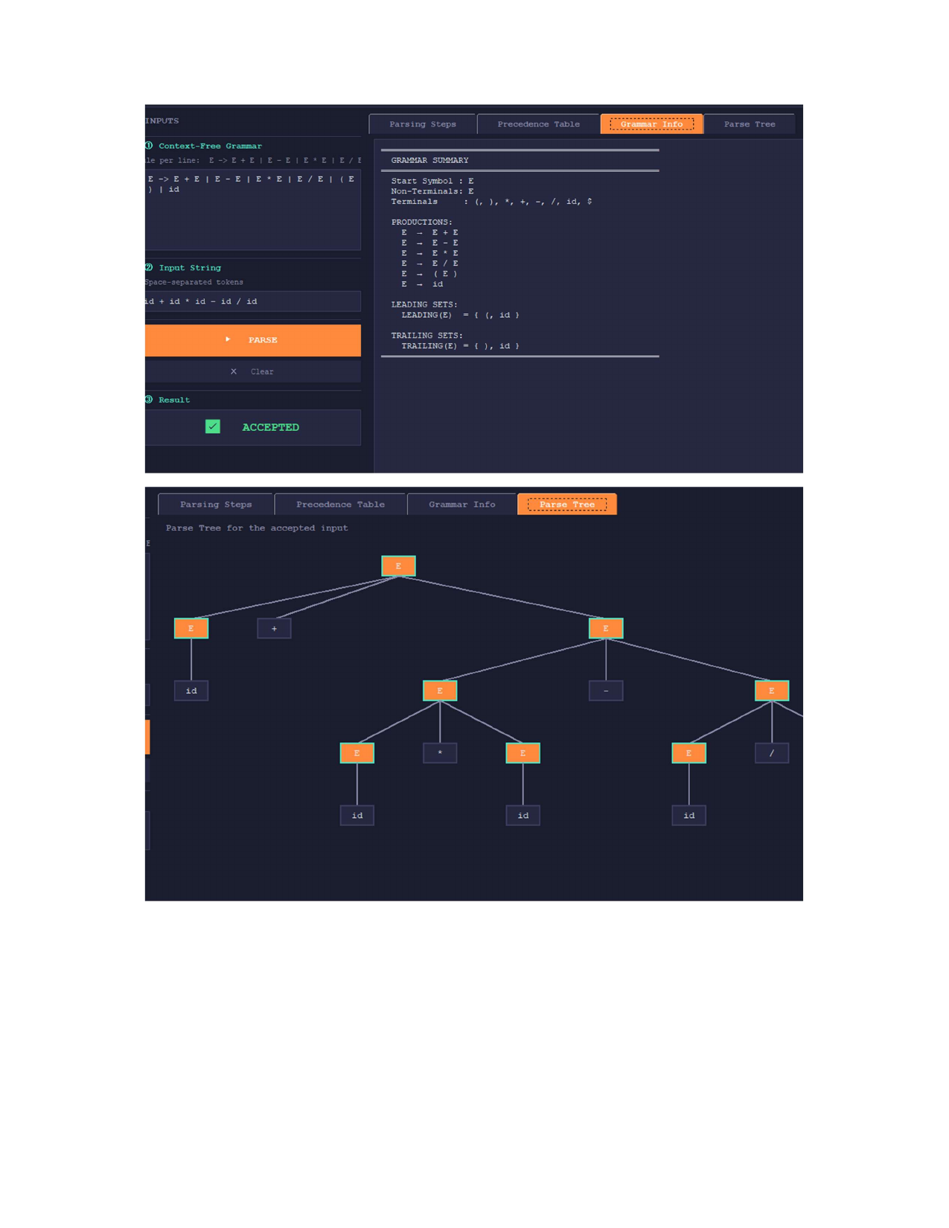

We added this tab to help debug our math. It prints out the exact LEADING and TRAILING sets the program calculated for each non-terminal.

6.4. Parse Tree Visualization


This is our favorite feature. Once the parser accepts the string, it uses the nodes it saved during the shift-reduce process to draw this hierarchical tree.

7. Challenges and Observations

7.1. Challenges We Faced
- Wrapping our heads around the math: Translating the textbook definitions of LEADING and TRAILING sets into actual Python code that loops correctly was a lot harder than we expected. We had a few infinite loops early on!
- GUI Headaches: Getting tkinter to draw the parse tree nicely was a struggle. Calculating the X and Y coordinates so the branches didn't overlap took a lot of trial and error.
- Error Handling: Right now, if you type in a bad expression, the parser just stops and says "Rejected" or "No relation defined." Figuring out how to make it gracefully recover and suggest fixes was a bit beyond the scope of our current timeline.

7.2. What We Learned
- Seeing is believing: Building the step-by-step table made the whole concept of shift-reduce parsing click for us. It's one thing to read about it, but watching the stack grow and shrink in real-time is incredibly helpful.
- The value of modular code: Because we separated the table builder from the parsing engine, it was much easier to test. If the parse failed, we could check the Grammar Info tab to see if the LEADING sets were wrong before tearing apart the shift-reduce loop.

8. Conclusion
Overall, we consider this project a major success. We managed to build a fully functional Operator Precedence Parser from scratch, complete with a graphical interface that visualizes the entire process. It successfully takes a grammar, builds the precedence relations, and accurately parses expressions while drawing the resulting tree. While there is always room for improvement—like adding better error recovery—this project gave us a much deeper, hands-on understanding of how the syntactic analysis phase of a compiler actually works under the hood.

9. References
- [1] Aho, A. V., Lam, M. S., Sethi, R., & Ullman, J. D. (2007). Compilers: Principles, Techniques, & Tools (2nd ed.). Addison-Wesley. (This was our main guide for the Floyd parsing algorithms).
- [2] Python tkinter Documentation. (Used extensively for building the GUI and drawing the canvas).
- [3] Our own operator_precedence_parser.py source code.

