Name: Prathamesh Gadekar
Roll No: 15
Class: SE(IT)

ASC:
#include <stdio.h>
#include <stdlib.h>
#include <pic18f4550.h>
void main(void)
{
int i,j,temp;
int num_asc[] = {10,2,5,1,6};
for(i=0; i<=4; i++) // point to LHS number
{
for(j=i+1;j<=4;j++) // point to RHS number
{
if (num_asc[i] > num_asc[j]) // if LHS > RHS , change the position
{
temp = num_asc[i];
num_asc[i] =num_asc[j];
num_asc[j]= temp;
}
}
}
}
DESC:
#include <stdio.h>
#include <stdlib.h>
#include <pic18f4550.h>
void main(void)
{
int i,j,temp;
int num_asc[] = {10,2,5,1,6};
for(i=0; i<=4; i++) // point to LHS number
{
for(j=i+1;j<=4;j++) // point to RHS number
{
if (num_asc[i] < num_asc[j]) // if LHS > RHS , change the position
{
temp = num_asc[i];
num_asc[i] =num_asc[j];
num_asc[j]= temp;
}
}
}
}
OUTPUT:
ASC:

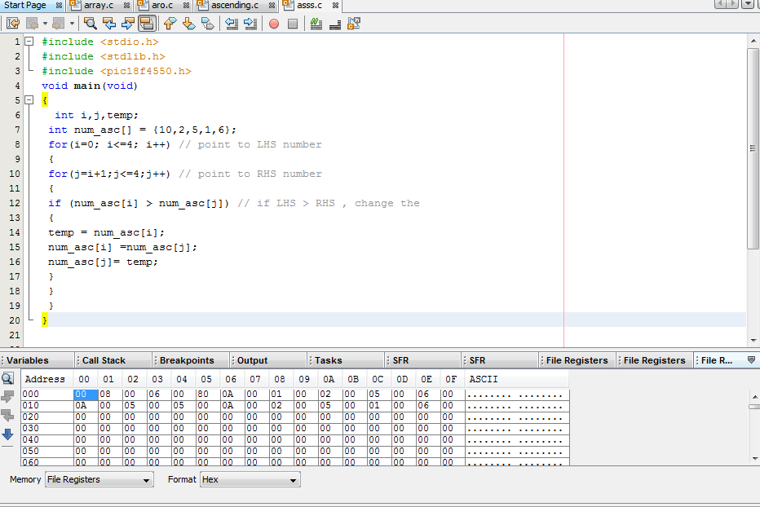

DESC:
