Body Image Trajectories and Parenting
  - Analysis report
Taren Sanders
2026-09-08
Table of contents

1. Methods
- Body dissatisfaction scored as perceived - ideal. I also made a version which is binary (any form of body dissatisfaction, no measure of magnitude) as a sanity check
- Fit latent class growth analysis for 1-5 classes. Tested sex-stratified classes too.
- Used regression to see if the parenting variables predicted which class children were in. Includes a moderation by child sex.
- Main analysis is just the parent 1 varibles because of the significant loss of sample size. The sensitivity analysis includes both parents data.

2. Main results

2.1 Analysis sample
Body dissatisfaction was scored as the Pictorial Body Image (PBI) perceived − ideal figure discrepancy at ages 8, 10, and 12 (B and K cohorts pooled by age). The trajectory analyses use children with scores at two or more ages (N = 7,843); the regressions additionally require complete baseline (age 8) covariates — sex, SES, BMI z-score, and Parent 1 warmth and anger (N = 7,090). Parent 2 parenting is missing for ~38% of the sample (mostly no second-carer questionnaire), so the primary models use Parent 1 only, with a both-parent sensitivity model on the subset with second-carer data (N = 4,780; Section 3.5).
Table 1: Sample flow from the cleaned data to the analysis samples.
Stage | N children | % of total
Children in cleaned data | 8660 | 100.0
>= 1 wave with a PBI score | 8572 | 99.0
>= 2 waves with a PBI score (trajectory sample) | 7843 | 90.6
All 3 waves with a PBI score | 6509 | 75.2
Complete baseline covariates, Parent 1 model (regression sample) | 7090 | 81.9
Complete baseline covariates incl. Parent 2 (sensitivity sample) | 4780 | 55.2

2.2 Descriptive statistics
Descriptive statistics by age group (cohorts pooled).
 | Age 8 | Age 10 | Age 12
n | 8416 | 7933 | 7337
Sex = Female (%) | 4109 (48.8) | 3872 (48.8) | 3583 (48.8)
Age (Years) (mean (SD)) | 8.33 (0.47) | 10.37 (0.48) | 12.44 (0.50)
Socioeconomic Position (mean (SD)) | 0.01 (0.98) | 0.01 (0.98) | 0.01 (0.98)
Body Mass Index (mean (SD)) | 17.60 (2.84) | 18.92 (3.73) | 20.45 (3.85)
BMI z-score (mean (SD)) | 0.38 (0.98) | 0.34 (1.02) | 0.35 (1.01)
Body Image (Current) (%)
Picture 1 | 213 (2.6) | 52 (0.7) | 21 (0.3)
Picture 2 | 679 (8.2) | 331 (4.3) | 251 (3.6)
Picture 3 | 2293 (27.8) | 1799 (23.5) | 1601 (22.8)
Picture 4 | 3870 (46.9) | 3779 (49.3) | 3227 (45.9)
Picture 5 | 1070 (13.0) | 1478 (19.3) | 1623 (23.1)
Picture 6 | 94 (1.1) | 197 (2.6) | 281 (4.0)
Picture 7 | 24 (0.3) | 32 (0.4) | 29 (0.4)
Body Image (Ideal) (%)
Picture 1 | 555 (6.7) | 117 (1.5) | 44 (0.6)
Picture 2 | 1223 (14.8) | 557 (7.3) | 385 (5.5)
Picture 3 | 3008 (36.5) | 2674 (34.9) | 2286 (32.5)
Picture 4 | 3064 (37.2) | 3965 (51.7) | 3862 (54.9)
Picture 5 | 359 (4.4) | 336 (4.4) | 427 (6.1)
Picture 6 | 16 (0.2) | 16 (0.2) | 19 (0.3)
Picture 7 | 11 (0.1) | 7 (0.1) | 8 (0.1)
Body Dissatisfaction (Perceived - Ideal) (mean (SD)) | 0.45 (1.04) | 0.40 (0.85) | 0.40 (0.82)
Body Dissatisfaction (%)
Thinner than ideal | 889 (10.8) | 552 (7.2) | 480 (6.8)
Ideal | 3882 (47.2) | 4242 (55.4) | 3932 (55.9)
Larger than ideal | 3462 (42.1) | 2868 (37.4) | 2617 (37.2)
Body Dissatisfaction (Any Direction) = Dissatisfied (%) | 4351 (52.8) | 3420 (44.6) | 3097 (44.1)
Parental Warmth (Parent 1) (mean (SD)) | 4.38 (0.54) | 4.31 (0.58) | 4.18 (0.63)
Parental Anger (Parent 1) (mean (SD)) | 2.16 (0.61) | 2.14 (0.64) | 2.13 (0.67)
Parental Warmth (Parent 2) (mean (SD)) | 4.04 (0.63) | 3.95 (0.65) | 3.80 (0.70)
Parental Anger (Parent 2) (mean (SD)) | 2.17 (0.61) | 2.13 (0.62) | 2.11 (0.65)
Parental Warmth (Mother) (mean (SD)) | 4.38 (0.54) | 4.31 (0.58) | 4.19 (0.62)
Parental Anger (Mother) (mean (SD)) | 2.16 (0.61) | 2.14 (0.64) | 2.13 (0.67)
Parental Warmth (Father) (mean (SD)) | 4.04 (0.63) | 3.96 (0.65) | 3.81 (0.70)
Parental Anger (Father) (mean (SD)) | 2.16 (0.61) | 2.13 (0.62) | 2.11 (0.65)

 Interpretation
- Just under half of children pick an ideal figure different from their current figure at every age, most often a thinner one.
- Cohorts look near-identical at matched ages (Section 3.1), supporting pooling; sex-specific patterns are also shown there.

2.3 Trajectory classes
Latent class growth analysis (LCGA — a model that sorts children into a small number of groups, each sharing an average trajectory) was fit with lcmm::hlme() for 1–5 classes, each from 50 random starts. LCGA (no within-class random effects) was used rather than a latent growth mixture model because three timepoints with linear class trajectories cannot reliably identify within-class random slopes or growth-mixture variance components. Full enumeration statistics (including the number of final iterations each model took to converge) are in Section 3.3; the three-class model was chosen on entropy (a 0–1 index of how cleanly children are classified into classes; higher is better, ≥0.8 is the rule of thumb for good allocation), class sizes, and interpretability. Entropy peaked at K = 3 (0.85), and a sex-stratified check (Section 3.4) showed the same three classes in boys and girls so I left them as pooled (the moderation analysis still tests for sex differences).
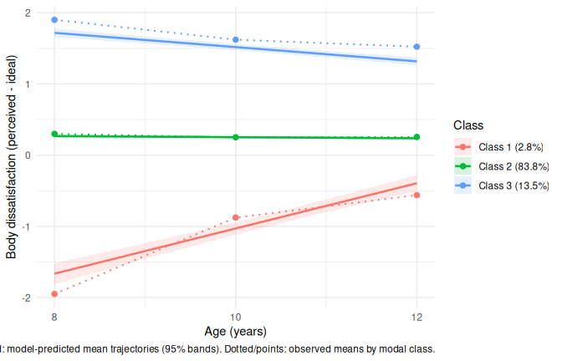
Final three-class model: predicted trajectories (95% bands) and observed means by modal class.
Class sizes and classification quality (posterior probability = the model’s estimated probability that a child belongs to their assigned class).
Class | N | % | Mean posterior prob. | Min posterior prob.
1 | 218 | 2.8 | 0.81 | 0.54
2 | 6570 | 83.8 | 0.94 | 0.53
3 | 1055 | 13.5 | 0.90 | 0.54

 Interpretation
- Class 1 — “thinner than ideal, converging” (2.8%): starts ~−1.7 at age 8, closing to ~−0.4 by 12. Class 2 — “satisfied” (83.8%): flat, near zero. Class 3 — “larger than ideal, declining” (13.5%): starts ~1.7, easing to ~1.3 — persistent dissatisfaction.
- Even though Class 3 is declining, they still finish (on average) more than one full image different than their ideal. So while they are improving, it’s worth noting that it’s probably best classified as consistently dissatisfied.
- Mean posterior probabilities (the probability that a child belongs to each trajectory class, given their observed scores) are all above the 0.70 rule of thumb; class names are working labels.

2.4 Who is in each class?
Baseline (age 8) characteristics by modal trajectory class. Children without an age-8 record are not shown.
 | Class 1 | Class 2 | Class 3
n | 212 | 6400 | 1029
Sex = Female (%) | 73 (34.4) | 3131 (48.9) | 535 (52.0)
Socioeconomic Position (mean (SD)) | 0.04 (1.02) | 0.10 (0.97) | -0.30 (0.91)
Body Mass Index (mean (SD)) | 15.33 (2.06) | 17.14 (2.29) | 20.63 (3.56)
BMI z-score (mean (SD)) | -0.68 (1.01) | 0.26 (0.90) | 1.29 (0.81)
Body Dissatisfaction (Perceived - Ideal) (mean (SD)) | -1.95 (0.95) | 0.30 (0.71) | 1.90 (1.00)
Body Dissatisfaction (%)
Thinner than ideal | 207 (97.6) | 598 (9.3) | 4 (0.4)
Ideal | 5 (2.4) | 3569 (55.8) | 46 (4.5)
Larger than ideal | 0 (0.0) | 2233 (34.9) | 979 (95.1)
Parental Warmth (Parent 1) (mean (SD)) | 4.33 (0.56) | 4.38 (0.54) | 4.37 (0.56)
Parental Warmth (Parent 2) (mean (SD)) | 3.89 (0.62) | 4.05 (0.62) | 3.98 (0.67)
Parental Anger (Parent 1) (mean (SD)) | 2.25 (0.63) | 2.14 (0.60) | 2.23 (0.62)
Parental Anger (Parent 2) (mean (SD)) | 2.31 (0.63) | 2.16 (0.61) | 2.20 (0.60)

 Interpretation
- Strong face validity, differing most sharply on BMI z-score: −0.68 (thinner than ideal) vs +0.26 (satisfied) vs +1.29 (larger than ideal). In other words, those in Class 3 have much higher BMIs than those in Class 1.
- Class 3 is lower-SES and slightly majority-female; Class 1 is two-thirds male.

2.5 Parenting and trajectory class membership
I used the standard approach for the regressions. Class membership was regressed on baseline parenting and covariates using a three-step approach (the trajectory model is fit first, then class membership is predicted in a separate regression): each child contributes one row per class, weighted by their posterior membership probabilities, which carries classification uncertainty into the regression. Models used the satisfied class as reference; confidence intervals come from a cluster bootstrap (refitting the model in 500 resamples drawn child-by-child). N = 7,090.
Table 2: Primary model: relative risk ratios (RRR — the multiplicative change in the relative chance of being in a class vs the satisfied class, per SD of the predictor) with 95% bootstrap CIs.
Term | Class 1 vs 2 | Class 3 vs 2
Warmth P1 (per SD) | 1.01 (0.90, 1.14); p=0.908 | 1.00 (0.94, 1.06); p=0.910
Anger P1 (per SD) | 1.13 (0.99, 1.27); p=0.050 | 1.16 (1.09, 1.23); p=<0.001
Sex: female | 0.58 (0.46, 0.74); p=<0.001 | 1.39 (1.23, 1.56); p=<0.001
SES (per SD) | 0.85 (0.75, 0.97); p=0.011 | 0.77 (0.73, 0.82); p=<0.001
BMI z-score (per SD) | 0.39 (0.35, 0.43); p=<0.001 | 3.91 (3.61, 4.23); p=<0.001

 Interpretation
- Warmth: no association with class membership (RRRs ≈ 1.00) — H2 not supported.
- Anger predicts both dissatisfied classes: per SD, RRR 1.16 (1.09–1.23) for larger-than-ideal and 1.13 (1.00–1.27) for thinner-than-ideal. Modest effects, in either direction of dissatisfaction.
- Covariates are much stronger — BMI z dominates (RRR 3.91 / 0.39 per SD).
- Sensitivity models (modal assignment; both parents) all agree (Section 3.5), so can be reasonably sure about the results.

2.6 Sex moderation
Joint tests of the sex × parenting interaction block (4 parameters).
test | statistic | df | p
Likelihood ratio (approximate, weighted) | 1.616 | 4 | 0.806
Joint Wald (cluster-bootstrap covariance) | 2.273 | 4 | 0.686

 Interpretation
- No sex moderation (H3): LR p = .81, bootstrap Wald p = .69; all interaction RRRs near 1. Full model and plot in Section 3.7.
- In other words - the there doesn’t seem to be a lot of difference for boys and girls in terms of the effect that parenting has.

2.7 Secondary analysis: growth models
Because three timepoints separate classes mainly on level (the slopes are pretty small), multilevel linear growth models (regressions allowing each child their own starting level and rate of change) complement the class analysis by estimating associations of baseline parenting with the level (age 8) and change (per year) of dissatisfaction. Same sample as the primary regressions, for both the signed score and its absolute value. We can report this as a supplementary analysis - it shows if our results are robust to the methods we chose.
Table 3: Growth model of absolute body dissatisfaction |perceived − ideal|.
Term | Estimate (95% CI) | p
Intercept | 0.217 (0.192, 0.241) | <0.001
Warmth P1 | 0.004 (-0.018, 0.026) | 0.726
Anger P1 | 0.035 (0.013, 0.057) | 0.002
Time (per year) | -0.013 (-0.019, -0.006) | <0.001
Female | 0.142 (0.116, 0.168) | <0.001
SES | -0.043 (-0.056, -0.029) | <0.001
BMI z-score | 0.416 (0.403, 0.429) | <0.001
Warmth P1 x Time (per year) | -0.001 (-0.008, 0.006) | 0.783
Anger P1 x Time (per year) | -0.005 (-0.012, 0.002) | 0.147
Term | Estimate (95% CI) | p
Intercept | 0.601 (0.579, 0.623) | <0.001
Warmth P1 | 0.001 (-0.019, 0.020) | 0.953
Anger P1 | 0.055 (0.035, 0.075) | <0.001
Time (per year) | -0.043 (-0.049, -0.037) | <0.001
Female | 0.035 (0.010, 0.060) | 0.006
SES | -0.075 (-0.088, -0.063) | <0.001
BMI z-score | 0.226 (0.214, 0.239) | <0.001
Warmth P1 x Time (per year) | -0.004 (-0.010, 0.003) | 0.241
Anger P1 x Time (per year) | -0.010 (-0.016, -0.003) | 0.003

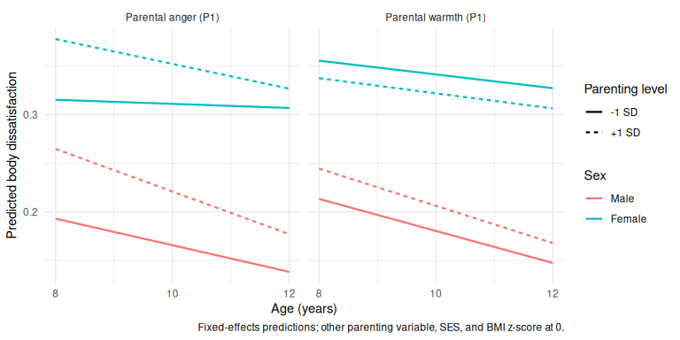
Predicted trajectories at ±1 SD of baseline parenting, by sex (other covariates at 0).
 Interpretation
- Agrees with the class analysis: anger, not warmth, and on level, not slope.
- +0.035 (signed) and +0.055 (absolute) units per SD of anger at age 8; the only slope term is a slight narrowing of the anger gap in the absolute model (−0.010/yr).
- Effects are small (BMI z: +0.42 per SD, for comparison)
- No sex moderation (LR χ² = 4.93, p = 0.42).

3. Supplementary material

3.1 Additional descriptive statistics
Table 4: Descriptive statistics by cohort within age group.
 | B:Age 8 | K:Age 8 | B:Age 10 | K:Age 10 | B:Age 12 | K:Age 12
n | 4085 | 4331 | 3764 | 4169 | 3381 | 3956
Sex = Female (%) | 1989 (48.7) | 2120 (48.9) | 1835 (48.8) | 2037 (48.9) | 1647 (48.7) | 1936 (48.9)
Age (Years) (mean (SD)) | 8.39 (0.49) | 8.26 (0.44) | 10.42 (0.49) | 10.32 (0.47) | 12.48 (0.51) | 12.41 (0.49)
Socioeconomic Position (mean (SD)) | 0.01 (0.98) | 0.01 (0.98) | 0.01 (0.98) | 0.01 (0.97) | 0.01 (0.98) | 0.01 (0.98)
Body Mass Index (mean (SD)) | 17.62 (2.84) | 17.58 (2.84) | 18.85 (3.55) | 18.98 (3.87) | 20.40 (3.80) | 20.49 (3.88)
BMI z-score (mean (SD)) | 0.39 (0.96) | 0.38 (1.00) | 0.31 (1.01) | 0.36 (1.03) | 0.34 (1.00) | 0.36 (1.02)
Body Image (Current) (%)
Picture 1 | 96 (2.4) | 117 (2.8) | 23 (0.6) | 29 (0.7) | 13 (0.4) | 8 (0.2)
Picture 2 | 337 (8.4) | 342 (8.1) | 152 (4.2) | 179 (4.4) | 100 (3.1) | 151 (3.9)
Picture 3 | 1182 (29.6) | 1111 (26.2) | 800 (22.3) | 999 (24.5) | 669 (21.0) | 932 (24.3)
Picture 4 | 1836 (45.9) | 2034 (47.9) | 1811 (50.5) | 1968 (48.2) | 1476 (46.2) | 1751 (45.6)
Picture 5 | 493 (12.3) | 577 (13.6) | 694 (19.4) | 784 (19.2) | 779 (24.4) | 844 (22.0)
Picture 6 | 43 (1.1) | 51 (1.2) | 88 (2.5) | 109 (2.7) | 136 (4.3) | 145 (3.8)
Picture 7 | 10 (0.3) | 14 (0.3) | 15 (0.4) | 17 (0.4) | 19 (0.6) | 10 (0.3)
Body Image (Ideal) (%)
Picture 1 | 260 (6.5) | 295 (7.0) | 50 (1.4) | 67 (1.6) | 22 (0.7) | 22 (0.6)
Picture 2 | 654 (16.4) | 569 (13.4) | 249 (6.9) | 308 (7.5) | 149 (4.7) | 236 (6.1)
Picture 3 | 1538 (38.5) | 1470 (34.7) | 1214 (33.9) | 1460 (35.7) | 971 (30.4) | 1315 (34.2)
Picture 4 | 1386 (34.7) | 1678 (39.6) | 1886 (52.6) | 2079 (50.8) | 1803 (56.5) | 2059 (53.6)
Picture 5 | 143 (3.6) | 216 (5.1) | 171 (4.8) | 165 (4.0) | 231 (7.2) | 196 (5.1)
Picture 6 | 6 (0.2) | 10 (0.2) | 9 (0.3) | 7 (0.2) | 8 (0.3) | 11 (0.3)
Picture 7 | 7 (0.2) | 4 (0.1) | 4 (0.1) | 3 (0.1) | 7 (0.2) | 1 (0.0)
Body Dissatisfaction (Perceived - Ideal) (mean (SD)) | 0.48 (1.01) | 0.43 (1.06) | 0.39 (0.82) | 0.42 (0.88) | 0.40 (0.80) | 0.40 (0.83)
Body Dissatisfaction (%)
Thinner than ideal | 342 (8.6) | 547 (12.9) | 243 (6.8) | 309 (7.6) | 205 (6.4) | 275 (7.2)
Ideal | 1977 (49.5) | 1905 (44.9) | 2016 (56.3) | 2226 (54.5) | 1779 (55.8) | 2153 (56.1)
Larger than ideal | 1674 (41.9) | 1788 (42.2) | 1319 (36.9) | 1549 (37.9) | 1205 (37.8) | 1412 (36.8)
Body Dissatisfaction (Any Direction) = Dissatisfied (%) | 2016 (50.5) | 2335 (55.1) | 1562 (43.7) | 1858 (45.5) | 1410 (44.2) | 1687 (43.9)
Parental Warmth (Parent 1) (mean (SD)) | 4.43 (0.54) | 4.32 (0.54) | 4.35 (0.57) | 4.27 (0.59) | 4.21 (0.61) | 4.16 (0.64)
Parental Anger (Parent 1) (mean (SD)) | 2.17 (0.61) | 2.14 (0.61) | 2.14 (0.64) | 2.15 (0.64) | 2.12 (0.67) | 2.15 (0.66)
Parental Warmth (Parent 2) (mean (SD)) | 4.05 (0.62) | 4.03 (0.64) | 3.98 (0.65) | 3.93 (0.65) | 3.82 (0.69) | 3.78 (0.70)
Parental Anger (Parent 2) (mean (SD)) | 2.16 (0.61) | 2.17 (0.62) | 2.08 (0.61) | 2.18 (0.62) | 2.08 (0.64) | 2.14 (0.65)
Parental Warmth (Mother) (mean (SD)) | 4.44 (0.54) | 4.33 (0.54) | 4.36 (0.57) | 4.28 (0.59) | 4.22 (0.61) | 4.16 (0.64)
Parental Anger (Mother) (mean (SD)) | 2.17 (0.61) | 2.15 (0.61) | 2.14 (0.64) | 2.15 (0.64) | 2.12 (0.67) | 2.15 (0.67)
Parental Warmth (Father) (mean (SD)) | 4.05 (0.62) | 4.03 (0.64) | 3.98 (0.65) | 3.93 (0.65) | 3.82 (0.69) | 3.79 (0.70)
Parental Anger (Father) (mean (SD)) | 2.16 (0.61) | 2.16 (0.61) | 2.08 (0.61) | 2.17 (0.62) | 2.08 (0.64) | 2.14 (0.65)

Table 5: Descriptive statistics by sex within age group (cohorts pooled).
 | Male:Age 8 | Female:Age 8 | Male:Age 10 | Female:Age 10 | Male:Age 12 | Female:Age 12
n | 4307 | 4109 | 4061 | 3872 | 3754 | 3583
Age (Years) (mean (SD)) | 8.32 (0.47) | 8.33 (0.47) | 10.37 (0.48) | 10.37 (0.48) | 12.44 (0.50) | 12.45 (0.50)
Socioeconomic Position (mean (SD)) | 0.00 (0.96) | 0.01 (0.99) | 0.00 (0.98) | 0.02 (0.98) | 0.00 (0.97) | 0.01 (1.00)
Body Mass Index (mean (SD)) | 17.59 (2.86) | 17.62 (2.81) | 18.90 (3.57) | 18.94 (3.89) | 20.19 (3.88) | 20.72 (3.79)
BMI z-score (mean (SD)) | 0.41 (0.99) | 0.36 (0.96) | 0.39 (1.03) | 0.29 (1.01) | 0.31 (1.06) | 0.39 (0.95)
Body Image (Current) (%)
Picture 1 | 137 (3.3) | 76 (1.9) | 31 (0.8) | 21 (0.6) | 12 (0.3) | 9 (0.3)
Picture 2 | 340 (8.1) | 339 (8.4) | 154 (3.9) | 177 (4.7) | 133 (3.7) | 118 (3.4)
Picture 3 | 1375 (32.6) | 918 (22.8) | 1059 (27.1) | 740 (19.7) | 955 (26.6) | 646 (18.8)
Picture 4 | 1843 (43.7) | 2027 (50.3) | 1807 (46.2) | 1972 (52.5) | 1552 (43.3) | 1675 (48.6)
Picture 5 | 462 (11.0) | 608 (15.1) | 736 (18.8) | 742 (19.8) | 765 (21.3) | 858 (24.9)
Picture 6 | 48 (1.1) | 46 (1.1) | 109 (2.8) | 88 (2.3) | 154 (4.3) | 127 (3.7)
Picture 7 | 8 (0.2) | 16 (0.4) | 18 (0.5) | 14 (0.4) | 17 (0.5) | 12 (0.3)
Body Image (Ideal) (%)
Picture 1 | 300 (7.1) | 255 (6.3) | 67 (1.7) | 50 (1.3) | 18 (0.5) | 26 (0.8)
Picture 2 | 611 (14.5) | 612 (15.2) | 266 (6.8) | 291 (7.8) | 185 (5.2) | 200 (5.8)
Picture 3 | 1646 (39.1) | 1362 (33.8) | 1469 (37.5) | 1205 (32.1) | 1182 (33.0) | 1104 (32.0)
Picture 4 | 1422 (33.8) | 1642 (40.8) | 1889 (48.2) | 2076 (55.3) | 1878 (52.4) | 1984 (57.6)
Picture 5 | 209 (5.0) | 150 (3.7) | 211 (5.4) | 125 (3.3) | 302 (8.4) | 125 (3.6)
Picture 6 | 11 (0.3) | 5 (0.1) | 11 (0.3) | 5 (0.1) | 13 (0.4) | 6 (0.2)
Picture 7 | 9 (0.2) | 2 (0.0) | 5 (0.1) | 2 (0.1) | 7 (0.2) | 1 (0.0)
Body Dissatisfaction (Perceived - Ideal) (mean (SD)) | 0.39 (1.06) | 0.52 (1.01) | 0.38 (0.89) | 0.43 (0.80) | 0.31 (0.82) | 0.49 (0.81)
Body Dissatisfaction (%)
Thinner than ideal | 555 (13.2) | 334 (8.3) | 330 (8.4) | 222 (5.9) | 321 (9.0) | 159 (4.6)
Ideal | 1958 (46.5) | 1924 (47.8) | 2172 (55.5) | 2070 (55.2) | 2112 (58.9) | 1820 (52.8)
Larger than ideal | 1694 (40.3) | 1768 (43.9) | 1408 (36.0) | 1460 (38.9) | 1151 (32.1) | 1466 (42.6)
Body Dissatisfaction (Any Direction) = Dissatisfied (%) | 2249 (53.5) | 2102 (52.2) | 1738 (44.5) | 1682 (44.8) | 1472 (41.1) | 1625 (47.2)
Parental Warmth (Parent 1) (mean (SD)) | 4.37 (0.55) | 4.39 (0.54) | 4.30 (0.58) | 4.32 (0.58) | 4.16 (0.63) | 4.21 (0.62)
Parental Anger (Parent 1) (mean (SD)) | 2.22 (0.62) | 2.09 (0.59) | 2.19 (0.66) | 2.09 (0.62) | 2.19 (0.68) | 2.07 (0.65)
Parental Warmth (Parent 2) (mean (SD)) | 4.01 (0.64) | 4.07 (0.62) | 3.92 (0.65) | 3.99 (0.65) | 3.78 (0.71) | 3.83 (0.69)
Parental Anger (Parent 2) (mean (SD)) | 2.23 (0.63) | 2.10 (0.59) | 2.19 (0.62) | 2.07 (0.61) | 2.17 (0.66) | 2.05 (0.64)
Parental Warmth (Mother) (mean (SD)) | 4.38 (0.54) | 4.39 (0.54) | 4.31 (0.58) | 4.32 (0.58) | 4.17 (0.62) | 4.21 (0.63)
Parental Anger (Mother) (mean (SD)) | 2.22 (0.62) | 2.09 (0.59) | 2.20 (0.66) | 2.09 (0.62) | 2.20 (0.68) | 2.07 (0.65)
Parental Warmth (Father) (mean (SD)) | 4.00 (0.64) | 4.08 (0.62) | 3.92 (0.65) | 4.00 (0.65) | 3.78 (0.71) | 3.83 (0.69)
Parental Anger (Father) (mean (SD)) | 2.22 (0.63) | 2.10 (0.59) | 2.19 (0.63) | 2.07 (0.61) | 2.17 (0.65) | 2.06 (0.63)

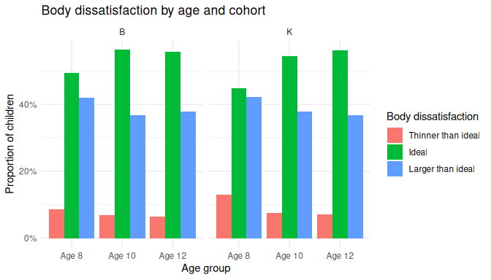
Body dissatisfaction category proportions by age and cohort.
 Interpretation
- B and K cohorts are near-identical at matched ages, supporting pooling.
- The decline in dissatisfaction with age is mostly a boys’ pattern; girls rebound at 12, driven by “larger than ideal” — motivating the sex-stratified enumeration check and sex-moderation tests.

3.1.1 Distribution of the outcome within classes
lcmm::hlme() assumes the outcome is normal within each class. The histograms show the distribution of scores by age within each trajectory class, and the table gives skewness and kurtosis (0 would mean normal).
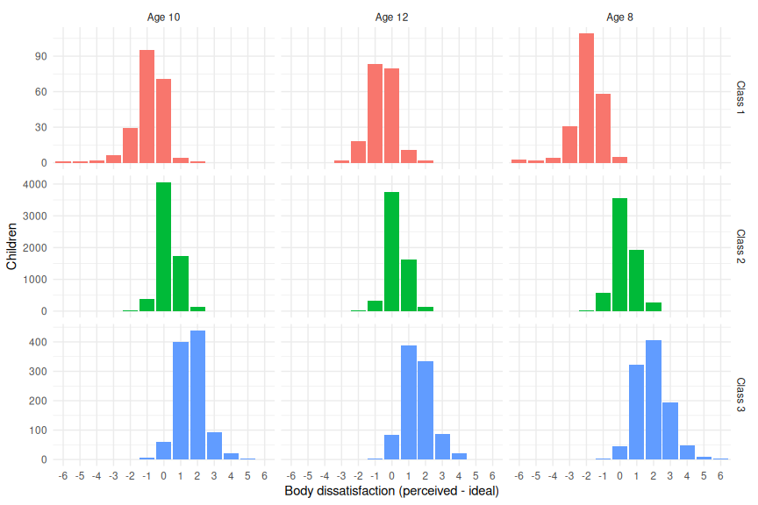
Distribution of body dissatisfaction by age within each latent class.
Table 6: Skewness and excess kurtosis of body dissatisfaction by wave and by latent class.
Grouping | Group | N | Mean | SD | Skewness | Excess kurtosis
By wave | Age 10 | 7580 | 0.40 | 0.85 | 0.55 | 3.08
By wave | Age 12 | 6974 | 0.40 | 0.82 | 0.73 | 2.55
By wave | Age 8 | 7641 | 0.45 | 1.02 | 0.31 | 2.54
By class | Class 1 | 618 | -1.14 | 1.10 | -0.79 | 2.26
By class | Class 2 | 18608 | 0.27 | 0.66 | 0.22 | 1.55
By class | Class 3 | 2969 | 1.69 | 0.94 | 0.48 | 0.97
By class x wave | Class 1, Age 10 | 210 | -0.88 | 0.99 | -1.32 | 4.50
By class x wave | Class 1, Age 12 | 196 | -0.56 | 0.82 | -0.00 | 0.58
By class x wave | Class 1, Age 8 | 212 | -1.95 | 0.95 | -1.33 | 4.07
By class x wave | Class 2, Age 10 | 6349 | 0.25 | 0.63 | 0.16 | 2.19
By class x wave | Class 2, Age 12 | 5859 | 0.26 | 0.63 | 0.15 | 2.61
By class x wave | Class 2, Age 8 | 6400 | 0.30 | 0.71 | 0.26 | 0.42
By class x wave | Class 3, Age 10 | 1021 | 1.62 | 0.86 | 0.50 | 1.54
By class x wave | Class 3, Age 12 | 919 | 1.52 | 0.90 | 0.46 | 0.79
By class x wave | Class 3, Age 8 | 1029 | 1.90 | 1.00 | 0.39 | 0.67

 Interpretation
- There is a small amount of skewness (especially the “thinner than ideal class), probably because the outcome is discrete and bounded. So the assumption is approximate rather than exact.
- The sensitivity analyse all give the same result, (especially the absolute-discrepenacy analysis) which suggests that the minor non-normality doesn’t change what we conclude.

3.2 Missingness and attrition
Table 7: Baseline (age 8) covariate missingness in the trajectory sample.
Covariate | N missing | % missing
Sex | 129 | 1.6
Socioeconomic position (z) | 188 | 2.4
BMI z-score | 198 | 2.5
Parental warmth, Parent 1 (z) | 645 | 8.2
Parental warmth, Parent 2 (z) | 2972 | 37.9
Parental anger, Parent 1 (z) | 635 | 8.1
Parental anger, Parent 2 (z) | 2977 | 38.0

 Interpretation
- Parent 2 warmth/anger missing for ~38% (largely single-parent households); all other covariates under 9% — the basis for the Parent-1-primary decision.

To see if any baseline characteristics are related to attrition, the tables below compare children by how many waves of the outcome they contributed. Don’t just look at the p-value (the sample size inflates significance here). The standardized mean difference (SMD) is helpful to know if it is actually a big difference (SMD ≳ 0.1 is normally considered a non-trivial difference).
Table 8: Baseline (age 8) characteristics of children included in vs excluded from the trajectory sample (< 2 vs ≥ 2 waves).
 | Excluded (<2) | Included (>=2) | p | test | SMD
n | 729 | 7843
Sex = Female (%) | 306 (48.2) | 3778 (49.0) | 0.734 |  | 0.016
Socioeconomic position (mean (SD)) | -0.36 (0.96) | 0.04 (0.97) | <0.001 |  | 0.414
BMI z-score (mean (SD)) | 0.49 (1.06) | 0.38 (0.97) | 0.007 |  | 0.111
Parental warmth, Parent 1 (mean (SD)) | 4.42 (0.54) | 4.38 (0.54) | 0.064 |  | 0.082
Parental anger, Parent 1 (mean (SD)) | 2.17 (0.64) | 2.15 (0.60) | 0.449 |  | 0.032
Parental warmth, Parent 2 (mean (SD)) | 4.08 (0.64) | 4.04 (0.63) | 0.344 |  | 0.066
Parental anger, Parent 2 (mean (SD)) | 2.16 (0.67) | 2.16 (0.61) | 0.997 |  | <0.001

Table 9: Baseline (age 8) characteristics by number of observed waves.
 | 1 wave | 2 waves | 3 waves | p | test | SMD
n | 729 | 1334 | 6509
Sex = Female (%) | 306 (48.2) | 588 (48.8) | 3190 (49.0) | 0.921 |  | 0.011
Socioeconomic position (mean (SD)) | -0.36 (0.96) | -0.23 (0.99) | 0.09 (0.96) | <0.001 |  | 0.310
BMI z-score (mean (SD)) | 0.49 (1.06) | 0.42 (1.00) | 0.37 (0.97) | 0.005 |  | 0.080
Parental warmth, Parent 1 (mean (SD)) | 4.42 (0.54) | 4.38 (0.57) | 4.37 (0.54) | 0.162 |  | 0.056
Parental anger, Parent 1 (mean (SD)) | 2.17 (0.64) | 2.16 (0.61) | 2.15 (0.60) | 0.725 |  | 0.023
Parental warmth, Parent 2 (mean (SD)) | 4.08 (0.64) | 4.06 (0.61) | 4.03 (0.63) | 0.470 |  | 0.047
Parental anger, Parent 2 (mean (SD)) | 2.16 (0.67) | 2.16 (0.64) | 2.16 (0.61) | 0.964 |  | 0.008

 Interpretation
- The SMDs are all pretty small, so attrition looks close to missing-at-random.
- There is a small effect of socioeconomic position (which is pretty normal in longitudinal studies - lower SES families tend to dropout first), and maybe an effect of BMI (but, I’d say that is just because higher SES tends to mean higher BMI). I would probably report this, but say that the effect is small enough that it is unlikely to bias the results and so we went with MAR.

3.3 Trajectory class enumeration
Fit statistics for K = 1-5 latent class growth models of body dissatisfaction. BIC/SABIC are fit indices penalised for model complexity (lower is better).
K | Converged | Iterations | Log-likelihood | Parameters | AIC | BIC | SABIC | Entropy | Class % (largest → smallest)
1 | Yes | 8 | -29234.7 | 3 | 58475 | 58496 | 58487 | — | 100.0
2 | Yes | 1 | -27805.2 | 6 | 55622 | 55664 | 55645 | 0.77 | 84.7 / 15.3
3 | Yes | 1 | -27407.3 | 9 | 54833 | 54895 | 54867 | 0.85 | 83.8 / 13.5 / 2.8
4 | Yes | 1 | -27142.6 | 12 | 54309 | 54393 | 54355 | 0.81 | 72.1 / 22.6 / 2.7 / 2.6
5 | Yes | 1 | -26950.2 | 15 | 53930 | 54035 | 53987 | 0.81 | 72.2 / 19.1 / 4.4 / 2.8 / 1.6
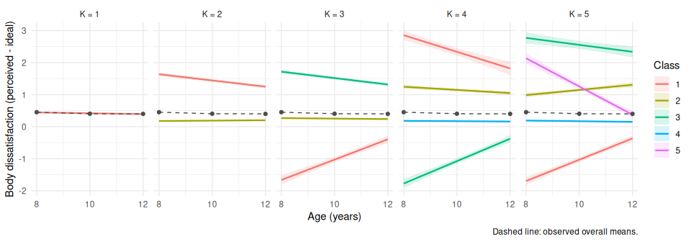
Predicted class trajectories (95% bands) by number of classes. Dashed line: observed overall means.
 Interpretation
- All models converged. AIC/BIC/SABIC fall through K = 5, as expected at this N, so enumeration leans on entropy (peak 0.85 at K = 3), class sizes, and interpretability.
- The Iterations column reports the iterations of the final convergence refit. Because that refit starts from the best of the 50 random starts (based on the first model), the multi-class models finish in a single additional iteration.
- K = 4–5 split off small (<3%) fragments at the cost of entropy; the 2.8% class at K = 3 maps onto the “thinner than ideal” group in the descriptives, arguing for keeping it.
- When reporting, it’s worth knowing that I followed the usual BIC + entropy + size + interpretability approach (GRoLTS-consistent).
- I only tested linear trajectories (three timepoints not enough to try quadratics).

3.4 Sex-stratified enumeration check
The same K = 1–5 enumeration repeated separately by sex, to check whether the pooled classes are robust.
Class enumeration in the pooled sample and stratified by sex.
Sample | K | Converged | BIC | SABIC | Entropy | Class % (largest → smallest)
Boys | 1 | Yes | 30310 | 30301 | — | 100.0
Boys | 2 | Yes | 28904 | 28885 | 0.78 | 85.6 / 14.4
Boys | 3 | Yes | 28485 | 28456 | 0.85 | 83.8 / 12.6 / 3.5
Boys | 4 | Yes | 28236 | 28198 | 0.82 | 74.8 / 20.6 / 2.9 / 1.7
Boys | 5 | Yes | 28130 | 28083 | 0.80 | 75.7 / 11.7 / 7.2 / 3.5 / 1.8
Girls | 1 | Yes | 28094 | 28084 | — | 100.0
Girls | 2 | Yes | 26677 | 26658 | 0.76 | 84.7 / 15.3
Girls | 3 | Yes | 26370 | 26342 | 0.85 | 83.7 / 14.3 / 2.0
Girls | 4 | Yes | 26092 | 26054 | 0.81 | 73.2 / 20.9 / 4.0 / 2.0
Girls | 5 | Yes | 25882 | 25834 | 0.80 | 69.9 / 22.3 / 3.5 / 2.3 / 2.0
Pooled | 1 | Yes | 58496 | 58487 | — | 100.0
Pooled | 2 | Yes | 55664 | 55645 | 0.77 | 84.7 / 15.3
Pooled | 3 | Yes | 54895 | 54867 | 0.85 | 83.8 / 13.5 / 2.8
Pooled | 4 | Yes | 54393 | 54355 | 0.81 | 72.1 / 22.6 / 2.7 / 2.6
Pooled | 5 | Yes | 54035 | 53987 | 0.81 | 72.2 / 19.1 / 4.4 / 2.8 / 1.6
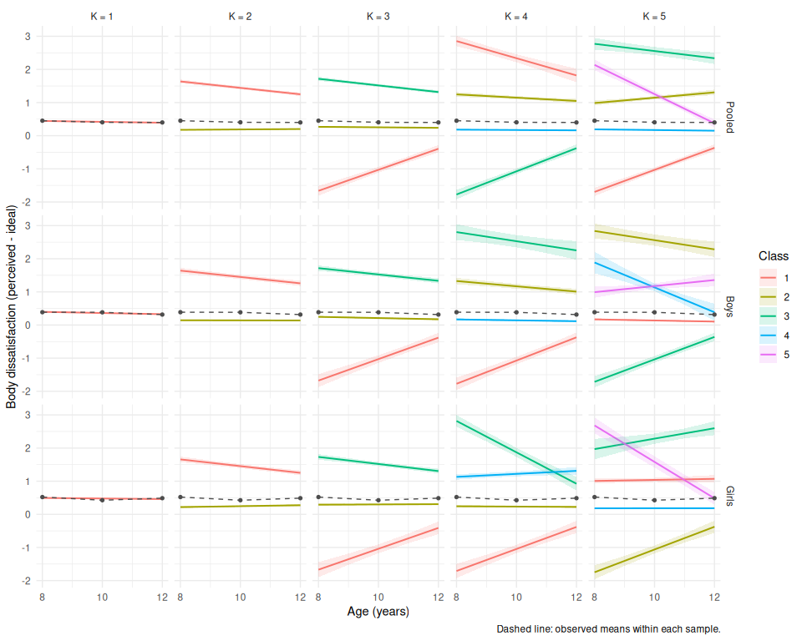
Predicted class trajectories by sample (pooled, boys, girls) and number of classes. Dashed lines: observed means within each sample.
 Interpretation
- At K = 3 the class shapes replicate almost exactly in both sexes.
- Entropy peaks at 0.85 in boys, girls, and pooled. Sexes differ in class prevalence (thinner-than-ideal ~2× as common in boys), not shape. This is handled by sex in the membership model.
- The pooled LCGA therefore makes sense as the primary specification.

3.5 Parenting model sensitivity analyses
Table 10: Sensitivity: both parents’ warmth and anger jointly (subset with second-carer data).
Term | Class 1 vs 2 | Class 3 vs 2
Warmth P1 (per SD) | 1.02 (0.88, 1.20); p=0.816 | 1.01 (0.94, 1.10); p=0.811
Anger P1 (per SD) | 1.18 (1.01, 1.38); p=0.042 | 1.19 (1.10, 1.30); p=<0.001
Sex: female | 0.53 (0.38, 0.69); p=<0.001 | 1.32 (1.13, 1.52); p=<0.001
SES (per SD) | 0.87 (0.75, 0.99); p=0.057 | 0.74 (0.68, 0.79); p=<0.001
BMI z-score (per SD) | 0.38 (0.33, 0.44); p=<0.001 | 4.34 (3.91, 4.87); p=<0.001
Term | Class 1 vs 2 | Class 3 vs 2
Warmth P1 (per SD) | 1.08 (0.92, 1.25); p=0.342 | 0.99 (0.92, 1.08); p=0.847
Warmth P2 (per SD) | 0.86 (0.74, 1.00); p=0.037 | 0.97 (0.90, 1.06); p=0.505
Anger P1 (per SD) | 1.07 (0.90, 1.28); p=0.454 | 1.14 (1.05, 1.24); p=0.002
Anger P2 (per SD) | 1.07 (0.91, 1.25); p=0.387 | 1.01 (0.93, 1.09); p=0.834
Sex: female | 0.60 (0.43, 0.80); p=<0.001 | 1.52 (1.32, 1.77); p=<0.001
SES (per SD) | 0.97 (0.84, 1.11); p=0.675 | 0.74 (0.68, 0.79); p=<0.001
BMI z-score (per SD) | 0.39 (0.35, 0.44); p=<0.001 | 4.25 (3.86, 4.69); p=<0.001

 Interpretation
- Both agree with the primary model. Modal assignment gives slightly larger anger RRRs (1.18–1.19), consistent with mild attenuation under weighting.
- In the both-parent subset (N = 4,780, two-parent households), Parent 1 anger → Class 3 holds (RRR 1.14). Parent 2 effects are essentially null (I wouldn’t read into the the P2 warmth → Class 1 result. There’s no adjustment for multiplicity and it doesn’t show up elsewhere).

3.6 Between-class residual variance
The primary LCGA holds the residual variance equal across classes. As a check on that choice, the chosen K = 3 model was re-fit allowing class-specific (proportional) residual variances and compared on fit and classification quality.
Table 11: Primary equal-variance LCGA vs a class-specific residual-variance sensitivity, at K = 3.
Model | Converged | BIC | SABIC | Entropy | Class % (largest → smallest) | Smallest class %
Equal variance (primary) | Yes | 54895 | 54867 | 0.85 | 83.8 / 13.5 / 2.8 | 2.8
Class-specific variance | No | 54913 | 54878 | 0.85 | 83.8 / 13.5 / 2.8 | 2.8

 Interpretation
- The table shows whether allowing class-specific variances improves BIC/SABIC/entropy and if it changes the classes. It does not - the model we already had fits (very slightly better) and given that class-specific variance can be more prone to not converging we can just stick with the original model.

3.7 Sex moderation: full model
Sex-moderation model: RRRs including sex × parenting interactions.
Term | Class 1 vs 2 | Class 3 vs 2
Warmth P1 (per SD) | 1.01 (0.86, 1.19); p=0.914 | 1.03 (0.94, 1.13); p=0.486
Sex: female | 0.58 (0.45, 0.72); p=<0.001 | 1.40 (1.23, 1.56); p=<0.001
Anger P1 (per SD) | 1.16 (1.00, 1.37); p=0.075 | 1.21 (1.11, 1.32); p=<0.001
SES (per SD) | 0.85 (0.75, 0.97); p=0.011 | 0.77 (0.73, 0.82); p=<0.001
BMI z-score (per SD) | 0.39 (0.34, 0.43); p=<0.001 | 3.91 (3.63, 4.26); p=<0.001
Warmth P1 x female | 1.00 (0.76, 1.29); p=0.975 | 0.93 (0.83, 1.06); p=0.277
sexFemale:parenting_angry_p1_z_bl | 0.94 (0.73, 1.21); p=0.648 | 0.92 (0.81, 1.04); p=0.176
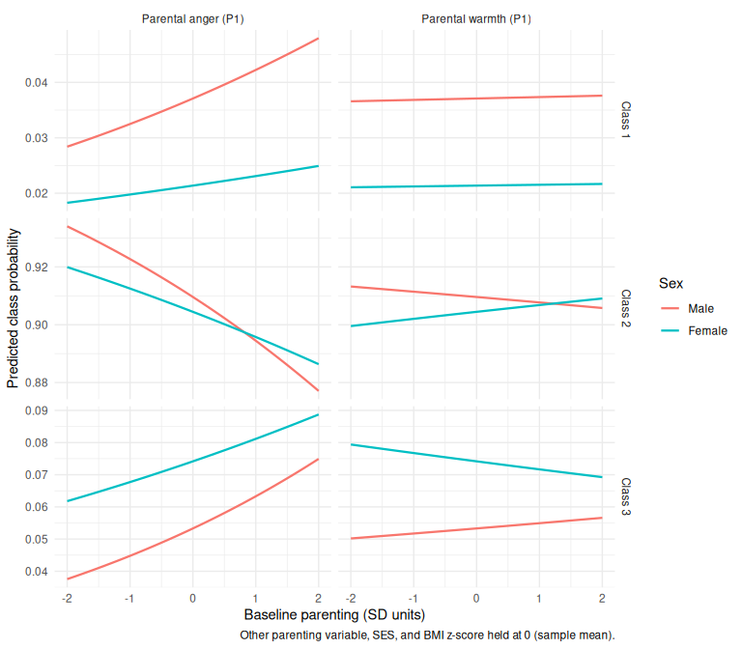
Predicted class probabilities across baseline parenting, by sex (other covariates at sample mean).
 Interpretation
- Same qualitative pattern in both sexes: probabilities shift with anger, barely with warmth; sex differences are in levels only (already captured by the sex main effect).

3.8 Sensitivity: absolute body dissatisfaction
The primary analyses use the signed discrepancy, in which “thinner than ideal” and “larger than ideal” offset. The full analysis was repeated on the absolute discrepancy |perceived − ideal|, which is more about ‘severity’ than direction.
Class enumeration for absolute body dissatisfaction.
K | Converged | BIC | SABIC | Entropy | Class % (largest → smallest)
1 | Yes | 51870 | 51860 | — | 100.0
2 | Yes | 48478 | 48459 | 0.85 | 86.4 / 13.6
3 | Yes | 47715 | 47686 | 0.87 | 83.1 / 9.2 / 7.7
4 | Yes | 47086 | 47048 | 0.85 | 82.1 / 8.6 / 7.8 / 1.5
5 | Yes | 46861 | 46814 | 0.79 | 71.4 / 18.2 / 6.4 / 2.5 / 1.5
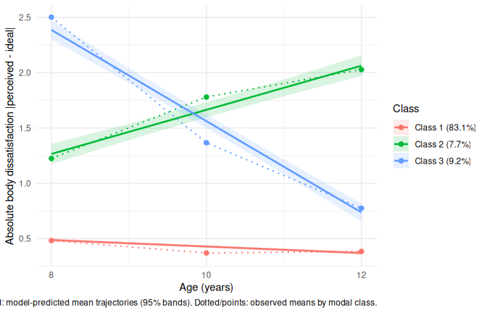
Final three-class model of absolute body dissatisfaction.
Table 12: Three-step model for absolute-discrepancy classes: RRR (95% bootstrap CI) vs the stable-low class (Class 1).
Term | Class 2 vs 1 | Class 3 vs 1
Warmth P1 (per SD) | 0.94 (0.87, 1.02); p=0.115 | 1.03 (0.96, 1.12); p=0.457
Anger P1 (per SD) | 1.11 (1.02, 1.20); p=0.022 | 1.23 (1.13, 1.34); p=<0.001
Sex: female | 1.17 (1.01, 1.37); p=0.033 | 1.11 (0.95, 1.29); p=0.169
SES (per SD) | 0.80 (0.74, 0.86); p=<0.001 | 0.70 (0.64, 0.76); p=<0.001
BMI z-score (per SD) | 2.86 (2.57, 3.22); p=<0.001 | 2.07 (1.88, 2.30); p=<0.001

 Interpretation
- K = 3 again (entropy peak 0.87; only multi-class solution with all classes ≥5%): stable-low difference 83.1%, worsening 7.7% (~1.2 → 2.0), resolving 9.2% (~2.4 → 0.8). These classes captures when dissatisfaction occurs where the signed one captured direction.
- Results are broadly the same: anger predicts both non-stable classes (worsening RRR 1.11, resolving 1.23 per SD). That suggests that the primary model is fine - this doesn’t really change the results.

