Benefits and risks associated with children’s and adolescents’ interactions with electronic screens: An umbrella review

Taren Sanders1, Michael Noetel2, Philip Parker1, Borja Del Pozo Cruz3, Stuart Biddle4, Rimante Ronto5, Ryan Hulteen6, Rhiannon Parker7, George Thomas8, Katrien De Cocker5, Jo Salmon9, Kylie Hesketh9, Nicole Weeks1, Hugh Arnott1, Emma Devine10, Roberta Vasconcellos1, & Chris Lonsdale1

1 Institute for Positive Psychology and Education, Australian Catholic University

2 School of Health and Behavioural Sciences, Australian Catholic University

3 Department of Sport Science and Clinical Biomechanics, University of Southern Denmark

4 School of Psychology and Counselling, University of Southern Queensland

5 Department of Health Systems and Populations, Faculty of Medicine, Health and Human Sciences, Macquarie University

6 School of Kinesiology, Louisiana State University

7 School of Medicine and Health, Sydney University

8 Faculty of Health Sciences, Curtin University

9 Institute for Physical Activity and Nutrition, Deakin University

10 The Matilda Centre for Research in Mental Health and Substance Use, University of Sydney

Author note

Add complete departmental affiliations for each author here. Each new line herein must be indented, like this line.

Enter author note here.

The authors made the following contributions. Taren Sanders: Conceptualization, Data curation, Writing - Original Draft; Michael Noetel: Conceptualization, Writing - Original Draft; Philip Parker: Conceptualization, Writing - Original Draft; Borja Del Pozo Cruz: Writing - Review & Editing; Stuart Biddle: Writing - Review & Editing; Rimante Ronto: Writing - Review & Editing; Ryan Hulteen: Writing - Review & Editing; Rhiannon Parker: Writing - Review & Editing; George Thomas: Writing - Review & Editing; Katrien De Cocker: Writing - Review & Editing; Jo Salmon: Writing - Review & Editing; Kylie Hesketh: Writing - Review & Editing; Nicole Weeks: Writing - Review & Editing; Hugh Arnott: Writing - Review & Editing; Emma Devine: Writing - Review & Editing; Roberta Vasconcellos: Writing - Review & Editing; Chris Lonsdale: Writing - Original Draft, Project Administration.

Correspondence concerning this article should be addressed to Taren Sanders, 33 Berry St, North Sydney, NSW, Australia. E-mail: [Taren.Sanders@acu.edu.au](mailto:Taren.Sanders@acu.edu.au)

Abstract

One or two sentences providing a **basic introduction** to the field, comprehensible to a scientist in any discipline.

Two to three sentences of **more detailed background**, comprehensible to scientists in related disciplines.

One sentence clearly stating the **general problem** being addressed by this particular study.

One sentence summarizing the main result (with the words “**here we show**” or their equivalent).

Two or three sentences explaining what the **main result** reveals in direct comparison to what was thought to be the case previously, or how the main result adds to previous knowledge.

One or two sentences to put the results into a more **general context**.

Two or three sentences to provide a **broader perspective**, readily comprehensible to a scientist in any discipline.

*Keywords:* keywords

*Word count:* X

Benefits and risks associated with children’s and adolescents’ interactions with electronic screens: An umbrella review

# 1 Background

In the 16th century, hysteria reigned around a new technology that threatened to be “confusing and harmful” to the mind. The cause of such concern? The widespread availability of books brought about by the invention of the printing press [1]. In the early 19th century, concerns about schooling “exhausting the children’s brains” followed, with the medical community accepting that excessive study could be a cause of madness [2]. By the 20th century, the invention of the radio was accompanied by assertions that it would distract children from their reading (which by this point was no longer considered confusing and harmful) leading to impaired learning [3].

Today, the same arguments that were once leveled against reading, schooling, and radio are being made about screen use (e.g., television, mobile phones, and computers) [4]. Excessive screen time use is the number one concern parents have about their children’s health and behaviour, ahead of nutrition, bullying, and physical inactivity [5]. Yet, the evidence to support parents’ concerns is inadequate. A Lancet editorial [6] suggested that, “Our understanding of the benefits, harms, and risks of our rapidly changing digital landscape is sorely lacking.”

While some forms of screen use (e.g., television viewing) may be detrimental to behaviour and health [7,8], evidence for other forms of screen exposure (e.g., video games or online communication, such as Zoom) remains less certain and, in some cases, may even be beneficial [9,10]. Thus, according to a Nature Human Behaviour editorial, research to determine the effect of screen exposure on youth is “a defining challenge of the digital age” [11]. With concerns over the impact of screen use including education, health, social development, and psychological well-being, a broad overview that identifies potential benefits and risks is needed.

Citing the negative effects on health (e.g., increased risk of obesity) and health-related behaviours (e.g., sleep), guidelines from the World Health Organisation [12] and numerous government agencies [13,14] and statements by expert groups [15] have recommended that young people’s time spent using electronic media devices for entertainment purposes should be limited. For example, the Australian Government guidelines regarding sedentary behaviour recommend that young children (under the age of two) should not spend any time watching screens. They also recommend that children aged 2-5 years should spend a maximum of one hour engaged in recreational sedentary screen use per day, while children aged 5-12 and adolescents should spend no more than two hours. In contrast, some recent evidence suggests that exposure to electronic entertainment media that exceeds these guidelines (e.g., 3-4 hours per day) may not have meaningful adverse effects on children’s behaviour or mental health [16], and might, in fact, benefit their well-being, as long as this exposure does not reach extreme levels (e.g., 7 hours per day). Some research also indicates that content (e.g., video games vs television programs) may also play an important role in determining the potential benefit or harm of youths’ exposure to screen-based media [17]. Indeed, educational screen time is positively related to educational outcomes [18]. This evidence has led some researchers to argue that a more nuanced approach to screen time guidelines is required.

In 2016, the American Academy of Pediatrics used a narrative review to examine the benefits and risks of children and adolescents’ electronic media [19] as a basis for updating their guidelines about screen use [15]. Since then, a large number of systematic reviews and meta-analyses have provided evidence about the potential benefits and risks of screen use. Yet, no review has synthesised the evidence available across a broad range of outcome domains, such as physical health, education, development, behaviour, and well-being.

In order to crystallise the evidence base and support further evidence-based guideline development and refinement, we reviewed published meta-analyses examining the effects of screen use on children and youth. This review synthesises evidence on any plausible outcome of electronic media exposure. Adopting this broad approach allowed us to provide a holistic perspective on the influence of screens on children’s lives. By synthesising across life domains (e.g., school and home), this review provides evidence to support better guidelines and advice for parents, teachers, pediatricians and other professionals in order to maximise human functioning.

# 2 Methods

### 2.0.1 Eligibility criteria.

*Population*: To be eligible for inclusion, meta-analyses needed to include meta-analytic effect sizes for children or adolescents (age 0-18 years). We included meta-analyses containing studies that combined data from adults and youth if meta-analytic effect size estimates specific to participants aged 18 years or less could be extracted (i.e., the highest individual study from the meta-analysis had a mean age was < 18 years). We excluded meta-analyses that only contained evidence gathered from adults (age >18 years).

*Exposure*: We included meta-analyses examining all types of electronic screens including (but not necessarily limited to) television, gaming consoles, computer, tablet, and mobile phones. We also included analyses of all types of content on these devices, including (but not necessarily limited to) recreational content (e.g., television programs, movies, games), homework, and communication (e.g., video chat). In this review we adopted a population-level perspective, meaning that we examined electronic media exposure that occurs during typical daily living activities (e.g., home, school-based electronic media exposure). Consistent with this population-level approach, we excluded technology-based treatments for clinical conditions. However, we included studies examining the effect of screen exposure on non-clinical outcomes (e.g., learning children) for children and youth with a clinical condition. For example, a meta-analysis of the effect of television watching on learning among adolescents diagnosed with depression would be included. However, a meta-analysis of interventions designed to treat clinical depression delivered by a mobile phone app would be excluded.

*Outcomes*: We included all reported outcomes.

*Publications*:We included meta-analyses (or meta-regressions) of quantitative evidence. To be included, meta-analyses needed to analyse data from studies identified in a systematic review. For our purposes, a systematic review was one in which the authors attempted to acquire all the research evidence that pertained to their research question(s). We excluded meta-analyses that did not attempt to summarise all the available evidence (e.g., a meta-analysis of all studies from one laboratory). We included meta-analyses regardless of the study designs included in the review (e.g., laboratory-based experimental studies, randomised controlled trials, non-randomised controlled trials, longitudinal, cross-sectional, case studies), as long as the studies in the review collected quantitative evidence. We excluded systematic reviews of qualitative evidence. We did not formulate inclusion/exclusion criteria related to the risk of bias of the review. We did, however, employ a risk of bias tool to help interpret the results. We included full-text, peer-reviewed meta-analyses published or ‘in-press’ in English. We excluded conference abstracts and meta-analyses that were unpublished.

### 2.0.2 Information sources.

We searched records contained in the following databases: Pubmed, MEDLINE, CINAHL, PsycINFO, SPORTDiscus, Education Source, Embase, Cochrane Library, Scopus, Web of Science, ProQuest Social Science Premium Collection, and ERIC. We conducted an initial search on August 17, 2018 and refreshed the search on May 13, 2020. We searched reference lists of included papers in order to identify additional eligible meta-analyses. We also searched PROSPERO to identify relevant protocols and contacted authors to determine if these reviews have been completed and published.

### 2.0.3 Search strategy.

The search strategy associated with each of the 12 databases can be found [here](https://docs.google.com/document/d/1hz5Dgw0aVOMeXL3vpRXsNtCIbf6dHZTb8uz7wQ29ke4/edit#heading=h.i6znptfz9nwa). We hand searched reference lists from any relevant umbrella reviews to identify systematic meta-analyses that our search may have missed.

### 2.0.4 Selection process.

Using Covidence software (Veritas Health Innovation, Melbourne, Australia), two researchers independently screened all titles and abstracts. Two researchers then independently reviewed full-text articles. We resolved disagreements at each stage of the process by consensus, with a third researcher employed, when needed.

### 2.0.5 Data collection process.

From each included meta-analysis, two researchers independently extracted data into a custom-designed database.

### 2.0.6 Data items.

From each meta-analysis we extracted the following items: First author, year of publication, study design restrictions (e.g., cross-sectional, observational, experimental), region restrictions (e.g., specific countries), earliest and latest study publication dates, sample age (mean), lowest and highest mean age reported, outcomes reported, and exposures reported.

### 2.0.7 Study risk of bias assessment.

For each meta-analysis, two researchers independently completed the National Health, Lung and Blood Institute’s Quality Assessment of Systematic Reviews and Meta-Analyses tool [20] (see Table 1). We resolved disagreements by consensus, with a third researcher employed when needed. We did not assess risk of bias in the individual studies that were included in each meta-analysis.

### 2.0.8 Effect measures.

Two researchers independently extracted all quantitative meta-analytic effect sizes, including moderation results. Where possible, they also extracted effect sizes from primary studies included in each meta-analysis. To facilitate comparisons, we converted effect sizes to Pearson’s using established formulae [21–23]. We excluded relative risk ratios from this conversion because meta-analyses did not contain sufficient information to meaningfully convert. Effect sizes on the original metric are provided in supplementary materials.

### 2.0.9 Synthesis methods.

After extracting data, we examined the combinations of exposure and outcomes and removed any effects that appeared more than once, keeping the effect with the largest total sample size. In instances where effect sizes from the same combination of exposure and outcome were drawn from different populations (e.g., children vs adolescents) we retained both estimates in our dataset.

We excluded effect size estimates when the authors did not provide a sample size. We descriptively present the remaining meta-analytic effect sizes. When the meta-analysis’s authors provided primary study data associated with these effects we reran the effect size estimate using a random effects meta-analysis via the metafor package [24] in R [25] (version 4.1.2). When required, we imputed missing sample sizes using mean imputation from the other studies within that review. From our reanalysis we also extracted values. To test for publication bias, we conducted Egger’s test [26] when the number of studies within the review was ten or more [27], and conducted a test of excess significance [28]. We contacted authors who did not provide primary study data in their published article. Where authors did not provide data in a format that could be re-analysed, we used the published results of their original meta-analysis.

### 2.0.10 Evidence assessment criteria.

*Statistical Credibility*. We employed a statistical classification approach to grade the statistical credibility of the effect sizes in the literature. To be considered credible an effect needed to be derived from a combined sample of >1,000 [29] and have non-significant tests of publication bias (i.e., Egger’s test and excess significance test). We performed these analyses, and therefore the review needed to provide usable study-level data in order to be included.

*Consistency of Effect within the Population*. We also examined the consistency of the effect size using the measure. We considered to indicate effects that were relatively consistent across the population of interest. values of were taken to indicate an effect was potentially heterogeneous within the population.

*Direction of Effect*. Finally, we examined the extent to which significance testing suggested screen exposure was associated with benefit, harm, or no effect on outcomes. We used thresholds of for weak evidence and for strong evidence. An effect that was neither significant at or that also passed the criteria for statistical credibility was taken to indicate no association of interest.

### 2.0.11 Deviations from protocol.

We initially planned to include systematic reviews without meta-analyses in a narrative summary alongside the main meta-analytic findings. However, we determined that combining results from the meta-analyses provided a robust overview. Readers interested in the relevant systematic reviews (i.e., without meta-analysis) can consult the list of references in [Supplementary File 1](https://drive.google.com/file/d/1JhMsySEyfby5MtcUcIVpp0LjDDfTA5IH/view?usp=sharing).

We altered our evidence assessment plan when we identified that, as written, it would treat effects from large reviews, with limited evidence of publication bias, and with consistency of effect in the population as not credible if the effect size was not statistically significant. This would have significantly harmed knowledge gained from our review as it would have restricted our ability to show where the empirical evidence strongly indicated that there was no association between screen time and a given outcome.

# 3 Results

### 3.0.1 Search Results.

The searches yielded 41,928 results, of which 24,023 were duplicates. After screening titles and abstracts, we assessed 1,964 full-texts for inclusion. One hundred and seventeen met the inclusion criteria and we extracted the data from these meta-analyses. Figure 1 presents the full results of the selection process.

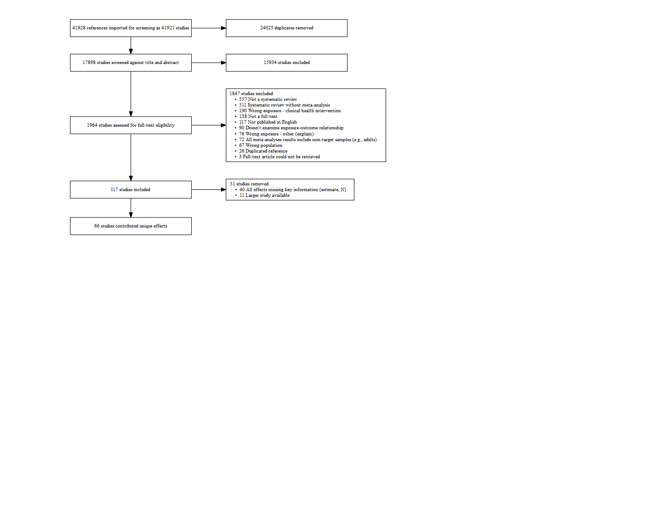

*Figure* *1.*  PRISMA Diagram

The most frequently reported exposures were general tv programs and movies (n = 26), physically active video games (n = 15), screen-based lifestyle risk behaviour interventions (at school) (n = 14), and general screen use (n = 13). [Supplementary file 2](https://drive.google.com/file/d/12rB0ihW9Hi1kxM-8AIBfjdCMO6TqP28n/view?usp=sharing) provides a list of all exposures identified. The most frequently reported outcomes were body composition (n = 34), general physical activity (n = 15), general literacy (n = 13), general learning (n = 12), and duration sleep (n = 9). In most cases (121/197), there was only one exposure/outcome combination for an age group, with 20 appearing twice, and 8 appearing three or more times. Full characteristics of the included studies are provided in Table 1. Our process yielded 167 unique effects/outcome combinations contributed from 51 reviews. These effects represent the findings of 2,171 primary studies comprised of 1,652,944 participants.

The quality of the included meta-analyses was mixed (see Table 1). Most assessed heterogeneity (n low risk = 59/66, 89% of meta-analyses), reported the characteristics of the included studies (n low risk = 57/66, 86%), and used a comprehensive and systematic search strategy (n low risk = 56/66, 85%). Most reviews did not clearly report if their eligibility criteria was predefined (n unclear = 45/66, 68%). Many papers also did not complete dual independent screening of abstracts and full text (n high risk = 16/66, 24%) or did not clearly report the method of screening (n unclear = 21/66, 32%). A similar trend was observed for dual independent quality assessment (n high risk = 31/66, 47%; n unclear = 19/66, 29%). Overall, only 5 meta-analyses were graded as low risk of bias on all criteria. Zero meta-analyses showed high risk of bias on all criteria (one meta-analysis if ‘unclear’ was included as ‘high’).

### 3.0.2 Education Outcomes.

There were 46 unique effects associated with education outcomes, including general learning outcomes, literacy, numeracy, and science. We removed 20 effects that did not provide individual study-level data, 7 effects with samples < 1,000, and 8 with a significant Egger’s test or insufficient studies to conduct the test. No remaining studies showed evidence of excessive significance. Effects not meeting one or more of these standards are presented in [Supplementary File 3](https://drive.google.com/file/d/1wUotZRh-jvdBJh5dkstkMtvcz7DPn-vS/view?usp=sharing). The remaining 12 met our criteria for statistical credibility and are described in Figure 2. These 12 effects came from 8 meta-analytic reviews analysing data from 226 empirical studies with 186,631 individual participants.

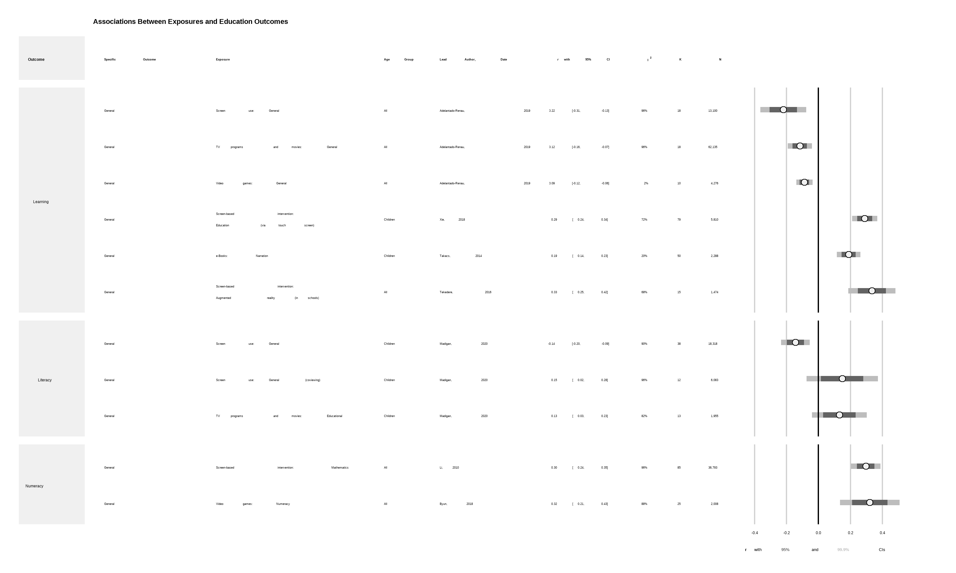

*Figure* *2.*  Education outcomes

Among the statistically credible effects, general screen use, television viewing, and video games were all negatively associated with learning. E-books that included narration, as well as touch screen education interventions, and augmented reality education interventions were positively associated with learning. General screen use was negatively associated with literacy outcomes. However, if the screen use involved co-viewing (e.g., watching with a parent), or the content of television programs was educational, the association with literacy was positive (95% CI, weak evidence). Numeracy outcomes were positively associated with screen-based mathematics interventions and video games with numeracy content.

As shown in Figure 2, most of the credible results (10 of 12 effects) showed statistically significant associations, with 99.9% confidence intervals not encompassing zero (strong evidence). The remaining two associations were significant at the 95% confidence level (weak evidence). All credible effects related to education outcomes were small-to-moderate. Screen-based interventions designed to influence an outcome (e.g., a computer based program designed to enhance learning [30]) tended to have larger effect sizes than non-intervention exposure (e.g., the association between television viewing and learning [31]). The largest effect size observed was for augmented reality-based education interventions on general learning (). Most effects showed high levels of heterogeneity (10 of 12 with ).

### 3.0.3 Health and Health-related Behaviours.

We identified 121 unique outcome-exposure combinations associated with health or health-related behaviour outcomes. We removed 33 effects that did not provide individual study-level data, 30 effects with samples < 1,000, and 43 effects with a significant Egger’s test or insufficient studies to conduct the test. No remaining studies showed evidence of excessive significance. Effects not meeting one or more of these standards are presented in [Supplementary File 4](https://drive.google.com/file/d/1-3frrZ3woWjPqkO84Dn3_1CCaE8thIZn/view?usp=sharing) The remaining 17 meta-analytic associations met our criteria for credible evidence and are described below (see also Figure 3). These 121 effects came from 12 meta-analytic reviews analysing data from 231 empirical studies with 676,331 individual participants.

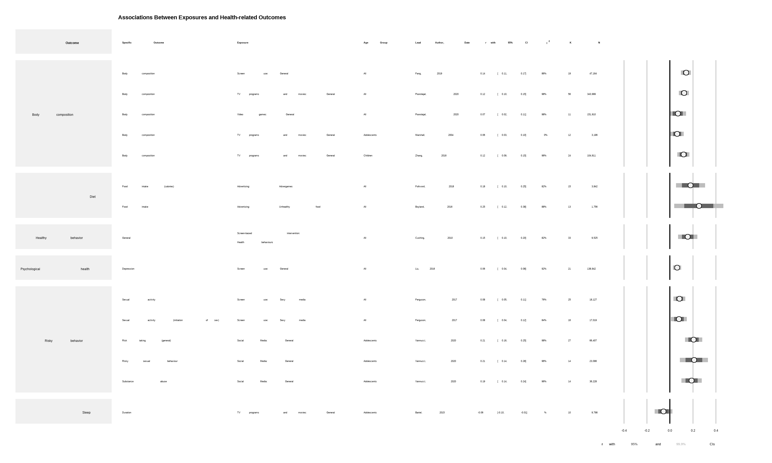

*Figure* *3.*  Health and health-related behaviour outcomes

Digital advertising of unhealthy foods—both traditional advertising and video games developed by a brand for promotion—were associated with higher unhealthy food intake. Risky behaviors (e.g., sexual activity, risk taking, and substance abuse) were positively associated with social media use and sexy media use. General screen use was positively associated with depression. Television viewing was negatively correlated with sleep duration, but only at the 95% confidence level (weak evidence). All forms of screen use (general, television, and video games) were positively associated with body composition (e.g., BMI), although the association was smaller for children than for adolescents or for combined populations. Screen-based interventions which target health behaviours appeared effective.

Across the health outcomes, most (14 of 17 effects) were statistically significant at the 99.9% level, with the remaining seven significant at 95% confidence. However, most of the credible effects exhibited high levels of heterogeneity, with all but one having . Additionally, most effects were small, with the association between unhealthy food advertising and intake the largest at (). Most of the effect sizes (14/17) had an absolute value of .

# 4 Discussion

The primary goal of this review was to provide a holistic perspective on the influence of screens on children’s lives across a broad domain of outcomes. We found that when meta-analyses examined general screen use, and did not specify the content, context or device, there was strong evidence showing potentially harmful associations with general learning, literacy, body composition, and depression. However, when meta-analyses included a more nuanced examination of exposures a more complex picture appeared.

#### 4.0.0.1 Broad summary of the findings relating back to the purpose.

For example, watching television programs was associated with poorer academic performance and learning. However, there was also evidence that if the content of the program was educational or the child watched the program with a parent (i.e., coviewing) then television viewing was associated with better literacy. Thus, parents play an important role in selecting content that is likely to benefit their children and, perhaps, interacting with their children in ways that may foster literacy (e.g., asking their children questions about the program). Similarly, the credible evidence we identified showed video game playing is associated with poorer body composition and learning. When the video game was designed specifically to teach numeracy, playing these games showed learning benefits. One might expect that video games designed to be physically active could confer health benefits, but none of the meta-analyses examining this hypothesis met our thresholds for credibility (see Supplementary File X).

Social media was one type of exposure that showed consistent risks to health, with no indication of potential benefit. Social media showed strong evidence of harmful associations with risk taking in general, as well as unsafe sex and substance abuse. Meta-analytic evidence from adults indicates that social media use is also associated with increased risk of depression. Recent evidence from social media companies themselves suggest there may also be negative effects of

Finally, there was strong evidence that sexy media was associated with sexual activity.

One category of exposure appeared to consistently confer benefits: screen-based interventions designed to promote learning or health behaviours.This finding indicates that interventions can be effectively delivered using electronic media platforms. It does not necessarily indicate that screens are more effective than other methods (e.g., face-to-face, printed material).

* Touch screen = strong evidence of benefit for learning
* Math interventions = strong evidence on numeracy.
* Augmented reality on learning, strong evidence.
* Screen-based interventions. Strong effect on health behaviours.

Largely owing to small number of studies or missing individual study data, there were few age-based conclusions that could be drawn from reviews which met our criteria for statistical certainty. If we expand our view to include those reviews which did meet this threshold, there remains no clear trend. For example, advertising of unhealthy food was associated with unhealthy food choice for young children, but was not statistically significant for other age groups. Conversely, TV programs and movies were more strongly associated with lower physical activity for adolescents than for younger age groups.

#### 4.0.0.2 Implications of findings for targeted policy and practice.

Screen use is complex. We need to stop thinking about it in simplistic terms as “bad” and something that should be minimised in all instances. Need to think about how it can best be used. For example, recreational television and video games appear to confer few, if any benefits, and appear to be associated with poor body composition and academic performance. However, television programs and video games designed to promote learning may be effective. The current literature indicates that social media is likely harmful, but if social media platforms specifically designed to promote learning can be designed and popularised, perhaps they could have benefits.

#### 4.0.0.3 Survey of the field and implications for future research.

Screen use research is big, varied, and rapidly growing. Reviews tended to be general (e.g., all screen time) and even when more targeted (e.g., social media) nuances related to specific content (e.g., Instagram vs Facebook) have not been meta-analysed or have not produced credible evidence.

Need to unpack the aggression research (violent video games - what happened to those reviews?)

There is credible evidence for X, we need more evidence for Y. All observational research with self-report evidence.

#### 4.0.0.4 Limitations of the review.

Can’t look at fine-grained detail - eg moderators, but we did look at different exposures and outcomes (quasi moderators).

We did not rate the risk of bias of the X,XXX individual studies that contributed data to this review. Thus, our assessment of evidence quality was restricted to statistical credibility, rather than a more complete assessment (e.g., GRADE).

Also, we made somewhat arbitrary decisions to present effects that reach certain thresholds (e.g., N>1,000, non-significant Egger’s test). We do, however, provide more complete results in the supplementary files for those who wish to consider those meta-analyses.

#### 4.0.0.5 Conclusions.

# 5 References

References marked with an asterisk indicate studies which were included in the synthesis.

1. Blair A. Reading Strategies for Coping With Information Overload ca.1550-1700. Journal of the History of Ideas. 2003;64(1):11–28.

2. Bell AN. The sanitarian. Vol. 11. AN Bell; 1883.

3. Dill KE. The Oxford handbook of media psychology. Oxford University Press; 2013.

4. Wartella EA, Jennings N. Children and computers: New technology. Old concerns. The future of children. 2000;31–43.

5. Rhodes A. Top ten child health problems: What the public thinks. The Royal Children’s Hospital Melbourne; 2015.

6. The Lancet. Social media, screen time, and young people’s mental health. The Lancet. 2019;393(10172):611.

7. Hale L, Guan S. Screen time and sleep among school-aged children and adolescents: A systematic literature review. Sleep Medicine Reviews. 2015;21:50–8.

8. Sweetser P, Johnson D, Ozdowska A, Wyeth P. Active versus Passive Screen Time for Young Children. Australasian Journal of Early Childhood. 2012;37(4):94–8.

9. Li X, Atkins MS. Early childhood computer experience and cognitive and motor development. Pediatrics. 2004;113(6):1715–22.

10. Warburton W, Highfield K. Children and technology in a smart device world. In: Children, families and communities. Oxford University Press; 2017. p. 195–221.

11. Orben A, Przybylski AK. The association between adolescent well-being and digital technology use. Nature Human Behaviour. 2019;3(2):173–82.

12. World Health Organization. Guidelines on physical activity, sedentary behaviour and sleep for children under 5 years of age. World Health Organization; 2019.

13. Australian Government. Physical activity and exercise guidelines for all Australians. Department of Health; 2021.

14. Canadian Society for Exercise Physiology. Canadian 24-Hour Movement Guidelines for Children and Youth: An Integration of Physical Activity, Sedentary Behaviour, and Sleep. Canadian Society for Exercise Physiology; 2016.

15. Council On Communication and Media. Media Use in School-Aged Children and Adolescents. Pediatrics. 2016;138(5):e20162592.

16. Ferguson CJ. Everything in Moderation: Moderate Use of Screens Unassociated with Child Behavior Problems. Psychiatric Quarterly. 2017;88(4):797–805.

17. Przybylski AK, Weinstein N. A Large-Scale Test of the Goldilocks Hypothesis: Quantifying the Relations Between Digital-Screen Use and the Mental Well-Being of Adolescents. Psychological Science. 2017;28(2):204–15.

18. Sanders T, Parker PD, del Pozo-Cruz B, Noetel M, Lonsdale C. Type of screen time moderates effects on outcomes in 4013 children: Evidence from the Longitudinal Study of Australian Children. International Journal of Behavioral Nutrition and Physical Activity. 2019;16(1):1–0.

19. Chassiakos YLR, Radesky J, Christakis D, Moreno MA, Cross C, Council On Communication and Media. Children and Adolescents and Digital Media. Pediatrics. 2016;138(5):e20162593.

20. National Health, Lung, and Blood Institute. Quality Assessment of Systematic Reviews and Meta-Analyses. National Health, Lung, and Blood Institute; 2014.

21. Bonett DG. Transforming odds ratios into correlations for meta-analytic research. American Psychologist. 2007;62(3):254–5.

22. Bowman NA. Effect Sizes and Statistical Methods for Meta-Analysis in Higher Education. Research in Higher Education. 2012;53(3):375–82.

23. Jacobs P, Viechtbauer W. Estimation of the biserial correlation and its sampling variance for use in meta-analysis: Biserial Correlation. Research Synthesis Methods. 2017;8(2):161–80.

24. Viechtbauer W. Metafor: Meta-analysis package for r [Internet]. 2021. Available from: <https://CRAN.R-project.org/package=metafor>

25. R Core Team. R: A language and environment for statistical computing [Internet]. Vienna, Austria: R Foundation for Statistical Computing; 2021. Available from: <https://www.R-project.org/>

26. Egger M, Smith GD, Schneider M, Minder C. Bias in meta-analysis detected by a simple, graphical test. BMJ. 1997;315(7109):629–34.

27. Page MJ, Higgins JP, Sterne JA. Chapter 13: Assessing risk of bias due to missing results in a synthesis. In: Higgins JP, Thomas J, Chandler J, Cumpston M, Li T, Page MJ, et al., editors. Cochrane Handbook for Systematic Reviews of Interventions. 6.2 ed. Cochrane; 2021.

28. Ioannidis JP, Trikalinos TA. An exploratory test for an excess of significant findings. Clinical Trials. 2007;4(3):245–53.

29. Papadimitriou N, Markozannes G, Kanellopoulou A, Critselis E, Alhardan S, Karafousia V, et al. An umbrella review of the evidence associating diet and cancer risk at 11 anatomical sites. Nature Communications. 2021;12(1):4579.

*30. Xie H, Peng J, Qin M, Huang X, Tian F, Zhou Z. Can Touchscreen Devices be Used to Facilitate Young Children’s Learning? A Meta-Analysis of Touchscreen Learning Effect. Frontiers in Psychology. 2018;9:2580.

*31. Adelantado-Renau M, Moliner-Urdiales D, Cavero-Redondo I, Beltran-Valls MR, Martínez-Vizcaíno V, Álvarez-Bueno C. Association Between Screen Media Use and Academic Performance Among Children and Adolescents: A Systematic Review and Meta-analysis. JAMA Pediatrics. 2019;173(11):1058.

*32. Abrami P, Borohkovski E, Lysenko L. The effects of ABRACADABRA on reading outcomes: A meta-analysis of applied field research. Journal of Interactive Learning Research. 2015;26(4):337–67.

*33. Aghasi M, Matinfar A, Golzarand M, Salari-Moghaddam A, Ebrahimpour-Koujan S. Internet Use in Relation to Overweight and Obesity: A Systematic Review and Meta-Analysis of Cross-Sectional Studies. Advances in Nutrition. 2019;nmz073.

*34. Ameryoun A, Sanaeinasab H, Saffari M, Koenig HG. Impact of Game-Based Health Promotion Programs on Body Mass Index in Overweight/Obese Children and Adolescents: A Systematic Review and Meta-Analysis of Randomized Controlled Trials. Childhood Obesity. 2018;14(2):67–80.

*35. Anderson CA, Shibuya A, Ihori N, Swing EL, Bushman BJ, Sakamoto A, et al. Violent video game effects on aggression, empathy, and prosocial behavior in eastern and western countries: A meta-analytic review. Psychological bulletin. 2010;136(2):151.

*36. Andrade A, Correia CK, Coimbra DR. The Psychological Effects of Exergames for Children and Adolescents with Obesity: A Systematic Review and Meta-Analysis. Cyberpsychology, Behavior, and Social Networking. 2019;22(11):724–35.

*37. Aspiranti KB, Larwin KH, Schade BP. iPads/tablets and students with autism: A meta-analysis of academic effects. Assistive Technology. 2020;32(1):23–30.

*38. Barnett A, Cerin E, Baranowski T. Active video games for youth: A systematic review. Journal of Physical Activity and Health. 2011;8(5):724–37.

*39. Bartel KA, Gradisar M, Williamson P. Protective and risk factors for adolescent sleep: A meta-analytic review. Sleep medicine reviews. 2015;21:72–85.

*40. Bayraktar S. A meta-analysis of the effectiveness of computer-assisted instruction in science education. Journal of research on technology in education. 2001;34(2):173–88.

*41. Blok H, Oostdam R, Otter ME, Overmaat M. Computer-assisted instruction in support of beginning reading instruction: A review. Review of educational research. 2002;72(1):101–30.

*42. Bochner RE, Sorensen KM, Belamarich PF. The Impact of Active Video Gaming on Weight in Youth: A Meta-Analysis. Clinical Pediatrics. 2015;54(7):620–8.

*43. Bossen D, Broekema A, Visser B, Brons A, Timmerman A, van Etten-Jamaludin F, et al. Effectiveness of Serious Games to Increase Physical Activity in Children With a Chronic Disease: Systematic Review With Meta-Analysis. Journal of Medical Internet Research. 2020;22(4):e14549.

*44. Boyland EJ, Nolan S, Kelly B, Tudur-Smith C, Jones A, Halford JC, et al. Advertising as a cue to consume: A systematic review and meta-analysis of the effects of acute exposure to unhealthy food and nonalcoholic beverage advertising on intake in children and adults, 2. The American journal of clinical nutrition. 2016;103(2):519–33.

*45. Byun J, Joung E. Digital game-based learning for K-12 mathematics education: A meta-analysis. School Science and Mathematics. 2018;118(3-4):113–26.

*46. Carter B, Rees P, Hale L, Bhattacharjee D, Paradkar MS. Association between portable screen-based media device access or use and sleep outcomes: A systematic review and meta-analysis. JAMA pediatrics. 2016;170(12):1202–8.

*47. Champion KE, Parmenter B, McGowan C, Spring B, Wafford QE, Gardner LA, et al. Effectiveness of school-based eHealth interventions to prevent multiple lifestyle risk behaviours among adolescents: A systematic review and meta-analysis. The Lancet Digital Health. 2019;1(5):e206–21.

*48. Chan KK, Leung SW. Dynamic geometry software improves mathematical achievement: Systematic review and meta-analysis. Journal of Educational Computing Research. 2014;51(3):311–25.

*49. Chen L, Ho SS, Lwin MO. A meta-analysis of factors predicting cyberbullying perpetration and victimization: From the social cognitive and media effects approach. New Media & Society. 2017;19(8):1194–213.

*50. Cheung AC, Slavin RE. The effectiveness of educational technology applications for enhancing mathematics achievement in K-12 classrooms: A meta-analysis. Educational research review. 2013;9:88–113.

*51. Cheung AC, Slavin RE. Effects of educational technology applications on reading outcomes for struggling readers: A best-evidence synthesis. Reading Research Quarterly. 2013;48(3):277–99.

*52. Cheung AC, Slavin RE. How features of educational technology applications affect student reading outcomes: A meta-analysis. Educational Research Review. 2012;7(3):198–215.

*53. Chodura S, Kuhn J-T, Holling H. Interventions for children with mathematical difficulties. Zeitschrift für Psychologie. 2015;

*54. Cox R, Skouteris H, Rutherford L, Fuller-Tyszkiewicz M. The Association between Television Viewing and Preschool Child Body Mass Index: A systematic review of English papers published from 1995 to 2010. Journal of Children and Media. 2012;6(2):198–220.

*55. Coyne SM, Padilla-Walker LM, Holmgren HG, Davis EJ, Collier KM, Memmott-Elison MK, et al. A meta-analysis of prosocial media on prosocial behavior, aggression, and empathic concern: A multidimensional approach. Developmental Psychology. 2018;54(2):331–47.

*56. Cushing CC, Steele RG. A Meta-Analytic Review of eHealth Interventions for Pediatric Health Promoting and Maintaining Behaviors. Journal of Pediatric Psychology. 2010;35(9):937–49.

*57. Darling KE, Sato AF. Systematic Review and Meta-Analysis Examining the Effectiveness of Mobile Health Technologies in Using Self-Monitoring for Pediatric Weight Management. Childhood Obesity. 2017;13(5):347–55.

*58. Davey S, Davey A. Assessment of smartphone addiction in Indian adolescents: A mixed method study by systematic-review and meta-analysis approach. International journal of preventive medicine. 2014;5(12):1500.

*59. de Ribera OS, Trajtenberg N, Shenderovich Y, Murray J. Correlates of youth violence in low- and middle-income countries: A meta-analysis. Aggression and Violent Behavior. 2019;49:101306.

*60. Fang K, Mu M, Liu K, He Y. Screen time and childhood overweight/obesity: A systematic review and meta-analysis. Child: Care, Health and Development. 2019;45(5):744–53.

*61. Fedele DA, Cushing CC, Fritz A, Amaro CM, Ortega A. Mobile Health Interventions for Improving Health Outcomes in Youth: A Meta-analysis. JAMA Pediatrics. 2017;171(5):461.

*62. Ferguson CJ. 13 Reasons Why Not: A Methodological and Meta-Analytic Review of Evidence Regarding Suicide Contagion by Fictional Media. Suicide and Life-Threatening Behavior. 2019;49(4):1178–86.

*63. Ferguson CJ. Do Angry Birds Make for Angry Children? A Meta-Analysis of Video Game Influences on Children’s and Adolescents’ Aggression, Mental Health, Prosocial Behavior, and Academic Performance. Perspectives on Psychological Science. 2015;10(5):646–66.

*64. Ferguson CJ, Nielsen RK, Markey PM. Does sexy media promote teen sex? A meta-analytic and methodological review. Psychiatric quarterly. 2017;88(2):349–58.

*65. Fischer P, Greitemeyer T, Kastenmüller A, Vogrincic C, Sauer A. The effects of risk-glorifying media exposure on risk-positive cognitions, emotions, and behaviors: A meta-analytic review. Psychological bulletin. 2011;137(3):367.

*66. Folkvord F, van ‘t Riet J. The persuasive effect of advergames promoting unhealthy foods among children: A meta-analysis. Appetite. 2018;129:245–51.

*67. Gao Z, Chen S, Pasco D, Pope Z. A meta-analysis of active video games on health outcomes among children and adolescents: A meta-analysis of active video games. Obesity Reviews. 2015;16(9):783–94.

*68. Gardella JH, Fisher BW, Teurbe-Tolon AR. A Systematic Review and Meta-Analysis of Cyber-Victimization and Educational Outcomes for Adolescents. Review of Educational Research. 2017;87(2):283–308.

*69. Ghobadi S, Hassanzadeh-Rostami Z, Salehi-Marzijarani M, Bellissimo N, Brett NR, Totosy de Zepetnek JO, et al. Association of eating while television viewing and overweight/obesity among children and adolescents: A systematic review and meta-analysis of observational studies: Television viewing, overweight, obesity, children. Obesity Reviews. 2018;19(3):313–20.

*70. Grabe S, Ward LM, Hyde JS. The role of the media in body image concerns among women: A meta-analysis of experimental and correlational studies. Psychological bulletin. 2008;134(3):460.

*71. Graham S, Hebert M, Harris KR. Formative assessment and writing: A meta-analysis. The Elementary School Journal. 2015;115(4):523–47.

*72. Hammersley ML, Jones RA, Okely AD. Parent-focused childhood and adolescent overweight and obesity eHealth interventions: A systematic review and meta-analysis. Journal of medical Internet research. 2016;18(7):e5893.

*73. Hernández-Jiménez C, Sarabia R, Paz-Zulueta M, Paras-Bravo P, Pellico A, Ruiz Azcona L, et al. Impact of Active Video Games on Body Mass Index in Children and Adolescents: Systematic Review and Meta-Analysis Evaluating the Quality of Primary Studies. International Journal of Environmental Research and Public Health. 2019;16(13):2424.

*74. Huang Q, Peng W, Ahn S. When media become the mirror: A meta-analysis on media and body image. Media Psychology. 2021;24(4):437–89.

*75. Hurwitz LB. Getting a Read on Ready To Learn Media: A Meta-analytic Review of Effects on Literacy. Child Development. 2019;90(5):1754–71.

*76. Janssen X, Martin A, Hughes AR, Hill CM, Kotronoulas G, Hesketh KR. Associations of screen time, sedentary time and physical activity with sleep in under 5s: A systematic review and meta-analysis. Sleep Medicine Reviews. 2020;49:101226.

*77. Kates AW, Wu H, Coryn CLS. The effects of mobile phone use on academic performance: A meta-analysis. Computers & Education. 2018;127:107–12.

*78. Kroesbergen EH, Van Luit JE. Mathematics interventions for children with special educational needs: A meta-analysis. Remedial and special education. 2003;24(2):97–114.

*79. Küçükalkan K, Beyazsaçlı M, Öz AŞ. Examination of the effects of computer-based mathematics instruction methods in children with mathematical learning difficulties: A meta-analysis. Behaviour & Information Technology. 2019;38(9):913–23.

*80. Lanca C, Saw S-M. The association between digital screen time and myopia: A systematic review. Ophthalmic and Physiological Optics. 2020;40(2):216–29.

*81. Larwin KH, Aspiranti KB. Measuring the Academic Outcomes of iPads for Students with Autism: A Meta-Analysis. Review Journal of Autism and Developmental Disorders. 2019;6(2):233–41.

*82. Lee J, Piao M, Byun A, Kim J. A systematic review and meta-analysis of intervention for pediatric obesity using mobile technology. Nursing Informatics 2016. 2016;491–4.

*83. Liao YC, Chang H, Chen Y. Effects of Computer Applications on Elementary School Students’ Achievement. Computers in the Schools. 2007;24(3):43.

*84. Liao Y-K. Effects of computer-assisted instruction on cognitive outcomes: A meta-analysis. Journal of Research on Computing in Education. 1992;24(3):367–80.

*85. Liao Y, Liao J, Durand CP, Dunton GF. Which type of sedentary behaviour intervention is more effective at reducing body mass index in children? A meta-analytic review. Obesity reviews. 2014;15(3):159–68.

*86. Li Q, Ma X. A meta-analysis of the effects of computer technology on school students’ mathematics learning. Educational Psychology Review. 2010;22(3):215–43.

*87. Liu D, Baumeister R, Yang C, Hu B. Digital Communication Media Use and Psychological Well-Being: A Meta-Analysis. Journal of Computer-Mediated Communication. 2019;24:259–73.

*88. Liu M, Wu L, Yao S. Doseresponse association of screen time-based sedentary behaviour in children and adolescents and depression: A meta-analysis of observational studies. British Journal of Sports Medicine. 2016;50(20):1252–8.

*89. Luckner H, Moss JR, Gericke CA. Effectiveness of interventions to promote healthy weight in general populations of children and adults: A meta-analysis. European Journal of Public Health. 2012;22(4):491–7.

*90. Madigan S, McArthur BA, Anhorn C, Eirich R, Christakis DA. Associations Between Screen Use and Child Language Skills: A Systematic Review and Meta-analysis. JAMA Pediatrics. 2020;174(7):665.

*91. Mahdi HS, Al Khateeb AA. The effectiveness of computer-assisted pronunciation training: A meta-analysis. Review of Education. 2019;7(3):733–53.

*92. Mares M-L, Pan Z. Effects of Sesame Street: A meta-analysis of children’s learning in 15 countries. Journal of Applied Developmental Psychology. 2013;34(3):140–51.

*93. Mares M-L, Woodard E. Positive Effects of Television on Children’s Social Interactions: A Meta-Analysis. Media Psychology. 2005;7(3):301–22.

*94. Marshall SJ, Biddle SJH, Gorely T, Cameron N, Murdey I. Relationships between media use, body fatness and physical activity in children and youth: A meta-analysis. International Journal of Obesity. 2004;28(10):1238–46.

*95. Martins N, Weaver A. The role of media exposure on relational aggression: A meta-analysis. Aggression and Violent Behavior. 2019;47:90–9.

*96. McArthur G, Eve PM, Jones K, Banales E, Kohnen S, Anandakumar T, et al. Phonics training for English-speaking poor readers. Cochrane Developmental, Psychosocial and Learning Problems Group, editor. Cochrane Database of Systematic Reviews. 2012;

*97. McArthur G, Sheehan Y, Badcock NA, Francis DA, Wang H-C, Kohnen S, et al. Phonics training for English-speaking poor readers. Cochrane Developmental, Psychosocial and Learning Problems Group, editor. Cochrane Database of Systematic Reviews. 2018;2018(11).

*98. Moran J, Ferdig RE, Pearson PD, Wardrop J, Blomeyer RL. Technology and Reading Performance in the Middle-School Grades: A Meta-Analysis with Recommendations for Policy and Practice. Journal of Literacy Research. 2008;40(1):6–58.

*99. Nikkelen SWC, Valkenburg PM, Huizinga M, Bushman BJ. Media use and ADHD-related behaviors in children and adolescents: A meta-analysis. Developmental Psychology. 2014;50(9):2228–41.

*100. Oldrati V, Corti C, Poggi G, Borgatti R, Urgesi C, Bardoni A. Effectiveness of Computerized Cognitive Training Programs (CCTP) with Game-like Features in Children with or without Neuropsychological Disorders: A Meta-Analytic Investigation. Neuropsychology Review. 2020;30(1):126–41.

*101. Oliveira CB, Pinto RZ, Saraiva BTC, Tebar WR, Delfino LD, Franco MR, et al. Effects of active video games on children and adolescents: A systematic review with meta-analysis. Scandinavian Journal of Medicine & Science in Sports. 2020;30(1):4–12.

*102. Oliveira RG de, Guedes DP. Physical Activity, Sedentary Behavior, Cardiorespiratory Fitness and Metabolic Syndrome in Adolescents: Systematic Review and Meta-Analysis of Observational Evidence. Rosenfeld CS, editor. PLOS ONE. 2016;11(12):e0168503.

*103. Ozdemir M, Sahin C, Arcagok S, Demir MK. The Effect of Augmented Reality Applications in the Learning Process: A MetaAnalysis Study. Eurasian Journal of Educational Research. 2018;18:1–22.

*104. Paik H, Comstock G. The Effects of Television Violence on Antisocial Behavior: A Meta-Analysis. Communication Research. 1994;21(4):516–46.

*105. Pearce LJ, Field AP. The Impact of “Scary” TV and Film on Children’s Internalizing Emotions: A Meta-Analysis. Human Communication Research. 2016;42(1):98–121.

*106. Peng W, Lin J-H, Crouse J. Is Playing Exergames Really Exercising? A Meta-Analysis of Energy Expenditure in Active Video Games. Cyberpsychology, Behavior, and Social Networking. 2011;14(11):681–8.

*107. Poorolajal J, Sahraei F, Mohamdadi Y, Doosti-Irani A, Moradi L. Behavioral factors influencing childhood obesity: A systematic review and meta-analysis. Obesity Research & Clinical Practice. 2020;14(2):109–18.

*108. Prescott AT, Sargent JD, Hull JG. Metaanalysis of the relationship between violent video game play and physical aggression over time. Proceedings of the National Academy of Sciences. 2018;115(40):9882–8.

*109. Prizant-Passal S, Shechner T, Aderka IM. Social anxiety and internet use A meta-analysis: What do we know? What are we missing? Computers in Human Behavior. 2016;62:221–9.

*110. Rodriguez Rocha NP, Kim H. eHealth Interventions for Fruit and Vegetable Intake: A Meta-Analysis of Effectiveness. Health Education & Behavior. 2019;46(6):947–59.

*111. Russell SJ, Croker H, Viner RM. The effect of screen advertising on children’s dietary intake: A systematic review and meta-analysis. Obesity Reviews. 2019;20(4):554–68.

*112. Ryan AW. Meta-Analysis of Achievement Effects of Microcomputer Applications in Elementary Schools. Educational Administration Quarterly. 1991;27(2):161–84.

*113. Sadeghirad B, Duhaney T, Motaghipisheh S, Campbell NRC, Johnston BC. Influence of unhealthy food and beverage marketing on children’s dietary intake and preference: A systematic review and meta-analysis of randomized trials. Obesity Reviews. 2016;17(10):945–59.

*114. Scherer R, Siddiq F, Sánchez Viveros B. The cognitive benefits of learning computer programming: A meta-analysis of transfer effects. Journal of Educational Psychology. 2019;111(5):764–92.

*115. Schroeder NL, Adesope OO, Gilbert RB. How Effective are Pedagogical Agents for Learning? A Meta-Analytic Review. Journal of Educational Computing Research. 2013;49(1):1–39.

*116. Scionti N, Cavallero M, Zogmaister C, Marzocchi GM. Is Cognitive Training Effective for Improving Executive Functions in Preschoolers? A Systematic Review and Meta-Analysis. Frontiers in Psychology. 2020;10:2812.

*117. Shahab L, McEwen A. Online support for smoking cessation: A systematic review of the literature. Addiction. 2009;104(11):1792–804.

*118. Shin Y, Kim SK, Lee M. Mobile phone interventions to improve adolescents’ physical health: A systematic review and meta-analysis. Public Health Nursing. 2019;36(6):787–99.

*119. Slavin RE, Lake C. Effective Programs in Elementary Mathematics: A Best-Evidence Synthesis. Review of Educational Research. 2008;78(3):427–515.

*120. Slavin RE, Lake C, Groff C. Effective Programs in Middle and High School Mathematics: A Best-Evidence Synthesis. Review of Educational Research. 2009;79(2):839–911.

*121. Slavin RE, Lake C, Hanley P, Thurston A. Experimental evaluations of elementary science programs: A best-evidence synthesis. Journal of Research in Science Teaching. 2014;51(7):870–901.

*122. Slavin RE. Reading Effects of IBM’s "Writing to Read" Program: A Review of Evaluations. Educational Evaluation and Policy Analysis. 21AD;13(1):1.

*123. Stavrinos D, Pope CN, Shen J, Schwebel DC. Distracted Walking, Bicycling, and Driving: Systematic Review and Meta-Analysis of Mobile Technology and Youth Crash Risk. Child Development. 2018;89(1):118–28.

*124. Steele JL, Bozick R, Davis LM. Education for Incarcerated Juveniles: A Meta-Analysis. Journal of Education for Students Placed at Risk (JESPAR). 2016;21(2):65–89.

*125. Strong GK, Torgerson CJ, Torgerson D, Hulme C. A systematic meta-analytic review of evidence for the effectiveness of the ‘Fast ForWord’ language intervention program. Journal of Child Psychology and Psychiatry. 2011;52(3):224–35.

*126. Takacs ZK, Swart EK, Bus AG. Benefits and Pitfalls of Multimedia and Interactive Features in Technology-Enhanced Storybooks: A Meta-Analysis. Review of Educational Research. 2015;85(4):698–739.

*127. Takacs ZK, Swart EK, Bus AG. Can the computer replace the adult for storybook reading? A meta-analysis on the effects of multimedia stories as compared to sharing print stories with an adult. Frontiers in Psychology. 2014;5.

*128. Takacs ZK, Kassai R. The efficacy of different interventions to foster children’s executive function skills: A series of meta-analyses. Psychological Bulletin. 2019;145(7):653–97.

*129. Tamim RM, Bernard RM, Borokhovski E, Abrami PC, Schmid RF. What Forty Years of Research Says About the Impact of Technology on Learning: A Second-Order Meta-Analysis and Validation Study. Review of Educational Research. 2011;81(1):4–28.

*130. Tekedere H, Göke H. Examining the Effectiveness of Augmented Reality Applications in Education: A Meta-Analysis. International Journal of Environmental and Science Education. 2016;11(16):9469–81.

*131. Tingir S, Cavlazoglu B, Caliskan O, Koklu O, Intepe-Tingir S. Effects of mobile devices on K-12 students’ achievement: A meta-analysis: Effects of mobile devices. Journal of Computer Assisted Learning. 2017;33(4):355–69.

*132. Tremblay MS, LeBlanc AG, Kho ME, Saunders TJ, Larouche R, Colley RC, et al. Systematic review of sedentary behaviour and health indicators in school-aged children and youth. International Journal of Behavioral Nutrition and Physical Activity. 2011;8(1):98.

*133. Vahedi Z, Sibalis A, Sutherland JE. Are media literacy interventions effective at changing attitudes and intentions towards risky health behaviors in adolescents? A meta-analytic review. Journal of Adolescence. 2018;67:140–52.

*134. van Ekris E, Altenburg TM, Singh AS, Proper KI, Heymans MW, Chinapaw MJM. An evidence-update on the prospective relationship between childhood sedentary behaviour and biomedical health indicators: A systematic review and meta-analysis. Obesity Reviews. 2016;17(9):833–49.

*135. van Grieken A, Ezendam NP, Paulis WD, van der Wouden JC, Raat H. Primary prevention of overweight in children and adolescents: A meta-analysis of the effectiveness of interventions aiming to decrease sedentary behaviour. International Journal of Behavioral Nutrition and Physical Activity. 2012;9(1):1–1.

*136. Vannucci A, Simpson EG, Gagnon S, Ohannessian CM. Social media use and risky behaviors in adolescents: A meta-analysis. Journal of Adolescence. 2020;79:258–74.

*137. van ’t Riet J, Crutzen R, Lu AS. How effective are active videogames among the young and the old? Adding meta-analyses to two recent systematic reviews. GAMES FOR HEALTH: Research, Development, and Clinical Applications. 2014;3(5):311–8.

*138. Villegas-Navas V, Montero-Simo M-J, Araque-Padilla RA. The Effects of Foods Embedded in Entertainment Media on Children’s Food Choices and Food Intake: A Systematic Review and Meta-Analyses. Nutrients. 2020;12(4):964.

*139. Wahi G, Parkin PC, Beyene J, Uleryk EM, Birken CS. Effectiveness of interventions aimed at reducing screen time in children: A systematic review and meta-analysis of randomized controlled trials. Archives of pediatrics & adolescent medicine. 2011;165(11):979–86.

*140. Weng P-L, Maeda Y, Bouck EC. Effectiveness of cognitive skills-based computer-assisted instruction for students with disabilities: A synthesis. Remedial and Special Education. 2014;35(3):167–80.

*141. Williams PA, Haertel EH, Haertel GD, Walberg HJ. The impact of leisure-time television on school learning: A research synthesis. American educational research journal. 1982;19(1):19–50.

*142. Wood W, Wong FY, Chachere JG. Effects of media violence on viewers’ aggression in unconstrained social interaction. Psychological bulletin. 1991;109(3):371.

*143. Zhang G, Wu L, Zhou L, Lu W, Mao C. Television watching and risk of childhood obesity: A meta-analysis. The European Journal of Public Health. 2016;26(1):13–8.

*144. Zhou C, Occa A, Kim S, Morgan S. A Meta-analysis of Narrative Game-based Interventions for Promoting Healthy Behaviors. Journal of Health Communication. 2020;25(1):54–65.

*145. Zucker TA, Moody AK, McKenna MC. The effects of electronic books on pre-kindergarten-to-grade 5 students’ literacy and language outcomes: A research synthesis. Journal of educational computing research. 2009;40(1):47–87.