Benefits and risks associated with children’s and adolescents’ interactions with electronic screens: An umbrella review

2022-01-06

# Background

In the 16th century, hysteria reigned around a new technology that threatened to be “confusing and harmful” to the mind. The cause of such concern? The widespread availability of books brought about by the invention of the printing press [1]. In the early 19th century, concerns about schooling “exhausting the children’s brains” followed, with the medical community accepting that excessive study could be a cause of madness [2]. By the 20th century, the invention of the radio was accompanied by assertions that it would distract children from their reading (which by this point was no longer considered confusing and harmful) leading to impaired learning [3].

Today, the same arguments that were once leveled against reading, schooling, and radio are being made about screen use (e.g., television, mobile phones, and computers) [4]. Excessive screen time use is the number one concern parents have about their children’s health and behaviour, ahead of nutrition, bullying, and physical inactivity [5]. Yet, the evidence to support parents’ concerns is inadequate. A Lancet editorial [6] suggested that, “Our understanding of the benefits, harms, and risks of our rapidly changing digital landscape is sorely lacking.”

While some forms of screen use (e.g., television viewing) may be detrimental to behaviour and health [7,8], evidence for other forms of screen exposure (e.g., video games or online communication, such as Zoom) remains less certain and, in some cases, may even be beneficial [9,10]. Thus, according to a Nature Human Behaviour editorial, research to determine the effect of screen exposure on youth is “a defining challenge of the digital age” [11]. With concerns over the impact of screen use including education, health, social development, and psychological well-being, a broad overview that identifies potential benefits and risks is needed.

Citing the negative effects on health (e.g., increased risk of obesity) and health-related behaviours (e.g., sleep), guidelines from the World Health Organisation [12] and numerous government agencies [13,14] and statements by expert groups [15] have recommended that young people’s time spent using electronic media devices for entertainment purposes should be limited. For example, the Australian Government guidelines regarding sedentary behaviour recommend that young children (under the age of two) should not spend any time watching screens. They also recommend that children aged 2-5 years should spend a maximum of one hour engaged in recreational sedentary screen use per day, while children aged 5-12 and adolescents should spend no more than two hours. In contrast, some recent evidence suggests that exposure to electronic entertainment media that exceeds these guidelines (e.g., 3-4 hours per day) may not have meaningful adverse effects on children’s behaviour or mental health [16], and might, in fact, benefit their well-being, as long as this exposure does not reach extreme levels (e.g., 7 hours per day). Some research also indicates that content (e.g., video games vs television programs) may also play an important role in determining the potential benefit or harm of youths’ exposure to screen-based media [17]. Indeed, educational screen time is positively related to educational outcomes [18]. This evidence has led some researchers to argue that a more nuanced approach to screen time guidelines is required.

In 2016, the American Academy of Pediatrics used a narrative review to examine the benefits and risks of children and adolescents’ electronic media [19] as a basis for updating their guidelines about screen use [15]. Since then, a large number of systematic reviews and meta-analyses have provided evidence about the potential benefits and risks of screen use. Yet, no review has synthesised the evidence available across a broad range of outcome domains, such as physical health, education, development, behaviour, and well-being.

In order to crystallise the evidence base and support further evidence-based guideline development and refinement, we reviewed published meta-analyses examining the effects of screen use on children and youth. This review synthesises evidence on any plausible outcome of electronic media exposure. Adopting this broad approach allowed us to provide a holistic perspective on the influence of screens on children’s lives. By synthesising across life domains (e.g., school and home), this review provides evidence to support better guidelines and advice for parents, teachers, pediatricians and other professionals in order to maximise human functioning.

# Methods

### Eligibility criteria

*Population*: To be eligible for inclusion, meta-analyses needed to include meta-analytic effect sizes for children or adolescents (age 0-18 years). We included meta-analyses containing studies that combined data from adults and youth if meta-analytic effect size estimates specific to participants aged 18 years or less could be extracted (i.e., the highest individual study from the meta-analysis had a mean age was < 18 years). We excluded meta-analyses that only contained evidence gathered from adults (age >18 years).

*Exposure*: We included meta-analyses examining all types of electronic screens including (but not necessarily limited to) television, gaming consoles, computer, tablet, and mobile phones. We also included analyses of all types of content on these devices, including (but not necessarily limited to) recreational content (e.g., television programs, movies, games), homework, and communication (e.g., video chat). In this review we adopted a population-level perspective, meaning that we examined electronic media exposure that occurs during typical daily living activities (e.g., home, school-based electronic media exposure). Consistent with this population-level approach, we excluded technology-based treatments for clinical conditions. However, we included studies examining the effect of screen exposure on non-clinical outcomes (e.g., learning children) for children and youth with a clinical condition. For example, a meta-analysis of the effect of television watching on learning among adolescents diagnosed with depression would be included. However, a meta-analysis of interventions designed to treat clinical depression delivered by a mobile phone app would be excluded.

*Outcomes*: We included all reported outcomes.

*Publications*:We included meta-analyses (or meta-regressions) of quantitative evidence. To be included, meta-analyses needed to analyse data from studies identified in a systematic review. For our purposes, a systematic review was one in which the authors attempted to acquire all the research evidence that pertained to their research question(s). We excluded meta-analyses that did not attempt to summarise all the available evidence (e.g., a meta-analysis of all studies from one laboratory). We included meta-analyses regardless of the study designs included in the review (e.g., laboratory-based experimental studies, randomised controlled trials, non-randomised controlled trials, longitudinal, cross-sectional, case studies), as long as the studies in the review collected quantitative evidence. We excluded systematic reviews of qualitative evidence. We did not formulate inclusion/exclusion criteria related to the risk of bias of the review. We did, however, employ a risk of bias tool to help interpret the results. We included full-text, peer-reviewed meta-analyses published or ‘in-press’ in English. We excluded conference abstracts and meta-analyses that were unpublished.

### Information sources

We searched records contained in the following databases: Pubmed, MEDLINE, CINAHL, PsycINFO, SPORTDiscus, Education Source, Embase, Cochrane Library, Scopus, Web of Science, ProQuest Social Science Premium Collection, and ERIC. We conducted an initial search on August 17, 2018 and refreshed the search on May 13, 2020. We searched reference lists of included papers in order to identify additional eligible meta-analyses. We also searched PROSPERO to identify relevant protocols and contacted authors to determine if these reviews have been completed and published.

### Search strategy

The search strategy associated with each of the 12 databases can be found [here](https://docs.google.com/document/d/1hz5Dgw0aVOMeXL3vpRXsNtCIbf6dHZTb8uz7wQ29ke4/edit#heading=h.i6znptfz9nwa). We hand searched reference lists from any relevant umbrella reviews to identify systematic meta-analyses that our search may have missed.

### Selection process

Using Covidence software (Veritas Health Innovation, Melbourne, Australia), two researchers independently screened all titles and abstracts. Two researchers then independently reviewed full-text articles. We resolved disagreements at each stage of the process by consensus, with a third researcher employed, when needed.

### Data collection process

From each included meta-analysis, two researchers independently extracted data into a custom-designed database.

### Data items

From each meta-analysis we extracted the following items: First author, year of publication, study design restrictions (e.g., cross-sectional, observational, experimental), region restrictions (e.g., specific countries), earliest and latest study publication dates, sample age (mean), lowest and highest mean age reported, outcomes reported, and exposures reported.

### Study risk of bias assessment

For each meta-analysis, two researchers independently completed the National Health, Lung and Blood Institute’s Quality Assessment of Systematic Reviews and Meta-Analyses tool [20] (see Table @ref(tab:desctable)). We resolved disagreements by consensus, with a third researcher employed when needed. We did not assess risk of bias in the individual studies that were included in each meta-analysis.

### Effect measures

Two researchers independently extracted all quantitative meta-analytic effect sizes, including moderation results. Where possible, they also extracted effect sizes from primary studies included in each meta-analysis. To facilitate comparisons, we converted effect sizes to Pearson’s using established formulae [21–23]. We excluded relative risk ratios from this conversion because meta-analyses did not contain sufficient information to do so. Effect sizes on the original metric are provided in supplementary materials.

### Synthesis methods

After extracting data, we examined the combinations of exposure and outcomes and removed any effects that appeared more than once, keeping the effect with the largest total sample size. In instances where effect sizes from the same combination of exposure and outcome were drawn from different populations (e.g., children vs adolescents) we retained both estimates in our dataset.

We excluded effect size estimates when the authors did not provide a sample size. We descriptively present the remaining meta-analytic effect sizes. When the meta-analysis’s authors provided primary study data associated with these effects we reran the effect size estimate using a random effects meta-analysis via the metafor package [24] in R [25] (version 4.1.1). When required, we imputed missing sample sizes using mean imputation from the other studies within that review. From our reanalysis we also extracted values. To test for publication bias, we conducted Egger’s test [26] when the number of studies within the review was ten or more [27], and conducted a test of excess significance [28]. We contacted authors who did not provide primary study data in their published article. Where authors did not provide data in a format that could be re-analysed, we used the published results of their original meta-analysis.

### Evidence assessment criteria

*Statistical Credibility*. We employed a statistical classification approach to grade the statistical credibility of the effect sizes in the literature. To be considered credible an effect needed to be derived from a combined sample of >1,000 [29] and have non-significant tests of publication bias (i.e., Egger’s test and excess significance test). We performed these analyses, and therefore the review needed to provide usable study-level data in order to be included.

*Consistency of Effect within the Population*. We also examined the consistency of the effect size using the measure. We considered to indicate effects that were relatively consistent across the population of interest. values of were taken to indicate an effect was potentially heterogeneous within the population.

*Direction of Effect*. Finally, we examined the extent to which significance testing suggested screen exposure was associated with benefit, harm, or no effect on outcomes. We used thresholds of for weak evidence and for strong evidence. An effect that was neither significant at or that also passed the criteria for statistical credibility was taken to indicate no association of interest.

### Deviations from protocol

We initially planned to include systematic reviews without meta-analyses in a narrative summary alongside the main meta-analytic findings. However, we determined that combining results from the meta-analyses provided a robust overview. Readers interested in the relevant systematic reviews (i.e., without meta-analysis) can consult the list of references in eSupplementary File X.

We altered our evidence assessment plan when we identified that, as written, it would treat effects from large reviews, with limited evidence of publication bias, and with consistency of effect in the population as not credible if the effect size was not statistically significant. This would have significantly harmed knowledge gained from our review as it would have restricted our ability to show where the empirical evidence strongly indicated that there was no association between screen time and a given outcome.

# Results

### Search Results

The searches yielded 41,928 results, of which 24,023 were duplicates. After screening titles and abstracts, we assessed 1,964 full-texts for inclusion. One hundred and eighteen met the inclusion criteria and we extracted the data from these meta-analyses. Figure @ref(fig:prisma) presents the full results of the selection process.

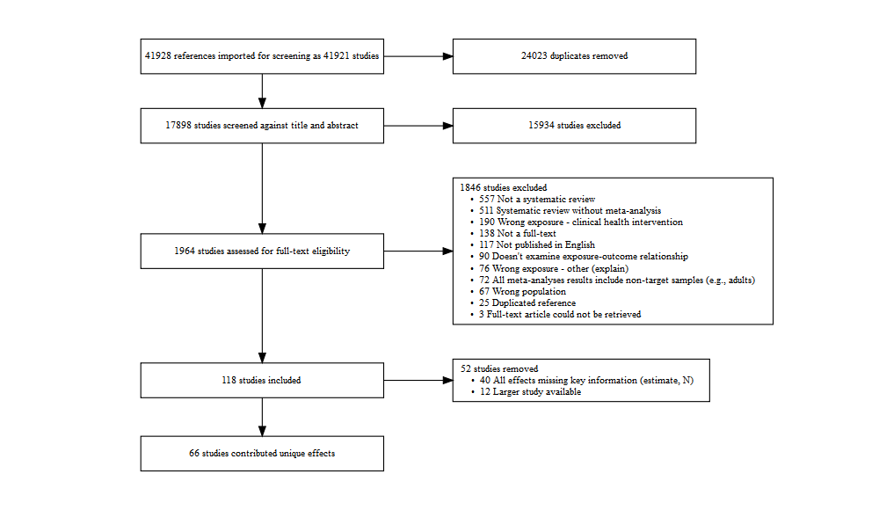

PRISMA Diagram

The most frequently reported exposures were general tv programs and movies (n = 26), physically active video games (n = 15), screen-based lifestyle risk behaviour interventions (at school) (n = 14), and general screen use (n = 13). Supplementary file X provides a list of all exposures identified. The most frequently reported outcomes were body composition (n = 34), general physical activity (n = 15), general literacy (n = 13), general learning (n = 12), and duration sleep (n = 9). In most cases (121/197), there was only one exposure/outcome combination, with 20 appearing twice, and 8 appearing three or more times. Full characteristics of the included studies are provided in Table @ref(tab:desctable). Our process yielded 167 unique effects/outcome combinations contributed from 52 reviews. These effects represent the findings of 2,171 primary studies comprised of 1,652,944 participants.

The quality of the included meta-analyses was mixed (see Table @ref(tab:desctable)). Most assessed heterogeneity (n low risk = 59/66, 89% of meta-analyses), reported the characteristics of the included studies (n low risk = 57/66, 86%), and used a comprehensive and systematic search strategy (n low risk = 56/66, 85%). Most reviews did not clearly report if their eligibility criteria was predefined (n unclear = 45/66, 68%). Many papers also did not complete dual independent screening of abstracts and full text (n high risk = 16/66, 24%) or did not clearly report the method of screening (n unclear = 21/66, 32%). A similar trend was observed for dual independent quality assessment (n high risk = 31/66, 47%; n unclear = 19/66, 29%). Overall, only 5 meta-analyses were graded as low risk of bias on all criteria. Zero meta-analyses showed high risk of bias on all criteria.

### Education Outcomes

There were 46 unique effects associated with education outcomes, including general learning outcomes, literacy, numeracy, and science. We removed 20 effects that did not provide individual study-level data, 7 effects with samples < 1,000, and 8 with a significant Egger’s test or insufficient studies to conduct the test. No remaining studies showed evidence of excessive significance. Effects not meeting one or more of these standards are presented in the supplementary material. The remaining 12 met our criteria for statistical credibility and are described in Figure @ref(fig:eduplot). These 12 effects came from 8 meta-analytic reviews analysing data from 226 empirical studies with 186,631 individual participants.

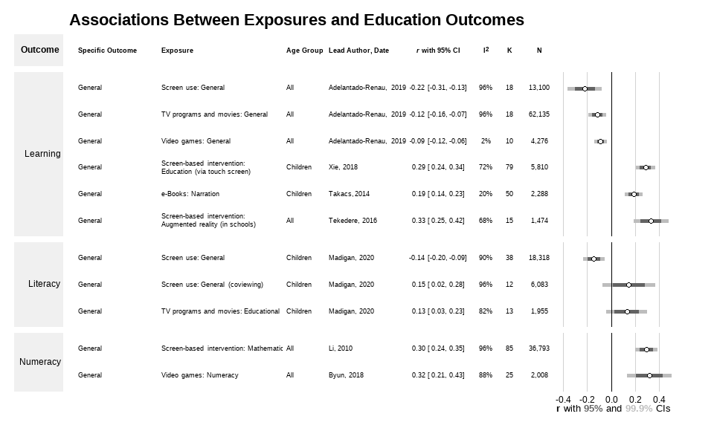

Education outcomes

Among the statistically credible effects, general screen use, television viewing, and video games were all negatively associated with learning. E-books that included narration, as well as touch screen education interventions, and augmented reality education interventions were positively associated with learning. General screen use was negatively associated with literacy outcomes. However, if the screen use involved co-viewing (e.g., watching with a parent), or the content of television programs was educational, the association with literacy was positive (95% CI, weak evidence). Numeracy outcomes were positively associated with screen-based mathematics interventions and video games with numeracy content.

As shown in Figure @ref(fig:eduplot), most of the credible results (10 of 12 effects) showed statistically significant associations, with 99.9% confidence intervals not encompassing zero (strong evidence). The remaining two associations were significant at the 95% confidence level (weak evidence). All credible effects related to education outcomes were small-to-moderate. Screen-based interventions designed to influence an outcome (e.g., a computer based program designed to enhance learning [30]) tended to have larger effect sizes than non-intervention exposure (e.g., the association between television viewing and learning [31]). The largest effect size observed was for augmented reality-based education interventions on general learning (). Most effects showed high levels of heterogeneity (10 of 12 with ).

### Health and Health-related Behaviours

We identified 121 unique outcome-exposure combinations associated with health or health-related behaviour outcomes. We removed 33 effects that did not provide individual study-level data, 30 effects with samples < 1,000, and 43 effects with a significant Egger’s test or insufficient studies to conduct the test. No remaining studies showed evidence of excessive significance. Effects not meeting one or more of these standards are presented in the supplementary material. The remaining 17 meta-analytic associations met our criteria for credible evidence and are described below (see also Figure @ref(fig:healthplot)). These 121 effects came from 12 meta-analytic reviews analysing data from 231 empirical studies with 676,331 individual participants.

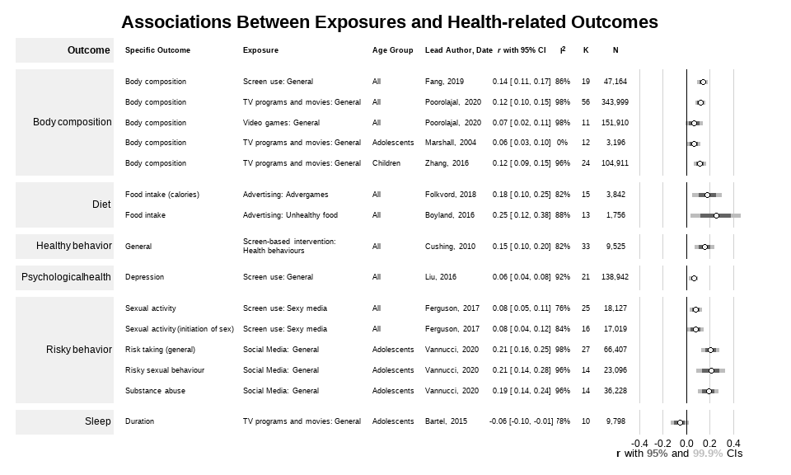

Health and health-related behaviour outcomes

Digital advertising of unhealthy foods—both traditional advertising and video games developed by a brand for promotion—were associated with higher unhealthy food intake. Risky behaviors (e.g., sexual activity, risk taking, and substance abuse) were positively associated with social media use and sexy media use. General screen use was positively associated with depression. Television viewing was negatively correlated with sleep duration, but only at the 95% confidence level (weak evidence). All forms of screen use (general, television, and video games) were positively associated with body composition (e.g., BMI). Screen-based interventions which target health behaviours appeared effective.

Across the health outcomes, most (14 of 17 effects) were statistically significant at the 99.9% level, with the remaining seven significant at 95% confidence. However, all of the credible effects exhibited high levels of heterogeneity, with the lowest . Additionally, most effects were small, with the association between unhealthy food advertising and intake the largest at (). Most of the effect sizes (14/17) had an absolute value of .

# Discussion

**Note:** *Below are rough notes on ideas for the discussion. Please feel free to add ideas. We will revise once we agree on the rest of the paper.*

#### Broad summary of the findings relating back to the purpose

When meta-analysis examined general screen use, and did not specify the content, context or device, there was strong evidence showing potentially harmful associations with general learning, literacy, body composition, and depression. However, when meta-analyses included a more nuanced examination of exposures a more complex picture appeared. Many exposures were likely neither universally harmful nor consistently beneficial. For example, watching television programs was associated with poorer academic performance and learning. However, there was also evidence that if the content of the program was educational or the child watched the program with a parent (i.e., coviewing) then television viewing was associated with better literacy. Thus, parents play an important role in selecting content that is likely to benefit their children and, perhaps, interacting with their children in ways that may foster literacy (e.g., asking their children questions about the program). Similarly, the credible evidence we identified showed video game playing is associated with poorer body composition and learning. When the video game was designed specifically to teach numeracy, playing these games showed learning benefits. One might expect that video games designed to be physically active could confer health benefits, but none of the meta-analyses examining this hypothesis met our thresholds for credibility (see Supplementary File X).

Social media was one type of exposure that showed consistent risks to health, with no indication of potential benefit. Social media showed strong evidence of harmful associations with risk taking in general, as well as unsafe sex and substance abuse. Meta-analytic evidence from adults indicates that social media use is also associated with increased risk of depression. Recent evidence from social media companies themselves suggest there may also be negative effects of

Finally, there was strong evidence that sexy media was associated with sexual activity.

One category of exposure appeared to consistently confer benefits: screen-based interventions designed to promote learning or health behaviours.This finding indicates that interventions can be effectively delivered using electronic media platforms. It does not necessarily indicate that screens are more effective than other methods (e.g., face-to-face, printed material).

* Touch screen = strong evidence of benefit for learning
* Math interventions = strong evidence on numeracy.
* Augmented reality on learning, strong evidence.
* Screen-based interventions. Strong effect on health behaviours.

#### Implications of findings for targeted policy and practice

Screen use is complex. We need to stop thinking about it in simplistic terms as “bad” and something that should be minimised in all instances. Need to think about how it can best be used. For example, recreational television and video games appear to confer few, if any benefits, and appear to be associated with poor body composition and academic performance. However, television programs and video games designed to promote learning may be effective. The current literature indicates that social media is likely harmful, but if social media platforms specifically designed to promote learning can be designed and popularised, perhaps they could have benefits.

#### Survey of the field and implications for future research

Screen use research is big, varied, and rapidly growing. Reviews tended to be general (e.g., all screen time) and even when more targeted (e.g., social media) nuances related to specific content (e.g., Instagram vs Facebook) have not been meta-analysed or have not produced credible evidence.

Need to unpack the aggression research (violent video games - what happened to those reviews?)

There is credible evidence for X, we need more evidence for Y. All observational research with self-report evidence.

#### Limitations of the review

Can’t look at fine-grained detail - eg moderators, but we did look at different exposures and outcomes (quasi moderators).

We did not rate the risk of bias of the X,XXX individual studies that contributed data to this review. Thus, our assessment of evidence quality was restricted to statistical credibility, rather than a more complete assessment (e.g., GRADE).

Also, we made somewhat arbitrary decisions to present effects that reach certain thresholds (e.g., N>1,000, non-significant Egger’s test). We do, however, provide more complete results in the supplementary files for those who wish to consider those meta-analyses.

#### Conclusions

# Appendix

#### Figures

* [Prisma Diagram](https://drive.google.com/file/d/1ezgeAr2WPhy6MNSESS8bhg3VMOrLAUC7/view?usp=sharing)
* [Education Outcomes](https://drive.google.com/file/d/1ODsKf3jjEGNCpUTz5tju8AHRpk_xIz-e/view?usp=sharing)
* [Health-Related Outcomes](https://drive.google.com/file/d/1wdKzliWLEFuVveAj6-MzOAsoqBhnkRJW/view?usp=sharing)
* [Supplemental Education Outcomes](https://drive.google.com/file/d/1wUotZRh-jvdBJh5dkstkMtvcz7DPn-vS/view?usp=sharing)
* [Supplemental Health-Related Outcomes](https://drive.google.com/file/d/1-3frrZ3woWjPqkO84Dn3_1CCaE8thIZn/view?usp=sharing)

#### Tables

* [Descriptive Table](https://drive.google.com/file/d/1t5XvwY2kzsOsbZ2FxbGPsYEecZz5PgD1/view?usp=sharing)
* Supplemental tables (TBC)

#### Supplementary Files

* [List of Exposures](https://drive.google.com/file/d/12rB0ihW9Hi1kxM-8AIBfjdCMO6TqP28n/view?usp=sharing)

#### Links

* [Manuscript Google Doc](https://docs.google.com/document/d/1NN4yJWQVepNjbX0mND4aidWWXcCDkg-eMepRnWdtQ9o/edit#)
* [Online Report](https://motivation-and-behaviour.github.io/screen_umbrella/)

# References

1. Blair A. Reading Strategies for Coping With Information Overload ca.1550-1700. Journal of the History of Ideas. 2003;64(1):11–28.

2. Bell AN. The sanitarian. Vol. 11. AN Bell; 1883.

3. Dill KE. The Oxford handbook of media psychology. Oxford University Press; 2013.

4. Wartella EA, Jennings N. Children and computers: New technology. Old concerns. The future of children. 2000;31–43.

5. Rhodes A. Top ten child health problems: What the public thinks. The Royal Children’s Hospital Melbourne; 2015.

6. The Lancet. Social media, screen time, and young people’s mental health. The Lancet. 2019 Feb;393(10172):611.

7. Hale L, Guan S. Screen time and sleep among school-aged children and adolescents: A systematic literature review. Sleep Medicine Reviews. 2015 Jun;21:50–8.

8. Sweetser P, Johnson D, Ozdowska A, Wyeth P. Active versus Passive Screen Time for Young Children. Australasian Journal of Early Childhood. 2012 Dec;37(4):94–8.

9. Li X, Atkins MS. Early childhood computer experience and cognitive and motor development. Pediatrics. 2004;113(6):1715–22.

10. Warburton W, Highfield K. Children and technology in a smart device world. In: Children, families and communities. Oxford University Press; 2017. p. 195–221.

11. Orben A, Przybylski AK. The association between adolescent well-being and digital technology use. Nature Human Behaviour. 2019 Feb;3(2):173–82.

12. World Health Organization. Guidelines on physical activity, sedentary behaviour and sleep for children under 5 years of age. World Health Organization; 2019.

13. Australian Government. Physical activity and exercise guidelines for all Australians. Department of Health; 2021.

14. Canadian Society for Exercise Physiology. Canadian 24-Hour Movement Guidelines for Children and Youth: An Integration of Physical Activity, Sedentary Behaviour, and Sleep. Canadian Society for Exercise Physiology; 2016.

15. Council On Communication and Media. Media Use in School-Aged Children and Adolescents. Pediatrics. 2016 Nov;138(5):e20162592.

16. Ferguson CJ. Everything in Moderation: Moderate Use of Screens Unassociated with Child Behavior Problems. Psychiatric Quarterly. 2017 Dec;88(4):797–805.

17. Przybylski AK, Weinstein N. A Large-Scale Test of the Goldilocks Hypothesis: Quantifying the Relations Between Digital-Screen Use and the Mental Well-Being of Adolescents. Psychological Science. 2017 Feb;28(2):204–15.

18. Sanders T, Parker PD, del Pozo-Cruz B, Noetel M, Lonsdale C. Type of screen time moderates effects on outcomes in 4013 children: Evidence from the Longitudinal Study of Australian Children. International Journal of Behavioral Nutrition and Physical Activity. 2019;16(1):1–0.

19. Chassiakos YLR, Radesky J, Christakis D, Moreno MA, Cross C, Council On Communication and Media. Children and Adolescents and Digital Media. Pediatrics. 2016 Nov;138(5):e20162593.

20. National Health, Lung, and Blood Institute. Quality Assessment of Systematic Reviews and Meta-Analyses. National Health, Lung, and Blood Institute; 2014.

21. Bonett DG. Transforming odds ratios into correlations for meta-analytic research. American Psychologist. 2007;62(3):254–5.

22. Bowman NA. Effect Sizes and Statistical Methods for Meta-Analysis in Higher Education. Research in Higher Education. 2012 May;53(3):375–82.

23. Jacobs P, Viechtbauer W. Estimation of the biserial correlation and its sampling variance for use in meta-analysis: Biserial Correlation. Research Synthesis Methods. 2017 Jun;8(2):161–80.

24. Viechtbauer W. Metafor: Meta-analysis package for r [Internet]. 2021. Available from: <https://CRAN.R-project.org/package=metafor>

25. R Core Team. R: A language and environment for statistical computing [Internet]. Vienna, Austria: R Foundation for Statistical Computing; 2021. Available from: <https://www.R-project.org/>

26. Egger M, Smith GD, Schneider M, Minder C. Bias in meta-analysis detected by a simple, graphical test. BMJ. 1997 Sep;315(7109):629–34.

27. Page MJ, Higgins JP, Sterne JA. Chapter 13: Assessing risk of bias due to missing results in a synthesis. In: Higgins JP, Thomas J, Chandler J, Cumpston M, Li T, Page MJ, et al., editors. Cochrane Handbook for Systematic Reviews of Interventions. 6.2 ed. Cochrane; 2021.

28. Ioannidis JP, Trikalinos TA. An exploratory test for an excess of significant findings. Clinical Trials. 2007 Jun;4(3):245–53.

29. Papadimitriou N, Markozannes G, Kanellopoulou A, Critselis E, Alhardan S, Karafousia V, et al. An umbrella review of the evidence associating diet and cancer risk at 11 anatomical sites. Nature Communications. 2021 Dec;12(1):4579.

30. Xie H, Peng J, Qin M, Huang X, Tian F, Zhou Z. Can Touchscreen Devices be Used to Facilitate Young Children’s Learning? A Meta-Analysis of Touchscreen Learning Effect. Frontiers in Psychology. 2018 Dec;9:2580.

31. Adelantado-Renau M, Moliner-Urdiales D, Cavero-Redondo I, Beltran-Valls MR, Martínez-Vizcaíno V, Álvarez-Bueno C. Association Between Screen Media Use and Academic Performance Among Children and Adolescents: A Systematic Review and Meta-analysis. JAMA Pediatrics. 2019 Nov;173(11):1058.