The relationship between sleep and physical activity across the lifespan
Taren Sanders¹, Timothy Hartwig², James Conigrave³, Borja del Pozo Cruz⁴, Philip Parker⁵, Michael Noetel⁶, Devan Antczak⁷, Stuart J. Fairclough⁸, Shona Halson², DATASET PROVIDERS TBD*⁹, & Chris Lonsdale¹⁰
¹ Institute for Positive Psychology and Education, Australian Catholic University, North Sydney, Australia
² School of Behavioural and Health Science, Australian Catholic University, North Sydney, Australia
³ Centre for Alcohol Policy Research, La Trobe University, Bundoora, Australia
⁴ Department of Sport Sciences, Faculty of Medicine, Health, and Sports, Universidad Europea de Madrid
⁵ Office of the Deputy Vice-Chancellor (Research and Enterprise), Australian Catholic University, North Sydney, Australia
⁶ School of Psychology, University of Queensland, Brisbane, Australia
⁷ School of Education, University of Wollongong, Wollongong, Australia
⁸ Department of Sport and Physical Activity, Edge Hill University, Ormskirk, United Kingdom
⁹ TBD
¹⁰ Office of the Provost, Australian Catholic University, North Sydney, Australia

Author note
Enter author note here.
Correspondence concerning this article should be addressed to Taren Sanders*, 33 Berry St, North Sydney, NSW, Australia. E-mail: Taren.Sanders@acu.edu.au

Abstract
Objectives: To examine the association between device-measured physical activity and sleep across the lifespan using individual participant data (IPD) meta-analysis. We furthed aimed to examine how the association differed by age.
Design: Pooled IPD analysis of accelerometer-based physical activity and sleep data from multiple observational studies.
Setting: We sourced data from 20 observational studies conducted multiple geographical regions and across the lifespan.
Participants: The dataset included 220,760 observations from 28,823 participants aged 2 to 94 years. Participants were selected from studies that used research-grade accelerometers with at least four valid days of wear time, including at least one weekend day. Exclusion criteria included insufficient wear time and missing key covariate data.
Main Outcome Measures: Sleep outcomes included total sleep time, sleep efficiency, sleep onset timing, and sleep regularity. Physical activity was assessed in terms of volume (average acceleration) and intensity (intensity gradient). Mixed-effects models were used to examine associations, adjusting for age, sex, body mass index, and socioeconomic status.
Results: Higher physical activity volume was associated with longer sleep duration, greater sleep efficiency, earlier sleep onset, and more regular sleep. The effect of physical activity on sleep regularity was particularly strong, with minimal variation across age groups. Conversely, individuals with more regular sleep patterns and earlier sleep onset exhibited higher levels of physical activity the following day, though these effects were modest.
Conclusions: Physical activity is positively associated with sleep regularity across the lifespan, supporting its role as a non-pharmacological intervention for maintaining consistent sleep patterns. Public health recommendations should emphasize the importance of regular physical activity for sleep health. Future research should investigate mechanisms underlying these associations and assess targeted intervention strategies.
Trial Registration: The study protocol was pre-registered on the Open Science Framework (https://osf.io/ahd96).
Keywords: keywords
Word count: X

The relationship between sleep and physical activity across the lifespan

Introduction
Sleep is an important determinant of population health across the lifespan[1]. The consequences of poor sleep include increased all-cause mortality [2], cardiovascular disease [3], cancers [4], and poor mental health [5]. Poor sleep - characteristed by low sleep quality, duration, or the presence of sleep disorders - is a frequent health problem: 14-68% of children and adolescents [6] and 35% of adults [7] report lower sleep duration than recommended [8]. Improving sleep should be a priority for public health policy, and more safe and accessible strategies that promote sleep are needed [9]. In adults, being physically active appears to improve both the quantity and quality of sleep [10]. The World Health Organization recommends physical activity as a method to improve sleep in adults [bullWorldHealthOrganisation2020?]. In children, adolescents, and older adults associations are unclear [9,11,12] and guidelines do not currently support a role for physical activity to improve sleep.
Promoting physical activity may be an effective method to improve sleep across the lifespan, but the published literature has at least two limitations. First, most studies have relied on self-report measures of sleep and physical activity [9,11,12], which could confound associations and limit the precision of analyses designed to identify a dose-response relationship between physical activity and sleep. Second, no study has collected day-to-day data from a large and geographically diversesample that included participants across the lifespan. Umbrella reviews [9] and meta-analyses [3,4,10–28] have provided some suggestive evidence about how physical activity may improve sleep across the lifespan. However, their reliance on aggregated study-level effects limits the quality and scope of data that can be used to analyse the influence of age [29]. Device-measured individual participant data analysis can overcome these limitations [30].
In this study we harmonised individual participant data from accelerometer observations obtained from studies around the world. The aim of this pooled study was to investigate the relationship between device-measured physical activity and sleep across the lifespan. We examined whether individuals who are more physically active have better sleep, whether age, sex, and socio-cultural factors moderate the association between physical activity and sleep, and whether there is a bidirectional association between physical activity and sleep.

Methods
We pre-registered all methods and analyses on the Open Science Framework (OSF) before data acquisition began (https://osf.io/ahd96).

Data sources and data acquisition
We included data from studies, with any design, that used research-grade accelerometers and a 24-hour wear time protocol over a minimum of 4 days, including 1 weekend day. Studies needed to have used accelerometers from which raw accelerations ($m/s^{2}$ or $mg$) could be obtained. Studies could use any wear location for the accelerometer (hip, wrist, or thigh) or accelerometer brand.
We identified potentially relevant studies by examining the reference lists of recent systematic reviews that explored the relationship between sleep and physical activity in children, adolescents, and adults [10–12]. We then used forward searching on potentially eligible studies [31]. We additionally performed a literature search to identify accelerometry consortiums and individual studies, searched trial registries (ANZCTR, ICTRP, ISRCTN) and the Open Science Framework for unpublished results, and asked collaborators to help identify any additional studies.
We contacted chief investigators or consortium leads by email to request access to deidentified individual data. To make the data acquisition manageable, we only invited studies with sample sizes larger than 400 participants. If required by the contributing research group, the contributing investigators or their university signed a data transfer agreement. All studies included in the pooled data meta-analysis had to have been approved by their local or institutional ethical committees, and all participants had to have provided written informed consent. The lead university’s Research Ethics Committee granted permission for each study’s data to be obtained, and investigators transferred their deidentified data via a secure file-sharing system.

Data harmonisation and outcomes
All accelerometer-derived data were harmonised by reprocessing raw files using an open-source GGIR package in R to produce physical activity and sleep outcomes [32,33]. By reprocessing all raw accelerometer data, we were able to generate outcomes that could be compared across studies, device wear locations, and populations [34]. Data were reprocessed by the core research team or the data contributors themselves using the GGIR package processing script provided by the core research team. Reprocessed individual study datasets were then pooled into a single dataset. A detailed description of the reprocessing method and decisions for specific accelerometer devices is available in an online supplementary file.
For sleep, GGIR produced the following metrics: total sleep time (minutes), sleep efficiency after onset (percentage of time asleep within the sleep period), sleep regularity (regularity of sleep and awake patterns on a day-to-day basis calculated as the sleep regularity index), and timing (time of sleep and awakening within the 24-hour time cycle). For physical activity, we used volume and intensity metrics proposed by Rowlands et al [35]. These measures are 1) average acceleration (measure of physical activity volume) and 2) intensity gradient (measure of intensity distribution where the natural logs of time and intensity are used to produce a straight-line graph with the slope of the graph being the intensity gradient). We used this approach to model the entire continuum of physical activity intensity for our primary analyses [36] and avoid collapsing physical activity data into population-specific intensity categories, which occurs when intensity cut-points are applied to accelerometer data [37].
To translate physical activity data for interpretation and public health recommendations and for time-use based analyses we then determined; 1) the number of minutes spent in acceleration intensity bands in $50mg$ increments [35], 2) the number of minutes spent in light and moderate to vigorous physical activity using age appropriate cut-points applied to the time in intensity bands data, and 3) the minimum acceleration measured for a range of different durations, this is the $MX$ metric where $X$ refers to the duration. For example, $M60$ refers to the minimum acceleration for the most active 60 minutes of the day [36]. We also categorise all awake time into bout lengths for sedentary, light, and moderate to vigorous physical activity bouts using the categories defined by Gába et al [38]. After extracting sleep and physical activity, the remaining time within the 24-hour time cycle was classified as sedentary behaviour. Non-wear time and abnormally high acceleration values were detected using the data processing default setting [39]. These data were classified as missing and imputed using the accelerometer data from the same time interval on the remaining days of the week.

Covariates and moderators
The following individual participant data were obtained when available: age, sex, height, weight, waist circumference, maturational status, socioeconomic status (SES), ethnicity, screen time, sleep medications, and medically diagnosed conditions known to affect sleep. The country, city, time zone, daylight length, and season in which data were collected were also obtained.
Body mass index was converted to an age- and sex-standardised z-score. For participants under 18 years we used the CDC 2000 BMI-for-age growth reference, applied with the childsds package. No age-based growth reference applies from 18 years, so for adults we standardised body mass index against the adults in this sample. The two halves are consequently not the same quantity: below 18 the z-score is expressed relative to an external growth reference, and at 18 and above relative to this sample. We use the z-score in place of raw body mass index throughout, both as a covariate and as a moderator, so that a given value carries a comparable meaning at every age.

Statistical analysis
To reduce the risk of bias in secondary data analysis of IPD, we used a blind analysis approach [40]. We developed and tested models on a 10% holdout subsample of the dataset. When the analysis code was ready, we conducted the final analysis [41].
We screened all data for implausibly low or high measurements, as these likely indicate measurement device failures. Screening had three stages. First, we excluded values falling outside fixed physiological limits; for average acceleration this was 200 mg, a value above any sustainable 24-hour average. Second, because a miscalibrated accelerometer corrupts every variable derived from acceleration magnitude rather than isolated days, we excluded all physical activity variables for files whose mean average acceleration exceeded that limit (76 participants). Third, we excluded remaining values falling outside ±4 SD of the mean of their own study, rather than of the pooled sample, so that the threshold reflected implausible measurement rather than between-study differences in device, protocol and population. The fixed limits were applied before the ±4 SD screen because the mean and standard deviation are themselves distorted by the values they are used to detect. Values excluded at any stage were treated as missing and imputed alongside genuinely missing data.
A day contributed to the analysis if it recorded more than 10 hours of wear time and, where sleep was detected, a sleep period longer than 200 minutes. Participants were additionally required to have at least 4 days of valid wear time. 345 participants, contributing 465 person-days, did not meet this criterion, leaving 24,264 participants and 148,749 person-days for analysis. Because the criterion is applied after imputation, the primary analysis and a sensitivity analysis that retains every eligible participant regardless of the number of valid wear days share the same imputations and the same standardisation constants, and are therefore directly comparable; the sensitivity analysis is reported in the supplementary materials.
We assumed missing covariate and moderator data to be missing at random or completely at random and imputed these missing values using multiple imputations by chained equations with the mice package in R [42] to provide 3 imputed datasets. Specifically, we used multilevel predictive mean matching imputation clustered by participants. We used Rubin’s rule to pool the results from analyses conducted using each imputed dataset into one single set of results. We examined 95% confidence intervals for all analyses and used P<0.05 to assess for statistical significance. Both the intervals and the p-values are computed on the pooled Barnard-Rubin degrees of freedom, which account for the additional uncertainty introduced by imputation. We fitted 16 models for each moderator and report all of them without adjustment for multiple comparisons, so p-values close to 0.05 should be interpreted with corresponding caution. We used R (version 4.5.3) for all data cleaning and analysis. We report mean and 95% confidence intervals. For categorical variables, percentages are reported. We examined model diagnostics from all models (see supplementary materials). Convergence and singularity are reported separately. A singular fit is one in which the optimiser succeeded but placed a variance component at zero, which indicates that the data do not support that random effect rather than that estimation failed.
To examine the relationship between sleep and physical activity (Research Questions 1-2) we ran mixed-effects models with random intercepts for study ID and for participant, accounting for the nesting of repeated days within participants and of participants within studies [43].
We predicted each sleep indicator by each physical activity indicator controlling for socioeconomic status, sex, and body mass index z-score. Quadratic terms were introduced in each model to allow for curvilinear relationships to be modelled. We interacted each predictor with age to reveal how the relationship between physical activity and sleep changes over the lifespan.
Models predicting physical activity from the preceding night’s sleep (Research Question 3) use each sleep indicator lagged by one day, constructed within participants after eligibility screening so that the lagged value is always an eligible measurement from the immediately preceding calendar day. Person-days whose preceding day was absent from the data or did not meet the eligibility criteria therefore have no lagged value and do not contribute to these models, leaving 120,660 of 149,214 eligible person-days.

Protocol deviations
This paper addresses Hypotheses 1 and 2 from our registered protocol. We will address the remaining hypotheses in future research. To streamline our analysis and reduce redundancy, we made some changes to our protocol while working with the holdout data.

Using Study ID as fixed effect.
We initially planned to use Study ID as a fixed effect, given that our study selection was not random. But, as we aimed for our findings to generalise to other studies and populations, we instead opted to include random intercepts for Study ID which can better model generalisable patterns. This approach allows us to account for variability between studies without fully partialling out study effects, thereby better modelling common phenomena. While this change lessened the strength of model intercepts, it did not significantly alter model slopes. The results using Study ID as a fixed effect (i.e., those that align with the protocol) can be found in the supplementary materials and are qualitatively similar to the main results.

Sleep indicator variable.
Our research examines various metrics of sleep: onset, duration, regularity, and efficiency. We initially planned to merge these variables into a single indicator to simplify analysis. However, no validated indicator existed which could be estimated from our measured variables. We decided against creating one as we could not validate it with our data. Consequently, our models illustrate the relationship between each aspect of sleep and physical activity, instead of describing a straightforward link between overall sleep and physical activity.

Log transformation.
We aimed to improve model diagnostics using log transformations of skewed variables. Pilot analysis using holdout data revealed that while diagnostics improved on the log scale, model predictions followed extreme exponential patterns near the edge of the data range when back-transformed. Accordingly, we do not use log transformations in the main paper. However, these models can be found in supplementary materials.

Patient and public involvement
Patients and members of the public were not involved in the design, analysis or interpretation of this IPD study using secondary data. The results of this study have broad public health interest, particularly for policymakers. Findings from this study will be disseminated through institutional websites, press and media platform releases, and tailored messages to public health Organizations and governing bodies.

Results
The aggregated dataset describes 220,760 observations of daily physical activity and sleep from 28,823 unique participants. Of these, 71,546 days were excluded as they had insufficient wear time, which also resulted in the exclusion of 4,214 participants. A further 345 participants (465 days) were excluded for having fewer than 4 days of valid wear time, leaving 24,264 participants and 148,749 person-days. Table 1 shows demographic information for the included participants. The majority of participants came from Europe, Oceania, and South America, with limited data from other regions. There was a near-even split by sex (50.4% female), but age skewed towards both younger children (2-11 years, 44.9%) and older adults (66+ years, 25.1%).
Valid observations were not uniform across the days of the week ($χ_{(6)}^{2}$ = 310.72, p = < .001). Weekends were over-represented (Saturday: z = 6.08; Sunday: z = 11.62), while Wednesdays (z = -9.91) and Thursdays (z = -8.85) were under-represented. A table of study characteristics can be found in supplementary materials.
Table 1
Participant characteristics
Characteristic | 2-11 years | 12-18 years | 19-35 years | 36-65 years | 66+ years
Numeric variables
N | 10,857 | 1,921 | 308 | 5,040 | 6,066
Age | 9.73 (1.49) | 15.74 (1.72) | 29.16 (5.07) | 57.68 (7.37) | 72.72 (4.52)
BMI | 17.99 (3.19) | 21.61 (3.76) | 26.46 (6.42) | 26.80 (4.79) | 27.08 (4.31)
BMI z-score | 0.25 (1.07) | 0.09 (1.02) | -0.09 (1.38) | -0.02 (1.03) | 0.05 (0.93)
Valid Weartime Hours | 23.13 (1.60) | 23.23 (1.54) | 23.25 (1.61) | 23.74 (0.82) | 23.89 (0.40)
Valid Weatime Days | 5.62 (1.89) | 4.97 (1.34) | 4.79 (1.31) | 7.34 (2.48) | 6.48 (2.09)
PA Intensity | -2.13 (0.19) | -2.23 (0.19) | -2.43 (0.19) | -2.50 (0.19) | -2.68 (0.22)
PA Volume | 42.53 (24.27) | 46.73 (14.30) | 39.53 (10.69) | 38.82 (11.60) | 30.86 (9.71)
Sleep Duration (min) | 486.90 (52.97) | 416.72 (55.29) | 421.10 (62.52) | 408.42 (55.81) | 404.16 (63.32)
Sleep Efficiency (%) | 80.75 (7.40) | 87.13 (6.30) | 87.28 (6.12) | 87.79 (5.52) | 86.50 (6.03)
Sleep Onset (clock time; SD in h:mm) | 20:55 (01:08) | 23:30 (01:26) | 23:40 (01:46) | 23:41 (01:23) | 00:23 (01:14)
Sleep Regularity | 54.00 (12.73) | 57.03 (12.15) | 55.79 (12.76) | 59.45 (11.35) | 54.53 (12.49)
Accelerometer Wear Location
Wrist | 2,567 (23.64%) | 1,883 (98.02%) | 308 (100.00%) | 5,040 (100.00%) | 6,066 (100.00%)
Hip | 8,290 (76.36%) | 38 (1.98%) | - | - | -
Country
Australia | 1,505 (13.86%) | 303 (15.77%) | 108 (35.06%) | 186 (3.69%) | -
Finland | 508 (4.68%) | - | - | 801 (15.89%) | -
New Zealand | 455 (4.19%) | - | 37 (12.01%) | 151 (3.00%) | -
Spain | 934 (8.60%) | 5 (0.26%) | - | 37 (0.73%) | 2,386 (39.33%)
Switzerland | - | - | - | 1,904 (37.78%) | 1,023 (16.86%)
United Kingdom | 447 (4.12%) | - | 144 (46.75%) | 1,961 (38.91%) | 2,657 (43.80%)
Brazil | 486 (4.48%) | 727 (37.84%) | 10 (3.25%) | - | -
Czech Republic | 281 (2.59%) | 848 (44.14%) | 9 (2.92%) | - | -
Canada | 522 (4.81%) | - | - | - | -
China | 124 (1.14%) | - | - | - | -
Colombia | 889 (8.19%) | - | - | - | -
Denmark | 689 (6.35%) | - | - | - | -
Ecuador | 981 (9.04%) | 38 (1.98%) | - | - | -
India | 574 (5.29%) | - | - | - | -
Kenya | 525 (4.84%) | - | - | - | -
Portugal | 702 (6.47%) | - | - | - | -
South Africa | 506 (4.66%) | - | - | - | -
United States | 729 (6.71%) | - | - | - | -
Ethnicity
Non-White | 2,127 (19.59%) | 169 (8.80%) | 14 (4.55%) | 94 (1.87%) | 240 (3.96%)
Unclear | 4,433 (40.83%) | 1,192 (62.05%) | 152 (49.35%) | 1,337 (26.53%) | 2,424 (39.96%)
White | 4,297 (39.58%) | 560 (29.15%) | 142 (46.10%) | 3,609 (71.61%) | 3,402 (56.08%)
Region
Europe | 3,561 (32.80%) | 853 (44.40%) | 153 (49.68%) | 4,703 (93.31%) | 6,066 (100.00%)
Oceania | 1,960 (18.05%) | 303 (15.77%) | 145 (47.08%) | 337 (6.69%) | -
South America | 2,356 (21.70%) | 765 (39.82%) | 10 (3.25%) | - | -
Africa | 1,031 (9.50%) | - | - | - | -
Asia | 698 (6.43%) | - | - | - | -
North America | 1,251 (11.52%) | - | - | - | -
Season
Autumn | 3,387 (31.20%) | 446 (23.22%) | 39 (12.66%) | 1,241 (24.62%) | 1,268 (20.90%)
Spring | 2,687 (24.75%) | 1,228 (63.93%) | 124 (40.26%) | 1,224 (24.29%) | 1,989 (32.79%)
Summer | 1,381 (12.72%) | 85 (4.42%) | 85 (27.60%) | 1,270 (25.20%) | 1,250 (20.61%)
Winter | 3,402 (31.33%) | 162 (8.43%) | 60 (19.48%) | 1,305 (25.89%) | 1,559 (25.70%)
Sex
Female | 5,693 (52.45%) | 1,002 (52.16%) | 222 (72.08%) | 2,714 (53.85%) | 2,551 (42.05%)
Male | 5,162 (47.55%) | 919 (47.84%) | 86 (27.92%) | 2,326 (46.15%) | 3,515 (57.95%)
Sleep Conditions Reported
No | 625 (5.76%) | - | - | 3,511 (69.66%) | 5,140 (84.73%)
Yes | 50 (0.46%) | - | - | 310 (6.15%) | 626 (10.32%)
Not Reported | 10,182 (93.78%) | 1,921 (100.00%) | 308 (100.00%) | 1,219 (24.19%) | 300 (4.95%)
Socioeconomic Status
Low | 2,306 (25.22%) | 208 (11.56%) | 2 (0.74%) | 1,074 (21.98%) | 2,388 (39.38%)
Medium | 2,920 (31.94%) | 884 (49.14%) | 191 (70.74%) | 2,407 (49.26%) | 2,324 (38.32%)
High | 3,916 (42.84%) | 707 (39.30%) | 77 (28.52%) | 1,405 (28.76%) | 1,352 (22.30%)
Note. For categorical variables the value is the count, and percentage. For numeric variables the value is the Mean and SD. Sleep onset is a clock time; its SD is a duration in hours:minutes. Total N = 24,264. 72 participants had missing age data and are counted in the total but not in any age band.

The effects of physical activity volume on sleep
We estimated the effects of physical activity on sleep (RQ1) using mixed-effects models. The effect of physical activity volume on sleep by age are presented in Table 2 and Figure 1. Higher physical activity volume was associated with longer sleep duration, higher sleep efficiency, earlier sleep onset, and more regular sleep. While we observed statistically significant curvilinear relationships, these did not appear to meaningfully change the effect. The relationship between physical activity volume and sleep duration, efficiency, and onset was consistent across the age groups, with some negligible evidence that the relationship with sleep regularity grew stronger with age.
Table 2
Physical activity predicting sleep controlling for SES, sex, and BMI z-score.
Term | $β$ [95% CI] | SE | t | p | $β$ [95% CI] | SE | t | p
Sleep duration (z)
(Intercept) | 0.08 [-0.09, 0.25] | 0.08 | 0.95 | .342 | 0.08 [-0.08, 0.24] | 0.08 | 1.00 | .315
Physical activity | 0.10 [0.09, 0.12] | 0.01 | 13.00 | < .001 | 0.09 [0.06, 0.12] | 0.01 | 7.59 | < .001
Age | 0.00 [0.00, 0.00] | 0.00 | -3.34 | < .001 | 0.00 [0.00, 0.00] | 0.00 | -3.42 | < .001
Physical activity$​^{2}$ | -0.01 [-0.01, 0.00] | 0.00 | -3.64 | < .001 | 0.01 [0.00, 0.02] | 0.01 | 1.59 | .130
Physical activity $×$ Age | 0.00 [0.00, 0.00] | 0.00 | -4.25 | < .001 | 0.00 [0.00, 0.00] | 0.00 | -5.32 | < .001
Age $×$ Physical activity$​^{2}$ | 0.00 [0.00, 0.00] | 0.00 | -1.57 | .135 | 0.00 [0.00, 0.00] | 0.00 | -3.41 | .003
Sleep efficiency (z)
(Intercept) | 0.16 [0.00, 0.32] | 0.08 | 2.00 | .046 | 0.19 [0.01, 0.36] | 0.09 | 2.11 | .035
Physical activity | 0.11 [0.09, 0.13] | 0.01 | 13.39 | < .001 | 0.07 [0.05, 0.10] | 0.01 | 7.52 | < .001
Age | 0.00 [0.00, 0.00] | 0.00 | -0.61 | .545 | 0.00 [0.00, 0.00] | 0.00 | -1.53 | .127
Physical activity$​^{2}$ | -0.02 [-0.03, -0.02] | 0.00 | -12.56 | < .001 | -0.04 [-0.05, -0.03] | 0.01 | -7.47 | < .001
Physical activity $×$ Age | 0.00 [0.00, 0.00] | 0.00 | -11.89 | < .001 | 0.00 [0.00, 0.00] | 0.00 | -6.78 | < .001
Age $×$ Physical activity$​^{2}$ | 0.00 [0.00, 0.00] | 0.00 | 2.59 | .010 | 0.00 [0.00, 0.00] | 0.00 | 6.40 | < .001
Sleep onset (z)
(Intercept) | 0.10 [-0.18, 0.37] | 0.14 | 0.71 | .479 | 0.10 [-0.17, 0.36] | 0.13 | 0.72 | .472
Physical activity | -0.02 [-0.03, -0.01] | 0.01 | -4.22 | < .001 | -0.06 [-0.08, -0.05] | 0.01 | -8.98 | < .001
Age | 0.00 [0.00, 0.00] | 0.00 | -1.61 | .111 | 0.00 [0.00, 0.00] | 0.00 | -0.69 | .493
Physical activity$​^{2}$ | -0.01 [-0.01, -0.01] | 0.00 | -7.33 | < .001 | -0.03 [-0.04, -0.02] | 0.00 | -7.50 | < .001
Physical activity $×$ Age | 0.00 [0.00, 0.00] | 0.00 | -15.31 | < .001 | 0.00 [0.00, 0.00] | 0.00 | 1.85 | .068
Age $×$ Physical activity$​^{2}$ | 0.00 [0.00, 0.00] | 0.00 | 9.23 | < .001 | 0.00 [0.00, 0.00] | 0.00 | 10.73 | < .001
Sleep regularity (z)
(Intercept) | 0.15 [-0.01, 0.32] | 0.08 | 1.95 | .067 | 0.31 [0.13, 0.49] | 0.09 | 3.40 | .001
Physical activity | 0.25 [0.21, 0.29] | 0.01 | 17.91 | < .001 | 0.29 [0.26, 0.32] | 0.01 | 22.24 | < .001
Age | 0.00 [-0.01, 0.01] | 0.00 | -0.14 | .900 | -0.01 [-0.01, 0.00] | 0.00 | -3.62 | .036
Physical activity$​^{2}$ | -0.02 [-0.03, -0.01] | 0.00 | -6.60 | .002 | -0.11 [-0.12, -0.10] | 0.01 | -19.48 | < .001
Physical activity $×$ Age | 0.00 [0.00, 0.00] | 0.00 | -1.49 | .211 | 0.00 [0.00, 0.00] | 0.00 | -19.73 | < .001
Age $×$ Physical activity$​^{2}$ | 0.00 [0.00, 0.00] | 0.00 | -15.25 | < .001 | 0.00 [0.00, 0.00] | 0.00 | 9.81 | < .001
Note. Adjusted for SES, sex, and BMI z-score. Outcomes variables are listed in the column headers.

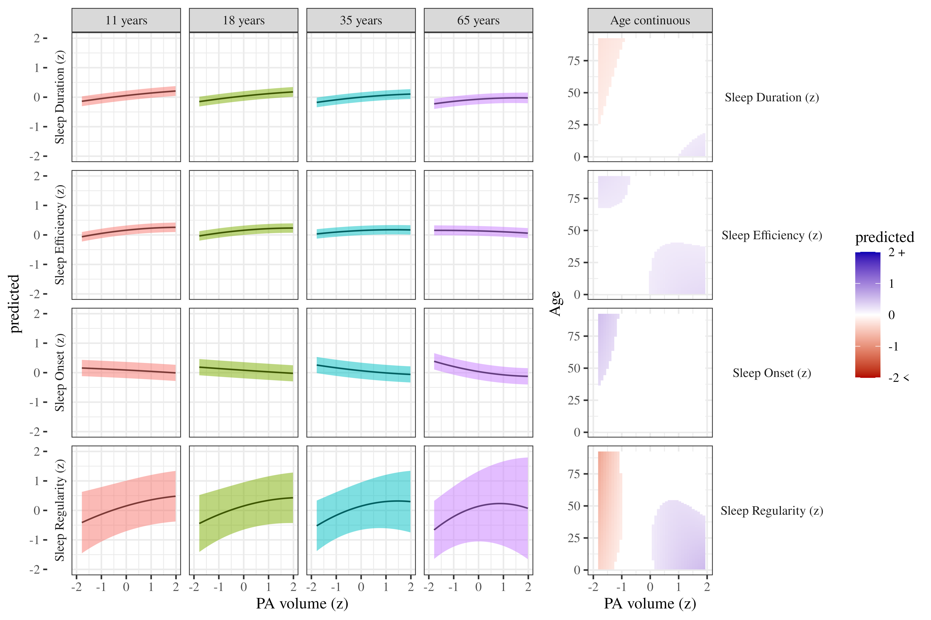
Figure 1. Sleep metrics predicted by physical activity volume. The panels on the left show the curvilinear relationship between PA volume and each of the sleep outcomes at the ages indicated in each column. The panels on the right show the same relationships but by age continuously. The white band indicates predictions which were not significantly different from zero. These plots demonstrate exact turning points where the effects of PA volume change by age.

The effects of physical activity intensity on sleep
We estimated how physical activity intensity affects sleep across different age groups and present the results controlling for sex, SES, and BMI, in Table 2 and Figure 2. We observed weak associations between physical activity intensity and sleep duration, sleep efficiency, and sleep onset, with a stronger relationship observed with sleep regularity. As with physical activity volume, we observed statistically significant curvilinear relationships, but these were only meaningful for the impact of physical activity intensity on sleep regularity, in which very low levels of intensity were strongly associated with poor sleep regularity and the benefits of increasing intensity diminished past one standard deviation above the mean. While age statistically significantly modified the relationship between physical activity intensity and sleep duration, efficiency, and regularity, the effect was negligible.
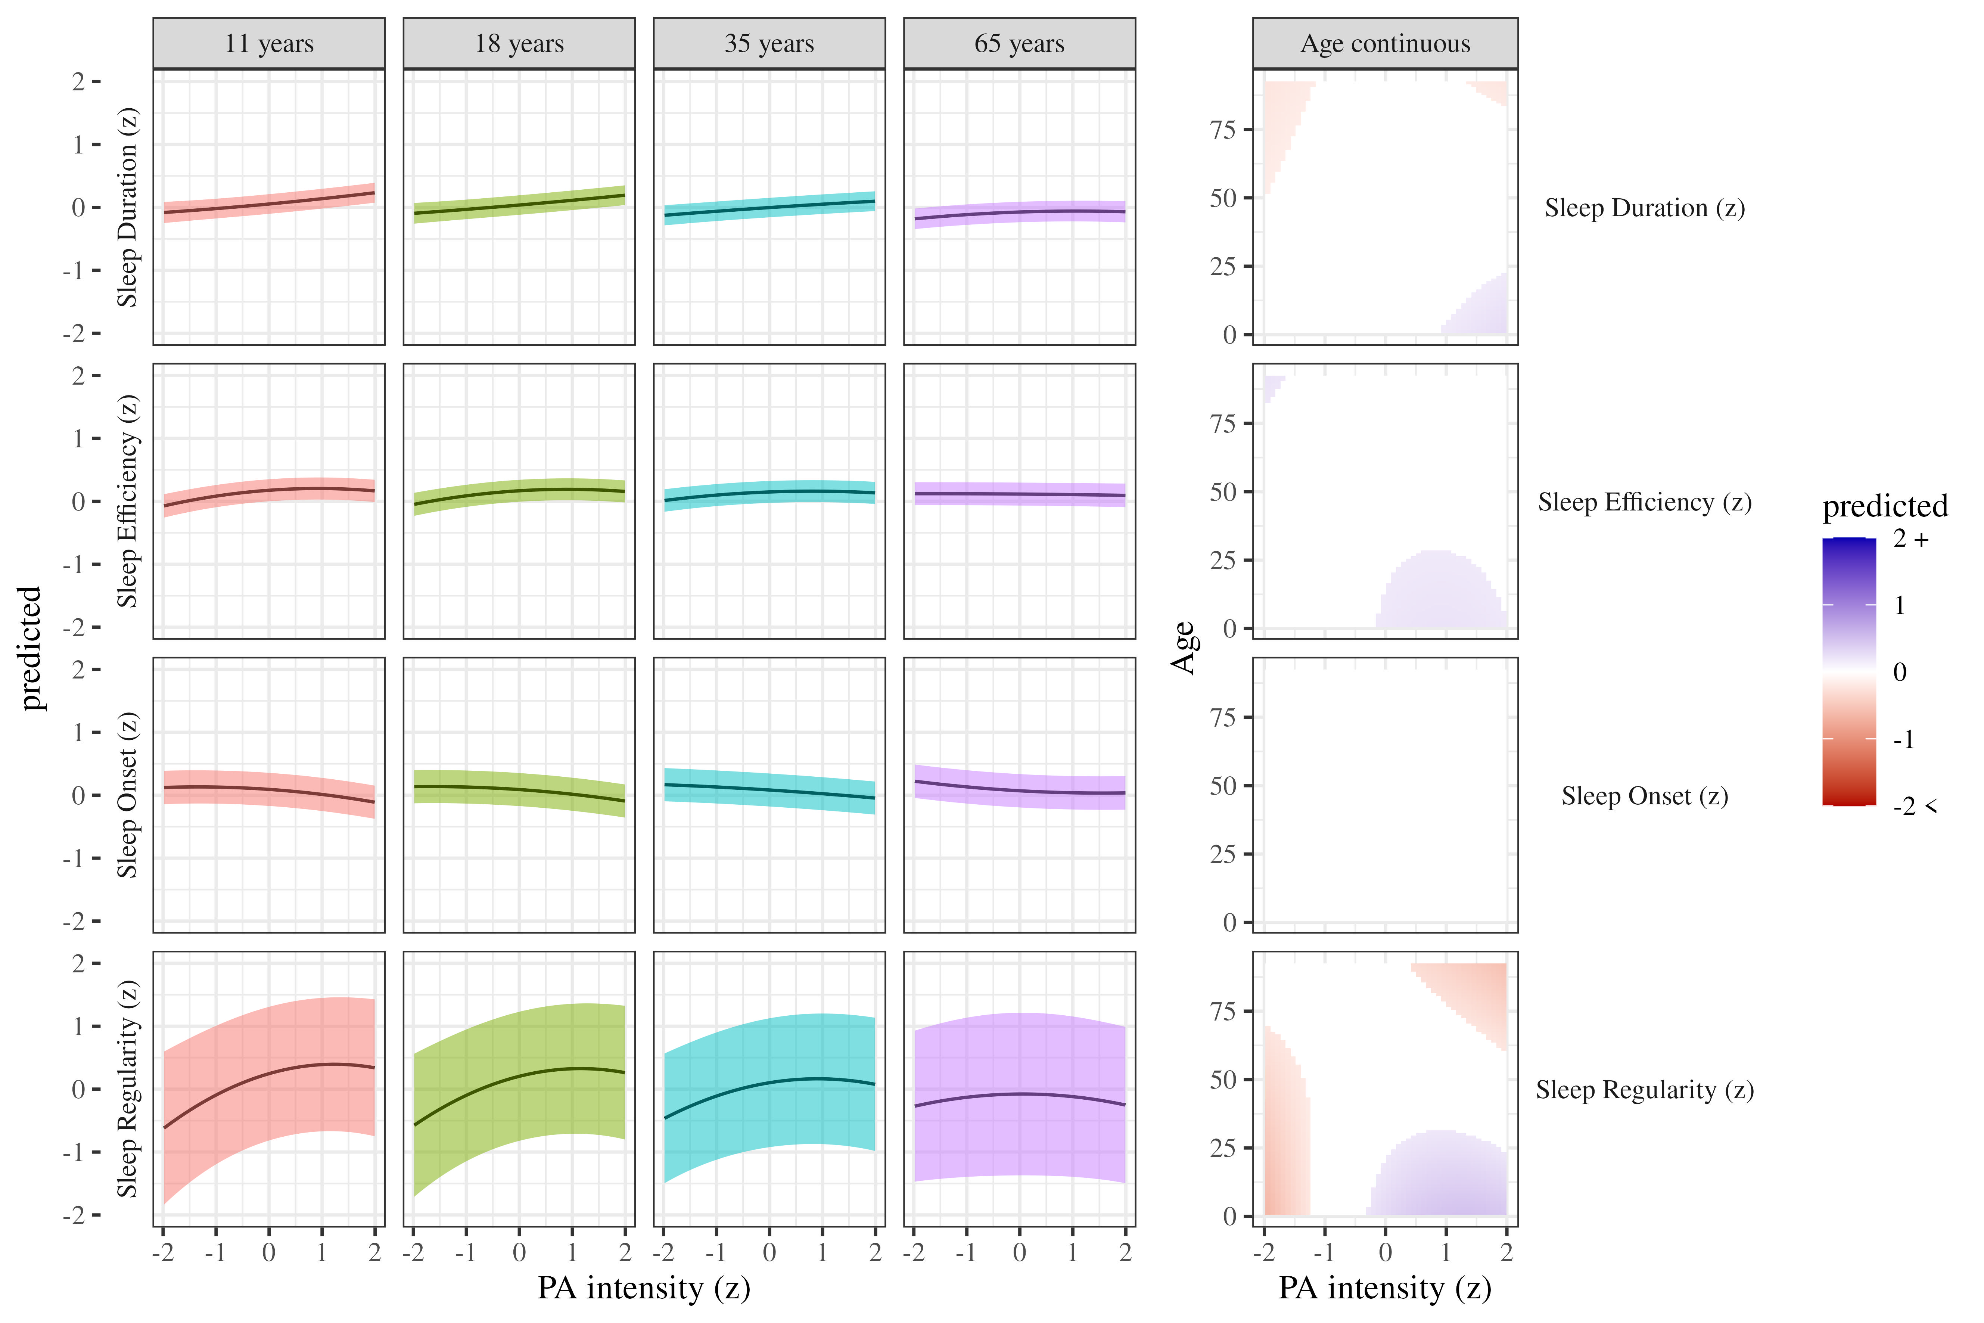
Figure 2. Sleep metrics predicted by physical activity intensity. The panels on the left show the curvilinear relationship between PA intensity and each of the sleep outcomes at the ages indicated in each column. The panels on the right show the same relationships but by age continuously. The white band indicates predictions which were not significantly different from zero.

The effects of sleep duration on physical activity
We estimated the effect of sleep duration on physical activity by age. Results, controlling for sex, SES, and BMI are presented in Table 3 and Figure 3. As age increases, both physical activity volume and intensity decrease. We found no evidence for an association between average sleep duration and physical activity volume or intensity.
Table 3
Sleep predicting physical activity controlling for SES, sex, and BMI z-score
Term | $β$ [95% CI] | SE | t | p | $β$ [95% CI] | SE | t | p
Sleep duration (z)
(Intercept) | 1.18 [0.83, 1.52] | 0.18 | 6.63 | < .001 | 1.01 [0.88, 1.14] | 0.07 | 15.09 | < .001
Sleep duration | 0.05 [0.04, 0.06] | 0.00 | 10.43 | < .001 | 0.04 [0.03, 0.05] | 0.00 | 8.38 | < .001
Age | -0.03 [-0.03, -0.02] | 0.00 | -38.85 | < .001 | -0.03 [-0.03, -0.03] | 0.00 | -48.18 | < .001
Sleep duration$​^{2}$ | -0.03 [-0.03, -0.02] | 0.00 | -9.32 | < .001 | -0.02 [-0.02, -0.01] | 0.00 | -5.72 | < .001
Sleep duration $×$ Age | 0.00 [0.00, 0.00] | 0.00 | -12.00 | < .001 | 0.00 [0.00, 0.00] | 0.00 | -3.04 | .002
Age $×$ Sleep duration$​^{2}$ | 0.00 [0.00, 0.00] | 0.00 | 2.60 | .010 | 0.00 [0.00, 0.00] | 0.00 | 2.33 | .022
Sleep efficiency (z)
(Intercept) | 1.16 [0.82, 1.51] | 0.18 | 6.59 | < .001 | 1.00 [0.87, 1.13] | 0.07 | 15.02 | < .001
Sleep efficiency | 0.00 [-0.01, 0.01] | 0.01 | -0.13 | .900 | 0.01 [0.00, 0.02] | 0.01 | 2.33 | .023
Age | -0.03 [-0.03, -0.02] | 0.00 | -38.47 | < .001 | -0.03 [-0.03, -0.03] | 0.00 | -47.92 | < .001
Sleep efficiency$​^{2}$ | -0.01 [-0.02, -0.01] | 0.00 | -6.73 | < .001 | -0.01 [-0.01, 0.00] | 0.00 | -4.49 | < .001
Sleep efficiency $×$ Age | 0.00 [0.00, 0.00] | 0.00 | 2.19 | .029 | 0.00 [0.00, 0.00] | 0.00 | -1.59 | .114
Age $×$ Sleep efficiency$​^{2}$ | 0.00 [0.00, 0.00] | 0.00 | 2.77 | .006 | 0.00 [0.00, 0.00] | 0.00 | 1.03 | .304
Sleep onset (z)
(Intercept) | 1.18 [0.82, 1.54] | 0.18 | 6.42 | < .001 | 1.00 [0.86, 1.13] | 0.07 | 14.47 | < .001
Sleep onset | -0.14 [-0.15, -0.12] | 0.01 | -20.95 | < .001 | -0.07 [-0.08, -0.06] | 0.01 | -11.53 | < .001
Age | -0.03 [-0.03, -0.02] | 0.00 | -39.55 | < .001 | -0.03 [-0.03, -0.03] | 0.00 | -48.40 | < .001
Sleep onset$​^{2}$ | -0.03 [-0.04, -0.02] | 0.00 | -7.92 | < .001 | 0.00 [-0.01, 0.00] | 0.00 | -0.67 | .506
Sleep onset $×$ Age | 0.00 [0.00, 0.00] | 0.00 | 13.34 | < .001 | 0.00 [0.00, 0.00] | 0.00 | 9.48 | < .001
Age $×$ Sleep onset$​^{2}$ | 0.00 [0.00, 0.00] | 0.00 | 4.11 | < .001 | 0.00 [0.00, 0.00] | 0.00 | 0.03 | .975
Sleep regularity (z)
(Intercept) | 1.11 [0.77, 1.44] | 0.17 | 6.50 | < .001 | 0.97 [0.85, 1.09] | 0.06 | 15.33 | < .001
Sleep regularity | 0.16 [0.15, 0.17] | 0.00 | 36.63 | < .001 | 0.12 [0.11, 0.13] | 0.00 | 29.40 | < .001
Age | -0.02 [-0.03, -0.02] | 0.00 | -36.44 | < .001 | -0.03 [-0.03, -0.03] | 0.00 | -47.16 | < .001
Sleep regularity$​^{2}$ | 0.00 [0.00, 0.01] | 0.00 | 1.86 | .070 | 0.00 [0.00, 0.01] | 0.00 | 0.44 | .659
Sleep regularity $×$ Age | 0.00 [0.00, 0.00] | 0.00 | -19.43 | < .001 | 0.00 [0.00, 0.00] | 0.00 | -17.15 | < .001
Age $×$ Sleep regularity$​^{2}$ | 0.00 [0.00, 0.00] | 0.00 | -1.04 | .316 | 0.00 [0.00, 0.00] | 0.00 | -0.16 | .871
Note. Adjusted for SES, sex, and BMI z-score. Outcomes variables are listed in the row headers.

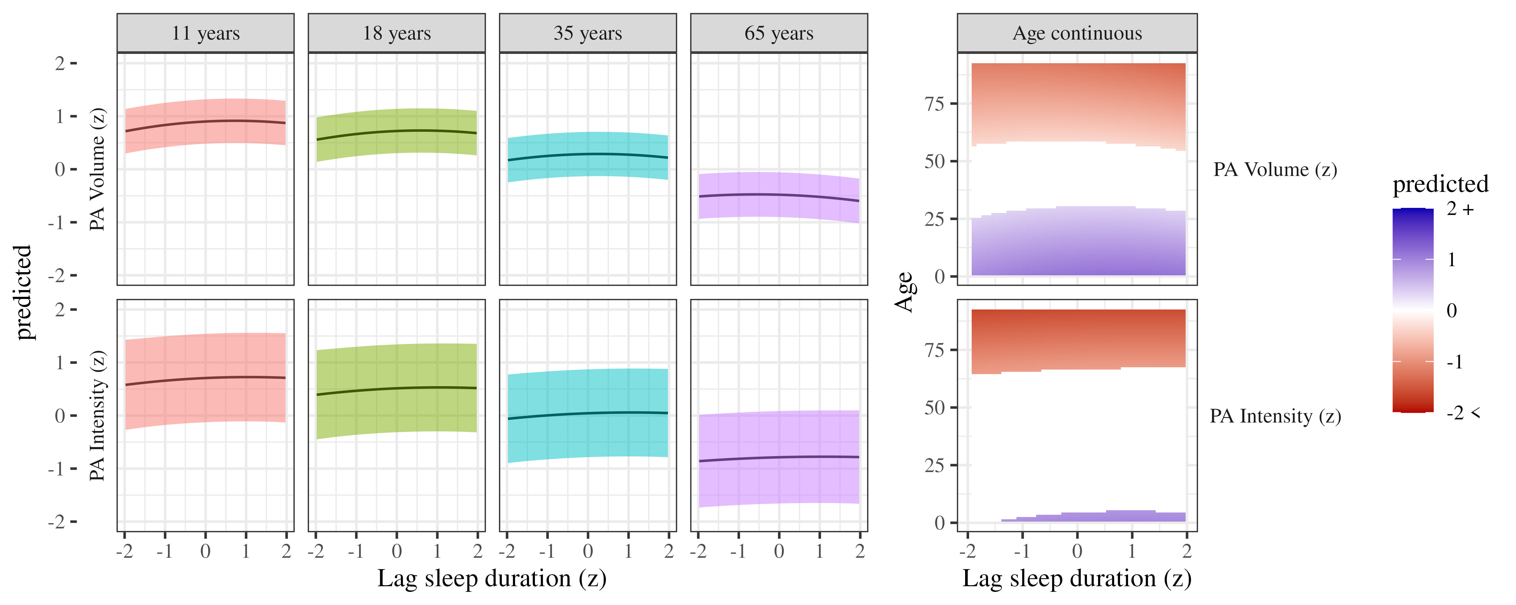
Figure 3. Physical activity predicted by previous night sleep duration. The panels on the left show the curvilinear relationship between sleep duration and each of the physical activity outcomes at the ages indicated in each column. The panels on the right show the same relationships but by age continuously. The white band indicates predictions which were not significantly different from zero.

The effects of sleep efficiency on physical activity
We estimated the effect of sleep efficiency on physical activity by age. Results, controlling for sex, SES, and BMI are presented in Table 3 and Figure 4. There was a negligible relationship between sleep efficiency and physical activity volume and a weak linear association between sleep efficiency and more intense physical activity.
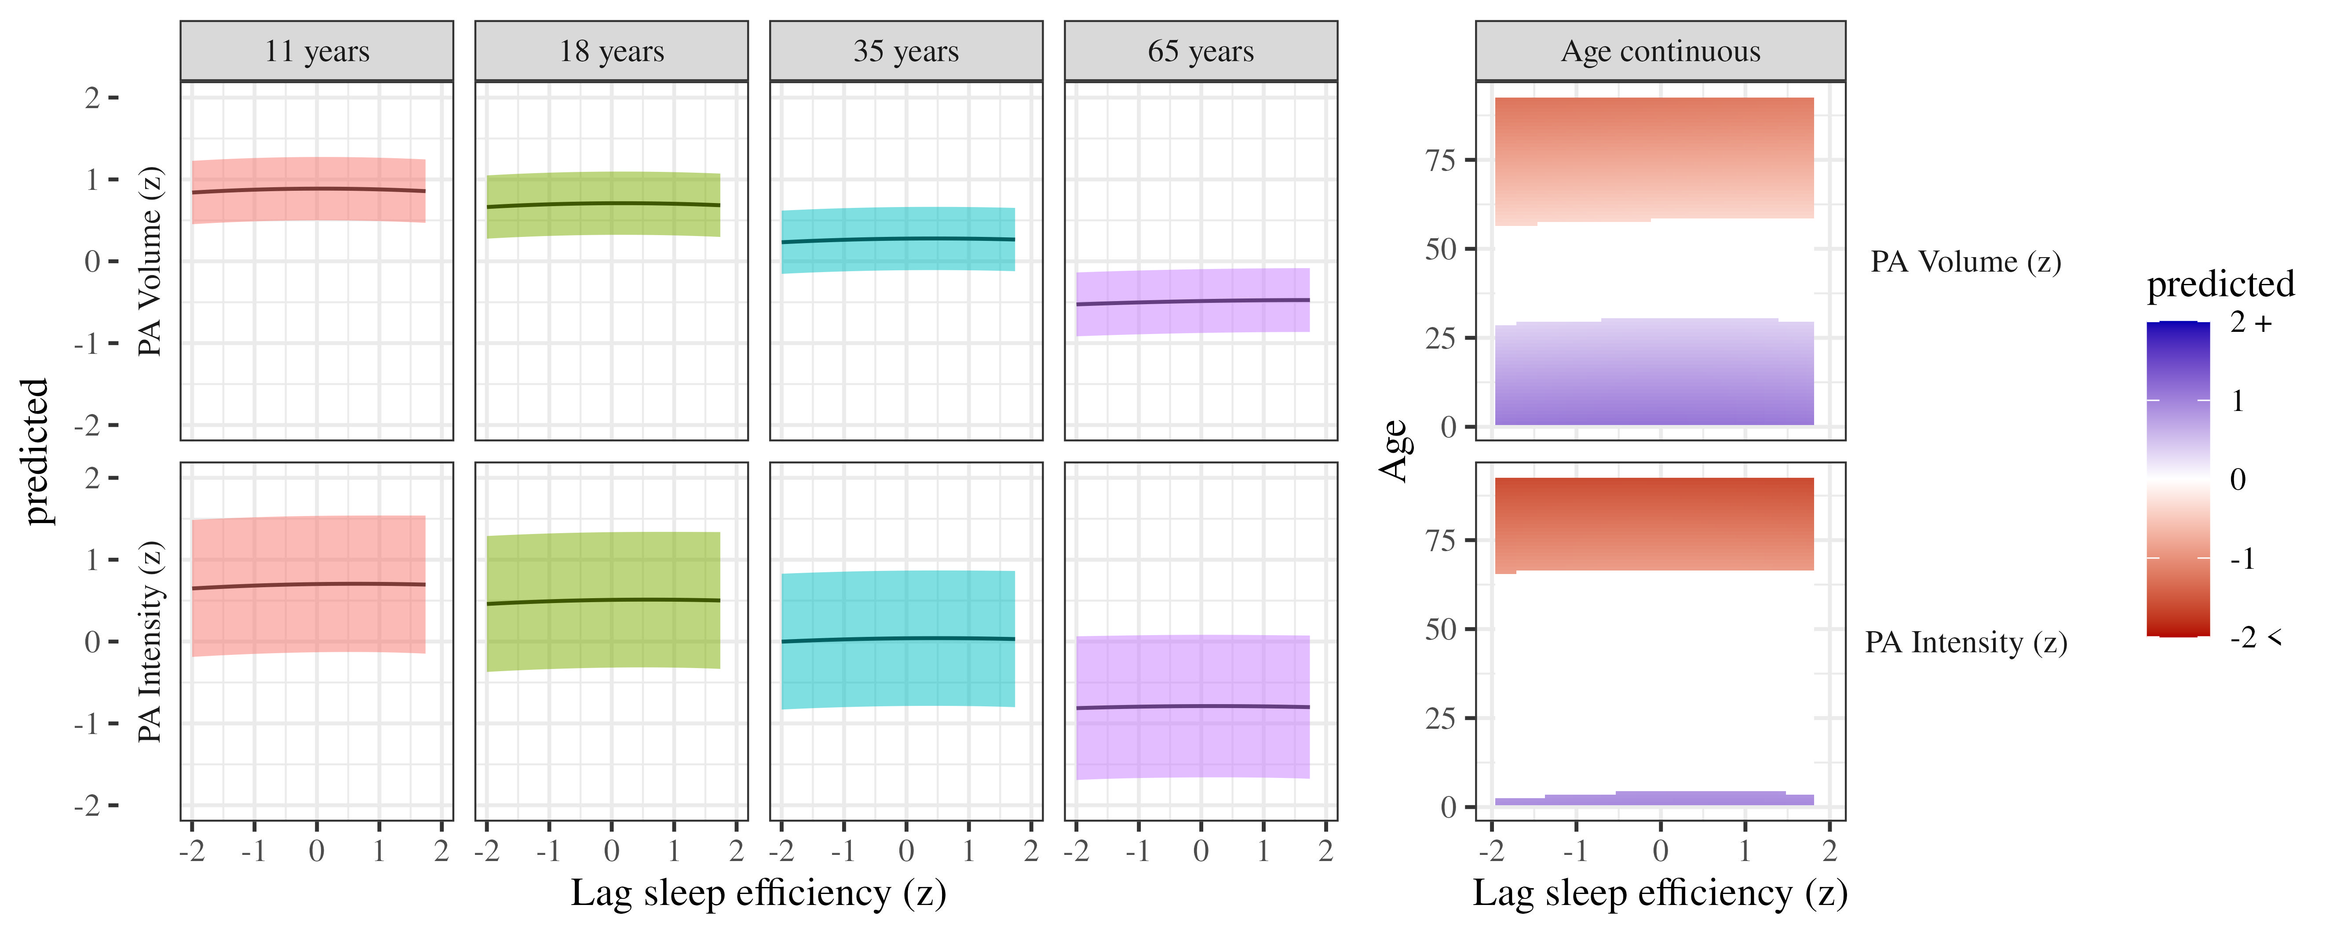
Figure 4. Physical activity predicted by previous night sleep efficiency. The panels on the left show the curvilinear relationship between sleep efficiency and each of the physical activity outcomes at the ages indicated in each column. The panels on the right show the same relationships but by age continuously. The white band indicates predictions which were not significantly different from zero.

The effects of sleep onset on physical activity
We estimated the effect of sleep onset on physical activity by age. Results, controlling for sex, SES, and BMI are presented in Table 3 and Figure 5. There were weak curvilinear relationships where average sleep onset was linked to the highest levels of physical activity volume, but not intensity.
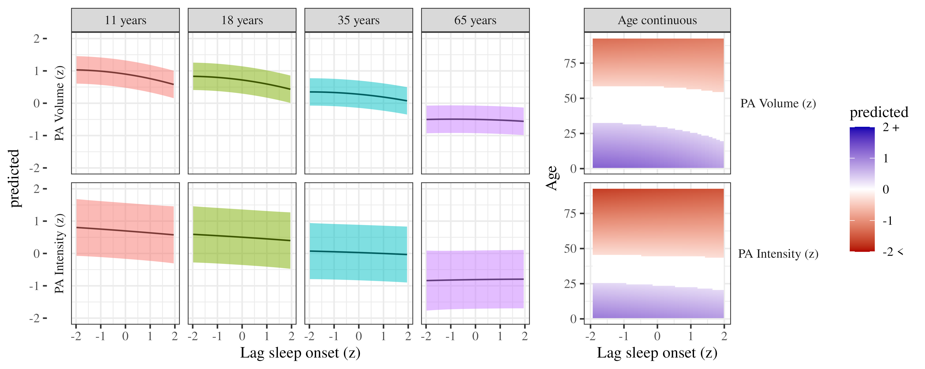
Figure 5. Physical activity predicted by previous night sleep onset. The panels on the left show the curvilinear relationship between sleep onset and each of the physical activity outcomes at the ages indicated in each column. The panels on the right show the same relationships but by age continuously. The white band indicates predictions which were not significantly different from zero.

The effects of sleep regularity on physical activity
We estimated the effect of sleep regularity on physical activity by age. Results, controlling for sex, SES, and BMI are presented in Table 3 and Figure 6. There was a positive linear relationship between sleep regularity and both physical activity volume and intensity. These relationships were slightly attenuated with age, such that for older adults the effect was negligible.
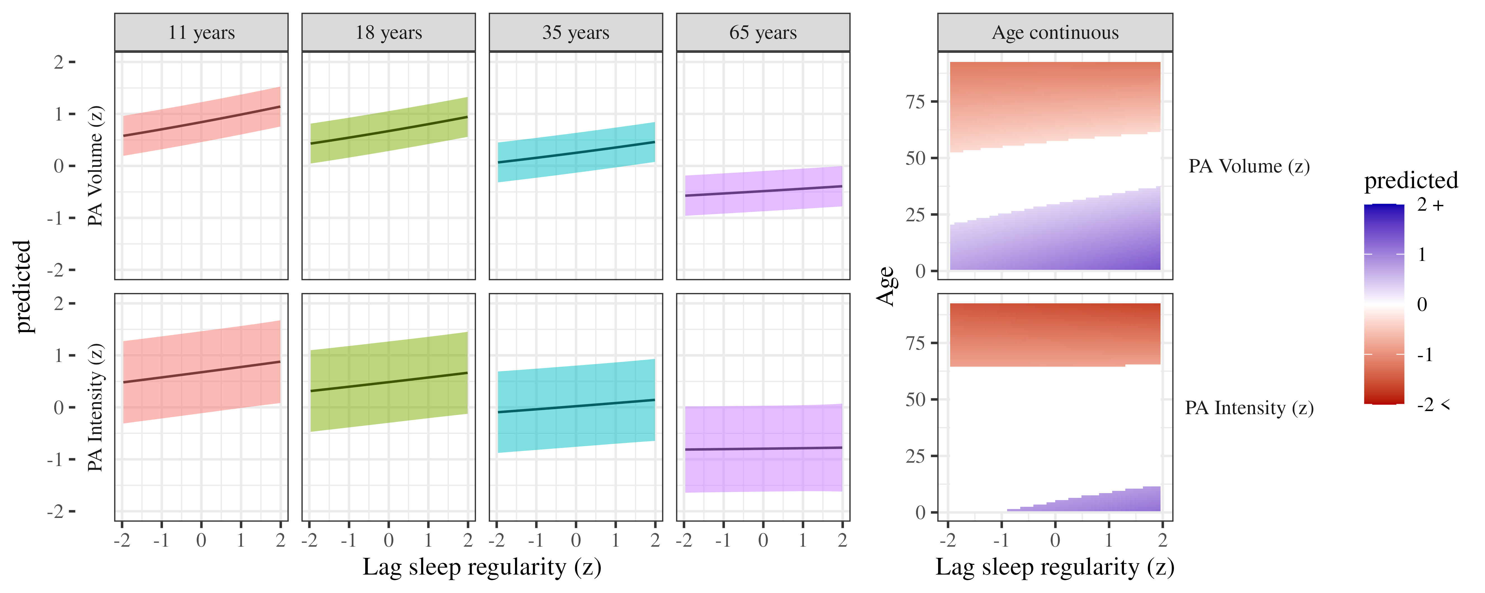
Figure 6. Physical activity predicted by previous night sleep regularity. The panels on the left show the curvilinear relationship between sleep regularity and each of the physical activity outcomes at the ages indicated in each column. The panels on the right show the same relationships but by age continuously. The white band indicates predictions which were not significantly different from zero.

Discussion
In this study, we collated and harmonised device-measured physical activity and sleep data from 20 studies around the world, covering participants across the lifespan. We found that both the volume and intensity of physical activity was associated with longer sleep duration, higher sleep efficiency, earlier sleep onset, and more regular sleep. These relationships were the strongest for sleep regularity, although the the relationship between physical activity intensity weakened with age.
When examining the reverse direction, we observed those who fell asleep earlier and at a more regular time engaged in more total physical activity, with an additional negligible benefit for those who slept more efficiently. Similarly, those who slept at a more regular time and with more efficiency engaged in more intense physical activity. These findings were largely robust to the decisions made during analysis (see supplementary materials for all analyses).
Our findings broadly align with meta-analyses of experimental research, although the strengths of the relationships we observed were much weaker [10]. For example, [10] found small ($0.22<d<0.30$) but significant relationships between physical activity and sleep duration and efficiency in adults using experimental studies for both acute and regular physical activity. It is difficult to directly compare these effect sizes, however, as the experimental studies directly manipulated physical activity, whereas our study examined the relationship between habitual physical activity and sleep. It may be that the routine nature of individuals’ physical activity makes associations more difficult to detect. Similarly, most of the previous studies which have examined acute changes to physical activity were conducted in laboratory settings. These studies, while useful for understanding the potential mechanisms, are not ecologically valid and may not reflect the relationship between physical activity and sleep in the real world. Laboratory studies also tend to use more sensitive measures of sleep and physical activity, which may generate less statistical noise and make relationships easier to detect. It could also be that duration of sleep is set more by parameters external to the individual, such as work schedules or parenting duties, than by individual health behaviours.
We found the most evidence for relationships between sleep regularity with physical activity volume and intensity. This relationship appeared to be bi-directional, with sleep onset and regularity influencing physical activity the following day, and physical activity influencing sleep onset and regularity that night. This is consistent with the idea that sleep and physical activity are mutually reinforcing behaviours [9], or that they are habitual and linked to factors such as the value placed on health. Sleep regularity is a stronger predictor of mortality than sleep duration [44], and so the finding that physical activity is associated with sleep regularity may be particularly important.
Contrary to expectations, we found little evidence to suggest that the associations between physical activity and sleep differed by age. While several of the analyses suggested statistically significant interactions between age and physical activity, these were too small to be clinically meaningful. This suggests that the benefits of physical activity and sleep are consistent across the lifespan, which is inconsistent with previous meta-analyses conducted on different ages. More specifically, meta-analyses in adult populations have generally found associations [10] while those conducted in children and adolescents are less clear [9,11,12]. This would seem to suggest that the differences in findings across these meta-analyses are due to differences beyond just the age of the populations, such as the type of study designs used or the measures of physical activity and sleep. It also demonstrates the importance of using individual participant data meta-analyses to examine these types of questions.
These findings have implications for public health recommendations. Our results support encouraging physical activity for maintaining regular sleep patterns across the lifespan. Sleep health may contribute to overall better health outcomes [2,3], and so promoting physical activity may be a useful strategy for improving population health. Public health messages should, therefore, emphasise the role of physical activity in promoting stable sleep schedules rather than framing physical activity as a universal solution for improving sleep. We note, however, that we did not examine the these relationships in individuals with sleep disorders or other health conditions. Physical activity interventions may still be a useful treatment for these conditions. Promoting more regular sleep may also be a useful strategy for increasing physical activity, although our results suggest a limited benefit from targeting other aspects of sleep quality.
Our study has several strengths, including the use of device-based measures, which reduce the bias associated with self-reported sleep and activity data, and the harmonisation of individual data from multiple studies, conducted in geographically diverse regions and among multiple age groups, allowing for robust and generalisable findings. We also used modern methods for processing and estimating physical activity, including using the full 24 hours of data, and avoiding the use of intensity cut-points. However, the study is not without limitations. Despite our efforts to harmonise data, variability in accelerometer wear locations and slight differences in data collection protocols across studies may have introduced measurement inconsistencies. We also chose to maximise the data available for analysis, at the expense of some precision in the estimates. Specifically, we included participants with four or more nights of valid sleep, while some recommend at least seven nights to estimate metrics such as sleep regularity [45]. However, the processing method we used specifically allows for comparisons to day-pairs and this methodology has been used by others [e.g., 44]. Additionally, although we controlled for several potential confounders, there may still be unmeasured factors affecting the observed associations. Our imputation model included study, but not the remaining moderators or their interactions with physical activity and sleep. It is therefore uncongenial with the analysis models, and moderator effects may be attenuated towards the null as a result. Finally, while our study captured data from across the lifespan, the limited representation of certain age groups, especially adolescents and young adults, restricts the generalisability of our conclusions to these populations. The limited research on those aged 18-35 is particularly concerning given the high prevalence of poor sleep in this age group [7].

Conclusion
Our findings contribute to the growing body of literature that highlights the complex relationship between physical activity and sleep. While physical activity appears to benefit sleep regularity, its effects on other sleep metrics are less clear, particularly when considering age differences. Future research should aim to explore mechanisms underlying these associations and identify specific intervention strategies that can effectively enhance both sleep and physical activity behaviours for diverse populations.

References
1. Luyster FS, Strollo PJ, Zee PC, Walsh JK. Sleep: A Health Imperative. Sleep. 2012 June;35(6):727–34.
2. Huang BH, Duncan MJ, Cistulli PA, Nassar N, Hamer M, Stamatakis E. Sleep and physical activity in relation to all-cause, cardiovascular disease and cancer mortality risk. British Journal of Sports Medicine. 2022 July;56(13):718–24.
3. Kwok CS, Kontopantelis E, Kuligowski G, Gray M, Muhyaldeen A, Gale CP, Peat GM, Cleator J, Chew-Graham C, Loke YK, Mamas MA. Self-Reported Sleep Duration and Quality and Cardiovascular Disease and Mortality: A Dose-Response Meta-Analysis. Journal of the American Heart Association. 2018 Aug;7(15).
4. Ma QQ, Yao Q, Lin L, Chen GC, Yu JB. Sleep duration and total cancer mortality: A meta-analysis of prospective studies. Sleep Medicine. 2016 Nov;27–28:39–44.
5. Wakefield JRH, Bowe M, Kellezi B, Butcher A, Groeger JA. Longitudinal associations between family identification, loneliness, depression, and sleep quality. British Journal of Health Psychology. 2020 Feb;25(1):1–16.
6. Gariepy G, Danna S, Gobiņa I, Rasmussen M, Gaspar De Matos M, Tynjälä J, Janssen I, Kalman M, Villeruša A, Husarova D, Brooks F, Elgar FJ, Klavina-Makrecka S, Šmigelskas K, Gaspar T, Schnohr C. How Are Adolescents Sleeping? Adolescent Sleep Patterns and Sociodemographic Differences in 24 European and North American Countries. Journal of Adolescent Health. 2020 June;66(6):S81–8.
7. Liu Y, Wheaton AG, Chapman DP, Cunningham TJ, Lu H, Croft JB. Prevalence of Healthy Sleep Duration among Adults–United States, 2014. MMWR Morbidity and mortality weekly report. 2016 Feb;65(6):137–41.
8. Hirshkowitz M, Whiton K, Albert SM, Alessi C, Bruni O, DonCarlos L, Hazen N, Herman J, Adams Hillard PJ, Katz ES, Kheirandish-Gozal L, Neubauer DN, O’Donnell AE, Ohayon M, Peever J, Rawding R, Sachdeva RC, Setters B, Vitiello MV, Ware JC. National Sleep Foundation’s updated sleep duration recommendations: Final report. Sleep Health. 2015 Dec;1(4):233–43.
9. Kline CE, Hillman CH, Bloodgood Sheppard B, Tennant B, Conroy DE, Macko RF, Marquez DX, Petruzzello SJ, Powell KE, Erickson KI. Physical activity and sleep: An updated umbrella review of the 2018 Physical Activity Guidelines Advisory Committee report. Sleep Medicine Reviews. 2021 Aug;58:101489.
10. Kredlow MA, Capozzoli MC, Hearon BA, Calkins AW, Otto MW. The effects of physical activity on sleep: A meta-analytic review. Journal of Behavioral Medicine. 2015 June;38(3):427–49.
11. Antczak D, Lonsdale C, Lee J, Hilland T, Duncan MJ, del Pozo Cruz B, Hulteen RM, Parker PD, Sanders T. Physical activity and sleep are inconsistently related in healthy children: A systematic review and meta-analysis. Sleep Medicine Reviews. 2020 June;51:101278.
12. Lang C, Kalak N, Brand S, Holsboer-Trachsler E, Pühse U, Gerber M. The relationship between physical activity and sleep from mid adolescence to early adulthood. A systematic review of methodological approaches and meta-analysis. Sleep Medicine Reviews. 2016 Aug;28:32–45.
13. Aiello KD, Caughey WG, Nelluri B, Sharma A, Mookadam F, Mookadam M. Effect of exercise training on sleep apnea: A systematic review and meta-analysis. Respiratory Medicine. 2016;116:85–92.
14. Banno M, Harada Y, Taniguchi M, Tobita R, Tsujimoto H, Tsujimoto Y, Kataoka Y, Noda A. Exercise can improve sleep quality: A systematic review and meta-analysis. PeerJ. 2018;2018(7).
15. Bartel KA, Gradisar M, Williamson P. Protective and risk factors for adolescent sleep: A meta-analytic review. Sleep Medicine Reviews. 2015 June;21:72–85.
16. Edwards BA, Bristow C, O’Driscoll DM, Wong A-M, Ghazi L, Davidson ZE, Young A, Truby H, Haines TP, Hamilton GS. Assessing the impact of diet, exercise and the combination of the two as a treatment for OSA: A systematic review and meta-analysis. Respirology. 2019;24(8):740–51.
17. Gao Y-N, Wu Y-C, Lin S-Y, Chang JZ-C, Tu Y-K. Short-term efficacy of minimally invasive treatments for adult obstructive sleep apnea: A systematic review and network meta-analysis of randomized controlled trials. Journal of the Formosan Medical Association. 2019;118(4):750–65.
18. Iftikhar IH, Bittencourt L, Youngstedt SD, Ayas N, Cistulli P, Schwab R, Durkin MW, Magalang UJ. Comparative efficacy of CPAP, MADs, exercise-training, and dietary weight loss for sleep apnea: A network meta-analysis. Sleep Medicine. 2017;30:7–14.
19. Iftikhar IH, Kline CE, Youngstedt SD. Effects of exercise training on sleep apnea: A meta-analysis. Lung. 2014;192(1):175–84.
20. Janssen X, Martin A, Hughes AR, Hill CM, Kotronoulas G, Hesketh KR. Associations of screen time, sedentary time and physical activity with sleep in under 5s: A systematic review and meta-analysis. Sleep Medicine Reviews. 2020 Feb;49:101226.
21. Lederman O, Ward PB, Firth J, Maloney C, Carney R, Vancampfort D, Stubbs B, Kalucy M, Rosenbaum S. Does exercise improve sleep quality in individuals with mental illness? A systematic review and meta-analysis. Journal of Psychiatric Research. 2019;109:96–106.
22. Lins-Filho OL, Pedrosa RP, Gomes JML, Dantas Moraes SL, Vasconcelos BCE, Lemos CAA, Pellizzer EP. Effect of exercise training on subjective parameters in patients with obstructive sleep apnea: A systematic review and meta-analysis. Sleep Medicine. 2020;69:1–7.
23. Mendelson M, Bailly S, Marillier M, Flore P, Borel JC, Vivodtzev I, Doutreleau S, Verges S, Tamisier R, Pépin J-L. Obstructive sleep apnea syndrome, objectively measured physical activity and exercise training interventions: A systematic review and meta-analysis. Frontiers in Neurology. 2018;9(FEB).
24. Rubio-Arias JÁ, Marín-Cascales E, Ramos-Campo DJ, Hernandez AV, Pérez-López FR. Effect of exercise on sleep quality and insomnia in middle-aged women: A systematic review and meta-analysis of randomized controlled trials. Maturitas. 2017;100:49–56.
25. Stutz J, Eiholzer R, Spengler CM. Effects of Evening Exercise on Sleep in Healthy Participants: A Systematic Review and Meta-Analysis. Sports Medicine. 2019;49(2):269–87.
26. Yang S-Y, Lan S-J, Yen Y-Y, Hsieh Y-P, Kung P-T, Lan S-H. Effects of Exercise on Sleep Quality in Pregnant Women: A Systematic Review and Meta-analysis of Randomized Controlled Trials. Asian Nursing Research. 2020;14(1):1–10.
27. Yang P-Y, Ho K-H, Chen H-C, Chien M-Y. Exercise training improves sleep quality in middle-aged and older adults with sleep problems: A systematic review. Journal of Physiotherapy. 2012;58(3):157–63.
28. Yang Y, Shin JC, Li D, An R. Sedentary Behavior and Sleep Problems: A Systematic Review and Meta-Analysis. International Journal of Behavioral Medicine. 2017;24(4):481–92.
29. Riley RD, Dias S, Donegan S, Tierney JF, Stewart LA, Efthimiou O, Phillippo DM. Using individual participant data to improve network meta-analysis projects. BMJ Evidence-Based Medicine. 2023 June;28(3):197–203.
30. Ioannidis J. Next-generation systematic reviews: Prospective meta-analysis, individual-level data, networks and umbrella reviews. British Journal of Sports Medicine. 2017 Oct;51(20):1456–8.
31. Hinde S, Spackman E. Bidirectional Citation Searching to Completion: An Exploration of Literature Searching Methods. PharmacoEconomics. 2015 Jan;33(1):5–11.
32. Migueles JH, Rowlands AV, Huber F, Sabia S, Van Hees VT. GGIR: A Research Community–Driven Open Source R Package for Generating Physical Activity and Sleep Outcomes From Multi-Day Raw Accelerometer Data. Journal for the Measurement of Physical Behaviour. 2019 Sept;2(3):188–96.
33. Van Hees VT, Sabia S, Jones SE, Wood AR, Anderson KN, Kivimäki M, Frayling TM, Pack AI, Bucan M, Trenell MI, Mazzotti DR, Gehrman PR, Singh-Manoux BA, Weedon MN. Estimating sleep parameters using an accelerometer without sleep diary. Scientific Reports. 2018 Aug;8(1).
34. Rowlands AV, Plekhanova T, Yates T, Mirkes EM, Davies M, Khunti K, Edwardson CL. Providing a Basis for Harmonization of Accelerometer-Assessed Physical Activity Outcomes Across Epidemiological Datasets. Journal for the Measurement of Physical Behaviour. 2019 Sept;2(3):131–42.
35. Rowlands AV. Moving Forward With Accelerometer-Assessed Physical Activity: Two Strategies to Ensure Meaningful, Interpretable, and Comparable Measures. Pediatric Exercise Science. 2018 Nov;30(4):450–6.
36. Rowlands AV, Dawkins NP, Maylor B, Edwardson CL, Fairclough SJ, Davies MJ, Harrington DM, Khunti K, Yates T. Enhancing the value of accelerometer-assessed physical activity: Meaningful visual comparisons of data-driven translational accelerometer metrics. Sports Medicine - Open. 2019 Dec;5(1).
37. Rowlands AV, Sherar LB, Fairclough SJ, Yates T, Edwardson CL, Harrington DM, Davies MJ, Munir F, Khunti K, Stiles VH. A data-driven, meaningful, easy to interpret, standardised accelerometer outcome variable for global surveillance. Journal of Science and Medicine in Sport. 2019 Oct;22(10):1132–8.
38. Gába A, Dygrýn J, Štefelová N, Rubín L, Hron K, Jakubec L, Pedišić Ž. How do short sleepers use extra waking hours? A compositional analysis of 24-h time-use patterns among children and adolescents. International Journal of Behavioral Nutrition and Physical Activity. 2020 Dec;17(1).
39. Van Hees VT, Gorzelniak L, Dean León EC, Eder M, Pias M, Taherian S, Ekelund U, Renström F, Franks PW, Horsch A, Brage S. Separating Movement and Gravity Components in an Acceleration Signal and Implications for the Assessment of Human Daily Physical Activity. Müller M, editor. PLoS ONE. 2013 Apr;8(4):e61691.
40. Weston SJ, Ritchie SJ, Rohrer JM, Przybylski AK. Recommendations for Increasing the Transparency of Analysis of Preexisting Data Sets. Advances in Methods and Practices in Psychological Science. 2019 Sept;2(3):214–27.
41. MacCoun R, Perlmutter S. Blind analysis: Hide results to seek the truth. Nature. 2015 Oct;526(7572):187–9.
42. Buuren SV, Groothuis-Oudshoorn K. Mice : Multivariate Imputation by Chained Equations in R. Journal of Statistical Software. 2011;45(3).
43. Curran PJ, Hussong AM. Integrative data analysis: The simultaneous analysis of multiple data sets. Psychological Methods. 2009;14(2):81–100.
44. Windred DP, Burns AC, Lane JM, Saxena R, Rutter MK, Cain SW, Phillips AJK. Sleep regularity is a stronger predictor of mortality risk than sleep duration: A prospective cohort study. SLEEP. 2024 Jan;47(1):zsad253.
45. Lok R, Suh S, Rue S, Weed L, Zeitzer JM. How many days are enough? Sleep–wake timing regularity and fragmentation scores change with the number of days included. Journal of Sleep Research. 2024 Sept;e14332.

