The title

First Author1 & Ernst-August Doelle1,2

1 Wilhelm-Wundt-University

2 Konstanz Business School

Author note

Add complete departmental affiliations for each author here. Each new line herein must be indented, like this line.

Enter author note here.

The authors made the following contributions. First Author: Conceptualization, Writing - Original Draft Preparation, Writing - Review & Editing; Ernst-August Doelle: Writing - Review & Editing, Supervision.

Correspondence concerning this article should be addressed to First Author, Postal address. E-mail: [my@email.com](mailto:my@email.com)

Abstract

One or two sentences providing a **basic introduction** to the field, comprehensible to a scientist in any discipline.

*Keywords:* keywords

*Word count:* X

The title

# Results

The aggregated data-set describes 193,318 observations of daily physical activity and sleep from 24,752 unique participants. Table 1 shows demographic information for all participants. Observations were not uniform across the days of the week = 108.75, p = < .001. There were fewer observations on Monday (z = -8.92) and Sunday (z = -3.54); and more on Wednesday (z = 4.00). A table of study characteristics can be found in supplementary materials.

Table 1:

*Participant characteristics*

|  |  |  |  |  |  |
| --- | --- | --- | --- | --- | --- |
| Characteristic | 2-11 years | 12-18 years | 19-35 years | 36-65 years | 66+ years |
| Numeric variables |  |  |  |  |  |
| N | 10,065 | 3,431 | 373 | 4,187 | 6,615 |
| Valid weartime hours | 21.77 (3.03) | 21.20 (3.97) | 21.06 (3.46) | 22.57 (2.49) | 23.78 (1.03) |
| PA volume | 43.68 (25.56) | 42.28 (16.83) | 41.37 (11.44) | 39.80 (13.35) | 31.23 (10.39) |
| PA intensity | -2.11 (0.19) | -2.20 (0.19) | -2.35 (0.20) | -2.50 (0.19) | -2.67 (0.22) |
| Sleep duration | 429.14 (120.91) | 374.98 (131.77) | 334.95 (108.40) | 399.97 (70.13) | 397.38 (74.34) |
| Sleep efficiency | 0.78 (0.12) | 0.81 (0.15) | 0.87 (0.10) | 0.87 (0.07) | 0.86 (0.06) |
| Sleep onset | 20.89 (1.14) | 22.17 (2.03) | 24.03 (1.73) | 23.66 (1.37) | 24.41 (1.32) |
| Sleep regularity | 54.58 (12.72) | 54.07 (13.28) | 53.13 (13.30) | 59.11 (11.76) | 54.68 (12.59) |
| Age | 9.58 (1.36) | 13.73 (2.40) | 22.56 (6.04) | 57.77 (6.91) | 72.22 (4.74) |
| BMI | 17.98 (3.28) | 20.43 (4.01) | 24.77 (5.94) | 26.99 (4.92) | 27.08 (4.41) |
| Accelerometer Wear Location |  |  |  |  |  |
| Hip | 7,487 (74.39%) | 1,321 (38.50%) | - | - | - |
| Wrist | 2,578 (25.61%) | 2,110 (61.50%) | 373 (100.00%) | 4,187 (100.00%) | 6,615 (100.00%) |
| Region |  |  |  |  |  |
| Africa | 910 (9.04%) | 175 (5.10%) | - | - | - |
| Asia | 635 (6.31%) | 95 (2.77%) | - | - | - |
| Europe | 3,002 (29.83%) | 1,238 (36.08%) | 107 (28.69%) | 3,772 (90.09%) | 6,612 (99.95%) |
| North america | 1,342 (13.33%) | 85 (2.48%) | - | - | - |
| Oceania | 1,798 (17.86%) | 694 (20.23%) | 146 (39.14%) | 415 (9.91%) | 3 (0.05%) |
| South america | 2,378 (23.63%) | 1,144 (33.34%) | 120 (32.17%) | - | - |
| Season |  |  |  |  |  |
| Autumn | 3,310 (32.89%) | 821 (23.93%) | 34 (9.12%) | 1,003 (23.96%) | 1,412 (21.35%) |
| Spring | 2,320 (23.05%) | 1,718 (50.07%) | 272 (72.92%) | 1,145 (27.35%) | 2,149 (32.49%) |
| Summer | 1,260 (12.52%) | 372 (10.84%) | 30 (8.04%) | 956 (22.83%) | 1,364 (20.62%) |
| Winter | 3,175 (31.54%) | 520 (15.16%) | 37 (9.92%) | 1,083 (25.87%) | 1,690 (25.55%) |
| Sex |  |  |  |  |  |
| Female | 5,259 (52.25%) | 1,757 (51.21%) | 232 (62.20%) | 2,250 (53.74%) | 2,739 (41.41%) |
| Male | 4,806 (47.75%) | 1,674 (48.79%) | 141 (37.80%) | 1,937 (46.26%) | 3,876 (58.59%) |
| Sleep Conditions Reported |  |  |  |  |  |
| Yes | 49 (0.49%) | 1 (0.03%) | - | 268 (6.40%) | 690 (10.43%) |
| Socioeconomic Status |  |  |  |  |  |
| Low | 3,576 (35.53%) | 898 (26.17%) | 67 (17.96%) | 1,180 (28.18%) | 2,505 (37.87%) |
| Medium | 2,798 (27.80%) | 1,228 (35.79%) | 148 (39.68%) | 1,681 (40.15%) | 2,589 (39.14%) |
| High | 3,691 (36.67%) | 1,305 (38.04%) | 158 (42.36%) | 1,326 (31.67%) | 1,521 (22.99%) |

*Note.* For categorical variables the value is the count, and percentage. For numeric variables the value is the Mean and SD. N = 24,752

## The effects of physical activity volume on sleep

We estimated the effects of physical activity on sleep (RQ1) using mixed-effects models We estimated the effect of physical activity volume on sleep by age, and the results are presented in Table 2 and Figure 1 There was no meaningful relationship between physical activity volume and sleep duration. However, we observed a curvilinear relationships between physical activity volume and sleep efficiency, onset, and regularity, all of which interacted with age. Sleep efficiency improved with greater physical activity volume, but improvements tapered off for older individuals. Physical activity volume and sleep onset had a positive association for younger individuals, but a negative association for older individuals, where sleep onset was reduced among those with the highest physical activity. There was a strong positive association between physical activity volume and sleep regularity, which was strongest among older participants. For participants aged 35 years and above, this link weakened among those with a physical activity volume greater than two standard deviations.

Table 2:

*Physical activity predicting sleep controlling for SES, sex, and BMI.*

|  |  |  |  |  |  |  |  |  |
| --- | --- | --- | --- | --- | --- | --- | --- | --- |
| Term | [95% CI] | SE | t | p | [95% CI] | SE | t | p |
| Sleep duration |  |  |  |  |  |  |  |  |
| (Intercept) | 0.45 [0.24, 0.65] | 0.11 | 4.17 | < .001 | 0.41 [0.20, 0.62] | 0.11 | 3.83 | < .001 |
| Physical activity | 0.03 [-0.03, 0.08] | 0.03 | 0.88 | .445 | 0.05 [0.01, 0.10] | 0.02 | 2.49 | .014 |
| Age | -0.01 [-0.01, 0.00] | 0.00 | -3.16 | .002 | -0.01 [-0.01, 0.00] | 0.00 | -2.80 | .005 |
| Physical activity | 0.00 [-0.01, 0.01] | 0.00 | 0.19 | .858 | 0.02 [-0.01, 0.04] | 0.01 | 1.15 | .256 |
| Physical activity age | 0.00 [0.00, 0.00] | 0.00 | 0.17 | .868 | 0.00 [0.00, 0.00] | 0.00 | -1.41 | .159 |
| Age Physical activity | 0.00 [0.00, 0.00] | 0.00 | 0.14 | .893 | 0.00 [0.00, 0.00] | 0.00 | -1.77 | .081 |
| Sleep efficency |  |  |  |  |  |  |  |  |
| (Intercept) | 0.24 [0.00, 0.48] | 0.12 | 1.95 | .052 | 0.24 [0.00, 0.48] | 0.12 | 1.92 | .055 |
| Physical activity | 0.04 [-0.01, 0.09] | 0.03 | 1.44 | .237 | 0.02 [-0.04, 0.08] | 0.03 | 0.68 | .516 |
| Age | 0.00 [0.00, 0.01] | 0.00 | 0.72 | .475 | 0.00 [0.00, 0.01] | 0.00 | 0.80 | .426 |
| Physical activity | 0.00 [-0.02, 0.01] | 0.01 | -0.55 | .621 | 0.00 [-0.03, 0.03] | 0.01 | -0.20 | .846 |
| Physical activity age | 0.00 [0.00, 0.00] | 0.00 | -1.42 | .226 | 0.00 [0.00, 0.00] | 0.00 | -1.23 | .239 |
| Age Physical activity | 0.00 [0.00, 0.00] | 0.00 | 0.28 | .788 | 0.00 [0.00, 0.00] | 0.00 | -0.60 | .555 |
| Sleep onset |  |  |  |  |  |  |  |  |
| (Intercept) | -0.13 [-0.45, 0.19] | 0.16 | -0.79 | .432 | -0.08 [-0.41, 0.25] | 0.17 | -0.49 | .628 |
| Physical activity | 0.01 [-0.01, 0.04] | 0.01 | 1.21 | .253 | -0.04 [-0.07, 0.00] | 0.02 | -1.96 | .072 |
| Age | 0.00 [0.00, 0.00] | 0.00 | 0.61 | .545 | 0.00 [0.00, 0.00] | 0.00 | 0.24 | .807 |
| Physical activity | 0.00 [-0.01, 0.00] | 0.00 | -1.05 | .355 | -0.03 [-0.05, -0.01] | 0.01 | -2.57 | .028 |
| Physical activity age | 0.00 [0.00, 0.00] | 0.00 | -4.82 | < .001 | 0.00 [0.00, 0.00] | 0.00 | -0.19 | .850 |
| Age Physical activity | 0.00 [0.00, 0.00] | 0.00 | 1.11 | .290 | 0.00 [0.00, 0.00] | 0.00 | 2.59 | .034 |
| Sleep regularity |  |  |  |  |  |  |  |  |
| (Intercept) | 0.57 [0.30, 0.84] | 0.14 | 4.17 | < .001 | 0.59 [0.34, 0.84] | 0.13 | 4.66 | < .001 |
| Physical activity | 0.06 [-0.01, 0.14] | 0.04 | 1.60 | .227 | 0.19 [0.14, 0.24] | 0.02 | 8.08 | < .001 |
| Age | 0.00 [0.00, 0.01] | 0.00 | 0.30 | .764 | 0.00 [-0.01, 0.00] | 0.00 | -0.22 | .823 |
| Physical activity | 0.00 [-0.01, 0.02] | 0.01 | 0.90 | .423 | -0.05 [-0.08, -0.01] | 0.02 | -2.61 | .027 |
| Physical activity age | 0.00 [0.00, 0.00] | 0.00 | 1.53 | .159 | 0.00 [0.00, 0.00] | 0.00 | -5.69 | < .001 |
| Age Physical activity | 0.00 [0.00, 0.00] | 0.00 | -1.04 | .386 | 0.00 [0.00, 0.00] | 0.00 | 0.74 | .461 |

*Note.* Adjusted for SES, sex, and BMI. Outcomes variables are listed in the column headers.

*Figure* *1.*  Sleep metrics on Physical activity volume

*Figure* *1.*  Sleep metrics on Physical activity volume

## The effects of physical activity intensity on sleep

We estimated how physical activity intensity affects sleep across different age groups We present the results controlling for sex, SES, and BMI, in Table 2 and Figure 2. We found that higher physical activity intensity is directly proportional to longer sleep duration and better sleep efficiency. In the case of older participants, physical activity intensity had a U-shaped relationship with sleep onset, meaning that individuals with very low or very high physical activity intensity had longer sleep onset. We also found a strong link between physical activity intensity and improved sleep regularity, which weakened at higher intensity levels.

*Figure* *2.*  Sleep metrics on Physical activity intensity

*Figure* *2.*  Sleep metrics on Physical activity intensity

## The effects of sleep duration on physical activity

We estimated the effect of sleep duration on physical activity by age Results, controlling for sex, SES, and BMI are presented in Table 3 and Figure 3. As age increases, both physical activity volume and intensity decrease. We found a subtle inverted U-shaped relationship between average sleep duration and physical activity volume, where the highest volume of physical activity was linked to average sleep duration.

Table 3:

*Sleep predicting physical activity controlling for SES, sex, and BMI*

|  |  |  |  |  |  |  |  |  |
| --- | --- | --- | --- | --- | --- | --- | --- | --- |
| Term | [95% CI] | SE | t | p | [95% CI] | SE | t | p |
| Sleep duration |  |  |  |  |  |  |  |  |
| (Intercept) | 1.52 [1.16, 1.88] | 0.18 | 8.30 | < .001 | 1.41 [1.17, 1.65] | 0.12 | 11.49 | < .001 |
| Sleep duration | 0.01 [-0.05, 0.06] | 0.03 | 0.27 | .809 | 0.00 [-0.03, 0.04] | 0.02 | 0.05 | .964 |
| Age | -0.02 [-0.03, -0.02] | 0.00 | -8.97 | < .001 | -0.03 [-0.03, -0.02] | 0.00 | -8.39 | .001 |
| Sleep duration | -0.01 [-0.03, 0.02] | 0.01 | -0.44 | .700 | 0.00 [-0.01, 0.00] | 0.00 | -0.82 | .439 |
| Sleep duration age | 0.00 [0.00, 0.00] | 0.00 | -0.59 | .590 | 0.00 [0.00, 0.00] | 0.00 | 0.60 | .578 |
| Age Sleep duration | 0.00 [0.00, 0.00] | 0.00 | -0.23 | .834 | 0.00 [0.00, 0.00] | 0.00 | -0.54 | .603 |
| Sleep efficency |  |  |  |  |  |  |  |  |
| (Intercept) | 1.52 [1.15, 1.88] | 0.18 | 8.20 | < .001 | 1.41 [1.17, 1.65] | 0.12 | 11.56 | < .001 |
| Sleep efficiency | -0.01 [-0.05, 0.02] | 0.02 | -0.66 | .547 | -0.01 [-0.03, 0.02] | 0.01 | -0.49 | .641 |
| Age | -0.02 [-0.03, -0.02] | 0.00 | -9.29 | < .001 | -0.03 [-0.03, -0.02] | 0.00 | -8.47 | .001 |
| Sleep efficiency | 0.00 [0.00, 0.01] | 0.00 | 0.64 | .544 | 0.00 [-0.01, 0.01] | 0.00 | 0.43 | .703 |
| Sleep efficiency age | 0.00 [0.00, 0.00] | 0.00 | 0.94 | .375 | 0.00 [0.00, 0.00] | 0.00 | 0.60 | .565 |
| Age Sleep efficiency | 0.00 [0.00, 0.00] | 0.00 | -0.87 | .402 | 0.00 [0.00, 0.00] | 0.00 | -0.50 | .654 |
| Sleep onset |  |  |  |  |  |  |  |  |
| (Intercept) | 1.55 [1.18, 1.91] | 0.19 | 8.29 | < .001 | 1.42 [1.18, 1.66] | 0.12 | 11.45 | < .001 |
| Sleep onset | -0.07 [-0.12, -0.02] | 0.03 | -2.70 | .018 | -0.04 [-0.08, 0.00] | 0.02 | -2.14 | .047 |
| Age | -0.02 [-0.03, -0.02] | 0.00 | -9.04 | < .001 | -0.03 [-0.03, -0.02] | 0.00 | -8.63 | < .001 |
| Sleep onset | -0.04 [-0.08, 0.00] | 0.02 | -1.76 | .170 | -0.01 [-0.03, 0.01] | 0.01 | -1.00 | .346 |
| Sleep onset age | 0.00 [0.00, 0.00] | 0.00 | 2.38 | .024 | 0.00 [0.00, 0.00] | 0.00 | 2.19 | .035 |
| Age Sleep onset | 0.00 [0.00, 0.00] | 0.00 | 1.11 | .325 | 0.00 [0.00, 0.00] | 0.00 | 0.81 | .427 |
| Sleep regularity |  |  |  |  |  |  |  |  |
| (Intercept) | 1.47 [1.12, 1.82] | 0.18 | 8.16 | < .001 | 1.39 [1.16, 1.63] | 0.12 | 11.60 | < .001 |
| Sleep regularity | 0.11 [0.04, 0.18] | 0.04 | 3.05 | .068 | 0.06 [0.04, 0.09] | 0.01 | 6.24 | < .001 |
| Age | -0.02 [-0.03, -0.02] | 0.00 | -9.09 | < .001 | -0.02 [-0.03, -0.02] | 0.00 | -8.52 | .001 |
| Sleep regularity | -0.01 [-0.02, 0.01] | 0.01 | -1.04 | .323 | -0.01 [-0.02, 0.00] | 0.01 | -1.21 | .253 |
| Sleep regularity age | 0.00 [0.00, 0.00] | 0.00 | -2.00 | .121 | 0.00 [0.00, 0.00] | 0.00 | -3.68 | .001 |
| Age Sleep regularity | 0.00 [0.00, 0.00] | 0.00 | 0.82 | .435 | 0.00 [0.00, 0.00] | 0.00 | 0.30 | .777 |

*Note.* Adjusted for SES, sex, and BMI. Outcomes variables are listed in the row headers.

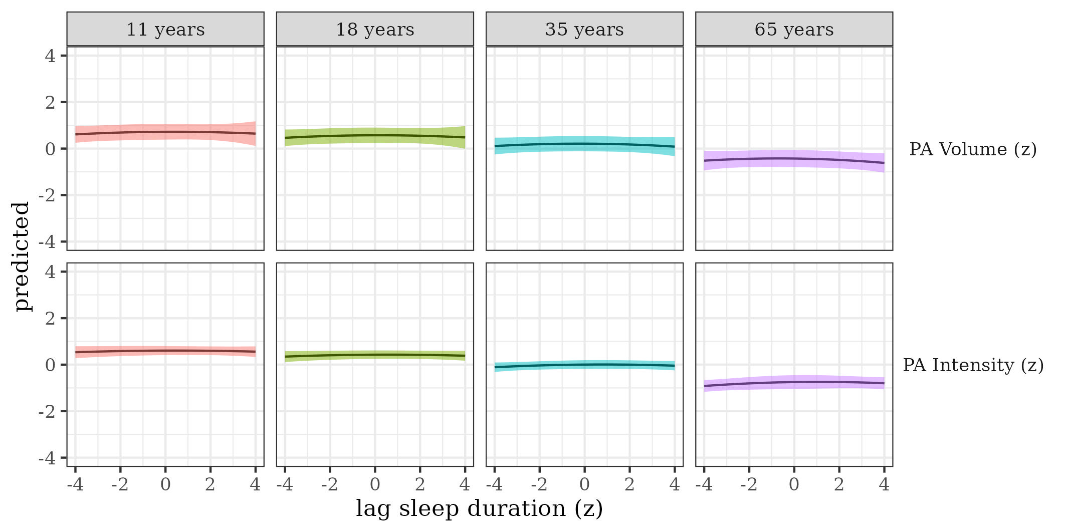

*Figure* *3.*  Physical activity by sleep duration

## The effects of sleep efficiency on physical activity

We estimated the effect of sleep efficiency on physical activity by age. Results, controlling for sex, SES, and BMI are presented in Table 3 and Figure 4. We did not find a relationship between physical activity volume and sleep efficiency. However, there was a subtle U-shaped relationship where individuals with above-average sleep efficiency engaged in more intense physical activity.

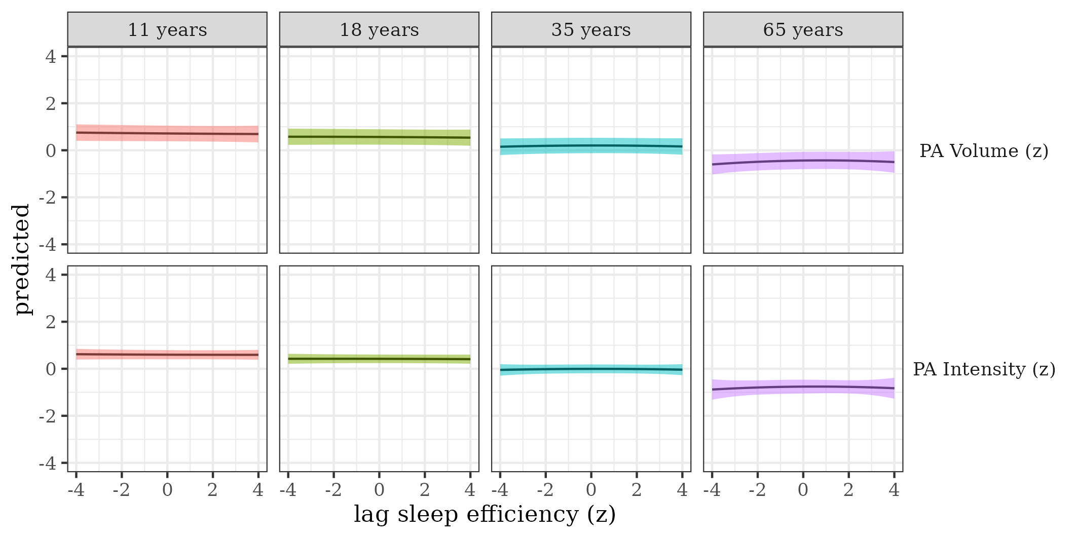

*Figure* *4.*  Physical activity by sleep efficiency

## The effects of sleep onset on physical activity

We estimated the effect of sleep onset on physical activity by age Results, controlling for sex, SES, and BMI are presented in Table 3 and Figure 5. There were strong U-shaped relationships where average sleep onset was linked to the highest levels of physical activity volume and intensity. The U-shaped relationship between sleep onset and physical activity volume attenuated for older participants.

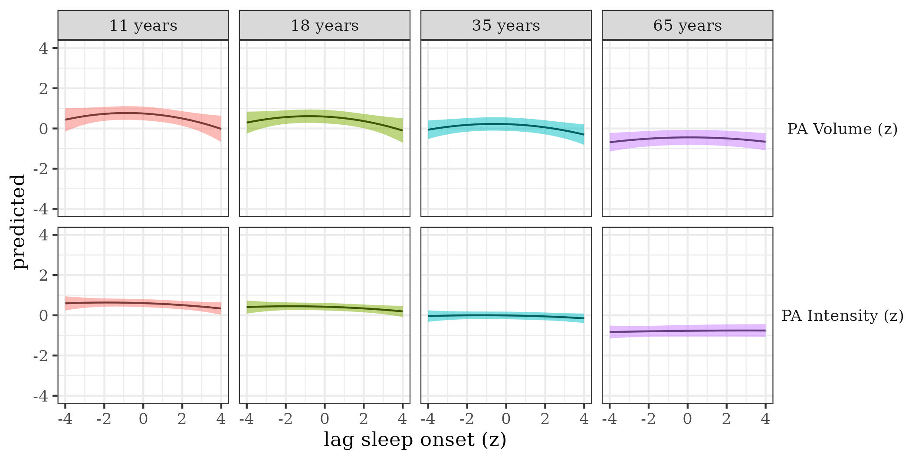

*Figure* *5.*  Physical activity by sleep onset

## The effects of sleep regularity on physical activity

We estimated the effect of sleep regularity on physical activity by age. Results, controlling for sex, SES, and BMI are presented in Table 3 and Figure 6. There was a U-shaped relationship between sleep regularity and physical activity volume. Participants with below-average sleep regularity tended to have average physical activity volume. Increases in regularity above the average were linked to greater physical activity volume. There was a strong linear relationship between sleep regularity and physical activity intensity which slightly attenuated with age. Greater sleep regularity was associated with greater physical activity the following day.

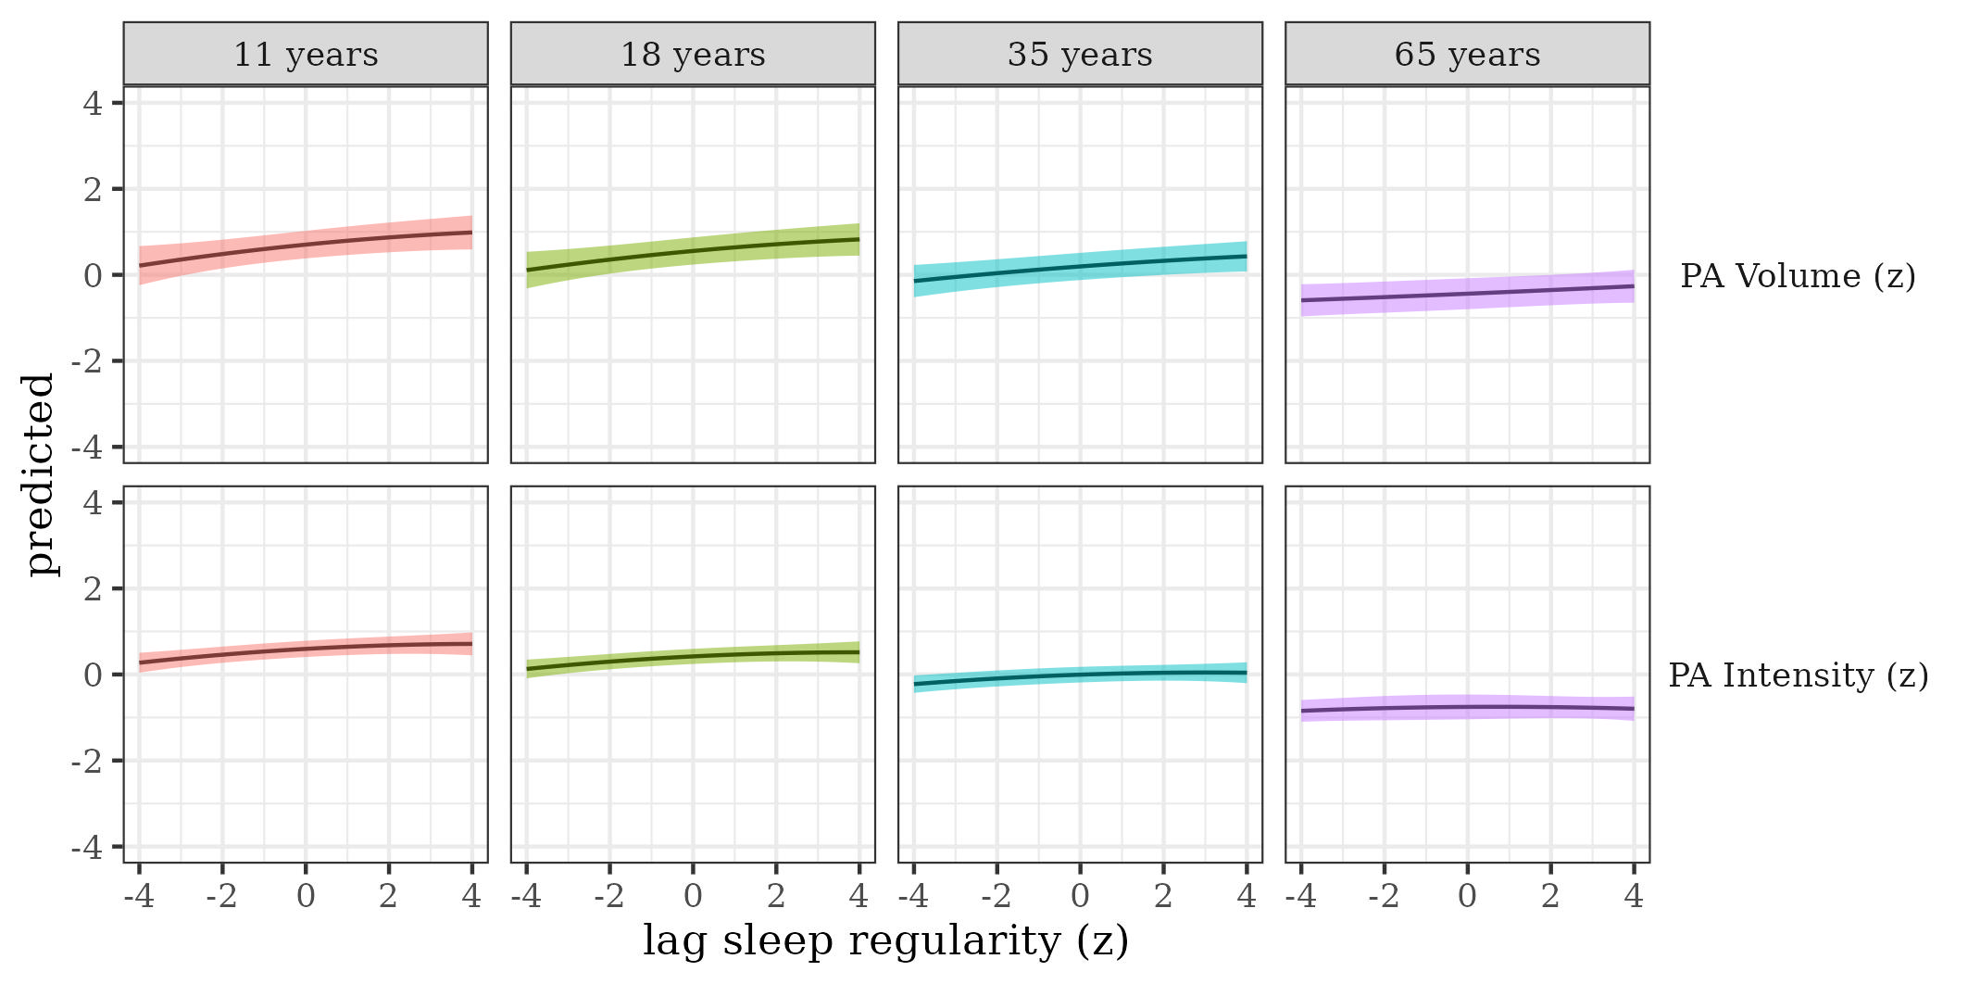

*Figure* *6.*  Physical activity by sleep regularity