Video Games, Self-Concept, and the Parent–Child Relationship
  - Analysis report
Taren Sanders
2026-08-27
Table of contents

1. Methods
- Data: LSAC B cohort at ages 10/11, 12/13, and 14/15 (waves 6–8). The K cohort is excluded because its age-14 wave (2012) did not have the video game time item.

1.1 Key Variables
- Video game use: reported minutes of electronic games in an average week, converted to hours/week.
- Self-concept: self-reported SDQ. The total difficulties score is the primary outcome, and internalising (emotional + peer) and externalising (conduct + hyperactivity) composites are for secondary analyses. The Parent 1-reported SDQ total is also kept for an informant-robustness check.
- Parental warmth (the moderator): Parent 1’s score on the 6-item Parental Warmth Scale (1–5). Parent 2’s score is retained for a both-parents sensitivity model. It’s not the primary model because so much of Parent 2’s data is missing.
- Covariates: sex, socioeconomic position, and age in months, all at the age 10/11 baseline.
- Cleaning: LSAC missing-data codes recoded to missing. Video game hours more than 4 SD above the within-wave mean are winsorised (that is, set to the 4 SD value). That is different from the proposal (which said set to NA), but I think makes more sense. The flagged values look like real heavy gamers overstating, so we keep them but cap their influence. I’ll also test setting them to missing as a sensitivity analysis. SES and warmth are not screened — there are only a few extreme SES values and these seem plausible given the size of LSAC, and low warmth scores are likely to be real given that these are likert scale items.
- Analysis sample: all children with data on at least one study variable (video games, SDQ, or warmth) at one or more waves, with models estimated using full-information maximum likelihood (FIML) under a missing-at-random (MAR) assumption. The proposal’s complete-case (data at all three waves) can be done as a sensitivity analysis.

2. Data and derivations

2.1 Sample and missingness per wave
Table 1: Non-missing observations (% of children in the wave file) for each study variable, after cleaning. N is the number of children with any data at that wave.
Variable | Age 10/11 (N = 3,764) | Age 12/13 (N = 3,381) | Age 14/15 (N = 3,127)
Video Game Use (hrs/week) | 3,586 (95.3%) | 3,154 (93.3%) | 3,104 (99.3%)
SDQ Total Difficulties (Self-Report) | 3,586 (95.3%) | 3,197 (94.6%) | 3,000 (95.9%)
SDQ Internalising (Emotional + Peer) | 3,586 (95.3%) | 3,197 (94.6%) | 3,000 (95.9%)
SDQ Externalising (Conduct + Hyperactivity) | 3,587 (95.3%) | 3,197 (94.6%) | 3,000 (95.9%)
SDQ Total Difficulties (Parent 1) | 3,663 (97.3%) | 3,334 (98.6%) | 3,085 (98.7%)
Parental Warmth (Parent 1) | 3,662 (97.3%) | 3,281 (97.0%) | 3,086 (98.7%)
Parental Warmth (Parent 2) | 2,306 (61.3%) | 1,991 (58.9%) | 1,851 (59.2%)
Socioeconomic Position | 3,707 (98.5%) | 3,303 (97.7%) | 3,109 (99.4%)
Sex | 3,764 (100.0%) | 3,381 (100.0%) | 3,127 (100.0%)

2.2 Distributions
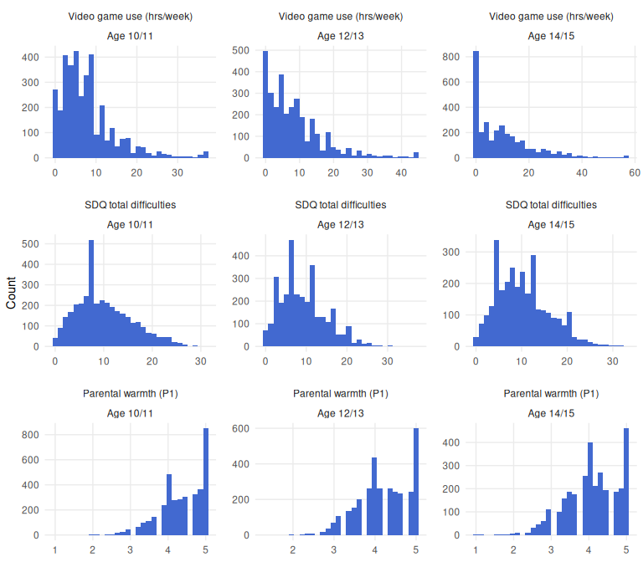
Distributions of the three core study variables at each age band (after cleaning).

2.3 Video game hours: outlier tail
Values more than 4 SD above the within-wave mean are winsorised to 4 SD from mean. The flagged values are shown below before windsorising.
Table 2: Unscreened video game hours per week: within-wave summary and all values above the 4 SD flagging threshold.
Age band | N | Mean (SD), hrs/wk | 4 SD threshold | n flagged | Flagged values (hrs/wk)
10/11 | 3,586 | 7.8 (7.3) | 36.9 | 25 | 95, 70, 70, 70, 62, 62, 62, 54, 48, 46, 44, 41, 41, 40, 40, 40, 40, 39, 39, 38.5, 38, 38, 37, 37, 37
12/13 | 3,154 | 8.6 (8.9) | 44.3 | 26 | 90, 73.5, 70, 70, 70, 66, 65, 58, 54, 53.2, 52, 51, 50, 50, 50, 49, 46, 45.5, 45, 45, 45, 45, 45, 45, 45, 45
14/15 | 3,104 | 10.2 (11.6) | 56.8 | 19 | 92, 88, 87, 85, 84, 82, 81, 70, 70, 69, 66.5, 64, 62, 61.8, 61.5, 60.1, 60, 58, 58

3. Sample and descriptives

3.1 Sample flow
The three B-cohort wave files contain 3,921 children. The analysis sample (children with data on at least one study variable at one or more waves) is N = 3,879. The proposal’s complete-case criterion would retain N = 2,473 (63.1% of the cohort file). That makes me think that FIML is definitely the way to go.
Table 3: Sample flow from the wave 6–8 B-cohort files to the analysis samples.
Criterion | N children | % of cohort file
B-cohort children in any wave 6–8 data file | 3921 | 100.0
Study data (video games, SDQ, or warmth) at ≥1 wave [analysis sample] | 3879 | 98.9
Study data at age 10/11 | 3710 | 94.6
Study data at age 12/13 | 3319 | 84.6
Study data at age 14/15 | 3125 | 79.7
Study data at ≥2 waves | 3395 | 86.6
Complete cases: video games and SDQ at all three waves | 2473 | 63.1
Complete cases with baseline warmth, sex, and SES | 2447 | 62.4

Table 4: Wave-participation patterns (any study data at each wave) among the analysis sample.
Age 10/11 | Age 12/13 | Age 14/15 | N | %
✓ | ✓ | ✓ | 2,880 | 74.2
✓ | ✓ | – | 312 | 8.0
✓ | – | ✓ | 113 | 2.9
✓ | – | – | 405 | 10.4
– | ✓ | ✓ | 90 | 2.3
– | ✓ | – | 37 | 1.0
– | – | ✓ | 42 | 1.1

 Interpretation
- Three-quarters of the analysis sample (74.2%) have study data at all three waves, and 86.6% at two or more.
- Complete-case analysis would discard more than a third (36.9%) of the sample. So FIML is a good option.

3.2 Descriptive statistics
Descriptive statistics by age band. N per column is children with any data at that wave; individual variables have additional item-level missingness.
 | Age 10/11 | Age 12/13 | Age 14/15
n | 3764 | 3381 | 3127
Sex = Female (%) | 1835 (48.8) | 1647 (48.7) | 1521 (48.6)
Age (Years) (mean (SD)) | 10.42 (0.49) | 12.48 (0.51) | 14.33 (0.47)
Socioeconomic Position (mean (SD)) | 0.00 (1.00) | 0.00 (1.00) | 0.00 (1.00)
Video Game Use (hrs/week) (mean (SD)) | 7.73 (6.72) | 8.54 (8.44) | 10.12 (11.18)
SDQ Total Difficulties (Self-Report) (mean (SD)) | 10.07 (5.81) | 9.26 (5.62) | 10.28 (5.81)
SDQ Internalising (Emotional + Peer) (mean (SD)) | 4.67 (3.30) | 4.17 (3.21) | 4.82 (3.48)
SDQ Externalising (Conduct + Hyperactivity) (mean (SD)) | 5.40 (3.43) | 5.08 (3.39) | 5.46 (3.38)
SDQ Prosocial (mean (SD)) | 8.00 (1.65) | 7.75 (1.74) | 7.46 (1.81)
SDQ Total Difficulties (Parent 1) (mean (SD)) | 7.55 (5.59) | 7.29 (5.49) | 7.23 (5.59)
Parental Warmth (Parent 1) (mean (SD)) | 4.35 (0.58) | 4.21 (0.62) | 4.08 (0.68)
Parental Warmth (Parent 2) (mean (SD)) | 3.98 (0.65) | 3.82 (0.70) | 3.62 (0.75)

3.3 Trajectories
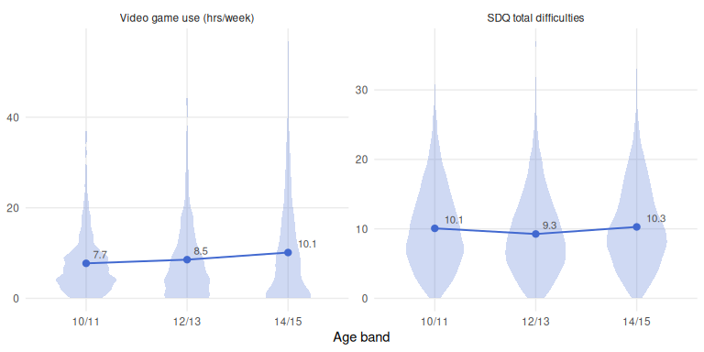
Video game hours and self-reported SDQ total difficulties by age band: distributions (violins) with means and 95% CIs.
Interpretation
- Video game use rises with age (7.7 → 8.5 → 10.1 hrs/week on average) and, quite interestingly, spreads out. The SD grows from 6.7 to 11.2, with a lengthening upper tail.
- SDQ total difficulties dips at 12/13 (10.1 → 9.3) then returns to baseline at 14/15 (10.3). It’s pretty small, so I wouldn’t overinterpret it.
- Parental warmth declines steadily with age (4.35 → 4.08). Again pretty small, and might just be due to dropout?

4. Missingness and attrition
Children with any study data at age 10/11 who also have study data at either follow-up wave (“retained”) are compared with those who have none (“lost”) on their baseline characteristics. Standardised mean differences (SMD) are the retained-minus-lost difference in pooled-SD units. |SMD| < 0.10 is conventionally negligible.
Table 5: Baseline (age 10/11) characteristics of children retained at follow-up vs lost to follow-up.
Variable | Retained (n = 3,305) | Lost (n = 405) | SMD | Test | p
Female, % | 48.6 | 49.1 | -0.01 | χ²(1) = 0.02 | = 0.887
Video game use (hrs/week) | 7.66 (6.63) | 8.32 (7.41) | -0.09 | t(461) = -1.67 | = 0.096
SDQ total difficulties | 9.99 (5.78) | 10.73 (6.02) | -0.12 | t(464) = -2.26 | = 0.024
Parental warmth (P1) | 4.35 (0.58) | 4.34 (0.62) | 0.01 | t(480) = 0.27 | = 0.788
Socioeconomic position | 0.04 (1.00) | -0.33 (0.98) | 0.37 | t(494) = 6.92 | < .001

Interpretation
- Attrition is clearly not completely at random: lost children are lower-SES (SMD 0.37) and report slightly higher baseline difficulties (SMD −0.12). Sex, warmth, and video game hours show negligible differences.
- The variables that predict dropout (SES, baseline SDQ) are observed and in the model. This is the MAR pattern FIML adjusts for, whereas complete-case analysis would tilt the sample toward higher-SES, better-functioning children.

5. Correlations
Table 6: Zero-order correlations among the study variables (pairwise complete). SES is the age-10/11 z-composite; Female sex is coded 1 = female. * p < .05, ** p < .01, *** p < .001.
Variable | M | SD | 1 | 2 | 3 | 4 | 5 | 6 | 7 | 8 | 9 | 10 | 11
1. Video games 10/11 | 7.73 | 6.72 | —
2. Video games 12/13 | 8.54 | 8.44 | .42*** | —
3. Video games 14/15 | 10.12 | 11.18 | .38*** | .51*** | —
4. SDQ total 10/11 | 10.07 | 5.81 | .12*** | .12*** | .17*** | —
5. SDQ total 12/13 | 9.26 | 5.62 | .13*** | .13*** | .15*** | .57*** | —
6. SDQ total 14/15 | 10.28 | 5.81 | .07*** | .07*** | .04* | .45*** | .61*** | —
7. Warmth (P1) 10/11 | 4.35 | 0.58 | -.04* | -.01 | -.03 | -.08*** | -.06** | -.05* | —
8. Warmth (P1) 12/13 | 4.21 | 0.62 | -.04* | -.06** | -.05** | -.10*** | -.12*** | -.09*** | .69*** | —
9. Warmth (P1) 14/15 | 4.08 | 0.68 | -.06*** | -.07*** | -.09*** | -.09*** | -.09*** | -.10*** | .62*** | .70*** | —
10. SES 10/11 | -0.00 | 1.00 | -.13*** | -.14*** | -.15*** | -.16*** | -.11*** | -.10*** | .01 | .02 | .00 | —
11. Female sex | 0.49 | 0.50 | -.24*** | -.34*** | -.48*** | -.09*** | -.03 | .14*** | -.01 | .02 | .06** | .01 | —

Interpretation
- The cross-sectional and cross-lagged video-game–SDQ correlations are all small and positive (r = .04–.17).
  - More gaming goes with slightly more difficulties, before any adjustment.
- Rank-order stability is moderate for video games (.42–.51), higher for SDQ (.57–.61) and warmth (.69–.70).
- Warmth correlates negatively with both gaming and difficulties (r ≈ −.05 to −.12).
- Sex is strongly related to gaming (girls lower, and increasingly so with age: −.24 → −.48) and flips sign for SDQ (−.09 at 10/11 to +.14 at 14/15). — Supports sex as a covariate in all models.

6. Cross-lagged models (H1)

6.1 What the models do
- Both models estimate whether video game use predicts later SDQ total difficulties (H1a) and whether difficulties predict later video game use (H1b), across the three age bands.
- The traditional CLPM relates each child’s score to their earlier score without separating “this child games more than other children” from “this child is gaming more than they usually do”. Sex and socioeconomic position are included as covariates.
- The RI-CLPM adds a random intercept for each variable, which captures each child’s stable average level. The lagged paths are then estimated on what is left over — deviations from a child’s own average — so they answer the within-person question the hypotheses are actually about. This is the primary model.
- The RI-CLPM does not include sex or SES. The random intercepts already absorb every stable difference between children, including those two and anything unmeasured, so the lagged paths are not confounded by them. Adding them back caused problems rather than solving them (see Section 6.4), and they are reported separately at Step 5 instead.
- Both are estimated with robust maximum likelihood and FIML, on the 3,877 children with data on at least one of the six modelled variables.
- Every result in this report is produced for both model families, so that the choice of primary model can be revisited without redoing the analysis. Throughout, the RI-CLPM is presented first as the primary model and the CLPM second as the comparison; nothing depends on that ordering.

6.2 Two different questions: within-child and between-child
The two models answer genuinely different questions, and it is worth being explicit about which one each hypothesis is asking.
- A between-child question compares children to each other: do children who game more than other children report more difficulties than other children?
- A within-child question compares a child to themselves at other times: when a child games more than is usual for them, do they report more difficulties than is usual for them, later on?
Both are reported below, because they are separate findings and neither implies the other. Two children can differ enormously in average gaming and average difficulties without gaming ever changing anything for either of them.
The RI-CLPM is the primary model because the hypotheses are phrased prospectively — H1a is that gaming predicts subsequent self-concept — and because a between-child comparison cannot support that claim on its own. The reason is structural rather than a matter of preference: a child’s stable average is a single number with no time attached to it, so there is no earlier and later to put in order. Between-child differences can establish that an association exists; they cannot establish direction.
The moment a between-child comparison is made prospective — “do children who game more at 10/11 have more difficulties at 12/13?” — it becomes vulnerable to any stable difference between children that was never measured. A child in a chaotic household might game more and report more difficulties at every wave, which produces exactly that prospective association with no causal link between the two. Separating the two levels is what the random intercepts are for.
The proposal specified cross-lagged panel analysis without distinguishing the two, so this is a decision made at the analysis-plan stage rather than a requirement inherited from the proposal.

6.3 Model fit
Table 7: Fit of the cross-lagged models. Robust (MLR-corrected) indices. Fit statistics and information criteria are only comparable between models fitted to the same variables, so the covariate-adjusted CLPM (8 variables) cannot be compared with the other two (6 variables).
Model | Variables | N | χ² (df) | p | CFI | TLI | RMSEA [90% CI] | SRMR | AIC | BIC
CLPM (covariates) | 8 | 3877 | 153.0 (6) | < .001 | .967 | .853 | .102 [.088, .116] | .026 | 142687 | 142925
CLPM (no covariates) | 6 | 3877 | 191.9 (6) | < .001 | .947 | .868 | .115 [.101, .130] | .040 | 127906 | 128038
RI-CLPM (primary) | 6 | 3877 | 42.6 (3) | < .001 | .990 | .949 | .072 [.053, .092] | .023 | 127731 | 127881

Interpretation
- The RI-CLPM fits substantially better than the CLPM on the same six variables: RMSEA .072 vs .115, CFI .990 vs .947, and a BIC around 157 points lower.
- That gap is the point of the exercise. Most of what looks like “gaming predicts difficulties” in the CLPM is stable between-child difference — some children simply game more and report more difficulties than others — rather than change within a child over time.
- No model reaches a non-significant χ², but with N ≈ 3,900 that is expected and not very informative.

6.4 Does the effect stay the same across the two lags?
The model can either estimate each lag separately or assume the paths are the same size from 10/11 → 12/13 as from 12/13 → 14/15. Assuming they are equal is normally preferred with only three waves, because leaving everything free leaves just one degree of freedom.
Table 8: Scaled chi-square difference tests of the constrained RI-CLPMs against the freely estimated model.
Comparison | Δχ² | Δdf | p | Decision
All lagged paths equal vs free | 89.35 | 4 | < .001 | Constraint rejected
Cross-lags equal, autoregressions free vs free | 4.63 | 2 | .099 | Constraint retained

Table 9: Univariate score tests on the fully constrained RI-CLPM: which lagged paths actually differ between the two lags.
Path | χ² (1) | p | Verdict
Video games autoregression | 52.54 | < .001 | Differs across lags
SDQ → video games (H1b) | 0.31 | .575 | Equal across lags
SDQ autoregression | 13.93 | < .001 | Differs across lags
Video games → SDQ (H1a) | 4.28 | .038 | Differs across lags

Interpretation
- Assuming all paths are equal across lags is clearly wrong here.
- But the second table shows the problem is entirely in the autoregressive paths — how strongly a child’s own earlier deviation predicts their later one — not in the cross-lagged paths the hypotheses are about. The SDQ → video games path in particular is statistically indistinguishable across the two lags.
- So the primary model pools the cross-lags (giving one estimate per hypothesis) and lets the autoregressions differ. That version is not significantly worse than the free model, and fits better than either alternative.
- I checked whether this was caused by video game hours being skewed, by refitting on square-root and log-transformed hours. It isn’t — the same pattern appears on every scale. The underlying cause is that the spread of gaming nearly triples between 10/11 and 14/15 (variance 45 → 125) as more children stop playing entirely and others play much more, and no transformation removes that.

6.5 Within-child effects: RI-CLPM (primary)
Table 10: RI-CLPM structural estimates. Unstandardised coefficients are in hours/week and SDQ points; β are fully standardised. Cross-lagged paths are constrained equal across lags.
Parameter | Lag | b (SE) | 95% CI | p | β | β 95% CI
Video games → video games | 10/11 → 12/13 | -0.434 (0.238) | [-0.899, 0.032] | .068 | -.257 | [-.509, -.005]
Video games → video games | 12/13 → 14/15 | 0.418 (0.045) | [0.329, 0.507] | < .001 | .277 | [.213, .342]
SDQ → SDQ | 10/11 → 12/13 | 0.263 (0.046) | [0.173, 0.352] | < .001 | .277 | [.188, .367]
SDQ → SDQ | 12/13 → 14/15 | 0.381 (0.040) | [0.303, 0.459] | < .001 | .356 | [.278, .433]
Video games → SDQ (H1a) | Both lags (constrained) | 0.005 (0.017) | [-0.029, 0.039] | .783 | .004 | [-.026, .034]
SDQ → video games (H1b) | Both lags (constrained) | 0.130 (0.047) | [0.038, 0.222] | .006 | .091 | [.024, .158]
Video games ↔ SDQ, within-wave | 10/11 | 0.263 (0.676) | [-1.062, 1.589] | .697 | .015 | [-.062, .093]
Video games ↔ SDQ, within-wave | 12/13 | 1.632 (0.851) | [-0.035, 3.299] | .055 | .065 | [-.002, .131]
Video games ↔ SDQ, within-wave | 14/15 | -3.597 (0.809) | [-5.183, -2.011] | < .001 | -.091 | [-.131, -.051]
Random intercept variance, video games | Between-person | 30.509 (2.487) | [25.635, 35.383] | < .001 | 1.000 | [1.000, 1.000]
Random intercept variance, SDQ | Between-person | 13.502 (1.130) | [11.288, 15.717] | < .001 | 1.000 | [1.000, 1.000]
Random intercept correlation | Between-person | 4.162 (0.737) | [2.716, 5.607] | < .001 | .205 | [.136, .274]

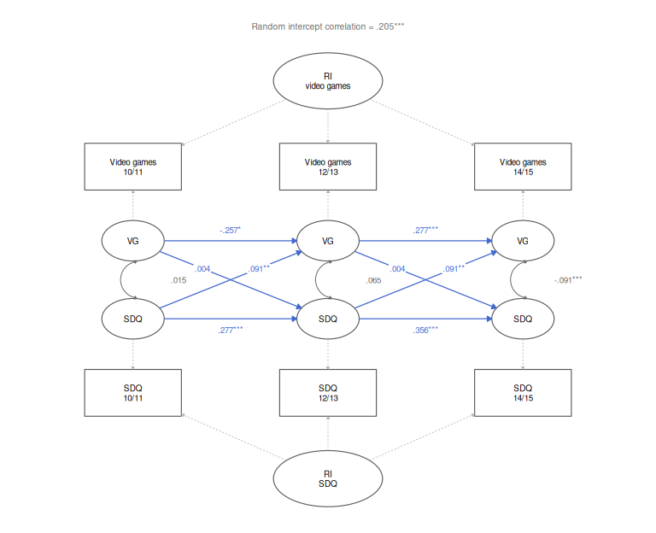
Figure 1: RI-CLPM with standardised estimates. Squares are observed variables, ellipses are latent: the random intercepts capture stable between-child differences, and the within-person components (VG, SDQ) capture each child’s deviation from their own average. Blue arrows are the estimated structural paths; grey dashed arrows are fixed at 1. * p < .05, ** p < .01, *** p < .001.
Interpretation
- H1b is supported. When a child reports more difficulties than usual for them, they report more video game use than usual two years later (β = .091, 95% CI [.024, .158], p = .006). The effect is small: roughly 0.13 extra hours per week per additional SDQ point.
- H1a is not supported. Gaming more than usual does not predict later difficulties (β = .004, 95% CI [−.026, .034], p = .783). This is a precise null, not an underpowered one — the confidence interval rules out anything beyond a trivially small effect in either direction.
- So the relationship looks one-directional, and in the opposite direction to the common assumption: difficulties appear to lead gaming rather than gaming leading difficulties.
- The random intercepts correlate .21 (p < .001), which is where the raw association mostly lives. Children who game more on average do report more difficulties on average — but that is a between-child difference, not evidence that gaming changes anything.
- One oddity worth flagging: the within-person video game autoregression is −.26 at the first lag and +.28 at the second. A negative within-person autoregression is not impossible (a spike above your own average tends to be followed by a dip below it), but a sign flip that large is more likely instability from the near-saturated three-wave model combined with gaming’s sharply growing variance. It does not affect the cross-lagged conclusions, which are stable across every specification tested.

6.6 Between-child differences
The same RI-CLPM also estimates the between-child side of the relationship, in the correlation between the two random intercepts — that is, between a child’s stable average gaming level and their stable average level of difficulties. This is the answer to “do children who game more than other children report more difficulties than other children?”.
Children who game more on average do report more difficulties on average: r = .205, 95% CI [.136, .274], p < .001.
This between-child association is larger than either within-child cross-lagged effect in the model. Most of the raw relationship between gaming and difficulties — the one visible in the correlation table earlier — is of this kind: a difference between children rather than a process operating within them.
How much of each variable exists at each level is itself informative:
Table 11: Proportion of each variable’s variance that is stable between-child difference versus within-child variation, from the RI-CLPM.
Variable | Age band | Between-person % | Within-person %
Video game use | 10/11 | 67.8 | 32.2
Video game use | 12/13 | 42.5 | 57.5
Video game use | 14/15 | 24.6 | 75.4
SDQ total difficulties | 10/11 | 40.0 | 60.0
SDQ total difficulties | 12/13 | 42.7 | 57.3
SDQ total difficulties | 14/15 | 39.3 | 60.7

Interpretation
- Difficulties are consistently about 40% between-child at every age: some children simply report more problems than others, stably, and that share does not change as they get older.
- Video game use behaves very differently. At 10/11 it is strongly trait-like (68% between-child), but by 14/15 only 25% is stable difference and three quarters is occasion-specific. Gaming stops being “the sort of child you are” and becomes “what you happened to be doing that year”.
- That shift is the same phenomenon as the growing variance noted earlier, and it is the most likely explanation for the unstable within-child gaming autoregression: there is progressively less stable signal to carry forward.
- Putting the two levels together: there is a real and reasonably clear association between gaming and difficulties between children (r = .21), and essentially no evidence that gaming drives difficulties within a child over time (β = .004). Reporting only one of those would misrepresent the data.

6.7 Comparison model: CLPM estimates
Table 12: Traditional CLPM structural estimates, adjusted for sex and socioeconomic position. Cross-lagged paths are constrained equal across lags.
Parameter | Lag | b (SE) | 95% CI | p | β | β 95% CI
Video games → video games | 10/11 → 12/13 | 0.435 (0.028) | [0.379, 0.490] | < .001 | .344 | [.305, .384]
Video games → video games | 12/13 → 14/15 | 0.494 (0.030) | [0.436, 0.552] | < .001 | .374 | [.333, .416]
SDQ → SDQ | 10/11 → 12/13 | 0.558 (0.015) | [0.529, 0.588] | < .001 | .576 | [.550, .601]
SDQ → SDQ | 12/13 → 14/15 | 0.633 (0.016) | [0.602, 0.663] | < .001 | .611 | [.586, .636]
Video games → SDQ (H1a) | Both lags (constrained) | 0.042 (0.009) | [0.026, 0.059] | < .001 | .051 | [.030, .071]
SDQ → video games (H1b) | Both lags (constrained) | 0.120 (0.020) | [0.080, 0.159] | < .001 | .082 | [.056, .109]
Video games ↔ SDQ, within-wave | 10/11 | 3.105 (0.692) | [1.749, 4.462] | < .001 | .084 | [.048, .120]
Video games ↔ SDQ, within-wave | 12/13 | 1.953 (0.628) | [0.721, 3.185] | .002 | .058 | [.022, .095]
Video games ↔ SDQ, within-wave | 14/15 | 0.059 (0.725) | [-1.362, 1.481] | .935 | .002 | [-.035, .038]

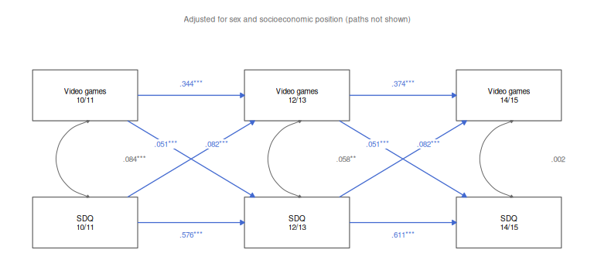
Figure 2: Traditional CLPM with standardised estimates. All variables are observed (squares); with no random intercepts, the lagged paths run directly between them and mix between-child and within-child variation. Sex and socioeconomic position are included as covariates but their paths are omitted for legibility. * p < .05, ** p < .01, *** p < .001.
Interpretation
- The CLPM finds both cross-lagged paths significant (H1a β = .051, H1b β = .082, both p < .001), which would support a bidirectional relationship.
- The RI-CLPM shows that the H1a path is an artefact of not separating between- from within-child variance. This is exactly the pattern Hamaker et al. (2015) describe, and the reason the RI-CLPM is the primary model here.
- Reporting the CLPM alone would have produced a materially different — and I think wrong — conclusion.

7. Supplementary material

7.1 Stationarity in the CLPM
The same constraint tests for the comparison CLPM, for completeness.
Table 13: Scaled chi-square difference tests of the constrained CLPMs against the freely estimated CLPM.
Comparison | Δχ² | Δdf | p | Decision
All lagged paths equal vs free | 20.85 | 4 | < .001 | Constraint rejected
Cross-lags equal, autoregressions free vs free | 8.24 | 2 | .016 | Constraint rejected

Table 14: Univariate score tests on the fully constrained CLPM.
Path | χ² (1) | p | Verdict
Video games autoregression | 2.40 | .121 | Equal across lags
SDQ → video games (H1b) | 5.82 | .016 | Differs across lags
SDQ autoregression | 12.63 | < .001 | Differs across lags
Video games → SDQ (H1a) | 1.76 | .185 | Equal across lags

The CLPM does not show the same pattern as the RI-CLPM. Full stationarity is rejected here too, but so is the cross-lags-only constraint, and the paths that differ across lags are different ones — the SDQ autoregression and the SDQ → video games cross-lag, rather than both autoregressions.
The CLPM reported in the main text still uses the same constraint as the RI-CLPM, so that the fit comparison in Table 7 is like-for-like. That imposes one constraint the CLPM’s own data reject, which is a real cost, but it does not change what the CLPM concludes: with all lagged paths freely estimated its cross-lags remain significant in both directions and at both lags (video games → SDQ β = .072 and .043; SDQ → video games β = .055 and .091; all p < .01). The divergence from the RI-CLPM in Table 10 is therefore driven by the between/within separation, not by the constraint choice.

7.2 Descriptive statistics by sex
Table 15: Descriptive statistics by sex within age band.
 | Male:Age 10/11 | Female:Age 10/11 | Male:Age 12/13 | Female:Age 12/13 | Male:Age 14/15 | Female:Age 14/15
n | 1929 | 1835 | 1734 | 1647 | 1606 | 1521
Age (Years) (mean (SD)) | 10.42 (0.49) | 10.42 (0.49) | 12.48 (0.51) | 12.48 (0.52) | 14.32 (0.47) | 14.34 (0.47)
Socioeconomic Position (mean (SD)) | -0.01 (1.01) | 0.02 (0.99) | -0.01 (0.99) | 0.01 (1.01) | -0.02 (0.99) | 0.02 (1.01)
Video Game Use (hrs/week) (mean (SD)) | 9.32 (7.15) | 6.02 (5.76) | 11.28 (8.95) | 5.49 (6.61) | 15.38 (11.59) | 4.54 (7.39)
SDQ Total Difficulties (Self-Report) (mean (SD)) | 10.58 (5.94) | 9.54 (5.62) | 9.41 (5.61) | 9.10 (5.64) | 9.47 (5.39) | 11.14 (6.10)
SDQ Internalising (Emotional + Peer) (mean (SD)) | 4.58 (3.32) | 4.76 (3.28) | 3.88 (3.07) | 4.48 (3.33) | 3.91 (3.04) | 5.78 (3.66)
SDQ Externalising (Conduct + Hyperactivity) (mean (SD)) | 6.00 (3.51) | 4.78 (3.23) | 5.53 (3.44) | 4.62 (3.27) | 5.55 (3.33) | 5.35 (3.42)
SDQ Prosocial (mean (SD)) | 7.61 (1.75) | 8.40 (1.43) | 7.37 (1.82) | 8.15 (1.56) | 6.96 (1.84) | 7.98 (1.62)
SDQ Total Difficulties (Parent 1) (mean (SD)) | 8.11 (5.78) | 6.96 (5.32) | 7.70 (5.59) | 6.85 (5.36) | 7.46 (5.51) | 6.99 (5.66)
Parental Warmth (Parent 1) (mean (SD)) | 4.35 (0.57) | 4.34 (0.59) | 4.19 (0.61) | 4.22 (0.63) | 4.04 (0.68) | 4.11 (0.69)
Parental Warmth (Parent 2) (mean (SD)) | 3.95 (0.65) | 4.02 (0.64) | 3.81 (0.71) | 3.83 (0.68) | 3.57 (0.74) | 3.68 (0.75)

