MILESTONE 1 – CLIENT DESIGN
Project ID: CMPG325-2026-146
Client ID: CLI-146
Organisation: Pula Cloud Services (Kimberley)
Industry: Technology
Assigned Addressing Block: 172.30.96.0/23

1. Client Requirements
1.1 Client Information
Organisation: Pula Cloud Services (Kimberley)
Client ID: CLI-146
Project ID: CMPG325-2026-146
Industry: Technology
Assigned Addressing Block: 172.30.96.0/23
Pula Cloud Services is a technology organisation based in Kimberley. The purpose of this project is to design and simulate a computer network that provides appropriate connectivity and network services while addressing the client's security, access and wireless networking requirements.
1.2 Business and Network Requirements
Requirement | Design Implication
Provide appropriate network connectivity | The network must allow authorised devices to communicate with the network resources they require.
Use the assigned 172.30.96.0/23 addressing block | All internal IP addressing must be derived from the assigned address space.
Support wired users | Appropriate Ethernet switching infrastructure must be provided.
Support wireless users | Wireless infrastructure must be included in the network design.
Provide appropriate network services | Required network services must be incorporated into the final implementation.
Support authorised IT staff | IT staff must have appropriate access to resources required for administration.
Provide server resources | Server resources should be logically separated from ordinary user networks.
Provide Guest Wi-Fi | A dedicated wireless network must be available for visitors.
Isolate Guest Wi-Fi | Guest users must not have unrestricted access to internal organisational resources.
Produce a working Packet Tracer implementation | The proposed design must be practical and capable of being implemented and tested in Cisco Packet Tracer.

1.3 Security Requirements
WPA2-PSK Wireless Security
The assigned networking challenge requires the implementation of WPA2-PSK wireless security hardening. The wireless network must therefore use appropriate WPA2-PSK authentication rather than allowing unauthenticated wireless access.
Guest Wi-Fi Isolation
The client change request requires Guest Wi-Fi to be provided for visitors while isolating guest users from internal resources. The design will therefore place Guest Wi-Fi in a separate logical network and use appropriate access controls to prevent unauthorised access to internal networks.
Server-Room Access
Access to the server room is restricted to authorised IT staff only. The server environment will therefore be separated from general user and guest networks, with appropriate access controls used to restrict access to authorised users.
1.4 Design Constraints
The primary design constraint specified by the client is:
Server room access is restricted to authorised IT staff only.
This constraint influences the network design by requiring the server environment to be logically separated from general user networks. Authorised IT staff must be able to access the required server resources, while guest and other unauthorised networks must not receive unrestricted access.
1.5 Client Change Request
CR3: Guest Wi-Fi must be added for visitors, isolated from internal resources.
The proposed design accommodates this change by providing a dedicated Guest Wi-Fi network. Guest traffic will be logically separated from internal staff, IT and server networks. Appropriate access controls will subsequently be implemented and tested to verify that guest users cannot access protected internal resources.

1.6 Technical Requirements
Area | Requirement
IP Addressing | Use the assigned 172.30.96.0/23 address block.
Switching | Provide appropriate switches for LAN connectivity.
Routing | Provide communication between required network segments.
Wireless | Provide wireless connectivity for appropriate users.
Wireless Security | Implement WPA2-PSK security hardening.
Guest Network | Provide a dedicated Guest Wi-Fi network.
Guest Security | Isolate Guest Wi-Fi from internal organisational resources.
Server Network | Provide a dedicated logical network for server resources.
IT Access | Allow authorised IT staff to access required server resources.
Testing | Verify connectivity and security requirements through appropriate testing.
Documentation | Document the network design, configuration, testing and evidence.

2. Physical Topology
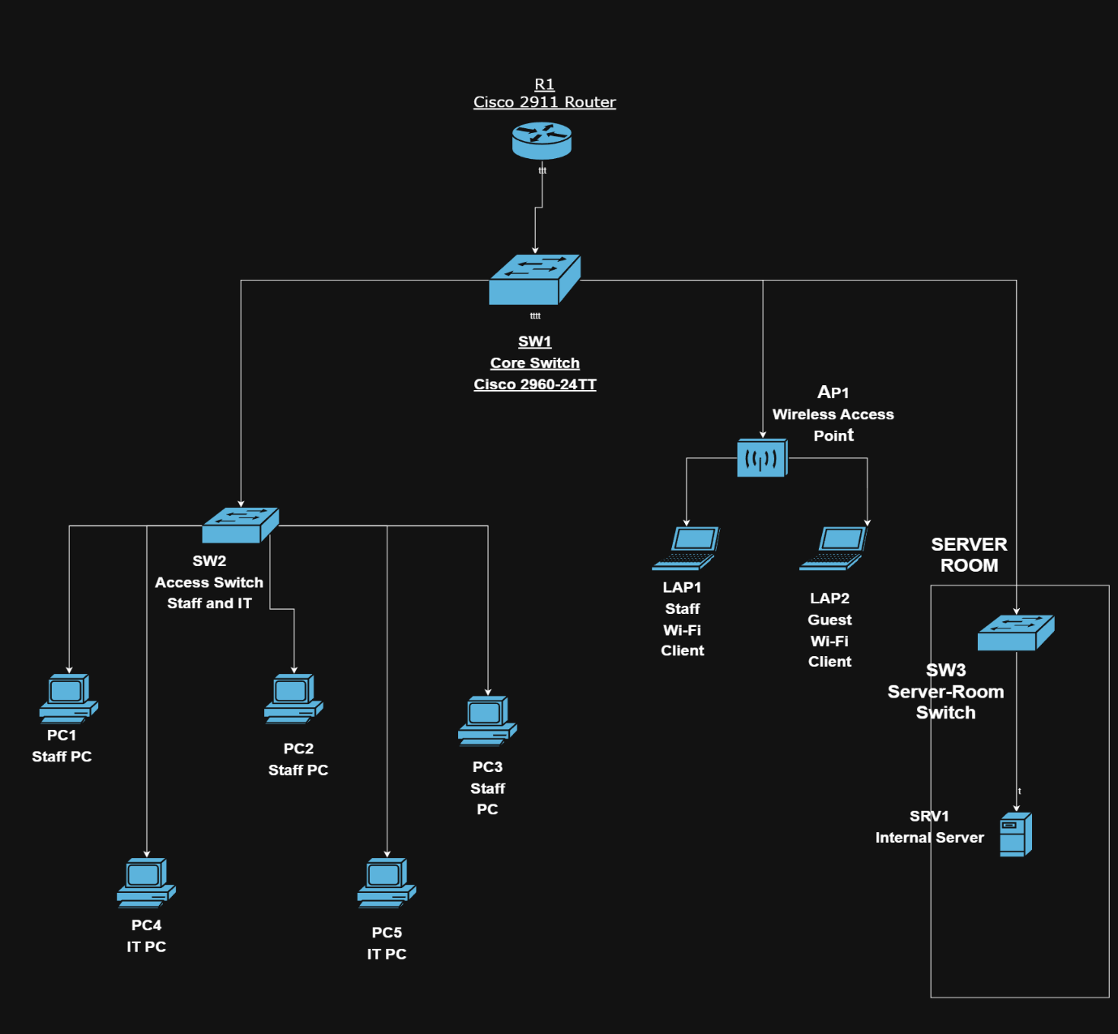
3. Logical Topology
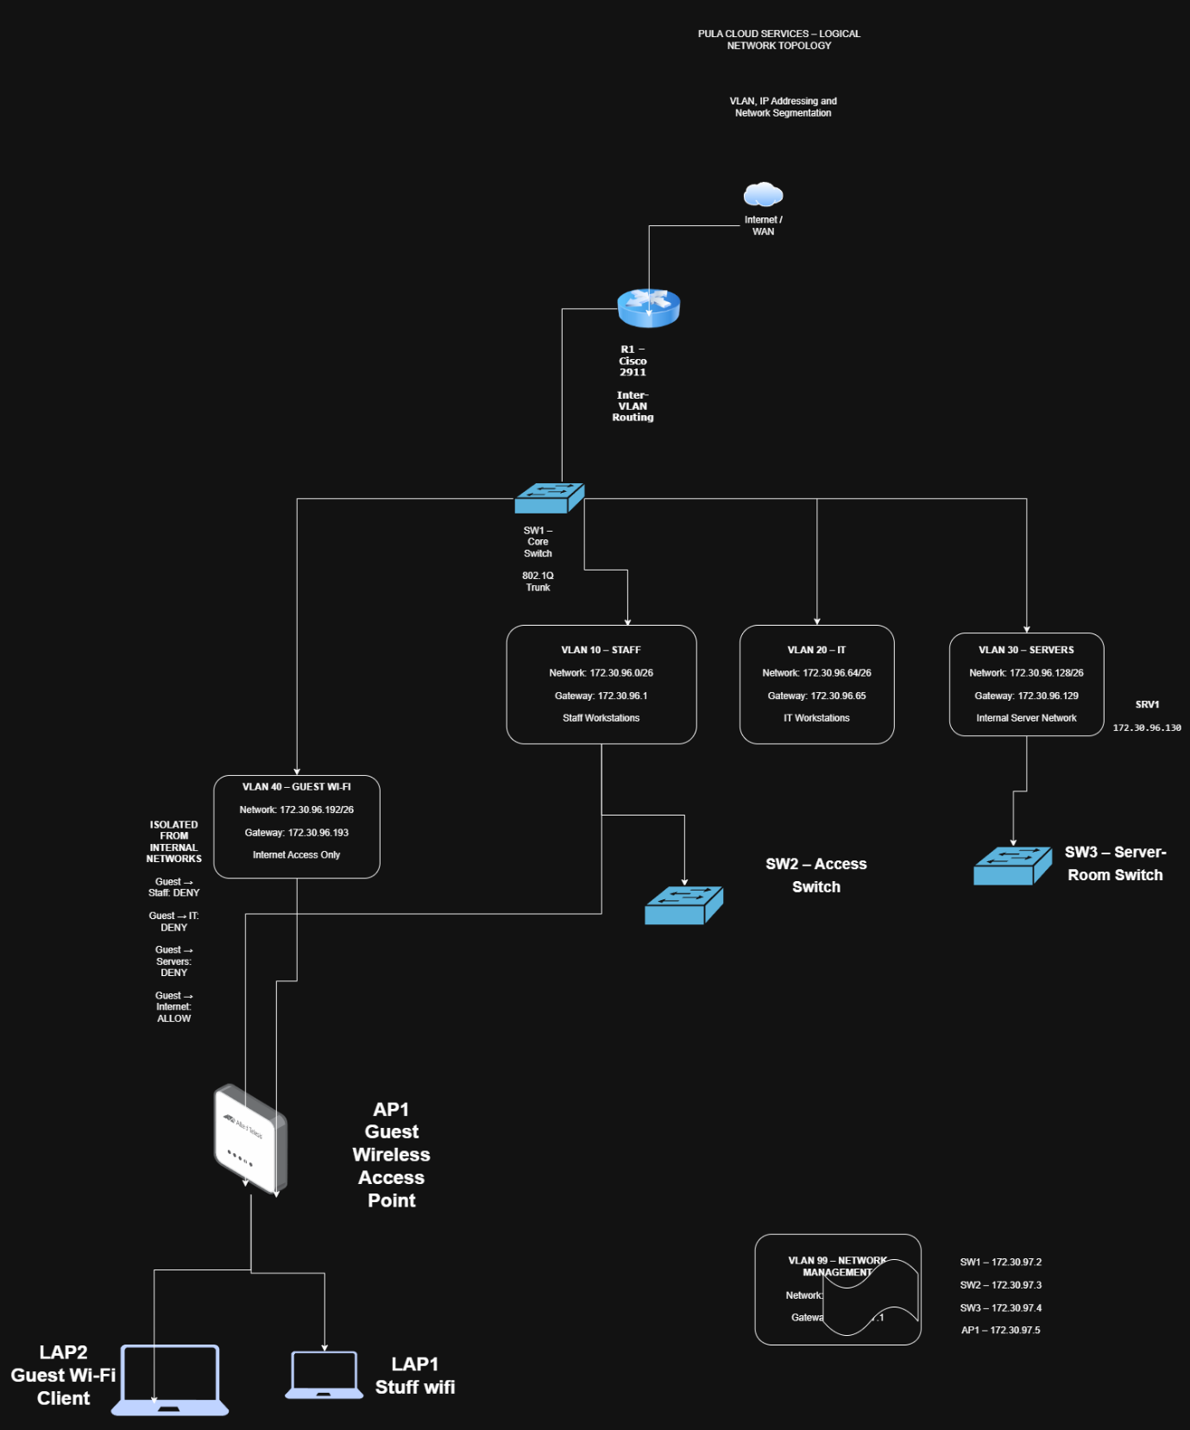

4. IP Addressing Plan
VLAN | Network | Subnet Mask | Default Gateway | Purpose
10 | 172.30.96.0/26 | 255.255.255.192 | 172.30.96.1 | Staff
20 | 172.30.96.64/26 | 255.255.255.192 | 172.30.96.65 | IT
30 | 172.30.96.128/26 | 255.255.255.192 | 172.30.96.129 | Servers
40 | 172.30.96.192/26 | 255.255.255.192 | 172.30.96.193 | Guest Wi-Fi
99 | 172.30.97.0/28 | 255.255.255.240 | 172.30.97.1 | Network Management

DHCP will be used for Staff, IT and Guest client addressing. Servers and network infrastructure will use statically assigned addresses.

DEVICE ADDRESSING
Device | VLAN | IP Address | Default Gateway | Addressing Method | Purpose
R1 – Staff Gateway | 10 | 172.30.96.1 | N/A | Static | Staff gateway
R1 – IT Gateway | 20 | 172.30.96.65 | N/A | Static | IT gateway
R1 – Server Gateway | 30 | 172.30.96.129 | N/A | Static | Server gateway
R1 – Guest Gateway | 40 | 172.30.96.193 | N/A | Static | Guest gateway
R1 – Management Gateway | 99 | 172.30.97.1 | N/A | Static | Management gateway
SW1 | 99 | 172.30.97.2 | 172.30.97.1 | Static | Core switch management
SW2 | 99 | 172.30.97.3 | 172.30.97.1 | Static | Access switch management
SW3 | 99 | 172.30.97.4 | 172.30.97.1 | Static | Server-room switch management
AP1 | 99 | 172.30.97.5 | 172.30.97.1 | Static | AP management
Server1 | 30 | 172.30.96.130 | 172.30.96.129 | Static | Internal server
PC1 – Staff | 10 | 172.30.96.10 | 172.30.96.1 | DHCP | Staff workstation
PC2 – Staff | 10 | 172.30.96.11 | 172.30.96.1 | DHCP | Staff workstation
PC3 – Staff | 10 | 172.30.96.12 | 172.30.96.1 | DHCP | Staff workstation
PC4 – IT | 20 | 172.30.96.70 | 172.30.96.65 | DHCP | IT workstation
PC5 – IT | 20 | 172.30.96.71 | 172.30.96.65 | DHCP | IT workstation
Laptop1 – Staff | 10 | DHCP pool | 172.30.96.1 | DHCP | Staff wireless client
Laptop2 – Guest | 40 | DHCP pool | 172.30.96.193 | DHCP | Guest wireless client

Design Justification:
The assigned address block 172.30.96.0/23 has been subnetted into separate VLANs to provide logical segmentation between Staff, IT, Servers, Guest Wi-Fi and network management traffic. /26 subnets provide sufficient host capacity for the main user and service networks while maintaining clear separation between departments and services. A dedicated /28 management subnet is used for network infrastructure devices. Static addressing is assigned to infrastructure and server devices, while end-user devices are planned for DHCP allocation. The Guest Wi-Fi network is separated into VLAN 40 to support the client's requirement that visitor devices be isolated from internal resources.

