**Control and Robotics Design**

**White-Paper Updated - April 14, 2021**

ELEC 391 Team MotoGuzzi - Jeff Eom, Mark Gnocato, Yanyu (Grace) Zhang, ECE, University of BC

# Abstract

A 3-DOF planar joint robot arm is developed to discard 3 faulty products on a stopped conveyor. In this report, control and robotic parts of the project is focused. Section 1. Motors and Controllers describes the detailed usage of each motors and their controllers. Section 2. Robotics describes the robotics on direct, inverse kinematics and the path planning. Section 3. Controllers describes the detailed information of the controllers that is implemented in the system. Lastly, section 4. Co-simulation describes how it is simulated using Simulink and Simulation X simulation program.

# Nomenclature

A1 Length of 1st arm (m)

A2 Length of 2nd arm (m)

Q1 Angle of 1st arm (Degree)

Q2 Angle of 2nd arm (Degree)

Q3 Angle of gripper (Degree)

Q4 Angle to close and open gripper (Degree)

# 1. Motors and Controllers

The robot arm consists of four motors: one motor mounted at the base of the arm, two motors mounted at two joints of the arm and lastly one motor mounted at the gripper. Each of the motors are controlled individually according to the angle that is calculated from the inverse kinematics of the path plan.

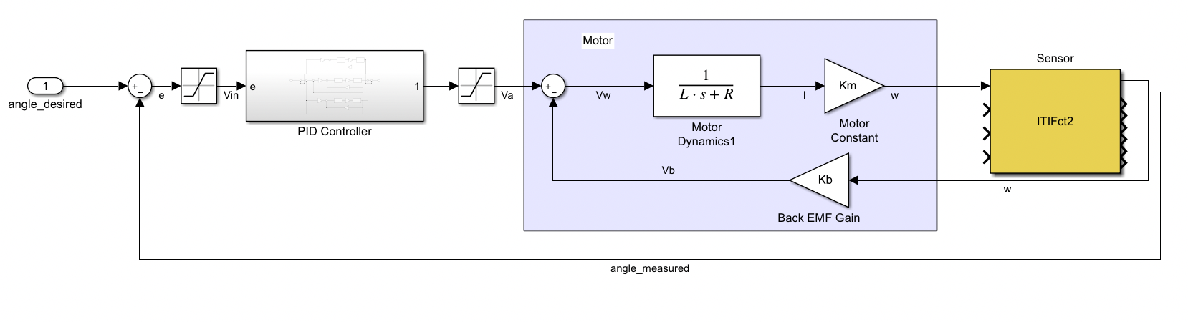

Figure 1. Linear model

The linear model of the control system is shown in Figure 1, the controller has an input of desired angle and uses PID controller then feeds the correct amount of voltage to the motor. The angle measured from the sensor is then used to calculate error which goes back to the input of the controller to minimize its error by subtracting with the desire value. Each motor uses the above controller, so the full system uses four of them in total shown in Figure 2.

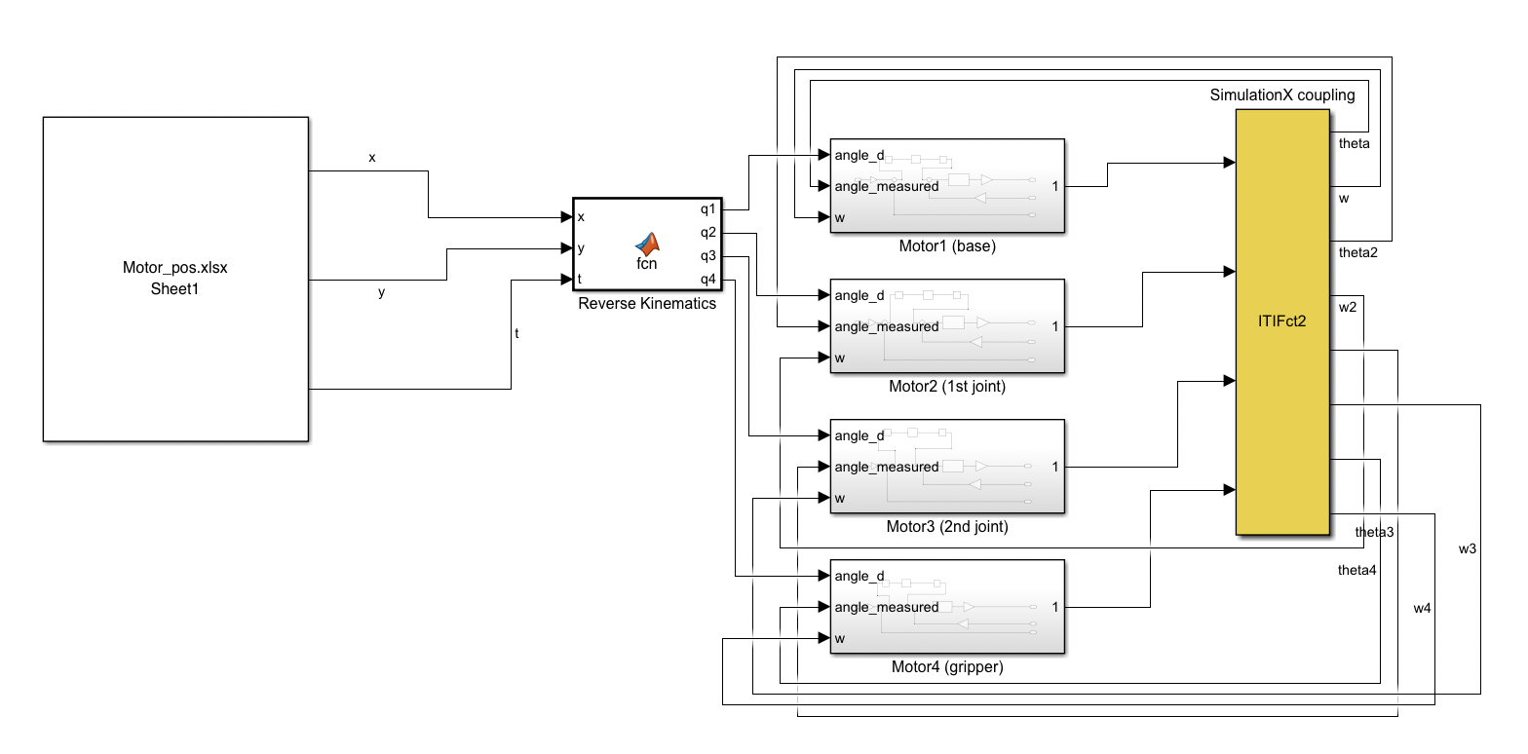

Figure 2. Linear model for all motors

# 2. Robotics

The path planning of the arm is designed to use excel data sheet to reference the location as shown in Figure 2. Excel sheet contains the position data and the time. Position data contains where faulty products are located and where to dispose the faulty product. The time data is used so the arm will know when and what to do at a certain time.

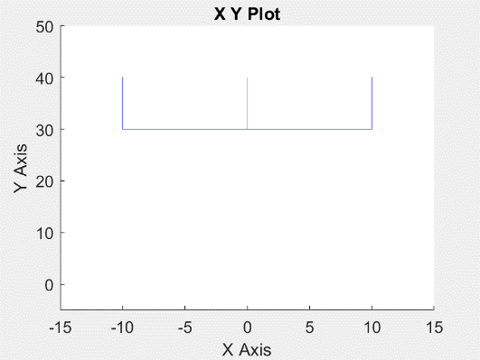

Figure 3. Excel sheet of the path and the path of the arm during the process

In Figure 3. Excel sheet of the path and the path of the arm during the process, excel data sheet shows the position data during 7.5 seconds to 8.5 seconds. The first column represents the elapsed time, second column is the desired x-position in cm, and the last column is the desired y-position in cm. At 7.5 seconds, the arm is moving from where marshmallow is at position (-10,40) to the garbage chute that is at (-10,30).

The visual of the path is shown with blue lines in Figure 3, the image on the right. The detailed path plan is as follows in Figure 4.

0-1 sec to stand still at pos (0, 20)

1-3 sec to move to pos (-10, 30)

3-5 sec to move to first marshmallow (-10, 40)

5-9 sec to close the grip

7-9 sec to move to garbage chute (-10, 30)

9-11 sec to open the grip

11-13 to move to pos (0, 30)

13-15 sec to move to second marshmallow (0, 40)

15-19 sec to close the grip

17-19 sec to move to garbage chute (0,30)

19-21 sec to open the grip

21-23 sec to move to pos (10, 30)

23-25 sec to move to last marshmallow (10, 40)

25-29 sec to close the grip

27-29 sec to move to garbage chute (10,30)

29-31 sec to open the grip

31-33 sec to come back to the original pos (0, 20)

Figure 4. Path in detail

The info above written in the excel sheet is read from the user defined MATLAB function that uses the inverse kinematics to calculate how much the motor must turn. The inverse kinematics uses trigonometric functions to measure their desired angles. The equations used for the inverse kinematics are shown in Figure 5. and the code that does the inverse kinematics is in Figure 6.

Figure 5. Inverse kinematics calculation [1]

Figure 6. Inverse kinematics code

# 3. Controllers

All robot arm joints have the controllers that was discussed in section 1. Motors and Controllers. Each controller uses PID controller to reach the correct voltage in a right amount of time with 0 overshoot to not have any interfere with other marshmallows while traveling. In the project, PID controller was written in 3 different ways.

## 3.1 PID controller written in C

PID controller written in C is shown below in Figure 7. This code creates the PIDController struct and functions on the bottom calculates and initiates the PIDController.

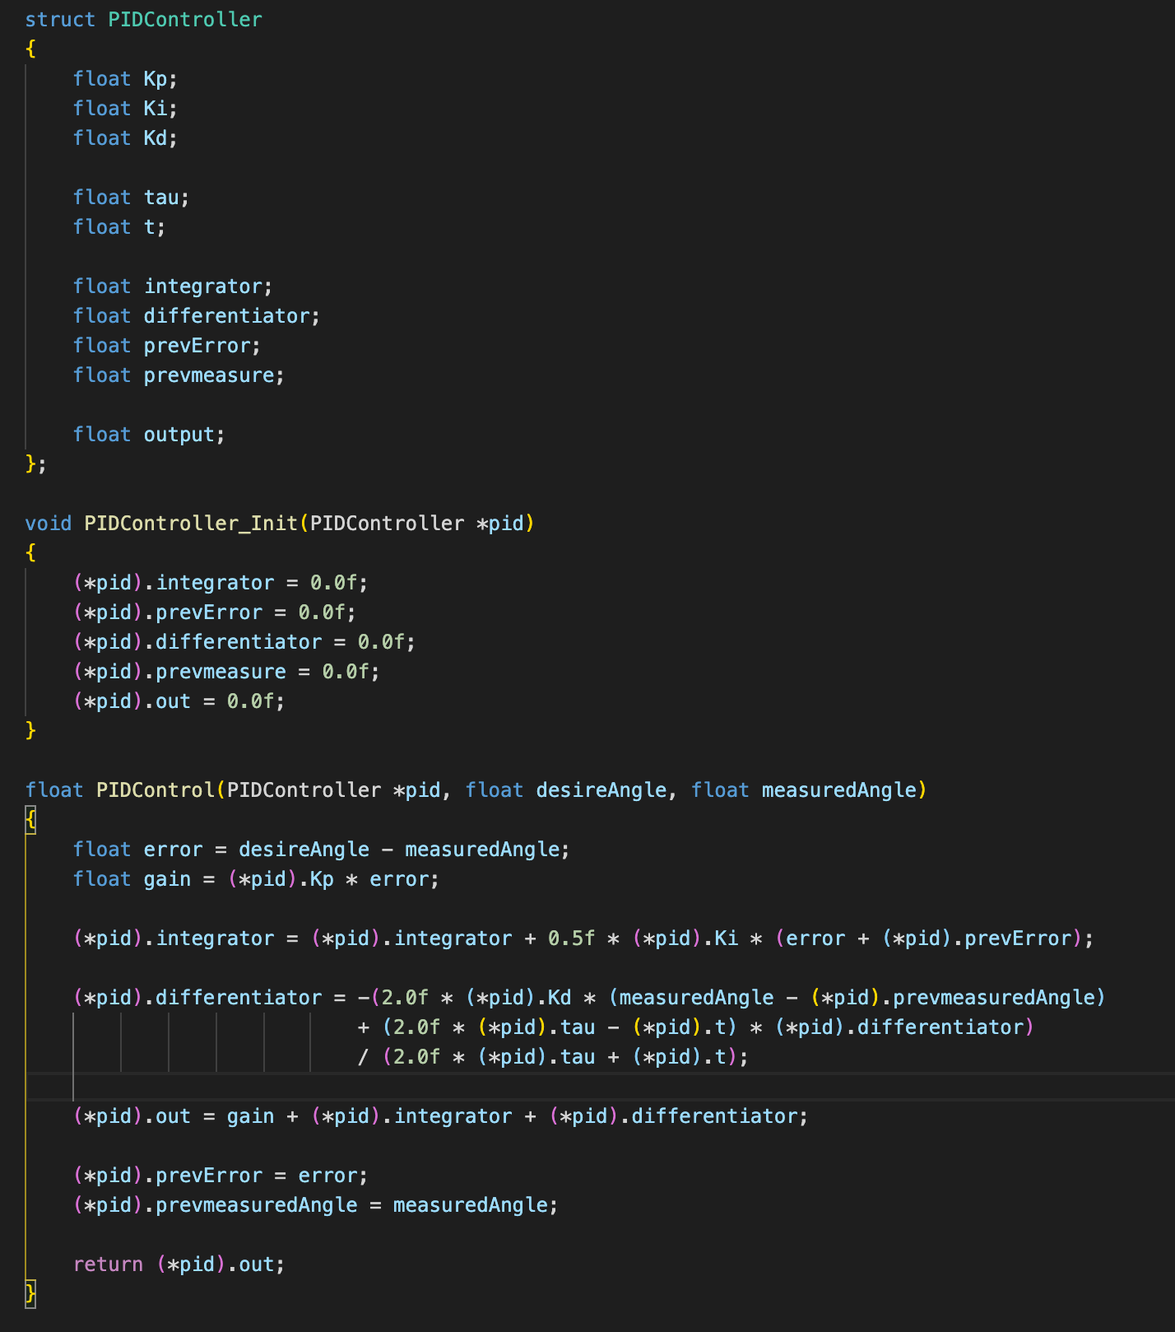

Figure 7. PID controller written in C. [2]

## 3.2 PID controller in MATLAB

PID controller in MATLAB is shown in Figure 8. The controller that is built is tested to a random transfer function and the result plot is just the same as the PID block in the Simulink shown in Figure 8.

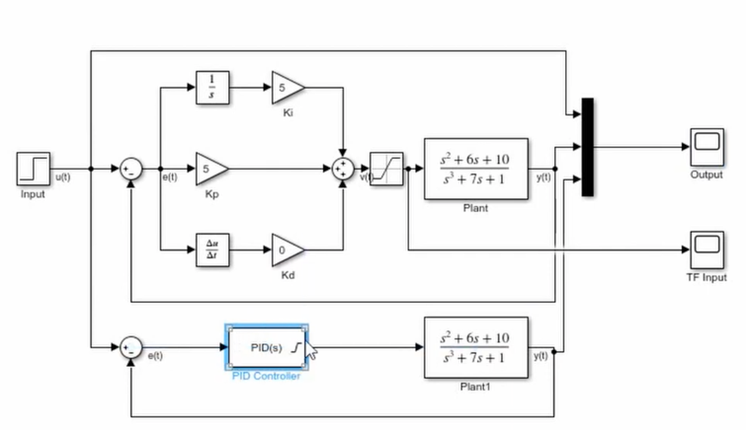

Figure 8. User-defined PID controller and its test [3]

## 3.3 PID controller in Arduino IDE

In order to estimate the ISR clock rate for the PID controller, Arduino code was written. The estimated ISR clock rate for the controller is measured to be 180 cycles each loop after the setup. The Arduino code is shown in Figure 9.

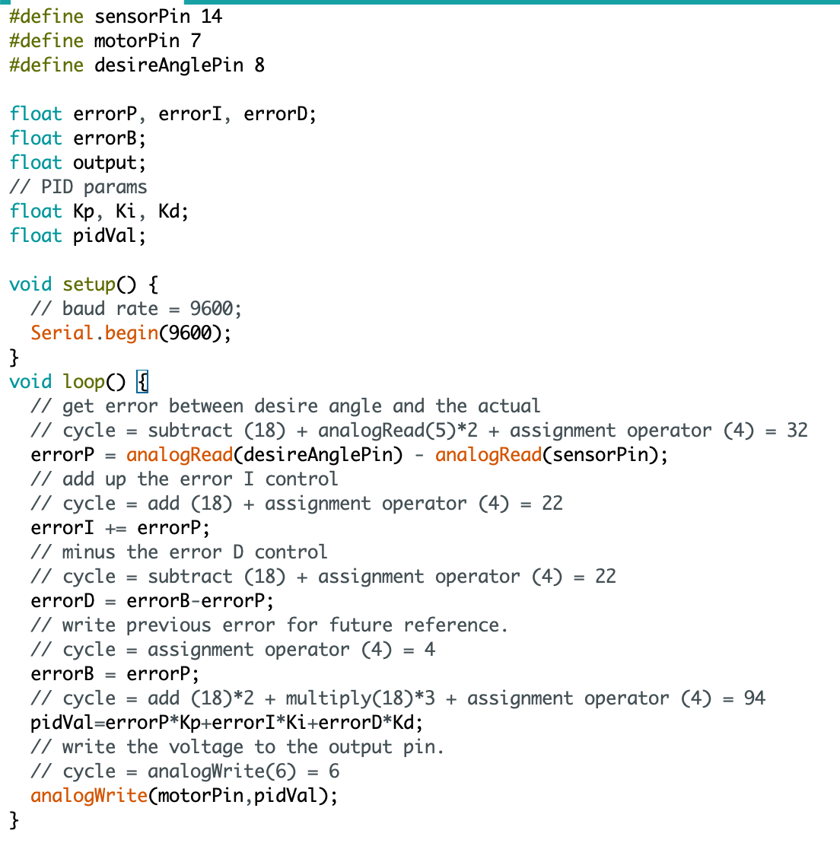

Figure 9. PID controller written in Arduino IDE [3]

# 4. Co-simulation

Using the TCP/IP shown in Figure 2, Simulink is connected with SimulationX so that the sensors from the SimulationX deliver value of the motors’ angles and their angular speeds to apply the PID control in the Simulink. During the co-simulation, re-tune of the controllers was done to produce near to 0% overshoot as shown in Figure 10.

The tuning technique that was used during the re-tune process of the co-simulation was to increase the P value first by doubling its number until the arm moves in a uniform oscillation. Then increase the D value by doubling until it reaches to almost 0% overshoot and increase, I value at the end to fine-tune until the overshoot is at 0% during each motion.

In SimulationX, all the designs from the Solidworks are transferred so that it simulates like in a real environment. The design of the arm is shown in Figure 11 and it shows that the grip successfully grabs one of the marshmallows. The entire diagram view is shown in Figure 13.

During the design process, the gripper of the final product was meant to be a better and efficient looking gripper than what is shown in Figure 11. The initially designed gripper is shown in Figure 12. Our team failed to transfer the product from the Solidworks to the SimulationX correctly in time, so a simpler version of the gripper was used instead. If there were more time given for the project, this is the one of the things that must have been prioritized first to be improved in the project.

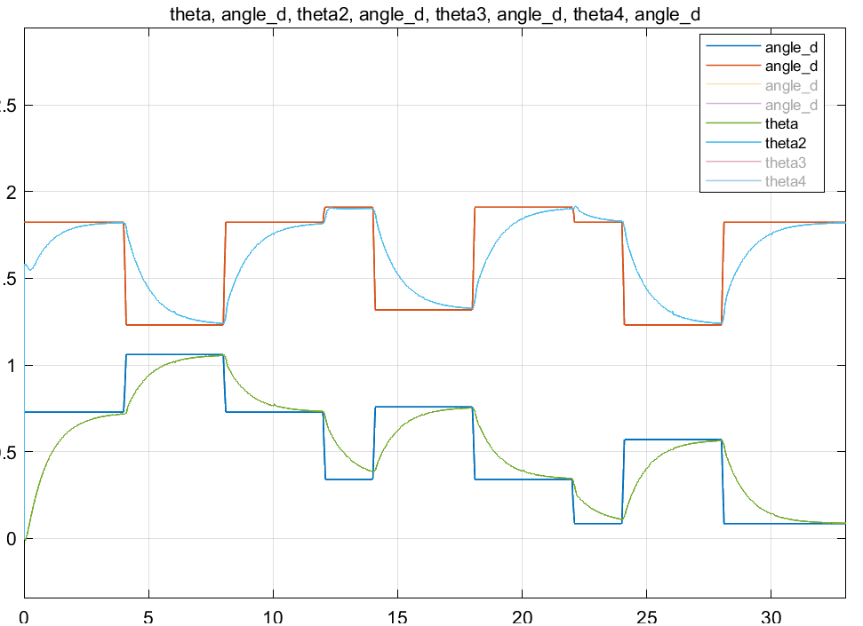

Figure 10. SimulationX data of Q1 and Q2

# Appendix

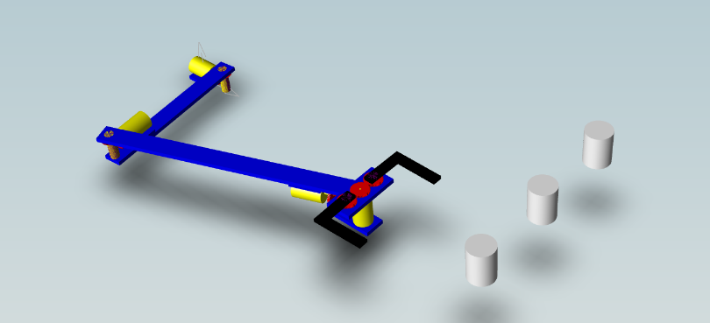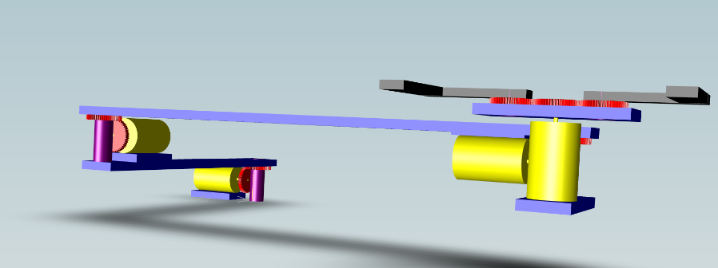

Figure 11. Robot arm in SimulationX

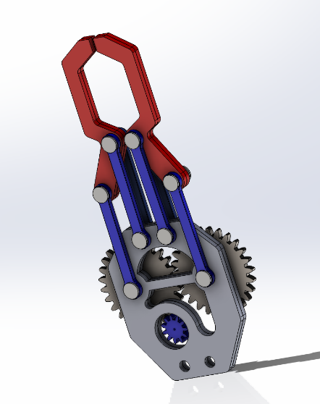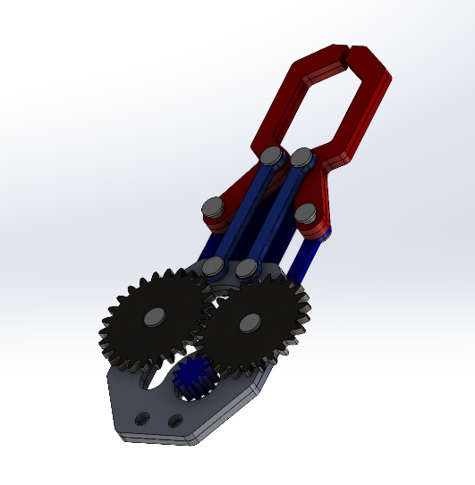

Figure 12. Gripper that was initially designed

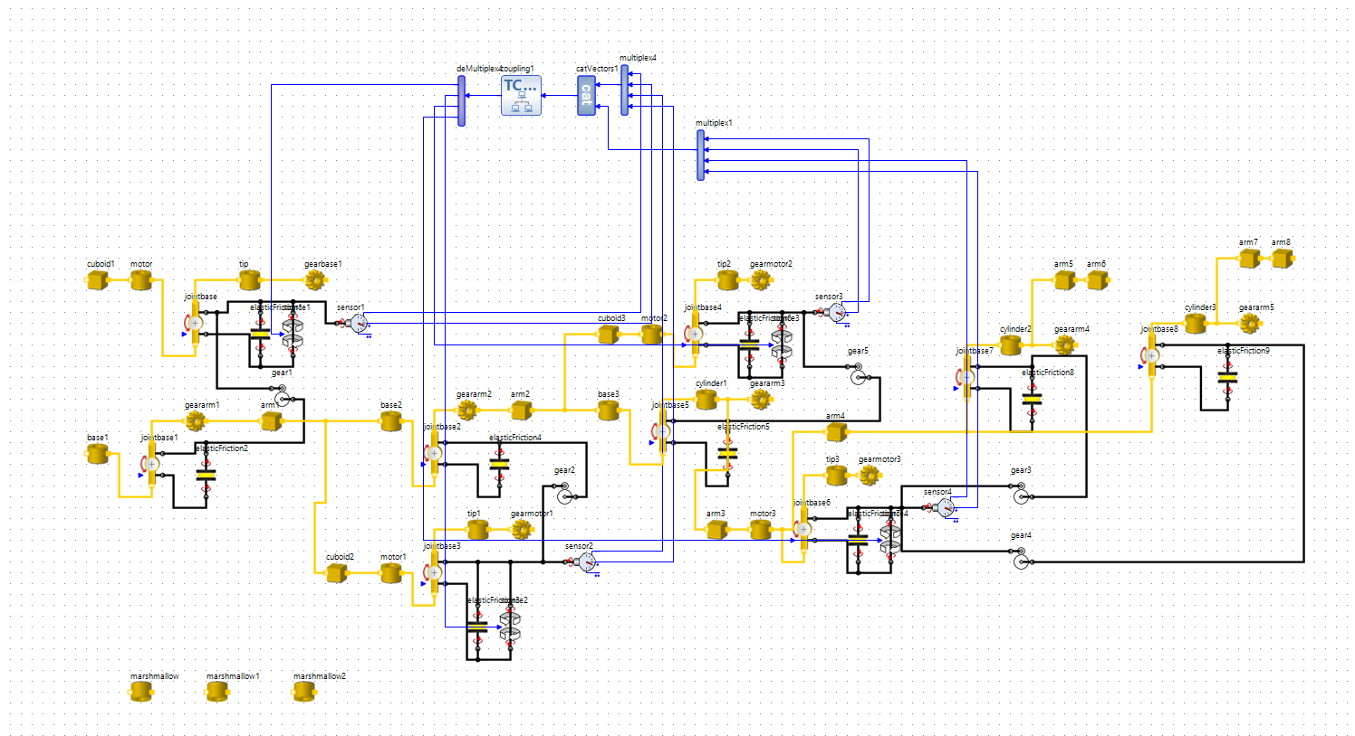

Figure 13. Full diagram built in SimulationX

# References

[1] Inverse Kinematics for a 2-Joint Robot Arm Using Geometry. (2018, July 31). Robot Academy. <https://robotacademy.net.au/lesson/inverse-kinematics-for-a-2-joint-robot-arm-using-geometry/>

[2] Embedded PID Temperature Control, Part 3: Implementation and Visualization - Projects. (2016, April 4). All About Circuits. <https://www.allaboutcircuits.com/projects/embedded-pid-temperature-control-part-3-implementation-and-visualization/>

[3] Phil’s Lab. (2020, May 22). PID Controller Implementation in Software. YouTube. <https://www.youtube.com/watch?v=zOByx3Izf5U>