*Jeff Eom, Mark Gnocato, Yanyu Zhang*

*University of British Columbia | ELEC 391 | April 14th, 2021*

*Robotics & Control*

# Abstract

A 3-DOF planar joint robot arm is developed to discard a faulty product on a stopped conveyor. In this report, control part of the project is focused. Section 1 describes the detailed usage of each motors and their controllers. Section 2 describes the robotics on direct, inverse kinematics and the path planning. Section 3 describes the detailed information of the controllers that is implemented in the system. Lastly, section 4 describes how it is simulated using Simulink and Simulation X simulation program.

# Nomenclature

A1 Length of 1st arm (m)

A2 Length of 2nd arm (m)

Q1 Angle of 1st arm (Degree)

Q2 Angle of 2nd arm (Degree)

Q3 Angle of gripper (Degree)

Q4 Angle to close and open gripper (Degree)

# Motors and Controllers

The robot arm consists of four motors: one motor mounted at the base of the arm, two motors mounted at two joints of the arm and lastly one motor mounted at the gripper. Each of the motors are controlled individually according to the angle that is calculated from the inverse kinematics of the path plan.

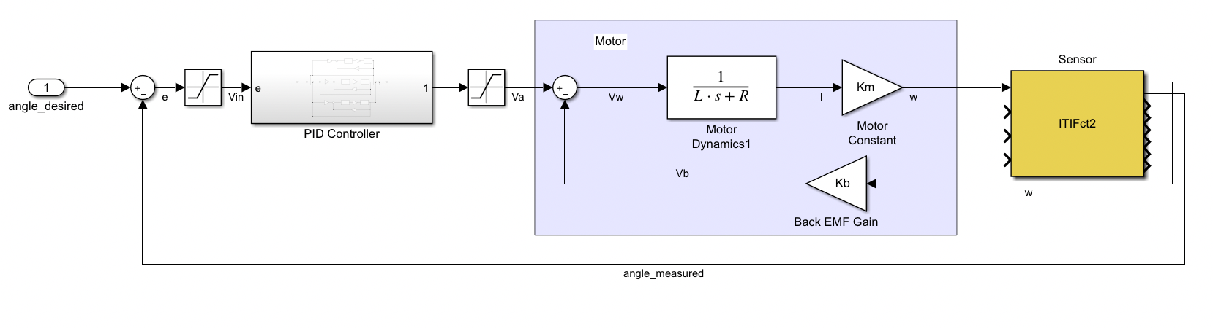

Figure 1. Linear model

The linear model of the control system is shown in figure 1, the controller has an input of desired angle and uses PID controller then feeds the correct amount of voltage to the motor. The angle measured from the sensor is then used to calculate error which goes back to the input of the controller to minimize its error. Each motor uses the above controller, so the full system uses four of them in total shown in Figure 2.

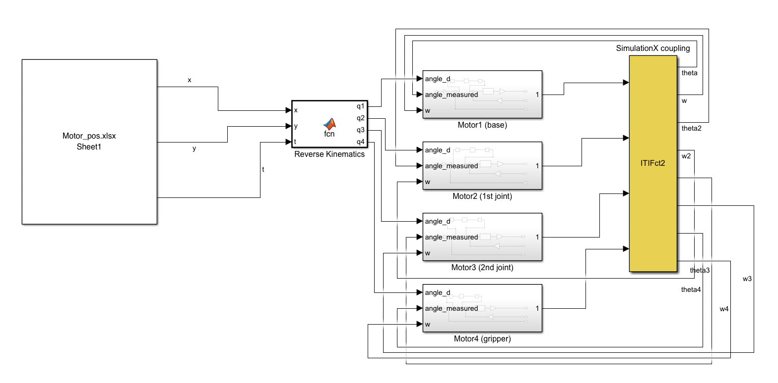

Figure 2. Linear model for all motors

# 2. Robotics

The path planning of the arm is designed to use excel data sheet to reference the location as shown in figure 2. Excel sheet contains the position data and the time. Position data contains where faulty products are located and where to dispose the faulty product at. The time data is used so the arm will know when and what to do at a certain time.

Figure 3. Excel sheet

In Figure 3, excel data sheet shows the position data during 7.5 seconds to 8.5 seconds. The first column represents the elapsed time, second column is the desired x-position in cm, and the last column is the desired y-position in cm. At 7.5 seconds, the arm is moving from where marshmallow is at position (-10,40) to the garbage chute that is at (-10,30).

The total path plan is as follows:

0-1 sec to stand still at pos (0, 20)

1-3 sec to move to pos (-10, 30)

3-5 sec to move to first marshmallow (-10, 40)

5-9 sec to close the grip

7-9 sec to move to garbage chute (-10, 30)

9-11 sec to open the grip

11-13 to move to pos (0, 30)

13-15 sec to move to second marshmallow (0, 40)

15-19 sec to close the grip

17-19 sec to move to garbage chute (0,30)

19-21 sec to open the grip

21-23 sec to move to pos (10, 30)

23-25 sec to move to last marshmallow (10, 40)

25-29 sec to close the grip

27-29 sec to move to garbage chute (10,30)

29-31 sec to open the grip

31-33 sec to come back to the original pos (0, 20)

The info above written in the excel sheet is read from the user defined MATLAB function that does the inverse kinematics to calculate how much the motor must turn. The inverse kinematics uses trigonometric functions to measure their desired angles the equations used are shown in figure 4. and the code that does the inverse kinematics in figure 5.

Figure 4. Inverse kinematics calculation

Figure 5. Inverse kinematics code

After the inverse kinematics, all the angles that motor must turn are all calculated, and the info is fed to the motors shown in Figure 2. Then, the direct kinematics happens as shown in figure 1 for each motor.

# 3. Controllers

All robot arm joints have the controllers as explained in section 1. Each controller uses PID controller to reach the correct voltage in a right amount of time with 0 overshoot to not have any interfere with other marshmallows while traveling.

**Pid**

The estimated ISR clock rate for the PID controller is measured to be 180 cycles to do each loop after the setup. The Arduino code is shown in figure 6.

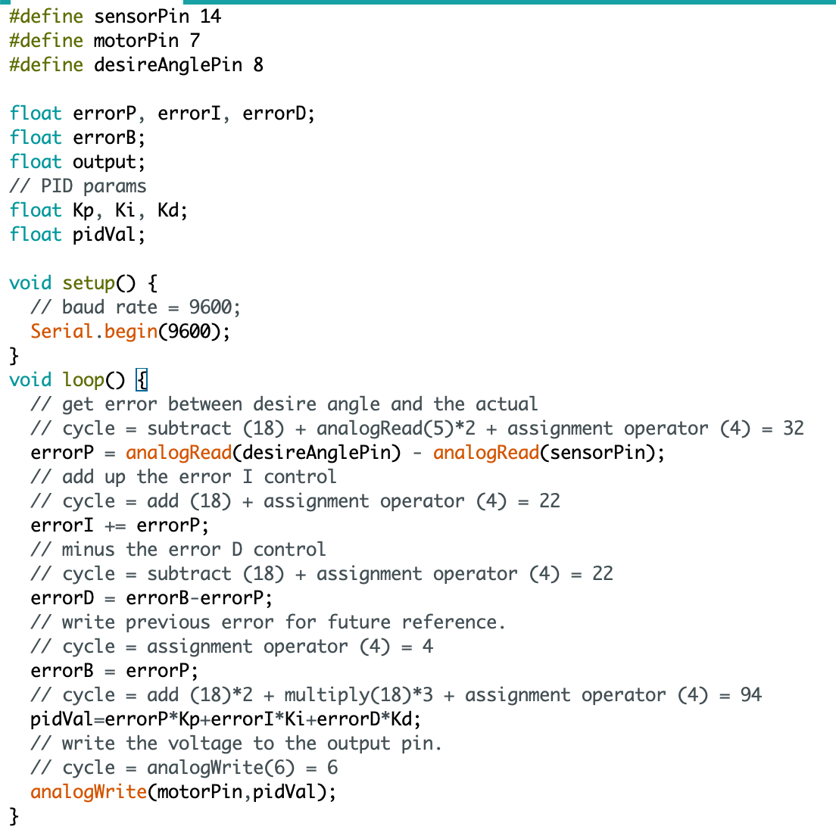

Figure 6. PID controller written in Arduino IDE

# 4. Co-simulation

Using the TCP/IP shown in figure 2, Simulink is connected with SimulationX so that the sensors from the SimulationX deliver value of the motors’ angles to apply the PID control in Simulink. During the co-simulation, re-tune of the controllers was done to produce near to 0% overshoot as shown in **figure 7.**

In SimulationX, all the designs from the Solidworks are transferred so that it simulates like in a real environment. The design of the arm is shown in figure 8 and it shows that the grip successfully grabs one of the marshmallows.

During the design of the arm, the gripper of the final product was meant to be a better and efficient looking gripper than what is shown in figure 8. The initially designed gripper is shown in figure 9. Our team failed to transfer the product from the Simulink to the SimulationX in time, so a miniature version of the gripper was used instead. If there were more time given for the project, this is the one of the things that must be prioritized first to be improved in the project.

Figure 7. SimulationX data

Figure 8. Robot arm in SimulationX

Figure 9. Gripper that was initially designed