# 数据库设计

### 一、逻辑模型

由于服务端采用的是开源的XMPP服务器Openfire，所以数据库设计方面该软件设计方已经设计好，我将其核心部分ER图抽取出来如图1所示：

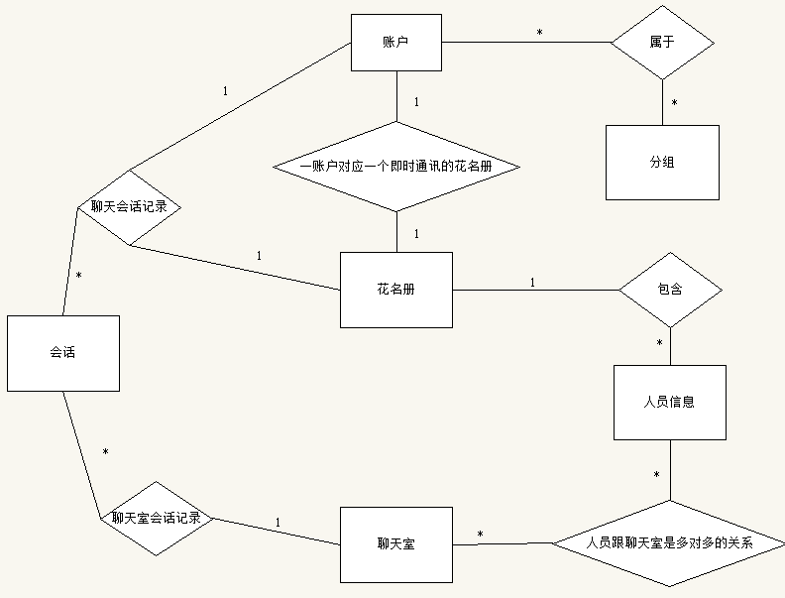

图1

具体每一个实体的子图如下图所示：

（1）账户：

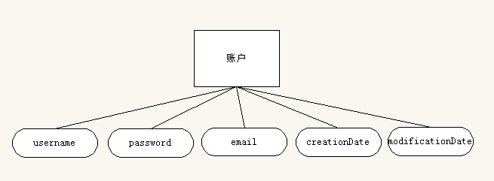

（2）花名册：

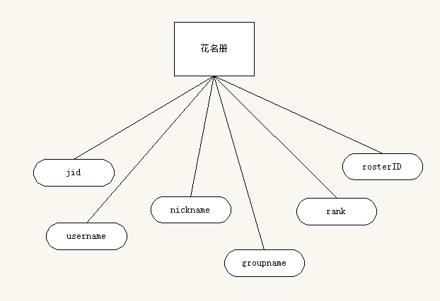

（3）聊天室：

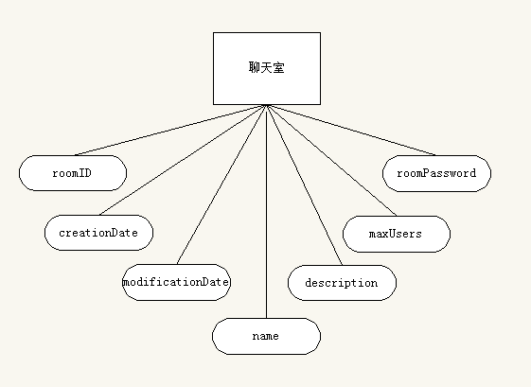

（4）会话：

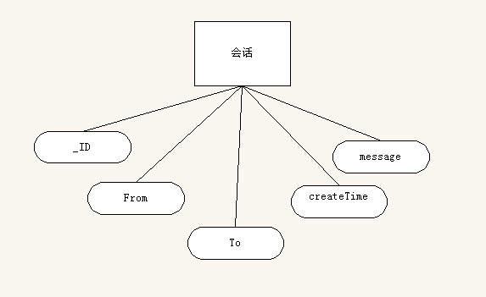

（5）分组：

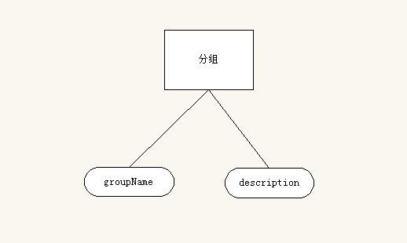

### 二、物理模型

各个物理表结构如下（已除去外键，目的是数据库性能优化，外键约束可以通过软件控制实现）：

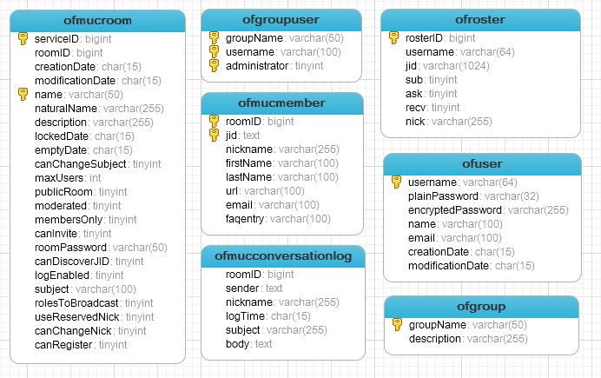

每个表描述如下：

|  |  |  |  |
| --- | --- | --- | --- |
| **ofRoster (所有人员花名册)** | | | |
| **Column Name** | **Type** | **Length** | **Description** |
| rosterID | NUMBER | n/a | ID of roster (Primary Key) |
| username | VARCHAR | 32 | User Name |
| jid | TEXT | n/a | The address of the roster entry |
| sub | NUMBER | n/a | The subscription status of the entry |
| ask | NUMBER | n/a | The ask status of the entry |
| recv | NUMBER | n/a | Flag indicating the entry is a roster request that was received |
| nick | VARCHAR | 255 | The nickname assigned to this roster entry |

|  |  |  |  |
| --- | --- | --- | --- |
| **ofRosterGroups (****花名册与分组关系表)** | | | |
| **Column Name** | **Type** | **Length** | **Description** |
| rosterID | NUMBER | n/a | Roster ID (Primary Key) |
| rank | NUMBER | n/a | Position of the entry (Primary Key) |
| groupName | VARCHAR | 255 | The user defined name for this roster group |

|  |  |  |  |
| --- | --- | --- | --- |
| **ofGroup (分组表)** | | | |
| **Column Name** | **Type** | **Length** | **Description** |
| groupName | VARCHAR | 50 | Group Name (Primary Key) |
| description | VARCHAR | 255 | Group Description |

|  |  |  |  |
| --- | --- | --- | --- |
| **ofGroupUser (花名册与分组管理员关系表)** | | | |
| **Column Name** | **Type** | **Length** | **Description** |
| groupName | VARCHAR | 50 | Group Name (Primary Key) |
| username | VARCHAR | 100 | User Name (Primary Key) |
| administrator | NUMBER | n/a | Adminstrator (Boolean) (Primary Key) |

|  |  |  |  |
| --- | --- | --- | --- |
| **ofUser (用户账户表)** | | | |
| **Column Name** | **Type** | **Length** | **Description** |
| username | VARCHAR | 32 | User Name (Primary Key) |
| plainPassword | VARCHAR | 32 | Plain-text password data |
| encryptedPassword | VARCHAR | 255 | Encrypted password data (default) |
| name | VARCHAR | 100 | Name |
| email | VARCHAR | 100 | Email Address |
| creationDate | VARCHAR | 15 | Creation Date |
| modificationDate | VARCHAR | 15 | Last Modified Date |

|  |  |  |  |
| --- | --- | --- | --- |
| **ofMucRoom (聊天室表)** | | | |
| **Column Name** | **Type** | **Length** | **Description** |
| roomID | NUMBER | n/a | ID of room (Primary Key) |
| creationDate | VARCHAR | 15 | Creation Date |
| modificationDate | VARCHAR | 15 | Last Modified Date |
| name | VARCHAR | 50 | Name of the room used as the public ID |
| naturalName | VARCHAR | 255 | Natural name of the room |
| description | VARCHAR | 255 | Room Description |
| canChangeSubject | NUMBER | n/a | Flag indicating whether participants can change the subject |
| maxUsers | NUMBER | n/a | Max number of room occupants |
| canChangeSubject | NUMBER | n/a | Flag indicating whether participants can change the subject or not |
| publicRoom | NUMBER | n/a | Flag indicating whether the room will be listed in the directory or not |
| moderated | NUMBER | n/a | Flag indicating whether the room is moderated or not |
| membersOnly | NUMBER | n/a | Flag indicating whether the room is members-only or not |
| canInvite | NUMBER | n/a | Flag indicating whether occupants can invite other users |
| roomPassword | VARCHAR | 50 | Password Data for joining the room |
| canDiscoverJID | NUMBER | n/a | Flag indicating whether real JID of occupants is public or not |
| logEnabled | NUMBER | n/a | Flag indicating whether room conversations are logged or not |
| subject | VARCHAR | 100 | Last known subject of the room |
| rolesToBroadcast | NUMBER | n/a | Binary representation of the roles to broadcast |
| useReservedNick | NUMBER | n/a | Flag indicating whether users can only join the room using their reserved nicknames |
| canChangeNick | NUMBER | n/a | Flag indicating whether occupants can change their nicknames in the room |
| canRegister | NUMBER | n/a | Flag indicating whether users are allowed to register with the room |

|  |  |  |  |
| --- | --- | --- | --- |
| **ofMucMember (房间成员关系表)** | | | |
| **Column Name** | **Type** | **Length** | **Description** |
| roomID | NUMBER | n/a | ID of room (Primary Key) |
| jid | TEXT | n/a | User JID (Primary Key) |
| nickname | VARCHAR | 255 | Reserved nickname of the member |

|  |  |  |  |
| --- | --- | --- | --- |
| **ofMucConversationLog (群聊天日志表)** | | | |
| **Column Name** | **Type** | **Length** | **Description** |
| roomID | NUMBER | n/a | ID of room |
| sender | TEXT | n/a | JID of the user that sent the message to the room |
| nickname | VARCHAR | 255 | Nickname used by the user when sending the message |
| logTime | VARCHAR | 15 | Date when the message was sent to the room |
| subject | VARCHAR | 50 | New subject changed with the message |
| body | TEXT | n/a | Body of the message |

由于本项目只做android客户端开发，主要也是针对XMPP协议跟服务器实现即时通讯，所以只能列举以上核心部分数据库设计。此外Android也做一部分数据库，目的只是作为暂存数据使用。因为相对于客户端开发Model层不一定是本地数据库，而是网络层。