Source Code:

%DfT of a sequence clc;

close all;

N=input('Length of sequence='); x=input('The Sequence='); n=0:1:N-1;

k=0:1:N-1;

wN=exp(-1i\*2\*pi/N); nk=n.\*k; wNnk=wN\*nk; xk=x\*wNnk; disp('xk='); disp(xk); mag=abs(xk); subplot(2,1,1);

stem(k,mag); grid on;

xlabel('--->k');ylabel('Magnitude'); title('Magnitude of fourier transform'); phase=angle(xk);

subplot(2,1,2); stem(k,phase); grid on;

xlabel('--->');ylabel('Phase'); title('Phase of fourier transform');

Output:

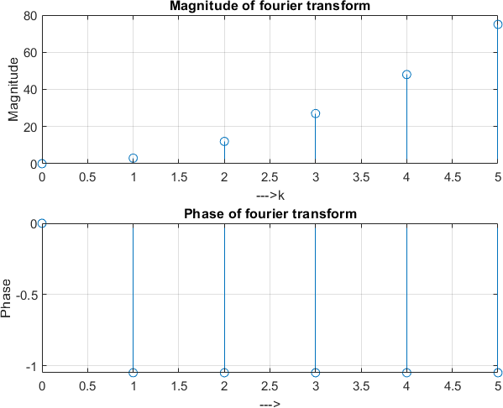

Source Code:

clc; close all;

%figure(1);

x = [1 2 3 4 5 6 7 6 5 4 3 2 1];

n = -2:10;

subplot(4,1,1);

stem(n,x);

%figure(2); n1 = 3:15;

%a = n+n1; subplot(4,1,2);

stem(n1,x);

%figure(3); n2 = -6:6;

%b = n-n2; subplot(4,1,3);

stem(n2,x);

m = min(min(n1),min(n2)):max(max(n1),max(n2)); y1 = [];

temp = 1;

for i = 1:length(m)

if (m(i)<min(n1)||m(i)>max(n1)) y1 = [y1 0];

else

y1 = [y1 x(temp)]; temp = temp+1;

end

end

y2 = [];

temp = 1;

for i = 1:length(m)

if (m(i)<min(n2)||m(i)>max(n2)) y2 = [y2 0];

else

y2 = [y2 x(temp)];

end

end

temp = temp+1;

y = (2.\*y1)-(3.\*y2);

subplot(4,1,4);

stem(m,y);

Output:

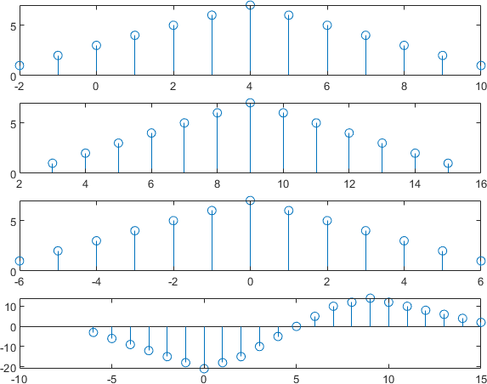

clc; close all; close all; A = 5;

f = 5;

t = 0:0.01:1;

x = A\*sin(2\*pi\*f\*t); subplot(4,1,1);

plot(t,x);

title('Continuous time signal'); xlabel('time(sec)');

ylabel('Amplitude(v)');

%%After sampling discrete time signal subplot(4,1,2);

stem(t,x); title('Sampling'); xlabel('time(sec)');

ylabel('Amplitude(v)');

%%Dc level+discrete time signal x1 = A+x;

subplot(4,1,3);

stem(t,x1);

title('DC level+discrete time signal'); xlabel('time(sec)');

ylabel('Amplitude(v)');

%%Quantized

x2 = round(x1); subplot(4,1,4);

stem(t,x2); title('Quantization'); xlabel('time(sec)');

ylabel('Amplitude(v)');

%%coding

x3 = dec2bin(x2); disp(x3);

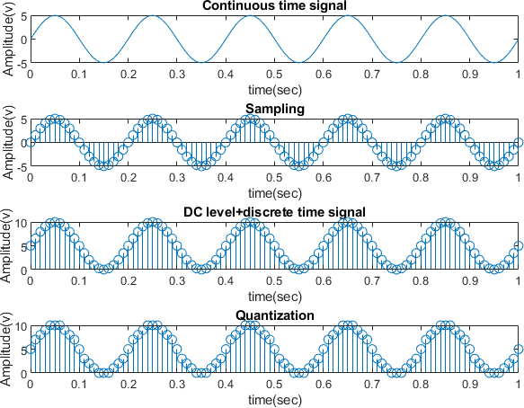

clc; close all; n=-5:5;

x=2\*deltaF(-2,-5,5)-deltaF(4,-5,5); stem(n,x);

xlabel('n');

ylabel('X(n)');

title('The desired function'); axis([-6 6 -3 3]);

grid on;

function [x,n]=deltaF(n0,n1,n2) n=n1:n2;

x=(n-n0)==0;

end

Output:

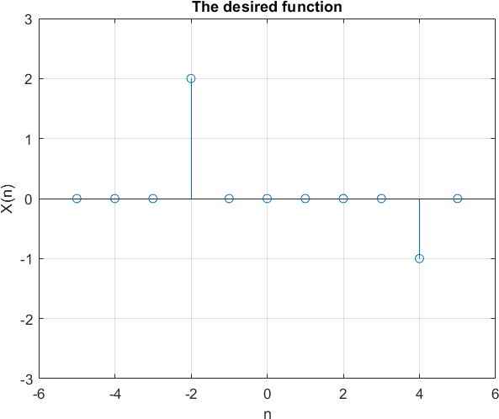

clc; close all; figure(1);

x = [1 0 3 4];

n1 = -2:1;

subplot(3,1,1);

stem(n1,x); grid on; title('X=');

xlabel('n');

ylabel('x(n)');

axis([-3 3 0 5]);

y = [1 1 1 1];

n2 = 0:3;

subplot(3,1,2);

stem(n2,y); grid on; title('Y=');

xlabel('n');

ylabel('x(n)');

axis ([-3 5 0 5]);

m = min(min(n1),min(n2)):max(max(n1),max(n2)); y1 = [];

temp = 1;

for i = 1:length(m) if(m(i)<min(n1)||m(i)>max(n1))

y1 = [y1 0];

else

y1 = [y1 x(temp)]; temp = temp+1;

end

end

y2 = [];

temp = 1;

for i = 1:length(m)

if(m(i)<min(n2)||m(i)>max(n2)) y2 = [y2 0];

else

y2 = [y2 y(temp)]; temp = temp+1;

end

end

add = y1+y2; subplot(3,1,3) stem(m,add); grid on;

title('Addition of signals(X+Y)'); xlabel('n');

ylabel('x(n)+y(n)'); axis ([-3 5 0 7]);

figure(2);

x = [3 -1 0 -4];

n = -1:2;

subplot(2,1,1);

stem(n,x);

title('Original signal x(n)'); xlabel('n');

ylabel('x(n)');

axis([-2 3 -5 4]);

c = fliplr(x); y = fliplr(-n); subplot(2,1,2) stem(y,c);

title('Folding of signals'); xlabel('n');

ylabel('-x(n)');

axis([-3 2 -5 4]);

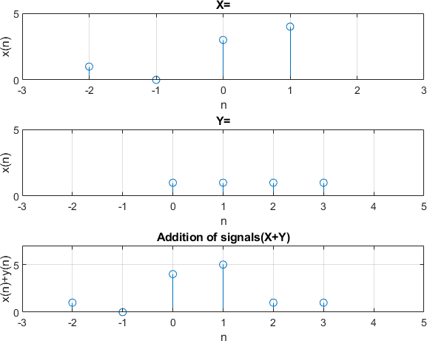

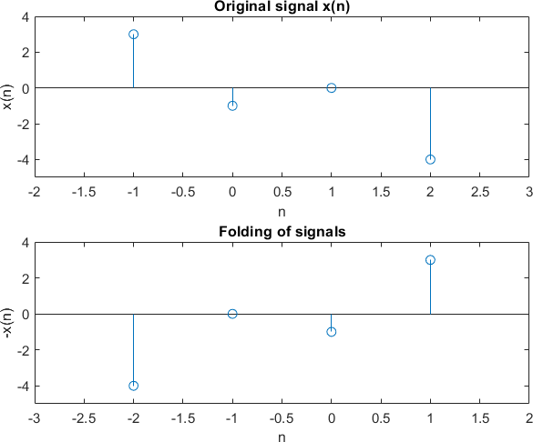

clc; close all; figure(1);

x = [1 2 3 4];

n1 = -2:1;

subplot(3,1,1);

stem(n1,x);

xlabel('n');

ylabel('x1(n)');

title('X1(n)');

axis([-8 10 -2 5]);

grid on;

y = [1 1 1 1];

n2 = 0:3;

subplot(3,1,2);

stem(n2,y);

xlabel('n');

ylabel('x2(n)');

title('X2(n)');

axis([-8 10 -2 5]);

grid on;

m = min(min(n1),min(n2)):max(max(n1),max(n2)); y1 = [];

temp = 1;

for i = 1:length(m) if(m(i)<min(n1)||m(i)>max(n1))

y1 = [y1 0];

else

y1 = [y1 x(temp)]; temp = temp+1;

end

end

y2 = [];

for i = 1:length(m) if(m(i)<min(n2)||m(i)>max(n2))

y2 = [y2 0];

else

y2 = [y2 y(temp)]; temp = temp+1;

end

end

mul = y1.\*y2; subplot(3,1,3);

stem(m,mul);

xlabel('n'); ylabel('X1(n)\*X2(n)'); title('Signal Multiplication'); axis([-8 10 -2 5]);

grid on;

figure(2); n = -2:2;

x = [-2 3 0 1 5];

subplot(3,1,1);

stem(n,x);

xlabel('n');

ylabel('x1(n)');

title('X1(n)');

axis([-8 10 -4 6]);

grid on;

n1 = 5;

a = n+n1; subplot(3,1,2);

stem(a,x);

xlabel('n');

%ylabel('x2(n)');

title('X1(n-5)');

axis([-8 10 -4 6]);

grid on;

n2 = 4;

b = n-n2; subplot(3,1,3);

stem(b,x);

xlabel('n');

ylabel('X1(n+4)'); title('Signal Shifting'); axis([-8 10 -4 6]);

grid on;

Output:

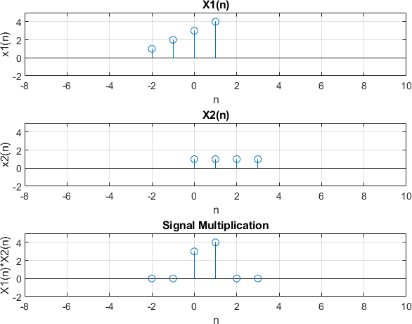

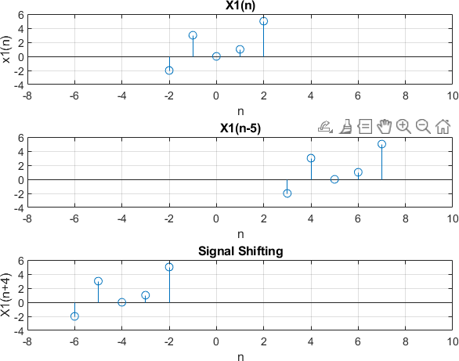

f=0:0.01:2;

x=4\*sinc(4\*f); figure(1); subplot(3,1,1);

plot(f,real(x)); title('Real Part'); xlabel('f-->');

subplot(3,1,2);

plot(f,abs(x)); title('Magnitude Part'); xlabel('f-->');

subplot(3,1,3);

plot(f,angle(x)); title('Phase Part'); xlabel('f-->');

Output:

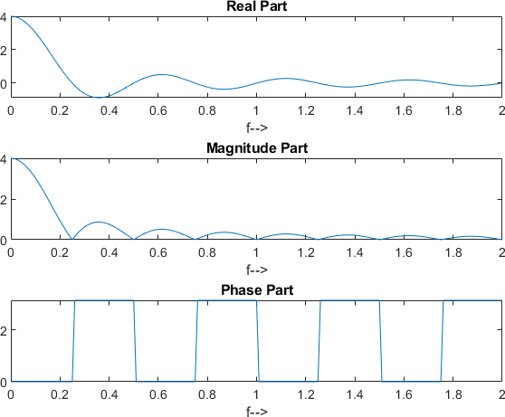

N=250; ts=.0002;

t=(0:N-1)\*ts; x=cos(2\*pi\*100\*t)+cos(2\*pi\*500\*t); subplot(2,1,1)

plot(t,x) xlabel("x");

ylabel("Time (sec) ");

k=0;

for f=0:1:800 k=k+1;

X(k)=trapz(t,x.\*exp(-1i\*2\*pi\*f\*t));

end f=0:800;

subplot(2,1,2);

plot(f, abs(X));

Output:

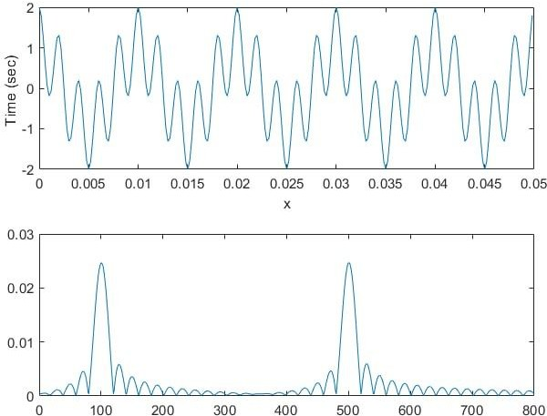

A=5; f=100;

T=1/f; t=0:T/100:T;

y=A\*sin(2\*pi\*f\*t); plot(t,y);

xlabel('T');ylabel('Amplitude'); title('Sinusoidal Wave');

Output:

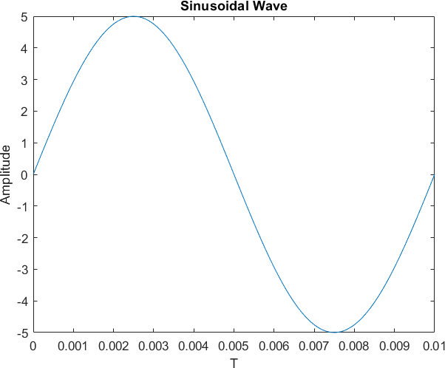

% Unit sample sequence clc;

close all; n=-5:5; x=n==0;

stem(n,x);

subplot(3,1,1);

title('Unit Sample Sequence'); xlabel('n');ylabel('x');

%unit step signal

N=5;

n2=-N:1:N;

x2=[zeros(1,N) 1 ones(1,N)]; subplot(3,1,2);

stem(n2,x2); xlabel('Time');ylabel('Amplitude'); title('Unit Step');

%unit ramp function

n3=-5:5; x3=n3.\*(n3>=0);

subplot(3,1,3);

stem(n3,x); xlabel('Time');ylabel('Amplitude'); title('Unit ramp');

