|  |
| --- |
| **Concepts** |
| **Enterprise IT infra intro** |
| **Servers and their classes** |
| **Server locations (cloud, on-premise, rented)** |
| **Databases and their types** |
| **Directory introduction** |
| **Servers** |
| **Windows administration** |
| **Linux administrative activities** |
| **Active directory installation and working** |
| **DNS installation and working** |
| **Application servers working & admin** |
| **Databases** |
| **MySQL administration** |
| **MongoDB/NoSQL administration** |
| **Query structure in SQL/NoSQL DBs** |
| **Export and import of data from databases** |
| **Storage** |
| **Direct attached storage** |
| **RAID 5 concepts (storage availability)** |
| **File Servers / Shares** |
| **FTP Servers** |
| **Windows File Sharing** |
| **NFS introduction** |
| **File mounting on servers** |
| **Mail Server Setup** |
| **Configuring a basic mail server** |
| **Load Balancers** |
| **Setting up TCP load balancers** |
| **HTTP load balancing using HA Proxies / Nginx** |

**What is IT Infrastructure?**

Information technology infrastructure, or IT infrastructure, refers to the combined components needed for the operation and management of enterprise IT services and IT environments.

Information technology (IT) infrastructure are the components required to operate and manage enterprise IT environments. ... These components include hardware, software, networking components, an operating system (OS), and data storage, all of which are used to deliver IT services and solutions.

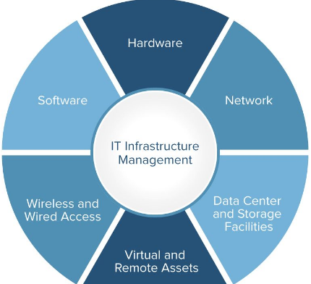

## **Introduction to Server**

A computer program or a device that provides functionalities to other computer programs known as clients or customers is called a server. This entire architecture is called client-server architecture. The single process of the architecture is distributed to the entire processes of computation of devices or programs. It basically works on the network and manages network resources. No other tasks can be assigned to the server and it does not do other tasks. Once operated, a single computer can carry out multiple programs of the server at a time. In simple words, it provides data to other computers.

# 

### **Types of Servers**

**1. Application Server**

This is an environment where different applications can run irrespective of what they are or what functions they will perform. It is utilized in developing, processing and running web-based applications. Some of the examples are PHP, Java, and .NET Framework. Application, they provide the advantage of processing high-end jobs and centralized storage of data.

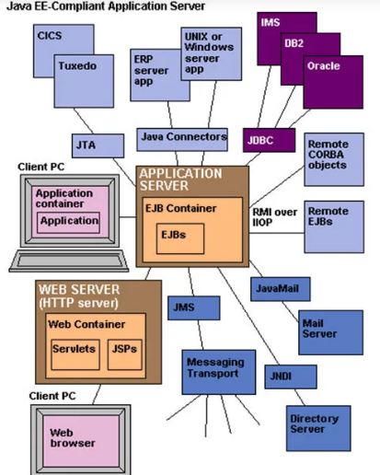

**2. Database Server**

They provide access and retrieving of data from a database. We can access the database by “frontend”, which runs locally user machine and “backend” termed as running on the database itself accessed by any remote device or shell. Any information in the database is retrieved by firing query then it is outputted to the user requesting the data. The big organization utilizes a database for storage and users can access the data by executing a query using any query language.

Example: SQL Server

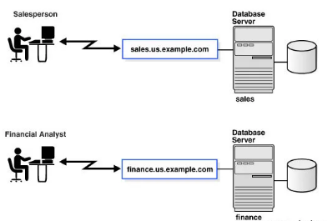

**3. Mail Server**

It is a centralized or remote computer that holds e-mail messages for the client on a particular network. It is the same as to the post office, where mails are stored and sorted before dispatching it to the final destination. Whenever the user requests or sends any e-mail through the client machine, they need to contact the mail server, to deliver mail to receiving the client’s computer.

Examples: Simple Mail Transfer Protocol (SMTP), Post office Protocol 3(POP3).

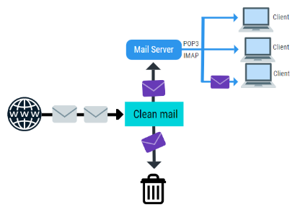

**4. Domain Name Service**

It is popularly known by Domain Name System which receives a request having a domain name hostname and responds back corresponding IP address. DNS uses port 53 for providing the service.

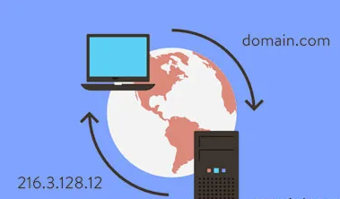

**5. Web Server**

It is a computer or a bunch of computers, used to deliver web pages and other content to multiple users as per request.

Examples: Apache, Tomcat, Microsoft Web Server(IIS)

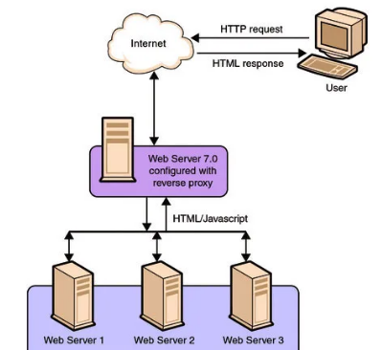

**6. Proxy Server**

It is a computer that’s part of the gateway server or another computer which separates a local network from worldwide networks. It caches all the pages accessed through the network which will allow users who want to visit that same page, which will load the load faster and reduce the network’s bandwidth. When a page is accessed without proxy server’s access the web page using its own IP address caches that page and forwards it to the respective user.

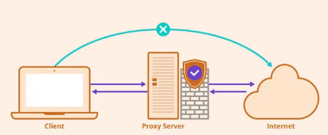

**Server locations**

**1. on-premise**

"On-prem" refers to private data centers that companies house in their own facilities and maintain themselves. On-prem infrastructure can be used to run private clouds, in which compute resources are virtualized in much the same way as those of public clouds (however, private clouds can also be run on leased third-party hardware).

**2. Cloud**

A cloud server is powerful physical or virtual infrastructure that performs application- and information-processing storage. Cloud servers are created using virtualization software to divide a physical (bare metal) server into multiple virtual servers.

**3. Rented**

Dedicated server rental is when a hosting company leases an entire server unit to a client. Put simply: only your data is stored on the server. Dedicated server rental is contrasted against a shared server - this works in much the same way, but the only difference is that you share a server with multiple other users.

**Storage classes**

**Databases and their types**

A database is an organized collection of data, so that it can be easily accessed and managed.

**Types**

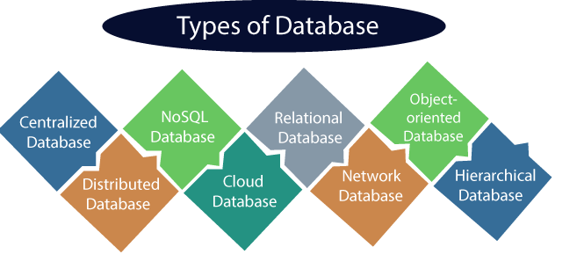

1. **Centralized Database**

It is the type of database that stores data at a centralized database system. It comforts the users to access the stored data from different locations through several applications. These applications contain the authentication process to let users access data securely.

2) **Distributed Database**

Unlike a centralized database system, in distributed systems, data is distributed among different database systems of an organization. These database systems are connected via communication links. Such links help the end-users to access the data easily. Examples of the Distributed database are Apache Cassandra, HBase, Ignite, etc.

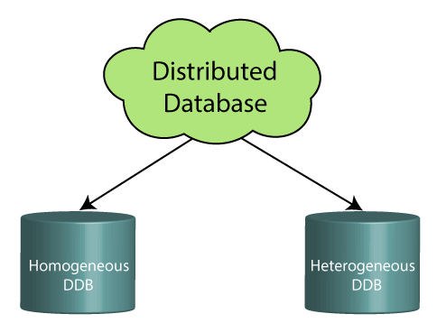

Homogeneous DDB: Those database systems which execute on the same operating system and use the same application process and carry the same hardware devices.

Heterogeneous DDB: Those database systems which execute on different operating systems under different application procedures, and carries different hardware devices.

3) **Relational Database**

This database is based on the relational data model, which stores data in the form of rows(tuple) and columns(attributes), and together forms a table(relation). A relational database uses SQL for storing, manipulating, as well as maintaining the data. E.F. Codd invented the database in 1970. Each table in the database carries a key that makes the data unique from others. Examples of Relational databases are MySQL, Microsoft SQL Server, Oracle, etc.

4) **NoSQL Database**

Non-SQL/Not Only SQL is a type of database that is used for storing a wide range of data sets. It is not a relational database as it stores data not only in tabular form but in several different ways. It came into existence when the demand for building modern applications increased. Thus, NoSQL presented a wide variety of database technologies in response to the demands.

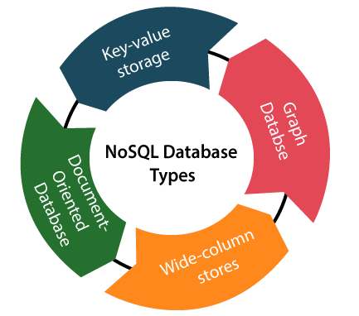

* Key-value storage: It is the simplest type of database storage where it stores every single item as a key (or attribute name) holding its value, together.
* Document-oriented Database: A type of database used to store data as JSON-like document. It helps developers in storing data by using the same document-model format as used in the application code.
* Graph Databases: It is used for storing vast amounts of data in a graph-like structure. Most commonly, social networking websites use the graph database.
* Wide-column stores: It is similar to the data represented in relational databases. Here, data is stored in large columns together, instead of storing in rows.

5) **Cloud Database**

A type of database where data is stored in a virtual environment and executes over the cloud computing platform. It provides users with various cloud computing services (SaaS, PaaS, IaaS, etc.) for accessing the database. There are numerous cloud platforms, but the best options are:

Amazon Web Services(AWS)

Microsoft Azure

Kamatera

PhonixNAP

ScienceSoft

Google Cloud SQL, etc.

6) **Hierarchical Databases**

It is the type of database that stores data in the form of parent-children relationship nodes. Here, it organizes data in a tree-like structure.

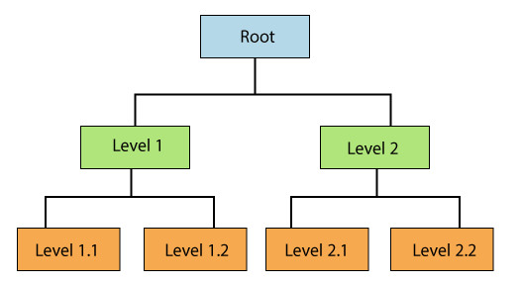 Data get stored in the form of records that are connected via links. Each child record in the tree will contain only one parent. On the other hand, each parent record can have multiple child records.

**Directory introduction**

A directory is a collection of information about objects that are arranged in a hierarchical structure. It is a data repository that enables users or applications to find resources that have the characteristics that are needed for a particular task.

A directory can be centralized or distributed. If a directory is centralized, there is one directory server at one location that provides access to the directory. If the directory is distributed, more than one server, sometimes geographically dispersed, provides access to the directory.

Directory clients and servers

Directories are accessed by the client/server model of communication. The directory clients and servers might not be on the same machine. A server can serve many clients. An application that wants to read or write information in a directory does not access the directory directly. Instead, it calls a function or an application programming interface (API) that causes a message to be sent to another process. This second process accesses the information in the directory on behalf of the requesting application. The results of the read or write actions are then returned to the requesting application.

Eg; LDAP, DNS

**Servers**

**Windows administration**

Windows Server Administration is an advanced computer networking topic that includes server installation and configuration, server roles, storage, Active Directory and Group Policy, file, print, and web services, remote access, virtualization, application servers, troubleshooting, performance, and reliability.

**Linux administration**

Linux systems administrator has to manage the operations of a computer system like maintain, enhance, create user account/report, taking backups using Linux tools and command-line interface tools. Most computing devices are powered by Linux because of its high stability, high security, and open-source environment. There are some of the things that a Linux system administrator should know and understand:

**Linux File Systems**

File System Hierarchy

Managing Root/super User

Basic Bash Command

Handling File, Directories and Users

**Active Directory**

Active Directory (AD) is a database and set of services that connect users with the network resources they need to get their work done. The database (or directory) contains critical information about your environment, including what users and computers there are and who’s allowed to do what.

For example, the database might list 100 user accounts with details like each person’s job title, phone number and password. It will also record their permissions.

**Installing ADUC for Windows 10 Version 1809 and Above**

* + From the Start menu, select Settings > Apps.
  + Click the hyperlink on the right side labeled Manage Optional Features and then click the button to Add feature.
  + Select RSAT: Active Directory Domain Services and Lightweight Directory Tools.
  + Click Install.
  + When the installation completes, you will have a new menu item in the start menu called Windows Administrative Tools.

Active Directory working:

* Active Directory Administrative Center: Allows management for the AD Trash Can (accidental deletes), password policies, and displays the PowerShell history.
* Active Directory Domains and Trusts: Lets you administer multiple domains to manage functional level, manage forest functional level, manage User Principal Names (UPN), and manage trusts between domains and forests.
* Active Directory Module for Windows PowerShell: Enables the PowerShell cmdlets to administer AD.
* Active Directory Sites and Services: Allows you to view and manage Sites and Services. You can define the topology of AD and schedule replication.
* ADSI Edit: ADSI Edit is a low-end tool to manage AD objects. AD experts don’t recommend that you use ADSI Edit, use ADUC instead.

**DNS installation and working: -** [How to Setup DNS server using Bind9 on Ubuntu 16.04 - Alibaba Cloud Community](https://www.alibabacloud.com/blog/how-to-setup-dns-server-using-bind9-on-ubuntu-16-04_594469)

**Application servers working & admin :-** [Introduction to Application Server Administration (unipi.it)](http://pages.di.unipi.it/ghelli/didattica/bdldoc/A97329_03/core.902/a92171/intro.htm)

**Database**

**MySQL admin**

MySQL is the most popular Open-Source Relational SQL Database Management System. MySQL is one of the best RDBMS being used for developing various web-based software applications. MySQL is developed, marketed and supported by MySQL.

Few definitions related to the database.

* + Database – A database is a collection of tables, with related data.
  + Table – A table is a matrix with data. A table in a database looks like a simple spreadsheet.
  + Column – One column (data element) contains data of one and the same kind, for example the column postcode.
  + Row – A row (= tuple, entry or record) is a group of related data, for example the data of one subscription.
  + Redundancy – Storing data twice, redundantly to make the system faster.
  + Primary Key – A primary key is unique. A key value can not occur twice in one table. With a key, you can only find one row.
  + Foreign Key – A foreign key is the linking pin between two tables.
  + Compound Key – A compound key (composite key) is a key that consists of multiple columns, because one column is not sufficiently unique.
  + Index – An index in a database resembles an index at the back of a book.
  + Referential Integrity – Referential Integrity makes sure that a foreign key value always points to an existing row.

Installing MySQL on Linux/UNIX

* + MySQL – The MySQL database server manages the databases and tables, controls user access and processes the SQL queries.
  + MySQL-client – MySQL client programs, which make it possible to connect to and interact with the server.
  + MySQL-devel – Libraries and header files that come in handy when compiling other programs that use MySQL.
  + MySQL-shared – Shared libraries for the MySQL client.
  + MySQL-bench – Benchmark and performance testing tools for the MySQL database server.

# MongoDB

# MongoDB is an open-source document database and leading NoSQL database. MongoDB is written in C++. This tutorial will give you great understanding on MongoDB concepts needed to create and deploy a highly scalable and performance-oriented database.

|  |  |
| --- | --- |
| **RDBMS** | **MongoDB** |
| Database | Database |
| Table | Collection |
| Tuple/Row | Document |
| column | Field |
| Table Join | Embedded Documents |
| Primary Key | Primary Key (Default key _id provided by MongoDB itself) |

# DAS

# DAS stands for Direct Attached Storage. It is a digital storage device connected directly to the server, workstation, or personal computer via the cable. In Direct Attached Storage, applications use the block-level access protocol for accessing the data. There is no need for any network to attach the device to the server or workstation. So, DAS (Direct Attached Storage) is not a part of the storage network. Some examples of this storage device are solid-state drive, hard drives, tape libraries, and optical disk drives.

# Types of DAS

# Following are the two types of Direct Attached Storage (DAS):

# Internal DAS

# Internal DAS is a DAS in which the storage device is attached internally to the server or PC to used for high-speed bus connectivity over a short distance.

# External DAS

# External DAS is a DAS in which the external storage device is directly connected to the server without any device. In this type of DAS, FCP and SCSI are the protocols which act as an interface between server and the storage device.

# What is RAID?

# RAID or redundant array of independent disks is a data storage virtualization technology that combines multiple physical disk drive components into one or more logical units for data redundancy, performance improvement, or both.

**RAID 5: -** RAID 5 is a [redundant array of independent disks](https://searchstorage.techtarget.com/definition/RAID) configuration that uses [disk striping](https://searchstorage.techtarget.com/definition/RAID-0-disk-striping) with [parity](https://searchstorage.techtarget.com/definition/parity). Because data and parity are striped evenly across all of the disks, no single disk is a bottleneck. Striping also allows users to reconstruct data in case of a disk failure. RAID 5 evenly balances reads and writes, and is currently one of the most commonly used RAID methods. It has more usable storage than RAID 1 and RAID 10 configurations, and provides performance equivalent to RAID 0. RAID 5 groups have a minimum of three hard disk drives (HDDs) and no maximum. Because the parity data is spread across all drives, RAID 5 is considered one of the most secure RAID configurations.

# RAID 5

# [RAID 5 vs RAID 6 - YouTube](https://www.youtube.com/watch?v=UuUgfCvt9-Q&ab_channel=PowerCertAnimatedVideos)

# FTP Server

## The primary purpose of an FTP server is to allow users to upload and download files.An FTP server is a computer that has a [file transfer protocol (FTP)](https://www.techopedia.com/definition/1872/file-transfer-protocol-ftp) address and is dedicated to receiving an FTP connection. FTP is a protocol used to transfer files via the internet between a server (sender) and a client (receiver)**.**An FTP server is a computer that offers files available for download via an FTP protocol, and it is a common solution used to facilitate remote data sharing between computers.

# Windows File Sharing Basics

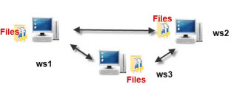

All windows computers since windows for workgroups have been capable of sharing resources like files and printers on the network, and also of accessing shared resources on a network.

### Networking Models

Microsoft networks were originally designed as**peer to peer** networks back in the days of windows for workgroups 3.1.

In **peer to peer** networks all computers are equal and can function as both a client and server.

This means that workstation1 could share its files on the network and they could be accessed by workstation 2 and vice versa.

This is in contrast to**client server** networks used on the internet and corporate networks were a single computer shares files (the server) and all other computers can access these files (the clients).

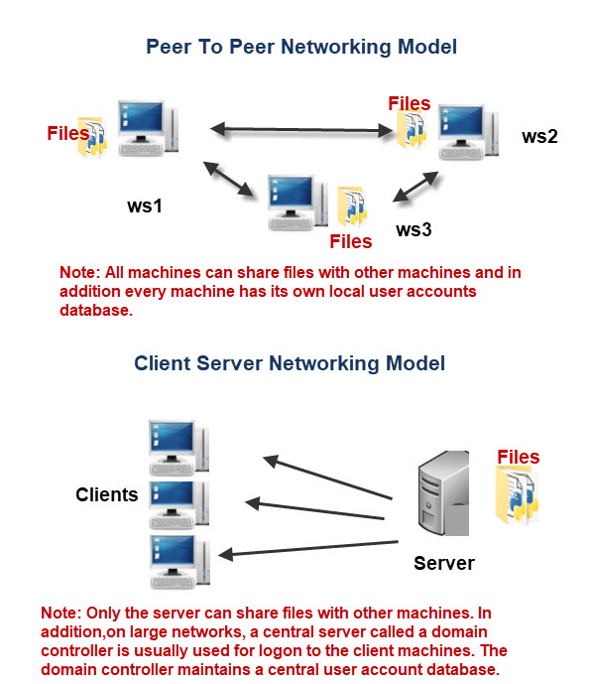

For More Detail [Click On This](https://stevessmarthomeguide.com/windows-file-sharing-basics/)

**Introduction to Network File System (NFS)**

Network File System or NFS is basically developed for sharing of files and folders between Linux/Unix systems by Sun Microsystems in 1980. NFS, like many other protocols, builds on the Open Network Computing Remote Procedure Call (ONC RPC) system.

The NFS is an open standard defined in a Request for Comments (RFC), allowing anyone to implement the protocol. It allows you to mount your local file systems over a network and remote hosts to interact with them as they are mounted locally on the same system. With the help of NFS, we can set up file sharing between Unix to Linux system and Linux to Unix system.

**NFS Benefits**

* NFS allows local access to remote files
* It uses standard client/server architecture for file sharing between all *nix based machines
* With NFS it is not necessary that both machines run on the same Operating System (OS)
* With the help of NFS we can configure centralized storage solutions
* Users get their data irrespective of physical location
* No manual refresh needed for new files
* Newer version of NFS also supports acl and pseudo root mounts
* Can be secured with Firewalls and Kerberos

NFS Services on Linux

NFS on Linux launch as System-V service with some core loaded as kernel extensions. The NFS server package includes three facilities, included in the portmap and nfs-utils packages

* portmap : It maps calls made from other machines to the correct RPC service (not required with NFSv4)
* nfs : It translates remote file sharing requests into requests on the local file system
* rpc.mountd : This service is responsible for mounting and unmounting of file systems

NFS Files on Linux

There are several files related to NFS configuration on Linux that we must know

* /etc/exports : Its a main configuration file of NFS, all exported files and directories are defined in this file at the NFS Server end
* /etc/fstab : To mount a NFS directory on your system across the reboots, we need to make an entry in /etc/fstab
* /etc/sysconfig/nfs : Configuration file of NFS to control on which port rpc and other services are listening

**File mounting on servers**

[**More Details is hear**](https://www.ge.com/digital/documentation/meridium/APMConnect/V4302_UDLP210/Content/MountaFileShare.htm)

## How to Configure Mail Sever ?

1. Click **Admin** tab on the web console
2. Under **Server Settings**, click **Mail Server Settings**
3. Specify the following information:
   1. Server Name: **smtp.gmail.com**
   2. Port: **465 (SSL) / 587 (TLS)**
   3. Sender Email Address: Your **email address**
   4. Test Email Address:**email address**to receive test mails**.**
   5. Email Type: **SMTP / SMTPS**
   6. Enable TLS:**Yes / No.** If you choose No, then SSL will be set as default.
   7. You need to **enable authentication** for configuring Gmail account
   8. Username: Specify your email address
   9. Password: Specify your password

You have successfully configured the mail server using Gmail account.

**What Is Load Balancing?**

**Load balancing** refers to efficiently distributing incoming network traffic across a group of backend servers, also known as a server farm or server pool.

A [load balancer](https://www.nginx.com/solutions/adc) acts as the “traffic cop” sitting in front of your servers and routing client requests across all servers capable of fulfilling those requests in a manner that maximizes speed and capacity utilization and ensures that no one server is overworked, which could degrade performance. If a single server goes down, the load balancer redirects traffic to the remaining online servers. When a new server is added to the server group, the load balancer automatically starts to send requests to it.

In this manner, a load balancer performs the following functions:

* Distributes client requests or network load efficiently across multiple servers
* Ensures high availability and reliability by sending requests only to servers that are online
* Provides the flexibility to add or subtract servers as demand dictates

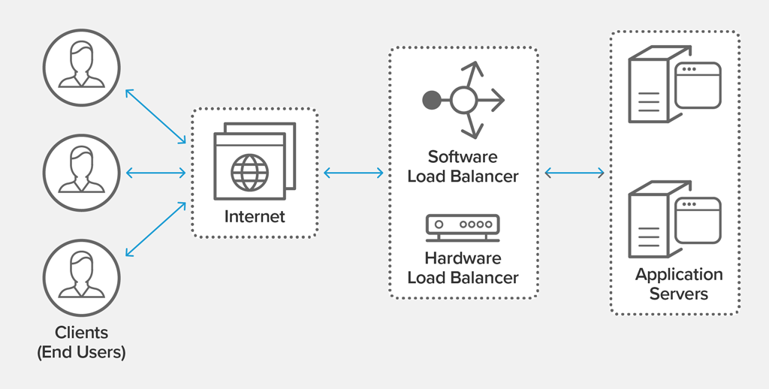

## TCP Load Balancer Definition

A **TCP Load Balancer** uses transmission control protocol (TCP), which verifies information sent to internet protocol (IP) addresses. It ensures the data arrives error-free to non-HTTP applications.

